Step 13 Report
Freeze the data (version 1.0)
Environment: Claude Code (this chat) | Completed: 11 October 2026 | Report version 2 (11 October 2026)
Thesis: Intelligent Power Transformer Fault Diagnosis Using Dissolved Gas Analysis and Machine Learning (MPhil, UMaT)
Abbreviations (such as PD, D1, T1, ppm) and technical terms are explained in the last section of this report.
In short: All data and standards tables that later steps depend on are now frozen as data version 1.0: the digital fingerprints of 16 files are recorded, and every later step must check them before reading the data. Figure 3.2 shows, with counts, how the 117 + 584 + 70 + 49 + 201 raw records became the 827 records of the master table. While building this figure, an automatic count check found an error in Table 4.1b of Step 11, which was corrected before the freeze.

1. Purpose of this step
From this point the project moves from preparing the data to using it. Freezing the data means that every later result - conventional methods, machine learning, statistics - can be traced to exactly the same files. Any change after this point must be made openly, as a new data version.

2. Method used

Approach
Content fingerprinting: the SHA-256 fingerprint of every file that later steps depend on - the raw data, the processed tables, the standards tables and the figure-style file - was calculated and written into one list (a 'manifest') named after the data version.
Enforcement: a check function (verify_data_version) recalculates every fingerprint and compares it with the manifest; every later step must call it before reading the data, and an automated test does the same.
Flow figure: Figure 3.2 shows how many records entered, were removed and ended in each data role. Every number is calculated from the files, and the program stops if the numbers do not add up.

Why this method
• Freezing the data means every later result can be traced to exactly these files; if any file changes, even by one character, the check fails at once.
• Recording the fingerprints is the standard way to prove that the analysed data are the data described in the thesis (data integrity and reproducibility).
• A flow figure with counts lets readers see where every record went, as reporting guidelines for data preparation recommend; computing it from the files and checking that the counts add up prevents typing errors.

Settings and rules
Setting | Value
Data version | 1.0 (11 October 2026)
Files frozen | 16: 5 raw data files, 3 processed tables, 7 standards tables, 1 figure-style file
Manifest | 03_Data/data_version_1.0.sha256 (sha256sum format: fingerprint, two spaces, file path)
Rule from now on | a frozen file changes only through a new, recorded data version (e.g. 1.1)
Count checks in Figure 3.2 | development = training file - removed; master = development + three test roles; folds cover the development set

Tools and programs
• 06_Python_ML/src/data_prep/step13_freeze.py; common.verify_data_version()
• Python hashlib (SHA-256), pandas 3.0.6, matplotlib 3.11.2 (Figure 3.2); tests/test_data_version.py (pytest 9.1.1)

Method references
[M1] National Institute of Standards and Technology, "Secure Hash Standard (SHS)," FIPS PUB 180-4, Aug. 2015. doi: 10.6028/NIST.FIPS.180-4

3. What was done, step by step
1. Listed every file that later steps depend on: the five raw data files, the three processed tables (master table, folds, label map), the seven standards tables and the figure-style file.
2. Calculated the SHA-256 fingerprint of each file and wrote them into 03_Data/data_version_1.0.sha256 and into the CHANGELOG.
3. Added a check function (verify_data_version) that recalculates every fingerprint and reports any file that has changed or is missing, and an automated test that runs it.
4. Drew Figure 3.2 from the files, with built-in checks that the counts add up.
5. The count check failed on the first run. The cause was traced to Table 4.1b of Step 11 (see Problems and fixes); the table was corrected, and the step was run again until every check passed.

4. What we found

Frozen files (data version 1.0)
File | SHA-256 fingerprint (first 16 characters)
03_Data/raw/iec_tc10_duval2001_full/iec_tc10_faulty_equipment.csv | EF9F6B542821264A...
03_Data/raw/ieee_dataport_1375187/DGA_test_unseen.xlsx | 23513C428C52F3BD...
03_Data/raw/ieee_dataport_1375187/DGA_train.xlsx | C1C376718D72A747...
03_Data/raw/ieee_dataport_1375187/IEC_TC_10_data.xlsx | 2B5B128ABF38533E...
03_Data/raw/ieee_dataport_7226/DGA dataset.xlsx | B797638252DB69C0...
03_Data/processed/dga_master.csv | AE9E6C0C84CF7180...
03_Data/processed/folds.csv | 0CE7D9AF3C7CE9F6...
03_Data/processed/label_map.csv | F66465BFB7BFB445...
02_Standards/duval_triangle_zones.csv | A8CE9CE85A012CD6...
02_Standards/iec_ratio_table.csv | 92BC70362EAC3654...
02_Standards/iec_typical_values.csv | 88D0D57E2EEB4737...
02_Standards/ieee_condition1_limits.csv | 4A4523269A91B89F...
02_Standards/rogers_ratio_table.csv | 0F7427C7E77AA1B2...
02_Standards/rogers_secondary_versions.csv | 798EE67752CD4C8B...
02_Standards/worked_examples.csv | 12ADBA9AEE570B61...
11_Results/figures/plot_style.csv | 041FE94B9DB6D78A...
The full 64-character fingerprints are in 03_Data/data_version_1.0.sha256 and in the CHANGELOG.

Figure 3.2 - how the data were prepared
Figure 3.2 - Data-preparation flow with record counts (Steps 5 to 13)
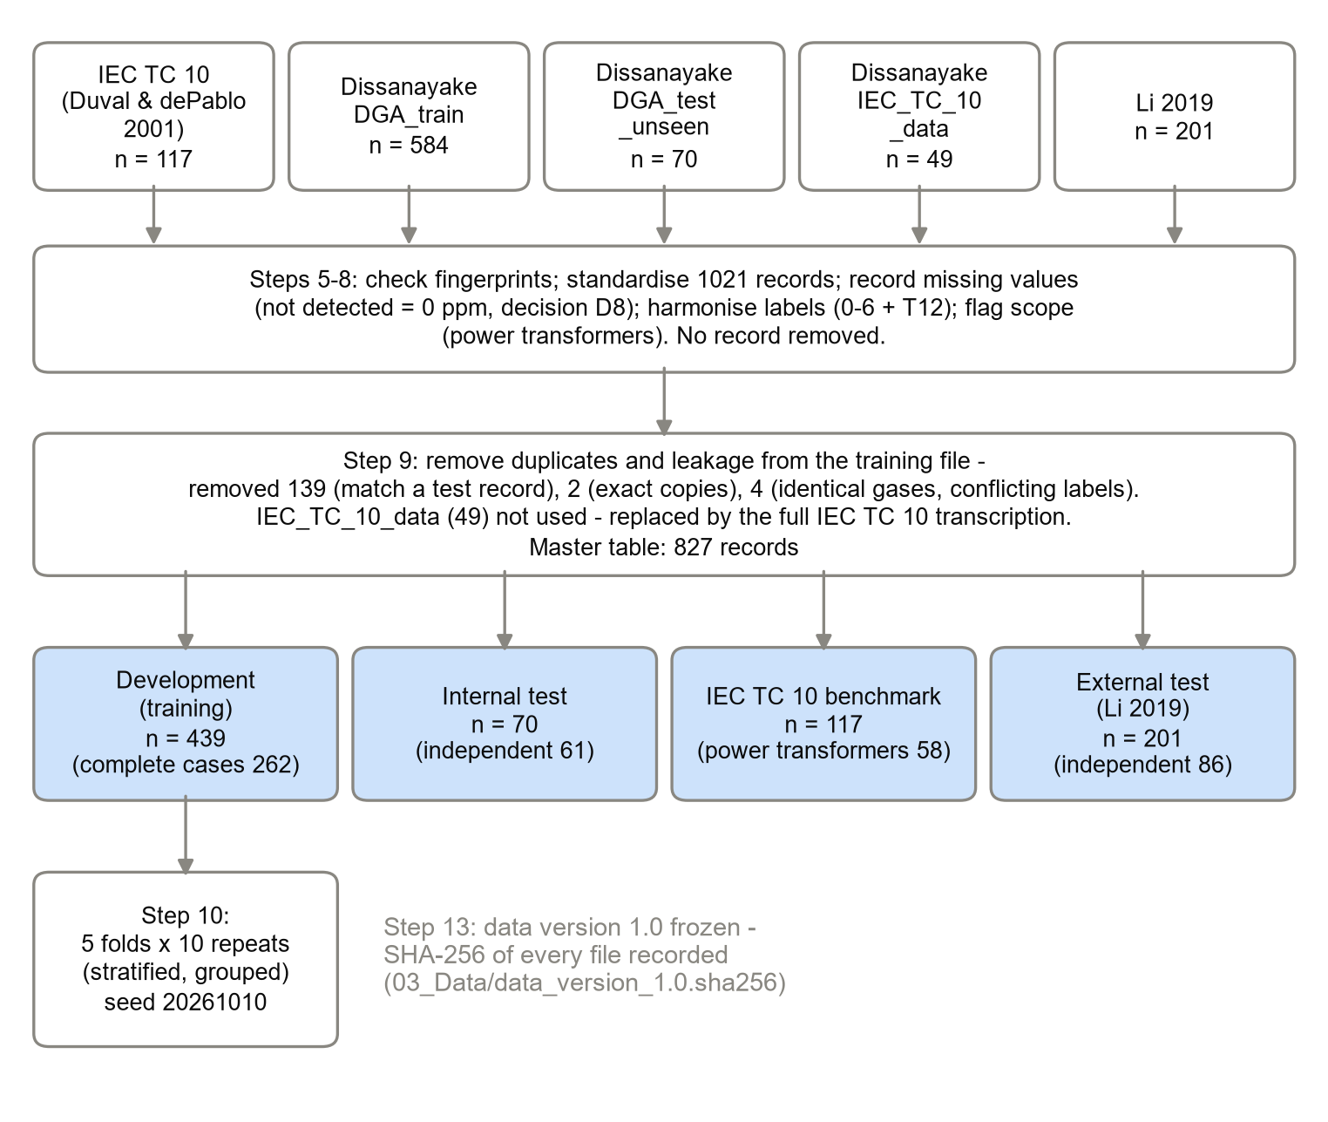
Reading the figure from top to bottom: the five raw files hold 117, 584, 70, 49 and 201 records. Steps 5 to 8 changed no record count. Step 9 removed 139 training records that match a test record, 2 exact copies and 4 records with conflicting labels, and did not use the 49-record IEC subset. The master table has 827 records: development 439, internal test 70, benchmark 117 and external test 201.

5. Checks
Check | Result
Manifest re-verified (every fingerprint recalculated) | 0 differences - PASS
Development = training file - removed records | 439 = 584 - 139 - 2 - 4 - PASS
Master table = sum of the four data roles | 827 - PASS
Folds cover exactly the development set | 439 records - PASS
Automated test suite (pytest) | 11 of 11 PASS (2 new tests for the frozen version)

6. Problems and fixes
• Table 4.1b of Step 11 (records removed in Step 9) was wrong. The program counted the 'record_id' column of the duplicate report; but in a leakage row that column sometimes holds the matched test record, not the removed training record. The table therefore showed 137 leakage removals instead of 139, and listed 96 IEC TC 10 benchmark records as 'removed' although they were never removed. The new count check in this step exposed the error. The program now counts the training records that are missing from the master table; the corrected table shows 2 exact copies, 4 conflicting labels and 139 leakage removals, exactly as in the Step 9 report. No other table, figure or data file changed. The Step 11 report records this correction.
• The first version of Figure 3.2 had text touching the box edges; the lines were wrapped and the boxes widened, and the figure was checked again.

7. Decisions
• Decision D10 (Rogers) was closed in Step 12 before the freeze, so the Rogers table is part of data version 1.0.
• Decision D11 (approved by the researcher on 11 October 2026): the implementation rules for Steps 14-17 - normality gate at the upper end of the IEC Table A.2 ranges (lower end as sensitivity); C2H2 range by tap-changer type; printed ranges include their end points; IEC dual D1/D2 answers counted as correct for D1 or D2 and reported separately; Rogers cases 0-5 mapped to Normal, PD, D2, T1, T2, T3; one common normality gate for all three methods.

8. Files produced
• 03_Data/data_version_1.0.sha256 (the manifest); 03_Data/interim/step13_report.md
• 11_Results/figures/F3_2_data_preparation_flow.png, .pdf and .csv (Figure 3.2 and its numbers)
• 06_Python_ML/src/data_prep/step13_freeze.py; verify_data_version() in common.py; 06_Python_ML/tests/test_data_version.py
• Corrected: 11_Results/tables/T4_1b_records_removed.csv (Step 11)

9. What was achieved
• Data version 1.0 is frozen: the fingerprints of 16 files are recorded in 03_Data/data_version_1.0.sha256 and in the CHANGELOG.
• Every later step can now prove it uses exactly these files (verify_data_version, automated tests 11 of 11 PASS).
• Figure 3.2 shows the whole data preparation with counts, all calculated from the files.
• The new count check found an error in Table 4.1b of Step 11, which was corrected before the freeze.

10. Record of this step
Item | Record
Step | 13 - Freeze the data (version 1.0)
Environment | Claude Code (this chat)
Completed | 11 October 2026
Status | Done
Main inputs | All files from Steps 5 to 12
Main outputs | 03_Data/data_version_1.0.sha256; Figure 3.2 (F3_2_data_preparation_flow PNG/PDF/CSV); 03_Data/interim/step13_report.md
Checks | Manifest re-verified with 0 differences; counts add up; pytest 11 of 11 PASS
Decisions | D11 approved - implementation rules for the conventional methods (Steps 14-17)

11. Data and sources used in this step
Every dataset, document and file this step used is listed below with its full reference, link and fingerprint (SHA-256, first 16 characters shown). Method references are listed in the 'Method used' section. The complete record, with access dates, licences and full fingerprints, is the Data and Source Register (00_Project_Admin/Step_Reports/Data_and_Source_Register.docx and 03_Data/provenance/data_and_source_register.csv).
ID | Reference and use in the project | Link, DOI and local file
DS1 | M. Duval and A. dePablo, "Interpretation of gas-in-oil analysis using new IEC publication 60599 and IEC TC 10 databases," IEEE Electrical Insulation Magazine, vol. 17, no. 2, pp. 31-41, Mar./Apr. 2001. Use: Main benchmark (labels confirmed by inspection): primary analysis = 58 power transformers (codes P, U); sensitivity = all 117. | https://doi.org/10.1109/57.917529; DOI 10.1109/57.917529; File: 03_Data/raw/iec_tc10_duval2001_full/iec_tc10_faulty_equipment.csv; SHA-256 EF9F6B542821264A...
DS2 | T. Dissanayake, "DGA dataset," IEEE DataPort, 2026. Use: Development (training) set: 439 records after removing leakage and copies (Step 9). | https://ieee-dataport.org/documents/dga-dataset; DOI 10.21227/27vy-h479; File: 03_Data/raw/ieee_dataport_1375187/DGA_train.xlsx; SHA-256 C1C376718D72A747...
DS3 | T. Dissanayake, "DGA dataset," IEEE DataPort, 2026. Use: Internal test set: 61 records independent of the benchmark (primary); all 70 as sensitivity. | https://ieee-dataport.org/documents/dga-dataset; DOI 10.21227/27vy-h479; File: 03_Data/raw/ieee_dataport_1375187/DGA_test_unseen.xlsx; SHA-256 23513C428C52F3BD...
DS4 | T. Dissanayake, "DGA dataset," IEEE DataPort, 2026. Use: Not used in any role: replaced by our full transcription DS1 (only 31 of its 49 rows match Annex 1). | https://ieee-dataport.org/documents/dga-dataset; DOI 10.21227/27vy-h479; File: 03_Data/raw/ieee_dataport_1375187/IEC_TC_10_data.xlsx; SHA-256 2B5B128ABF38533E...
DS5 | E. Li, "Dissolved gas data in transformer oil - Fault Diagnosis of Power Transformers with Membership Degree," IEEE DataPort, 2019. Use: External test set: 86 records independent of the benchmark (primary); all 201 as sensitivity. | https://ieee-dataport.org/documents/dissolved-gas-data-transformer-oil-fault-diagnosis-power-transformers-membership-degree; DOI 10.21227/h8g0-8z59; File: 03_Data/raw/ieee_dataport_7226/DGA dataset.xlsx; SHA-256 B797638252DB69C0...
DF1 | Made in Step 7 from DS1-DS5 and the dataset pages. Use: Translation of every original fault label into the shared scheme. | File: 03_Data/processed/label_map.csv; SHA-256 F66465BFB7BFB445...
DF2 | Made in Step 9 from DS1-DS5 (Steps 5-9 programs). Use: All clean records with role, class, flags and original values. | File: 03_Data/processed/dga_master.csv; SHA-256 AE9E6C0C84CF7180...
DF3 | Made in Step 10 from DF2. Use: Fold number of every training record in each of 10 repeats. | File: 03_Data/processed/folds.csv; SHA-256 0CE7D9AF3C7CE9F6...
DF4 | Made in Step 11 from the approved colour table (Analysis Plan). Use: Shared colours for Python and MATLAB figures. | File: 11_Results/figures/plot_style.csv; SHA-256 041FE94B9DB6D78A...
DF5 | Made in Step 12 from ST1-ST4 and P1-P4. Use: Limits used by the conventional methods (Steps 14-17). | File: 02_Standards/*.csv
DF6 | Made in Step 13 from all frozen files. Use: SHA-256 of every frozen file; checked by verify_data_version() before every later step. | File: 03_Data/data_version_1.0.sha256; SHA-256 260EBE0C8921E52C...
DF7 | Made in Step 13 from the frozen files. Use: Thesis Figure 3.2 (counts behind the figure). | File: 11_Results/figures/F3_2_data_preparation_flow.csv; SHA-256 3B62DA2E0F2229A8...
SW1 | Python 3.12.10 with 55 pinned packages (06_Python_ML/requirements.txt). Use: Runs every data-preparation, statistics and checking program. | https://www.python.org/downloads/release/python-31210/; File: 06_Python_ML/requirements.txt; SHA-256 594BC0CB122EED99...

12. How this helps the next steps
Next step: Steps 14 to 17 in the MATLAB Agentic Toolkit - complete the conventional-method functions so that they read every limit from 02_Standards, unit-test them with worked_examples.csv, run them on every record, and plot the Duval Triangles. The instructions for the toolkit are in 00_Project_Admin/Toolkit_Instructions/Steps_14-17_MATLAB.md.
• Steps 14-17 (MATLAB Agentic Toolkit) read the frozen standards tables and dga_master.csv; the MATLAB code can check the same fingerprints.
• Steps 18-24 (machine learning) call verify_data_version() first, so no model can be trained on changed data by accident.
• If a TO VERIFY value is later corrected (e.g. after checking a licensed copy of a standard), it becomes data version 1.1 with its own record, and the affected results are re-run.

13. Open items and limitations
• Values marked TO VERIFY in the standards tables (IEC against the 2022 text, Duval against IEEE C57.104-2019 or IEC 60599:2022, Rogers against a licensed copy) - any correction will create data version 1.1.
• Steps 2 and 3 (toolkit set-up) are still to be checked.
• Correction recorded on 11 October 2026: Table 4.1b of Step 11 was wrong (137 leakage removals instead of 139, and 96 IEC TC 10 benchmark records wrongly listed as removed). It was fixed; no other result changed.

14. Abbreviations and terms used in this report
Every abbreviation and technical term that appears in this report is explained below. The fault types follow the definitions of IEC 60599 (clause 5.2). The full list for the whole project is kept in 00_Project_Admin/abbreviations_glossary.csv.
Abbreviation or term | Meaning | Plain explanation
MPhil | Master of Philosophy | The research degree this thesis is written for.
UMaT | University of Mines and Technology, Tarkwa | The university where the thesis is submitted.
DGA | Dissolved Gas Analysis | Measuring the gases dissolved in transformer oil to find faults inside the transformer without opening it.
H2 | hydrogen | Gas formed mainly by partial discharges (low-energy electrical activity) in the oil.
C2H2 | acetylene | Gas that needs at least 800 to 1 200 °C; formed in significant amounts mainly in electrical arcs.
Normal (class 0) | no fault | A transformer without a fault: its gases stay at the levels normally found in service.
PD | partial discharges | Small electrical discharges that only partly bridge the insulation (corona type, can form X-wax, or small sparking punctures in paper).
D1 | discharges of low energy | Sparking or tracking: larger punctures in paper, carbonised paper surface or carbon particles in oil.
D2 | discharges of high energy | Arcing with power follow-through: extensive carbonisation, metal fusion, sometimes tripping of the equipment.
T1 | thermal fault below 300 °C | Overheating in which the paper has turned brownish.
T2 | thermal fault 300 to 700 °C | Overheating in which the paper has carbonised.
T3 | thermal fault above 700 °C | Very hot fault: carbonised oil, metal colouring (800 °C) or metal fusion (above 1 000 °C).
OLTC | on-load tap changer | A switch that changes the transformer's voltage ratio while it is in service; its sparking makes gases that can leak into the main tank.
IEC | International Electrotechnical Commission | The world body that publishes electrical standards, such as IEC 60599.
IEC 60599 | IEC guide to the interpretation of dissolved and free gas analysis | The international standard that defines the fault types and the IEC gas-ratio method.
IEC TC 10 | IEC Technical Committee 10 (fluids for electrotechnical applications) | The committee that wrote IEC 60599; its database of 117 inspected faulty units is this thesis's main benchmark.
IEEE | Institute of Electrical and Electronics Engineers | A professional body that publishes engineering standards and journals.
IEEE C57.104 | IEEE guide for the interpretation of gases generated in oil-immersed transformers | The IEEE standard that contains the Duval Triangle 1 (2019 edition) and the Rogers ratio table (2008 edition).
Duval Triangle 1 | graphical DGA method by M. Duval | The shares of CH4, C2H4 and C2H2 are plotted as one point in a triangle divided into fault zones.
Rogers ratios | older gas-ratio method by R.R. Rogers | A ratio table that names faults from three gas ratios; kept in IEEE C57.104.
Normality gate | rule that lets conventional methods answer 'Normal' | If all gases are below their typical values, the conventional methods give Normal instead of a fault (decision D3).
ML | machine learning | Computer methods that learn the link between gas values and fault type from labelled examples.
Benchmark | fixed reference test set | The IEC TC 10 cases whose faults were confirmed by inspection; every method is scored on them.
Inspection-based label | fault confirmed by opening the equipment | The fault type was seen by engineers after the unit was opened, not guessed from the gases.
Training (development) set | records used to build the models | 439 clean records from the Dissanayake training file.
Internal test set | Dissanayake unseen test file | 70 records (61 independent of the benchmark) kept away from training.
External test set | Li (2019) dataset | 201 records from a different source (86 independent of the benchmark), used to test the models on new data.
Leakage | test cases hidden in the training data | If a model has already seen a test case, its score is falsely high.
Primary and sensitivity analysis | main analysis and its repeat under another reasonable choice | The sensitivity analysis shows whether the conclusion changes when a choice is made differently.
Label map | translation table of fault labels | Lists every original label, its new code and the reason.
SHA-256 | Secure Hash Algorithm, 256-bit | A file's digital fingerprint: if one byte of the file changes, the fingerprint changes.
Fold | one part of the cross-validation split | Here the training data are cut into 5 folds (parts).
CSV | comma-separated values | A plain-text table file that any program can read.
PNG, PDF, dpi | image file, printable document file, dots per inch | Figures are saved as PNG at 300 dpi (sharp for printing) and as PDF.
docx | Microsoft Word document | The format of these reports.
Python | programming language | Used for data preparation, machine learning and statistics (Claude Code).
pytest | Python testing tool | Runs the automated checks that prove the data rules hold.
MATLAB | MATLAB (MathWorks) | Numerical programming environment; used for the conventional methods and the dashboard (MATLAB Agentic Toolkit).
D1-D11 (decisions) | numbered project decisions | Decisions recorded in 00_Project_Admin/decisions_log.md; not the same as the fault codes D1 and D2.
Analysis Plan | Expected Results and Analysis Plan | The approved document that fixes the measures, tests, tables and figures before results are seen.
TO VERIFY | not yet checked against the original source | Marks any value or fact that must still be confirmed before final use.

