Step 17 Report
Plot the Duval Triangles
Environment: MATLAB (run from Claude Code through the MATLAB MCP connection) | Completed: 11 October 2026 | Report version 1 (11 October 2026)
Thesis: Intelligent Power Transformer Fault Diagnosis Using Dissolved Gas Analysis and Machine Learning (MPhil, UMaT)
Abbreviations (such as PD, D1, T1, ppm) and technical terms are explained in the last section of this report.
In short: Duval Triangle 1 was drawn for each of the four data roles, with the zones taken from the ten rules of duval_triangle_zones.csv and every record placed by its gas percentages and coloured and shaped by its true class (Figure 4.4). Each figure is saved as a 300 dpi PNG, a vector PDF and a CSV of the plotted points. 825 of the 827 records have a position in the triangle; two development records have no CH4, C2H4 or C2H2 and are listed as not plotted.

1. Purpose of this step
The Duval Triangle is a picture-based method. Before any accuracy is calculated, these figures show where the true classes of each data set fall in the triangle and how close they lie to the zone lines. They are also the Figure 4.4 of Chapter 4.

2. Method used

Approach
Drawing from the rules: the 10 Duval rules are converted into polygons, filled with a light tint of the class colour, and the lines between different zones are drawn on top. The zone names, the 20 % grid and the three scales are added.
Plotting the data: each record is placed in the triangle by its three percentages (equation below) and drawn with the colour and marker of its TRUE class, both read from plot_style.csv. One figure is made for each data role, with a PNG (300 dpi), a vector PDF and a CSV of the plotted points.
Visual check: every PNG was opened and looked at; problems found were fixed and the figures made again.

Why this method
• The Duval Triangle is a picture-based method; showing where the true classes of each data set fall explains where the method can and cannot work, before any number is calculated.
• Colours and markers come from one shared file (plot_style.csv, written in Step 11) so that Python and MATLAB figures look the same across the thesis.
• Saving the plotted points as CSV lets a reader redraw or check the figure without MATLAB.

Settings and rules
Setting | Value
Figure | Figure 4.4 (one panel per data role)
Data roles | development, internal_test, benchmark, external_test
Class of each point | class_name; where it is empty (32 inspected T1/T2 cases) class_merged = T12 is used
Position | percentages from the raw gas values, WITHOUT the normality gate
Resolution and formats | PNG 300 dpi, vector PDF, CSV
Style file | 11_Results/figures/plot_style.csv

Equations
$$\begin{aligned}y=\left(\frac{\sqrt{3}}{2}\right)⋅p_{CH_{4}}\#\left(1\right)\end{aligned}$$
where:
$y$ – vertical position of the sample in the triangle [percentage points]
$p_{CH_{4}}$ – percentage of methane [%]
The horizontal position is x = p(C2H4) + p(CH4)/2. The triangle has its 100 % C2H2 corner at (0, 0), its 100 % C2H4 corner at (100, 0) and its 100 % CH4 corner at the top.

Tools and programs
• 04_MATLAB_Conventional/plot_duval_triangle.m and plot_duval_by_role.m (MATLAB R2025b, exportgraphics)

Method references
[P3] Manisha, K. Kaur, N. K. Sharma, J. Singh and D. Bhalla, "Performance Assessment of IEEE/IEC Method and Duval Triangle technique for Transformer Incipient Fault Diagnosis," IOP Conf. Ser.: Mater. Sci. Eng., vol. 1228, art. 012027, 2022. doi: 10.1088/1757-899X/1228/1/012027
[P4] A. Moser, "The Duval Triangle for Transformer Fault Diagnosis," HV Assets, 20 May 2025 (updated 20 July 2025). https://www.hvassets.com/en/post/the-duval-triangle-for-transformer-fault-diagnosis
[M8] I. E. Sutherland and G. W. Hodgman, "Reentrant polygon clipping," Communications of the ACM, vol. 17, no. 1, pp. 32-42, Jan. 1974. https://cacmb4.acm.org/magazines/1974/1/11767-reentrant-polygon-clipping

3. What was used
Input | Content
03_Data/processed/dga_master.csv | 827 records and their true class (data version 1.0). [DF2]
02_Standards/duval_triangle_zones.csv | The 10 rules that define the zones. [DF5]
11_Results/figures/plot_style.csv | Colour and marker of each class. [DF4]

4. What was done, step by step
1. Rewrote plot_duval_triangle.m: it now builds the zones from the rules (duval_zone_polygons), draws the decision edges (duval_decision_edges), the 20 % grid, the scales and the zone names, and plots points by class. The old call used by the dashboard still works.
2. Wrote plot_duval_by_role.m: for each data role it selects the records, takes the true class (class_name, or T12 for the inspected T1/T2 cases), draws the figure, and saves PNG (300 dpi), PDF (vector) and the CSV of plotted points.
3. Looked at every PNG. Three faults were found in the first version and fixed (see Problems and fixes); the figures were made again.

5. What we found
How to read a figure: each corner is a pure gas (100 % CH4 at the top, 100 % C2H2 at the bottom left, 100 % C2H4 at the bottom right). A point near a corner is dominated by that gas. The coloured areas are the zones PD, T1, T2, T3, D1, D2 and DT; the grey lines are the lines where the diagnosis changes. The colour and shape of a marker is the TRUE class, so a marker lying in a zone of another colour is a case the Duval Triangle would get wrong.

Figure 4.4a - Development
Figure 4.4a - Duval Triangle 1: Development (437 records plotted), coloured by true class
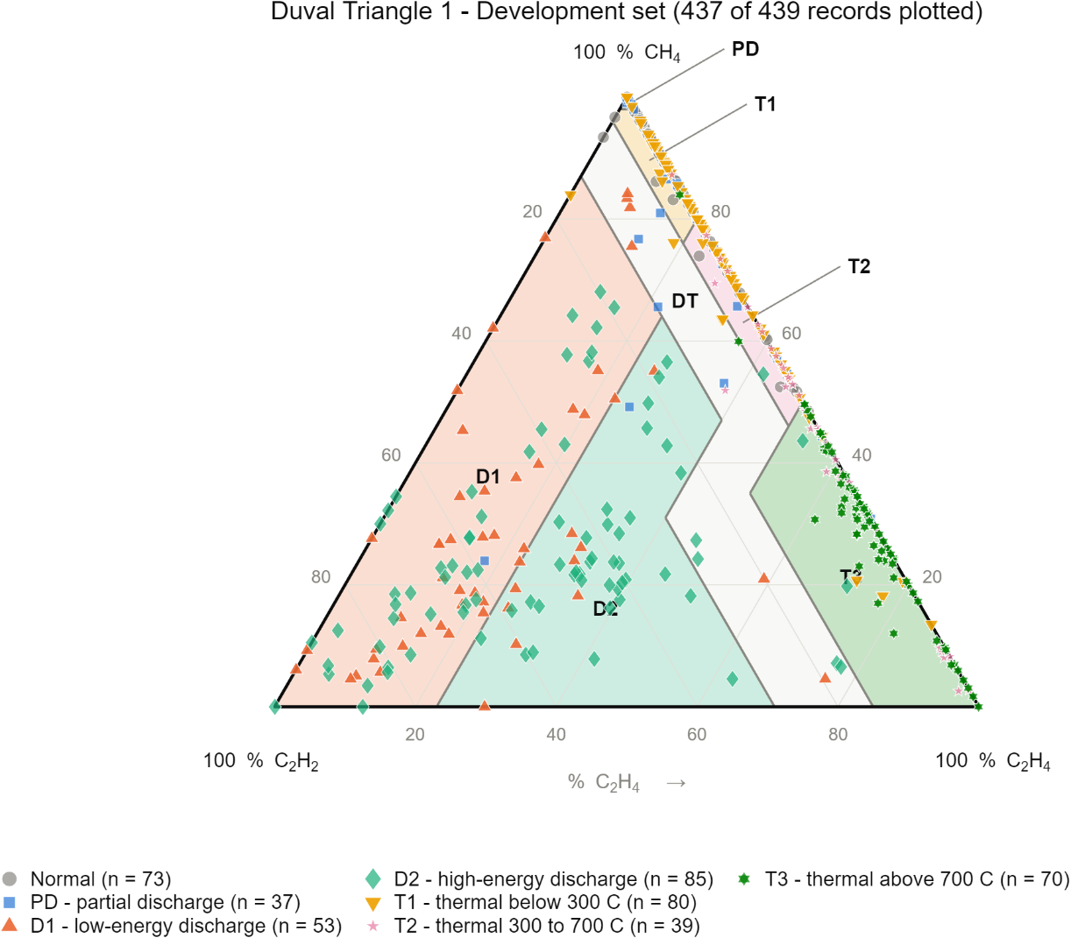
True class | Records plotted
D1 | 53
D2 | 85
Normal | 73
PD | 37
T1 | 80
T2 | 39
T3 | 70

Figure 4.4b - Internal test
Figure 4.4b - Duval Triangle 1: Internal test (70 records plotted), coloured by true class
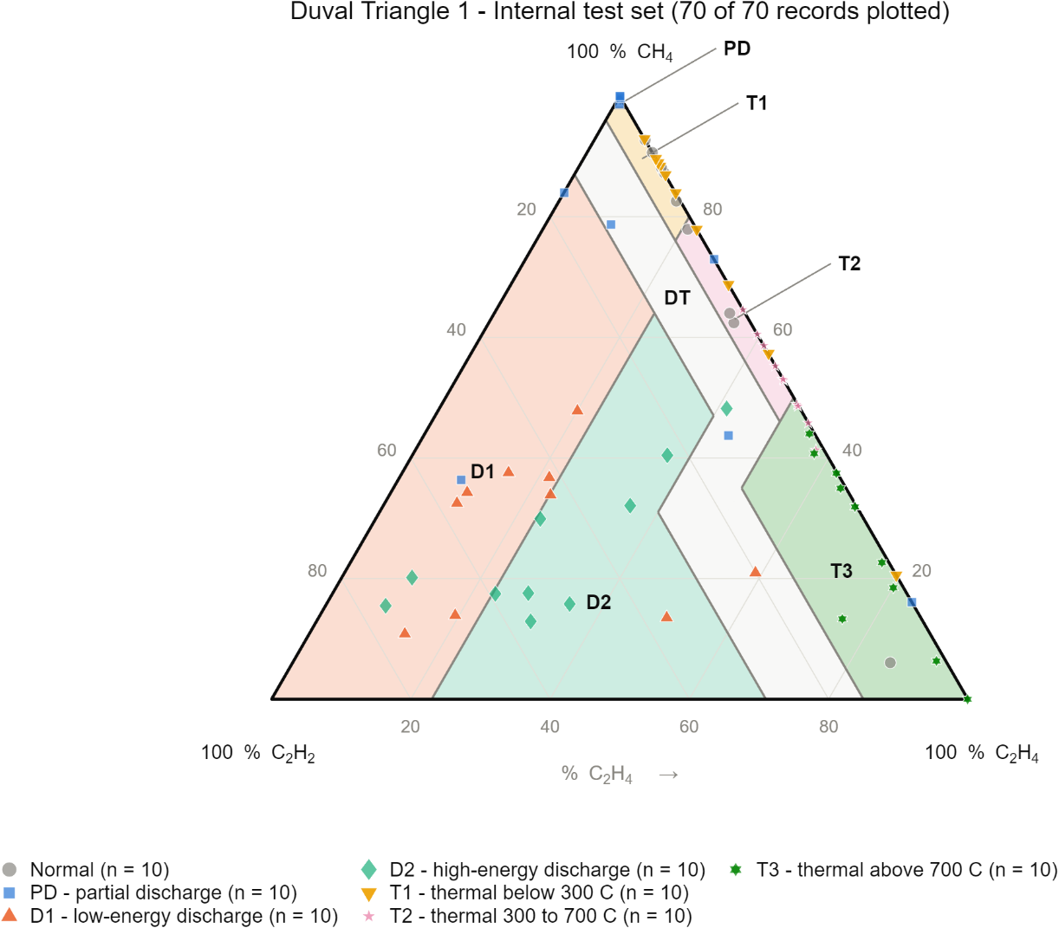
True class | Records plotted
D1 | 10
D2 | 10
Normal | 10
PD | 10
T1 | 10
T2 | 10
T3 | 10

Figure 4.4c - IEC TC 10 benchmark
Figure 4.4c - Duval Triangle 1: IEC TC 10 benchmark (117 records plotted), coloured by true class
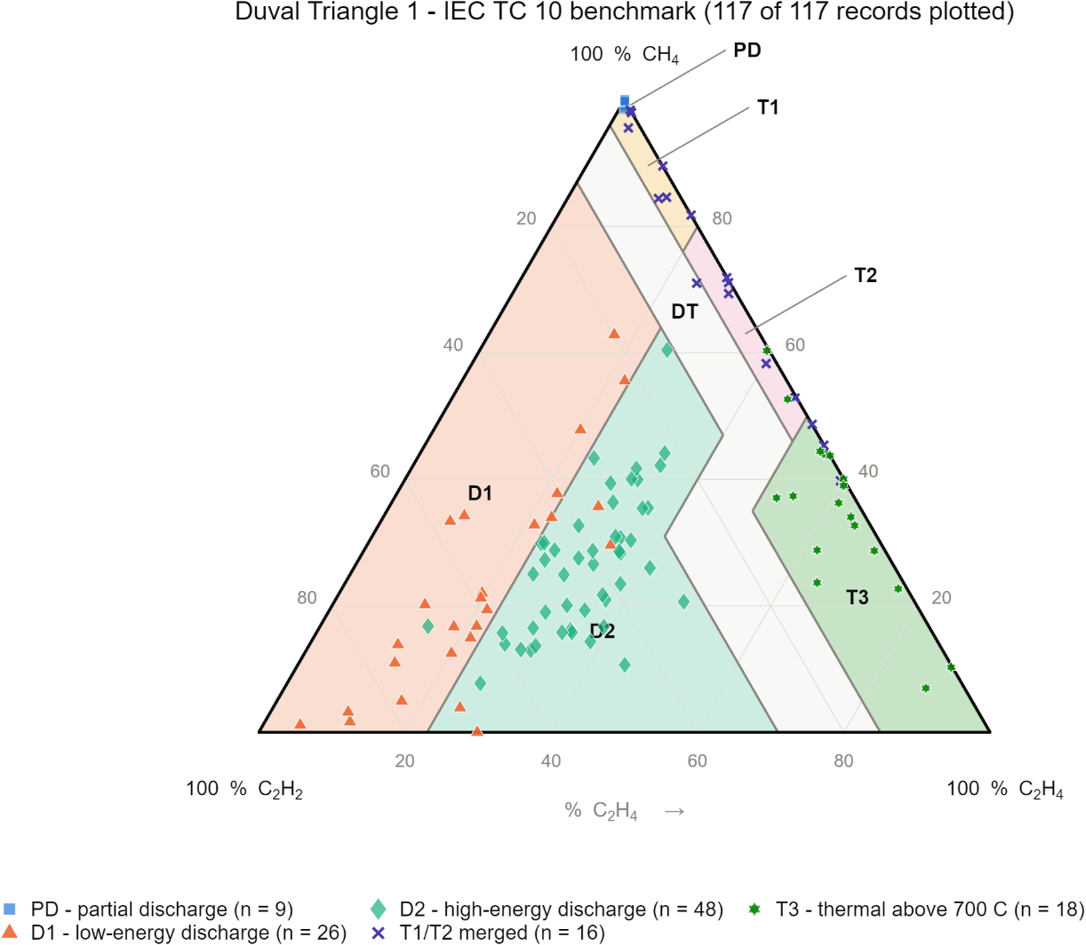
True class | Records plotted
D1 | 26
D2 | 48
PD | 9
T12 | 16
T3 | 18

Figure 4.4d - External test (Li 2019)
Figure 4.4d - Duval Triangle 1: External test (Li 2019) (201 records plotted), coloured by true class
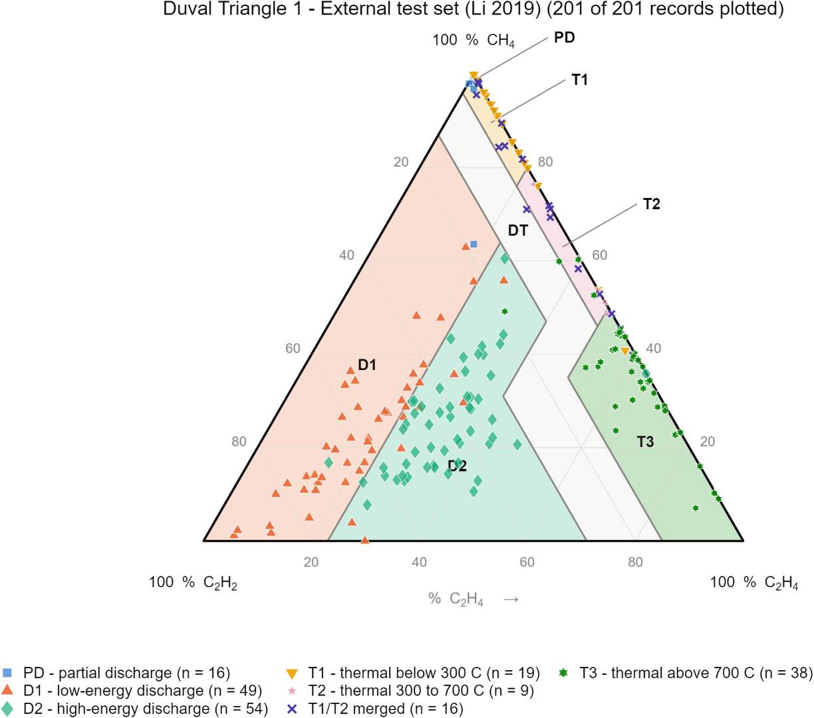
True class | Records plotted
D1 | 49
D2 | 54
PD | 16
T1 | 19
T12 | 16
T2 | 9
T3 | 38

Records without a position
Two development records, DISTRAIN_0531 and DISTRAIN_0532, have CH4, C2H4 and C2H2 all equal to 0 ppm; their percentages are undefined and the Duval method gives ND. They are not plotted. All other records of all roles are plotted (development 437 of 439; internal test 70 of 70; benchmark 117 of 117; external test 201 of 201).

6. Checks
Check | Result
Figures made by script from the CSV rules and the master table | plot_duval_by_role.m - PASS
Zone lines match the 10 rules | polygons cover the triangle: area 5000 of 5000 (test in Step 15) - PASS
Files saved for each role | PNG 300 dpi, PDF, CSV (12 files) - PASS
Plotted points | 825 of 827 (2 undefined) - PASS
Every PNG looked at | yes; three faults found and fixed

7. Problems and fixes
• Title and legend text was almost invisible: the MATLAB desktop uses a dark theme and the invisible figure inherited light text. The figure is now set to the light theme and the title and legend use the text colour of plot_style.csv.
• The markers of the merged T1/T2 class (an 'x') were invisible, because line markers cannot be filled and had a white edge. They are now drawn in the class colour.
• The names of the thin zones PD, T1 and T2 were hidden under the points that lie along the right side. They are now written outside the triangle with a short leader line.

8. Decisions
• None new.

9. Files produced
• 11_Results/figures: duval_development, duval_internal_test, duval_benchmark, duval_external_test, each as .png (300 dpi), .pdf (vector) and .csv (plotted points).
• 04_MATLAB_Conventional: plot_duval_triangle.m, plot_duval_by_role.m.

10. What was achieved
• Figure 4.4 was made for each of the four data roles from the script (PNG 300 dpi, vector PDF, plotted points as CSV).
• The zone lines are computed from the 10 rules in duval_triangle_zones.csv, not drawn by hand.
• Problems found by looking at the first figures (light title text, invisible markers for the merged T1/T2 class, hidden labels of the thin zones) were fixed and the figures remade.

11. Record of this step
Item | Record
Step | 17 - Plot the Duval Triangles
Environment | MATLAB, run from Claude Code through the MATLAB MCP connection
Completed | 11 October 2026
Status | Done
Main inputs | dga_master.csv; duval_triangle_zones.csv; plot_style.csv
Main outputs | 11_Results/figures: duval_development, duval_internal_test, duval_benchmark, duval_external_test (.png, .pdf, .csv)
Checks | figures made by script; zone polygons cover the triangle (area 5000 = 100 x 100 / 2); 825 of 827 records plotted, 2 have no position
Decisions | none new

12. Data and sources used in this step
Every dataset, document and file this step used is listed below with its full reference, link and fingerprint (SHA-256, first 16 characters shown). Method references are listed in the 'Method used' section. The complete record, with access dates, licences and full fingerprints, is the Data and Source Register (00_Project_Admin/Step_Reports/Data_and_Source_Register.docx and 03_Data/provenance/data_and_source_register.csv).
ID | Reference and use in the project | Link, DOI and local file
DF2 | Made in Step 9 from DS1-DS5 (Steps 5-9 programs). Use: All clean records with role, class, flags and original values. | File: 03_Data/processed/dga_master.csv; SHA-256 AE9E6C0C84CF7180...
DF4 | Made in Step 11 from the approved colour table (Analysis Plan). Use: Shared colours for Python and MATLAB figures. | File: 11_Results/figures/plot_style.csv; SHA-256 041FE94B9DB6D78A...
DF5 | Made in Step 12 from ST1-ST4 and P1-P4. Use: Limits used by the conventional methods (Steps 14-17). | File: 02_Standards/*.csv
DF14 | Made in Step 17 by plot_duval_by_role.m (PNG 300 dpi, vector PDF and the plotted points as CSV for each role). Use: Figure 4.4 of the thesis. | File: 11_Results/figures/duval_<role>.png, .pdf, .csv; SHA-256 9CBC5509A7CE692F...
SW2 | MATLAB R2025b, version 25.2.0.2998904, The MathWorks, Inc., Natick, MA, USA. Use: Runs the conventional-method functions, unit tests, batch run and Duval figures (Steps 14-17). | https://www.mathworks.com/products/matlab.html

13. How this helps the next steps
Next step: Step 18 [Claude Code] - re-implement the three methods in Python from the same tables and check that MATLAB and Python agree on 100 % of the 2481 prediction rows.
• Step 18 (Claude Code) re-implements the three methods in Python and checks agreement with the MATLAB predictions.
• The figures are Figure 4.4 of Chapter 4; the CSV of plotted points lets the Python figures in later steps use identical positions.

14. Open items and limitations
• The figures show where the true classes lie; they are descriptive and do not by themselves measure accuracy.
• Two development records have CH4 + C2H4 + C2H2 = 0 ppm and therefore no position in the triangle; they are listed as not plotted.
• Duval zone limits are TO VERIFY against a primary source (see Step 12).
• Many thermal records lie along the C2H2 = 0 side of the triangle, so their markers overlap; the CSV lists every point.

15. Abbreviations and terms used in this report
Every abbreviation and technical term that appears in this report is explained below. The fault types follow the definitions of IEC 60599 (clause 5.2). The full list for the whole project is kept in 00_Project_Admin/abbreviations_glossary.csv.
Abbreviation or term | Meaning | Plain explanation
MPhil | Master of Philosophy | The research degree this thesis is written for.
UMaT | University of Mines and Technology, Tarkwa | The university where the thesis is submitted.
DGA | Dissolved Gas Analysis | Measuring the gases dissolved in transformer oil to find faults inside the transformer without opening it.
ppm | parts per million | Amount of gas in the oil; 1 ppm = 1 microlitre of gas in 1 litre of oil.
H2 | hydrogen | Gas formed mainly by partial discharges (low-energy electrical activity) in the oil.
CH4 | methane | Hydrocarbon gas formed when oil is overheated, mainly at the lower fault temperatures.
C2H4 | ethylene | Hydrocarbon gas favoured above about 500 °C; it rises as thermal faults get hotter.
C2H2 | acetylene | Gas that needs at least 800 to 1 200 °C; formed in significant amounts mainly in electrical arcs.
PD | partial discharges | Small electrical discharges that only partly bridge the insulation (corona type, can form X-wax, or small sparking punctures in paper).
D1 | discharges of low energy | Sparking or tracking: larger punctures in paper, carbonised paper surface or carbon particles in oil.
D2 | discharges of high energy | Arcing with power follow-through: extensive carbonisation, metal fusion, sometimes tripping of the equipment.
T1 | thermal fault below 300 °C | Overheating in which the paper has turned brownish.
T2 | thermal fault 300 to 700 °C | Overheating in which the paper has carbonised.
T3 | thermal fault above 700 °C | Very hot fault: carbonised oil, metal colouring (800 °C) or metal fusion (above 1 000 °C).
T12 | T1 or T2 (merged class) | Used in this project when a source does not say whether the thermal fault was below or above 300 °C.
DT | mixture of thermal and electrical faults | A zone of the Duval Triangle 1 for cases that look partly thermal and partly electrical.
Duval Triangle 1 | graphical DGA method by M. Duval | The shares of CH4, C2H4 and C2H2 are plotted as one point in a triangle divided into fault zones.
Normality gate | rule that lets conventional methods answer 'Normal' | If all gases are below their typical values, the conventional methods give Normal instead of a fault (decision D3).
Benchmark | fixed reference test set | The IEC TC 10 cases whose faults were confirmed by inspection; every method is scored on them.
Inspection-based label | fault confirmed by opening the equipment | The fault type was seen by engineers after the unit was opened, not guessed from the gases.
Training (development) set | records used to build the models | 439 clean records from the Dissanayake training file.
Internal test set | Dissanayake unseen test file | 70 records (61 independent of the benchmark) kept away from training.
External test set | Li (2019) dataset | 201 records from a different source (86 independent of the benchmark), used to test the models on new data.
SHA-256 | Secure Hash Algorithm, 256-bit | A file's digital fingerprint: if one byte of the file changes, the fingerprint changes.
CSV | comma-separated values | A plain-text table file that any program can read.
PNG, PDF, dpi | image file, printable document file, dots per inch | Figures are saved as PNG at 300 dpi (sharp for printing) and as PDF.
Python | programming language | Used for data preparation, machine learning and statistics (Claude Code).
MATLAB | MATLAB (MathWorks) | Numerical programming environment; used for the conventional methods and the dashboard (MATLAB Agentic Toolkit).
Analysis Plan | Expected Results and Analysis Plan | The approved document that fixes the measures, tests, tables and figures before results are seen.
TO VERIFY | not yet checked against the original source | Marks any value or fact that must still be confirmed before final use.
ND (no diagnosis) | No diagnosis | The answer of a method when no rule applies or a ratio it needs cannot be calculated. It is a result and is never deleted.
Boundary distance | Distance to the nearest decision boundary | How far a sample is from the line where the diagnosis would change. A small distance means a small measurement error could change the diagnosis.
Polygon clipping (Sutherland-Hodgman) | Cutting a shape with straight lines | A standard way to find the area of the triangle that satisfies one limit after another; used to draw the Duval zones from their limits.
Unit test (matlab.unittest) | Automatic test of one small piece of code | A test that feeds a function a known input and checks the answer, so that any later change that breaks the function is noticed at once.

