Step 23 Report
Explain the model
Environment: Claude Code (this chat) | Completed: 12 October 2026 | Report version 1 (12 October 2026)
Thesis: Intelligent Power Transformer Fault Diagnosis Using Dissolved Gas Analysis and Machine Learning (MPhil, UMaT)
Abbreviations (such as PD, D1, T1, ppm) and technical terms are explained in the last section of this report.
In short: The final model reasons in a physically sensible way. Shuffling acetylene (C2H2) is among the two most damaging changes on all three test sets, and methane (CH4) is among the two least. For each of the six fault classes, the model's strongest evidence involves the key gas engineers would expect (6 of 6), and the directions of its main effects agree with the IEC 60599 ratio limits - for example, a low CH4/H2 ratio points to partial discharge and a high C2H4/C2H6 ratio to severe overheating (T3). Because the development labels may partly come from such methods, this shows plausibility rather than independent discovery.

1. Purpose of this step
This step opens the 'black box': it shows which gases and gas ratios the final model relies on, and whether its reasoning matches transformer engineering knowledge (Analysis Plan Section 8.1). Results are reported as found.

2. Method used

Approach
Two standard, complementary explanation methods were applied to the fitted model of Step 22, which was not changed. Permutation importance asks how much worse the model gets when one input is scrambled; SHAP values show, for every record, how much each input pushed the prediction towards or away from each fault class.
Permutation importance was computed on the three test sets at two levels: gas level (one of the five gases is shuffled before the features are built, so all its ratios and percentages move together) and feature level (one of the 18 features is shuffled). The gas level is the main ranking, because the 18 features are built from only five gases and share much of their information.
SHAP values were computed exactly (TreeSHAP) for all 439 development records and all 388 test records. The model's reasoning was then compared with the engineering expectation written down before the results (decision D20) and with the IEC 60599 ratio table.

Why this method
• A diagnosis that engineers cannot check is hard to trust in a utility; explanations show whether the model relies on physically sensible evidence (Analysis Plan Section 8.1).
• Shuffling one feature at a time understates inputs whose information is shared with other features (Strobl et al., 2008); shuffling a whole gas avoids this.
• TreeSHAP gives exact, additive explanations for tree models (Lundberg et al., 2020), so the contributions add up to the predicted probability - this was checked.

Settings and rules
Setting | Value
Model explained | final pipeline of Step 22 (Random Forest, F4), fingerprint checked
Permutation importance | Eq. 38; R = 30 shuffles; seed 20261010; score = macro-F1 with each set's class list
Records (permutation) | internal test 61, IEC TC 10 power transformers 58, Li 2019 86 (primary sets of D19)
SHAP | exact TreeSHAP, class-probability units; 439 development + 388 test records; shap 0.53.0
Interval | 2.5-97.5 percentile of the 30 shuffles (shuffle variability only, not sampling variability)
Engineering check (D20) | PD - H2; D1, D2 - C2H2; T1 - CH4 or C2H6; T2 - C2H4 or CH4; T3 - C2H4

Equations
$$\begin{aligned}I_{j}=s-\frac{1}{R}\sum_{r=1}^{R}{s_{r,j}}\#\left(1\right)\end{aligned}$$
where:
$I_{j}$ – permutation importance of gas or feature j (drop in macro-F1)
$s$ – macro-F1 of the model on the unshuffled test set
$s_{r,j}$ – macro-F1 after input j is shuffled in repeat r; R = 30 repeats
$$\begin{aligned}Φ_{j}=\frac{1}{N}\sum_{i=1}^{N}{\left|φ_{i,j}\right|}\#\left(2\right)\end{aligned}$$
where:
$Φ_{j}$ – overall SHAP importance of feature j for one class (probability units)
$φ_{i,j}$ – SHAP value: contribution of feature j to the predicted probability of that class for record i
$N$ – number of records explained (439 development records for Figure 4.15)

Tools and programs
• 06_Python_ML/src/ml/step23_explain.py (permutation importance, SHAP, engineering check, Figures 4.14 and 4.15)
• shap 0.53.0 (TreeExplainer); scikit-learn; matplotlib with the shared style file plot_style.csv

Method references
[M15] L. Breiman, "Random Forests," Machine Learning, vol. 45, no. 1, pp. 5-32, 2001. doi: 10.1023/A:1010933404324
[M16] S. M. Lundberg and S.-I. Lee, "A unified approach to interpreting model predictions," in Advances in Neural Information Processing Systems 30 (NIPS 2017), 2017. https://papers.nips.cc/paper/7062-a
[M17] S. M. Lundberg, G. Erion, H. Chen, A. DeGrave, J. M. Prutkin, B. Nair, R. Katz, J. Himmelfarb, N. Bansal and S.-I. Lee, "From local explanations to global understanding with explainable AI for trees," Nature Machine Intelligence, vol. 2, no. 1, pp. 56-67, 2020. doi: 10.1038/s42256-019-0138-9
[M18] C. Strobl, A.-L. Boulesteix, T. Kneib, T. Augustin and A. Zeileis, "Conditional variable importance for random forests," BMC Bioinformatics, vol. 9, art. 307, 2008. doi: 10.1186/1471-2105-9-307

3. What was done, step by step
1. Fixed the design as decision D20 before computing anything, including the engineering expectation for each fault class.
2. Wrote step23_explain.py; it checks the fingerprint of the fitted model, computes permutation importance (gas and feature level) and SHAP values, and draws Figures 4.14 and 4.15.
3. Added a table of the direction of each main effect (does a high or a low value push towards the class?) and ran the program again; all earlier results were reproduced exactly.
4. Compared the directions with the limits of IEC 60599 Table 2, read from the project's transcribed table (02_Standards/iec_ratio_table.csv).

4. What we found

Which gases matter most (permutation importance, gas level)
Gas shuffled | Internal test (n = 61) | IEC TC 10 power transformers (n = 58) | Li 2019 (n = 86)
H2 | 0.241 [0.180, 0.286] (3) | 0.288 [0.219, 0.349] (2) | 0.111 [0.050, 0.174] (3)
CH4 | 0.091 [0.031, 0.162] (5) | 0.127 [0.030, 0.314] (4) | 0.031 [-0.065, 0.120] (5)
C2H6 | 0.241 [0.175, 0.314] (4) | -0.033 [-0.095, 0.038] (5) | 0.097 [0.035, 0.147] (4)
C2H4 | 0.360 [0.280, 0.452] (1) | 0.224 [0.142, 0.424] (3) | 0.285 [0.201, 0.356] (1)
C2H2 | 0.257 [0.140, 0.349] (2) | 0.371 [0.189, 0.484] (1) | 0.277 [0.217, 0.324] (2)
Each cell: mean drop in macro-F1 over 30 shuffles [2.5-97.5 percentile of the shuffles] (rank within the set, 1 = most important).
• Internal test: C2H4 > C2H2 > H2 > C2H6 > CH4
• IEC TC 10 (power transformers): C2H2 > H2 > C2H4 > CH4 > C2H6
• Li 2019: C2H4 > C2H2 > H2 > C2H6 > CH4
Acetylene (C2H2) is among the two most important gases on every set - the gas of electrical discharges. Ethylene (C2H4), the gas of severe overheating, is the most important on the internal test and Li 2019 sets. Methane (CH4) is among the two least important gases on every set. On the IEC TC 10 benchmark, shuffling ethane (C2H6) slightly improved the score (-0.033): the way the model uses ethane, learned from the development data, does not carry over to that benchmark - a finding to discuss in Chapter 4.
Figure 4.14 Permutation importance of the final model, internal test set (n = 61)
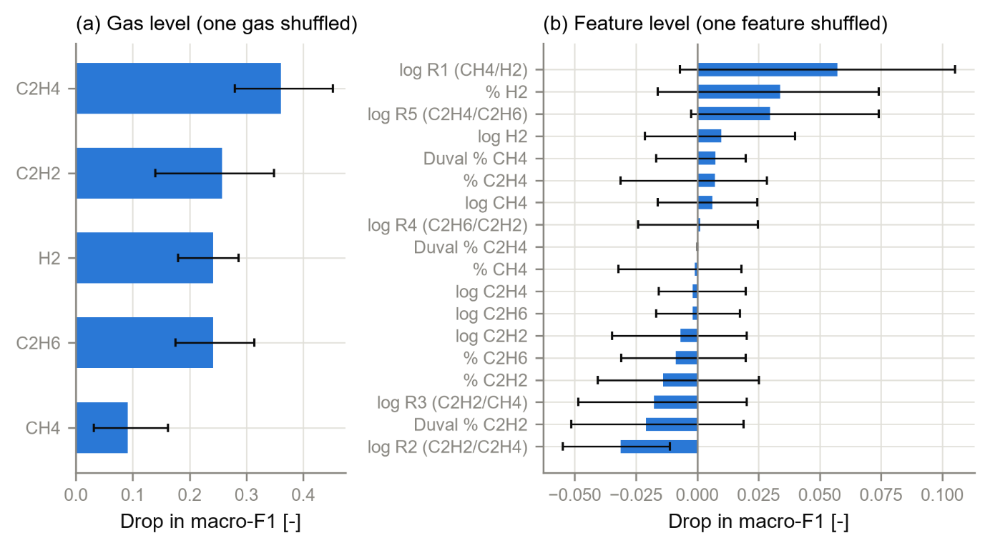
Bars: mean drop in macro-F1 over 30 shuffles; whiskers: 2.5-97.5 percentile range of the shuffles (shuffle variability only). Panel (b): 17 of the 18 single features have a range that includes zero - shuffling one feature alone is largely compensated by the related features built from the same gases, which is why the gas level (panel a) is the main ranking (decision D20).

How the model uses each feature (SHAP)
Rank | Feature | Mean |SHAP|, development (n = 439) | Mean |SHAP|, test (n = 388)
1 | Duval % C2H2 | 0.237 | 0.272
2 | log R1 (CH4/H2) | 0.212 | 0.206
3 | log R5 (C2H4/C2H6) | 0.199 | 0.198
4 | % C2H2 | 0.196 | 0.232
5 | % C2H4 | 0.194 | 0.194
6 | log R2 (C2H2/C2H4) | 0.162 | 0.157
7 | log C2H4 | 0.130 | 0.119
8 | % H2 | 0.124 | 0.127
Mean absolute SHAP value summed over the seven classes (probability units), top 8 of 18 features. The three strongest are the Duval share of acetylene and the ratios CH4/H2 (R1) and C2H4/C2H6 (R5) - the same quantities the Duval Triangle and the IEC and Rogers ratio methods use. The ranking on the test records agrees closely with that on the development records (Spearman 0.961).
Figure 4.15 SHAP summary of the final model, one panel per class (439 development records)
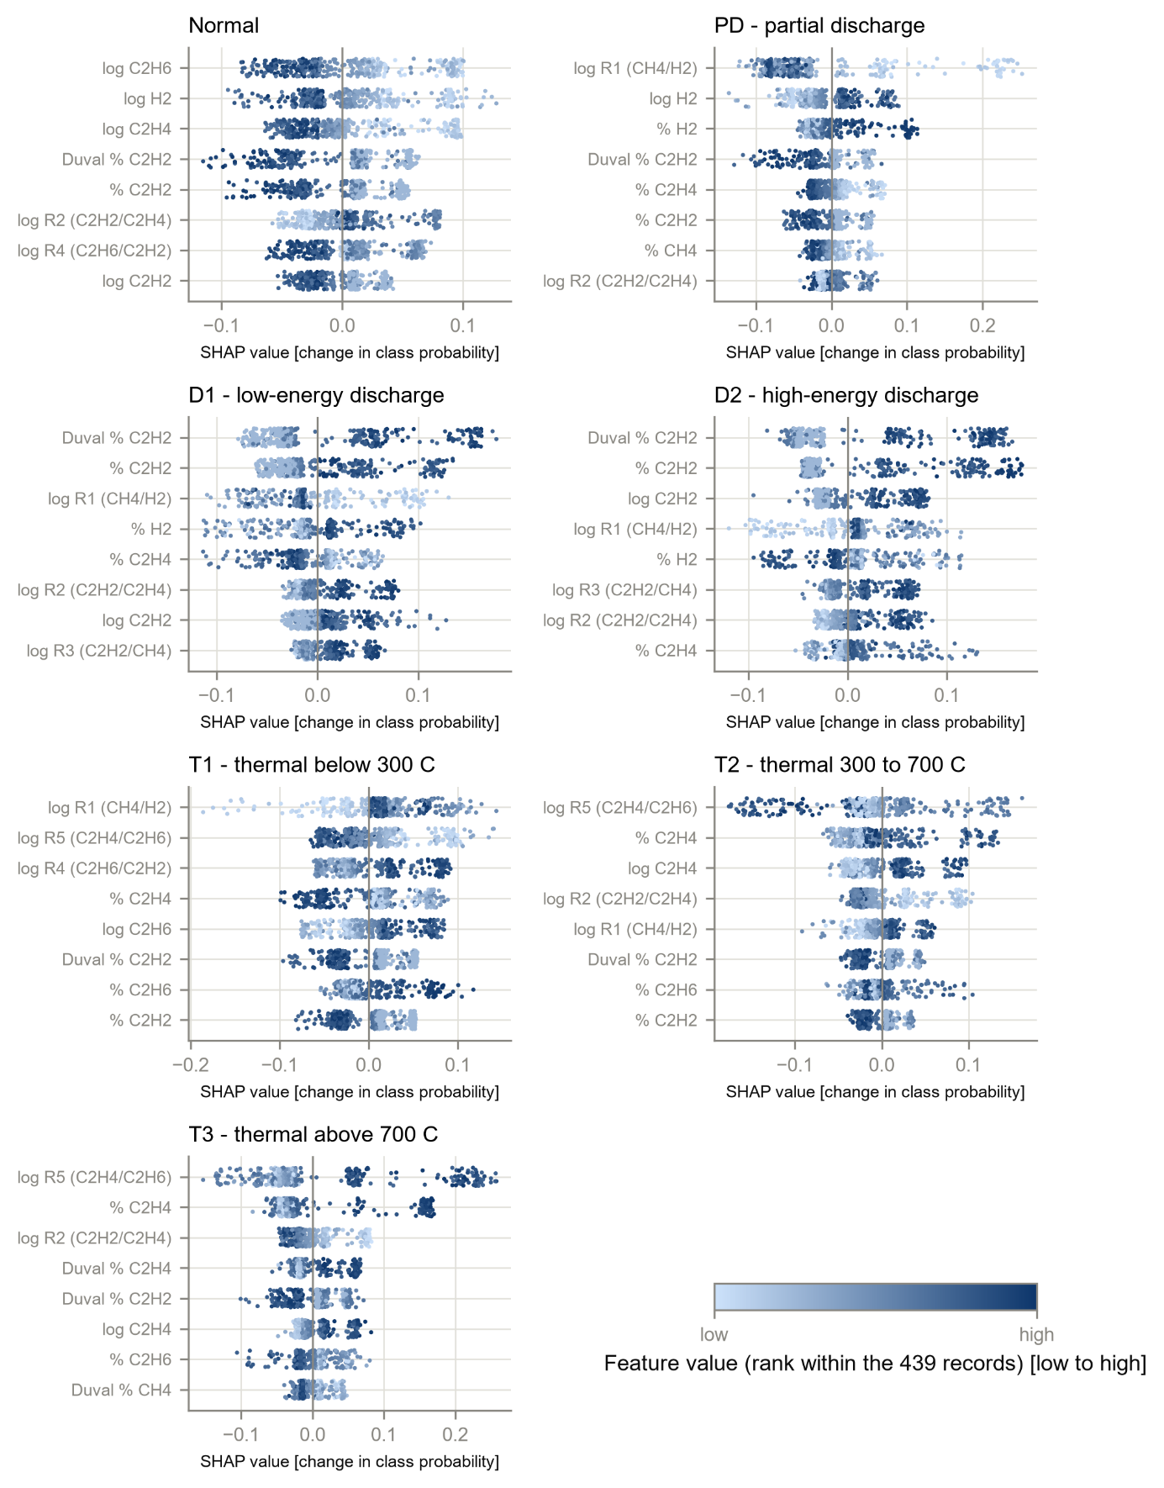
Each dot is one record; its horizontal position is how much that feature pushed the record towards (right) or away from (left) the class; its colour shows whether the feature value was low (light) or high (dark). The eight strongest features of each class are shown.

Does the model reason like an engineer?
Class | Expected key gas (D20) | Three strongest features (SHAP) | Consistent?
PD | H2 | log R1 (CH4/H2); log H2; % H2 | yes
D1 | C2H2 | Duval % C2H2; % C2H2; log R1 (CH4/H2) | yes
D2 | C2H2 | Duval % C2H2; % C2H2; log C2H2 | yes
T1 | C2H6/CH4 | log R1 (CH4/H2); log R5 (C2H4/C2H6); log R4 (C2H6/C2H2) | yes
T2 | C2H4/CH4 | log R5 (C2H4/C2H6); % C2H4; log C2H4 | yes
T3 | C2H4 | log R5 (C2H4/C2H6); % C2H4; log R2 (C2H2/C2H4) | yes
Consistent = at least one of the three strongest features involves an expected gas (a ratio involves both of its gases). This check is generous, because ratios contain two gases; the direction check below is stricter.
Class | Feature | What the model learned | IEC 60599 Table 2 rule
PD | log R1 (CH4/H2) | low value -> PD (rho -0.67) | CH4/H2 <0.1
T1 | log R5 (C2H4/C2H6) | low value -> T1 (rho -0.86) | C2H4/C2H6 <1
T2 | log R5 (C2H4/C2H6) | middle values -> T2 (rho -0.22) | C2H4/C2H6 1 - 4
T3 | log R5 (C2H4/C2H6) | high value -> T3 (rho 0.62) | C2H4/C2H6 >4
T3 | log R2 (C2H2/C2H4) | low value -> T3 (rho -0.89) | C2H2/C2H4 <0.2
D1 | Duval % C2H2 | high value -> D1 (rho 0.83) | C2H2/C2H4 >1
D2 | Duval % C2H2 | high value -> D2 (rho 0.61) | C2H2/C2H4 0.6 - 2.5
rho: Spearman correlation between the feature value and its SHAP value for that class (development records); positive means high values push towards the class. Every direction agrees with the IEC 60599 limit for that class. For T2 the effect is not one-sided, as expected for a class defined by a middle band of C2H4/C2H6 (1 to 4). For D1 and D2 the model relies mainly on the Duval share of acetylene, a related but different measure from the IEC C2H2/C2H4 ratio.

5. Checks
Check | Result
Data version 1.0 unchanged (SHA-256 manifest) | PASS
Fitted pipeline unchanged since Step 22 (SHA-256) | PASS
SHAP additivity (base value + SHAP values = predicted probability) | PASS - largest error below 1e-12
Program run twice: results identical | PASS - same SHA-256 of both importance tables
Engineering expectation fixed before the results (D20) | PASS
Text statements checked against the result files by the report builder | PASS

6. Problems and fixes
• None in the computation. To state the direction of each effect from numbers rather than from reading the figure, a direction table was added after the first run; the second run reproduced all earlier results exactly.

7. Decisions
• D20 (procedural, within the approved plan): gas-level importance as the main ranking; feature level as Figure 4.14 panel (b); exact TreeSHAP on development and test records; engineering expectation fixed in advance and reported as found.

8. Files produced
• 11_Results/explain/: permutation_importance.csv, shap_importance.csv, shap_direction.csv, engineering_check.csv, shap_values_development.csv, shap_values_test.csv, step23_summary.json
• 11_Results/figures/: F4_14_permutation_importance and F4_15_shap_summary (PNG 300 dpi, PDF, CSV)
• 06_Python_ML/src/ml/step23_explain.py; 03_Data/interim/step23_report.md

9. What was achieved
• The model's use of each gas and feature was measured on all three test sets and explained record by record with exact SHAP values.
• For all six fault classes, the model's strongest evidence involves the key gas expected from engineering knowledge (6 of 6).
• The directions of the strongest effects agree with the IEC 60599 ratio limits (for example, low CH4/H2 towards partial discharge, high C2H4/C2H6 towards T3).
• Figures 4.14 and 4.15 were produced with their data tables, in the thesis style.

10. Record of this step
Item | Record
Step | 23 - Explain the model
Environment | Claude Code (this chat)
Completed | 12 October 2026
Status | Done
Main inputs | 07_Experiments/2026-10-12_final_fit/final_pipeline.joblib; dga_master.csv (data version 1.0)
Main outputs | 11_Results/explain/ (5 tables + SHAP values); Figures F4_14 and F4_15 (PNG, PDF, CSV)
Checks | pipeline fingerprint; SHAP additivity error below 1e-12; rerun identical; development-test rank agreement 0.961
Decisions | D20 (explainability design; procedural)

11. Data and sources used in this step
Every dataset, document and file this step used is listed below with its full reference, link and fingerprint (SHA-256, first 16 characters shown). Method references are listed in the 'Method used' section. The complete record, with access dates, licences and full fingerprints, is the Data and Source Register (00_Project_Admin/Step_Reports/Data_and_Source_Register.docx and 03_Data/provenance/data_and_source_register.csv).
ID | Reference and use in the project | Link, DOI and local file
ST1 | IEC 60599:1999+A1:2007, Mineral oil-impregnated electrical equipment in service - Guide to the interpretation of dissolved and free gases analysis, Ed. 2.1. Geneva: IEC, 2007. Use: Primary source of the IEC ratio table (Table 2, p.11) and simplified scheme (Table 3, p.12); fault definitions (5.2). | https://standards.iteh.ai/catalog/standards/iec/31551405-c771-4a06-b021-4c2433c11fb9/iec-60599-1999; File: 02_Standards/iec_ratio_table.csv
ST5 | IEEE Guide for the Interpretation of Gases Generated in Oil-Immersed Transformers, IEEE Std C57.104-2008 (Revision of IEEE Std C57.104-1991). New York: IEEE, published 2 Feb. 2009. Use: Rogers ratio table (Table 6, p.16); Condition 1 limits (Table 1, p.10); Rogers worked example (Figure 2, p.7). | https://standards.ieee.org/ieee/C57.104/4030/; File: 02_Standards/rogers_ratio_table.csv; 02_Standards/ieee_condition1_limits.csv
DF2 | Made in Step 9 from DS1-DS5 (Steps 5-9 programs). Use: All clean records with role, class, flags and original values. | File: 03_Data/processed/dga_master.csv; SHA-256 AE9E6C0C84CF7180...
DF6 | Made in Step 13 from all frozen files. Use: SHA-256 of every frozen file; checked by verify_data_version() before every later step. | File: 03_Data/data_version_1.0.sha256; SHA-256 260EBE0C8921E52C...
DF24 | Produced in Step 22 by step22_final_fit.py: Random Forest on F4 tuned and fitted on all 439 development records (decision D19). Use: The fitted model used for every test prediction; saved before any test record was predicted. | File: 07_Experiments/2026-10-12_final_fit/final_pipeline.joblib; SHA-256 1C46D10391429385...
DF26 | Produced in Step 23 by step23_explain.py from DF24 (decision D20). Use: Mean absolute SHAP value per class and feature; permutation importance at gas and feature level; engineering check. | File: 11_Results/explain/shap_importance.csv; SHA-256 90A0706BD3BCEB9D...
SW1 | Python 3.12.10 with 55 pinned packages (06_Python_ML/requirements.txt). Use: Runs every data-preparation, statistics and checking program. | https://www.python.org/downloads/release/python-31210/; File: 06_Python_ML/requirements.txt; SHA-256 594BC0CB122EED99...

12. How this helps the next steps
Next step: Step 24: save the preprocessing and the model together as dga_model_v1.joblib with its SHA-256 and a short model card, and check that reloading it reproduces the Step 22 predictions exactly.
• Step 24 saves the versioned model with a model card, which will summarise these explanations.
• Chapter 4 and the journal paper can show that the model reasons in a physically sensible way, which reviewers in power engineering expect.
• The per-record SHAP values can be shown in the dashboard (Step 38 onwards) so an engineer sees why each diagnosis was given.

13. Open items and limitations
• Agreement with IEC 60599 and the key gases is expected in part, because the development labels may have been produced partly with such methods (decision D7); it shows the model is plausible, not that it discovered the physics independently.
• Explanations describe the model, not the transformer: an important feature is one the model uses, not necessarily a cause of the fault.
• The intervals reflect only the randomness of shuffling; the test sets are small (58-86 records), so rankings of inputs with similar importance are uncertain.
• Lundberg and Lee (2017) is cited without page numbers until they are confirmed (register M16, TO VERIFY).

14. Abbreviations and terms used in this report
Every abbreviation and technical term that appears in this report is explained below. The fault types follow the definitions of IEC 60599 (clause 5.2). The full list for the whole project is kept in 00_Project_Admin/abbreviations_glossary.csv.
Abbreviation or term | Meaning | Plain explanation
MPhil | Master of Philosophy | The research degree this thesis is written for.
UMaT | University of Mines and Technology, Tarkwa | The university where the thesis is submitted.
DGA | Dissolved Gas Analysis | Measuring the gases dissolved in transformer oil to find faults inside the transformer without opening it.
ppm | parts per million | Amount of gas in the oil; 1 ppm = 1 microlitre of gas in 1 litre of oil.
H2 | hydrogen | Gas formed mainly by partial discharges (low-energy electrical activity) in the oil.
CH4 | methane | Hydrocarbon gas formed when oil is overheated, mainly at the lower fault temperatures.
C2H6 | ethane | Hydrocarbon gas formed when oil is overheated, mainly at the lower fault temperatures.
C2H4 | ethylene | Hydrocarbon gas favoured above about 500 °C; it rises as thermal faults get hotter.
C2H2 | acetylene | Gas that needs at least 800 to 1 200 °C; formed in significant amounts mainly in electrical arcs.
PD | partial discharges | Small electrical discharges that only partly bridge the insulation (corona type, can form X-wax, or small sparking punctures in paper).
D1 | discharges of low energy | Sparking or tracking: larger punctures in paper, carbonised paper surface or carbon particles in oil.
D2 | discharges of high energy | Arcing with power follow-through: extensive carbonisation, metal fusion, sometimes tripping of the equipment.
T1 | thermal fault below 300 °C | Overheating in which the paper has turned brownish.
T2 | thermal fault 300 to 700 °C | Overheating in which the paper has carbonised.
T3 | thermal fault above 700 °C | Very hot fault: carbonised oil, metal colouring (800 °C) or metal fusion (above 1 000 °C).
IEC | International Electrotechnical Commission | The world body that publishes electrical standards, such as IEC 60599.
IEC 60599 | IEC guide to the interpretation of dissolved and free gas analysis | The international standard that defines the fault types and the IEC gas-ratio method.
IEC TC 10 | IEC Technical Committee 10 (fluids for electrotechnical applications) | The committee that wrote IEC 60599; its database of 117 inspected faulty units is this thesis's main benchmark.
IEEE | Institute of Electrical and Electronics Engineers | A professional body that publishes engineering standards and journals.
IEEE C57.104 | IEEE guide for the interpretation of gases generated in oil-immersed transformers | The IEEE standard that contains the Duval Triangle 1 (2019 edition) and the Rogers ratio table (2008 edition).
Ratio method | diagnosis from gas ratios | Divides one gas by another (for example C2H2/C2H4) and compares the result with fixed limits to name the fault.
Duval Triangle 1 | graphical DGA method by M. Duval | The shares of CH4, C2H4 and C2H2 are plotted as one point in a triangle divided into fault zones.
Rogers ratios | older gas-ratio method by R.R. Rogers | A ratio table that names faults from three gas ratios; kept in IEEE C57.104.
Random Forest | random forest | Many decision trees, each trained on a random sample; they vote for the answer.
SHAP | SHapley Additive exPlanations | Shows how much each gas pushed a model's decision towards or away from each fault.
Benchmark | fixed reference test set | The IEC TC 10 cases whose faults were confirmed by inspection; every method is scored on them.
Training (development) set | records used to build the models | 439 clean records from the Dissanayake training file.
Internal test set | Dissanayake unseen test file | 70 records (61 independent of the benchmark) kept away from training.
SHA-256 | Secure Hash Algorithm, 256-bit | A file's digital fingerprint: if one byte of the file changes, the fingerprint changes.
Random seed | starting number for the random shuffle | Recording it means the same split can be made again exactly (seed 20261010).
Spearman correlation | rank correlation | How strongly two gases rise and fall together (from -1 to +1).
CSV | comma-separated values | A plain-text table file that any program can read.
PNG, PDF, dpi | image file, printable document file, dots per inch | Figures are saved as PNG at 300 dpi (sharp for printing) and as PDF.
docx | Microsoft Word document | The format of these reports.
Python | programming language | Used for data preparation, machine learning and statistics (Claude Code).
D1-D18 (decisions) | numbered project decisions | Decisions recorded in 00_Project_Admin/decisions_log.md; not the same as the fault codes D1 and D2.
Roadmap | the 45-step project plan | Project_Roadmap.docx: every step, its environment and its outputs, done strictly in order.
Analysis Plan | Expected Results and Analysis Plan | The approved document that fixes the measures, tests, tables and figures before results are seen.
TO VERIFY | not yet checked against the original source | Marks any value or fact that must still be confirmed before final use.
R1, R2, R5 | Rogers gas ratios | R1 = CH4/H2, R2 = C2H2/C2H4, R5 = C2H4/C2H6; the three ratios the Rogers method compares with its table.
Condition 1 | IEEE normal-level gas limits | The highest gas levels at which IEEE C57.104 considers a transformer to be operating satisfactorily (e.g. H2 100 ppm, C2H2 1 ppm).
Pipeline | chain of processing steps and a model | Feature building, imputation, scaling and the classifier joined so that they are always fitted together on the same training rows.
Feature set (F1-F4) | the inputs given to a model | F1 log gases, F2 gas percentages, F3 log-ratios and Duval percentages, F4 all of them (Analysis Plan 5.1).
Macro-F1 | average F1 score over the classes | The primary performance measure; every class counts equally however rare it is.
joblib | Python file format for saved models | Stores the fitted pipeline (preprocessing and model together) so it can be reloaded and give exactly the same predictions.
Permutation importance | drop in score when one input is shuffled | The values of one input are mixed up at random across records; the bigger the drop in macro-F1, the more the model relies on that input (Analysis Plan Eq. 38).
Gas-level importance | shuffling one gas and everything made from it | One raw gas is shuffled before the features are built, so all its ratios and percentages move together; this avoids under-rating gases whose information is shared by several features.
TreeSHAP | exact SHAP calculation for tree models | An algorithm that computes SHAP values of a tree ensemble exactly and quickly, without approximation.
Key gas | the gas most typical of a fault type | For example hydrogen for partial discharge, acetylene for arcing and ethylene for severe overheating; used to judge whether the model reasons like an engineer.

