Step 27 Report
Find the minimum gas panel
Environment: Claude Code (this chat) | Completed: 12 October 2026 | Report version 1 (12 October 2026)
Thesis: Intelligent Power Transformer Fault Diagnosis Using Dissolved Gas Analysis and Machine Learning (MPhil, UMaT)
Abbreviations (such as PD, D1, T1, ppm) and technical terms are explained in the last section of this report.
In short: The minimum gas panel is four gases: H2+C2H6+C2H4+C2H2 - everything except methane (CH4). Its macro-F1 is 0.834 against 0.851 with all five gases; the loss is 0.017 (95 % interval [-0.006, 0.038]), inside the approved tolerance of 0.05. It is the only reduced combination that qualifies, and the robustness check agrees. Notably, none of the three conventional methods can be used with this panel - each needs methane - while the ML model keeps nearly all its accuracy.

1. Purpose of this step
This step turns the reduced-gas results into a clear engineering answer: what is the smallest set of gases a utility must measure for the ML diagnosis to remain reliable, and which conventional methods would still work with it?

2. Method used

Approach
For each of the 31 gas combinations of Step 25, the loss of macro-F1 against the five-gas panel was computed with a 95 % confidence interval, and the rule fixed in the Analysis Plan was applied: the minimum panel is the combination with the fewest gases whose loss, at the UPPER end of its 95 % interval, is at most the approved tolerance of 0.05.
Macro-F1 for a combination is computed on all 439 out-of-fold predictions of each of the 10 repeats and averaged (decision D24). The interval comes from a stratified percentile bootstrap: the records are drawn again with replacement within each fault class, 2000 times, and the same drawn records are used for every combination, so the loss is a paired comparison.
As a check on robustness, the corrected resampled t interval of the fold-by-fold loss was also computed. The conventional-method column of Table 4.9 comes from Step 26.

Why this method
• Using the upper end of the interval, not the average, means a combination is accepted only if the data show that its loss is small - the cautious choice for an engineering recommendation.
• The tolerance (0.05) was approved in Step 4, before any result was seen, so the decision cannot be tuned to the results.
• The stratified bootstrap is the interval method approved in Analysis Plan Section 6.2 (Efron and Tibshirani, 1993); pairing the resamples removes the variation that all combinations share.

Settings and rules
Setting | Value
Tolerance delta | 0.05 macro-F1 (approved item 13, Step 4)
Bootstrap | stratified percentile; B = 2000; seed 20261010; n = 439 development records; paired across combinations
Statistic | macro-F1 on the out-of-fold predictions of each repeat, averaged over 10 repeats
Decision rule | fewest gases with upper 95 % limit of the loss <= 0.05 (Eq. 37)
Sensitivity | corrected resampled t interval of the mean fold loss (Eq. 28)

Equations
$$\begin{aligned}Δ_{S}={\text{Macro-F1}}_{full}-{\text{Macro-F1}}_{S}\#\left(1\right)\end{aligned}$$
where:
$Δ$ – _
$l$ – o
$$\begin{aligned}U_{95}\left(Δ_{S}\right)≤δ\#\left(2\right)\end{aligned}$$
where:
$U_{95}\left(Δ_{S}\right)$ – upper limit of the 95 % bootstrap interval of the loss (97.5th percentile of the 2000 resampled losses)
$δ$ – tolerance, 0.05

Tools and programs
• 06_Python_ML/src/ml/step27_minimum_panel.py (bootstrap, decision rule, Table 4.9, Figures 4.16 and 4.17)
• tests/test_minimum_panel.py (the fast macro-F1 equals scikit-learn's)

Method references
[M20] B. Efron and R. J. Tibshirani, An Introduction to the Bootstrap. New York: Chapman and Hall, 1993.
[M14] C. Nadeau and Y. Bengio, "Inference for the generalization error," Machine Learning, vol. 52, no. 3, pp. 239-281, 2003. doi: 10.1023/A:1024068626366

3. What was done, step by step
1. Fixed the interval and decision details as decision D24 before computing any interval.
2. Wrote step27_minimum_panel.py and a test that its fast macro-F1 equals scikit-learn's; ran it (about one minute).
3. Improved the label position in Figure 4.16 and ran the program again: the seeded bootstrap gave an identical Table 4.9.

4. What we found

Table 4.9 - reduced-gas study (cross-validation, 439 development records)
Gas combination | Gases | ML macro-F1 [95 % CI] | Loss [95 % CI] | Within 0.05? | Conventional methods still usable
H2+CH4+C2H6+C2H4+C2H2 | 5 | 0.851 [0.819, 0.881] | 0 (reference) | - | Rogers, IEC 60599, Duval
H2+C2H6+C2H4+C2H2 | 4 | 0.834 [0.801, 0.867] | 0.017 [-0.006, 0.038] | yes | none
H2+CH4+C2H4+C2H2 | 4 | 0.775 [0.739, 0.810] | 0.076 [0.052, 0.103] | no | Duval
H2+CH4+C2H6+C2H4 | 4 | 0.734 [0.695, 0.769] | 0.117 [0.089, 0.149] | no | none
CH4+C2H6+C2H4+C2H2 | 4 | 0.726 [0.689, 0.760] | 0.125 [0.093, 0.158] | no | Duval
H2+CH4+C2H6+C2H2 | 4 | 0.704 [0.669, 0.740] | 0.147 [0.117, 0.177] | no | none
C2H6+C2H4+C2H2 | 3 | 0.736 [0.699, 0.772] | 0.115 [0.081, 0.148] | no | none
H2+C2H6+C2H4 | 3 | 0.710 [0.670, 0.747] | 0.141 [0.107, 0.177] | no | none
H2+C2H4+C2H2 | 3 | 0.688 [0.654, 0.725] | 0.163 [0.131, 0.195] | no | none
H2+CH4+C2H4 | 3 | 0.659 [0.618, 0.697] | 0.192 [0.156, 0.232] | no | none
H2+CH4+C2H2 | 3 | 0.636 [0.599, 0.673] | 0.215 [0.179, 0.250] | no | none
CH4+C2H4+C2H2 | 3 | 0.620 [0.581, 0.658] | 0.231 [0.194, 0.273] | no | Duval
H2+C2H6+C2H2 | 3 | 0.604 [0.562, 0.644] | 0.247 [0.209, 0.288] | no | none
CH4+C2H6+C2H4 | 3 | 0.580 [0.541, 0.617] | 0.271 [0.232, 0.309] | no | none
H2+CH4+C2H6 | 3 | 0.577 [0.536, 0.615] | 0.274 [0.233, 0.319] | no | none
CH4+C2H6+C2H2 | 3 | 0.525 [0.490, 0.562] | 0.326 [0.287, 0.365] | no | none
C2H6+C2H4 | 2 | 0.587 [0.547, 0.624] | 0.264 [0.224, 0.305] | no | none
C2H4+C2H2 | 2 | 0.556 [0.518, 0.591] | 0.295 [0.255, 0.336] | no | none
H2+C2H4 | 2 | 0.536 [0.499, 0.572] | 0.315 [0.274, 0.356] | no | none
H2+CH4 | 2 | 0.500 [0.459, 0.540] | 0.351 [0.306, 0.398] | no | none
CH4+C2H4 | 2 | 0.470 [0.435, 0.503] | 0.381 [0.342, 0.421] | no | none
C2H6+C2H2 | 2 | 0.444 [0.409, 0.479] | 0.407 [0.364, 0.448] | no | none
H2+C2H6 | 2 | 0.440 [0.403, 0.479] | 0.411 [0.367, 0.454] | no | none
CH4+C2H2 | 2 | 0.440 [0.408, 0.471] | 0.411 [0.369, 0.453] | no | none
H2+C2H2 | 2 | 0.439 [0.403, 0.474] | 0.412 [0.372, 0.450] | no | none
CH4+C2H6 | 2 | 0.372 [0.336, 0.405] | 0.480 [0.439, 0.521] | no | none
C2H4 | 1 | 0.391 [0.356, 0.425] | 0.460 [0.421, 0.500] | no | none
C2H6 | 1 | 0.284 [0.255, 0.314] | 0.567 [0.524, 0.609] | no | none
H2 | 1 | 0.272 [0.244, 0.300] | 0.579 [0.539, 0.621] | no | none
CH4 | 1 | 0.251 [0.222, 0.279] | 0.600 [0.561, 0.639] | no | none
C2H2 | 1 | 0.246 [0.220, 0.271] | 0.606 [0.565, 0.643] | no | none
Within tolerance = upper 95 % limit of the loss at most 0.05. The last column follows from the gases each method needs (Step 26): IEC 60599 and Rogers need all five gases, Duval needs CH4, C2H4 and C2H2.
Figure 4.16 Macro-F1 against the number of gases available (439 development records, cross-validation)
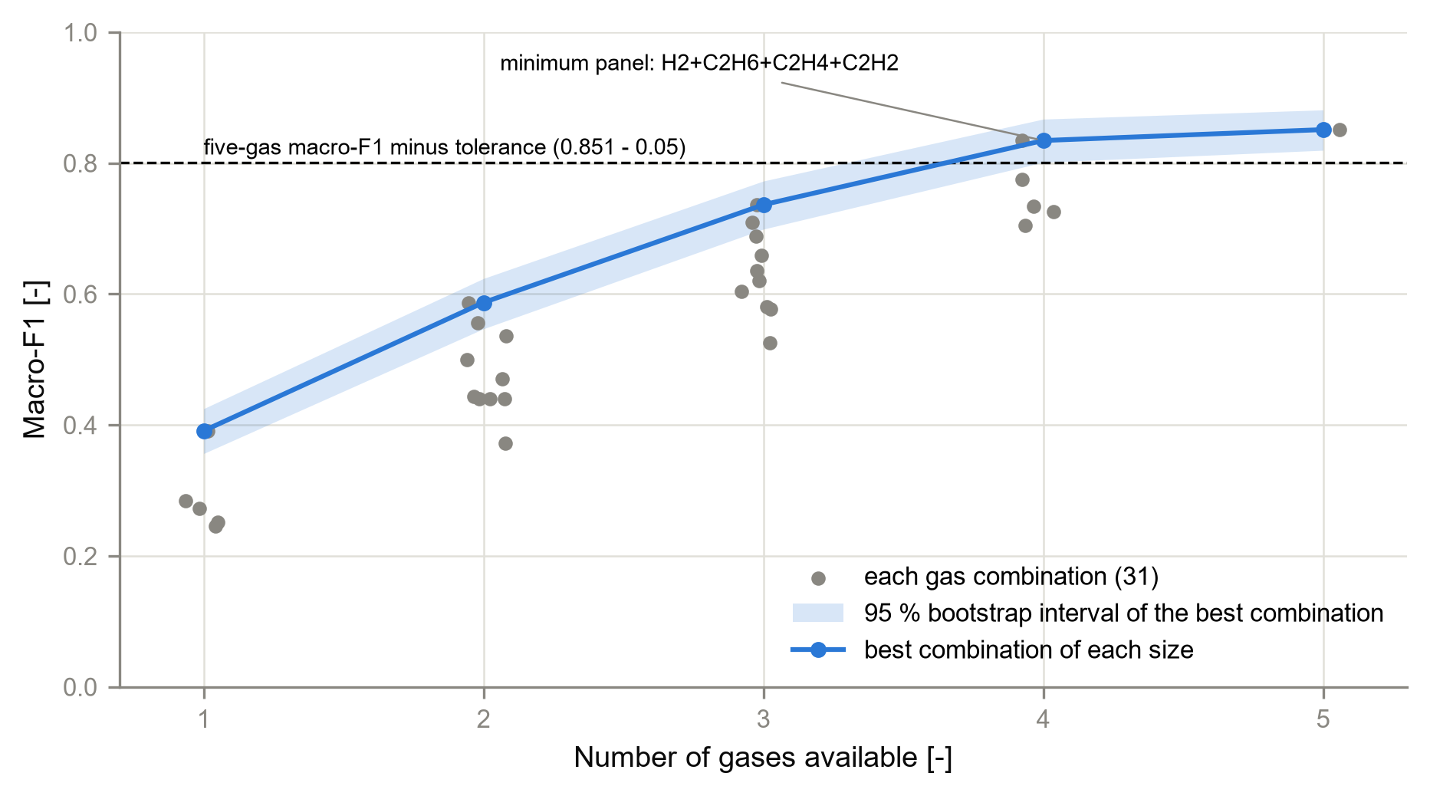
Grey points: the 31 gas combinations; blue line and band: the best combination of each size with its 95 % bootstrap interval; dashed line: five-gas macro-F1 minus the tolerance.
Figure 4.17 Gas-subset matrix: ML macro-F1 of every combination and the conventional methods still usable
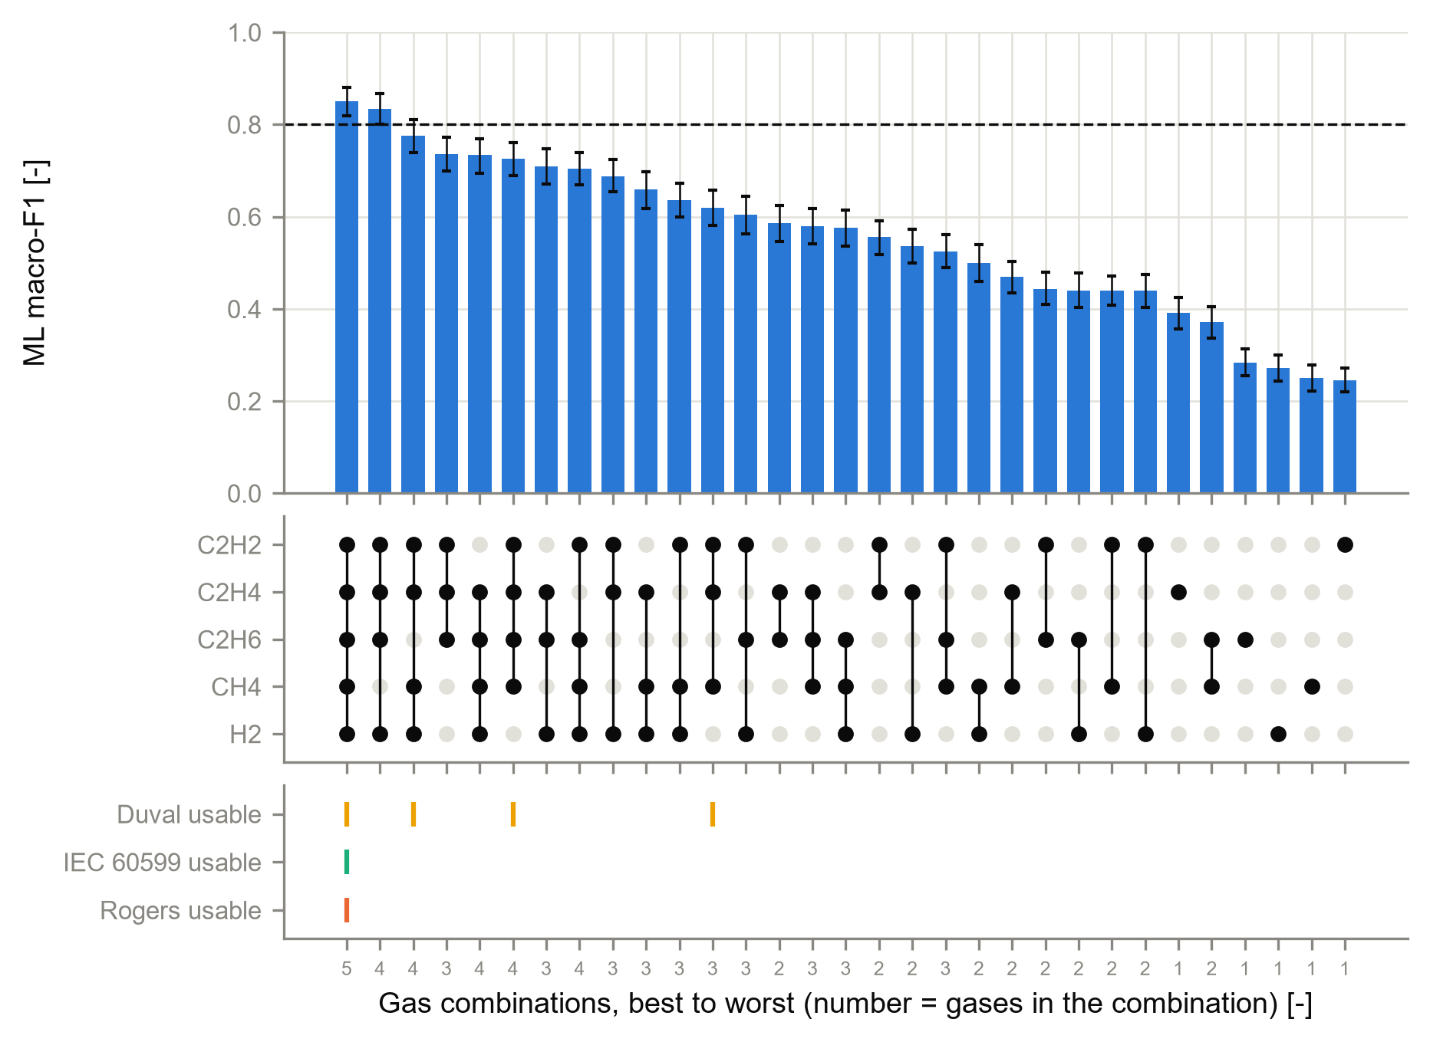
Upper part: macro-F1 with 95 % bootstrap interval, best to worst; middle: filled dots mark the gases in each combination; lower part: a tick where a conventional method can still be used.

What this means
• Without methane the ML model loses only 0.017 macro-F1 (interval [-0.006, 0.038], which includes zero). Methane carries little information that the other four gases do not already provide - in line with Step 23, where methane was among the two least important gases on every test set.
• Every other reduced combination loses more than the tolerance. The best combination that keeps the Duval Triangle usable (without ethane, H2+CH4+C2H4+C2H2) loses 0.076 [0.052, 0.103].
• Single gases are poor (macro-F1 0.25 to 0.39): one gas cannot tell the seven classes apart, so with a single gas this model cannot diagnose the fault type reliably.
• Robustness: with the corrected resampled t interval the same combination qualifies (upper limit 0.0497), but only just - the conclusion should be confirmed on other data before it is used as a general rule.

5. Checks
Check | Result
Data version 1.0 unchanged (SHA-256 manifest) | PASS
Tolerance used = the approved 0.05 (fixed in Step 4, before the results) | PASS
Every record predicted once per combination and repeat | PASS (checked by the program)
Fast macro-F1 equals scikit-learn (automated test) | PASS
Re-run gives an identical Table 4.9 (seeded bootstrap) | PASS
Robustness check (corrected t interval) gives the same minimum panel | PASS

6. Problems and fixes
• A label in Figure 4.16 crossed the curve; it was moved and the program run again - all numbers were identical.
• When adding this step to the source register, the number DF29 had already been used by the Step 26 session; this step's entry was renumbered DF33.

7. Decisions
• D24 (procedural, within the approved plan): statistic, paired stratified bootstrap (B = 2000), decision rule when several combinations qualify, t-interval sensitivity check.

8. Files produced
• 11_Results/tables/T4_9_reduced_gas.csv; 11_Results/reduced_gas/minimum_panel.json
• 11_Results/figures/F4_16_accuracy_vs_number_of_gases and F4_17_gas_subset_matrix (PNG, PDF, CSV)
• 06_Python_ML/src/ml/step27_minimum_panel.py; 06_Python_ML/tests/test_minimum_panel.py; 03_Data/interim/step27_report.md

9. What was achieved
• The minimum gas panel was found by the rule fixed in advance: H2+C2H6+C2H4+C2H2 (loss 0.017, 95 % interval [-0.006, 0.038]).
• The corrected t interval, used as a robustness check, gives the same answer.
• Table 4.9 and Figures 4.16-4.17 are produced with their data files.
• Stage E (reduced-gas study, Steps 25-27) is complete.

10. Record of this step
Item | Record
Step | 27 - Find the minimum gas panel
Environment | Claude Code (this chat)
Completed | 12 October 2026
Status | Done
Main inputs | Step 25 run (predictions and fold results); reduced_gas_subsets.csv; conventional_applicability.csv (Step 26)
Main outputs | 11_Results/tables/T4_9_reduced_gas.csv; 11_Results/reduced_gas/minimum_panel.json; Figures F4_16, F4_17
Checks | tolerance = the approved 0.05; bootstrap reproducible (seeded; re-run gave an identical table); fast macro-F1 tested against scikit-learn
Decisions | D24 (interval and decision details; procedural)

11. Data and sources used in this step
Every dataset, document and file this step used is listed below with its full reference, link and fingerprint (SHA-256, first 16 characters shown). Method references are listed in the 'Method used' section. The complete record, with access dates, licences and full fingerprints, is the Data and Source Register (00_Project_Admin/Step_Reports/Data_and_Source_Register.docx and 03_Data/provenance/data_and_source_register.csv).
ID | Reference and use in the project | Link, DOI and local file
DF28 | Produced in Step 25 by step25_reduced_gas.py (run 2026-10-12_reducedgas_v1; decision D22). Use: Cross-validated macro-F1 and mean loss against the five-gas panel for every gas combination. | File: 11_Results/reduced_gas/reduced_gas_results.csv; SHA-256 D6BA6AC101A26298...
DF29 | Produced in Step 26 by run_reduced_gas_applicability.m (decision D23): share of ND per gas combination, method and data role. Use: Shows which conventional method can still give a diagnosis when gases are not measured; input of Step 27 comparison. | File: 11_Results/conventional/conventional_applicability.csv; SHA-256 BBF05021D951CC65...
DF33 | Produced in Step 27 by step27_minimum_panel.py from DF28 and DF29 (Step 26 applicability; decision D24). Use: Macro-F1 and loss with 95 % bootstrap intervals, tolerance test, conventional methods still usable; Figures 4.16-4.17. | File: 11_Results/tables/T4_9_reduced_gas.csv; SHA-256 95A4A4E848CF5CCA...
DF6 | Made in Step 13 from all frozen files. Use: SHA-256 of every frozen file; checked by verify_data_version() before every later step. | File: 03_Data/data_version_1.0.sha256; SHA-256 260EBE0C8921E52C...
SW1 | Python 3.12.10 with 55 pinned packages (06_Python_ML/requirements.txt). Use: Runs every data-preparation, statistics and checking program. | https://www.python.org/downloads/release/python-31210/; File: 06_Python_ML/requirements.txt; SHA-256 594BC0CB122EED99...

12. How this helps the next steps
Next step: Stage F - Step 28: join the true classes, the conventional predictions and the ML predictions of the test sets on record_id (merged_predictions.csv), checking that no record is lost or duplicated.
• Chapter 4 can state which gases an online monitor must measure for the ML model to keep its accuracy, and which conventional methods are lost.
• The dashboard (Steps 38 onwards) can warn when a sample lacks a gas of the minimum panel.

13. Open items and limitations
• Results are cross-validation results on the development data only; the reduced-gas models were not tested on the test sets.
• Records of a near-duplicate group are resampled independently in the bootstrap, so the intervals may be slightly too narrow.
• The minimum panel holds for this data set and this model; its upper loss limit under the t check is close to the tolerance, so it should be confirmed on other data.
• Which commercial online monitors measure this gas combination is still to be taken from published sources (TO VERIFY).
• Decision D23 rule (4) (normality gate with missing gases) awaits the researcher's confirmation; it does not affect which methods are usable.

14. Abbreviations and terms used in this report
Every abbreviation and technical term that appears in this report is explained below. The fault types follow the definitions of IEC 60599 (clause 5.2). The full list for the whole project is kept in 00_Project_Admin/abbreviations_glossary.csv.
Abbreviation or term | Meaning | Plain explanation
MPhil | Master of Philosophy | The research degree this thesis is written for.
UMaT | University of Mines and Technology, Tarkwa | The university where the thesis is submitted.
DGA | Dissolved Gas Analysis | Measuring the gases dissolved in transformer oil to find faults inside the transformer without opening it.
ppm | parts per million | Amount of gas in the oil; 1 ppm = 1 microlitre of gas in 1 litre of oil.
H2 | hydrogen | Gas formed mainly by partial discharges (low-energy electrical activity) in the oil.
CH4 | methane | Hydrocarbon gas formed when oil is overheated, mainly at the lower fault temperatures.
C2H6 | ethane | Hydrocarbon gas formed when oil is overheated, mainly at the lower fault temperatures.
C2H4 | ethylene | Hydrocarbon gas favoured above about 500 °C; it rises as thermal faults get hotter.
C2H2 | acetylene | Gas that needs at least 800 to 1 200 °C; formed in significant amounts mainly in electrical arcs.
PD | partial discharges | Small electrical discharges that only partly bridge the insulation (corona type, can form X-wax, or small sparking punctures in paper).
D1 | discharges of low energy | Sparking or tracking: larger punctures in paper, carbonised paper surface or carbon particles in oil.
T1 | thermal fault below 300 °C | Overheating in which the paper has turned brownish.
IEC | International Electrotechnical Commission | The world body that publishes electrical standards, such as IEC 60599.
IEC 60599 | IEC guide to the interpretation of dissolved and free gas analysis | The international standard that defines the fault types and the IEC gas-ratio method.
Duval Triangle 1 | graphical DGA method by M. Duval | The shares of CH4, C2H4 and C2H2 are plotted as one point in a triangle divided into fault zones.
Rogers ratios | older gas-ratio method by R.R. Rogers | A ratio table that names faults from three gas ratios; kept in IEEE C57.104.
Normality gate | rule that lets conventional methods answer 'Normal' | If all gases are below their typical values, the conventional methods give Normal instead of a fault (decision D3).
ML | machine learning | Computer methods that learn the link between gas values and fault type from labelled examples.
Training (development) set | records used to build the models | 439 clean records from the Dissanayake training file.
Primary and sensitivity analysis | main analysis and its repeat under another reasonable choice | The sensitivity analysis shows whether the conclusion changes when a choice is made differently.
Complete-case | records with all five gases reported | Used only for the sensitivity analysis.
SHA-256 | Secure Hash Algorithm, 256-bit | A file's digital fingerprint: if one byte of the file changes, the fingerprint changes.
Cross-validation | repeated train-and-test on parts of the training data | The data are split into parts; each part is used once for testing while the others train the model.
Fold | one part of the cross-validation split | Here the training data are cut into 5 folds (parts).
Stratified group k-fold | splitting method | Every part has the same mix of fault classes, and near-identical records stay together in one part.
Random seed | starting number for the random shuffle | Recording it means the same split can be made again exactly (seed 20261010).
CSV | comma-separated values | A plain-text table file that any program can read.
PNG, PDF, dpi | image file, printable document file, dots per inch | Figures are saved as PNG at 300 dpi (sharp for printing) and as PDF.
docx | Microsoft Word document | The format of these reports.
Python | programming language | Used for data preparation, machine learning and statistics (Claude Code).
pytest | Python testing tool | Runs the automated checks that prove the data rules hold.
D1-D23 (decisions) | numbered project decisions | Decisions recorded in 00_Project_Admin/decisions_log.md; not the same as the fault codes D1 and D2.
Roadmap | the 45-step project plan | Project_Roadmap.docx: every step, its environment and its outputs, done strictly in order.
Analysis Plan | Expected Results and Analysis Plan | The approved document that fixes the measures, tests, tables and figures before results are seen.
TO VERIFY | not yet checked against the original source | Marks any value or fact that must still be confirmed before final use.
ND (no diagnosis) | No diagnosis | The answer of a method when no rule applies or a ratio it needs cannot be calculated. It is a result and is never deleted.
Feature set (F1-F4) | the inputs given to a model | F1 log gases, F2 gas percentages, F3 log-ratios and Duval percentages, F4 all of them (Analysis Plan 5.1).
Macro-F1 | average F1 score over the classes | The primary performance measure; every class counts equally however rare it is.
Corrected resampled t-test | test for two models compared on the same folds | A t-test whose variance is enlarged because cross-validation folds share training records (Nadeau and Bengio, 2003; Analysis Plan Eq. 28).
Reduced-gas study | testing the model with fewer gases | The model is retrained with only some gases available, to see how much accuracy is lost - relevant for monitors that measure fewer gases.
Online gas monitor | instrument fitted to a transformer | Measures dissolved gases continuously in service; many measure only some of the five gases.
NaN (not measured) | Not a Number, used here for a gas that was not measured | A marker for a missing value. It is different from 0 ppm: 0 ppm means the gas was measured and not found, NaN means nobody measured it, so no ratio or percentage can be calculated from it.
Applicable (method) | A method that has all the gases it needs | A method is applicable to a gas combination when every gas it uses is measured. IEC 60599 and Rogers need all five gases; Duval Triangle 1 needs CH4, C2H4 and C2H2. If a method is not applicable it answers ND for every sample.
Gas combination (subset) | A choice of the gases that are measured | One of the 31 ways to keep at least one of the five gases, as with an online monitor that measures only some gases.
Bootstrap (stratified percentile) | resampling to get a confidence interval | The records are drawn again at random, with replacement and within each fault class, 2000 times; the middle 95 % of the recomputed values is the 95 % interval (Analysis Plan Section 6.2).
Minimum gas panel | fewest gases that are good enough | The smallest gas combination whose loss of macro-F1, at the upper end of its 95 % interval, stays within the approved tolerance of 0.05 (Analysis Plan Eq. 37).
Tolerance (delta) | largest acceptable loss | Fixed before the study at 0.05 macro-F1 (5 percentage points), approved in Step 4.

