Step 29 Report
Compute the performance measures with 95 % confidence intervals
Environment: Claude Code (this chat) | Completed: 12 October 2026 | Report version 1 (12 October 2026)
Thesis: Intelligent Power Transformer Fault Diagnosis Using Dissolved Gas Analysis and Machine Learning (MPhil, UMaT)
Abbreviations (such as PD, D1, T1, ppm) and technical terms are explained in the last section of this report.
In short: Results are mixed and are reported as found. On the internal test set the ML model is clearly the most accurate (strict accuracy 0.820 against at most 0.557). On the IEC TC 10 benchmark of inspected power transformers, the Duval Triangle scores higher than the ML model (0.776 against 0.724), but the difference lies within its uncertainty; the ML model is clearly better than Rogers there. On Li 2019 the ML model leads with the approved normality gate, but Duval leads when the gate is removed. The normality gate, which calls many low-gas faults Normal, strongly affects the conventional methods' scores. Significance tests follow in Step 30.

1. Purpose of this step
This step measures, with honest uncertainty, how well the ML model and each conventional method diagnose the faults of the three test sets. It provides Tables 4.3 and 4.5 and Figures 4.5 and 4.8 of Chapter 4.

2. Method used

Approach
From the merged file of Step 28 only, the performance of the ML model and of the three conventional methods was measured on each test set: strict accuracy (every no-diagnosis counted as wrong), conditional accuracy (only the records that got a diagnosis), coverage, macro-F1, balanced accuracy, Cohen's kappa and the Matthews correlation coefficient, with per-class precision, recall and F1 and the confusion matrices.
95 % confidence intervals: the Wilson interval for the three proportions, and a stratified percentile bootstrap (2000 resamples within each true class, the same resample for all four methods) for macro-F1, the other measures and the differences between the ML model and each method.
The scoring rules were fixed before computing (decision D25): the IEC dual answer D1/D2 counts as correct for a true D1 or D2; the Duval DT zone and a Normal answer on a fault-only set count as wrong; IEC TC 10 is scored on five merged classes. Sensitivity analyses repeat the scoring with the lower normality gate, with no gate, and with the dual answer counted wrong.

Why this method
• Strict accuracy, conditional accuracy and coverage together show whether a method is better because it is more often right, or only because it answers more often (Analysis Plan Section 4.3) - the core of the research hypothesis.
• Macro-F1 gives every fault class equal weight, so a method cannot look good by recognising only the common faults.
• Intervals show how uncertain each number is on these small test sets (58-86 records); the paired bootstrap of the differences shows whether a gap between two methods is larger than the uncertainty.

Settings and rules
Setting | Value
Evaluation sets (D19) | internal test 61 independent records, 7 classes; IEC TC 10 58 power transformers, 5 merged classes; Li 2019 86 independent records, 6 classes; plus all records of each set as sensitivity
Scoring (D25) | D1/D2 correct for true D1 or D2; DT wrong; Normal on a fault-only set wrong; ND wrong in strict accuracy, excluded from conditional accuracy
Gate | upper normality gate (primary, D11); lower gate and no gate as sensitivity
Intervals | Wilson (z = 1.96); stratified paired bootstrap, B = 2000, seed 20261010
Input | 08_Statistical_Analysis/merged_predictions.csv only (fingerprint checked)

Equations
$$\begin{aligned}U=\frac{n_{ND}}{N} \text{Coverage}=1-U\#\left(1\right)\end{aligned}$$
where:
$n$ – _
$n$ – u
$$\begin{aligned}A_{strict}=\frac{n_{correct}}{N} A_{cond}=\frac{n_{correct}}{N-n_{ND}}\#\left(2\right)\end{aligned}$$
where:
$n$ – _
$n$ – u
$$\begin{aligned}{\text{CI}}_{95}=\frac{p+\frac{z^{2}}{2n}±z\sqrt{\frac{p\left(1-p\right)}{n}+\frac{z^{2}}{4n^{2}}}}{1+\frac{z^{2}}{n}}\#\left(3\right)\end{aligned}$$
where:
$p, n$ – observed proportion and the number of records it is based on
$z$ – 1.96 for 95 % confidence

Tools and programs
• 06_Python_ML/src/stats/step29_measures.py (measures, intervals, Tables 4.3 and 4.5, Figures 4.5 and 4.8)
• tests/test_measures.py (measures equal scikit-learn's where comparable; ND and dual rules; Wilson hand value)

Method references
[M21] E. B. Wilson, "Probable inference, the law of succession, and statistical inference," Journal of the American Statistical Association, vol. 22, no. 158, pp. 209-212, 1927. doi: 10.1080/01621459.1927.10502953
[M20] B. Efron and R. J. Tibshirani, An Introduction to the Bootstrap. New York: Chapman and Hall, 1993.
[M22] J. Cohen, "A coefficient of agreement for nominal scales," Educational and Psychological Measurement, vol. 20, no. 1, pp. 37-46, 1960. doi: 10.1177/001316446002000104
[M23] J. Gorodkin, "Comparing two K-category assignments by a K-category correlation coefficient," Computational Biology and Chemistry, vol. 28, pp. 367-374, 2004.

3. What was done, step by step
1. Fixed the scoring details as decision D25 before computing any conventional-method measure on the test sets.
2. Wrote step29_measures.py and tests that check its measures against scikit-learn and a hand-computed Wilson interval.
3. Ran it (about three minutes). The ML values equal the first-look values of Step 22, which confirms the scoring.
4. Improved the confusion-matrix colours (white for 0 % as the plan specifies) and label layout, and ran it again: all numbers identical.

4. What we found

Table 4.5 - main comparison on each test set (primary scoring, 95 % CI)

Internal test (n = 61)
Method | Strict accuracy | Conditional accuracy | Coverage | Macro-F1
ML (selected model) | 0.820 [0.705, 0.896] | 0.820 [0.705, 0.896] | 1.000 [0.941, 1.000] | 0.812 [0.711, 0.900]
Rogers Ratio | 0.328 [0.223, 0.453] | 0.526 [0.373, 0.675] | 0.623 [0.497, 0.734] | 0.282 [0.190, 0.362]
IEC 60599 ratio | 0.475 [0.355, 0.598] | 0.659 [0.511, 0.781] | 0.721 [0.598, 0.818] | 0.501 [0.359, 0.606]
Duval Triangle 1 | 0.557 [0.433, 0.675] | 0.557 [0.433, 0.675] | 1.000 [0.941, 1.000] | 0.528 [0.414, 0.621]

IEC TC 10 (power transformers) (n = 58)
Method | Strict accuracy | Conditional accuracy | Coverage | Macro-F1
ML (selected model) | 0.724 [0.598, 0.822] | 0.724 [0.598, 0.822] | 1.000 [0.938, 1.000] | 0.731 [0.611, 0.827]
Rogers Ratio | 0.483 [0.359, 0.608] | 0.667 [0.516, 0.790] | 0.724 [0.598, 0.822] | 0.330 [0.248, 0.411]
IEC 60599 ratio | 0.638 [0.509, 0.749] | 0.725 [0.591, 0.829] | 0.879 [0.771, 0.940] | 0.731 [0.616, 0.820]
Duval Triangle 1 | 0.776 [0.653, 0.864] | 0.776 [0.653, 0.864] | 1.000 [0.938, 1.000] | 0.752 [0.626, 0.891]
Home-advantage caveat: the IEC 60599 ratio limits were refined using the IEC TC 10 cases (Duval and dePablo, 2001), so the conventional methods may score higher here than on new data.

Li 2019 (n = 86)
Method | Strict accuracy | Conditional accuracy | Coverage | Macro-F1
ML (selected model) | 0.628 [0.522, 0.723] | 0.628 [0.522, 0.723] | 1.000 [0.957, 1.000] | 0.595 [0.480, 0.700]
Rogers Ratio | 0.174 [0.109, 0.268] | 0.254 [0.161, 0.378] | 0.686 [0.582, 0.774] | 0.256 [0.160, 0.341]
IEC 60599 ratio | 0.302 [0.215, 0.406] | 0.382 [0.276, 0.501] | 0.791 [0.693, 0.863] | 0.436 [0.307, 0.539]
Duval Triangle 1 | 0.453 [0.353, 0.558] | 0.453 [0.353, 0.558] | 1.000 [0.957, 1.000] | 0.564 [0.447, 0.659]

Table 4.3 - conventional methods: answers given (primary scoring)
Test set | Method | Records | ND | DT | D1/D2 | Normal answers
Internal test | Rogers Ratio | 61 | 23 | 0 | 0 | 26
Internal test | IEC 60599 ratio | 61 | 17 | 0 | 1 | 24
Internal test | Duval Triangle 1 | 61 | 0 | 4 | 0 | 24
IEC TC 10 (power transformers) | Rogers Ratio | 58 | 16 | 0 | 0 | 7
IEC TC 10 (power transformers) | IEC 60599 ratio | 58 | 7 | 0 | 11 | 7
IEC TC 10 (power transformers) | Duval Triangle 1 | 58 | 0 | 1 | 0 | 7
Li 2019 | Rogers Ratio | 86 | 27 | 0 | 0 | 37
Li 2019 | IEC 60599 ratio | 86 | 18 | 0 | 4 | 37
Li 2019 | Duval Triangle 1 | 86 | 0 | 1 | 0 | 37

Differences: ML minus each method (paired bootstrap 95 % CI)
Test set | Compared with | Strict accuracy gap | Conditional accuracy gap | Macro-F1 gap
Internal test | Rogers Ratio | 0.492 [0.377, 0.607] | 0.293 | 0.530 [0.419, 0.654]
Internal test | IEC 60599 ratio | 0.344 [0.230, 0.475] | 0.161 | 0.311 [0.192, 0.467]
Internal test | Duval Triangle 1 | 0.262 [0.131, 0.393] | 0.262 | 0.283 [0.145, 0.429]
IEC TC 10 (power transformers) | Rogers Ratio | 0.241 [0.121, 0.345] | 0.057 | 0.401 [0.292, 0.502]
IEC TC 10 (power transformers) | IEC 60599 ratio | 0.086 [-0.017, 0.190] | -0.001 | 0.000 [-0.075, 0.080]
IEC TC 10 (power transformers) | Duval Triangle 1 | -0.052 [-0.172, 0.069] | -0.052 | -0.021 [-0.200, 0.132]
Li 2019 | Rogers Ratio | 0.453 [0.349, 0.558] | 0.374 | 0.340 [0.224, 0.461]
Li 2019 | IEC 60599 ratio | 0.326 [0.221, 0.430] | 0.246 | 0.160 [0.054, 0.293]
Li 2019 | Duval Triangle 1 | 0.174 [0.035, 0.314] | 0.174 | 0.031 [-0.122, 0.192]
A positive gap means the ML model scored higher. An interval that includes 0 means the data cannot tell the two apart; Step 30 adds the formal paired tests.

How much the normality gate and the dual-answer rule matter (strict accuracy)
Test set | Method | Upper gate (primary) | Lower gate | No gate | Dual answer wrong
Internal test | Rogers Ratio | 0.328 | 0.410 | 0.361 | 0.328
Internal test | IEC 60599 ratio | 0.475 | 0.541 | 0.426 | 0.459
Internal test | Duval Triangle 1 | 0.557 | 0.623 | 0.525 | 0.557
Internal test | ML (selected model) | 0.820 | - | - | -
IEC TC 10 (power transformers) | Rogers Ratio | 0.483 | 0.500 | 0.534 | 0.483
IEC TC 10 (power transformers) | IEC 60599 ratio | 0.638 | 0.655 | 0.724 | 0.448
IEC TC 10 (power transformers) | Duval Triangle 1 | 0.776 | 0.828 | 0.897 | 0.776
IEC TC 10 (power transformers) | ML (selected model) | 0.724 | - | - | -
Li 2019 | Rogers Ratio | 0.174 | 0.256 | 0.256 | 0.174
Li 2019 | IEC 60599 ratio | 0.302 | 0.442 | 0.442 | 0.256
Li 2019 | Duval Triangle 1 | 0.453 | 0.709 | 0.744 | 0.453
Li 2019 | ML (selected model) | 0.628 | - | - | -
The ML model does not use the gate (it learned its own Normal class), so its value is the same in every column.
Figure 4.5a Confusion matrices of the conventional methods - internal test set (n = 61)
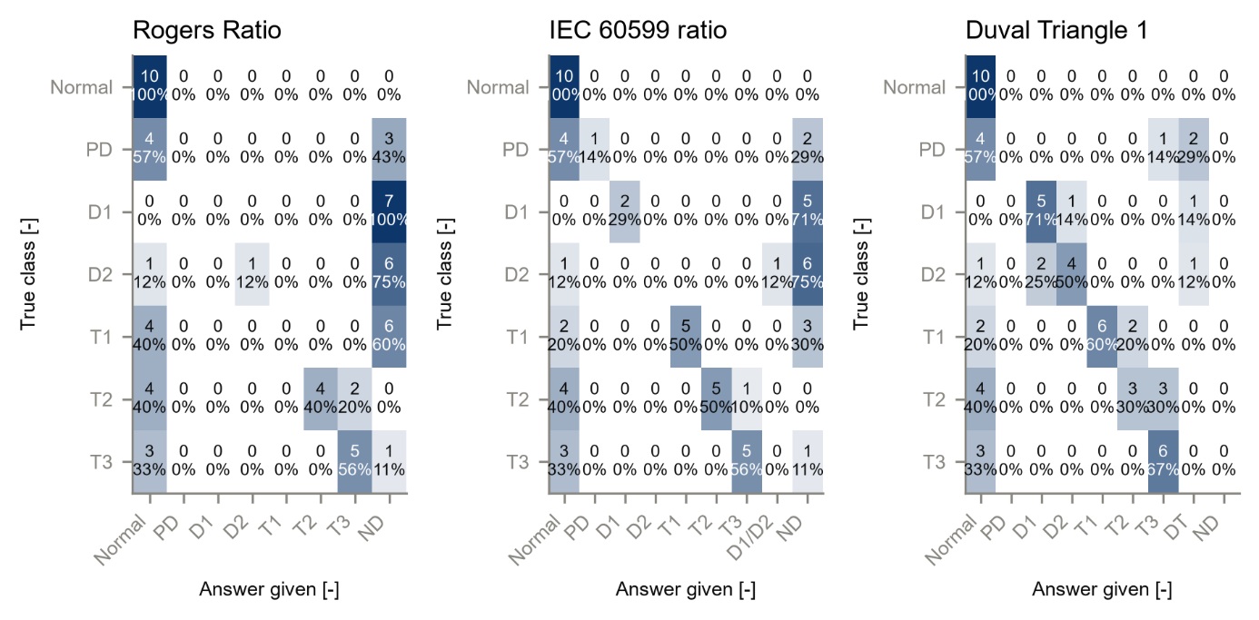
Figure 4.5b Confusion matrices of the conventional methods - IEC TC 10 power transformers (n = 58, merged classes)
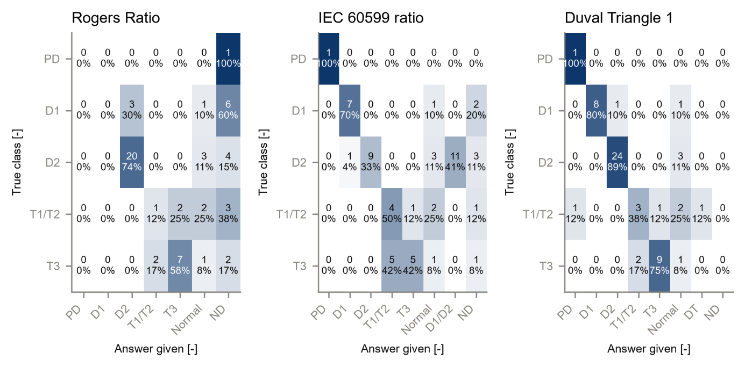
Figure 4.5c Confusion matrices of the conventional methods - Li 2019 (n = 86)
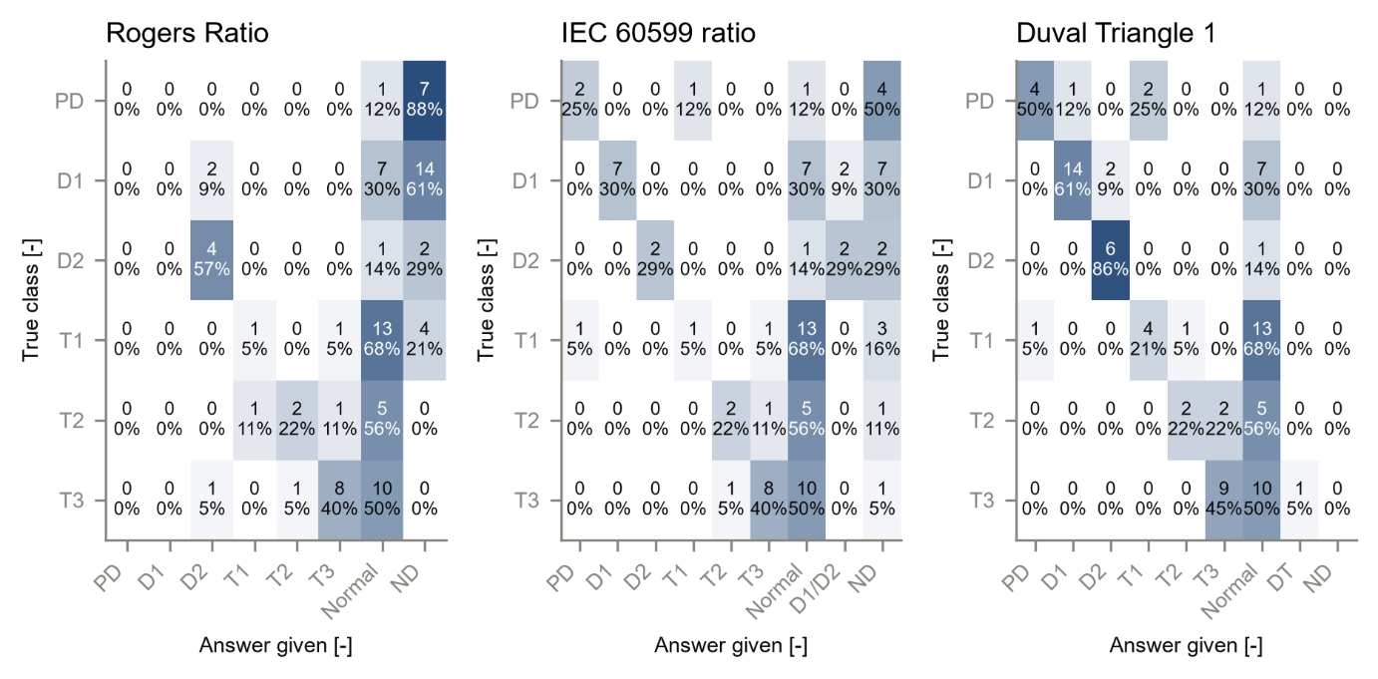
Figure 4.8 Confusion matrices of the ML model on the three test sets
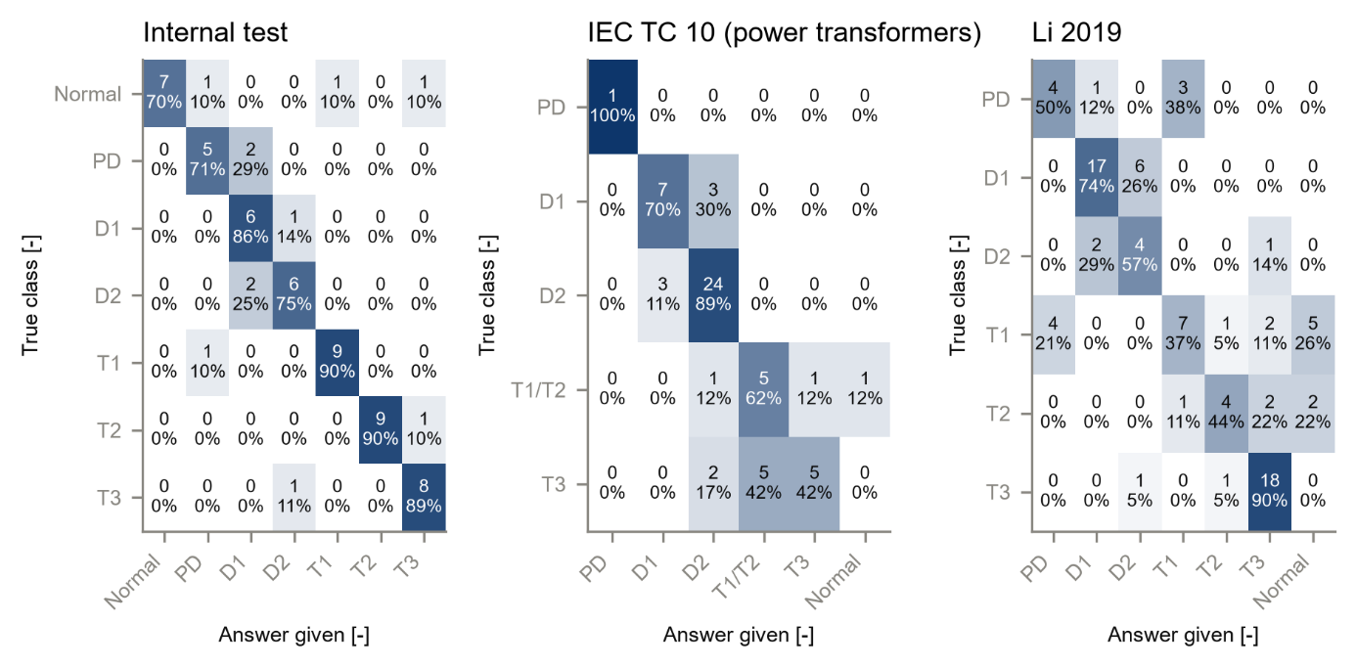
Each cell: count and row percentage; white = 0 %, dark blue = 100 % of the true class. Rows: true class; columns: answer given, including Normal, D1/D2, DT and ND where they occur.

What this means
• Internal test (same source as the training data): the ML model is clearly better than all three methods; every interval of the strict-accuracy gap lies above zero.
• IEC TC 10 (inspected power transformers): Duval 0.776, ML 0.724, IEC 0.638, Rogers 0.483. The gaps to Duval and IEC lie within their uncertainty; only the gap to Rogers is clear. Without the gate Duval reaches 0.897.
• Li 2019: with the approved gate the ML model is clearly ahead of all three methods, but the gate calls many of Li's low-gas faults Normal (Figure 4.5c). Without the gate, Duval scores 0.744 against the ML model's 0.628. The ML model's advantage on Li therefore depends on the gate.
• Preview of hypothesis criterion 2: for Rogers and IEC 60599, which often give no diagnosis, the ML model's lead is smaller in conditional than in strict accuracy on all three sets - part of its advantage comes from always answering. Duval always answers, so its two gaps are equal. The formal judgement of the hypothesis is made in Step 30.

5. Checks
Check | Result
Data version 1.0 unchanged; merged file unchanged since Step 28 (SHA-256) | PASS
ML measures equal the Step 22 first-look values | PASS
Measure functions equal scikit-learn where comparable; Wilson hand value (automated tests) | PASS
Re-run after the figure changes: all numbers identical | PASS
Text statements checked against the result files by the report builder | PASS
Full automated test suite | PASS - 112 of 112 tests pass

6. Problems and fixes
• The first confusion-matrix figures used a light blue for 0 % and their column labels overlapped; the colour scale now starts at white, as the plan specifies, and the labels are rotated. Numbers were not affected.

7. Decisions
• D25 (procedural, within the approved plan): evaluation sets, scoring of dual, DT, Normal and ND answers, measures on answers outside the class list, interval methods, sensitivity analyses.

8. Files produced
• 08_Statistical_Analysis/: performance_measures.csv, per_class_measures.csv, differences.csv, confusion_matrices.csv
• 11_Results/tables/T4_3_conventional.csv, T4_5_main_comparison.csv; 11_Results/figures/F4_5a, F4_5b, F4_5c, F4_8 (PNG, PDF, CSV)
• 06_Python_ML/src/stats/step29_measures.py; 06_Python_ML/tests/test_measures.py; 03_Data/interim/step29_report.md

9. What was achieved
• All Chapter 4 performance measures of the test sets are computed with 95 % confidence intervals from one checked file.
• Tables 4.3 and 4.5 and Figures 4.5 (one per test set) and 4.8 are produced with their data files.
• The sensitivity analyses show how much the results depend on the normality gate and on the dual-answer rule.

10. Record of this step
Item | Record
Step | 29 - Compute the performance measures with 95 % confidence intervals
Environment | Claude Code (this chat)
Completed | 12 October 2026
Status | Done
Main inputs | 08_Statistical_Analysis/merged_predictions.csv (Step 28)
Main outputs | 08_Statistical_Analysis/performance_measures.csv, per_class_measures.csv, differences.csv, confusion_matrices.csv; Tables T4_3, T4_5; Figures F4_5a-c, F4_8
Checks | ML values equal the Step 22 first look; re-run identical; 112 of 112 tests pass
Decisions | D25 (scoring details; procedural)

11. Data and sources used in this step
Every dataset, document and file this step used is listed below with its full reference, link and fingerprint (SHA-256, first 16 characters shown). Method references are listed in the 'Method used' section. The complete record, with access dates, licences and full fingerprints, is the Data and Source Register (00_Project_Admin/Step_Reports/Data_and_Source_Register.docx and 03_Data/provenance/data_and_source_register.csv).
ID | Reference and use in the project | Link, DOI and local file
DF34 | Produced in Step 28 by step28_merge_predictions.py from DF2, DF9 (conventional predictions) and DF25 (ML predictions). Use: True class, flags, ML prediction and probabilities, conventional answers (raw, upper gate, lower gate, merged classes), boundary distances. | File: 08_Statistical_Analysis/merged_predictions.csv; SHA-256 EDB799A2CDA41A69...
DF35 | Produced in Step 29 by step29_measures.py from DF34 only (decision D25). Use: Strict and conditional accuracy, coverage (Wilson), macro-F1, balanced accuracy, kappa, MCC (bootstrap) for every method and set. | File: 08_Statistical_Analysis/performance_measures.csv; SHA-256 C86B438A3EF7873F...
DF36 | Produced in Step 29 by step29_measures.py from DF34. Use: Main comparison of ML and the three conventional methods on the three primary test sets. | File: 11_Results/tables/T4_5_main_comparison.csv; SHA-256 6FFA92BDC9F5D4D6...
DS1 | M. Duval and A. dePablo, "Interpretation of gas-in-oil analysis using new IEC publication 60599 and IEC TC 10 databases," IEEE Electrical Insulation Magazine, vol. 17, no. 2, pp. 31-41, Mar./Apr. 2001. Use: Main benchmark (labels confirmed by inspection): primary analysis = 58 power transformers (codes P, U); sensitivity = all 117. | https://doi.org/10.1109/57.917529; DOI 10.1109/57.917529; File: 03_Data/raw/iec_tc10_duval2001_full/iec_tc10_faulty_equipment.csv; SHA-256 EF9F6B542821264A...
SW1 | Python 3.12.10 with 55 pinned packages (06_Python_ML/requirements.txt). Use: Runs every data-preparation, statistics and checking program. | https://www.python.org/downloads/release/python-31210/; File: 06_Python_ML/requirements.txt; SHA-256 594BC0CB122EED99...

12. How this helps the next steps
Next step: Step 30: Friedman and Nemenyi tests for the classifiers; Cochran's Q, then McNemar tests with Holm correction for the ML model against each conventional method; Cohen's kappa between all pairs of methods; and the judgement of the research hypothesis by its three written criteria.
• Step 30 tests whether the differences are statistically significant (Cochran's Q, McNemar with Holm correction, kappa between methods) and judges the research hypothesis by its three written criteria.
• Step 31 uses the same records to test whether disagreements cluster near the conventional decision boundaries.

13. Open items and limitations
• On the IEC TC 10 benchmark the conventional methods have a home advantage: the IEC 60599 limits were refined with these cases (Duval and dePablo, 2001, p. 32). Whether the Duval Triangle zones were also tuned on these cases has not been checked in a primary source (TO VERIFY); its strong result on this set should be read with that question in mind.
• The results for the conventional methods depend strongly on the normality gate (decision D11): it calls many low-gas faults Normal. The gate is part of the approved method, so the primary results keep it; the no-gate results are reported beside them.
• The test sets are small; most intervals are wide, and differences inside them should not be over-interpreted.
• Gorodkin (2004): DOI not yet confirmed (register M23, TO VERIFY).

14. Abbreviations and terms used in this report
Every abbreviation and technical term that appears in this report is explained below. The fault types follow the definitions of IEC 60599 (clause 5.2). The full list for the whole project is kept in 00_Project_Admin/abbreviations_glossary.csv.
Abbreviation or term | Meaning | Plain explanation
MPhil | Master of Philosophy | The research degree this thesis is written for.
UMaT | University of Mines and Technology, Tarkwa | The university where the thesis is submitted.
DGA | Dissolved Gas Analysis | Measuring the gases dissolved in transformer oil to find faults inside the transformer without opening it.
ppm | parts per million | Amount of gas in the oil; 1 ppm = 1 microlitre of gas in 1 litre of oil.
H2 | hydrogen | Gas formed mainly by partial discharges (low-energy electrical activity) in the oil.
Normal (class 0) | no fault | A transformer without a fault: its gases stay at the levels normally found in service.
PD | partial discharges | Small electrical discharges that only partly bridge the insulation (corona type, can form X-wax, or small sparking punctures in paper).
D1 | discharges of low energy | Sparking or tracking: larger punctures in paper, carbonised paper surface or carbon particles in oil.
D2 | discharges of high energy | Arcing with power follow-through: extensive carbonisation, metal fusion, sometimes tripping of the equipment.
T1 | thermal fault below 300 °C | Overheating in which the paper has turned brownish.
DT | mixture of thermal and electrical faults | A zone of the Duval Triangle 1 for cases that look partly thermal and partly electrical.
IEC | International Electrotechnical Commission | The world body that publishes electrical standards, such as IEC 60599.
IEC 60599 | IEC guide to the interpretation of dissolved and free gas analysis | The international standard that defines the fault types and the IEC gas-ratio method.
IEC TC 10 | IEC Technical Committee 10 (fluids for electrotechnical applications) | The committee that wrote IEC 60599; its database of 117 inspected faulty units is this thesis's main benchmark.
IEEE | Institute of Electrical and Electronics Engineers | A professional body that publishes engineering standards and journals.
Duval Triangle 1 | graphical DGA method by M. Duval | The shares of CH4, C2H4 and C2H2 are plotted as one point in a triangle divided into fault zones.
Rogers ratios | older gas-ratio method by R.R. Rogers | A ratio table that names faults from three gas ratios; kept in IEEE C57.104.
Normality gate | rule that lets conventional methods answer 'Normal' | If all gases are below their typical values, the conventional methods give Normal instead of a fault (decision D3).
ML | machine learning | Computer methods that learn the link between gas values and fault type from labelled examples.
Benchmark | fixed reference test set | The IEC TC 10 cases whose faults were confirmed by inspection; every method is scored on them.
Inspection-based label | fault confirmed by opening the equipment | The fault type was seen by engineers after the unit was opened, not guessed from the gases.
Training (development) set | records used to build the models | 439 clean records from the Dissanayake training file.
Internal test set | Dissanayake unseen test file | 70 records (61 independent of the benchmark) kept away from training.
Primary and sensitivity analysis | main analysis and its repeat under another reasonable choice | The sensitivity analysis shows whether the conclusion changes when a choice is made differently.
SHA-256 | Secure Hash Algorithm, 256-bit | A file's digital fingerprint: if one byte of the file changes, the fingerprint changes.
Stratified group k-fold | splitting method | Every part has the same mix of fault classes, and near-identical records stay together in one part.
Random seed | starting number for the random shuffle | Recording it means the same split can be made again exactly (seed 20261010).
CSV | comma-separated values | A plain-text table file that any program can read.
PNG, PDF, dpi | image file, printable document file, dots per inch | Figures are saved as PNG at 300 dpi (sharp for printing) and as PDF.
docx | Microsoft Word document | The format of these reports.
Python | programming language | Used for data preparation, machine learning and statistics (Claude Code).
venv | virtual environment | A private copy of Python and its libraries that belongs to this project only.
pytest | Python testing tool | Runs the automated checks that prove the data rules hold.
D1-D23 (decisions) | numbered project decisions | Decisions recorded in 00_Project_Admin/decisions_log.md; not the same as the fault codes D1 and D2.
Roadmap | the 45-step project plan | Project_Roadmap.docx: every step, its environment and its outputs, done strictly in order.
Analysis Plan | Expected Results and Analysis Plan | The approved document that fixes the measures, tests, tables and figures before results are seen.
TO VERIFY | not yet checked against the original source | Marks any value or fact that must still be confirmed before final use.
ND (no diagnosis) | No diagnosis | The answer of a method when no rule applies or a ratio it needs cannot be calculated. It is a result and is never deleted.
Dual answer (D1/D2) | Two classes returned together | Sometimes the IEC table fits two fault types at once. The method then answers with both (D1/D2); it counts as correct if the true class is either one.
Boundary distance | Distance to the nearest decision boundary | How far a sample is from the line where the diagnosis would change. A small distance means a small measurement error could change the diagnosis.
Feature set (F1-F4) | the inputs given to a model | F1 log gases, F2 gas percentages, F3 log-ratios and Duval percentages, F4 all of them (Analysis Plan 5.1).
Macro-F1 | average F1 score over the classes | The primary performance measure; every class counts equally however rare it is.
Balanced accuracy | mean of the per-class recalls | The share of each class that is found, averaged over the classes, so a rare class counts as much as a common one.
Kappa | Cohen's kappa | Agreement between predicted and true classes after removing the agreement expected by chance: 0 = chance, 1 = perfect.
MCC | Matthews correlation coefficient | One score from -1 to 1 that uses the whole confusion matrix; 0 means no better than guessing.
Friedman and Nemenyi tests | rank-based comparison of several models | Friedman tests whether models' average ranks over the folds differ; Nemenyi then shows which pairs differ (Step 30).
Confusion matrix | table of true against predicted classes | Each row is a true class, each column a predicted class; the diagonal holds the correct answers, every other cell a particular mistake.
Class probability | model's confidence in each class | For every record the model gives a probability for each of the seven classes; they add up to 1 and the largest is the prediction.
Bootstrap (stratified percentile) | resampling to get a confidence interval | The records are drawn again at random, with replacement and within each fault class, 2000 times; the middle 95 % of the recomputed values is the 95 % interval (Analysis Plan Section 6.2).
Strict accuracy | correct answers out of all records | Every no-diagnosis (ND) counts as wrong, because the engineer got no help (Analysis Plan Eq. 7).
Conditional accuracy | correct answers out of the records answered | Looks only at the cases where the method gave a diagnosis (Analysis Plan Eq. 7).
Coverage | share of records that get a diagnosis | 1 minus the share of no-diagnosis answers (Analysis Plan Eq. 6); the ML model always answers, so its coverage is 100 %.
Wilson interval | confidence interval for a proportion | A 95 % interval for an accuracy or a coverage that works well for small samples (Analysis Plan Eq. 21).
Home advantage | benchmark used when the method was built | The IEC 60599 limits were refined with the IEC TC 10 cases, so the conventional methods may score higher on that benchmark than on new data.

