Step 31D Report
Measures, paired contrasts and reject option (Study 2)
Environment: Claude Code (this chat) | Completed: 12 October 2026 | Report version 1 (12 October 2026)
Thesis: Intelligent Power Transformer Fault Diagnosis Using Dissolved Gas Analysis and Machine Learning (MPhil, UMaT)
Abbreviations (such as PD, D1, T1, ppm) and technical terms are explained in the last section of this report.
In short: Exploratory results. On the three outside sources, training on several sources (B) and adding the conventional answers (C) raise macro-F1 a little in most cases - on IEC TC 10 from 0.731 (released model) to 0.821 (hybrid), against 0.752 for Duval - but the gains are within their uncertainty. The clearest result is the reject option: when the hybrid model answers as many records as IEC 60599 does, it is more accurate on every source (on IEC TC 10 the interval of the gain includes 0). Step 31E applies the pre-registered decision rules.

1. Purpose of this step
This step measures how well the Study 2 models perform on data sources they never saw, and whether the three remedies improve on the released model and on the conventional methods.

2. Method used

Approach
From the saved Study 2 predictions only, each model and each conventional method was scored on every held-out source: macro-F1 over the classes present in that source (primary), strict and balanced accuracy, and coverage and conditional accuracy for the conventional methods (with the approved normality gate and the D1/D2 rule of D25).
Uncertainty: Wilson intervals for proportions and a stratified bootstrap (2000 resamples within each class, the same resample for every model - paired) for macro-F1 and for the differences B - A, C - B and C - best conventional method; McNemar with Holm correction on correctness.
Reject option (Chow, 1970): the threshold tau was set, from model C's probabilities only, so that C answers as many records as IEC 60599 (or Rogers) does on that source; C's accuracy on the answered records was then compared with the method's conditional accuracy. Decision D29 recorded, before any number was computed, which model the rule uses and how tau is kept fixed in the bootstrap.

Why this method
• Comparing at equal coverage is the fair way to judge a model that may decline to answer against methods that sometimes give no diagnosis.
• Paired bootstrap differences use the same records for both models, so they show whether a gain is larger than the uncertainty.

Settings and rules
Setting | Value
Records | held-out sources of Step 31C (primary variant): Dissanayake training 439, Dissanayake unseen 61, IEC TC 10 58, Li 2019 85
Scoring | six classes; macro-F1 over the classes present; D1/D2 correct for D1 or D2; upper normality gate; ND wrong in strict accuracy
Intervals | Wilson; stratified paired bootstrap B = 2000, seed 20261012
Contrasts | B - A (external sources), C - B, C - best conventional (highest strict accuracy, D29); McNemar with Holm per source
Reject option | model C (D29); tau from probabilities only, fixed in the bootstrap

Equations
$$\begin{aligned}\text{Coverage}\left(τ\right)=\frac{1}{N}\sum_{i=1}^{N}{1\left[\max_{k}{p_{ik}}≥τ\right]}\#\left(1\right)\end{aligned}$$
where:
$τ$ – threshold chosen so that the model covers as many records as the conventional method
$p_{ik}$ – probability of class k for record i

Tools and programs
• 06_Python_ML/src/study2/step31d_measures.py (measures, contrasts, reject option, Tables 4.12-4.13, Figures 4.23-4.24)

Method references
[M32] C. K. Chow, "On optimum recognition error and reject tradeoff," IEEE Transactions on Information Theory, vol. 16, no. 1, pp. 41-46, 1970. doi: 10.1109/TIT.1970.1054406
[M20] B. Efron and R. J. Tibshirani, An Introduction to the Bootstrap. New York: Chapman and Hall, 1993.
[M29] Q. McNemar, "Note on the sampling error of the difference between correlated proportions or percentages," Psychometrika, vol. 12, no. 2, pp. 153-157, 1947. doi: 10.1007/BF02295996
[M30] S. Holm, "A simple sequentially rejective multiple test procedure," Scandinavian Journal of Statistics, vol. 6, no. 2, pp. 65-70, 1979. https://www.jstor.org/stable/4615733
[M21] E. B. Wilson, "Probable inference, the law of succession, and statistical inference," Journal of the American Statistical Association, vol. 22, no. 158, pp. 209-212, 1927. doi: 10.1080/01621459.1927.10502953

3. What was done, step by step
1. Recorded decision D29 (which model the reject-option rule uses; how the best conventional method is chosen; tau fixed in the bootstrap) before computing any value.
2. Wrote step31d_measures.py and ran it (about 1.5 minutes).
3. For the equal-source-weight variant, model A's predictions were taken from the primary variant (model A does not depend on training weights); re-running confirmed that the primary results did not change.

4. What we found

Table 4.12 - results by held-out source (primary; exploratory)

Dissanayake training held out (n = 439; classes Normal, PD, D1, D2, T1/T2, T3)
Model / method | Macro-F1 [95 % CI] | Strict accuracy [95 % CI] | Balanced accuracy | Coverage
B pooled | 0.679 [0.635, 0.722] | 0.699 [0.655, 0.740] | 0.705 | 1.000
C hybrid | 0.630 [0.583, 0.673] | 0.656 [0.610, 0.699] | 0.656 | 1.000
IEC 60599 | 0.484 [0.433, 0.530] | 0.469 [0.423, 0.516] | 0.439 | 0.738
Rogers | 0.383 [0.336, 0.425] | 0.369 [0.325, 0.415] | 0.362 | 0.642
Duval | 0.541 [0.493, 0.586] | 0.560 [0.514, 0.606] | 0.544 | 0.998

Dissanayake unseen held out (n = 61; classes Normal, PD, D1, D2, T1/T2, T3)
Model / method | Macro-F1 [95 % CI] | Strict accuracy [95 % CI] | Balanced accuracy | Coverage
A released | 0.793 [0.682, 0.895] | 0.820 [0.705, 0.896] | 0.802 | 1.000
B pooled | 0.851 [0.753, 0.936] | 0.869 [0.762, 0.932] | 0.852 | 1.000
C hybrid | 0.873 [0.777, 0.948] | 0.885 [0.782, 0.943] | 0.876 | 1.000
IEC 60599 | 0.473 [0.333, 0.589] | 0.475 [0.355, 0.598] | 0.435 | 0.721
Rogers | 0.289 [0.196, 0.371] | 0.328 [0.223, 0.453] | 0.313 | 0.623
Duval | 0.543 [0.430, 0.639] | 0.590 [0.465, 0.705] | 0.572 | 1.000

IEC TC 10 held out (n = 58; classes PD, D1, D2, T1/T2, T3)
Model / method | Macro-F1 [95 % CI] | Strict accuracy [95 % CI] | Balanced accuracy | Coverage
A released | 0.731 [0.622, 0.831] | 0.724 [0.598, 0.822] | 0.726 | 1.000
B pooled | 0.782 [0.678, 0.872] | 0.776 [0.653, 0.864] | 0.775 | 1.000
C hybrid | 0.821 [0.721, 0.905] | 0.810 [0.691, 0.891] | 0.817 | 1.000
IEC 60599 | 0.731 [0.623, 0.828] | 0.638 [0.509, 0.749] | 0.671 | 0.879
Rogers | 0.330 [0.246, 0.412] | 0.483 [0.359, 0.608] | 0.290 | 0.724
Duval | 0.752 [0.627, 0.882] | 0.776 [0.653, 0.864] | 0.763 | 1.000

Li 2019 held out (n = 85; classes PD, D1, D2, T1/T2, T3)
Model / method | Macro-F1 [95 % CI] | Strict accuracy [95 % CI] | Balanced accuracy | Coverage
A released | 0.628 [0.519, 0.733] | 0.647 [0.541, 0.740] | 0.633 | 1.000
B pooled | 0.651 [0.546, 0.753] | 0.659 [0.553, 0.751] | 0.653 | 1.000
C hybrid | 0.654 [0.546, 0.754] | 0.659 [0.553, 0.751] | 0.653 | 1.000
IEC 60599 | 0.477 [0.350, 0.584] | 0.306 [0.218, 0.410] | 0.348 | 0.788
Rogers | 0.269 [0.176, 0.354] | 0.188 [0.119, 0.284] | 0.223 | 0.682
Duval | 0.626 [0.508, 0.727] | 0.471 [0.368, 0.576] | 0.539 | 1.000
Figure 4.23 Study 2: macro-F1 with 95 % bootstrap interval by held-out source (exploratory)
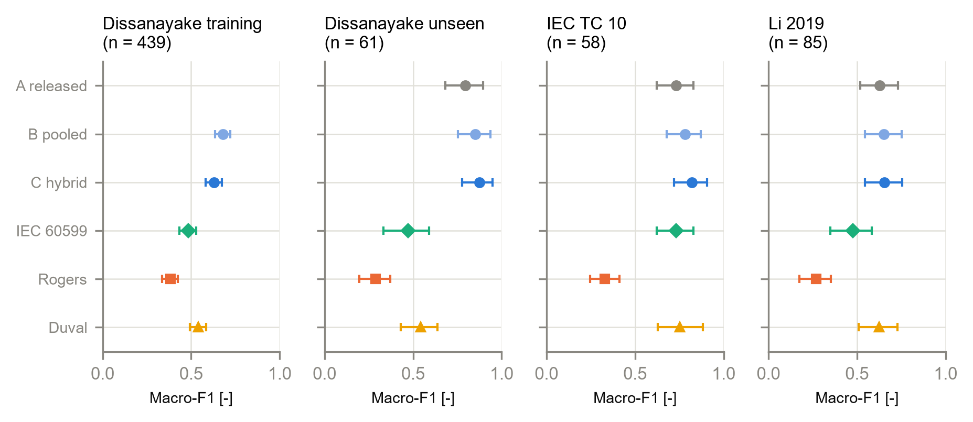

Table 4.13 - paired contrasts (primary; exploratory)
Held out | Contrast | Macro-F1 difference [95 % CI] | b | c | p | p (Holm)
Dissanayake training | C - B | -0.050 [-0.076, -0.025] | 6 | 25 | 0.001 | 0.002
Dissanayake training | C - Duval | 0.088 [0.040, 0.141] | 99 | 57 | 0.001 | 0.002
Dissanayake unseen | B - A | 0.058 [-0.026, 0.149] | 5 | 2 | 0.453 | 0.906
Dissanayake unseen | C - B | 0.022 [0.000, 0.069] | 1 | 0 | 1.000 | 1.000
Dissanayake unseen | C - Duval | 0.330 [0.192, 0.469] | 22 | 4 | < 0.001 | 0.003
IEC TC 10 | B - A | 0.052 [0.000, 0.118] | 3 | 0 | 0.250 | 0.750
IEC TC 10 | C - B | 0.038 [0.000, 0.097] | 2 | 0 | 0.500 | 1.000
IEC TC 10 | C - Duval | 0.069 [-0.084, 0.203] | 7 | 5 | 0.774 | 1.000
Li 2019 | B - A | 0.023 [-0.036, 0.090] | 4 | 3 | 1.000 | 1.000
Li 2019 | C - B | 0.003 [-0.024, 0.028] | 1 | 1 | 1.000 | 1.000
Li 2019 | C - Duval | 0.028 [-0.131, 0.186] | 27 | 11 | 0.015 | 0.045
b: first model right and second wrong; c: the reverse. The best conventional method was Duval on every source. When the Dissanayake training set is held out, only 204 records remain for training, and the hybrid model is worse than the pooled one there.

Reject option: hybrid model C at the coverage of IEC 60599 and Rogers
Held out | Compared with | Coverage | C: accuracy on answered | Method: conditional accuracy | Difference [95 % CI]
Dissanayake training | IEC 60599 | 0.738 | 0.725 | 0.636 | 0.090 [0.029, 0.148]
Dissanayake training | Rogers | 0.642 | 0.777 | 0.574 | 0.202 [0.139, 0.261]
Dissanayake unseen | IEC 60599 | 0.721 | 0.955 | 0.659 | 0.295 [0.161, 0.427]
Dissanayake unseen | Rogers | 0.623 | 0.947 | 0.526 | 0.421 [0.282, 0.550]
IEC TC 10 | IEC 60599 | 0.879 | 0.824 | 0.725 | 0.098 [-0.008, 0.212]
IEC TC 10 | Rogers | 0.724 | 0.881 | 0.667 | 0.214 [0.064, 0.357]
Li 2019 | IEC 60599 | 0.788 | 0.731 | 0.388 | 0.343 [0.213, 0.465]
Li 2019 | Rogers | 0.682 | 0.776 | 0.276 | 0.500 [0.360, 0.632]
Figure 4.24 Accuracy on answered records against coverage (models: lines; conventional methods: points)
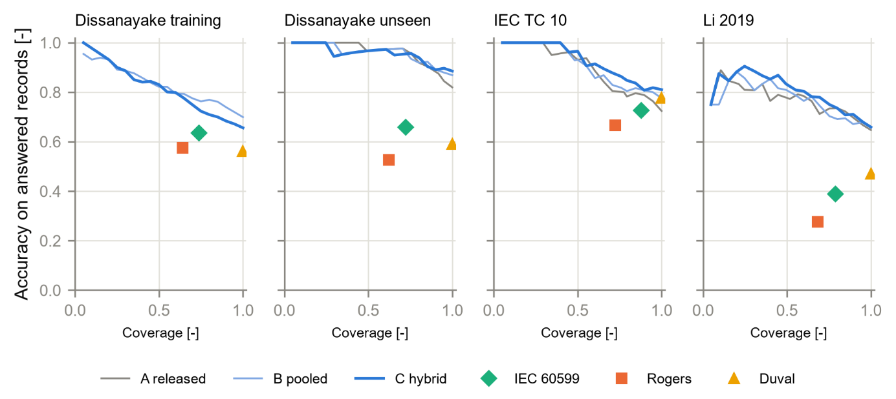
A model line above a method's point means the model is more accurate when it answers as many records as that method. The hybrid model's line (C) lies above every conventional point on all four sources; the released model (A) lies below Duval on IEC TC 10 when it answers every record.

5. Checks
Check | Result
Study 2 data manifest verified; predictions from Step 31C only | PASS
Primary results unchanged after adding model A to the equal-weight variant | PASS
Scoring functions shared with the confirmatory Step 29 (tested against scikit-learn) | PASS
Full automated test suite | PASS - 130 of 130

6. Problems and fixes
• The equal-source-weight variant had no model A predictions (Step 31C does not refit model A); they were taken from the primary variant for the same records, after which the decision step ran. Primary results were confirmed unchanged.

7. Decisions
• D29 (clarification, fixed before computing): rule 3 uses model C; the best conventional method is chosen by strict accuracy; tau fixed in the bootstrap.

8. Files produced
• 08_Statistical_Analysis/study2/: measures.csv, contrasts.csv, reject_option.csv, risk_coverage.csv
• 11_Results/tables/T4_12_study2_results.csv, T4_13_study2_contrasts.csv; 11_Results/figures/F4_23_study2_macro_f1, F4_24_study2_accuracy_coverage
• 06_Python_ML/src/study2/step31d_measures.py; 03_Data/interim/step31d_report.md

9. What was achieved
• All Study 2 measures, contrasts and reject-option comparisons are computed with intervals, for the primary analysis and both sensitivity variants.
• Tables 4.12-4.13 and Figures 4.23-4.24 are produced with their data files.

10. Record of this step
Item | Record
Step | 31D - Measures, paired contrasts and reject option (Study 2)
Environment | Claude Code (this chat)
Completed | 12 October 2026
Status | Done - EXPLORATORY
Main inputs | 07_Experiments/2026-10-12_study2_loso/predictions.csv; 03_Data/study2/study2_pooled.csv
Main outputs | 08_Statistical_Analysis/study2/ (measures, contrasts, reject_option, risk_coverage); Tables T4_12, T4_13; Figures F4_23, F4_24
Checks | manifest verified; adding model A to one sensitivity variant left the primary results identical; 130 of 130 tests pass
Decisions | D29 (clarification of the protocol, before computing)

11. Data and sources used in this step
Every dataset, document and file this step used is listed below with its full reference, link and fingerprint (SHA-256, first 16 characters shown). Method references are listed in the 'Method used' section. The complete record, with access dates, licences and full fingerprints, is the Data and Source Register (00_Project_Admin/Step_Reports/Data_and_Source_Register.docx and 03_Data/provenance/data_and_source_register.csv).
ID | Reference and use in the project | Link, DOI and local file
DF42 | Produced in Step 31C by step31c_loso.py from DF41 and DF27 (model A) following the Study 2 protocol (DF40). Use: Predicted class and six class probabilities of models A, B and C for every held-out record, 3 variants. | File: 07_Experiments/2026-10-12_study2_loso/predictions.csv; SHA-256 8DFC514A73CB7D83...
DF41 | Produced in Step 31B by step31b_pooled.py from DF2 and DF9 by the rules of the Study 2 protocol (DF40, decision D28). Use: Pooled, deduplicated records of the four sources with six classes, near-duplicate groups and hybrid inputs. | File: 03_Data/study2/study2_pooled.csv; SHA-256 3B03F7D44B56A87B...
DF43 | Produced in Step 31D by step31d_measures.py from DF42 and DF41 (protocol DF40, clarification D29). EXPLORATORY. Use: Macro-F1, accuracy, coverage with intervals; contrasts B-A, C-B, C-best; reject option. | File: 08_Statistical_Analysis/study2/measures.csv; SHA-256 E8E63171015FFF44...
DF44 | Produced in Step 31D by step31d_measures.py. EXPLORATORY. Use: Study 2 results by held-out source; contrasts and reject option. | File: 11_Results/tables/T4_12_study2_results.csv; SHA-256 EF6AD1852F9D8987...
DF40 | Written in Step 31A (decision D28) before any Study 2 model was trained; fingerprint recorded in 03_Data/study2/study2_protocol.sha256. Use: Fixes the questions, data rules, models, measures, statistics and decision rules of Study 2. | File: 00_Project_Admin/Study2_Protocol.docx; SHA-256 3EF4C2855A16C5A9...
SW1 | Python 3.12.10 with 55 pinned packages (06_Python_ML/requirements.txt). Use: Runs every data-preparation, statistics and checking program. | https://www.python.org/downloads/release/python-31210/; File: 06_Python_ML/requirements.txt; SHA-256 594BC0CB122EED99...

12. How this helps the next steps
Next step: Step 31E: apply the three pre-registered decision rules exactly as written and state what Study 2 shows and does not show.
• Step 31E applies the three pre-registered decision rules to these results.

13. Open items and limitations
• All Study 2 results are exploratory: IEC TC 10 and Li 2019 had already been seen. A positive result needs confirmation on fresh data (Step 31F).
• Many intervals are wide (58-85 records per external source); several lower limits sit exactly at 0, where only one or two records differ between the models.

14. Abbreviations and terms used in this report
Every abbreviation and technical term that appears in this report is explained below. The fault types follow the definitions of IEC 60599 (clause 5.2). The full list for the whole project is kept in 00_Project_Admin/abbreviations_glossary.csv.
Abbreviation or term | Meaning | Plain explanation
MPhil | Master of Philosophy | The research degree this thesis is written for.
UMaT | University of Mines and Technology, Tarkwa | The university where the thesis is submitted.
DGA | Dissolved Gas Analysis | Measuring the gases dissolved in transformer oil to find faults inside the transformer without opening it.
ppm | parts per million | Amount of gas in the oil; 1 ppm = 1 microlitre of gas in 1 litre of oil.
H2 | hydrogen | Gas formed mainly by partial discharges (low-energy electrical activity) in the oil.
PD | partial discharges | Small electrical discharges that only partly bridge the insulation (corona type, can form X-wax, or small sparking punctures in paper).
D1 | discharges of low energy | Sparking or tracking: larger punctures in paper, carbonised paper surface or carbon particles in oil.
D2 | discharges of high energy | Arcing with power follow-through: extensive carbonisation, metal fusion, sometimes tripping of the equipment.
T1 | thermal fault below 300 °C | Overheating in which the paper has turned brownish.
T2 | thermal fault 300 to 700 °C | Overheating in which the paper has carbonised.
T12 | T1 or T2 (merged class) | Used in this project when a source does not say whether the thermal fault was below or above 300 °C.
IEC | International Electrotechnical Commission | The world body that publishes electrical standards, such as IEC 60599.
IEC 60599 | IEC guide to the interpretation of dissolved and free gas analysis | The international standard that defines the fault types and the IEC gas-ratio method.
IEC TC 10 | IEC Technical Committee 10 (fluids for electrotechnical applications) | The committee that wrote IEC 60599; its database of 117 inspected faulty units is this thesis's main benchmark.
Rogers ratios | older gas-ratio method by R.R. Rogers | A ratio table that names faults from three gas ratios; kept in IEEE C57.104.
Normality gate | rule that lets conventional methods answer 'Normal' | If all gases are below their typical values, the conventional methods give Normal instead of a fault (decision D3).
Training (development) set | records used to build the models | 439 clean records from the Dissanayake training file.
Primary and sensitivity analysis | main analysis and its repeat under another reasonable choice | The sensitivity analysis shows whether the conclusion changes when a choice is made differently.
SHA-256 | Secure Hash Algorithm, 256-bit | A file's digital fingerprint: if one byte of the file changes, the fingerprint changes.
Stratified group k-fold | splitting method | Every part has the same mix of fault classes, and near-identical records stay together in one part.
Random seed | starting number for the random shuffle | Recording it means the same split can be made again exactly (seed 20261010).
CSV | comma-separated values | A plain-text table file that any program can read.
docx | Microsoft Word document | The format of these reports.
Python | programming language | Used for data preparation, machine learning and statistics (Claude Code).
venv | virtual environment | A private copy of Python and its libraries that belongs to this project only.
pytest | Python testing tool | Runs the automated checks that prove the data rules hold.
D1-D23 (decisions) | numbered project decisions | Decisions recorded in 00_Project_Admin/decisions_log.md; not the same as the fault codes D1 and D2.
Roadmap | the 45-step project plan | Project_Roadmap.docx: every step, its environment and its outputs, done strictly in order.
ND (no diagnosis) | No diagnosis | The answer of a method when no rule applies or a ratio it needs cannot be calculated. It is a result and is never deleted.
Dual answer (D1/D2) | Two classes returned together | Sometimes the IEC table fits two fault types at once. The method then answers with both (D1/D2); it counts as correct if the true class is either one.
Feature set (F1-F4) | the inputs given to a model | F1 log gases, F2 gas percentages, F3 log-ratios and Duval percentages, F4 all of them (Analysis Plan 5.1).
Macro-F1 | average F1 score over the classes | The primary performance measure; every class counts equally however rare it is.
Balanced accuracy | mean of the per-class recalls | The share of each class that is found, averaged over the classes, so a rare class counts as much as a common one.
Class probability | model's confidence in each class | For every record the model gives a probability for each of the seven classes; they add up to 1 and the largest is the prediction.
Bootstrap (stratified percentile) | resampling to get a confidence interval | The records are drawn again at random, with replacement and within each fault class, 2000 times; the middle 95 % of the recomputed values is the 95 % interval (Analysis Plan Section 6.2).
Strict accuracy | correct answers out of all records | Every no-diagnosis (ND) counts as wrong, because the engineer got no help (Analysis Plan Eq. 7).
Conditional accuracy | correct answers out of the records answered | Looks only at the cases where the method gave a diagnosis (Analysis Plan Eq. 7).
Coverage | share of records that get a diagnosis | 1 minus the share of no-diagnosis answers (Analysis Plan Eq. 6); the ML model always answers, so its coverage is 100 %.
Wilson interval | confidence interval for a proportion | A 95 % interval for an accuracy or a coverage that works well for small samples (Analysis Plan Eq. 21).
McNemar test | paired test of two methods on the same records | Uses only the records where one method is right and the other wrong (b and c); tests whether b and c differ more than chance (Analysis Plan Eqs. 30-31).
Holm correction | adjustment for several tests | Keeps the chance of any false positive among the three comparisons per test set at 5 % (Analysis Plan Eq. 32).
Study 2 | exploratory improvement study | An extra study, planned after the main results, that tests ways to improve the model; reported separately from the main (confirmatory) results.
Confirmatory vs exploratory | tested as planned vs looked into afterwards | Confirmatory results test a hypothesis fixed in advance on untouched data; exploratory results come from analyses planned after seeing some results and need confirmation on new data.
Pre-registration | writing the plan before the analysis | The questions, data rules, methods and decision rules are fixed and fingerprinted before any result exists, so the analysis cannot be fitted to the results.
Hybrid model | machine learning plus expert rules | A model that receives the conventional methods' answers and boundary distances as extra inputs besides the gas features.
Reject option | the model may decline to answer | The model gives a diagnosis only when its highest class probability reaches a threshold; otherwise it reports no diagnosis (Chow, 1970).

