Step 32 Report
Generate all Chapter 4 tables and figures
Environment: Claude Code (this chat) | Completed: 12 October 2026 | Report version 1 (12 October 2026)
Thesis: Intelligent Power Transformer Fault Diagnosis Using Dissolved Gas Analysis and Machine Learning (MPhil, UMaT)
Abbreviations (such as PD, D1, T1, ppm) and technical terms are explained in the last section of this report.
In short: One command now rebuilds every Chapter 4 table and figure from the saved result files - 79 files - without retraining any model or predicting any test set again. Rebuilding everything from scratch reproduced all files byte for byte, and every result table registered in earlier steps is unchanged. Four figures were added (4.6, 4.9, 4.10, 4.13). Stage F is complete.

1. Purpose of this step
This step makes Chapter 4 fully reproducible and completes its set of tables and figures for the work done so far.

2. Method used

Approach
One command (make_chapter4.py) runs, in dependency order, every program that produces a Chapter 4 table or figure. Each program reads only saved files - fold results, saved predictions, merged predictions - so nothing is retrained and no test set is predicted again.
Four figures that no earlier step had made were added (Figures 4.6, 4.9, 4.10, 4.13). The roadmap's check was then run: the current tables and figures were moved aside, everything was rebuilt from scratch, and every file was compared byte for byte with the earlier version.

Why this method
• A thesis whose every table and figure can be rebuilt by one command from saved data is fully reproducible - examiners can verify any number.
• Moving files aside instead of deleting them keeps the check safe and reversible.

Settings and rules
Setting | Value
Command | python -I 06_Python_ML/src/analysis/make_chapter4.py [--check]
Programs run | Steps 11, 20 (table only), 23, 27, 29, 30, 31, 31D, 31E and the new chapter4_figures.py
Not rebuilt here | plot_style.csv (frozen), Figure 3.2 (Step 13), Figure 4.4 (MATLAB, Step 17); Stage G-H outputs do not exist yet
Reproducibility settings | seeded bootstraps and shuffles; PDF files written without a creation date

Tools and programs
• 06_Python_ML/src/analysis/make_chapter4.py; chapter4_figures.py (Figures 4.6, 4.9a-c, 4.10, 4.13)

Method references
[M26] J. Demsar, "Statistical comparisons of classifiers over multiple data sets," Journal of Machine Learning Research, vol. 7, pp. 1-30, 2006. https://www.jmlr.org/papers/v7/demsar06a.html
[M20] B. Efron and R. J. Tibshirani, An Introduction to the Bootstrap. New York: Chapman and Hall, 1993.

3. What was done, step by step
1. Added a table-only option to the Step 20 summary, fixed the PDF creation date (so re-runs give identical files), and wrote chapter4_figures.py for the four missing figures.
2. Wrote make_chapter4.py, which runs all producing programs in order and fingerprints every output.
3. Ran it once and confirmed that every result file recorded in the source register is unchanged.
4. Ran the roadmap check: moved all outputs aside, rebuilt from scratch, compared byte for byte.

4. Chapter 4 tables and figures
Item | Content | Produced by
Table 4.1 / 4.1b | Records by role and class; records removed | Step 11
Table 4.2 (+ A4.2) | Gas medians and IQR by class, Kruskal-Wallis | Step 11
Table 4.3 | Conventional methods on each test set | Step 29
Table 4.4 | Classifier cross-validation results | Step 20
Table 4.5 | Main comparison on each test set | Step 29
Table 4.6 | McNemar tests with Holm correction | Step 30
Table 4.7 | Cohen's kappa between methods | Step 30
Table 4.8 | Boundary logistic regression | Step 31
Table 4.9 | Reduced-gas study and minimum panel | Step 27
Tables 4.10-4.11 | Simulink verification; integration (Stages G-H) | not yet - Steps 33-42
Tables 4.12-4.13 | Study 2 results and contrasts (exploratory) | Step 31D
Figures 4.1-4.3 | Records per class; gases by class; gas correlation | Step 11
Figure 4.4 | Duval triangles by data role (MATLAB) | Step 17 (not rebuilt here)
Figures 4.5a-c, 4.8 | Confusion matrices (conventional; ML) | Step 29
Figure 4.6 | Cross-validation box plots | Step 32 (new)
Figures 4.7, 4.11 | Critical-difference diagram; kappa heatmaps | Step 30
Figures 4.9a-c | Main comparison dot-and-whisker plots | Step 32 (new)
Figure 4.10 | F1 per fault class with 95 % CI | Step 32 (new)
Figure 4.12 | Disagreement against boundary distance | Step 31
Figure 4.13 | Disagreements in the Duval Triangle | Step 32 (new)
Figures 4.14-4.15 | Permutation importance; SHAP summary | Step 23
Figures 4.16-4.17 | Accuracy against number of gases; gas-subset matrix | Step 27
Figures 4.18-4.22 | Simulink and integration (Stages G-H) | not yet - Steps 33-42
Figures 4.23-4.24 | Study 2 macro-F1; accuracy against coverage (exploratory) | Step 31D

The four new figures
Figure 4.6 Cross-validation macro-F1 of the six models (feature set F4, 50 outer folds)
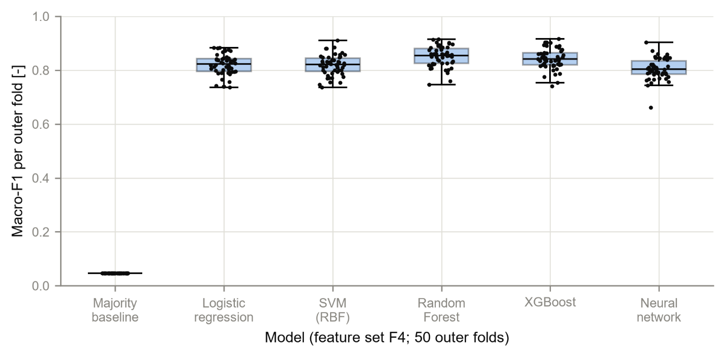
Figure 4.9b Main comparison on the IEC TC 10 benchmark (95 % CI; Figures 4.9a and 4.9c show the other test sets)
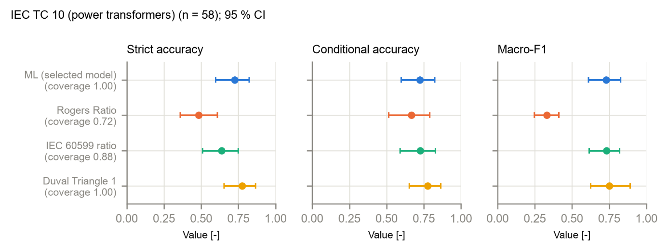
Figure 4.10 F1-score per fault class with 95 % bootstrap CI, on the three test sets
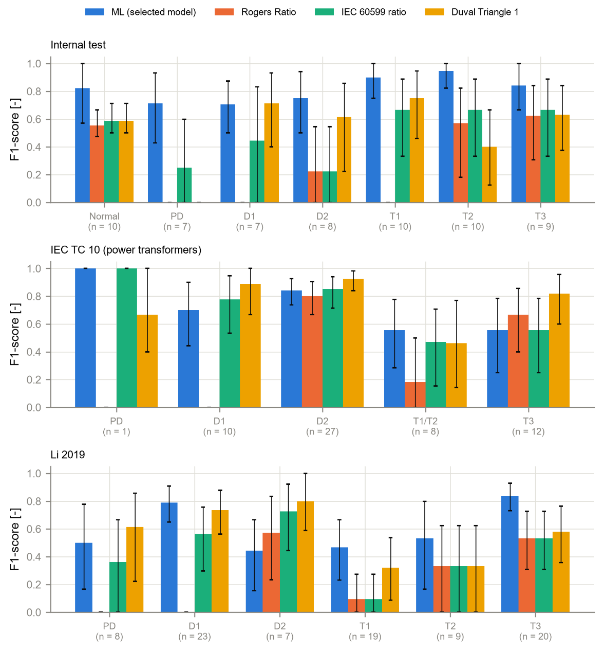
Figure 4.13 Disagreements between the ML model and Duval in the Duval Triangle (primary test records)
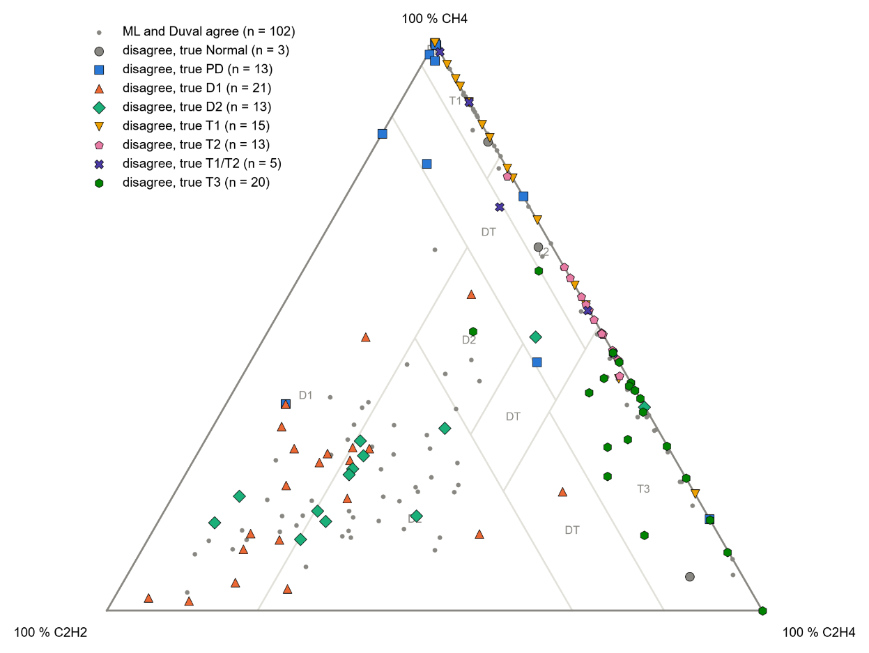
In Figure 4.13 many of the disagreements lie along the CH4-C2H4 edge (thermal faults and the T1/T2 boundary) and between the D1 and D2 zones, where Duval's zone lines separate neighbouring classes.

5. Checks
Check | Result
Rebuild from scratch: 79 files before, 79 after | PASS - none missing, none changed
Registered result tables and data files unchanged by the rebuild | PASS
No model retrained; no test set predicted again | PASS
Full automated test suite | PASS - 130 of 130

6. Problems and fixes
• The first run stopped because the Step 11 program is in the analysis folder, not data_prep; the path was corrected.
• PDF files carried a creation date, which would make identical rebuilds differ; the date is now omitted.

7. Decisions
• None new.

8. Files produced
• 06_Python_ML/src/analysis/make_chapter4.py, chapter4_figures.py; 11_Results/chapter4_manifest.sha256, chapter4_check.txt
• 11_Results/figures/F4_6_cv_boxplots, F4_9a-c_main_comparison_*, F4_10_f1_per_class, F4_13_duval_disagreements (PNG, PDF, CSV); 08_Statistical_Analysis/per_class_ci.csv

9. What was achieved
• All 79 Chapter 4 table and figure files are rebuilt by one command and fingerprinted (11_Results/chapter4_manifest.sha256).
• Rebuilding from scratch reproduced every file byte for byte (11_Results/chapter4_check.txt).
• Figures 4.6, 4.9, 4.10 and 4.13 were added; Chapter 4 now has every planned table and figure except those of the Simulink and integration stages.

10. Record of this step
Item | Record
Step | 32 - Generate all Chapter 4 tables and figures
Environment | Claude Code (this chat)
Completed | 12 October 2026
Status | Done (Stage F complete)
Main inputs | saved result files of Steps 11-31F
Main outputs | 11_Results/tables, 11_Results/figures, chapter4_manifest.sha256, chapter4_check.txt; 08_Statistical_Analysis/per_class_ci.csv
Checks | rebuild from scratch identical (79 files); registered result files unchanged; 130 of 130 tests pass
Decisions | none new

11. Data and sources used in this step
Every dataset, document and file this step used is listed below with its full reference, link and fingerprint (SHA-256, first 16 characters shown). Method references are listed in the 'Method used' section. The complete record, with access dates, licences and full fingerprints, is the Data and Source Register (00_Project_Admin/Step_Reports/Data_and_Source_Register.docx and 03_Data/provenance/data_and_source_register.csv).
ID | Reference and use in the project | Link, DOI and local file
DF21 | Produced in Step 20 by step20_nested_cv.py (run 2026-10-11_nestedcv_v1, 21:01-23:44, 6 workers). Use: Chosen setting, inner score and all Section 6 measures of every outer-fold task (6 models x 4 feature sets x 50 folds). | File: 07_Experiments/2026-10-11_nestedcv_v1/fold_metrics.csv; SHA-256 5215981A5636EF1E...
DF34 | Produced in Step 28 by step28_merge_predictions.py from DF2, DF9 (conventional predictions) and DF25 (ML predictions). Use: True class, flags, ML prediction and probabilities, conventional answers (raw, upper gate, lower gate, merged classes), boundary distances. | File: 08_Statistical_Analysis/merged_predictions.csv; SHA-256 EDB799A2CDA41A69...
DF35 | Produced in Step 29 by step29_measures.py from DF34 only (decision D25). Use: Strict and conditional accuracy, coverage (Wilson), macro-F1, balanced accuracy, kappa, MCC (bootstrap) for every method and set. | File: 08_Statistical_Analysis/performance_measures.csv; SHA-256 C86B438A3EF7873F...
DF37 | Produced in Step 30 by step30_tests.py from DF21 (fold results) and DF34 (merged predictions); decision D26. Use: McNemar (Holm), Cochran's Q, Friedman/Nemenyi, kappa, hypothesis criteria. | File: 08_Statistical_Analysis/cochran_mcnemar.csv; SHA-256 CCC3414122D688BB...
DF39 | Produced in Step 31 by step31_boundary.py from DF34 (decision D27). Use: Logistic regression of ML-method disagreement on boundary distance; criterion 3. | File: 08_Statistical_Analysis/boundary_regression.csv; SHA-256 0CB49CA5E7B168D4...
DF43 | Produced in Step 31D by step31d_measures.py from DF42 and DF41 (protocol DF40, clarification D29). EXPLORATORY. Use: Macro-F1, accuracy, coverage with intervals; contrasts B-A, C-B, C-best; reject option. | File: 08_Statistical_Analysis/study2/measures.csv; SHA-256 C19E61A7B3822A7F...
SW1 | Python 3.12.10 with 55 pinned packages (06_Python_ML/requirements.txt). Use: Runs every data-preparation, statistics and checking program. | https://www.python.org/downloads/release/python-31210/; File: 06_Python_ML/requirements.txt; SHA-256 594BC0CB122EED99...

12. How this helps the next steps
Next step: Stage G - Step 33 (Simulink Agentic Toolkit): rebuild the transformer operating model in pure Simscape, every parameter from params_transformer.m.
• Chapter 4 can be written directly from these files.
• Stage G (Steps 33-37, Simulink operating model) follows; its tables and figures (4.10-4.11, 4.18-4.22) will be added to the same command.

13. Open items and limitations
• Figure 4.4 is produced in MATLAB (Step 17) and is not part of the Python rebuild.
• Tables 4.10-4.11 and Figures 4.18-4.22 belong to Stages G-H and do not exist yet.

14. Abbreviations and terms used in this report
Every abbreviation and technical term that appears in this report is explained below. The fault types follow the definitions of IEC 60599 (clause 5.2). The full list for the whole project is kept in 00_Project_Admin/abbreviations_glossary.csv.
Abbreviation or term | Meaning | Plain explanation
MPhil | Master of Philosophy | The research degree this thesis is written for.
UMaT | University of Mines and Technology, Tarkwa | The university where the thesis is submitted.
DGA | Dissolved Gas Analysis | Measuring the gases dissolved in transformer oil to find faults inside the transformer without opening it.
ppm | parts per million | Amount of gas in the oil; 1 ppm = 1 microlitre of gas in 1 litre of oil.
H2 | hydrogen | Gas formed mainly by partial discharges (low-energy electrical activity) in the oil.
CH4 | methane | Hydrocarbon gas formed when oil is overheated, mainly at the lower fault temperatures.
C2H4 | ethylene | Hydrocarbon gas favoured above about 500 °C; it rises as thermal faults get hotter.
PD | partial discharges | Small electrical discharges that only partly bridge the insulation (corona type, can form X-wax, or small sparking punctures in paper).
D1 | discharges of low energy | Sparking or tracking: larger punctures in paper, carbonised paper surface or carbon particles in oil.
D2 | discharges of high energy | Arcing with power follow-through: extensive carbonisation, metal fusion, sometimes tripping of the equipment.
T1 | thermal fault below 300 °C | Overheating in which the paper has turned brownish.
T2 | thermal fault 300 to 700 °C | Overheating in which the paper has carbonised.
IEC | International Electrotechnical Commission | The world body that publishes electrical standards, such as IEC 60599.
IEC TC 10 | IEC Technical Committee 10 (fluids for electrotechnical applications) | The committee that wrote IEC 60599; its database of 117 inspected faulty units is this thesis's main benchmark.
Duval Triangle 1 | graphical DGA method by M. Duval | The shares of CH4, C2H4 and C2H2 are plotted as one point in a triangle divided into fault zones.
ML | machine learning | Computer methods that learn the link between gas values and fault type from labelled examples.
Logistic regression | multinomial logistic regression | A simple, explainable model that turns weighted gas values into class probabilities.
SHAP | SHapley Additive exPlanations | Shows how much each gas pushed a model's decision towards or away from each fault.
Benchmark | fixed reference test set | The IEC TC 10 cases whose faults were confirmed by inspection; every method is scored on them.
Training (development) set | records used to build the models | 439 clean records from the Dissanayake training file.
SHA-256 | Secure Hash Algorithm, 256-bit | A file's digital fingerprint: if one byte of the file changes, the fingerprint changes.
Cross-validation | repeated train-and-test on parts of the training data | The data are split into parts; each part is used once for testing while the others train the model.
Fold | one part of the cross-validation split | Here the training data are cut into 5 folds (parts).
Kruskal-Wallis test | rank-based test for differences between groups | Tests whether a gas differs between the fault classes without assuming a normal distribution.
Median, quartiles | middle value and the values a quarter and three quarters of the way up | Describe typical gas levels without being pulled by extreme values.
CSV | comma-separated values | A plain-text table file that any program can read.
PNG, PDF, dpi | image file, printable document file, dots per inch | Figures are saved as PNG at 300 dpi (sharp for printing) and as PDF.
docx | Microsoft Word document | The format of these reports.
Python | programming language | Used for data preparation, machine learning and statistics (Claude Code).
venv | virtual environment | A private copy of Python and its libraries that belongs to this project only.
pytest | Python testing tool | Runs the automated checks that prove the data rules hold.
MATLAB | MATLAB (MathWorks) | Numerical programming environment; used for the conventional methods and the dashboard (MATLAB Agentic Toolkit).
Simulink, Simscape | MATLAB's block-diagram modelling tool and its physical-modelling library | Used to model the transformer's operating conditions (Simulink Agentic Toolkit); it never makes gas values.
D1-D23 (decisions) | numbered project decisions | Decisions recorded in 00_Project_Admin/decisions_log.md; not the same as the fault codes D1 and D2.
Roadmap | the 45-step project plan | Project_Roadmap.docx: every step, its environment and its outputs, done strictly in order.
Boundary distance | Distance to the nearest decision boundary | How far a sample is from the line where the diagnosis would change. A small distance means a small measurement error could change the diagnosis.
Feature set (F1-F4) | the inputs given to a model | F1 log gases, F2 gas percentages, F3 log-ratios and Duval percentages, F4 all of them (Analysis Plan 5.1).
Nested cross-validation | cross-validation inside cross-validation | The inner loop chooses the settings, the outer loop measures performance on data the tuning never saw.
Macro-F1 | average F1 score over the classes | The primary performance measure; every class counts equally however rare it is.
Balanced accuracy | mean of the per-class recalls | The share of each class that is found, averaged over the classes, so a rare class counts as much as a common one.
Kappa | Cohen's kappa | Agreement between predicted and true classes after removing the agreement expected by chance: 0 = chance, 1 = perfect.
MCC | Matthews correlation coefficient | One score from -1 to 1 that uses the whole confusion matrix; 0 means no better than guessing.
F1-score (per class) | harmonic mean of precision and recall | High only when the model both finds the records of a class and is rarely wrong when it names that class.
Friedman and Nemenyi tests | rank-based comparison of several models | Friedman tests whether models' average ranks over the folds differ; Nemenyi then shows which pairs differ (Step 30).
Confusion matrix | table of true against predicted classes | Each row is a true class, each column a predicted class; the diagonal holds the correct answers, every other cell a particular mistake.
Class probability | model's confidence in each class | For every record the model gives a probability for each of the seven classes; they add up to 1 and the largest is the prediction.
Permutation importance | drop in score when one input is shuffled | The values of one input are mixed up at random across records; the bigger the drop in macro-F1, the more the model relies on that input (Analysis Plan Eq. 38).
Reduced-gas study | testing the model with fewer gases | The model is retrained with only some gases available, to see how much accuracy is lost - relevant for monitors that measure fewer gases.
Bootstrap (stratified percentile) | resampling to get a confidence interval | The records are drawn again at random, with replacement and within each fault class, 2000 times; the middle 95 % of the recomputed values is the 95 % interval (Analysis Plan Section 6.2).
Minimum gas panel | fewest gases that are good enough | The smallest gas combination whose loss of macro-F1, at the upper end of its 95 % interval, stays within the approved tolerance of 0.05 (Analysis Plan Eq. 37).
Conditional accuracy | correct answers out of the records answered | Looks only at the cases where the method gave a diagnosis (Analysis Plan Eq. 7).
Coverage | share of records that get a diagnosis | 1 minus the share of no-diagnosis answers (Analysis Plan Eq. 6); the ML model always answers, so its coverage is 100 %.
Wilson interval | confidence interval for a proportion | A 95 % interval for an accuracy or a coverage that works well for small samples (Analysis Plan Eq. 21).
McNemar test | paired test of two methods on the same records | Uses only the records where one method is right and the other wrong (b and c); tests whether b and c differ more than chance (Analysis Plan Eqs. 30-31).
Cochran's Q | test of several methods on the same records | Tests whether all methods have the same share of correct answers before the pairwise tests (Analysis Plan Eq. 29).
Holm correction | adjustment for several tests | Keeps the chance of any false positive among the three comparisons per test set at 5 % (Analysis Plan Eq. 32).
Logistic regression (of disagreement) | model for a yes/no outcome | Estimates how the chance that ML and a conventional method disagree changes with the distance to the nearest decision boundary (Analysis Plan Eq. 33).
Boundary distance | how far a sample lies from a decision line | For the ratio methods in decades of the ratio, for Duval in percentage points to the nearest zone edge (Analysis Plan Eqs. 9-10).
Study 2 | exploratory improvement study | An extra study, planned after the main results, that tests ways to improve the model; reported separately from the main (confirmatory) results.
Confirmatory vs exploratory | tested as planned vs looked into afterwards | Confirmatory results test a hypothesis fixed in advance on untouched data; exploratory results come from analyses planned after seeing some results and need confirmation on new data.
Reject option | the model may decline to answer | The model gives a diagnosis only when its highest class probability reaches a threshold; otherwise it reports no diagnosis (Chow, 1970).

