Step 33 Report
Rebuild the transformer operating model
Environment: Claude Code (this chat), MATLAB and Simulink through the MCP connection | Completed: 12 October 2026 | Report version 1 (12 October 2026)
Thesis: Intelligent Power Transformer Fault Diagnosis Using Dissolved Gas Analysis and Machine Learning (MPhil, UMaT)
Abbreviations (such as PD, D1, T1, ppm) and technical terms are explained in the last section of this report.
In short: The transformer operating model (Transformer_Operating_Model.slx) was rebuilt from Part B of the MATLAB Build Guide by a MATLAB program: 7 subsystems, 84 blocks, two physical networks (electrical and thermal), 19 annotations. The model updates and simulates without any error or warning from a clean MATLAB path, and all 9 automatic checks pass. Its structure is identical to the reference build (84 blocks compared; the only difference is the 273.15 K offset, which is now a named variable). A 24-hour run at rated demand gives a load factor of 0.9839, a final top-oil temperature of 78.638 degC and a hot-spot temperature of 100.276 degC, equal to the steady state of the IEC 60076-7 equations. The model never produces a gas value. Several points in the guide were reviewed and are listed in this report; the thermal constants are still TO VERIFY against IEC 60076-7.

1. Purpose of this step
The Simulink model supplies the operating context of the framework: how load, current, oil temperature, hot-spot temperature and insulation ageing of the 40 MVA transformer change over time. It does not take part in any diagnosis and never generates gas values (decision D4). This step builds the model; Steps 34 to 37 check it, verify it, run the scenarios and add the sampling-event subsystem.

2. Method used

Approach
The model is built by a MATLAB program (build_Transformer_Operating_Model.m) that follows Part B of the MATLAB Build Guide block by block: it creates the seven subsystems, places every block, sets its parameters and draws every connection. Because the whole model is written as code, every block, setting and line can be read, checked and rebuilt at any time.
The model has two physical networks. The electrical network (SS1 grid, SS2 transformer, SS3 measurement, SS4 load) is built from Simscape Electrical blocks. The thermal network (SS6) is built from Simscape Foundation thermal blocks as three heat-flow circuits (top oil and two hot-spot components), like electrical circuits with heat flow instead of current and temperature instead of voltage. The loss calculation (SS5) and the outputs and ageing (SS7) are ordinary Simulink arithmetic blocks.
The model is then checked against a reference: the model that was built and verified earlier from the same guide (reference_build). A program compares the two block by block (names, types, parameters, connections) and compares the simulation results; a separate calculation of the steady state of the IEC 60076-7 equations is used as an independent check of the numbers.

Why this method
• Building the model from a script, not by hand, gives a model that anyone can reproduce and that can be compared automatically with the reference; this is standard practice in model-based design.
• The arithmetic (square root, powers, products) is done in Simulink blocks, not in physical-signal blocks, because the electrical network uses the 'Frequency and time' equation formulation. That formulation lets a 24-hour, 50 Hz simulation run in seconds instead of hours, but accepts only switched-linear equations (the Build Guide documents the error that a nonlinear physical block causes).
• Every value is a variable of params_transformer.m, never a number typed into a block, so the model can be changed in one place and every number has a unit and a source.

Settings and rules
Setting | Value
Model | Transformer_Operating_Model.slx: 7 subsystems, 84 blocks, 2 physical networks
Solver | variable step, ode23t, stop time t_stop, maximum step t_step_max (variables)
Electrical network | Frequency and time equation formulation; ideal source (no source impedance); Delta 1 o'clock / grounded Wye transformer, linear (no saturation)
Load | resistive, unity power factor, P = K(t) x S_rated from load_profile; minimum power P_load_min
Thermal network | three first-order circuits; mass = heat capacity in J/K (cp_unit = 1); initial temperature = ambient
Callbacks | PreLoadFcn and InitFcn: put the model folder on the path if needed, then run params_transformer (D31)
Tolerance for checks | 0.1 K (approved, Analysis Plan Section 9; proposed in the roadmap for Step 35)
Software | MATLAB 25.2.0.2998904 (R2025b) with Simulink, Simscape and Simscape Electrical; run through the MATLAB MCP connection (D30)

Equations
$$\begin{aligned}K=\frac{\sqrt{\frac{i_{a}^{2}+i_{b}^{2}+i_{c}^{2}}{3}}}{I_{\text{LV,r}}}\#\left(1\right)\end{aligned}$$
where:
$K$ – load factor, per unit (1 = rated current)
$i_{a}, i_{b}, i_{c}$ – instantaneous phase currents on the low-voltage side, A
$I_{\text{LV,r}}$ – rated low-voltage line current, A (I_LV_rated)
$$\begin{aligned}Q_{\text{oil}}=P_{\text{tot,r}}·{\left[\frac{P_{0}+P_{k}·K^{2}}{P_{\text{tot,r}}}\right]}^{x}\#\left(2\right)\end{aligned}$$
where:
$Q_{\text{oil}}$ – equivalent heat input of the oil circuit, W
$P_{0}, P_{k}$ – no-load loss and load loss at rated current, W
$P_{\text{tot,r}}$ – total loss at rated load, W (the sum of P0 and Pk)
$x$ – oil exponent (x_oil), dimensionless
$$\begin{aligned}Q_{\text{h1}}=\frac{k_{21}·Δθ_{\text{hr}}·K^{y}}{R_{\text{th,h}}}, Q_{\text{h2}}=\frac{\left(k_{21}-1\right)·Δθ_{\text{hr}}·K^{y}}{R_{\text{th,h}}}\#\left(3\right)\end{aligned}$$
where:
$Q_{\text{h1}}, Q_{\text{h2}}$ – heat inputs of the two hot-spot circuits, W
$k_{21}$ – thermal model constant (k21)
$Δθ_{\text{hr}}$ – rated hot-spot-to-top-oil gradient, K
$y$ – winding exponent (y_wdg)
$R_{\text{th,h}}$ – analogue thermal resistance of the hot-spot circuits, K/W (a scaling choice, 1 K/W)
$$\begin{aligned}C\frac{dθ}{dt}=Q-\frac{θ-θ_{\text{amb}}}{R}\#\left(4\right)\end{aligned}$$
where:
$C$ – thermal capacity of the circuit, J/K
$θ$ – temperature of the circuit node, K
$Q$ – heat input, W
$θ_{\text{amb}}$ – ambient temperature, K
$R$ – thermal resistance to ambient, K/W
$$\begin{aligned}θ_{\text{hs}}=θ_{\text{oil}}+Δθ_{\text{h1}}-Δθ_{\text{h2}}\#\left(5\right)\end{aligned}$$
where:
$θ_{\text{hs}}$ – hot-spot temperature, °C
$θ_{\text{oil}}$ – top-oil temperature, °C
$Δθ_{\text{h1}}, Δθ_{\text{h2}}$ – the two hot-spot rise components, K
$$\begin{aligned}V=2^{\left[\frac{θ_{\text{hs}}-θ_{\text{ref}}}{Δθ_{\text{d}}}\right]}\#\left(6\right)\end{aligned}$$
where:
$V$ – relative ageing rate of the insulation (1 = normal)
$θ_{\text{ref}}$ – hot-spot temperature at which V = 1, °C (98 °C)
$Δθ_{\text{d}}$ – temperature rise that doubles the ageing rate, K (6 K)

Tools and programs
• 05_Simulink_Model/build_Transformer_Operating_Model.m (builder), verify_step33.m (9 checks), params_transformer.m, run_transformer_simulation.m
• Simulink, Simscape, Simscape Electrical, Simscape Foundation library (nesl_utility, ee_lib, fl_lib blocks)
• 00_Project_Admin/report_builder/update_register_step33.ps1 (register, glossary)

Method references
[ST6] IEC 60076-7:2018, Power transformers - Part 7: Loading guide for mineral-oil-immersed power transformers (Edition 2.0). The full text was NOT obtained; details TO VERIFY.
[SW4] Alliander N.V., transformer-thermal-model (IEC 60076-7 implementation, MPL-2.0), file transformer_thermal_model/transformer/power.py, class PowerTransformer, ONAF default specifications (source T1 of the Build Guide). https://github.com/alliander-opensource/transformer-thermal-model
[SW3] pandapower documentation, 'Basic Standard Types', transformer type '40 MVA 110/20 kV' (source code E1 of the MATLAB Build Guide, Section A4; accessed 3 Oct 2026 according to the guide). https://pandapower.readthedocs.io/en/latest/std_types/basic.html

3. What was used
• MATLAB Build Guide, Part B (sections B1 to B13) and Part A4 (sources of the parameters).
• 05_Simulink_Model/params_transformer.m: every value of the model, with unit and source.
• The reference build (05_Simulink_Model/reference_build, re-run on 11 October 2026), used only to check the new model.

4. Review of the Build Guide (points found before building)
As asked, the guide was reviewed before it was followed. The model equations agree with the IEC 60076-7 differential-equation form (oil rise with exponent x; two hot-spot components with k21, k22 and exponent y). The following points were found; each is handled as stated.
# | Point found | What was done
1 | The guide says that no number is typed into a block, but it types 273.15 (0 degC in kelvin) into four blocks. | New variable T_zero_C_in_K in params_transformer.m; the blocks use it (D31, clause 2).
2 | The start-up callbacks 'params_transformer;' work only if the model folder is on the MATLAB path (the same weakness as in the rerun model). | The callbacks add the model folder to the path when the script is not found (D31, clause 1); tested from a clean path.
3 | The roadmap and CLAUDE.md say 'pure Simscape', but the guide builds SS5, SS7 and the square root of SS3 from Simulink blocks. | Kept, because the guide documents why (the 'Frequency and time' formulation accepts only switched-linear equations). Described as 'Simscape networks with Simulink arithmetic' (D31, clause 4, to be confirmed).
4 | The thermal constants are default values of the Alliander open-source implementation, not values from IEC 60076-7 or a test report; the standard was not obtained. | Unchanged and marked TO VERIFY; ST6 and SW4 added to the register.
5 | The electrical data are the pandapower typical standard type (not a nameplate) and its 150 degree vector group cannot be built (the block offers Delta 1 or 11 o'clock). | Delta 1 o'clock used and stated on the diagram; no effect on current magnitudes, losses or temperatures.
6 | At a demand of K = 1.0 the measured load factor is slightly lower (0.9839 in the run), because the load sits behind the transformer impedance (16.2 % short-circuit impedance), so the voltage at the load is a little below rated. | Explained in an annotation in SS4; the thermal chain uses the measured K of SS3, as in the guide.
7 | The guide's 'Simulink Agentic Toolkit' was not installed (Steps 2 and 3 were replaced for MATLAB by the MCP connection in D14). | The same connection was used for Simulink (D30, to be confirmed).

5. What was done, step by step
1. Reviewed the guide and the reference build script and recorded decisions D30 and D31 before building.
2. Added the variable T_zero_C_in_K to params_transformer.m.
3. Wrote build_Transformer_Operating_Model.m (sections B2 to B11 of the guide, plus the extra annotations) and built the model.
4. Wrote verify_step33.m (9 checks) and ran it from a clean MATLAB path. Two of my own checks first gave false alarms and were corrected (see Problems and fixes).
5. Exported Figure 3.4 and the seven subsystem diagrams, tidied the layout of SS6, rebuilt and checked again.
6. Wrote this report and updated the register, the glossary, the READMEs, CHANGELOG.md and SESSION_SUMMARY.md.

6. What we found

The model
Colour code in the model: blue = Simscape Electrical, green = Simulink arithmetic, orange = Simscape thermal network. Blue lines are physical connections, black lines are Simulink signals.
Figure 3.4 Top level of Transformer_Operating_Model (built and simulated in MATLAB R2025b)
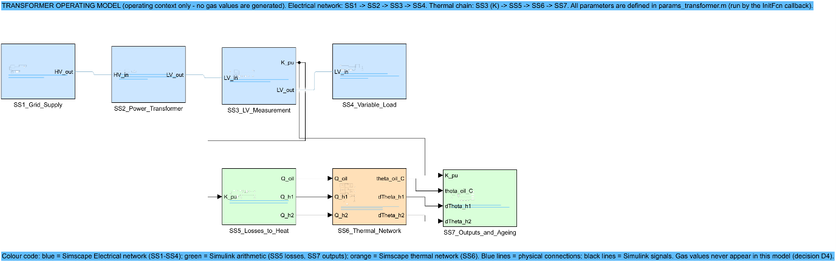
Subsystem | Domain | Blocks | Inputs | Outputs | Annotations
SS1_Grid_Supply | Simscape Electrical | 4 | 0 | 1 | 2
SS2_Power_Transformer | Simscape Electrical | 3 | 1 | 1 | 3
SS3_LV_Measurement | Simscape Electrical + Simulink | 9 | 1 | 2 | 2
SS4_Variable_Load | Simscape Electrical + Simulink | 7 | 1 | 0 | 3
SS5_Losses_to_Heat | Simulink | 15 | 1 | 3 | 2
SS6_Thermal_Network | Simscape thermal (Foundation) | 27 | 3 | 3 | 3
SS7_Outputs_and_Ageing | Simulink | 12 | 4 | 0 | 2
Total: 84 blocks (the seven subsystem blocks plus the blocks inside them) and 19 annotations (17 in the subsystems and 2 at the top level). Inputs and outputs count physical ports and signal ports.

Annotations
Every subsystem carries the annotation text of the Build Guide (what it does, inputs, outputs, parameters) and further notes where a reader would otherwise have to look in the code: the units along the measurement chain (SS3), the reason why the measured K is lower than the demanded K (SS4), the meaning of the gains (SS5), the circuit pattern and the two sensor types (SS6), and the ageing formula (SS7). Each subsystem also has a Description (shown in its block properties).

Simulation result
Quantity | Value | Unit
Load factor K measured in SS3 (demand 1.0) | 0.9839 | pu
Final top-oil temperature (24 h) | 78.638 | degC
Final hot-spot temperature (24 h) | 100.276 | degC
Relative ageing rate at the end | 1.301 | -
Equivalent ageing in 24 h (integral of V) | 27.9 | h
The analytic steady state of the IEC 60076-7 equations, calculated independently from params_transformer.m and the measured K, gives the same temperatures (difference below 0.001 K). The simulation of this model and of the reference build give identical signals.

Subsystem diagrams
Diagram of SS1_Grid_Supply
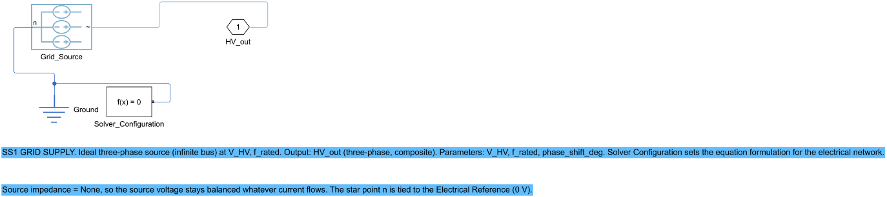
Diagram of SS2_Power_Transformer
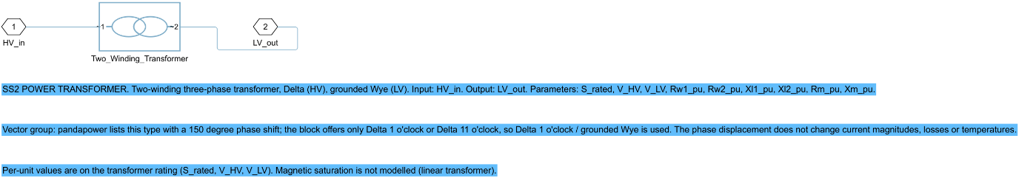
Diagram of SS3_LV_Measurement
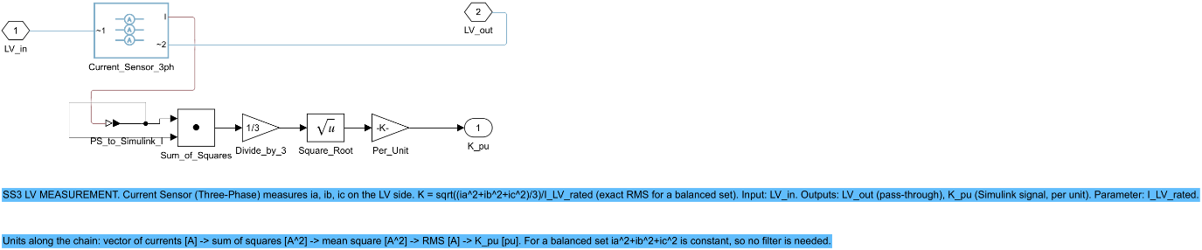
Diagram of SS4_Variable_Load
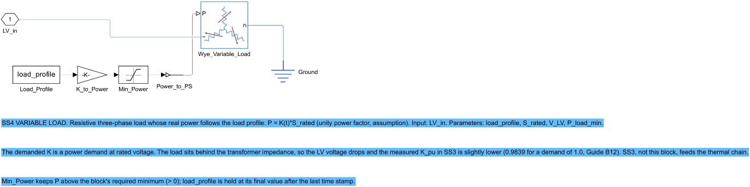
Diagram of SS5_Losses_to_Heat
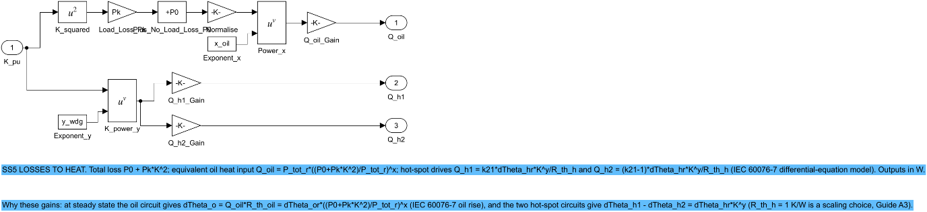
Diagram of SS6_Thermal_Network
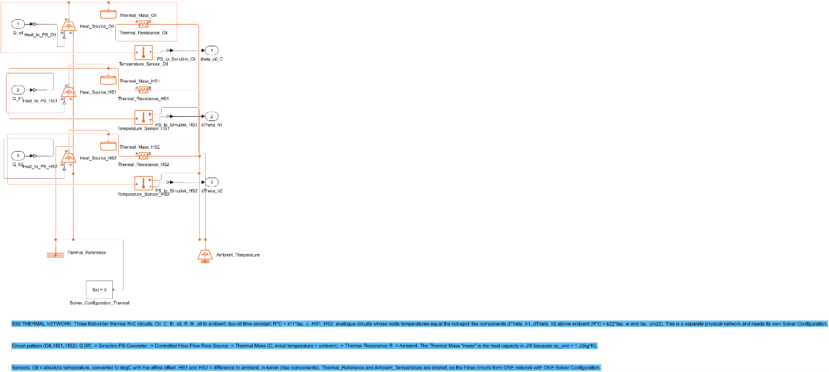
Diagram of SS7_Outputs_and_Ageing
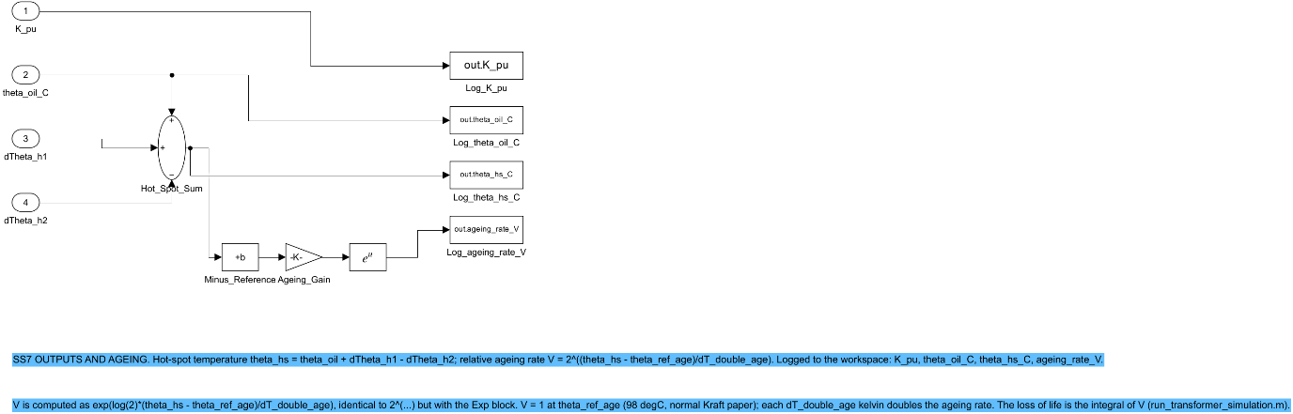

7. Checks
Check (verify_step33.m) | Result
opens, updates and simulates from a clean path | PASS
no warning during update/simulation | PASS
model and all 7 subsystems carry an annotation; every subsystem has a Description | PASS
no number typed into a block (all settings are variables or equation constants) | PASS
no block produces or names a gas concentration | PASS
exactly one Solver Configuration per physical network (electrical, thermal) | PASS
structure equals the reference model (blocks, parameters, connections) | PASS
24 h run equals the analytic steady state of the IEC 60076-7 equations (<= 0.1 K) | PASS
results equal the reference model (logged signals, same run) | PASS
Detail of the structure check: 84 blocks compared; 4 expected differences (273.15 -> T_zero_C_in_K); 0 unexpected. Detail of the steady-state check: K = 0.9839; oil 78.638 vs 78.638 degC (diff 0.000 K); hot-spot 100.276 vs 100.276 degC (diff 0.000 K). The block settings made by the builder (106 settings) are listed in 05_Simulink_Model/results/step33_block_settings.csv.

8. Problems and fixes
• Decision numbers: the first draft numbered the new decisions D24 and D25, but those numbers had already been used in Steps 27 to 31. They were renumbered D30 and D31 before anything was registered.
• My structure check first loaded the reference model under the same file name as the new model, so Simulink loaded the new model twice and reported a difference of exactly zero, which proved nothing. The reference is now loaded from a renamed copy. The check was confirmed to detect differences: it finds the four expected 273.15 K differences.
• My check helper stored only the last check because it had captured an empty table; it was rewritten as a function.
• Two checks gave false alarms and were corrected: the 'no gas block' check treated Q_h2 (heat input of hot-spot circuit 2) as hydrogen, so gas formulas are now matched case-sensitively as whole words; the 'no typed number' check flagged the selector 0 of the ideal source (0 = no source impedance) and log(2) (doubling of the ageing rate), which are not values.
• In the first export of SS6 the Thermal_Reference and the solver block overlapped. The shared blocks were moved apart, the notes moved down, and the model was rebuilt and checked again.
• In PowerShell the name R is an alias of Invoke-History; a helper of that name did nothing. The edit was made directly instead.

9. Decisions
• D30 (proposed): the Simulink steps 33 to 37 are run through the MATLAB MCP connection, as in D14 for MATLAB; the 'Simulink Agentic Toolkit' of the roadmap is not installed.
• D31: Step 33 build details: path-safe callbacks; T_zero_C_in_K; extra annotations and colour code; Simulink arithmetic in SS3, SS5 and SS7 as in the Build Guide (clause 4 proposed: the model is described as Simscape networks with Simulink arithmetic); the model is built by script and compared with the reference build.

10. Files produced
• 05_Simulink_Model/Transformer_Operating_Model.slx
• 05_Simulink_Model/figures/Figure_3_4_top_level.png and diag_SS1 ... SS7 (.png)
• 05_Simulink_Model/build_Transformer_Operating_Model.m, verify_step33.m, code_manifest_step33.sha256; params_transformer.m (one new variable)
• 05_Simulink_Model/results/: step33_checks.csv, step33_structure_differences.csv, step33_block_settings.csv, step33_block_inventory.csv, step33_run_summary.csv

11. What was achieved
• Transformer_Operating_Model.slx was built from the Build Guide, Part B, in 05_Simulink_Model: 7 subsystems, 84 blocks, 19 annotations; Figure 3.4 and one diagram per subsystem were exported.
• The model updates and simulates without any error or warning from a clean MATLAB path; all 9 automatic checks pass.
• Its structure equals the reference build: 84 blocks compared, 0 unexpected differences; the only difference is the 273.15 K offset, which is now a named variable.
• The 24-hour run at rated demand gives K = 0.9839, final top-oil 78.638 °C and hot-spot 100.276 °C, equal to the analytic steady state of the IEC 60076-7 equations and to the reference model.

12. Record of this step
Item | Record
Step | 33 - Rebuild the transformer operating model
Environment | Claude Code (this chat) through the MATLAB MCP connection (roadmap role: Simulink Agentic Toolkit; D30)
Completed | 12 October 2026
Status | Done (D30 and clause 4 of D31 await the researcher's confirmation)
Main inputs | MATLAB Build Guide Part B; params_transformer.m; the reference build (rerun 2026-10-11)
Main outputs | 05_Simulink_Model/Transformer_Operating_Model.slx; figures/Figure_3_4_top_level.png; results/step33_checks.csv
Checks | 9 of 9 automatic checks PASS (verify_step33.m); structure = reference build (84 blocks, 0 unexpected differences)
Decisions | D30 (tool route, proposed); D31 (build details; clause 4 proposed)

13. Data and sources used in this step
Every dataset, document and file this step used is listed below with its full reference, link and fingerprint (SHA-256, first 16 characters shown). Method references are listed in the 'Method used' section. The complete record, with access dates, licences and full fingerprints, is the Data and Source Register (00_Project_Admin/Step_Reports/Data_and_Source_Register.docx and 03_Data/provenance/data_and_source_register.csv).
ID | Reference and use in the project | Link, DOI and local file
DF48 | Transformer_Operating_Model.slx, built in Step 33 by build_Transformer_Operating_Model.m from the MATLAB Build Guide Part B (decisions D30, D31); MATLAB R2025b. Use: Operating-context model: load, current, oil and hot-spot temperature, ageing. Never generates gas values (D4).. | File: 05_Simulink_Model/Transformer_Operating_Model.slx; SHA-256 1D025498C38834CB...
DF49 | Screenshot of the top level of Transformer_Operating_Model.slx, printed from Simulink at 200 dpi. The seven subsystem diagrams are in 05_Simulink_Model/figures/diag_SS*.png. Use: Figure 3.4 of the thesis. | File: 05_Simulink_Model/figures/Figure_3_4_top_level.png; SHA-256 3C0A770DDA360D2F...
DF50 | Produced by verify_step33.m: 9 checks (clean-path update and run, no warning, annotations, no typed number, no gas block, one solver per network, structure equal to the reference build, analytic steady state, equal result to the reference). Use: Evidence for the Step 33 check of the roadmap. | File: 05_Simulink_Model/results/step33_checks.csv; SHA-256 EF5CBEEAD1B12392...
DF51 | Code written or changed in Step 33: build_Transformer_Operating_Model.m, verify_step33.m, params_transformer.m (new variable T_zero_C_in_K only). Use: Fingerprints of the Step 33 code. | File: 05_Simulink_Model/code_manifest_step33.sha256; SHA-256 272EED1A64788EEA...
DF52 | All parameters of the transformer operating model with unit and source (E1 pandapower, T1 Alliander). Step 33 added the constant T_zero_C_in_K = 273.15 K. Use: The only place where model values are defined; read by the model callbacks. | File: 05_Simulink_Model/params_transformer.m; SHA-256 54498D3151680FD1...
DF53 | Transformer_Operating_Model.slx built by reference_build/build_transformer_model.m and re-run on 11 October 2026; used in Step 33 as the structure and result reference. The Step 33 model is compared with it block by block. Use: Reference for the Step 33 structure check. | File: 05_Simulink_Model/reference_build/rerun_2026-10-11/Transformer_Operating_Model.slx; SHA-256 E7813F90454B4160...
SW2 | MATLAB R2025b, version 25.2.0.2998904, The MathWorks, Inc., Natick, MA, USA. Use: Runs the conventional-method functions, unit tests, batch run and Duval figures (Steps 14-17). | https://www.mathworks.com/products/matlab.html
SW3 | pandapower documentation, 'Basic Standard Types', transformer type '40 MVA 110/20 kV' (source code E1 of the MATLAB Build Guide, Section A4; accessed 3 Oct 2026 according to the guide). Use: Electrical rating of the transformer: S_rated, V_HV, V_LV, uk, ukr, P0, i0 (published typical data; replace with a real nameplate when a utility provides one). | https://pandapower.readthedocs.io/en/latest/std_types/basic.html
SW4 | Alliander N.V., transformer-thermal-model (IEC 60076-7 implementation, MPL-2.0), file transformer_thermal_model/transformer/power.py, class PowerTransformer, ONAF default specifications (source T1 of the Build Guide). Use: Default thermal constants of params_transformer.m (dTheta_or, g_r, H, tau_o, tau_w, k11, k21, k22, x, y) and the form of the thermal differential equations. | https://github.com/alliander-opensource/transformer-thermal-model
ST6 | IEC 60076-7:2018, Power transformers - Part 7: Loading guide for mineral-oil-immersed power transformers (Edition 2.0). The full text was NOT obtained; details TO VERIFY. Use: Basis of the top-oil and hot-spot differential equations in SS5-SS7; the thermal constants of params_transformer.m must be checked against it (TO VERIFY).

14. How this helps the next steps
Next step: Step 34 (Simulink): run Model Advisor and the checks of Build Guide Part D1 on this model, fix every issue or record why it is accepted.
• Step 34 runs Model Advisor on this model and the checks of Build Guide Part D1; the model is built so that every block is named and annotated, which makes the report easy to read.
• Step 35 verifies the model against an independent solution of the IEC 60076-7 equations at rated load and in a load step from 0.6 to 1.2 per unit (the result of this step is only the steady-state check and the reproduction of the reference model).
• Step 36 adds the operating scenarios and Step 37 the DGA sampling-event subsystem (which must not produce any gas value; check 6 of verify_step33.m is the test for that).

15. Open items and limitations
• The thermal constants (top-oil rise 60 K, winding gradient 17 K, hot-spot factor 1.3, time constants 150 and 7 min, exponents 0.8 and 1.3, constants k11, k21, k22) are default values of an open-source implementation (Alliander), not values from IEC 60076-7:2018 or a test report: TO VERIFY. The standard was not obtained.
• The electrical data (40 MVA, 110/20 kV, 16.2 % impedance, 18 kW no-load loss) are published typical values of the pandapower standard type, not a real nameplate; replace them if a utility provides one. The model is therefore an illustration of operating behaviour, not a model of a particular transformer.
• The model is linear (no magnetic saturation), the load has unity power factor and the vector group (Delta 1 o'clock) differs from the 150 degree group listed by pandapower; none changes current magnitudes, losses or temperatures. State these assumptions in the thesis.
• D30 (the Simulink steps are run through the MATLAB MCP connection and not the Simulink Agentic Toolkit) and clause 4 of D31 (Simulink arithmetic blocks in SS3, SS5 and SS7, so the model is 'Simscape networks with Simulink arithmetic' and not 'pure Simscape') are proposed and need the researcher's confirmation.
• The dynamic accuracy (comparison with an independent solution of the differential equations in a load step, and the 63 % rise time) is verified formally in Step 35; this step checked the steady state and the equality with the reference model, which was verified in the same way earlier.
• The exact error text that the researcher saw in the earlier Simulink rerun has still not been supplied (the path fix of 12 October is not confirmed to be that error).

16. Abbreviations and terms used in this report
Every abbreviation and technical term that appears in this report is explained below. The fault types follow the definitions of IEC 60599 (clause 5.2). The full list for the whole project is kept in 00_Project_Admin/abbreviations_glossary.csv.
Abbreviation or term | Meaning | Plain explanation
MPhil | Master of Philosophy | The research degree this thesis is written for.
UMaT | University of Mines and Technology, Tarkwa | The university where the thesis is submitted.
DGA | Dissolved Gas Analysis | Measuring the gases dissolved in transformer oil to find faults inside the transformer without opening it.
ppm | parts per million | Amount of gas in the oil; 1 ppm = 1 microlitre of gas in 1 litre of oil.
H2 | hydrogen | Gas formed mainly by partial discharges (low-energy electrical activity) in the oil.
PD | partial discharges | Small electrical discharges that only partly bridge the insulation (corona type, can form X-wax, or small sparking punctures in paper).
D1 | discharges of low energy | Sparking or tracking: larger punctures in paper, carbonised paper surface or carbon particles in oil.
T1 | thermal fault below 300 °C | Overheating in which the paper has turned brownish.
IEC | International Electrotechnical Commission | The world body that publishes electrical standards, such as IEC 60599.
Typical values | 90 % typical gas concentrations | Levels below which about 90 % of transformers in service are found; not limit values.
SHA-256 | Secure Hash Algorithm, 256-bit | A file's digital fingerprint: if one byte of the file changes, the fingerprint changes.
CSV | comma-separated values | A plain-text table file that any program can read.
PNG, PDF, dpi | image file, printable document file, dots per inch | Figures are saved as PNG at 300 dpi (sharp for printing) and as PDF.
docx | Microsoft Word document | The format of these reports.
MATLAB | MATLAB (MathWorks) | Numerical programming environment; used for the conventional methods and the dashboard (MATLAB Agentic Toolkit).
Simulink, Simscape | MATLAB's block-diagram modelling tool and its physical-modelling library | Used to model the transformer's operating conditions (Simulink Agentic Toolkit); it never makes gas values.
D1-D31 (decisions) | numbered project decisions | Decisions recorded in 00_Project_Admin/decisions_log.md; not the same as the fault codes D1 and D2.
Roadmap | the 45-step project plan | Project_Roadmap.docx: every step, its environment and its outputs, done strictly in order.
Analysis Plan | Expected Results and Analysis Plan | The approved document that fixes the measures, tests, tables and figures before results are seen.
TO VERIFY | not yet checked against the original source | Marks any value or fact that must still be confirmed before final use.
Unit test (matlab.unittest) | Automatic test of one small piece of code | A test that feeds a function a known input and checks the answer, so that any later change that breaks the function is noticed at once.
Hyperparameter grid | list of settings tried for a model | For example C and gamma of the SVM; the best combination is chosen in the inner loop (Analysis Plan 5.2).
Tolerance (delta) | largest acceptable loss | Fixed before the study at 0.05 macro-F1 (5 percentage points), approved in Step 4.
Simulink | MathWorks block-diagram simulation environment | Software in which the model is drawn as blocks and lines and simulated over time.
Simscape | Physical modelling extension of Simulink | Blocks that follow physical laws (electrical, thermal) and connect like real components, not like signals.
Subsystem (SS1-SS7) | A group of blocks shown as one block | The model is split into seven subsystems: grid, transformer, measurement, load, losses to heat, thermal network, outputs and ageing.
Annotation | Text note placed on a model diagram | A short description of what a subsystem does, its inputs, outputs and parameters, written on the diagram so that a reader does not need the code.
Top-oil temperature | Temperature of the oil at the top of the tank | The oil temperature used in the thermal model; it rises with load and falls back towards ambient.
Hot-spot temperature | Temperature of the hottest part of the winding | The winding temperature that mostly decides how fast the paper insulation ages; it is the top-oil temperature plus a load-dependent rise.
Load factor K | Load current divided by rated current | K = 1 means the transformer carries its rated current; K = 0.5 means half of it.
Relative ageing rate V | How many times faster than normal the paper ages | V = 1 at the reference hot-spot temperature (98 degC); every 6 K more doubles it. The loss of life is the sum of V over time.
per unit (pu) | Value divided by its rated value | A way of writing quantities so that 1.0 means rated, e.g. a current of 1.0 pu is the rated current.
IEC 60076-7 | IEC loading guide for oil-immersed power transformers | The standard that gives the equations for oil and hot-spot temperature and for ageing under a changing load.
Frequency and time (equation formulation) | Fast solver setting for power networks | Lets a 50 Hz network be simulated with large time steps; it accepts only linear equations, which is why the arithmetic is done outside the physical network.

