Step 36 Report
Run the operating scenarios
Environment: Claude Code (this chat), MATLAB and Simulink through the MCP connection | Completed: 13 October 2026 | Report version 2 (13 October 2026; re-run on the model with the sampling subsystem and solver tolerance 1e-4)
Thesis: Intelligent Power Transformer Fault Diagnosis Using Dissolved Gas Analysis and Machine Learning (MPhil, UMaT)
Abbreviations (such as PD, D1, T1, ppm) and technical terms are explained in the last section of this report.
In short: Three operating scenarios were simulated on the verified transformer model: a constant rated load, a daily load cycle and a short overload. Each run was stored in the Simulation Data Inspector and in a file, and drawn as one figure (Figure 4.19). The peak hot-spot temperature is 100.3 degC at rated load, 99.9 degC in the daily cycle (at 21.0 h) and 129.0 degC in the overload (at 10.0 h). The loss of life in the shown 24 hours is 27.88 h, 6.45 h and 38.58 h. All 13 checks pass: every run is identical when repeated from a fresh start, the saved files equal new runs, and the model file is unchanged. The scenarios are illustrative choices, not measured load data, and no temperature limit of IEC 60076-7 is applied because the standard was not obtained.

1. Purpose of this step
The model gives the operating context of the framework. This step defines three example load histories, runs them, logs the results and draws them, so that the dashboard and the thesis have concrete examples of how load, temperatures and insulation ageing move together. Each run must be reproducible from params_transformer.m and scenarios.m.

2. Method used

Approach
Scenario simulation: the verified model is run with three chosen load histories (scenarios) and nothing else is changed. The load history of each scenario is the only thing that differs, and it is defined in one file, scenarios.m, in which every number is a named variable with a unit. The temperatures, the ageing rate and the loss of life are then read from the model's logged outputs.
The three scenarios are: S1 a constant rated load (demand 1.0 per unit for 24 hours); S2 a daily load cycle (night load, daytime load and an evening peak; the same day is repeated three times and the last day is shown, so that the result does not depend on the cold start); S3 a short overload (a base load of 0.8 per unit, overloaded to 1.3 per unit for 2 hours, then back).
Each run is stored in the Simulation Data Inspector and in a .mat file. Reproducibility is tested, not assumed: every scenario is run twice from a fresh start, the saved file is compared with a new run, and the model file is fingerprinted before and after.

Why this method
• Scenario runs show the operating context the dashboard displays: how load, temperatures and ageing move together. The model was verified against the IEC 60076-7 equations in Step 35, so these curves are the equations' answer for these loads.
• Keeping all scenario numbers in one file, and the model and the parameter file unchanged, makes every run reproducible from params_transformer.m and scenarios.m, which is the roadmap check.
• Showing the third day of the daily cycle avoids a misleading cold start: the first day is a warm-up whose temperatures depend on the starting state, not on the load cycle.

Settings and rules
Setting | Value
S1 constant rated load | demand (0, 1) (24, 1); 24 h
S2 daily load cycle | demand (hour, pu): (0, 0.5) (6, 0.5) (8, 0.9) (12, 0.8) (17, 0.9) (18, 1) (21, 1) (23, 0.5) (24, 0.5); three days (72 h), last 24 h shown
S3 short overload | demand (hour, pu): (0, 0.8) (8, 0.8) (8.00027777777778, 1.3) (10, 1.3) (10.0002777777778, 0.8) (24, 0.8); 1 s ramps; 24 h
Ambient temperature | 20 degC (params_transformer.m), constant in all scenarios
Start | all temperatures equal to ambient (the model's initial state)
Loss of life L | integral of the ageing rate V over the shown 24 h (trapezoidal rule), in equivalent hours at the reference hot-spot temperature
Limits from IEC 60076-7 | none applied: the standard was not obtained; peaks and L are reported only
Software | MATLAB 25.2.0.2998904 (R2025b), Simulink, Simscape, Simscape Electrical

Equations
$$\begin{aligned}L=\int_{t_{1}}^{t_{2}}{V}dt, V=2^{\frac{θ_{h}-θ_{\text{ref}}}{Δθ_{d}}}\#\left(1\right)\end{aligned}$$
where:
$L$ – loss of life over the period, in equivalent hours at the reference hot-spot temperature, h
$V$ – relative ageing rate of the insulation, dimensionless (1 at the reference temperature)
$t_{1}, t_{2}$ – start and end of the shown 24 h, h
$θ_{h}$ – hot-spot temperature, °C
$θ_{\text{ref}}$ – hot-spot temperature at which V = 1, °C (98 °C)
$Δθ_{d}$ – temperature rise that doubles the ageing rate, K (6 K)

Tools and programs
• 05_Simulink_Model/scenarios.m (the scenario definitions), run_step36.m (runs, checks, figures, SDI session)
• Simulink.SimulationInput, Simulink.sdi (Simulation Data Inspector), exportgraphics; colours from 11_Results/figures/plot_style.csv
• 00_Project_Admin/report_builder/update_register_step36.ps1 (register, glossary)

Method references
[ST6] IEC 60076-7:2018, Power transformers - Part 7: Loading guide for mineral-oil-immersed power transformers (Edition 2.0). The full text was NOT obtained; details TO VERIFY.
[SW4] Alliander N.V., transformer-thermal-model (IEC 60076-7 implementation, MPL-2.0), file transformer_thermal_model/transformer/power.py, class PowerTransformer, ONAF default specifications (source T1 of the Build Guide). https://github.com/alliander-opensource/transformer-thermal-model

3. What was used
• The verified model Transformer_Operating_Model.slx and params_transformer.m (ambient 20 degC, thermal constants).
• scenarios.m, written in this step: the three load histories (decision D34).
• 11_Results/figures/plot_style.csv for the colours.

4. What was done, step by step
1. Fixed the three scenarios, the run lengths, the shown window and the checks in the decision log (D34) before simulating anything.
2. Wrote scenarios.m (every number a named variable with a unit) and run_step36.m.
3. Ran every scenario twice from a fresh start, saved sim_<scenario>.mat, stored the runs in the Simulation Data Inspector and drew Figure 4.19.
4. Looked at the figures: the peak label of the daily cycle ran outside the axes and the loss-of-life label lay on the curve; both were moved and the program was run again.
5. Wrote this report and updated the register, glossary, READMEs, CHANGELOG.md and SESSION_SUMMARY.md.

5. What we found

The scenarios
Scenario | Load history
S1 Constant rated load | Demand 1.0 per unit for 24 h.
S2 Daily load cycle | Demand (hour, per unit), repeated on three days: (0, 0.5) (6, 0.5) (8, 0.9) (12, 0.8) (17, 0.9) (18, 1) (21, 1) (23, 0.5) (24, 0.5). The third day (hours 48 to 72) is shown.
S3 Short overload | Demand (hour, per unit): (0, 0.8) (8, 0.8) (8.00027777777778, 1.3) (10, 1.3) (10.0002777777778, 0.8) (24, 0.8). Base 0.8, overload 1.3 for 2 h from hour 8.

Results
Scenario | Highest measured K (pu) | Peak top-oil (degC) | Peak hot-spot (degC) | Hot-spot peak at (h) | Loss of life L (h)
Constant rated load | 0.984 | 78.6 | 100.3 | 24.0 | 27.88
Daily load cycle | 0.984 | 78.1 | 99.9 | 21.0 | 6.45
Short overload | 1.267 | 96.2 | 129.0 | 10.0 | 38.58
All values are for the shown 24 hours. The measured load factor K is lower than the demand (a demand of 1.0 gives 0.984 and a demand of 1.3 gives 1.267) because the load sits behind the transformer impedance. In the rated-load scenario the hot spot is still rising at 24 hours, so its 'peak' is its final value. Loss of life is in equivalent hours at the reference hot-spot temperature of 98 degC; for the rated-load scenario it includes the warm-up from a cold start.

Figure 4.19
Figure 4.19a Operating scenario: constant rated load
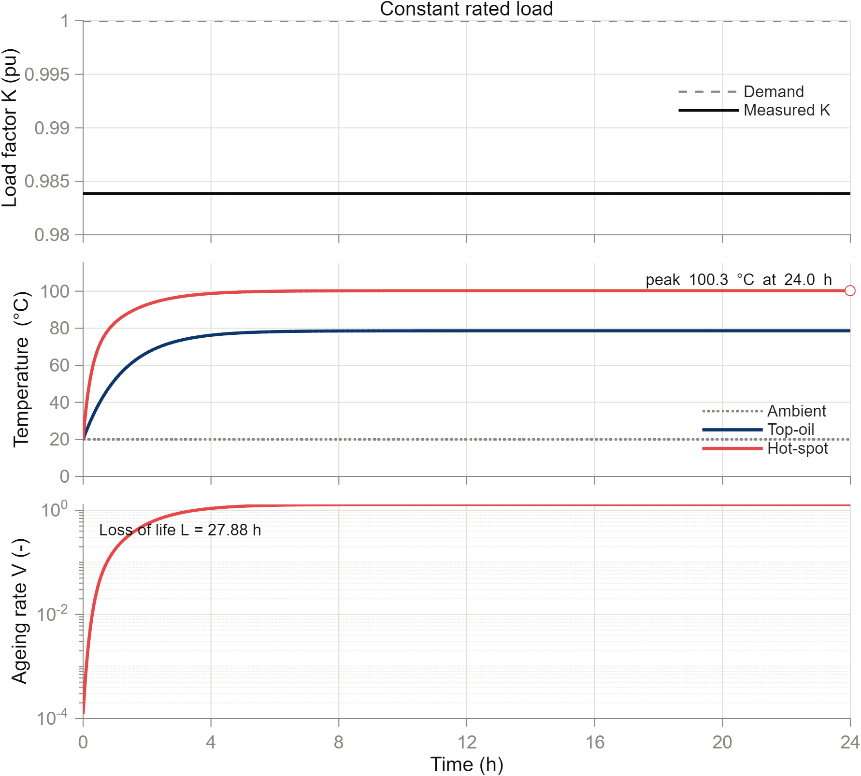

Figure 4.19b Operating scenario: daily load cycle (third day)
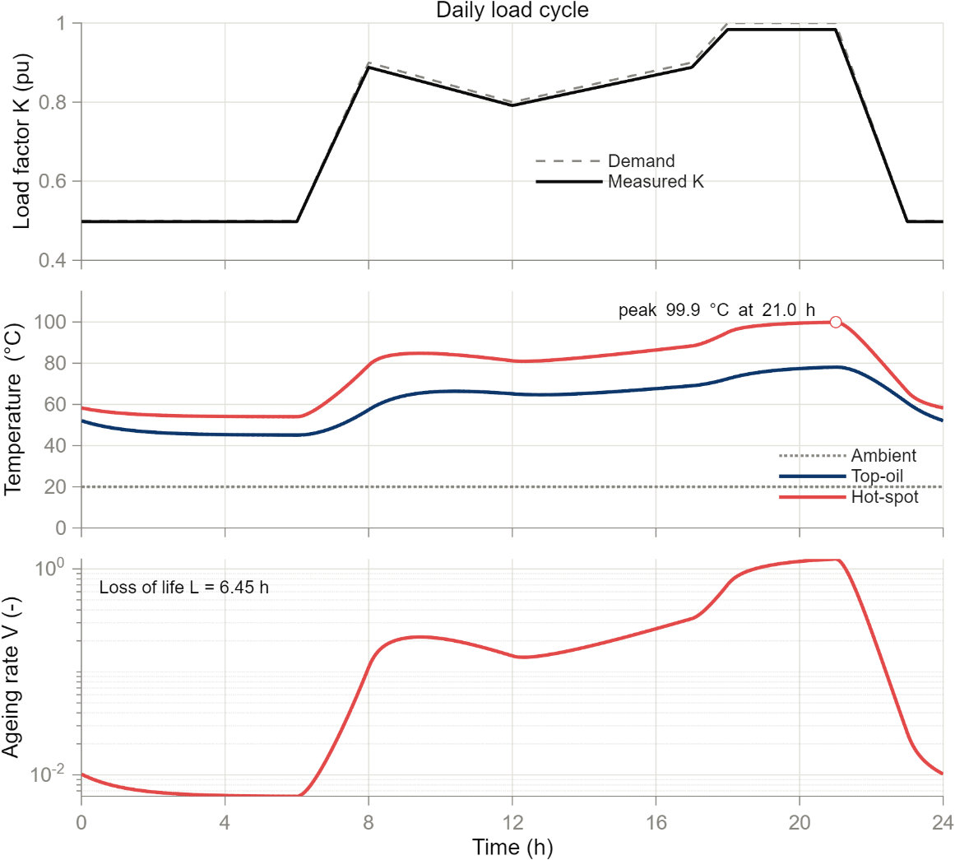

Figure 4.19c Operating scenario: short overload
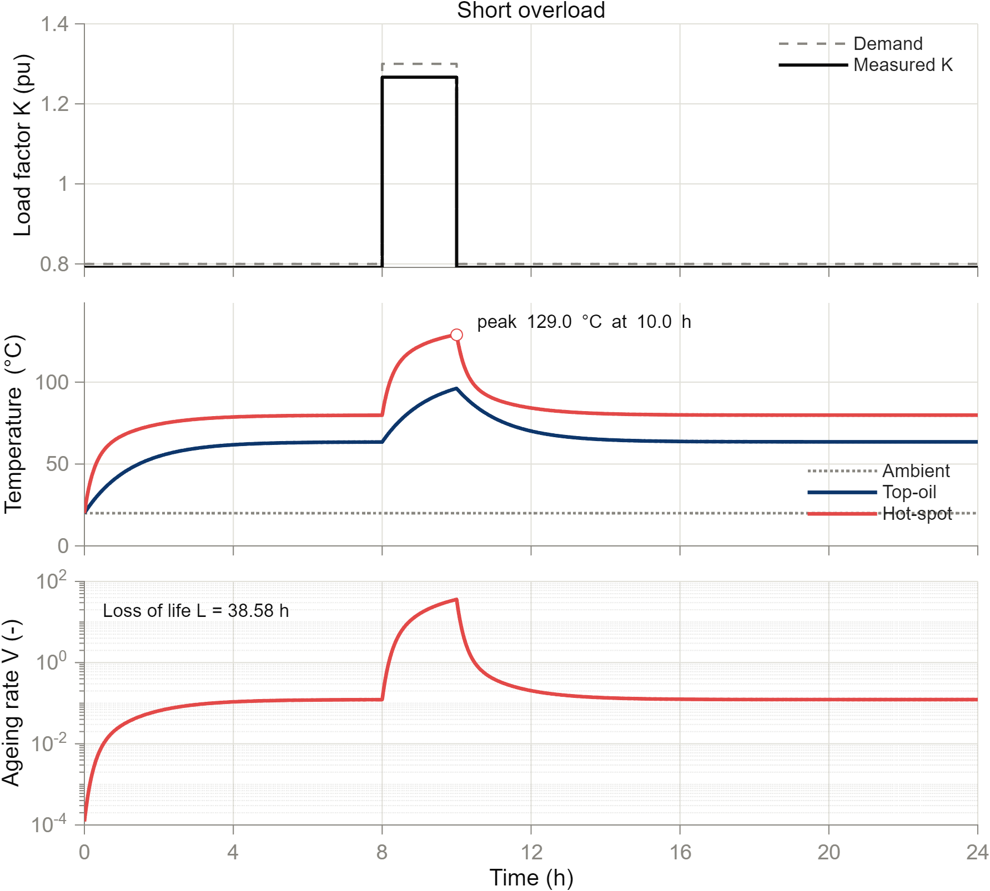
Each figure has three panels with a common time axis: the demanded and the measured load factor; the ambient, top-oil and hot-spot temperatures with the hot-spot peak marked; and the ageing rate on a logarithmic axis with the loss of life written in. The overload shows how steeply the ageing rate rises with the hot-spot temperature: during the two overload hours the ageing rate is several tens of times the reference rate, and after the overload it falls back within a few hours.

Reading the daily cycle
The hot-spot temperature follows the load with a delay set by the oil time constant (about 75 minutes for the top oil) and a much shorter one for the winding. The peak therefore occurs at the end of the evening peak load, not at its start. Day 3 and day 2 are identical to within 0.001 K, so the cycle has settled and the shown day does not depend on the cold start.

6. Checks
Check (run_step36.m) | Result
rated: two fresh runs are identical | PASS
rated: hot-spot >= top-oil >= ambient and V > 0 at all times | PASS
daily: two fresh runs are identical | PASS
daily: hot-spot >= top-oil >= ambient and V > 0 at all times | PASS
overload: two fresh runs are identical | PASS
overload: hot-spot >= top-oil >= ambient and V > 0 at all times | PASS
rated: saved sim_rated.mat equals a new run | PASS
daily: saved sim_daily.mat equals a new run | PASS
overload: saved sim_overload.mat equals a new run | PASS
model file unchanged by the runs (SHA-256) | PASS
rated: equals run_transformer_simulation of the default profile | PASS
rated: loss of life equals run_transformer_simulation (1e-9 h) | PASS
daily: day 3 and day 2 differ by less than 1 K in hot-spot temperature (cycle has settled; information) | PASS
The check 'day 3 and day 2 differ by less than 1 K' is information about the scenario, not a test of the model. The rated-load scenario gives exactly the signals and the loss of life of run_transformer_simulation, the default run of the model.

7. Problems and fixes
• In the first figures the peak label of the daily cycle ran outside the right edge and the loss-of-life label lay on the curve. The label positions and the temperature axis were changed and the figures were looked at again.
• A PowerShell edit left the characters backslash-n in a MATLAB line instead of a line break, so the program stopped with a syntax error; it was corrected by a direct edit and the program was run again.

8. Decisions
• D34: the three scenarios and their illustrative values (the researcher's 'proceed' to the proposal is taken as approval of the three scenarios and values); the 72 h run with the last day shown for the daily cycle; the checks; no standard limits applied.

9. Files produced
• 05_Simulink_Model/scenarios.m, run_step36.m, code_manifest_step36.sha256
• 05_Simulink_Model/results/sim_rated.mat, sim_daily.mat, sim_overload.mat, step36_scenario_definitions.csv, step36_scenario_summary.csv, step36_checks.csv, step36_sdi_session.mldatx
• 11_Results/figures/F4_19a_scenario_rated, F4_19b_scenario_daily, F4_19c_scenario_overload (.png, .pdf, .csv)

10. What was achieved
• Three operating scenarios were written in scenarios.m (decision D34) and simulated on the verified model; each run is stored in results/sim_<scenario>.mat and in a Simulation Data Inspector session.
• All 13 checks pass: every run is identical when repeated from a fresh start, the saved files equal new runs, the model file is unchanged, and the rated-load scenario equals the default run of the model.
• Peak hot-spot temperatures: 100.3 degC (rated load), 99.9 degC (daily cycle, at 21.0 h), 129.0 degC (overload, at 10.0 h). Loss of life in the shown 24 h: 27.88 h, 6.45 h and 38.58 h.
• Figure 4.19 (a, b, c) was produced, one figure per scenario.

11. Record of this step
Item | Record
Step | 36 - Run the operating scenarios
Environment | Claude Code (this chat) through the MATLAB MCP connection (roadmap role: Simulink Agentic Toolkit; D30)
Completed | 13 October 2026
Status | Done
Main inputs | Transformer_Operating_Model.slx; params_transformer.m; scenarios.m
Main outputs | results/sim_rated.mat, sim_daily.mat, sim_overload.mat; step36_*.csv; step36_sdi_session.mldatx; 11_Results/figures/F4_19a|b|c_*
Checks | verify: run_step36.m 13 of 13 checks PASS (runs repeatable to 0.00e+00; model file unchanged); peak hot-spot 100.3 / 99.9 / 129.0 degC
Decisions | D34 (the approved scenarios and how they are run and checked)

12. Data and sources used in this step
Every dataset, document and file this step used is listed below with its full reference, link and fingerprint (SHA-256, first 16 characters shown). Method references are listed in the 'Method used' section. The complete record, with access dates, licences and full fingerprints, is the Data and Source Register (00_Project_Admin/Step_Reports/Data_and_Source_Register.docx and 03_Data/provenance/data_and_source_register.csv).
ID | Reference and use in the project | Link, DOI and local file
ST6 | IEC 60076-7:2018, Power transformers - Part 7: Loading guide for mineral-oil-immersed power transformers (Edition 2.0). The full text was NOT obtained; details TO VERIFY. Use: Basis of the top-oil and hot-spot differential equations in SS5-SS7; the thermal constants of params_transformer.m must be checked against it (TO VERIFY).
SW4 | Alliander N.V., transformer-thermal-model (IEC 60076-7 implementation, MPL-2.0), file transformer_thermal_model/transformer/power.py, class PowerTransformer, ONAF default specifications (source T1 of the Build Guide). Use: Default thermal constants of params_transformer.m (dTheta_or, g_r, H, tau_o, tau_w, k11, k21, k22, x, y) and the form of the thermal differential equations. | https://github.com/alliander-opensource/transformer-thermal-model
DF48 | Transformer_Operating_Model.slx, built in Step 33 by build_Transformer_Operating_Model.m from the MATLAB Build Guide Part B (decisions D30, D31); MATLAB R2025b. Use: Operating-context model: load, current, oil and hot-spot temperature, ageing. Never generates gas values (D4).. | File: 05_Simulink_Model/Transformer_Operating_Model.slx; SHA-256 FB5422C605F266DF...
DF52 | All parameters of the transformer operating model with unit and source (E1 pandapower, T1 Alliander). Step 33 added the constant T_zero_C_in_K = 273.15 K. Use: The only place where model values are defined; read by the model callbacks. | File: 05_Simulink_Model/params_transformer.m; SHA-256 9288320B6672E1A1...
DF64 | sim_rated.mat, sim_daily.mat, sim_overload.mat written by run_step36.m from Transformer_Operating_Model.slx and scenarios.m (decision D34): time, demand, measured K, ambient, top-oil, hot-spot, ageing rate, loss of life, peak. Use: Operating context for the dashboard and Figure 4.19; no diagnosis use. | File: 05_Simulink_Model/results/sim_rated.mat; SHA-256 5A7923B6607F9E41...
DF65 | step36_scenario_definitions.csv (demand breakpoints), step36_scenario_summary.csv (peak hot-spot and time, loss of life L), step36_checks.csv (13 checks). Use: Evidence for the Step 36 check 'each run can be reproduced'. | File: 05_Simulink_Model/results/step36_scenario_summary.csv; SHA-256 A564940F9137E9E0...
DF66 | Three panels each (load factor; ambient, top-oil and hot-spot temperature; ageing rate on a log axis with the loss of life); colours from plot_style.csv. .pdf and .csv (plotted numbers) beside each .png. Use: Figure 4.19 of the thesis. | File: 11_Results/figures/F4_19a_scenario_rated.png; SHA-256 AD3C76ADD2AAF9E1...
DF67 | The three scenario runs (K_pu, theta_oil_C, theta_hs_C, ageing_rate_V) saved with Simulink.sdi.save. Use: SDI log required by the roadmap. | File: 05_Simulink_Model/results/step36_sdi_session.mldatx; SHA-256 E29EC9E7E2BE20DA...
DF68 | scenarios.m (the three scenario definitions) and run_step36.m (runs, checks, figures). Use: Fingerprints of the Step 36 code. | File: 05_Simulink_Model/code_manifest_step36.sha256; SHA-256 0D3BFA7108D51C43...

13. How this helps the next steps
Next step: Step 37 (Simulink): add a DGA sampling-event subsystem that outputs the record_id of the next real held-out record at the sampling times set in params_transformer.m; it must never produce a gas value (inspection plus a test).
• Step 37 adds the DGA sampling-event subsystem to the model. The runs of this step can be repeated afterwards (run_step36.m) to show that the temperatures and ageing did not change, and Step 37's own test must show that no block produces a gas value.
• The dashboard (Stage H) calls the model for an operating context; these three scenarios give it ready examples and show what it will plot.
• Chapter 3 can describe the operating-context model with Figure 3.4 (structure), Table 4.10 and Figure 4.18 (verification) and Figure 4.19 (scenarios).

14. Open items and limitations
• The scenario values (0.5 to 1.0 per unit daily cycle; 0.8 per unit with 1.3 per unit for 2 hours) are illustrative choices of this project, not measured load data. Replace them with real utility load curves if the Ghanaian utility records requested through the supervisor arrive; only scenarios.m changes.
• The peak hot-spot temperature of the overload scenario is reported without a limit because IEC 60076-7:2018, which gives the permitted temperatures, was not obtained (TO VERIFY). Do not describe the overload as safe or unsafe in the thesis without that standard.
• The thermal constants are default values of an open-source implementation (TO VERIFY against IEC 60076-7:2018), unchanged since Step 33.
• The measured load factor is lower than the demanded one (for example 1.267 for a demand of 1.3) because the load sits behind the transformer impedance; the figures show both.
• The .mat files and the Simulation Data Inspector session are binary files whose hashes change with every save; reproducibility is tested on the signals.
• The researcher's error text from the earlier Simulink rerun has still not been supplied.

15. Abbreviations and terms used in this report
Every abbreviation and technical term that appears in this report is explained below. The fault types follow the definitions of IEC 60599 (clause 5.2). The full list for the whole project is kept in 00_Project_Admin/abbreviations_glossary.csv.
Abbreviation or term | Meaning | Plain explanation
MPhil | Master of Philosophy | The research degree this thesis is written for.
UMaT | University of Mines and Technology, Tarkwa | The university where the thesis is submitted.
DGA | Dissolved Gas Analysis | Measuring the gases dissolved in transformer oil to find faults inside the transformer without opening it.
ppm | parts per million | Amount of gas in the oil; 1 ppm = 1 microlitre of gas in 1 litre of oil.
H2 | hydrogen | Gas formed mainly by partial discharges (low-energy electrical activity) in the oil.
PD | partial discharges | Small electrical discharges that only partly bridge the insulation (corona type, can form X-wax, or small sparking punctures in paper).
D1 | discharges of low energy | Sparking or tracking: larger punctures in paper, carbonised paper surface or carbon particles in oil.
T1 | thermal fault below 300 °C | Overheating in which the paper has turned brownish.
IEC | International Electrotechnical Commission | The world body that publishes electrical standards, such as IEC 60599.
Inspection-based label | fault confirmed by opening the equipment | The fault type was seen by engineers after the unit was opened, not guessed from the gases.
SHA-256 | Secure Hash Algorithm, 256-bit | A file's digital fingerprint: if one byte of the file changes, the fingerprint changes.
Log scale | logarithmic axis | Each step on the axis is ten times the previous one, so very small and very large values fit on one chart.
CSV | comma-separated values | A plain-text table file that any program can read.
docx | Microsoft Word document | The format of these reports.
MATLAB | MATLAB (MathWorks) | Numerical programming environment; used for the conventional methods and the dashboard (MATLAB Agentic Toolkit).
Simulink, Simscape | MATLAB's block-diagram modelling tool and its physical-modelling library | Used to model the transformer's operating conditions (Simulink Agentic Toolkit); it never makes gas values.
D1-D33 (decisions) | numbered project decisions | Decisions recorded in 00_Project_Admin/decisions_log.md; not the same as the fault codes D1 and D2.
Roadmap | the 45-step project plan | Project_Roadmap.docx: every step, its environment and its outputs, done strictly in order.
TO VERIFY | not yet checked against the original source | Marks any value or fact that must still be confirmed before final use.
ND (no diagnosis) | No diagnosis | The answer of a method when no rule applies or a ratio it needs cannot be calculated. It is a result and is never deleted.
NaN (not measured) | Not a Number, used here for a gas that was not measured | A marker for a missing value. It is different from 0 ppm: 0 ppm means the gas was measured and not found, NaN means nobody measured it, so no ratio or percentage can be calculated from it.
Tolerance (delta) | largest acceptable loss | Fixed before the study at 0.05 macro-F1 (5 percentage points), approved in Step 4.
Simulink | MathWorks block-diagram simulation environment | Software in which the model is drawn as blocks and lines and simulated over time.
Simscape | Physical modelling extension of Simulink | Blocks that follow physical laws (electrical, thermal) and connect like real components, not like signals.
Subsystem (SS1-SS7) | A group of blocks shown as one block | The model is split into seven subsystems: grid, transformer, measurement, load, losses to heat, thermal network, outputs and ageing.
Top-oil temperature | Temperature of the oil at the top of the tank | The oil temperature used in the thermal model; it rises with load and falls back towards ambient.
Hot-spot temperature | Temperature of the hottest part of the winding | The winding temperature that mostly decides how fast the paper insulation ages; it is the top-oil temperature plus a load-dependent rise.
Load factor K | Load current divided by rated current | K = 1 means the transformer carries its rated current; K = 0.5 means half of it.
Relative ageing rate V | How many times faster than normal the paper ages | V = 1 at the reference hot-spot temperature (98 degC); every 6 K more doubles it. The loss of life is the sum of V over time.
per unit (pu) | Value divided by its rated value | A way of writing quantities so that 1.0 means rated, e.g. a current of 1.0 pu is the rated current.
IEC 60076-7 | IEC loading guide for oil-immersed power transformers | The standard that gives the equations for oil and hot-spot temperature and for ageing under a changing load.
Loss of life (L) | Equivalent hours of insulation ageing at the reference hot-spot temperature | The sum of the ageing rate over time: L = 24 h would mean the insulation aged as much as in 24 hours at 98 degC.
Overload | Load above rated current | A load factor above 1.0 per unit; the hot spot heats quickly and the ageing rate rises steeply.
Operating scenario | A chosen load history used to run the model | An illustrative example of how the transformer is loaded over time (constant, daily cycle, overload); it is not measured data.
Simulation Data Inspector (SDI) | MathWorks tool that stores and compares logged simulation signals | A viewer in which the signals of each run are kept, so runs can be compared or saved as a session file.

