Step 41 Report
Run the end-to-end test bench
Environment: Claude Code (this chat), MATLAB and Simulink through the MCP connection | Completed: 13 October 2026 | Report version 1 (13 October 2026)
Thesis: Intelligent Power Transformer Fault Diagnosis Using Dissolved Gas Analysis and Machine Learning (MPhil, UMaT)
Abbreviations (such as PD, D1, T1, ppm) and technical terms are explained in the last section of this report.
In short: The whole framework was run once over every held-out record: the Simulink transformer model produced one sampling event every 15 minutes (388 events), and at each event the dashboard functions found the record, computed the Rogers, IEC 60599 and Duval diagnoses in MATLAB, and obtained the ML class and probabilities from the FastAPI service. The result is a log with 388 rows, one per record, and no failed call. The response time of the service call was 78.6 ms (median) and 95.5 ms (95th percentile) on the project laptop, including the first calls. All 12 checks pass. The comparison of the log with the offline predictions (fidelity) and the formal response-time statistics are the work of Step 42. Figure 4.20 shows the run.

1. Purpose of this step
The test bench shows that the parts of the framework work together on the whole held-out set, not only on a few examples, and it produces the log from which Step 42 computes fidelity and response time.

2. Method used

Approach
The test bench runs the whole framework once over every held-out record. The unchanged Simulink transformer model is simulated for 98 hours with one sampling event every 15 minutes, which gives one event for each of the 388 held-out records. At each event, in time order, the bench does what the dashboard does with a record: it finds the record in the DGA file, reads the five gases, computes the three conventional diagnoses in MATLAB, sends the gases to the FastAPI service and receives the ML class and the seven class probabilities, and works out how many conventional methods agree with ML.
Everything is logged, one row per record: the event time, the record, its data role, the gases as read, the three conventional answers, the ML class and probabilities, the model name, version and hash, the agreement, the simulated hot-spot temperature at the event, and three times. The response time is the time between sending the request and receiving the answer (Analysis Plan Section 10), measured around the web call on the project laptop. No true label is read or written.
The bench does not compare the answers with the offline predictions and does not compute statistics: that is Step 42. Here the checks are about the run itself: one row per record, no failed call, the events at the planned times, the same model before and after, and no label in the log (decision D39).

Why this method
• Step 42 needs a complete log of the integrated system to compute fidelity and response time; this step produces it under controlled conditions that are written down before the run (D39).
• Driving the records through the simulated sampling events keeps the model in the loop as designed in Steps 37 and 40, so the bench tests the same chain as the dashboard and not a shortcut.
• Logging every call, including the first five (warm-up), and every failure, means that nothing is selected after the fact.

Settings and rules
Setting | Value
Records | all 388 held-out records of dga_master.csv in file order: benchmark 117, internal_test 70, external_test 201
Sampling events | one every 15 min from 0.25 h to 97 h; simulation stop time 98 h (set for this run only; the model is unchanged)
Service | http://127.0.0.1:8000/diagnose on this computer; timeout 10 s
Response time | tic/toc around the web call (send request to receive answer), in ms; first 5 calls flagged warmup
Computer | project laptop: AMD64 Family 23 Model 24 Stepping 1, AuthenticAMD, 8 logical processors
Software | MATLAB 25.2.0.2998904 (R2025b), Simulink, Simscape; service: FastAPI (Step 38)

Tools and programs
• 10_Dashboard_Client/run_testbench.m (the bench), verify_step41.m (12 checks), tools/make_figure_4_20.m (Figure 4.20)
• 10_Dashboard_Client/find_dga_row.m, load_dga_record.m, ml_diagnose.m, dga_agreement.m (as in the dashboard)
• 05_Simulink_Model/get_sampling_events.m; 04_MATLAB_Conventional/conventional_diagnosis.m
• 00_Project_Admin/report_builder/update_register_step41.ps1 (register, glossary)

Method references
[ST6] IEC 60076-7:2018, Power transformers - Part 7: Loading guide for mineral-oil-immersed power transformers (Edition 2.0). The full text was NOT obtained; details TO VERIFY.
[SW4] Alliander N.V., transformer-thermal-model (IEC 60076-7 implementation, MPL-2.0), file transformer_thermal_model/transformer/power.py, class PowerTransformer, ONAF default specifications (source T1 of the Build Guide). https://github.com/alliander-opensource/transformer-thermal-model
[DF2] Made in Step 9 from DS1-DS5 (Steps 5-9 programs).

3. What was used
• The unchanged model Transformer_Operating_Model.slx with the sampling-event subsystem SS8 (Step 37).
• The dashboard functions of Steps 39 and 40 (find_dga_row, load_dga_record, conventional_diagnosis, ml_diagnose, dga_agreement) and the FastAPI service of Step 38.
• dga_master.csv: the 388 records whose role is not development.

4. What was done, step by step
1. Fixed the scope, the schedule, the definition of the response time, the log columns and the checks in the decision log (D39) before running.
2. Wrote run_testbench.m. A first test showed that the model can give 388 events when only the sample times and the stop time are set for the run: the model was not changed.
3. Ran the bench with the service running: simulation 9.5 s, the 388 records 196 s.
4. Wrote verify_step41.m (12 checks) and tools/make_figure_4_20.m; ran both.
5. Wrote this report and updated the register, glossary, READMEs, CHANGELOG.md and SESSION_SUMMARY.md.

5. What we found

The log
Data role | Records | Failed calls | Median response (ms) | 95th percentile (ms) | All three methods agree with ML
benchmark | 117 | 0 | 78.5 | 88.3 | 50
internal_test | 70 | 0 | 79.0 | 95.7 | 19
external_test | 201 | 0 | 78.9 | 97.0 | 71
All held-out | 388 | 0 | 78.6 | 95.5 | 140
The columns of the log are listed in decision D39. Every record was answered (status OK). The times are those of all calls, including the first five; they are descriptive. In 140 of the 388 records all three conventional methods give the same class as ML, and in 248 they do not; this is a count of the log, not a measure of accuracy: no label was used.

Figure 4.20
Figure 4.20 The test-bench run: simulated temperatures with the 388 sampling events, the ML class of the record taken at each event, and the number of conventional methods that agree with ML
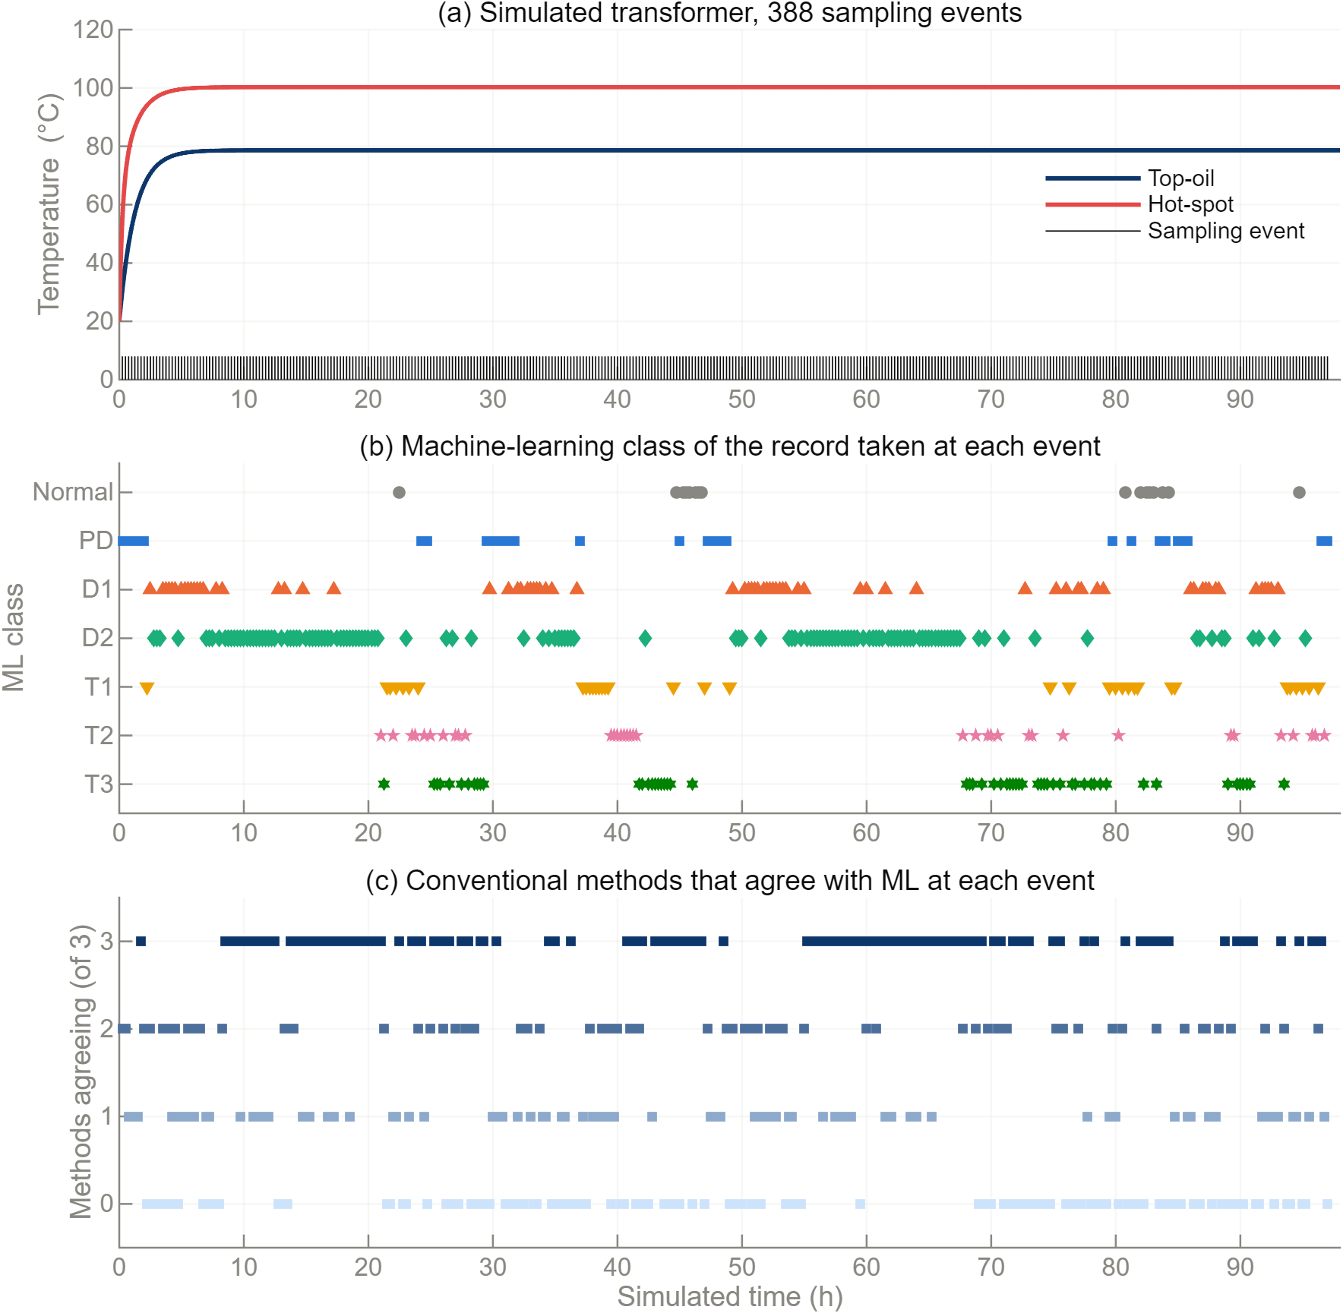
Panel (a) shows the clock of the bench: the simulated transformer reaches its steady temperatures within a few hours and the events follow every 15 minutes. Panel (b) shows the ML class of each record; its pattern follows the order of the records in the file (neighbouring records come from the same source and class), not time. Panel (c) shows how many of the three conventional methods agree with ML for each record.

6. Checks
Check (verify_step41.m) | Result
one log row per held-out record, in file order, no record twice | PASS
data_role in the log equals the role in dga_master.csv (benchmark 117, internal_test 70, external_test 201) | PASS
sampling events at the bench schedule (record k at k x 15 min), in order | PASS
no failed calls: every status OK, no error text | PASS
every row has the ML class, seven probabilities that sum to 1, the confidence, and the three conventional answers | PASS
response, conventional and total times are present, positive, and total >= response | PASS
the first 5 calls (and only they) are marked as warm-up | PASS
the gas values in the log are those of the file rows (read, never created) | PASS
service healthy before and after; the model hash is the same in both, in every row, and equals the saved model of Step 22 | PASS
the model file is unchanged by the bench (checksum before = after) | PASS
the log holds no true label of any record | PASS
agreement count 0 to 3 and state consistent (green only when all three agree) | PASS

7. Problems and fixes
• The roadmap names only the internal-test and benchmark records in one line and every held-out record in others; all 388 were run and the data role was logged (D39). This needs the researcher's confirmation.
• The first run of the verification script stopped on two coding errors in the script itself (an empty column and a version number were read as numbers instead of text); the log was not changed.
• The conventional diagnosis in MATLAB takes much longer than the service call (a median of several hundred milliseconds against about 80 ms). This was not investigated; it does not affect the response time of the service.

8. Decisions
• D39: all 388 held-out records; a sampling event every 15 minutes in the unchanged model; the same functions as the dashboard; the definition of the response time; one log row per record; the checks; Figure 4.20.

9. Files produced
• 10_Dashboard_Client/run_testbench.m, verify_step41.m, tools/make_figure_4_20.m, code_manifest_step41.sha256
• 10_Dashboard_Client/logs/testbench_log.csv, testbench_run_info.json, testbench_events.mat; 10_Dashboard_Client/results/step41_checks.csv
• 11_Results/figures/F4_20_testbench_run.png, .pdf and .csv (the plotted numbers)

10. What was achieved
• The integrated system was run over all 388 held-out records: 388 log rows, 0 failed calls (decision D39).
• All 12 checks pass: one row per record in file order, the events at the planned times, the same model hash before and after, no label in the log.
• The response time of the service call was 78.6 ms (median) and 95.5 ms (95th percentile) on the project laptop, all calls included; the formal statistics and Figure 4.21 are made in Step 42.
• Figure 4.20 (the test-bench run) was produced; the log is 10_Dashboard_Client/logs/testbench_log.csv.

11. Record of this step
Item | Record
Step | 41 - Run the end-to-end test bench
Environment | Claude Code (this chat) through the MATLAB MCP connection (roadmap role: MATLAB Agentic Toolkit; D30)
Completed | 13 October 2026
Status | Done
Main inputs | Transformer_Operating_Model.slx (unchanged); the running service; dga_master.csv (held-out records)
Main outputs | 10_Dashboard_Client/logs/testbench_log.csv, testbench_run_info.json, testbench_events.mat; results/step41_checks.csv; 11_Results/figures/F4_20_testbench_run.(png|pdf|csv)
Checks | verify_step41.m: 12 of 12 checks PASS; 388 rows, 0 failed calls; response time median 78.6 ms, 95th percentile 95.5 ms (all calls)
Decisions | D39 (scope, schedule, response-time definition, log columns, checks)

12. Data and sources used in this step
Every dataset, document and file this step used is listed below with its full reference, link and fingerprint (SHA-256, first 16 characters shown). Method references are listed in the 'Method used' section. The complete record, with access dates, licences and full fingerprints, is the Data and Source Register (00_Project_Admin/Step_Reports/Data_and_Source_Register.docx and 03_Data/provenance/data_and_source_register.csv).
ID | Reference and use in the project | Link, DOI and local file
ST6 | IEC 60076-7:2018, Power transformers - Part 7: Loading guide for mineral-oil-immersed power transformers (Edition 2.0). The full text was NOT obtained; details TO VERIFY. Use: Basis of the top-oil and hot-spot differential equations in SS5-SS7; the thermal constants of params_transformer.m must be checked against it (TO VERIFY).
SW4 | Alliander N.V., transformer-thermal-model (IEC 60076-7 implementation, MPL-2.0), file transformer_thermal_model/transformer/power.py, class PowerTransformer, ONAF default specifications (source T1 of the Build Guide). Use: Default thermal constants of params_transformer.m (dTheta_or, g_r, H, tau_o, tau_w, k11, k21, k22, x, y) and the form of the thermal differential equations. | https://github.com/alliander-opensource/transformer-thermal-model
DF2 | Made in Step 9 from DS1-DS5 (Steps 5-9 programs). Use: All clean records with role, class, flags and original values. | File: 03_Data/processed/dga_master.csv; SHA-256 AE9E6C0C84CF7180...
DF48 | Transformer_Operating_Model.slx, built in Step 33 by build_Transformer_Operating_Model.m from the MATLAB Build Guide Part B (decisions D30, D31); MATLAB R2025b. Use: Operating-context model: load, current, oil and hot-spot temperature, ageing. Never generates gas values (D4).. | File: 05_Simulink_Model/Transformer_Operating_Model.slx; SHA-256 FB5422C605F266DF...
DF52 | All parameters of the transformer operating model with unit and source (E1 pandapower, T1 Alliander). Step 33 added the constant T_zero_C_in_K = 273.15 K. Use: The only place where model values are defined; read by the model callbacks. | File: 05_Simulink_Model/params_transformer.m; SHA-256 9288320B6672E1A1...
DF76 | testbench_log.csv: one row per held-out record (388): event, simulated time, record_id, data_role, gases as read, Rogers / IEC 60599 / Duval answers, ML status, class, 7 probabilities, confidence, model name/version/hash, agreement, simulated hot-spot, response time, conventional time, total time, warm-up flag. No true label. testbench_run_info.json: run conditions (service health and model hash before/after, schedule, machine). Use: Input of Step 42 (fidelity, response time; Table 4.11, Figure 4.21). | File: 10_Dashboard_Client/logs/testbench_log.csv; SHA-256 5CA244E1635B9169...
DF77 | step41_checks.csv (12 checks of verify_step41.m) and the events file testbench_events.mat used for Figure 4.20. Use: Evidence for the Step 41 check: one log row per record, no failed calls. | File: 10_Dashboard_Client/results/step41_checks.csv; SHA-256 0C79EDBCB4B80EBF...
DF78 | run_testbench.m, verify_step41.m, tools/make_figure_4_20.m. Use: Fingerprints of the Step 41 code. | File: 10_Dashboard_Client/code_manifest_step41.sha256; SHA-256 CFD3D3F950C7FF22...

13. How this helps the next steps
Next step: Step 42 (Claude Code): compare testbench_log.csv with ml_predictions.csv and conventional_predictions.csv (fidelity must be 100 %); compute the median and 95th-percentile response times; write Table 4.11, Figure 4.21 and an integration report.
• Step 42 compares this log with ml_predictions.csv and conventional_predictions.csv (fidelity, which must be 100 %) and computes the median and 95th-percentile response times for Table 4.11 and Figure 4.21.
• The log carries the data role of every record, so the internal-test and benchmark records named in the roadmap can be analysed on their own by filtering.

14. Open items and limitations
• The roadmap names only the records of role internal test or benchmark in its instruction line, but asks for every held-out record in its output and check, and the Analysis Plan (Section 10) asks for all test records. All 388 were run (D39); the external-test records were already opened for the ML predictions on 12 October 2026 and no label is read. The researcher may restrict the analysis to the 187 internal-test and benchmark records by filtering data_role.
• The sampling schedule (15 min) is a choice of this bench; the 98-hour run is not a realistic operating period. The simulated temperature is almost constant after the first hours (rated load), so panel (a) of Figure 4.20 shows the clock of the bench rather than a load story.
• The pattern of classes along the time axis in Figure 4.20 (b) reflects the order of the records in the file (records of the same source and class are neighbours), not any property of time.
• The response time measured here is the round trip of the web call as seen from MATLAB; it includes the conversion of the request and the answer. The whole record takes longer (median 469 ms), of which the conventional diagnosis in MATLAB takes a median of 277 ms and the rest is reading the file; the reason for the 277 ms was not investigated. These times are logged but are not the response time of the service.
• The bench calls the same functions as the dashboard, without the plots; the dashboard itself was tested on four events in Step 40.
• The researcher's error text from the earlier Simulink rerun has still not been supplied.

15. Abbreviations and terms used in this report
Every abbreviation and technical term that appears in this report is explained below. The fault types follow the definitions of IEC 60599 (clause 5.2). The full list for the whole project is kept in 00_Project_Admin/abbreviations_glossary.csv.
Abbreviation or term | Meaning | Plain explanation
MPhil | Master of Philosophy | The research degree this thesis is written for.
UMaT | University of Mines and Technology, Tarkwa | The university where the thesis is submitted.
DGA | Dissolved Gas Analysis | Measuring the gases dissolved in transformer oil to find faults inside the transformer without opening it.
ppm | parts per million | Amount of gas in the oil; 1 ppm = 1 microlitre of gas in 1 litre of oil.
H2 | hydrogen | Gas formed mainly by partial discharges (low-energy electrical activity) in the oil.
PD | partial discharges | Small electrical discharges that only partly bridge the insulation (corona type, can form X-wax, or small sparking punctures in paper).
D1 | discharges of low energy | Sparking or tracking: larger punctures in paper, carbonised paper surface or carbon particles in oil.
T1 | thermal fault below 300 °C | Overheating in which the paper has turned brownish.
IEC | International Electrotechnical Commission | The world body that publishes electrical standards, such as IEC 60599.
IEC 60599 | IEC guide to the interpretation of dissolved and free gas analysis | The international standard that defines the fault types and the IEC gas-ratio method.
Rogers ratios | older gas-ratio method by R.R. Rogers | A ratio table that names faults from three gas ratios; kept in IEEE C57.104.
ML | machine learning | Computer methods that learn the link between gas values and fault type from labelled examples.
Benchmark | fixed reference test set | The IEC TC 10 cases whose faults were confirmed by inspection; every method is scored on them.
Training (development) set | records used to build the models | 439 clean records from the Dissanayake training file.
Internal test set | Dissanayake unseen test file | 70 records (61 independent of the benchmark) kept away from training.
SHA-256 | Secure Hash Algorithm, 256-bit | A file's digital fingerprint: if one byte of the file changes, the fingerprint changes.
Median, quartiles | middle value and the values a quarter and three quarters of the way up | Describe typical gas levels without being pulled by extreme values.
CSV | comma-separated values | A plain-text table file that any program can read.
docx | Microsoft Word document | The format of these reports.
MATLAB | MATLAB (MathWorks) | Numerical programming environment; used for the conventional methods and the dashboard (MATLAB Agentic Toolkit).
Simulink, Simscape | MATLAB's block-diagram modelling tool and its physical-modelling library | Used to model the transformer's operating conditions (Simulink Agentic Toolkit); it never makes gas values.
D1-D39 (decisions) | numbered project decisions | Decisions recorded in 00_Project_Admin/decisions_log.md; not the same as the fault codes D1 and D2.
Roadmap | the 45-step project plan | Project_Roadmap.docx: every step, its environment and its outputs, done strictly in order.
Analysis Plan | Expected Results and Analysis Plan | The approved document that fixes the measures, tests, tables and figures before results are seen.
TO VERIFY | not yet checked against the original source | Marks any value or fact that must still be confirmed before final use.
Class probability | model's confidence in each class | For every record the model gives a probability for each of the seven classes; they add up to 1 and the largest is the prediction.
Simulink | MathWorks block-diagram simulation environment | Software in which the model is drawn as blocks and lines and simulated over time.
Simscape | Physical modelling extension of Simulink | Blocks that follow physical laws (electrical, thermal) and connect like real components, not like signals.
Subsystem (SS1-SS7) | A group of blocks shown as one block | The model is split into seven subsystems: grid, transformer, measurement, load, losses to heat, thermal network, outputs and ageing.
Top-oil temperature | Temperature of the oil at the top of the tank | The oil temperature used in the thermal model; it rises with load and falls back towards ambient.
Hot-spot temperature | Temperature of the hottest part of the winding | The winding temperature that mostly decides how fast the paper insulation ages; it is the top-oil temperature plus a load-dependent rise.
Relative ageing rate V | How many times faster than normal the paper ages | V = 1 at the reference hot-spot temperature (98 degC); every 6 K more doubles it. The loss of life is the sum of V over time.
IEC 60076-7 | IEC loading guide for oil-immersed power transformers | The standard that gives the equations for oil and hot-spot temperature and for ageing under a changing load.
Sampling event | A moment in simulated time at which a gas sample would be taken | The model only says when; the gas values come from the real measured record in the data file, never from the model.
Held-out record | A record of the master table that is not used for development | A record kept aside (benchmark, internal test or external test) so that the methods are judged on data they did not learn from.
FastAPI | Python framework for web services | The library used to build the diagnosis service; it also checks every input against the declared rules.
Endpoint | one address of a web service | For example POST /diagnose (send a sample, get a diagnosis) or GET /health (is the service alive?).
127.0.0.1 (localhost) | the address of the computer itself | A service on 127.0.0.1 can be reached only from the same computer, not from the network.
95th percentile (p95) | the value below which 95 % of the measurements lie | Used for the response time: 95 of every 100 requests are answered at least this fast.
Fidelity | share of records for which the service gives exactly the offline answer | F = matches / records sent (Analysis Plan Eq. 47); the requirement is 100 %.
Test bench | A programme that runs the whole framework over many records and logs the results | The simulated transformer, the dashboard functions and the service are run together over all held-out records; every answer and time is written to a log file.
Warm-up call | One of the first calls to the service, which can be slower than the later ones | The first few requests set up the connection; they are flagged in the log so that they can be excluded or kept openly.
Response time | Time between sending a request to the service and receiving the answer | How long the engineer waits for the ML diagnosis; reported as the median and the 95th percentile.

