Reconstructing the Ur III Grain Economy from 135,000 Cuneiform Tablets:
A Rule-Based Extraction Pipeline and Exploratory Analysis
A computational study of the CDLI Ur III administrative corpus (c. 2100–2000 BCE)
Daniel Asaro
Computational Assyriology · asarodan/sumer
Abstract
The Third Dynasty of Ur (Ur III, c. 2112–2004 BCE) produced one of the most
densely documented administrative economies of the ancient world. We present a
deterministic, rule-based pipeline that parses the full Cuneiform Digital
Library Initiative (CDLI) bulk export of135,199 Ur III tabletsin transliterated ATF form and extracts220,034 quantified economic
transactionsacross nine commodity classes, together with a hierarchical
record structure (72,119 records, 242,381 line-entries) and a prosopographic
index of 32,493 named agents. Converting the Sumerian sexagesimal capacity
system to a common unit, the corpus accounts for2.275 million
gurof cereal grain (on the order of 400,000 metric tonnes),
of which barley alone constitutes 1.957 milliongur(86% of all
capacity-measured volume). Exploratory data analysis shows that transaction
sizes are approximately log-normal in their body (median = 300 sila₃ =
1gur) with an extreme heavy tail: the largest 1% of transactions carry
over half of all volume. A barley-flow network of 1,894 agents reveals a single
dominant component organised around provincial household managers
(šabra) acting as brokers and the royal granary as principal
sink. We give particular attention to themethodology of false-positive
control: the chief technical difficulty in mass cuneiform extraction is not
parsing grain lines but distinguishing them from the orthographically identical
lines that record onions, reed bundles, livestock, silver, and balance
carry-forwards. We document a corpus of 120 filtering rules, validated by 144
regression tests, that reduced spurious grain volume by roughly 0.96 milliongur(26%) relative to a naïve baseline.
Keywords: Ur III, computational Assyriology, information
extraction, economic history, cuneiform, ATF, network analysis, log-normal distribution
1. Introduction
The Ur III state bequeathed posterity an administrative habit of almost
pathological thoroughness. Scribes recorded the issue of a single sheep, the
seed-grain for a field, the beer ration of a messenger, and the annual balance
of a granary on small clay tablets, tens of thousands of which survive. The
Cuneiform Digital Library Initiative (CDLI) has transliterated this material
into the machine-readable ATF (ASCII Transliteration Format) standard, creating
an opportunity to study an ancient economy at a transaction-level granularity
that is unavailable for any other period before the late medieval era.
Yet the corpus resists naïve quantification. A line such as2(aš) gurdenotes twogurof barley; the
visually parallel2(aš) sa gidenotes two bundles of reed,
and2(aš) gu₄two head of cattle. The same numeral
classifiers, the same sexagesimal place-values, and the same scribal hand
serve grain, garlic, silver, and labour alike. A parser that simply harvests
every numeral followed by a capacity unit over-counts grain by hundreds of
thousands ofgur. The central methodological claim of this paper is
thatreliable extraction is dominated by the problem of negative
classification—of knowing what isnotgrain—and that this problem
is tractable with a disciplined, test-driven body of linguistic rules.
We make three contributions. First, a complete and reproducible extraction
pipeline (§3) that turns raw ATF into typed, dated, attributed transactions.
Second, an exploratory statistical portrait of the Ur III grain economy (§4–§5)
covering volume, concentration, temporality, and exchange structure. Third, an
explicit account of the false-positive-control methodology (§6) that we believe
generalises to other mass-extraction efforts on noisy historical corpora.
2. The Corpus and the Measurement System
Our source is the CDLI bulk ATF export, comprising 135,199 tablets
classified as Ur III. Each tablet is a sequence of transliterated lines
organised by surface (@obverse,@reverse) and column,
with editorial markers for damage ([…]), uncertain readings
(?,!), and determinatives ({d}divine,{ki}place,{gesz}wood).
Capacity is recorded in the Sumerian sexagesimal grain system. The base unit
is thesila₃(≈1 litre); the principal accounting unit is
thegur= 300sila₃. Larger granary quantities use a
nested sexagesimal scaffold (Table 1). Because these tokens multiply the gur by
factors up to 216,000, a single mis-classified large-denomination line can
inject tens of thousands of phantomgur—a fact that shapes the entire
extraction strategy.
Table 1. The Ur III sexagesimal capacity system and its
conversion to sila₃.
Token | Reading | in gur | in sila₃ | Role
sila3 | sila₃ | 1/300 | 1 | base (litre)
ban2 | ban | 1/30 | 10 | sub-gur
barig | barig | 1/5 | 60 | sub-gur
asz / gur | gur | 1 | 300 | unit gur
u | u | 10 | 3,000 | ×10
gesz2 | geš | 60 | 18,000 | ×60
gesz'u | gešu | 600 | 180,000 | ×600
szar2 | šar | 3,600 | 1,080,000 | ×3,600
szar'u | šaru | 36,000 | 10,800,000 | ×36,000
szargal | šargal | 216,000 | 64,800,000 | ×216,000

3. Extraction Pipeline
The pipeline is implemented in pure Python with no machine-learning
dependency; every decision is auditable and deterministic. Processing proceeds
in five stages.
3.1 Structural segmentation
Each tablet is split into sections at structural keywords—šunigin(subtotal),sza₃-bi-ta("therefrom", opening an expenditure block),sag-nig₂-gur₁₁("capital", opening an income block). Secondary surfaces (@seal,@envelope) are stripped, and non-administrative genres (lexical
lists, royal inscriptions, literary and non-Sumerian texts) are rejected on
header inspection.
3.2 Quantity parsing
Within a line, the numeral-classifier grammarN(unit)is parsed
and each token mapped through Table 1. Crucially, a line yields a grain quantity
only if it passes the negative-classification filters of §6; otherwise it is
routed to the appropriate non-grain channel (animals inhead, silver
ingin₂, labour inworker-days) or discarded.
3.3 Attribution and dating
Issuer, recipient, and intermediary (giri₃, "via") are resolved
from prepositional frames (ki …-ta"from",…
šu ba-ti"received"). Year-names are matched against a
reign-by-reign almanac and reduced to (king, regnal year, month, day).
3.4 Normalisation and prosopography
Personal names are normalised by stripping grammatical case suffixes only
when the bare form is independently attested, guarding against over-merging.
A patronymic scanner (X dumu Y, "X son of Y") yields 11,850
father–son pairs and flags 746 homonyms (identical names with distinct
fathers).
3.5 Output
The pipeline emits typed transaction tables, a three-level
tablet→record→entry hierarchy, an entity index, and a barley-flow
network in GEXF. Summary statistics appear in Table 2.
Table 2. Pipeline yield over the 135,199-tablet corpus.
Quantity | Value
Tablets processed | 135,199
Tablets yielding ≥1 transaction | 50,599
Total transactions extracted | 220,034
Tablets with structured records | 78,408
Records / line-entries | 72,119 / 242,381
Unique named entities | 32,493
Entity appearances | 336,453
Patronymic (kinship) pairs | 11,850
Transactions with a reign date | 88,064 (34.6%)

4. Exploratory Data Analysis: Volume and Composition
Aggregating all capacity-measured transactions and converting to a commongurbase yields the commodity profile of Table 3 and Fig. 1c. Cereal
grains—barley, emmer, wheat, and the flour milled from them—dominate at
2.275 milliongur, with barley alone supplying 86% of all capacity
volume. The "untyped" residue (385,000gur) comprises capacity lines
whose commodity word was lost to damage or stood in an elliptical subtotal; on
internal evidence the overwhelming majority is also barley, so the cereal figure
is a conservative lower bound.
Table 3. Capacity-measured volume by commodity (in gur).
Cereal grains in bold.
Commodity | Volume (gur) | Share | Unit basis
Barley | 2,006,590 | 72.5% | capacity
(untyped capacity) | 384,589 | 13.9% | capacity
Flour | 159,493 | 5.8% | capacity
Emmer | 76,527 | 2.8% | capacity
Bread (ninda) | 38,989 | 1.4% | capacity-equiv.
Dates | 27,240 | 1.0% | capacity-equiv.
Beer (kaš) | 26,810 | 1.0% | capacity-equiv.
Wheat | 23,717 | 0.9% | capacity
Oil (i₃) | 23,439 | 0.8% | capacity-equiv.
Total capacity: 2,767,393 gur;
cereal grains: 2,266,327 gur. Non-capacity channels:
weighed metals & commodities 166,128 gin₂; livestock 120,289
head; labour 238,942 worker-days.

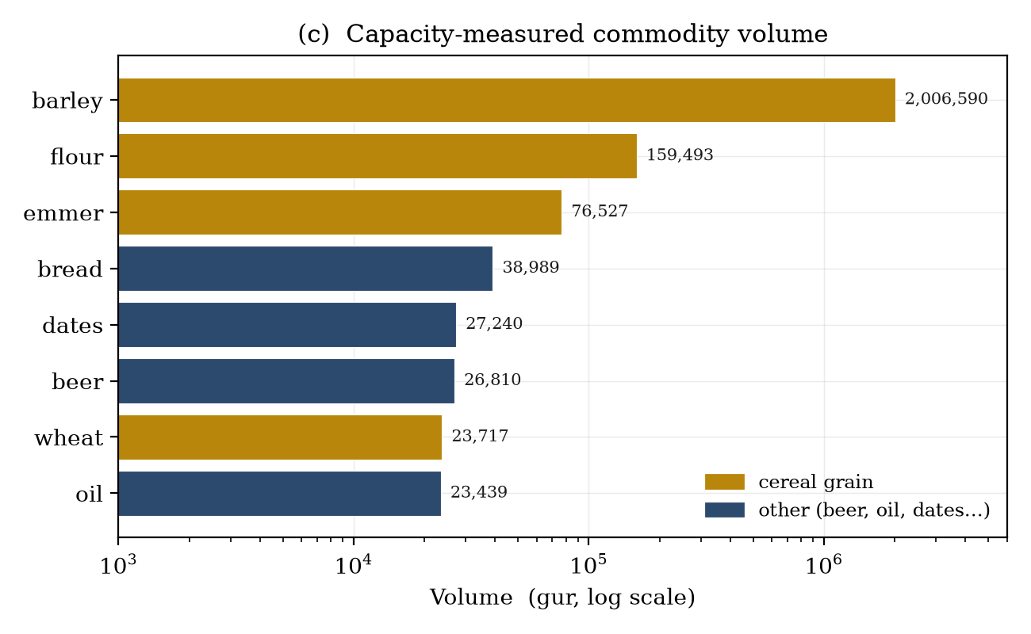
Figure 1c. Capacity-measured commodity volume on a
logarithmic axis. Cereal grains (gold) eclipse all other capacity commodities
by more than an order of magnitude, consistent with barley's role as the unit
of account and principal ration medium of the Ur III economy.
5. Exploratory Data Analysis: Distribution and Structure
5.1 Transaction sizes are log-normal with a heavy tail
The size distribution of the 44,599 barley capacity-transactions spans eight
orders of magnitude, from fractional-sila₃ messenger rations to a single
134,007-gurthreshing-floor receipt. On a logarithmic axis (Fig. 1a)
the body of the distribution is strikingly bell-shaped: a log-normal fit gives
μ = 5.78, σ = 2.77 (natural log of sila₃), and the modal class
sits exactly at the institutional default of onegur(300 sila₃),
which is also the median. The geometric mean, 318 sila₃, is nearly two
orders of magnitude below the arithmetic mean (11,763 sila₃)—the signature
of strong right-skew driven by a small number of granary-scale entries.
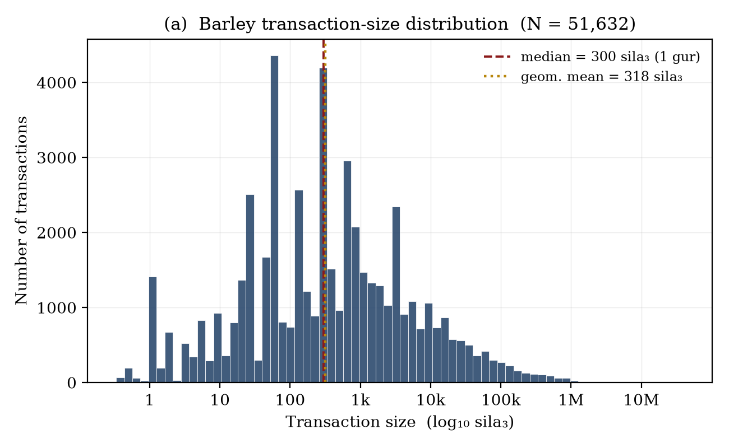
Figure 1a. Distribution of barley transaction
sizes (log₁₀ sila₃). The body is approximately log-normal; the
median coincides with the one-gur ration unit. The long right shoulder
reflects institutional granary and harvest receipts.
5.2 Extreme concentration of grain
Grain volume is concentrated to a degree that would be remarkable in any
economy. The top 1% of capacity transactions carry 53.4% of all barley by
volume, and the top 10% carry 91.2%. This is not an artefact of small-record
noise: 60% of grain-bearing tablets record 10guror less (everyday
disbursements; the per-tablet median is just 8gur), while only 20
tablets exceed 10,000gureach—the institutional granary and harvest
accounts that dominate the aggregate. The Ur III grain economy was,
statistically, a two-regime system: a vast substrate of small rationing
transactions overlaid by a thin stratum of enormous institutional flows. Formal inequality measurement is deferred pending resolution of name
conflation: common names aggregate multiple individuals into single nodes, which inflates apparent entity-level concentration.
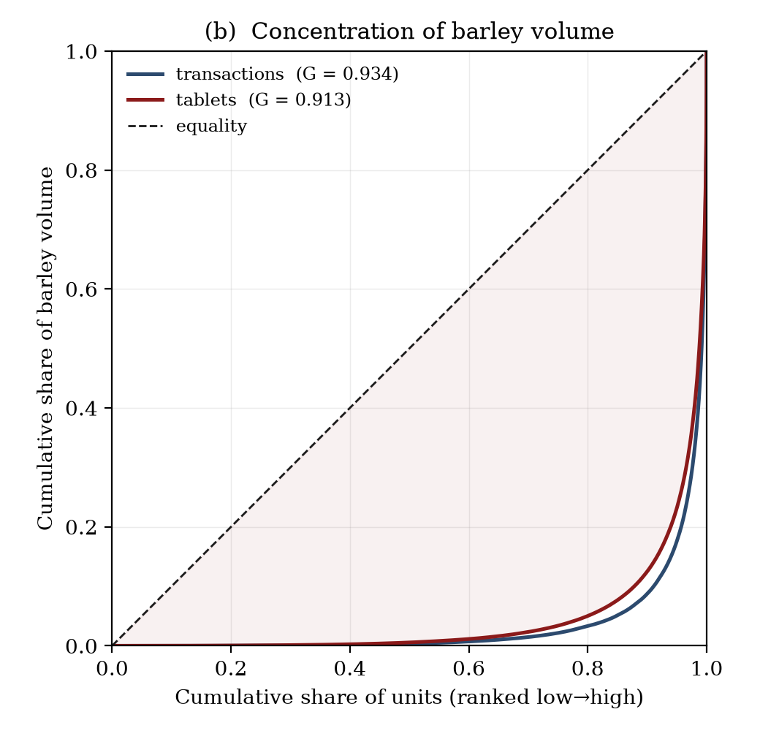
Figure 1b. Lorenz curves for barley volume across
transactions (steel) and tablets (red). Both lie far below the equality
diagonal. Over half of all recorded barley moves through 1%
of transactions.
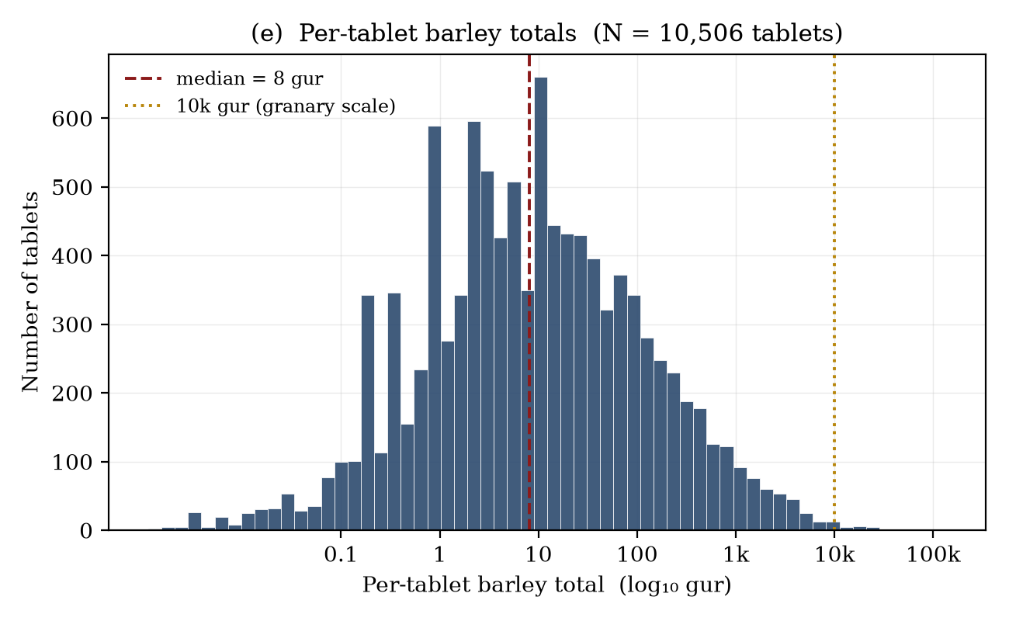
Figure 1e. Per-tablet barley totals
(log₁₀ gur). The bulk of tablets sit near the one-gur
ration scale; a separate cluster beyond 10,000 gur (gold line) marks the
provincial granary inventories and threshing-floor harvest receipts.
5.3 Temporal structure follows the surviving archives
One third of transactions carry a recoverable reign date, overwhelmingly from
the reign of Šulgi (67,107 transactions), reflecting the great Drehem,
Umma, and Girsu archives. Within Šulgi's reign the dated barley record
peaks sharply in years 45–48 (Fig. 1d), the period of the bala
redistributive system's fullest documentation. The temporal signal therefore
indexesarchival survival and bureaucratic intensityrather than any
simple economic cycle—an important caveat for any longitudinal reading of the
series.
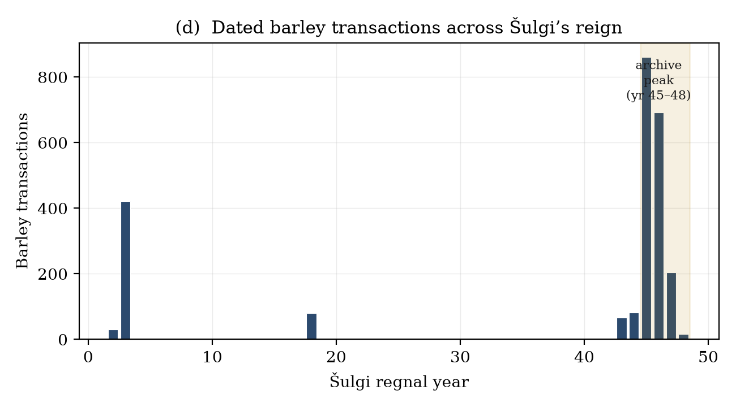
Figure 1d. Dated barley transactions across
Šulgi's regnal years. The years 45–48 (shaded) supply the densest
documentation, coinciding with the maturity of the provincial bala accounting
apparatus.
5.4 The exchange network and its brokers
Restricting to barley transactions with both a resolved issuer and recipient
(3,090 edges) yields a directed network of 1,894 agents. The graph is sparse
(density 0.00086) but cohesive: a single giant weakly-connected component spans
1,628 of the 1,894 nodes (83%), the remaining mass fragmenting into 146 small
components. Betweenness centrality (Fig. 1f) identifies the structural brokers,
and they are precisely the figures Assyriology would predict: provincial
household managers (šabra) and high stewards such asUr-BabaandUr-Nanše, who relay grain between
cultivators and the central administration. The single largestsinkby
in-degree—and the top node by PageRank—is the royal granary (in-degree 82), the
institutional terminus toward which provincial surpluses flow. The network thus
recovers, from raw transliteration alone, the textbook redistributive
architecture of the Ur III state: a hub-and-spoke system mediated by named
household officers.
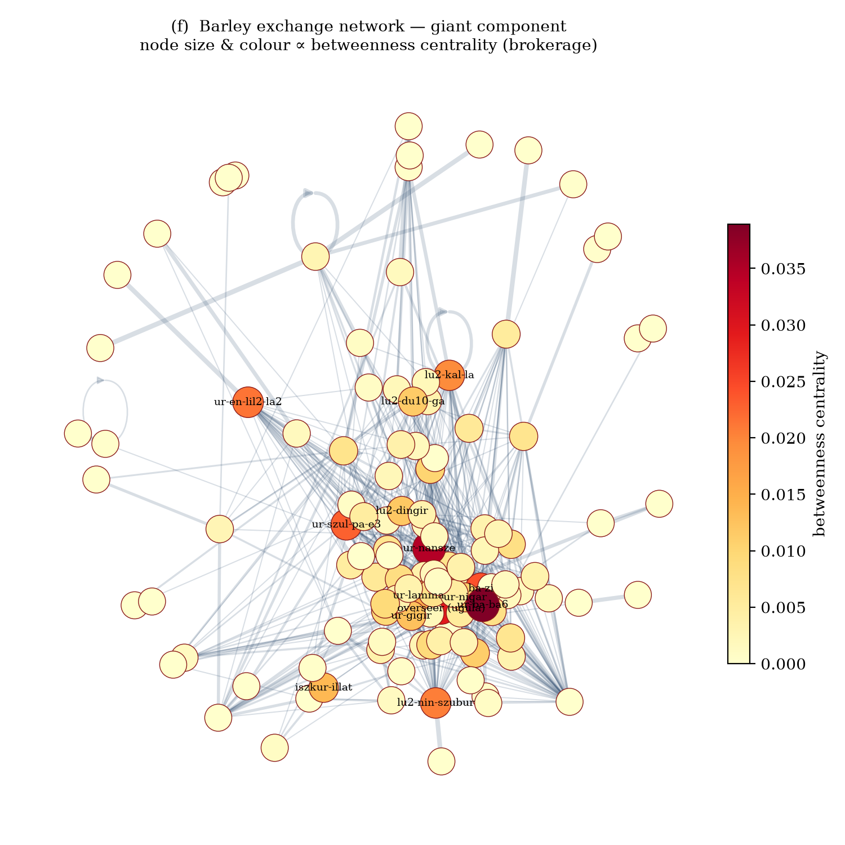
Figure 1f. Giant component of the barley-exchange
network (top-120 agents by weighted degree shown). Node size and colour encode
betweenness centrality. High-brokerage nodes correspond to provincial stewards
mediating between producers and the royal granary.
Table 4. Leading brokers (betweenness) and recipients
(in-degree) in the barley network.
Rank | Broker (betweenness) | BC | Recipient (in-degree) | deg⁻
1 | Ur-Baba | 0.039 | royal granary | 82
2 | Ur-Nanše | 0.035 | Ur-Baba | 44
3 | overseer (ugula) | 0.029 | Lu-Ninšubur | 41
4 | Ba-zi | 0.024 | Ur-Nanše | 35
5 | Ur-Šulpae | 0.023 | overseer (ugula) | 34

6. Methodology: Controlling False Positives CORE
We now turn to the paper's principal methodological contribution. In a corpus
where grain, garlic, reeds, cattle, silver, and accounting balances all share a
numeral-classifier grammar, the dominant source of error is not the failure to
parse grain (false negatives) but the eager parsing of non-grain (false
positives). Because a single large-denomination misread can inject up to
64.8 million sila₃ (Table 1),precision on the tail dominates the
aggregate. Our strategy is a layered body of negative-classification rules,
each motivated by a specific scribal idiom and each pinned by a regression test.
6.1 Taxonomy of false positives
Class | Example line | Why it is not grain
Place / personal names | sza₃ e2-duru5 1(szargal){gal} | a village name ("Šargal hamlet"), not 216,000 gur
Counted commodities | N(szar2) sa za-ha-din | bundles of shallots, not gur of grain
Fodder / reed | N(gesz2) in-bul5 / in-nu | thatch & straw measured by bulk, non-cereal
Livestock | N(asz) gu₄ / udu | head of cattle/sheep → routed to head
Weight / silver | N(disz) gin₂ ku₃-babbar | shekels of silver → routed to gin₂
Artisan item-counts | N(gesz2) nig₂ PERSON | manufactured-object tallies, not capacity
Balance carry-forward | N gur su-su / la₂-ia₃ / diri | repayment/deficit/surplus lines double-count the principal
Grand-total restatement | šunigin2 … sag-nig₂-gur₁₁ | re-states entries already counted within the section
Ration mis-scaling | 3(gesz'u) 4(gesz2) 2(u) 3(disz) PERSON | sila₃-scale worker ration, not gur-scale
Archaic curviform | szar2@c, gesz'u@c | pre-Sargonic sign forms 100–10,000× too large

6.2 The large-denomination ration trap
The most instructive false positive is the worker-ration list. On
brewer- and weaver-ration tablets, an individual entry such as3(gesz'u) 4(gesz2) 2(u) 3(disz) ARAD₂uses the large
sexagesimal tokens to countsila₃, notgur: the entry is
≈7gur, and the section's closingšuniginperforms
the gur conversion. A parser that applies the gur factor to thegesz'u/gesz2tokens inflates the line by ×300,
turning 7gurinto 2,063. Our guard encodes the diagnostic linguistic
fact precisely: a line carrying a large-denomination token butno sub-gur
anchor(asz,barig, orban2) is in
sila₃ scale and must not be promoted to gur scale. Because the sub-gur
anchors are themselves grain indicators, their presence is detected earlier in
the pipeline; theirabsencebeside agesz2+token is the
signature of a mis-scaled ration. This single rule removed ≈0.80 million
phantomgur.
6.3 Context-sensitive recovery (false-negative control)
Negative filtering, pursued alone, would discard legitimate elliptical grain
lines (e.g.4(u) 5(disz) PERSONwithin a proven grain section,
where the unit word is elided). We therefore pair the filters with acontextmechanism: a section that contains at least one explicit grain
line activates a guarded retry that recovers unit-elided lines, but only when
none of the §6.1 disqualifiers is present. The two mechanisms are adversarial by
design—every loosening of recovery is checked against the full false-positive
test suite, and vice versa.
6.4 Validation and net effect
The rule body comprises 120 distinct pattern terms, exercised by 144
regression tests (all passing) that encode both the lines thatmustparse and the lines thatmust not. Developed test-first across more than
eighty revisions, the filters reduced spurious grain volume from a permissive
baseline of roughly 3.73 milliongurto the present 2.275 million—a
reduction of about0.96 million gur (26%)—while the
regression suite guarantees that no documented legitimate line was lost in the
process. We regard the test corpus itself, rather than any single rule, as the
durable artefact: it freezes hundreds of adjudicated scribal idioms into
executable specifications.
7. Limitations
Several caveats bound the analysis. (i)Damage.Bracketed lacunae
suppress quantities and attributions; coverage is therefore a lower bound, and
the 385,000gurof untyped capacity reflects lost commodity words.
(ii)Prosopographic noise.The entity index conflates frequent
commodity words (kaš,ninda,udu) with personal
names at the head of the frequency table; genuine-person analysis should work
from the patronymic-anchored subset. (iii)Survivorship.The temporal
and provincial distribution tracks which archives were excavated and published,
not the ancient economy's true shape. (iv)Double-counting at the margin.Multi-section balanced accounts that re-state sub-section totals at several
levels remain the hardest residual case; we suppress the canonicalšunigin/sag-nig₂-gur₁₁restatements but
cannot guarantee zero leakage on idiosyncratic ledgers.
8. Conclusion
A deterministic, test-driven pipeline can convert 135,199 raw cuneiform
transliterations into a quantitatively coherent picture of the Ur III grain
economy: 2.275 milliongurof cereal moving through a sharply
two-regime distribution, organised as a broker-mediated
redistributive network terminating at the royal granary. The decisive technical
lesson is that mass extraction from such corpora is governed by negative
classification—by the disciplined, linguistically-grounded refusal to count what
merely looks like grain. The accompanying 144-test regression suite operationalises
that discipline and is, we argue, the methodology's most transferable component.
Future work will extend context-sensitive recovery to the untyped-capacity
residue and apply the same negative-classification framework to the silver and
livestock channels.

Data and Code Availability
All extraction code, the 144-test regression suite, and the
derived transaction/record/entity tables are available in the repositoryasarodan/sumer. Figures in this paper are regenerated fromoutput/figures/bytools/make_paper_figures.pyandtools/make_network_figure.pyover the CDLI bulk ATF export. The
CDLI corpus is distributed by the Cuneiform Digital Library Initiative under its
data-sharing terms.
Cuneiform Digital Library Initiative (CDLI).Ur III administrative
corpus, ATF bulk export.cdli.mpiwg-berlin.mpg.de.
Englund, R. K. (2012). "Equivalency Values and the Command Economy of the Ur
III Period in Mesopotamia." InThe Construction of Value in the Ancient
World, 427–458.
Garfinkle, S. J. (2015). "Ur III Administrative Texts: Building Blocks of
State Community." InFrom the 21st Century B.C. to the 21st Century A.D.
Molina, M. (2008). "The Corpus of Neo-Sumerian Tablets: An Overview." InThe Growth of an Early State in Mesopotamia, 19–53.
Sallaberger, W. (1999). "Ur III-Zeit." InMesopotamien: Akkade-Zeit und
Ur III-Zeit, OBO 160/3, 121–390.
Widell, M. (2004). "Reflections on Some Households and their Receiving
Officials in the City of Ur in the Ur III Period."JNES63, 283–290.
Manuscript compiled from pipeline output · corpus snapshot:
135,199 tablets · 220,034 transactions · 2.275 Mgurcapacity.

