Student Registration Form
WS 301 — Performance Task: Form Validation
Short explanation
The form collects the student's ID, personal and contact details, academic choices, password, address, and agreement.
Before validating, the JavaScript trims whitespace and checks required fields, email format, phone number, birth date, selections, password length and confirmation, and agreement.
A submit event listener calls preventDefault() so the page does not submit or reload while validation runs.
Each invalid field gets a specific nearby error message and an error CSS class; corrected values clear their own errors.
Password buttons use data-password-target attributes read through dataset, then update the password input type attribute and toggle button styling to show or hide the password.
The success message appears only after every check passes, and Reset clears the entered data, messages, error styling, password visibility, and success state.

Initial form — before entering information


Validation errors — required fields are identified
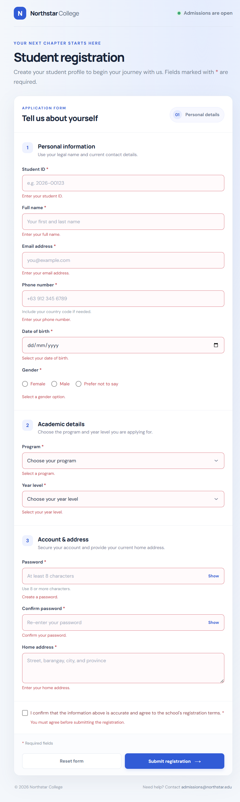

Correcting errors — corrected fields clear their messages
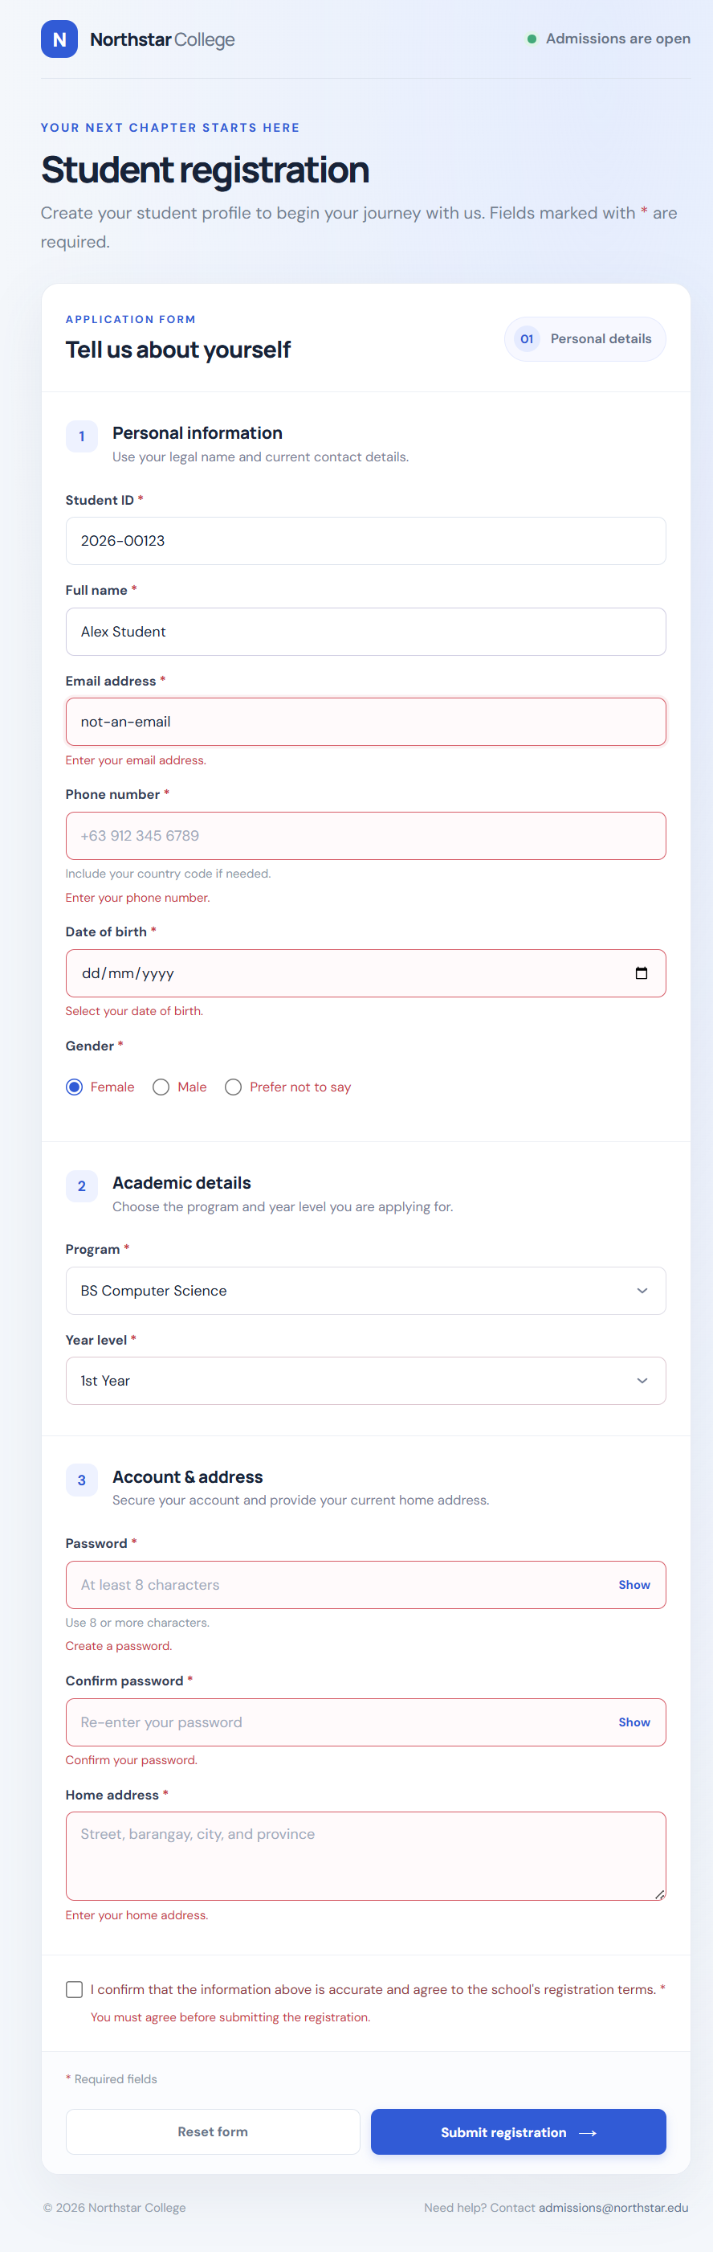

Successful form — all information is valid
