Recordings :
https://courses.thetestingacademy.com/login
UN : a.satish134@gmail.com
Password : Aadhy@260821
Navigation : After Login MY COURSES Scroll down
You will find “Playwright Automation Mastery”
Note : All other courses are bonus one’s , try to learn when you have a time.

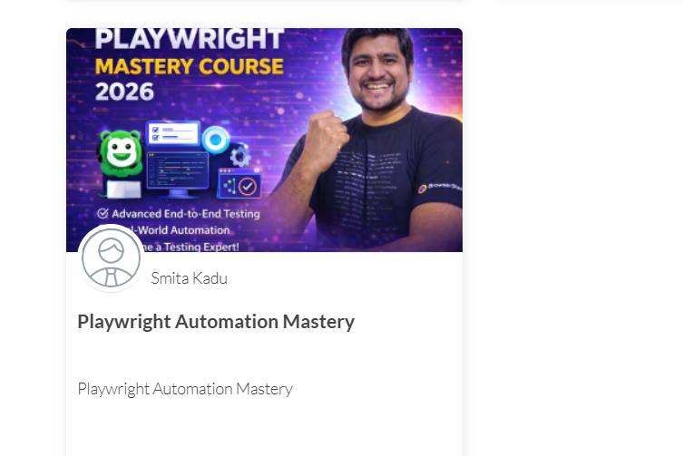

Other Links :

For Daily Notes :
https://app.eraser.io/workspace/Tz63v1Pz52oXHd70LdyM
Roadmap 90-100 Days
﻿www.figma.com/board/pkItIomNHwPzSdYrsWp1BT/90-Days-Roadmap-to-Playwright-with-JS-TS?node-id=1-13&t=yAXVWoruKX2fUmUP-1

Tracking Sheet | Playwright Sheet
﻿https://sdet.live/playwright-sheet

Doubt ‘sThread - ﻿www.sdetclub.com/c/playwright-a791f6/doubts-31th-jan-2026-intro-class

