**Problem Set 3: Sampling Distribution, CLT and Interval Estimation**

Please type your work here in this Word document. You may use Python to compute the values needed.

1. **Problem 29 on page 326**

Given:

Mean: μ = $ 183

Standard deviation: σ = $ 50

1. n = 30

E(x^) = μ = $ 183

σ x^ = σ / square root (n)

= 50 / square root (30)

= 9.129

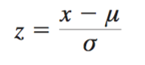

= (58 – 50) / 9.129

= 0.876

Also,

= (42 – 50) / 9.129

= -0.876

Taking cumulative probabilities for the standard Normal distribution:

P(-0.876 <= x^ <= +0.876) = p(z <= 0.876) - p(z < -0.876)

= 0.8106 – 0.1894

= 0.6212

= 62.12%

1. n = 50

σ x^ = σ / square root (n)

= 50 / square root (50)

= 7.071



= (58 – 50) / 7.071

= 1.131

Also,

= (42 – 50) / 9.129

= -1.131

Taking cumulative probabilities for the standard Normal distribution:

P(-1.131<= x^ <= +1.131) = p(z <= 1.131) - p(z < -1.131)

= 0.8708 – 0.1292

= 0.7416

= 74.16%

1. n = 100

σ x^ = σ / square root (n)

= 50 / square root (100)

= 5



= (58 – 50) / 5

= 1.6

Also,

= (42 – 50) / 5

= -1.6

Taking cumulative probabilities for the standard Normal distribution:

P(-1.6<= x^ <= +1.6) = p(z <= 1.6) - p(z < -1.6)

= 0.9452 – 0.0548

= 0.8904

= 89.04%

1. Adding the sample size from part b (n = 50) and c (n = 100), we get

n = 150

σ x^ = σ / square root (n)

= 50 / square root (150)

= 4.082



= (58 – 50) / 4.082

= 1.96

Also,

= (42 – 50) / 4.082

= -1.96

Taking cumulative probabilities for the standard Normal distribution:

P(-1.96<= x^ <= +1.96) = p(z <= 1.96) - p(z < -1.96)

= 0.9750 – 0.0250

= 0.9500

= **95%**

1. **Problem 39 on page 331**

Given:

Population proportion: p = 0.75

1. n = 450

Expected Value of (p^) = p = 0.75

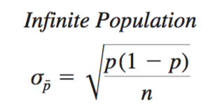

σ p^ = square root [(0.75 * 0.25)/450]

= 0.0204

The Sampling distribution of p^ can be approximated by a Normal distribution whenever

Np >= 5 and n(1-p) >=5

Here, n*p = 450 * 0.75 = 337.5 that is > 5 and,

N * (1 – p) = 450 * 0.25 = 112.5 that is > 5 as well

Therefore, Sampling distribution of p^ can be approximated by a Normal distribution

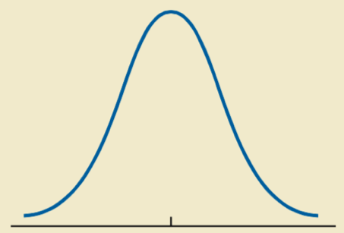

σ p^ = 0.0204 0.0204

0.77

0.75

difference = 0.04

σ p^ = 0.0204

z = (0.79 – 0.75) / 0.0204

z = 2

Also,

z = (0.71 – 0.75) / 0.0204

z = -2

Taking cumulative probabilities for the standard Normal distribution:

P(p^) = 0.9772 – 0.0228

= 0.9544

= **95.44%**

Therefore, the probability that the sample proportion will be within 0.04 of the population proportion is 95.44%

1. n = 200

Expected Value of (p^) = p = 0.75



σ p^ = square root [(0.75 * 0.25)/200]

= 0.031

The Sampling distribution of p^ can be approximated by a Normal distribution whenever

Np >= 5 and n(1-p) >=5

Here, n*p = 200 * 0.75 = 150 that is > 5 and,

N * (1 – p) = 200 * 0.25 = 50 that is > 5 as well

Therefore, Sampling distribution of p^ can be approximated by a Normal distribution



σ p^ = 0.031 0.0204

0.78

0.75

difference = 0.04

σ p^ = 0.031

z = (0.79 – 0.75) / 0.031

z = 1.29

Also,

z = (0.71 – 0.75) / 0.031

z = -1.29

Taking cumulative probabilities for the standard Normal distribution:

P(p^) = 0.9015 – 0.0985

= 0.8030

= **80.30%**

Therefore, the probability that the sample proportion will be within 0.04 of the population proportion is 80.30%

1. Gain in precision = 95.44% - 80.30% = **15.14%**
2. **Problem 15 on page 362**

Given:

Sample size: n = 65

Sample mean: x^ = 19.5

Sample standard deviation: s = 5.2

* 1. Interval Estimation of Population mean with unknown population standard deviation and

a 90% confidence level =

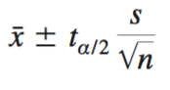

Now,

1 – a = 0.90

a = 0.10

a/2 = 0.05

 = 1.669

So, Interval Estimation of Population mean = 19.5 +- 1.669 * (5.2/ square root (65))

= 19.5 +- 1.076472

= **17.831 to 20.5764**

* 1. Interval Estimation of Population mean with unknown population standard deviation and

a 95% confidence level =



Now,

1 – a = 0.95

a = 0.05

a/2 = 0.025

 = 1.998

So, Interval Estimation of Population mean = 19.5 +- 1. 998 * (5.2/ square root (65))

= 19.5 +- 1.2886713

= **18.2114 to 20.57886**

**4. Problem 60 on page 376**

Given:

Sample size: n = 1993

Business travelers who listed frequent flyer program as the most important feature = 618

1. Point estimate of proportion of population of Business travelers who listed frequent flyer program as the most important feature: p^ = 618/1993 = **0.3101**
2. 95% interval estimate of the population proportion =

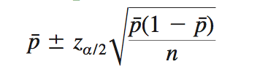

1 – a = 0.95

a = 0.05

a/2 = 0.025

 = 1.960

= 0.3101 +- 1.960 * square root [(0.3101 * 0.6899)/1993]

= 0.3101 +- 0.020307

= 0.2897 to 0.3304

= **28.97% to 33.04%**

1. Sample size =

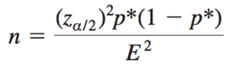

= [(1.96)2 * 0.3101 * 0.6899] / (0.01)2

= **8217.18**

No, I would not recommend USA today to provide degree of precision: p^ = 0.3101 and

(1-p^) = 0.6899 as the sample size = 8217 is too large.