**Problem Set 4: Hypothesis Testing**

Please type your work here in this Word document. You may use Python to compute the values needed.

1. Problem 31 of Chapter 9, 13th edition (**5 points total**)

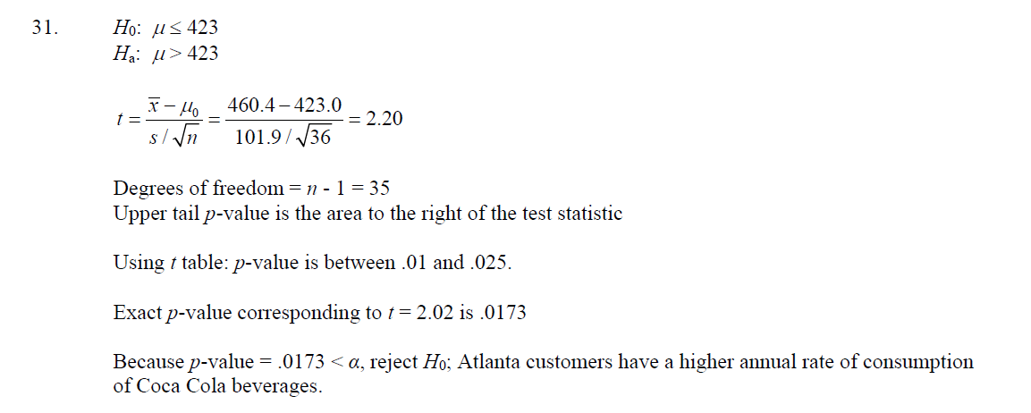

1. Problem 42 of Chapter 9, 13th edition (**7 points total**)

**Question a: 1 point; Question b: 3 points; Question c: 3 points**

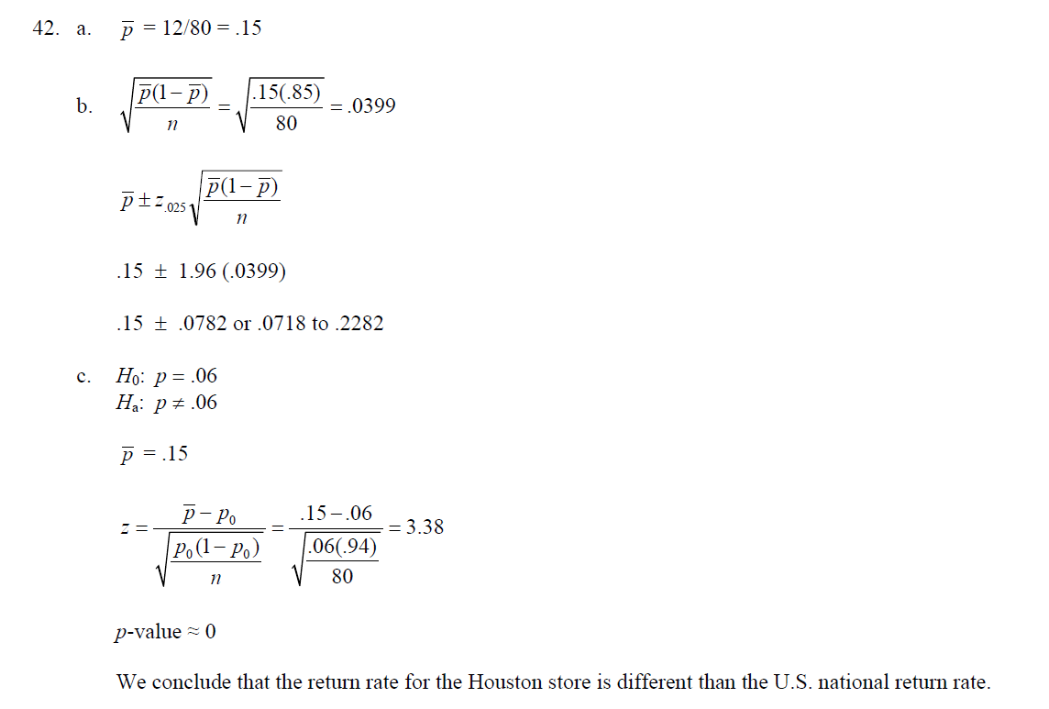

1. Problem 49 of Chapter 9, 13th edition (**8 points total**)

**Questions a-d: 2 points each**

