Marketing Analytics: Assignment- 3 April 16th, 2017

Submitted by: Surabhi Asati

Net-ID: va7892



**Case: Portland Trail Blazers**

**Introduction:**

In the 2005 season, the Portland Trail Blazers’ NBA franchise was in trouble. Fan following dropped, team’s coach had been fired, and the players couldn’t score well. The team sported a 22-36 record and creditors now ran the Rose Garden, team’s home arena after its owners had filed for Chapter 11 bankruptcy. The team’s image was spoiled by players’ involvement in fights, drugs and animal cruelty scandals. The television view also declined, sales of the ‘Club seats’ too declined with 700 seats remained available of the 1,800 club seats due to drop in subscriber base following the previous season.

Before the 2003-2004 season, the team had been beloved by Portland. But a month following All Star NBA 2005 season, attendance began to fall precipitously — by more than 15 percent by 2005. During the same time, 42 of 70 luxury suites sat empty during the season.

The Portland trail blazers management hired Acuity market research firm to help design their multi-game package to lure back the fans.

**Objective:**

To offer a multi-game ticket package that gad a high appeal to fans while still being profitable to the team and not undermining current pricing policies

**Questions:**

1. **Which attribute does the conjoint analysis indicate is most important in the overall purchase decision?**

Four quantifiable attributes are:

1. Number of games
2. Ticket price
3. Ticket Location
4. Promotion Item

Using the common metric to calculate the utility of each attribute:

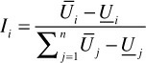

* Importance of Number of games = (0.24383+0.2764)/ {(0.17428+0.31786) + (0.65646+1.00257) + (1.01148+0.73169)} = 11.78%
* Importance of Ticket price = 37.58%
* Importance of Ticket Location = 39.49%
* Importance of Promotion Item = 11.15%

**Cost to management:**

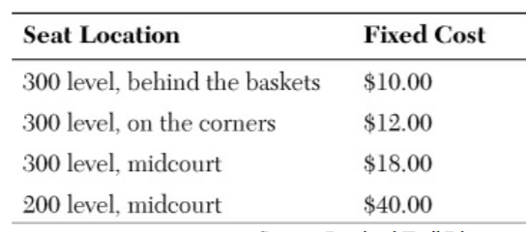

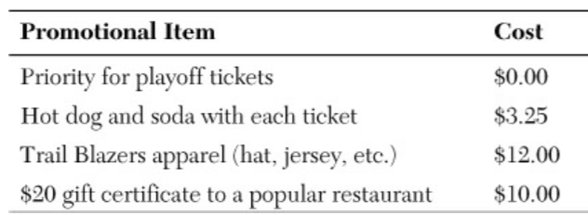

Taking into consideration both attribute importance and cost incurred for conjoint analysis, Ticket price is the most important attribute

**2. Are the conjoint results useful in making any pricing decisions? What useful information can be gleaned from the research?**

From the research and conjoint analysis, we could gather some very useful information:

- The ticket price’s utility is 37.58% in driving the purchasing decision of customers. That means price of the ticket plays a significant role in customer’s pricing decisions. Looking at the attribute kevel utility of ticket pricing:

- A higher priced seat ($ 60 per seat per game) has a very low utility: -1.00257. This indicates fans do not prefer spending high on tickets and rather prefer enjoying more number of games buying inexpensive tickets

- Customer’s price preferences can be combined with other attributes and many such attribute combinations can contribute to deciding customer preferences

**3. What about the promotional items? Are they worth giving away (free) to season ticket holders?**

Consider the cost of promotional items:



* Although, Promotional items contributes to only 11.15% in making the customer purchase decision; they are incentives to lure the customers. For example:
* The priority playoff tickets costs nothing to management and provides a chance to the customer to prioritize remaining play-off tickets. This is a huge advantage and will be very popular amongst the fans.
* This encourages customers to buy more tickets to unpopular games bundled with the tickets to top-notch team games’ scarce tickets. I.e. increases ticket sales and overall attendance
* Everyone likes snacking while watching a sport. It’s a very common trend. The hot dog and soda combo at cost $3.25 is therefore, worth including in the package because it has low cost - $3.25 and highest attribute level utility.
* Priority for play-off tickets and a Hot Dog and Soda for each ticket are worth giving away free to the season ticket holders.

**4. What about the size of ticket packages? What does the conjoint analysis suggest?**

Number of Games Attribute level utility:

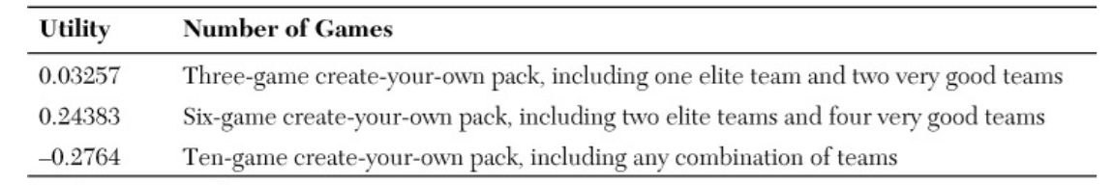

As shown in the table, the six-game create-your-own pack, including two elite teams and four very good teams has the highest utility, the next is ten-game pack, including any combination of teams.

The conjoint analysis suggests the six-game package because it allures the customer to buy tickets for the games with two top-notch players games for which the tickets were scarce combined with games that were difficult to sell the tickets.

Also, the ten-game create-your-own-pack including any combination of team because management can sell many tickets to unpopular games which were bundled with popular games to one customer. This increased over-all attendance

**5. What should the management of the Portland Trail Blazers do?**

Estimating the multi-game package value:

|  |  |  |  |  |  |
| --- | --- | --- | --- | --- | --- |
| No. | Multi game package | Seat location | Promotional item | Priority for Play-off tickets | Total  (Profit) |
| 1. | 6-Game Package | 200 level - midcourt | Hot Dog + Soda | No |  |
|  | **+$360** | **-$240** | **-$19.5** | **-$0** | **+$100.50** |
| 2. | 10-Game Package | 300 level - midcourt | No | Yes |  |
|  | **+$250** | **-$180** | **-$0** | **-$0** | **+$70** |

The management should go for both the promotional offer: Priority for Play-off tickets and free Hot Dog + Soda provided with multi game package tickets as customers value these features. Conjoint analysis shows that not only ticket location and ticket prices matters to the customers but promotional items and number of games can make a significant impact on their ticket buying decisions. Various combinations of these attributes trading one for another can encourage the customer to buy more tickets.

**References:**

* Wilcox, Ronald. "How the Portland Trail Blazers Won Back Their Fans". *Washington Post*. N.p., 2017. Web. 16 Apr. 2017.