# Marketing Analytics: Assignment 4

**Submitted by: Surabhi Asati May 7th, 2017**

**Svedka Vodka**



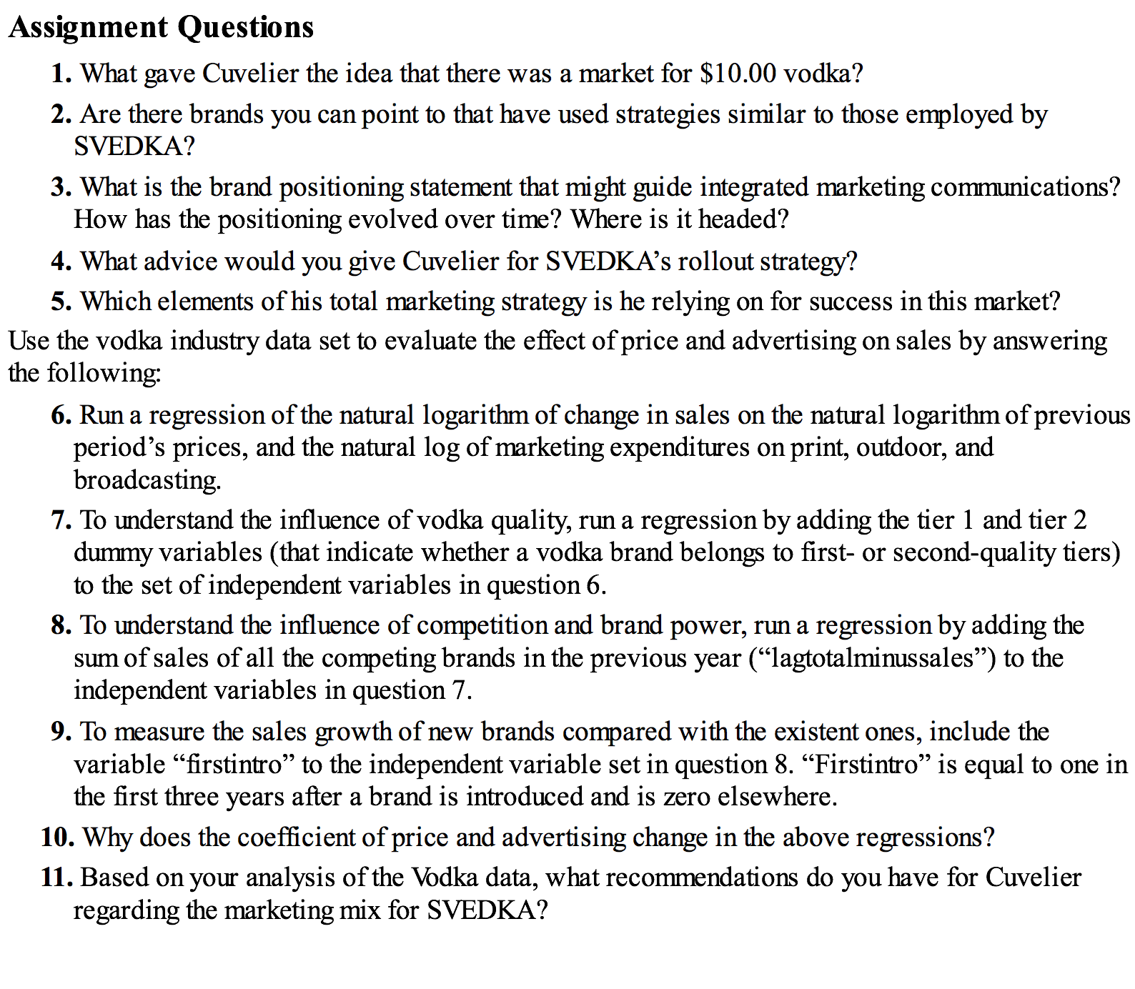

**Answers:**

1. With the success of ‘Grey Goose’ (increasing sales by 50% in one year priced at $30), Cuvelier observed that consumers were increasingly getting aware of the look, quality and the origin of vodka. Also, many Vodka brands priced under $10 were enjoying large market shares. Both reasons made him believe that a mid-price vodka could capture some volume sales from the under $10 market. He said – “This standard vodka category has never been expanded to include consumers who were willing to stretch their wallets a little bit”
2. Svedka was built on finding holes in the marketplace. Svedka’s founder saw a white space: There were low-end domestic vodkas, and high-end imported vodkas, but no low-end imported options. Other brands that uses strategies like those applied by Svedka is Grey Goose.
3. Svedka’s positioning as a high quality imported vodka at an affordable price focused on end benefits of vodka. Svedka promoted itself as both rational and aspirational product related to festivities and social occasions which consumers can enjoy. Everything Swedish is perceived as high-quality, fashionable and pure. The brand’s identity remains a high-quality 80-proof vodka that represents tremendous value for the price. The brand conjures Swedish simplicity ‘cheap chic’—and the bottle is the celebrity.
4. Svedka’s Roll out strategy:

The middle-tier consumer segment has not been capitalized so we can Persuade new vodka drinkers who are not brand loyal and the "upgraders" who sought something better than the basic.

Younger crowd can be persuaded to become lifelong brand enthusiasts

Cuvelier could expand his PR to larger publications and media outlets  
Also, we can focus on the opportunity of on premise channels, including bars, hotels and restaurants.

1. He considered looking historic vodka sales and was focused to evaluate the effects of new flavors, segments and majorly Advertisements.

* Cuvelier thought the new of flavors may have direct effect on the sales
* He considered spirit rewards and how their value can be quantified
* He focused on previous campaign outcomes to create the ones with larger profits and effectively allocate marketing resources

10. With increase in price, the sales tend to decrease. But when competitor’s price increase, svedka’s sales increase. Also, there is a reduction in advertisement.

11. Recommendations:

* Cuvelier can spent some of his marketing budget in traditional media. Specifically, he could have advertised on affordable radio stations that his target customers are listening to
* Cuvelier could use product placements in TV shows, movies and sports events to communicate the position of the brand; like Absolut’s product placements in popular show Sex and the City. Similarly, TV shows like Game of Thrones are targeted towards the 21-35 age group audience and are fun, exciting, and trendy. They will extend Svedka’s brand recognition among target customer.
* Based on the Analysis, spending on outdoor marketing activities has been most valuable for Svedka. Allocating more resources to advertising outside, campaigns will contribute towards higher profit margins