Marketing Analytics: Assignment- 5 May 15th, 2017

Submitted by: Surabhi Asati

Net-ID: va7892

**Netflix Case Study**

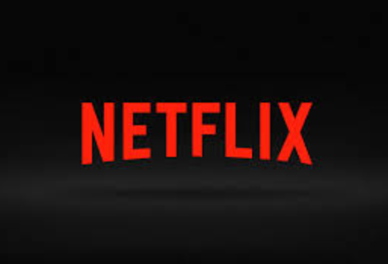

Questions:

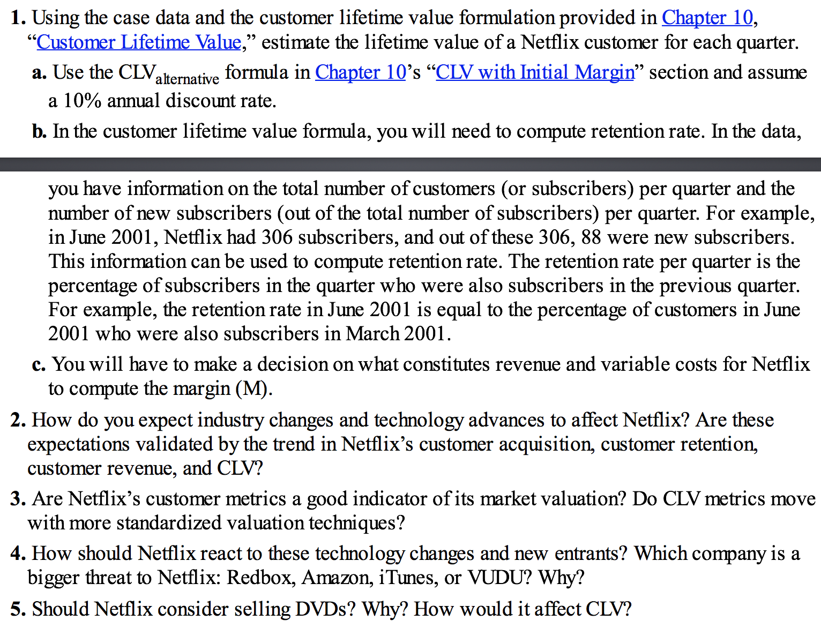

Solution 1:

(Attached Excel sheet)

**Retention Rate:**

Retention rate per quarter is calculated as percentage of subscribers in the quarter who were subscribers in the previous quarter.

Example: Quarter June 2001

New subscribers: 88

Total subscribers: 306

Old subscribers: 306 – 88 = 218

Total subscribers in previous quarter (March 2001): 303

Retention rate (r) = Percentage of subscribers in the quarter June 2001 who were subscribers in the previous quarter: 218/303 = 0.719

**CLV with Initial Margin:**



Given:

Discount Rate = 10% = 0.1

For June 2001,

 = (1 + 0.1) / (1 + 0.1 - 0719) = 2.891

**Margin (M)** = I have taken Cost of subscription, fulfillment expenses and technology development as variable expenses to calculate the Margin.

For Quarter September 2001, M = $ 1465.00

Calculations of CLV for the Data set:

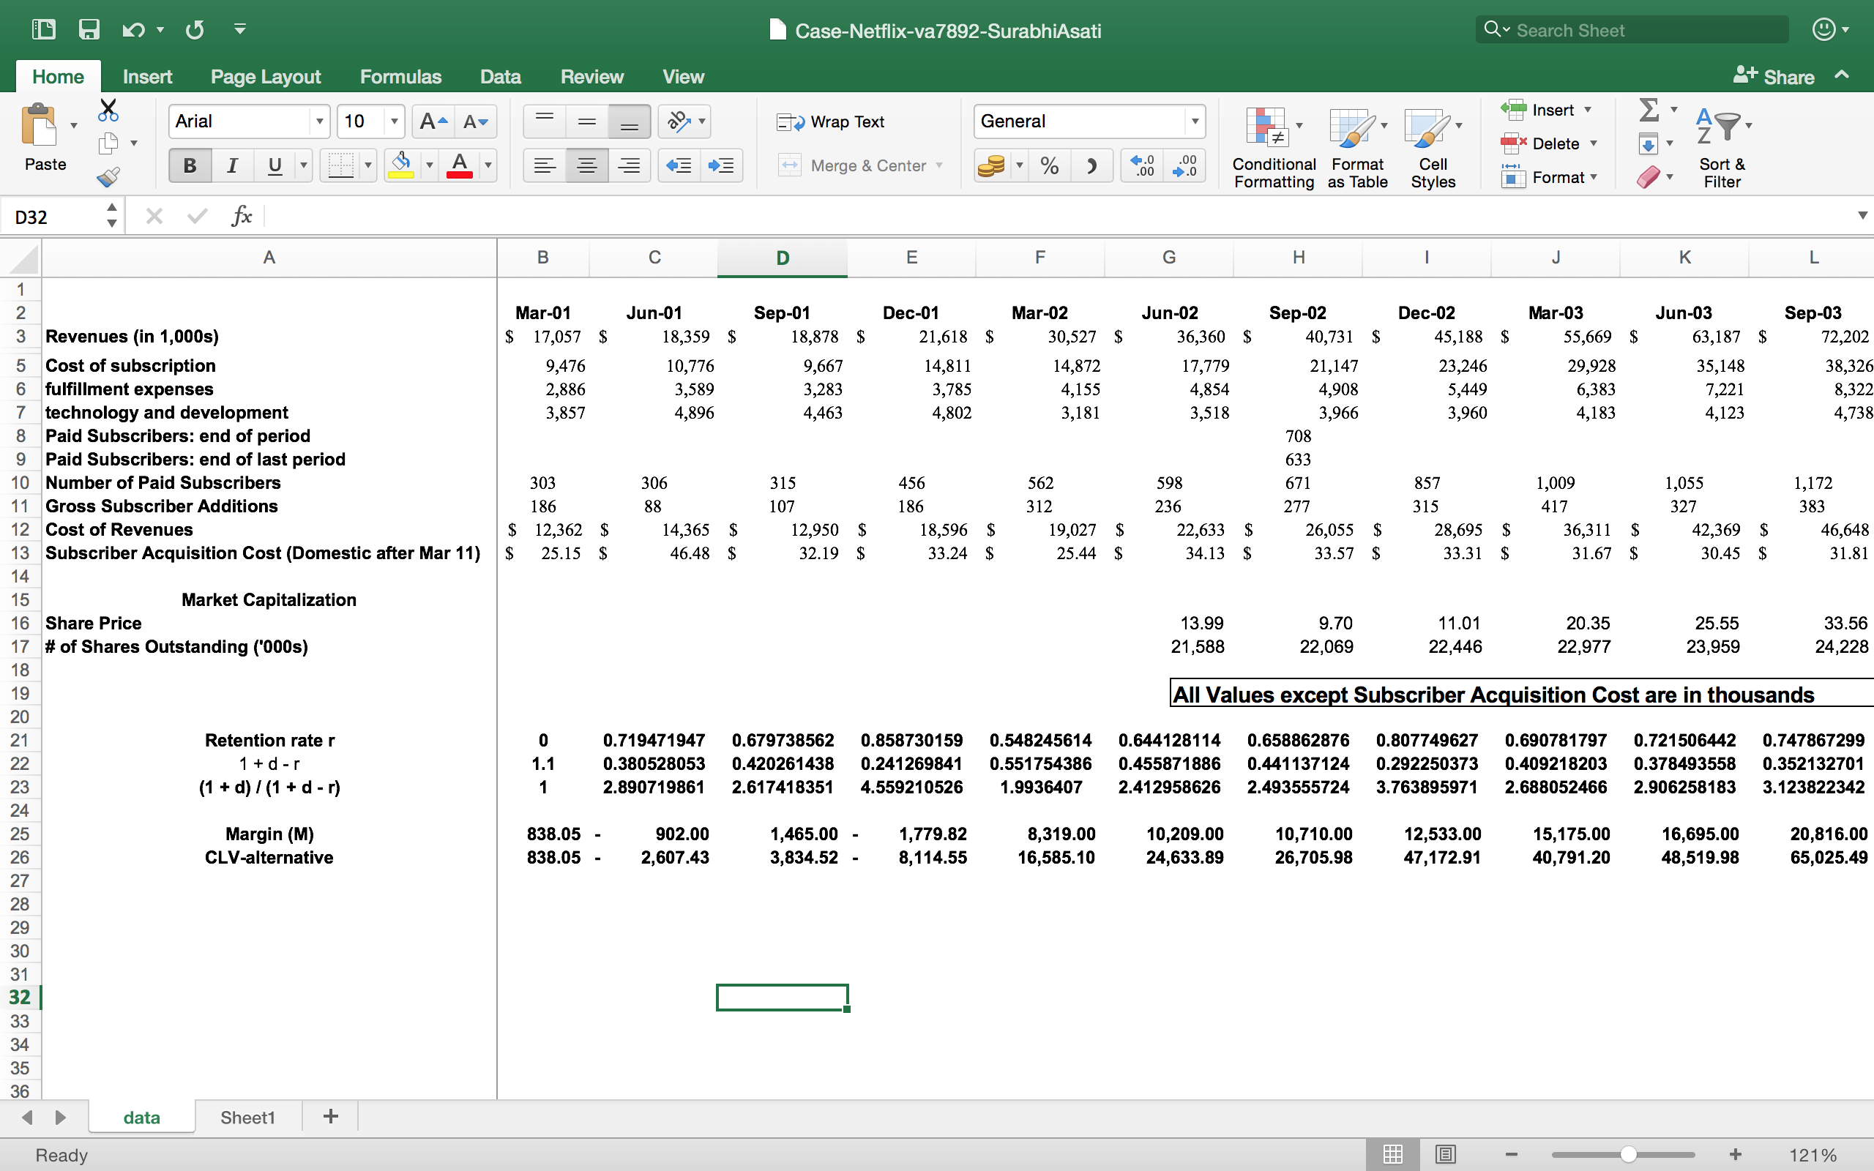





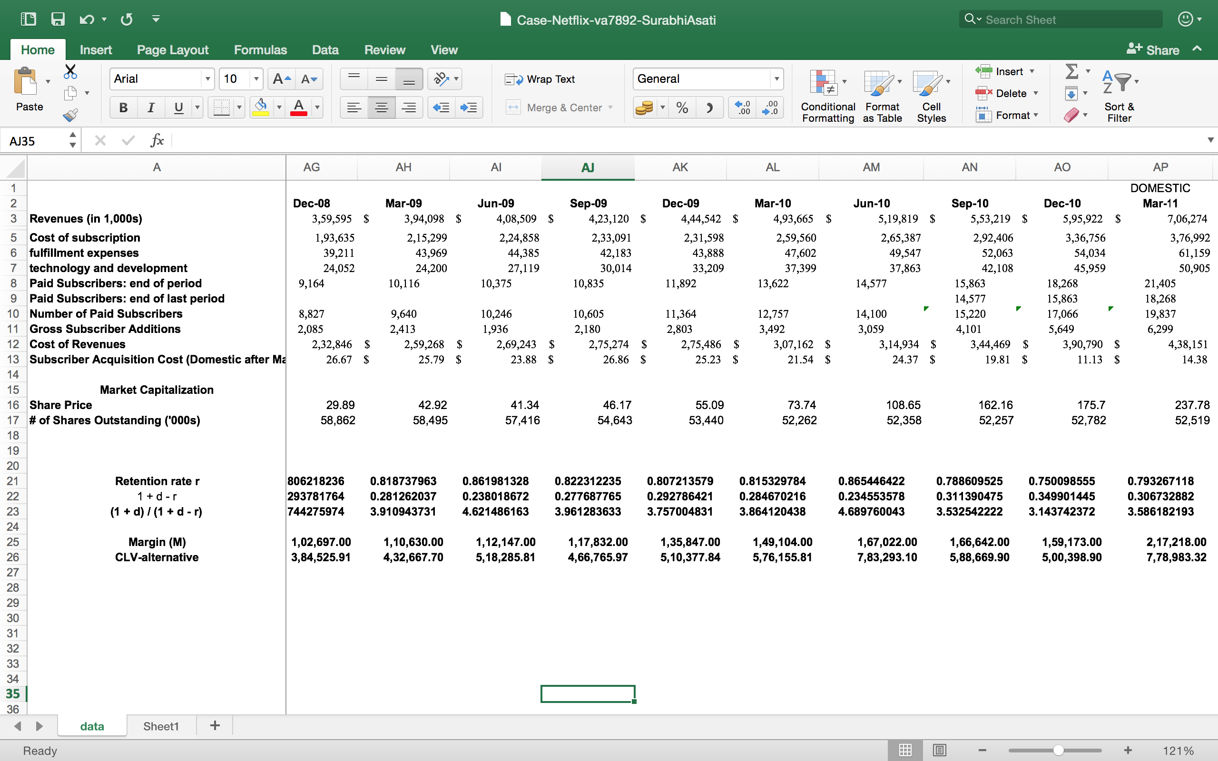

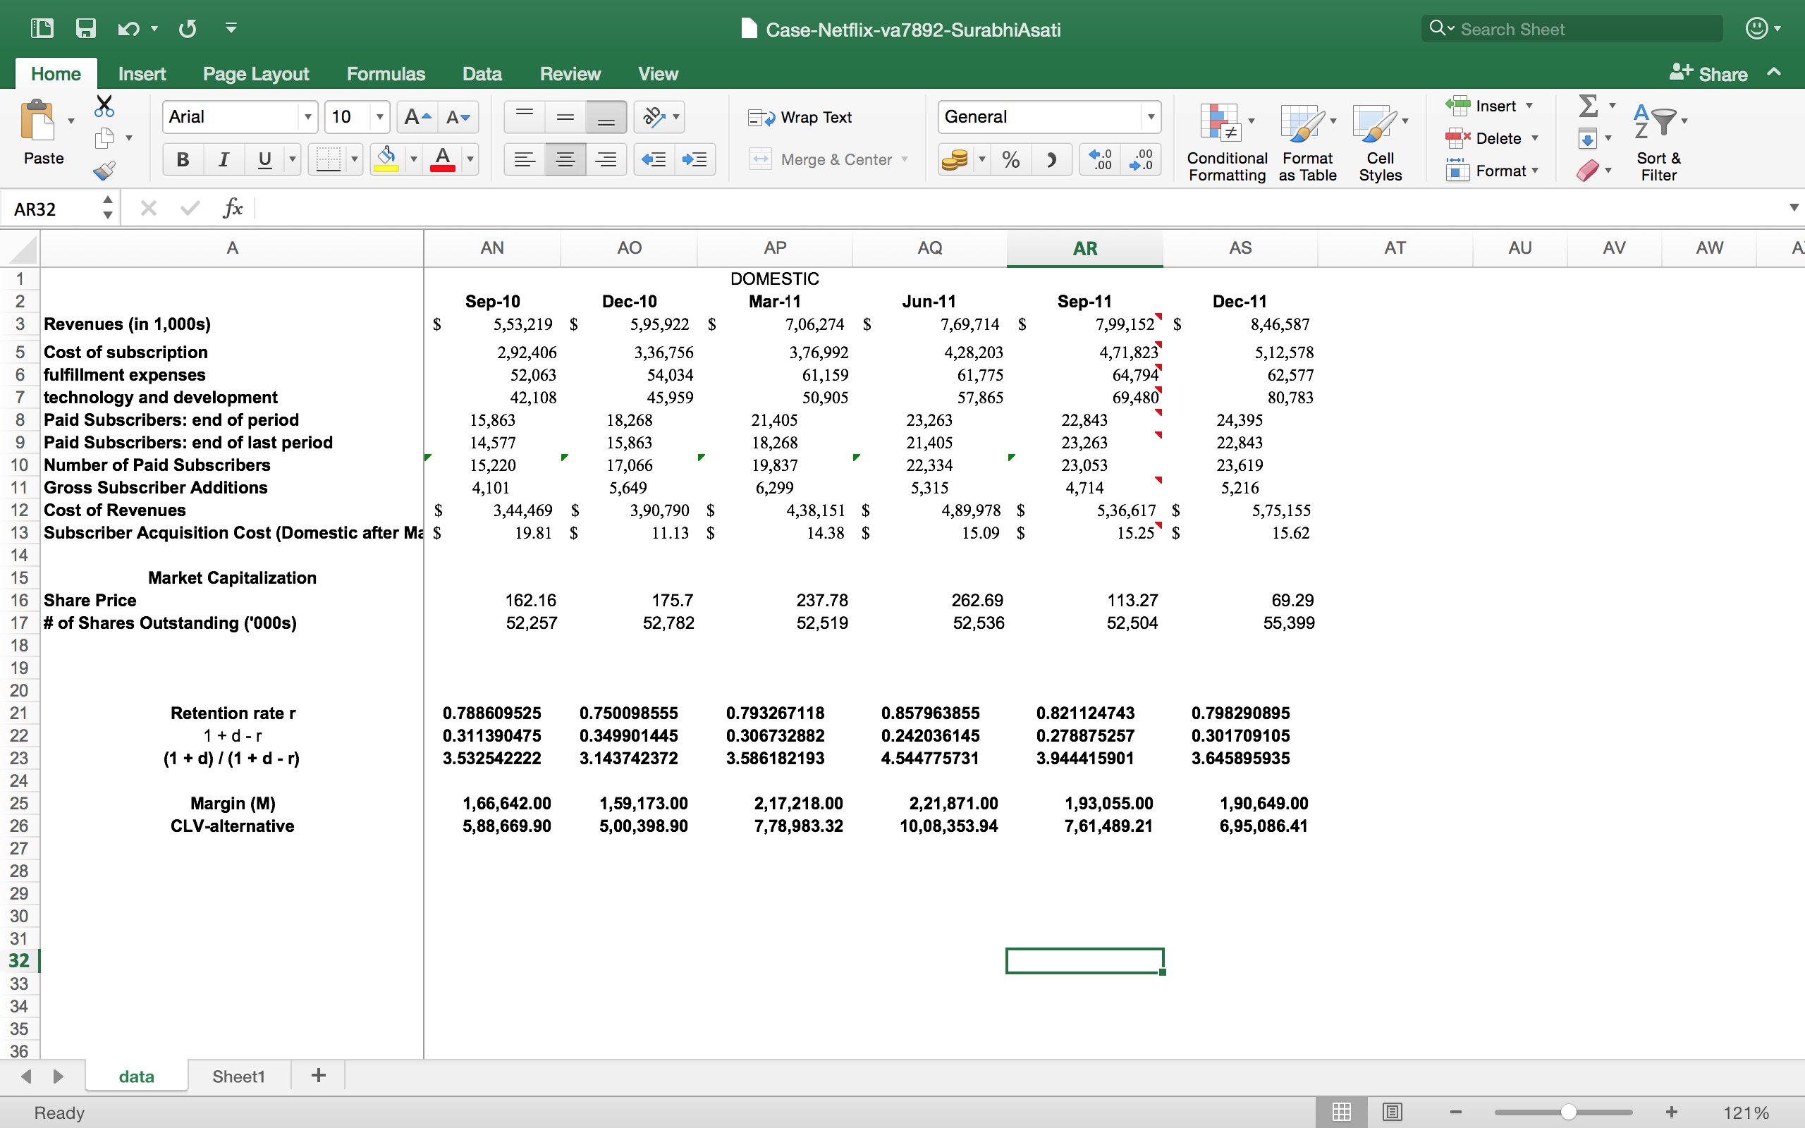

Answer 2:

Answer 3:

Netflix’s major focus this year is on Customer acquisition, Maximizing customer lifetime value. By tracking each customer individually, Netflix can optimize their lifetime value. For example, they know that if you don’t continually rent movies, you’ll cancel sooner or later. Because of this they added features like a queue where you can create a list of all the movies you want to watch. So, after you are done watching a movie, they keep on sending you more discs because you’ve told them what you want to watch. This is much more efficient then having your login every time after you finish watching one movie and asking Netflix to send you another.

Answer 4:

“Change is everything”. To keep at par with the competitors Netflix should implement new technologies. Netflix’s transformation has been rocky at times, but its evolution has become an example of how companies can adapt, tapping their legacy businesses to fuel growth in new areas as the ground underneath them shifts.

According to Boston Consulting Group Netflix is in second place among its TV network and subscription video-on-demand peers. It predicted that Netflix would spend $5 billion on content this year. making it one of the biggest spenders in media in the category.

Netflix biggest threat is Amazon as it global rollout begins with "The Grand Tour" and is expected to expand rapidly into new markets.

Netflix, in addition to the increased competition from Amazon is confronting a more aggressive Hulu, which plans to launch a live streaming TV service in 2017, in addition to its original and third-party content.

Answer 5:

Netflix has more than 5 million DVD subscribers which is a significant falloff from its peak of about 20 million in 2010; still the division continues to churn out millions of dollars in profit each year. The engineers at Netflix are trying to improve customer service and streamline the labor-intensive process of returning, sorting and shipping millions of DVDs each week.

Even as the Netflix subscribers’ base shrink, it has kept a core base of customers, particularly in rural zones with bad internet service and among people who and access to the breadth of its selection, and executives expect it to stay around.

Physical discs still own a huge percentage (~ 80%) of the content delivery market and Netflix claims to deliver DVD’s within 24 hours and plans to expand across the world this year. Netflix has managed to maintain a profitable physical DVD operation even as it transforms itself into a global streaming service.

CLV depends on the extent to which Netflix can leverage its large catalogue by encouraging it’s customer to rent more. With higher DVD sell, the CLV will enhance. Efforts in promoting DVD rents showed an upward trend in customer retention. To further hold on to these customers and the profits they bring, Netflix should continue to deploy innovative technologies that help trim costs as well as improve customer service.

References:

<https://www.nytimes.com/2015/07/27/business/while-its-streaming-service-booms-netflix-streamlines-old-business.html?_r=0>

<http://www.msn.com/en-au/money/technology/the-biggest-new-threat-to-netflix/ar-BBpgkze>

http://fortune.com/2016/12/06/netflix-future-tv/