**Ohio Art Company Case**

**Introduction:**

The Ohio Art Company is an American manufacturing company founded in 1908. Based in Bryan, Ohio, the company is principally engaged in two lines of business. The first line of business is the sales, marketing and distribution of toys including Etch-A-Sketch and Betty Spaghetty. The second line of business is the company’s Diversified Product segments which manufactures custom metal lithography for food container and specialty premium markets.

**Product Portfolio:**

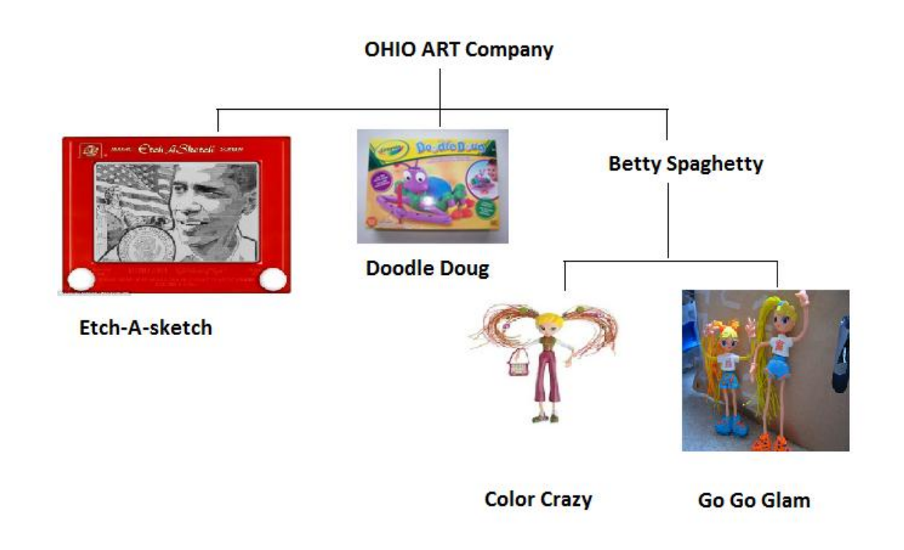

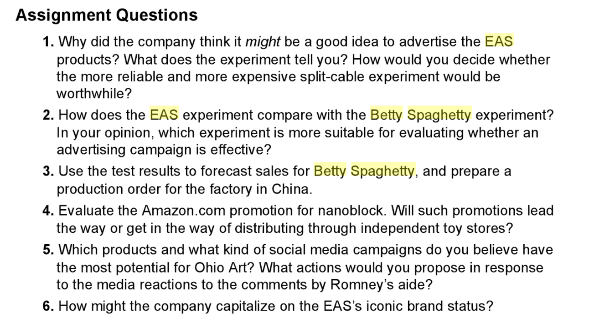

**Answers:**

**1.**

Etch-a-Sketch is an iconic product. It is personification of creativity. The company not only just wanted to boost sales of Etch-a-Sketch but also wanted to get people to remember Etch-A-Sketch again, and give them a reason to go buy this product in the store. The company thought they can use TV advertising to boost sales of Etch-A-Sketch. So the managers were aware of that they need to take care and pay attention to TV advertisement timing is because EAS is a highly seasonal product. The company was focused on finding out whether TV ads help Etch-A-Sketch sales increase.

**The Split Cable experiment:**

* Keeps track of what people buy, giving potential customers id cards that are scanned at checkout counters. Separate advertising campaigns or a different level of advertising exposures to different groups of households within a given market and track purchases through consumer diaries or other panel data and eliminates differences in retail environments, competitive activity, and other market characteristics among test and control groups.

**2.**

|  |  |  |
| --- | --- | --- |
| **Factors** | **Etch A Sketch Experiment** | **Betty Spaghetty Experiment** |
| Test City | Cincinnati | Arizona, Phoenix |
| Control Cities | Charleston, Cleveland, Indianapolis, Pittsburg | California |
| Media Spend | $30,150 | $39,522 |
| Duration | 3 weeks | 4 weeks |
| Time Period | November 27 to December 16 | 2006 June 17 to July 14, 2007 |
| Mode of communication | TV commercials | TV and Radio Commercials |
| Shows | Morning and evening talk shows, daytime soaps, evening news program | Cable channels like Nickelodeon and Cartoon Network; radio commercials on morning & evening commutes |
| Cost of Developing ads | $75,000 | $150,000 |
| Target Audience | Adults and kids | Girls aged 2 -11 years |
| Average gross margin | 58% | 56% |
| Reach of each commercial | 3.7% of population in Cincinnati | 1.8% of population in Phoenix |

**3.**

**Calculating projected lift: Betty Spaghetty**

|  |  |
| --- | --- |
| Test % of California sales | 10% |
| Total California Units | 1420 |
| California % of National sales | 12% |
| National retailer sale | 11833 |
| Retailer share | 25% |
| National Units | 47333 |
| Test % of Annual sales | 5.50% |
| Annual sales | 860,606 |
| Holiday % of Annual | 45% |
| Holiday Units without ads | 387273 |
| **Lift from Ads** | **267%** |

Holiday Units without ads = 45% of annual sales

= 45% of 860,060

= 387273

**4.**

Since Ohio had no purchase history for recommendation engine, it decided to fund a promotion for its Eiffel Tower nanoblock set in the “Lightning Deals” section of Gold Box to improve the recommendations. These “Lightning Deals” increased the number of user clicks on the nanoblock product, thereby increasing the relevance of Ohio Art and nanoblock even after the promotion ended

Gold Box promotion (on March 4th) :

* Price of Effil Tower nanoblock  - $12.99
* Number of Products Sold - 300
* Amazon Charged - Number of units made available * discount

= 300 * 7 = $2100

* Revenue (Ohio Art Made) - $12.99 * 300 = $3897

Amazon like platforms provides better customer acquisition and more reach to diverse markets but may cannibalized the offline retail stores sales. Also, multi-channel distribution and offline-online presence are very important strategy to stay competitive. Traditional Retail Top Stores has their own importance in terms of brand awareness and creating trust factor among consumers.  Therefore, such promotions will lead the way of distribution through retail toy stores.

**5.**

The Ohio Art Company launched new political-themed ads, after the toy made headlines when an aide for presidential hopeful Mitt Romney compared it with Romney’s fall election strategy. The Ohio Art Company launched an online ad and social media campaign to keep the toy in the national dialogue through the fourth quarter of 2012 and to find an interesting and creative way where the company can keep the conversation going throughout the fourth quarter.

In addition to a series of politically-themed online ads, Etch A Sketch has launched ShakeitupAmerica.net, where people can alternately shop for Etch-A-Sketch and other Ohio Art projects and register to vote. This concludes that politically-themed social media campaigns have the most potential for Ohio Art Company

6.

Ohio Art capitalized on EAS’s brand status in following ways:

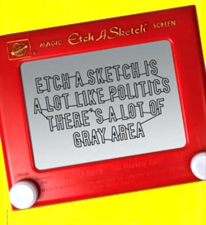

1. **Instant Product Placement on the Presidential Campaign Trail**

The Ohio Art capitalized on having its name in the news by creating a social marketing program that ties directly to the controversy while encouraging voting

.

Senior Romney Advisor Eric Fehrnstrom compared transitioning from in-party primary campaigning to the presidential campaign with an Etch-A-Sketch saying, “You can kind of shake it up, and we start all over again”, alluding to the fact that the campaign was looking forward to getting a do-over and Political experts and Romney’s competition jumped on the bandwagon to ridicule the gaffe. Ohio Art saw stock prices triple and sales increase 1500%. Etch a Sketch memes were spawned and it was the top searched term on Yahoo and Twitter Trends.

Etch A Sketch is the iconic brand ideally positioned for the development of value-added initiatives through an innovative model. It can capitalize on branded search traffic and can utilize a Pay Per Click campaign. It can also generate video content and spread awareness via dominance on Instagram and a pinterest board.