**Marketing Analytics: Assignment- 6 May 21st, 2017**

**Submitted by: Surabhi Asati**

**Net-ID: va7892**

**RETAIL RELAY**

1. **What is the expected customer lifetime value of a newly acquired customer? Use an annual discount rate of 10%.**

**CLV is calculated using following equation:**



where, rt is retention rate

Mt is the contribution margin of shopping basket at purchase occasion t

I is the relevant discount rate between any two purchase decisions

**i = (1 + a)1/17.33 – 1**

Average purchase time in this data is about three weeks, the relevant discount rate can be approximated by dividing the annual rate by 17.33

Given: Annual discount rate = 10%

**i = (1 + 10/100)1/17.33 – 1**

**= 0.0055**

**For Example, t = 5, (1 + i)(t – 1) = (1 + 0.0055)(5-1) = (1.0055)4 = 1.0221**

**t = 2, (1 + 0.0055) (2-1) = 1.0055**

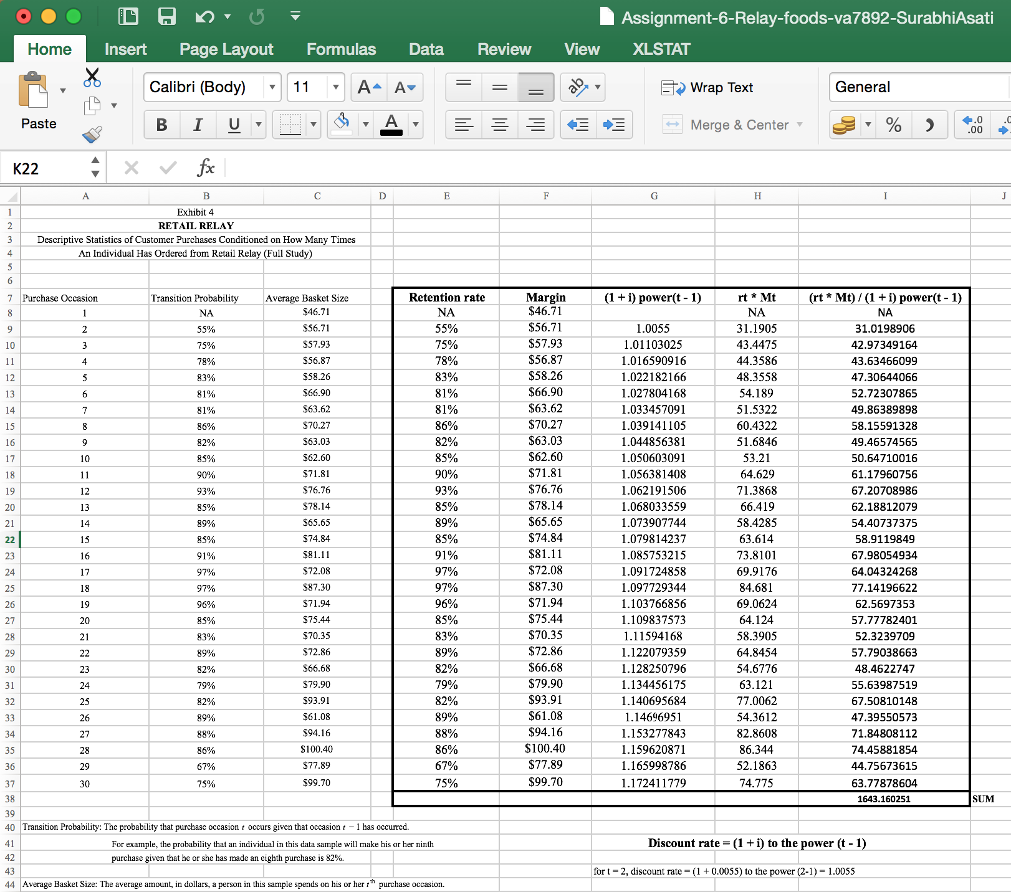

The expected CLV of a newly acquired customer is 1643.2

(attached the excel worksheet)

**2. Do you think this value is likely to increase or decrease as Retail Relay grows into a larger**

**company?**

Customer Lifetime Value is the amount calculated within a certain period and a dollar value is attached to that customer’s benefit to the company. Given that this is calculated for a given amount of time, it is important that this length of time is maintained over a larger time span. This would mean that Retail relay can maintain a consistent database of repeat customers. Retention rate is critical for this business and repeat customers will ensure that the margins are kept up. Higher margins would translate to higher CLV numbers as well. The frequency of the customer to Retail Relay will determine that the retention rate and therefore the increased CLV keeps pace with the growth of the company.

**3. Is the Valpak promotion worth pursuing at a larger scale? What about door-hanger coupons?**

Valpak promotion would mean continuing the tradition of inserts within the blue envelope. This had worked in Charlottesville and he Retail relay was trying to continue this in the newer markets of Richmond. Now Richmond is a larger metropolitan compare to Charlottesville. And this would mean a bigger, more thumping address of advertising and promotions to begin with. Having said that, it was proven to be successful previously and they have still had faith in its future. The initial costs of dong the Valpak inserts was marginal. For a mere $1100 they could reach 60,000 homes.

This could be quite a convenient statistic when it came to a larger metropolitan area like Richmond. It also generated 58 new customers with 10 repeat customers. If these numbers translated to Richmond, it would mean a good initial growth for Retail Relay and justify its expenditure on it.

When it comes to door hanger coupons, it seems like a bigger investment with comparatively smaller return. This is mainly because of the larger geographic area of Richmond. Although it would have been feasible in Charlottesville, it would require a bigger manpower to pull off in the metropolitan area. Door hangers are better suited to smaller locales.

**4. Would you recommend any adjustments to the company’s social media marketing campaign?**

Currently Retail Relay is focused on email advertising. The current wave of Facebook notifications is barely used by them. Facebook allows not only a platform to inform but also to engage their customers in a productive manner. Just like how it does utilize newsletters to talk about its suppliers, putting it on a Facebook page will make it mobile friendly, not to mention more accessible. The clientele can also communicate via this and allow the management to take valuable information to put back into the business. Feedback, ideas and a general opportunity to connect with its customers is a suggested approach for its next generation planning and Facebook is the way to go about it.

Another social media marketing would be to participate in Affiliate marketing which allows them to advertise in the suppliers’ forums. This gives them a wider database not to mention a direct access to the suppliers’ clientele that does not operate via Retail relay.

**5. Should Retail Relay move forward with the Richmond expansion?**

Expansion to Richmond should certainly be considered since it would mean the next step for Retail Relay. However, it’s not an exact replica of Charlottesville. Firstly, it is lager metropolitan. With a 1.2 million population. This change the logistical planning itself. Once it has the cost to operate the Relay truck, sorting facility expenses and supplier incentives sorted out, it will have all its ducks in a row. Another factor would be advertising in a larger geographical location. Acquiring and retaining customers and having repeat customers is important to the success of retail relay. Although it has had a substantial amount of capital injected into the business from a VC, it must decide if these initiatives will reap a decent ROI. Additionally, if they can source their products from current suppliers that would mean one less capital investment. However, even if they can’t do so, establishing these features first would allow them to move in seamlessly. All in all, it seems like a profitable market and worth exploring.

**Chapter – 14: Retail Relay Revisited**

**Question:**

Would a logistic regression analysis reveal the keys to improving customer retention?

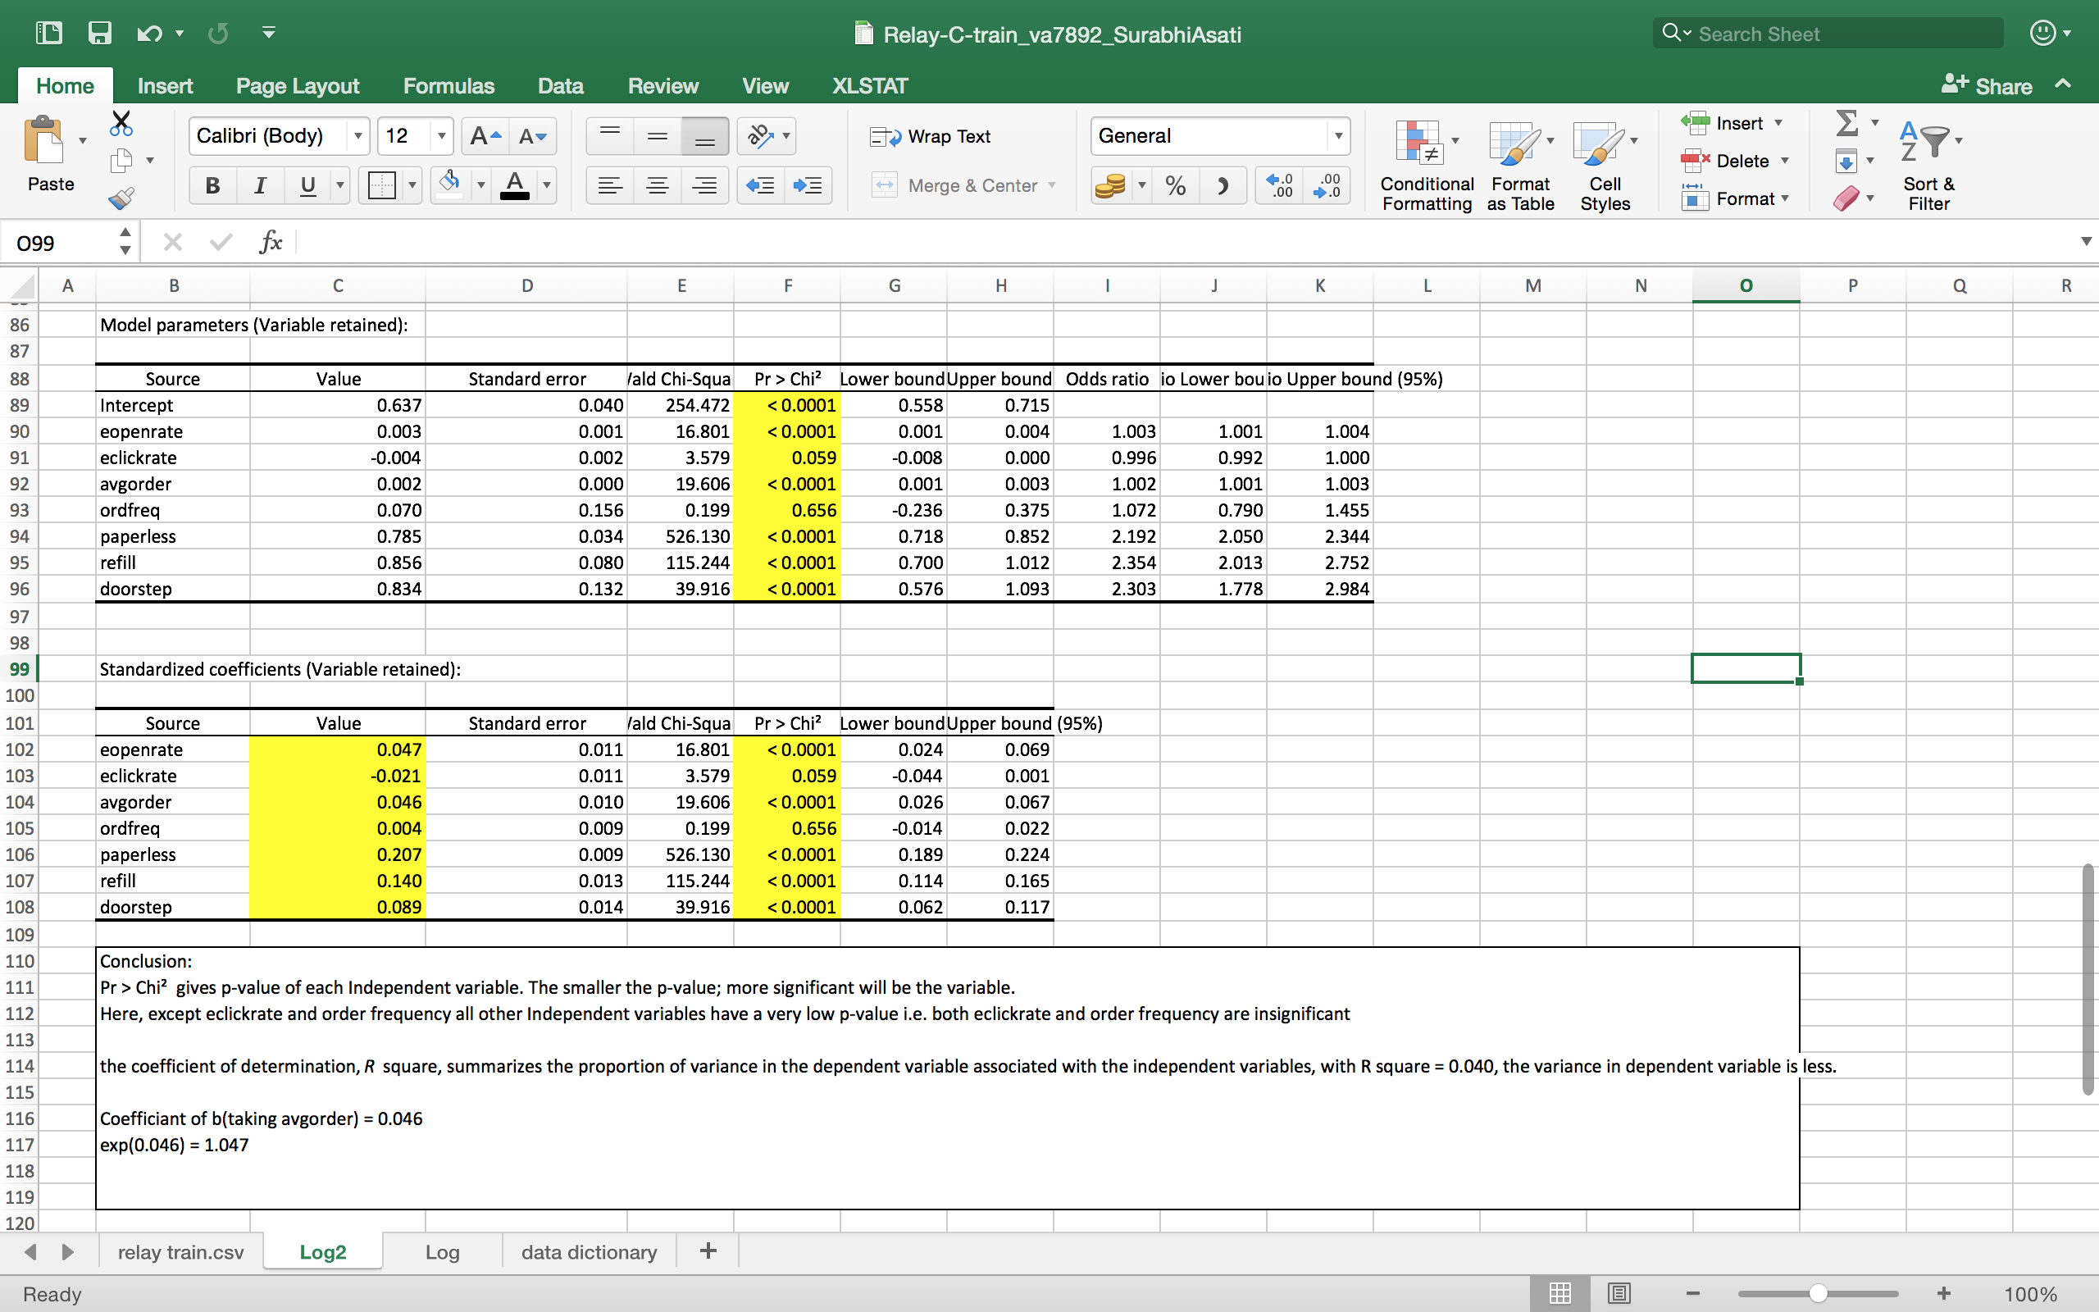

Attached the Excel worksheet with regression Analysis

Interpretation of the Analysis:

* Pr > Chi² gives p-value of each Independent variable. The smaller the p-value; more significant will be the variable.
* Here, except eclickrate and order frequency all other Independent variables have a very low p-value i.e. both eclickrate and order frequency are insignificant to impact customer retention
* The coefficient of determination, *R* square, summarizes the proportion of variance in the dependent variable associated with the independent variables, with R square = 0.040, the variance in dependent variable is less.
* Coefficiant of b(taking avgorder) = 0.046
* exp(0.046) = 1.047

**References:**

<http://www.lexjansen.com/nesug/nesug98/solu/p095.pdf>

<http://citeseerx.ist.psu.edu/viewdoc/download?doi=10.1.1.55.7177&rep=rep1&type=pdf>