**Surabhi Asati**

**STAT – 6610**

**Homework assignment-1**

Task: 1

Make a plot using [Gapminder Tools](https://www.gapminder.org/tools/) or [Gapmider Tools Offline](https://www.gapminder.org/downloads/). Print Screen your graph. Rather than using the Print Screen try to use the [Microsoft Snipping Tool](https://support.microsoft.com/en-us/instantanswers/671b2932-1274-452a-905b-f7ed3c7d8818/open-snipping-tool-and-take-a-screenshot). In Windows 10 Start > All apps > Windows Accessories > Snipping tool

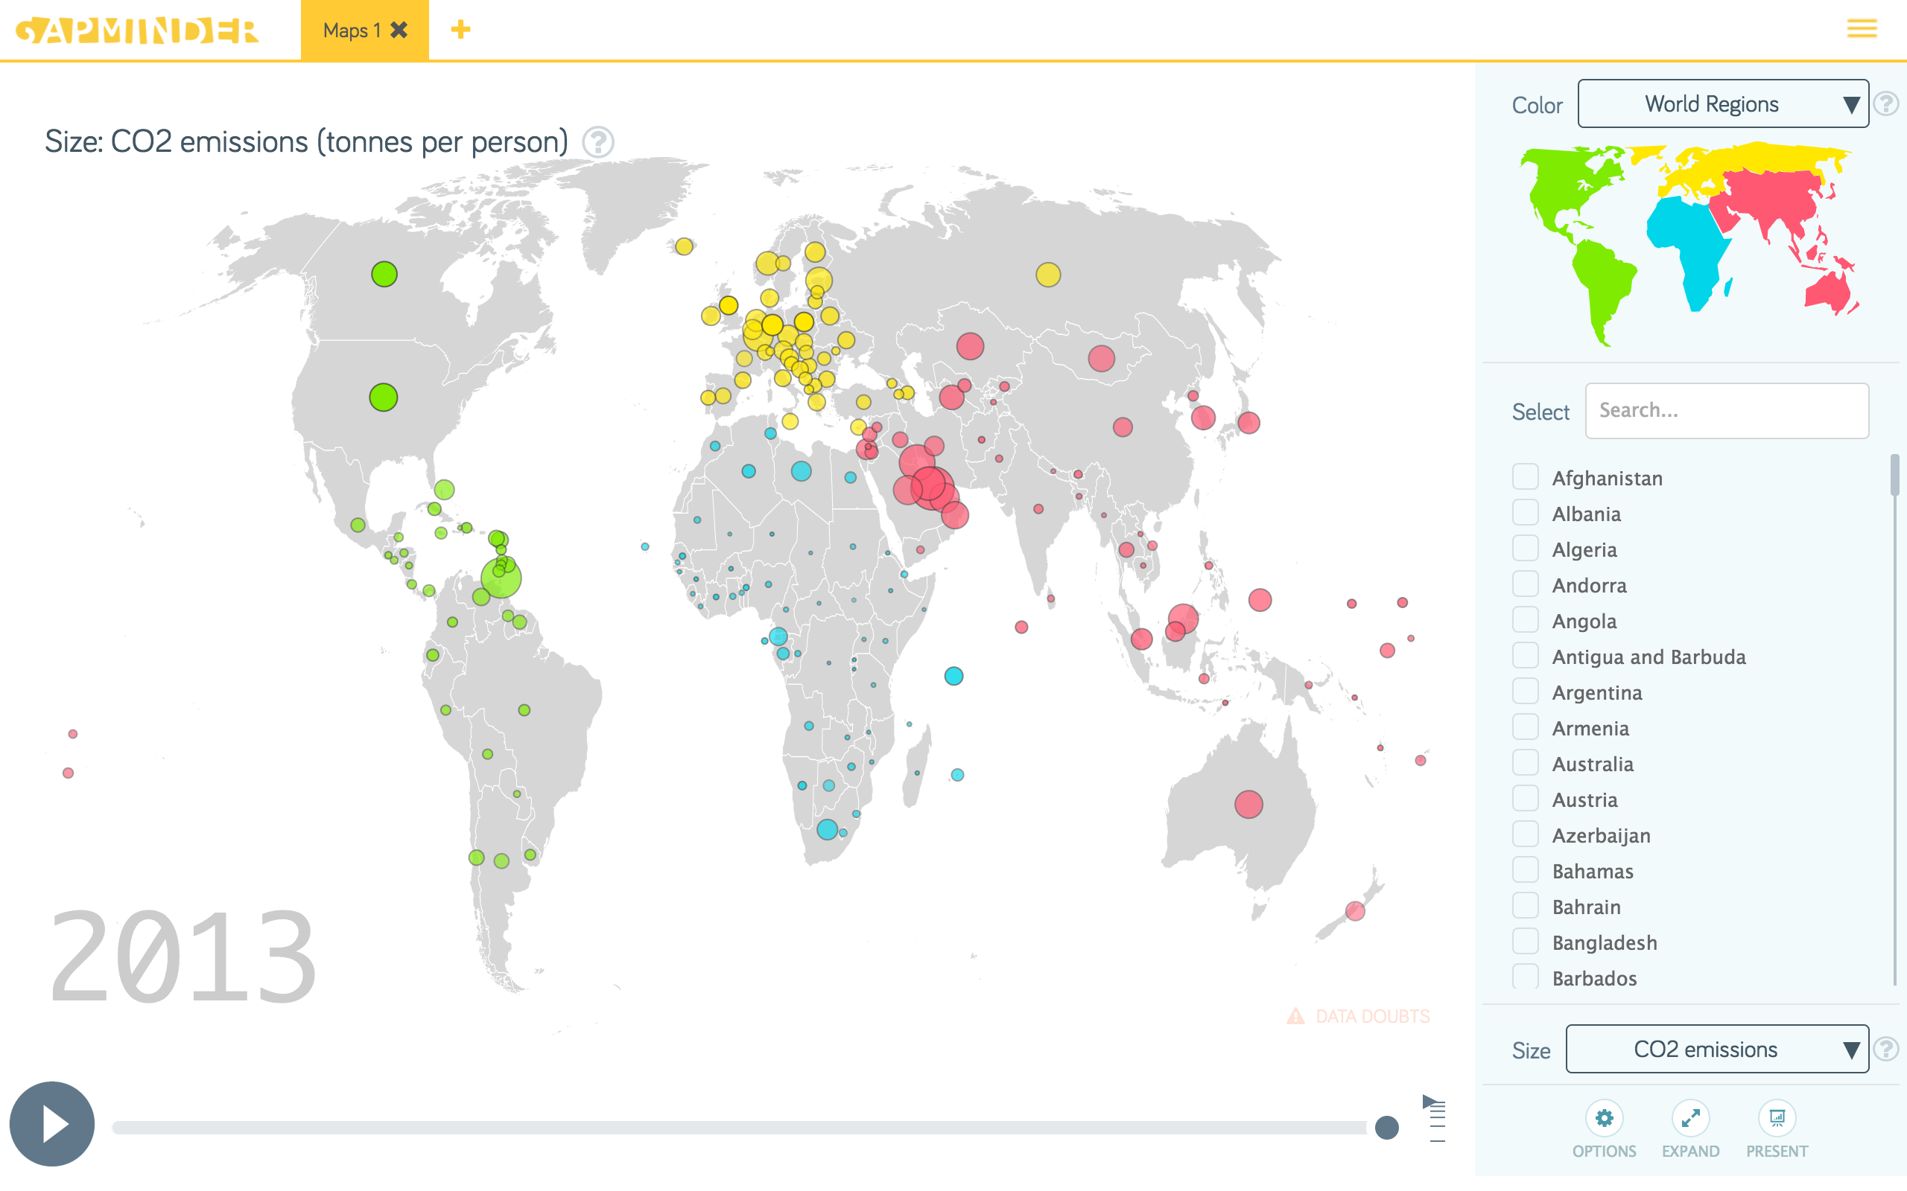

Task: 2

Use [yahoo finance chart](http://finance.yahoo.com/chart/%5EDJI?ltr=1) to plot a time series of a stock you are interested in. Print Screen the picture and turn it in.

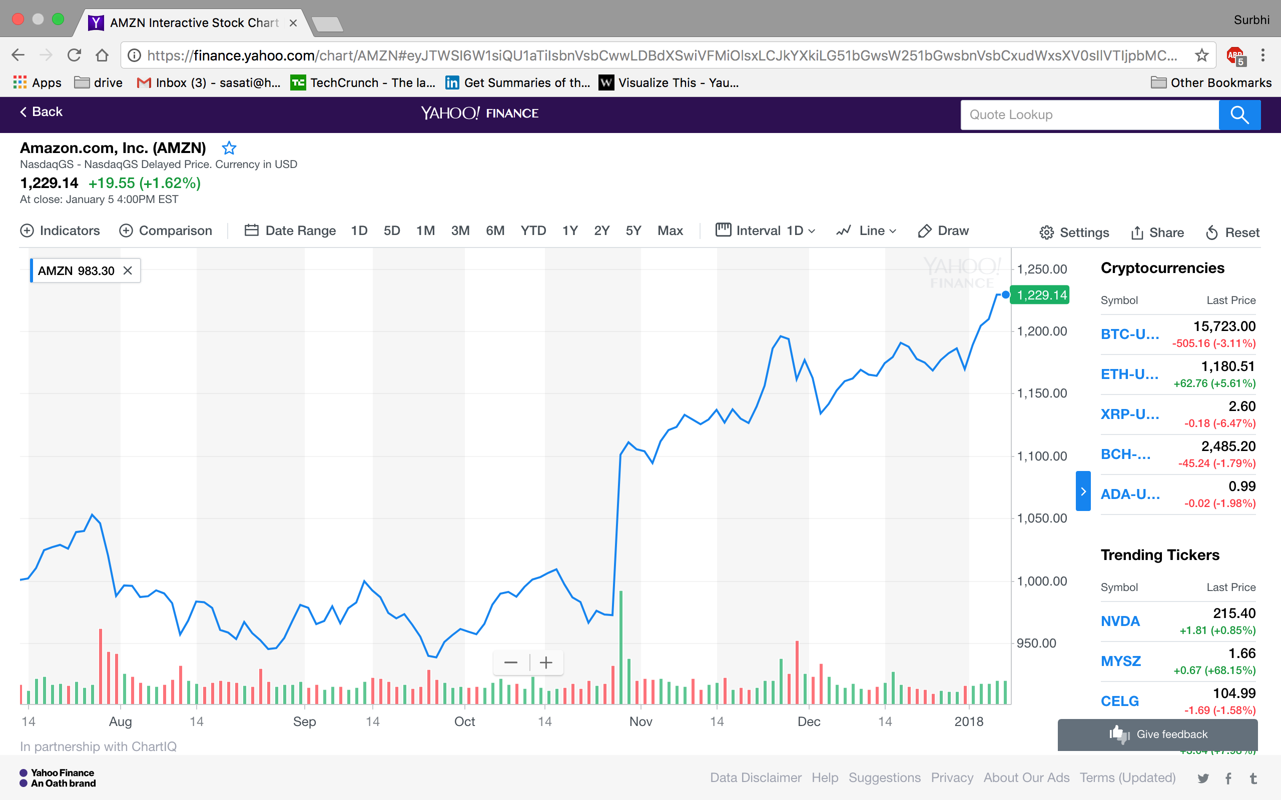

Task: 3

Download the historical data for your stock. [yahoo finance quote](https://finance.yahoo.com/quote/%5EDJI?p=%5EDJI) Check the file to make sure there are no problems, such as, dividend paid. Upload the text data into Tableau Public. Make a time plot. Print Screen the picture and turn it in.

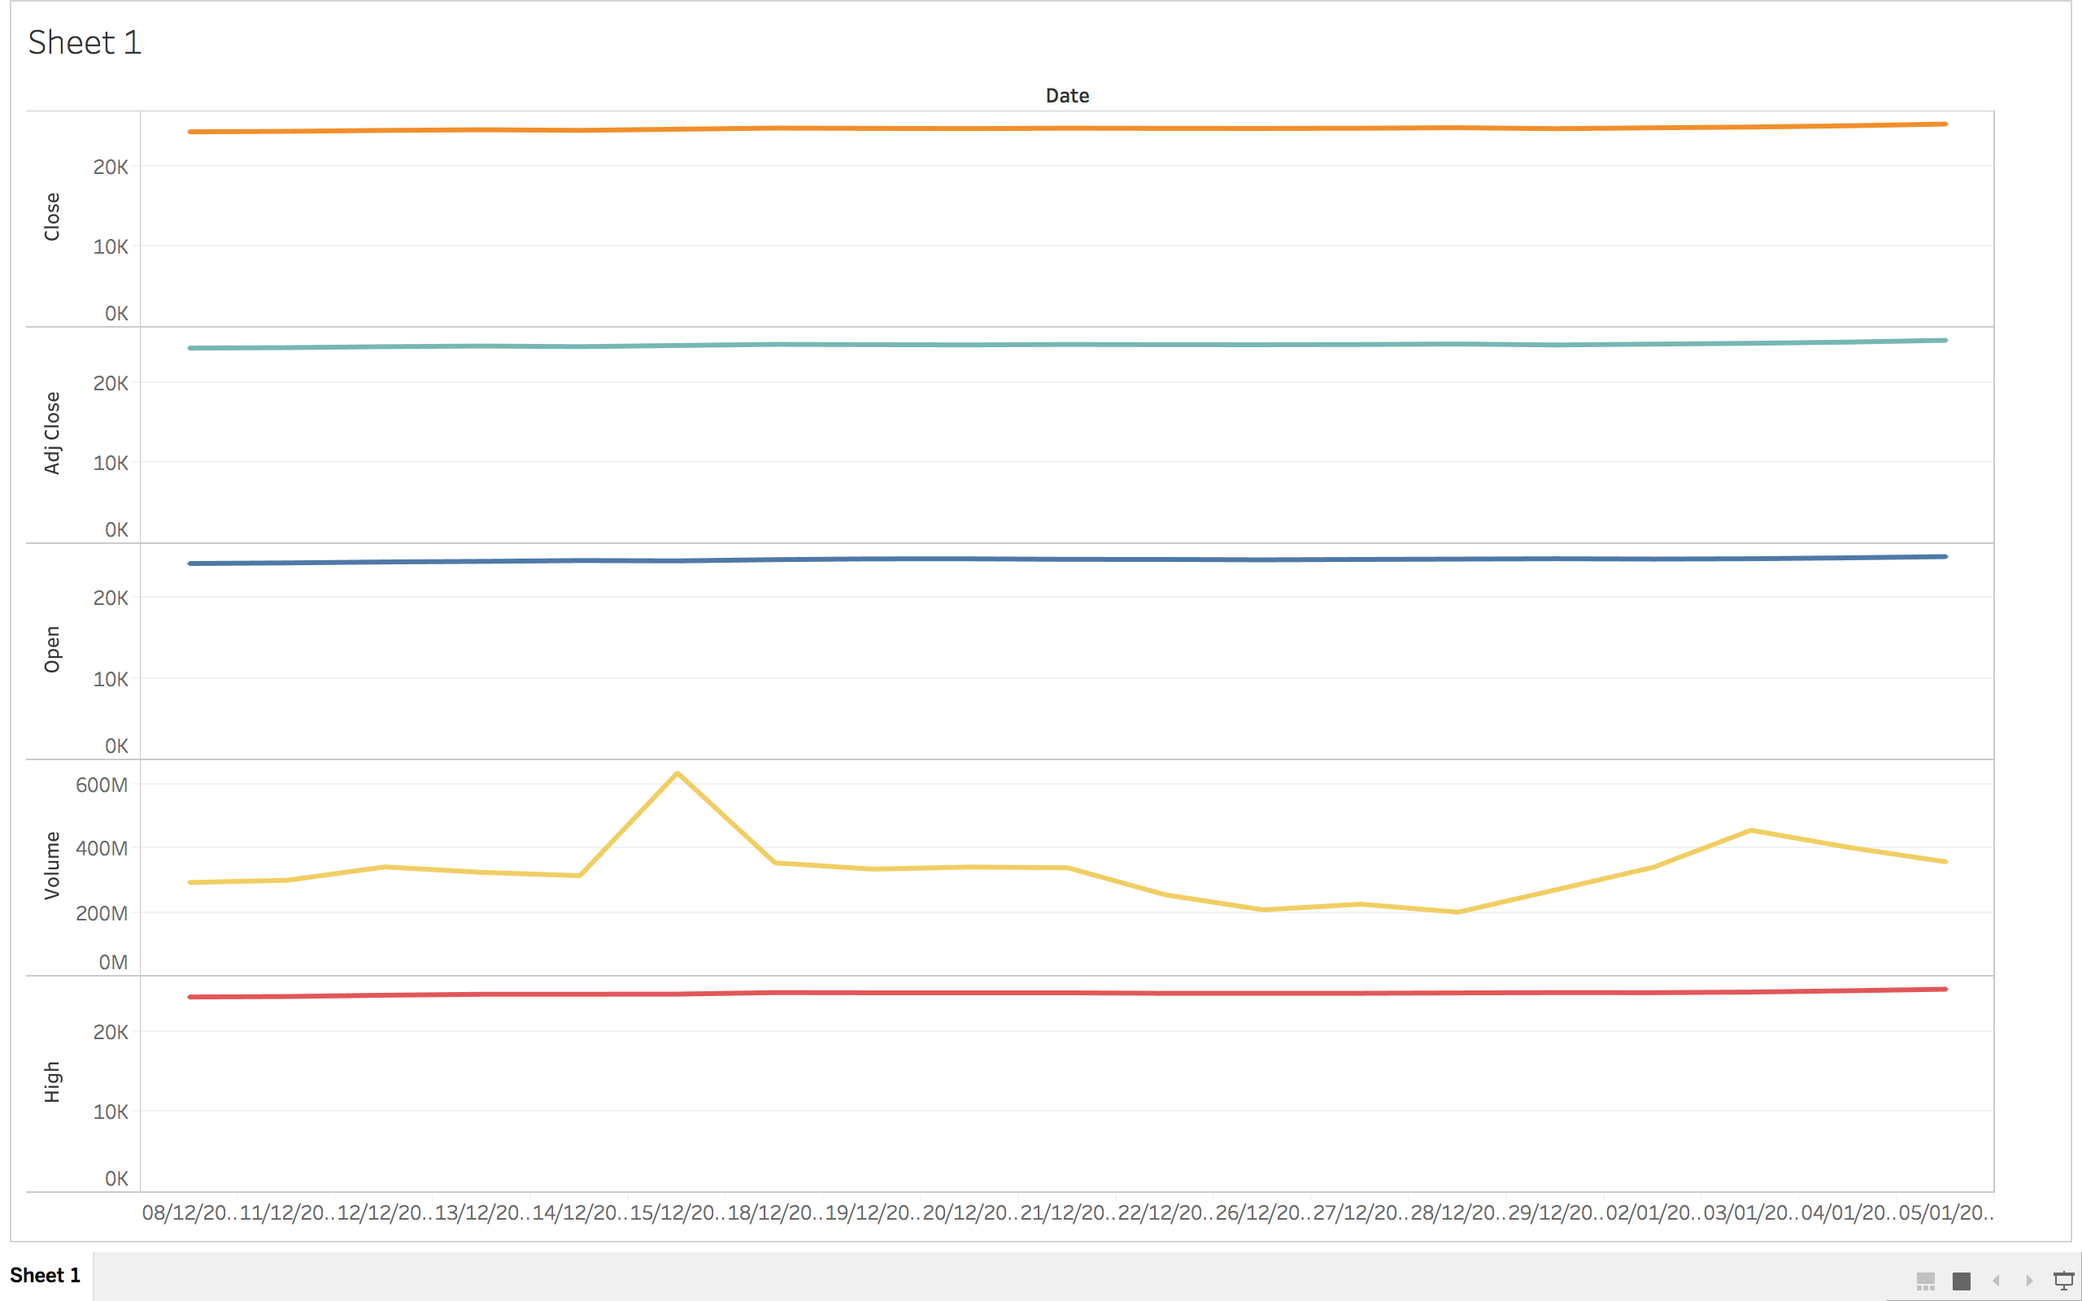

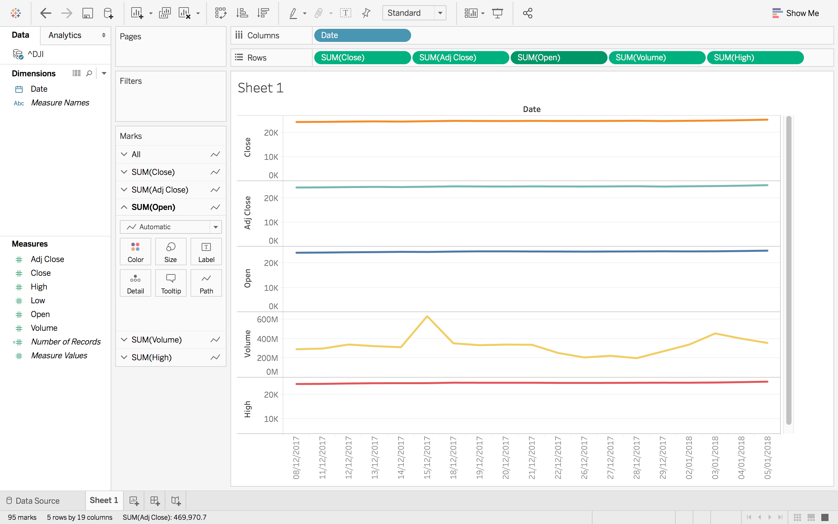

Task: 4

Using R run the cars examples from the ends of the Welcome and GettingStarted presentations. Copy the pictures and turn them in.

