**Stat 6610**

**Data Visualization**

**Project 2**

**Surabhi Asati**

**Va7892**

**Global Sugar production and Consumption**

**Data Source:**

[**https://www.ers.usda.gov/data-products/sugar-and-sweeteners-yearbook-tables.aspx**](https://www.ers.usda.gov/data-products/sugar-and-sweeteners-yearbook-tables.aspx)

**Project Summary**

This project contains analysis of global sugar production, exports, imports and consumptions. I have taken the data from United States Department of Agriculture - USDA. I transformed the data so I could do analysis in the tableau. My analysis shows World Production, Supply and distribution of Sugar with time series analysis for the period of 2007-2017. Following are the highlights of the analysis:

* Brazil, India, and China were the largest producers of the sugar in the world.
* Along with being the largest producers of sugar, Brazil is also the largest exporter. On the other hand, Indian domestic consumption has increased over the years which caused the exports drop drastically.
* While the consumption of sugar has increased in United States, rate of production remains almost the same.
* Although the production of sugar has remained almost constant, price of sugar has been more volatile for last 10 years.

**Story:**

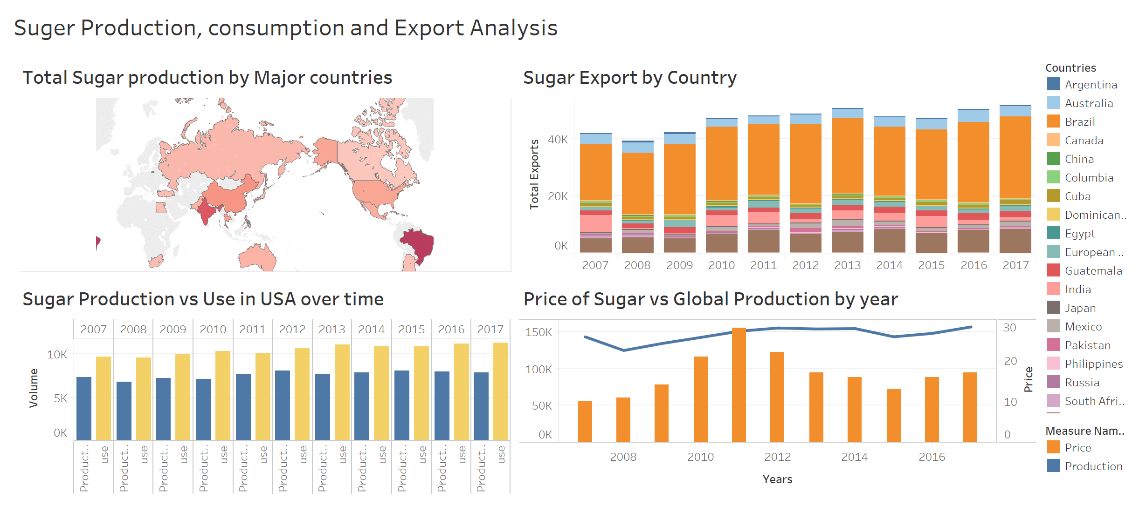

**Live tableau dashboard can also be accessed from this** [**url**](https://public.tableau.com/profile/surabhi7515#!/vizhome/Assignment2_613/Story1?publish=yes)**.**

I am attaching the downloaded data workbooks along with my workbook that contains cleaned and transformed data that I’ve used for visualization.