Quiz 2

Name: Surabhi Asati

Class Time: 12:00 PM

# Statistics 4868/6610 Data Visualization

# Fall 2018, Prof. Suess

**Instructions:** Download the quiz file to your computer and type your answers on your test paper in the space provided. This is an open-book and open-computer quiz. You may use a calculator if needed.

1. **What does the author mean by his tip, “Visualization is about communicating data, so take the time to learn about what makes the base of your graphic, or you will end up spouting numbers.”**

With his tip, “Visualization is about communicating data, so take the time to learn about what makes the base of your graphic, or you will end up spouting numbers.” The author is advising us to learn all we can about our data, to take time to get to know it and learn the context of numbers. This prepares us to design our own graphics. He quotes an example of visual story telling will come natural if we learn all we can about the data from the movie – “The Karate kid.” If we jump right into design without knowing the source data, we may not be able to visualize what we want or miss some interesting points in the data or worse the design would not make sense.

Airline eg

People

Sw airline doesn’t fly to centre of the ocean – airline route example

Overpopulate the picture- mess – not good design to allow the user to produce a mess

Help guide user to use ur viz to be able to make conclusion

Understand map

Geolocation

Don’t allow people to overuse n make a mess

Quantative data – want to look for relationship in data

Pic appropriate viz for the type of data you have

U got data

What to do with it

Go to source

If u donno what to convey,

1. **(Stat. 6610 students) On page 333 the author mentions “dry humor and sarcasm.”**
   1. **What is sarcasm?**

Sarcasm is "a sharp, bitter, or cutting expression or remark; a bitter gibe or taunt". Sarcasm may employ ambivalence, although sarcasm is not necessarily ironic. Most noticeable in spoken word, sarcasm is mainly distinguished by the inflection with which it is spokenand is largely context-dependent.

In sarcasm, ridicule or mockery is used harshly, often crudely and contemptuously, for destructive purposes. It may be used in an indirect manner, and have the form of irony, as in "What a fine musician you turned out to be!, “ "It's like you're a whole different person now...," and "Oh... Well then thanks for all the first aid over the years!" or it may be used in the form of a direct statement, "You couldn't play one piece correctly if you had two assistants." The distinctive quality of sarcasm is present in the spoken word and manifested chiefly by vocal inflection

* 1. **Is the use of sarcasm on the web recommended? If not, why?**

Use of sarcasm on the web is not recommended because it doesn’t translate very well online, especially when people aren’t used to reading one’s writing.

According to Poe’s law: “without a winking smiley or other blatant display of humour, it is utterly impossible to parody a Creationist in such a way that someone won't mistake for the genuine article”

**However,** researchers from Harvard University found in a 2015 paper titled, "The highest form of intelligence: Sarcasm - increases creativity for both expressers and recipients." Sarcasm can be off-putting or endearing. But, in either case, it's smart.

Those who experienced more sarcasm — through expression or reception — in the first task were shown to be more creative in the paper. The research establishes sarcasm as a double-edged sword: it helps people think creatively even as they seethe in conflict. Paper shows that abstract thinking is the driving force that connects sarcasm to creativity and that sarcastic exchanges in trusting relationships boost creativity without incurring conflict. As Oscar Wilde believed, sarcasm, at times, represents a lower form of humanity, but it certainly catalyses a higher form of thought.

Sarcasm is encouraged when individuals know about the appropriate circumstances under which sarcasm can be used. By doing so, both the individuals involved in creatively.”

The Author learned that sarcasm doesn’t translate very well online with his work on a map that compares number of bars to number of grocery stores in the United States. Most people got his joke, but other got offended.

Don’t make joke! On internet

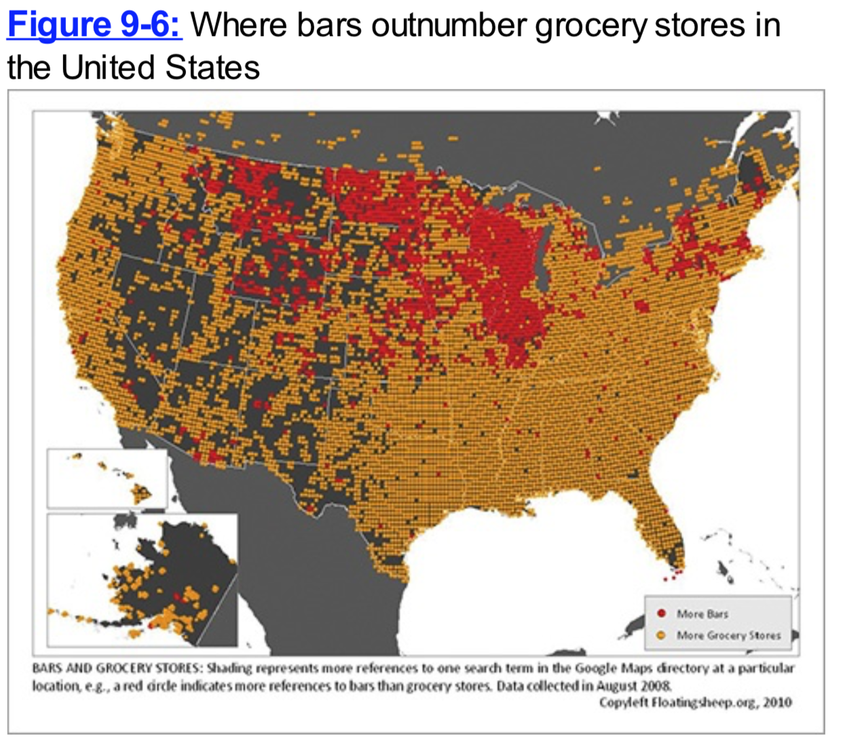

1. **Recall the TED Talk by David McCandless:** [**Beauty of Data Visualization**](http://ed.ted.com/lessons/david-mccandless-the-beauty-of-data-visualization) **and his blog** [**Information is Beautiful**](http://www.informationisbeautiful.net/)**. When we watched the video we did not focus on his opening slide. That slide gives the Colours of Culture. See Figure 9-11.**
   1. **What color(s) represent anger?**

Red -Anger

* 1. **What color(s) represent joy?**

Yellow-Joy

* 1. **What color(s) represent death?**

Black - Death

n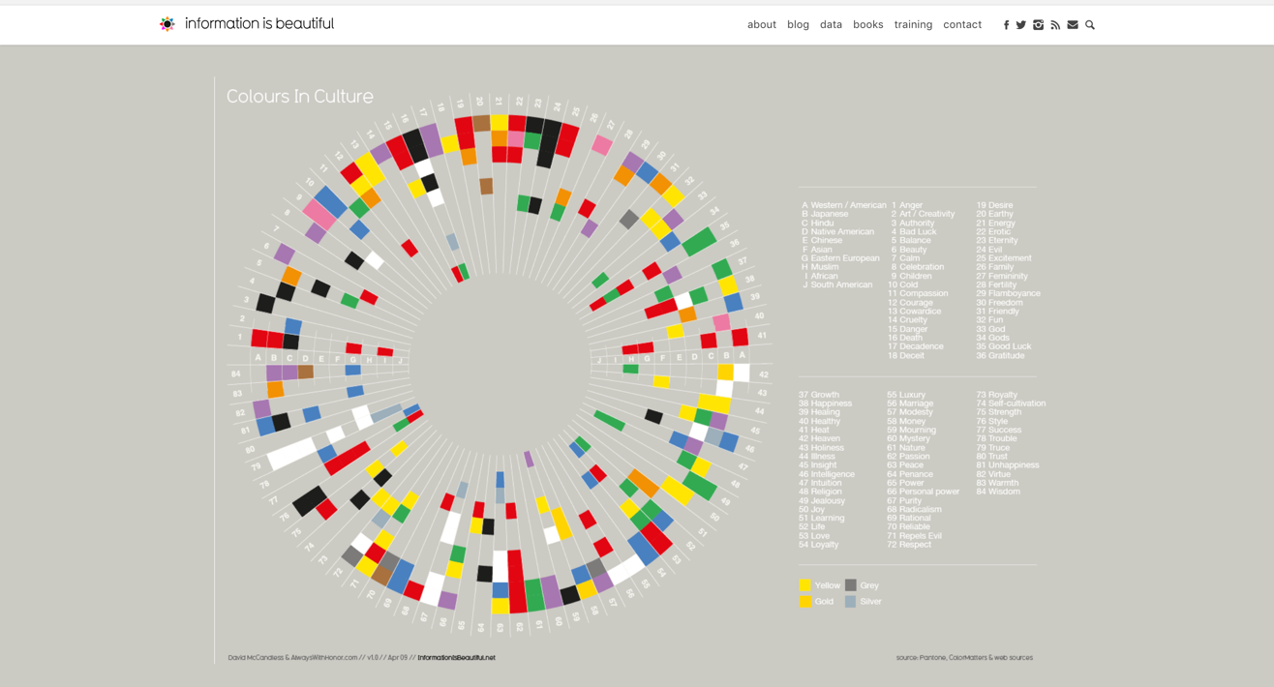

1. **When using color in visualizations there are different kinds of pallets that can be used.**
   1. **Describe the pallet and explain when you would used such a pallet.**

Pallet: Sequential

This palette is suited to ordered data that progress from low to high. It is used when Lightness steps dominate the look of the schemes, with light colors for low data values to dark colors for high data values.

The sequential palettes names are:

Blues BuGn BuPu GnBu

Greens Greys Oranges OrRd PuBu PuBuGn PuRd

Purples RdPu

Reds YlGn YlGnBu YlOrBr YlOrRd

All the sequential palettes are available in variations from 3 different values up to 9 different values.

Less of variable to more variable

Light to dark

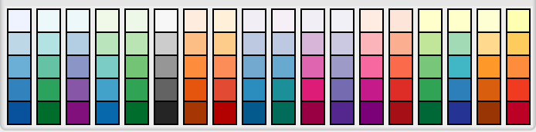

* 1. **Describe the pallet and explain when you would used such a pallet.**

Pallet: Diverging.

Diverging palettes are used when we put equal emphasis on mid-range critical values and extremes at both ends of the data range. The critical class or break in the middle of the legend is emphasized with light colors and low and high extremes are emphasized with dark colors that have contrasting hues.

The diverging palettes are:

BrBG PiYG PRGn PuOr RdBu RdGy RdYlBu RdYlGn Spectral

All the diverging palettes are available in variations from 3 different values up to 11 different values.

Likert scale

Agree – green stock – gain money

Disagree – red - stock loss money

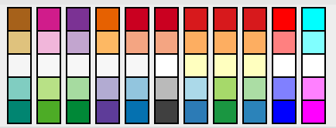

* 1. **Describe the pallet and explain when you would used such a pallet.**

Pallet: Qualitative

Qualitative palettes do not imply magnitude differences between legend classes, and hues are used to create the primary visual differences between classes. Qualitative schemes are best used to representing nominal or categorical data.

For qualitative palettes, the lowest number of distinct values available always is 3, but the largest number is different for different palettes. It is given together with the palette names in the following table.

|  |  |  |
| --- | --- | --- |
| 1 | Accent | 8 |
| 2 | Dark2 | 8 |
| 3 | Paired | 12 |
| 4 | Pastel1 | 9 |
| 5 | Pastel2 | 8 |
| 6 | Set1 | 9 |
| 7 | Set2 | 8 |
| 8 | Set3 | 12 |

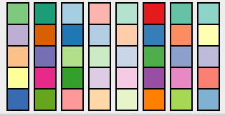

Displaying all pallets simultaneously in rstudio: (Top to bottom) Sequential, Qualitative and Divergent pallet respectively.

Qualitative – no order

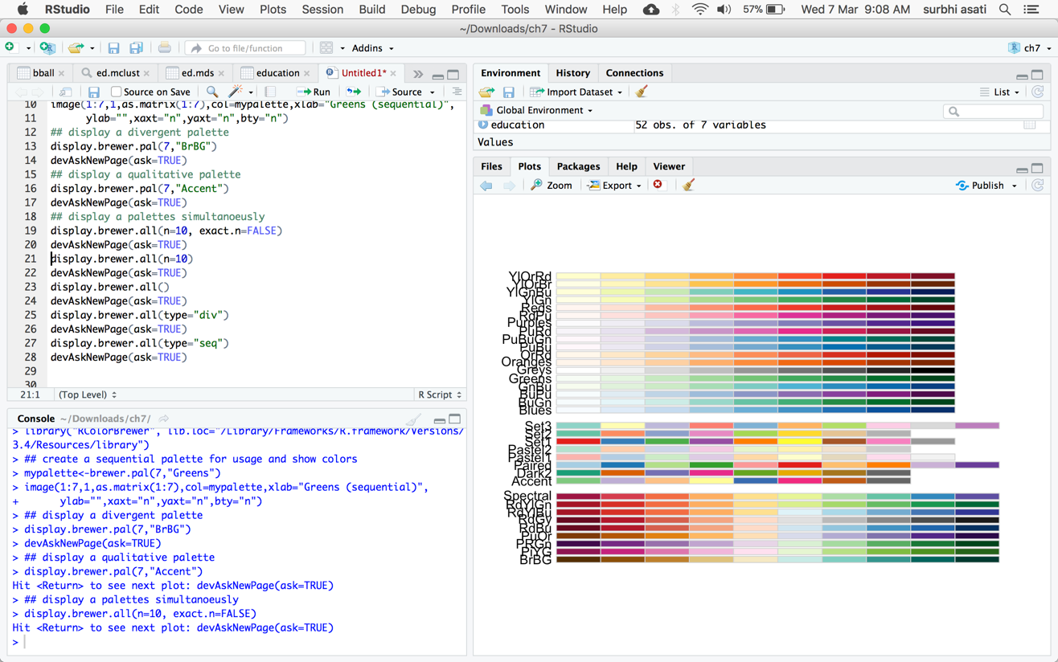

Divergent Pallet:

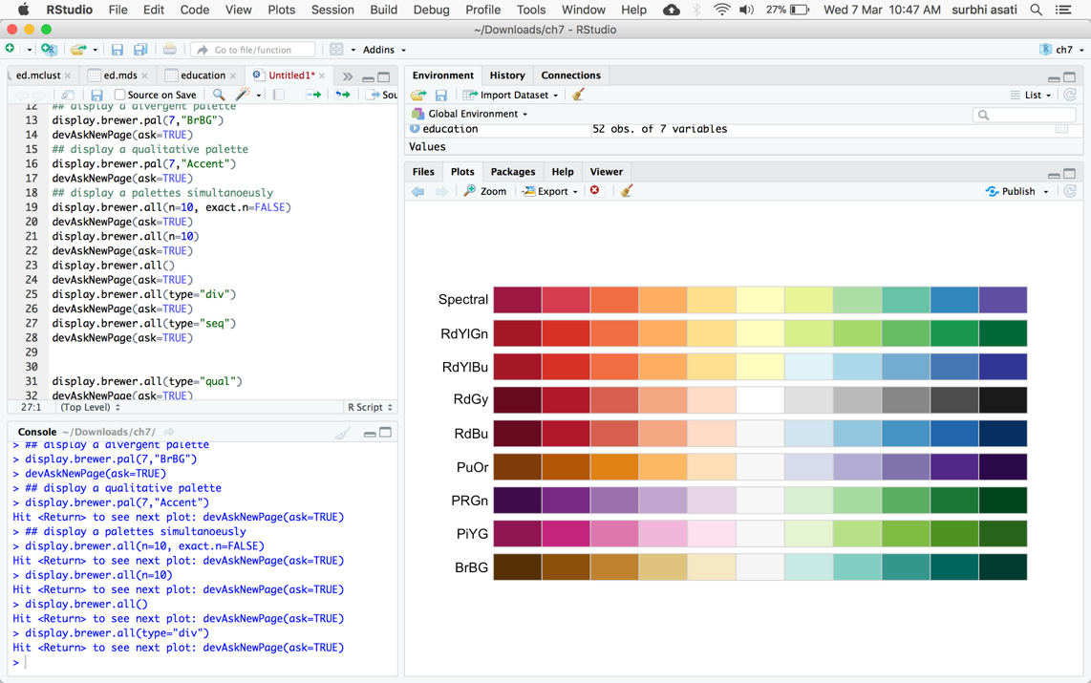

Sequential Pallet:

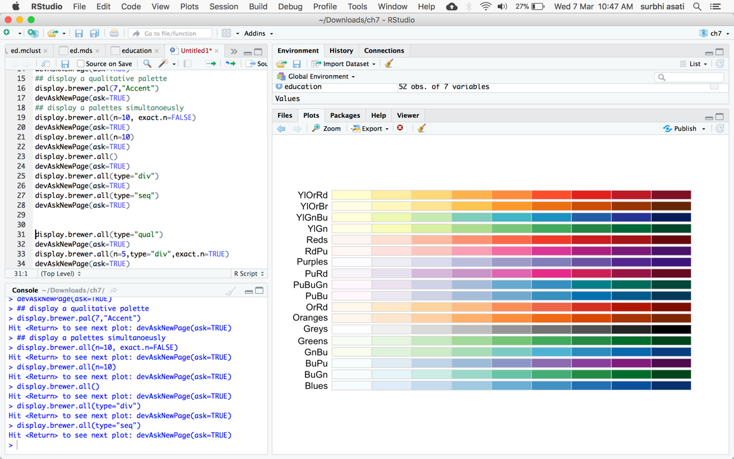

Qualitative Pallet:

