**ECON 6511: Advanced Applied Econometrics**

**Homework 2 January 24, 2018**

**Submitted By:**

**Surabhi Asati**

**va7892**

1. **(Based on Wooldridge, Chapter 12, Problem 2) Let {et : t = −1, 0, 1, . . .} be a sequence of independent, identically distributed random variables with mean zero and variance one. Define a stochastic process by *xt* = *et* - (1/2) *et*-1 + (1/2) *et*-2, *t* = 1, 2, ....**

**(a)  Find E(xt) and Var(xt). Do either of these depend on t?**

E(xt) = E(et) – (1/2) E(et-1) + (1/2) E(et-2)

E(xt) = 0 – (1/2) * 0 + (1/2) * 0

E(xt) = 0

As et is a sequence of independent stochastic variables, they are uncorrelated

Var(xt) = Var(et) + (1/4) Var(et-1) + (1/4) Var(et-2)

Also, Var (et) = 1 for all t. Therefore,

Var(xt) = 1 + (1/4) + (1/4) = 3/2

**(b)  Show that Corr(xt,xt+1) = - ½ and Corr(xt,xt+2) =1/3. Note: For two random variables  a and b, Corr(a, b) = Cov(a,b) / σa σb**

**Cov** (xt,xt+1) = E(xt,xt+1)

= E [(et – (1/2) et-1 + (1/2) et-2) (et+1 – (1/2) et + (1/2) et-1)]

= E(et * et+1) – (1/2) E (et2 ) + (1/2) E(et*et-1) – (1/2) E(e t-1*et+1) + (1/4(E(et-1*et) –

(1/4) E (e t-12 ) + (1/2) E (et-2*e t+1) – (1/4) E(e t-2*e t) +(1/4) E(e t-2*e t-1)

= – (1/2) E(et2 ) – (1/4) E(et2 )

= – (1/2) * 1 – (1/4) * 1

= –3/4

**Corr** (a, b) = Cov(a,b) / (σa * σb)

Corr (xt,xt+1) = – (3/4) / (3/2)

= –1/2

E(et2 ) = 1⁄2

Corr (xt,xt+2) = (1/2) / (3/2) = 1/3

**(c)  What is Corr (xt, xt+h) for h > 2?**

Corr (xt, xt+h) for h > 2 = 0

**(d)  Is {xt} covariance stationary? Is it weakly dependent?**

xt is weakly dependent because Correlation (xt,xt+h) < 1 i.e. observations more than two periods apart are uncorrelated

**2. (Based on Wooldridge, Chapter 12, Problem 5) For the U.S. economy, let gprice denote the monthly growth in the overall price level and let gwage be the monthly growth in hourly wages. These are both obtained as differences of logarithms: gprice = ∆log(price) and gwage = ∆log(wage).**

**(a)  Using the monthly data in WAGEPRC.dta, estimate a distributed lag model:  gprice =α + β1gwaget + β2gwaget−1 + β3gwaget−2 + β4gwaget−3 + β5gwaget−4 + β6gwaget−5 + β7gwaget−6 + β8gwaget−7 + β9gwaget−8 + β10gwaget−9 + β11gwaget−10 + β12gwaget−11 + β13gwaget−12 + ut  and sketch the estimated lag distribution. At what lag is the effect of gwage on gprice largest? Which lag has the smallest coefficient?**

**Using stata:**

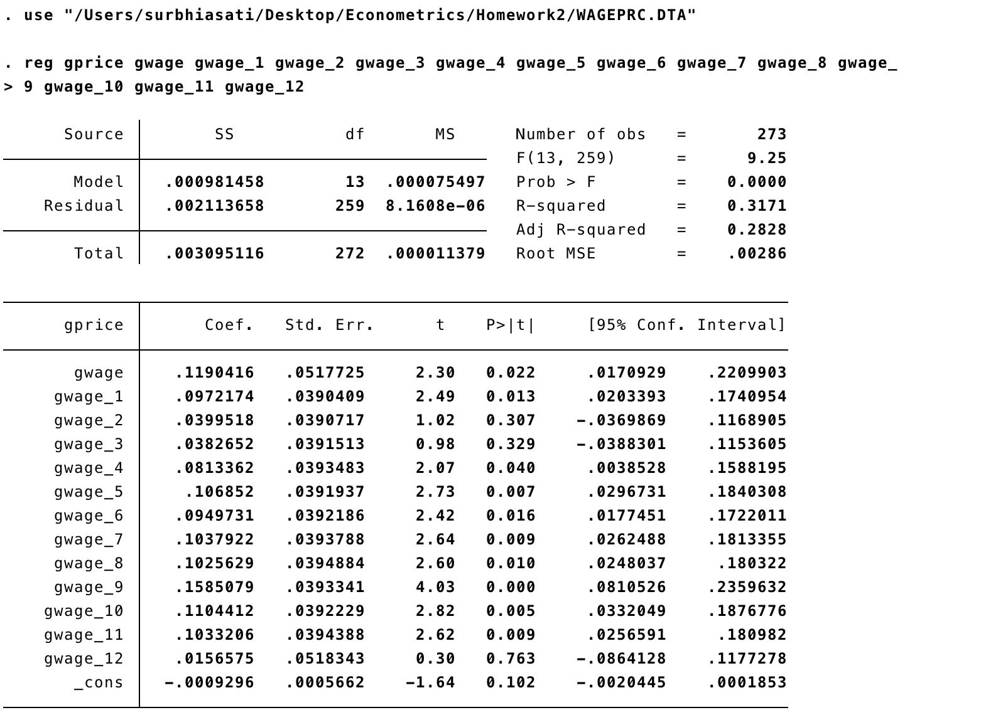

Model:

gprice = - .00 + .11 gwaget + .09 gwaget−1 + .04 gwaget−2 + .04 gwaget−3 + .08 gwaget−4 + .10 gwaget−5 + .09 gwaget−6 + .10 gwaget−7 + .10 gwaget−8 + .15 gwaget−9 + .11 gwaget−10 + .10 gwaget−11 + .01 gwaget−12



The largest effect is at the ninth lag 0.158. The smallest effect is at the twelfth lag 0.015.

**(b)  For which lags are the t statistics less than two?**

The t statistics is less than two at the second (t = 1.02), third (t = 0.98) and twelfth ( t = 0.30) lag.

**(c)  What is the estimated long-run propensity? Is it much different than one? Explain what  the LRP tells us in this example.**

The estimated long-run propensity is the sum of the lag coefficients from zero through twelve. In a distributed lag model, the eventual change in the dependent variable given a permanent, one-unit increase in the independent variable.

LRP = 1.172

As, LRP > 1, is a cumulative effect of wage on price. This difference indicates error.

**(d)  What regression would you run to obtain the standard error of the LRP directly?**

Assuming LRP coefficients = q1, q2, q3, …., q12

LRP = q0, q1, q2, q3, …., q12

q0 = LRP – q1 -q2 -q3- …. -q12

Plug into the estimated model:

gpricet =α + (LRP – q1 -q2 -q3- …. -q12) gwaget + q1gwaget−1 + q2gwaget−2 + q3gwaget−3 + q4gwaget−4 + q5gwaget−5 + q6gwaget−6 + q7gwaget−7 + q8gwaget−8 + q9gwaget−9 + q10gwaget−10 + q11gwaget−11 + q12gwaget−12 + ut

**3. Use the data in PHILLIPS.dta for this exercise.**

**(a) Estimate an AR(1) model for the unemployment rate. Use this equation to predict the unemployment rate for 2004. Compare this with the actual unemployment rate for 2004. (You can find this information in a recent Economic Report of the President.)**

Using stata:

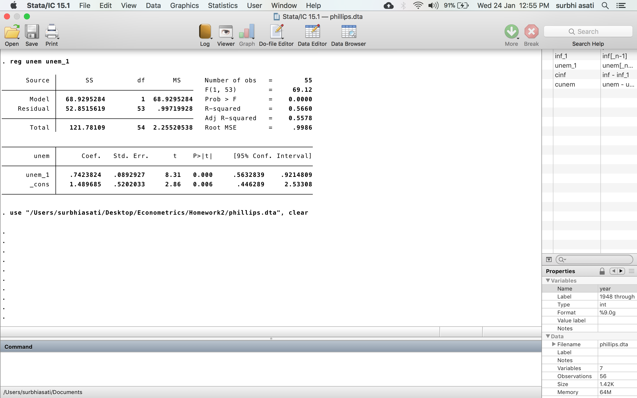

The estimated AR model is:

Unemt = 1.489 + 0.742 Unemt-1

The unemployment rate in 2003 was 6. The predicted unemployment rate for 2004 is

 1.49 + 0.742(6) = 5.94

According to the Economic Report of the President, the unemployment rate was 5.5. Therefore, the equation over predicts the 2004 unemployment rate by 0.44 percentage.

**(b)  Add a lag of inflation to the AR(1) model from part (a). Is inft−1 statistically significant?**

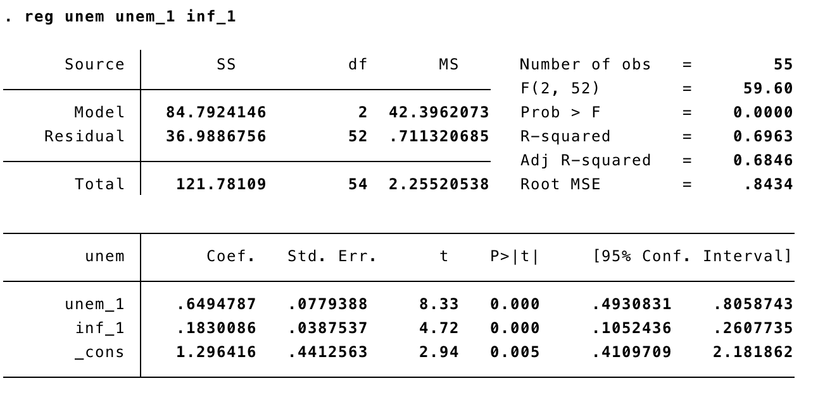

Adding inf_1 to the model we get:

Unemt = 1.296 + 0.649 Unem t-1 + 0.183 inft-1

With p value = 0 (less than 0.05) and a t- statistic of 4.72, Lagged inflation is statistically significant.

**(c)  Use the equation from part (b) to predict the unemployment rate for 2004. Is the result  better or worse than in the model from part (a)?**

Equation in part (b):

Unemt = 1.296 + 0.649 Unemt-1 + 0.183 inft-1

Inflation rate for 2003 = 2.3

Prediction of unemployment in 2003:

Unemt = 1.296 + 0.649(6) + 0.183(2.3) = 5.6

This is very close to the actual rate of 5.5, and it is certainly better than the predication from part (a) that is 5.94

**4. (Wooldridge, Chapter 12, C2)**

**(a)  Using the data in WAGEPRC.dta, estimate the distributed lag model from Problem 2 above. Regress uˆt on uˆt−1 to test for AR(1) serial correlation.**

Estimated distributed lag model:

gprice =α + β1gwaget + β2gwaget−1 + β3gwaget−2 + β4gwaget−3 + β5gwaget−4 + β6gwaget−5 + β7gwaget−6 + β8gwaget−7 + β9gwaget−8 + β10gwaget−9 + β11gwaget−10 + β12gwaget−11 + β13gwaget−12 + ut

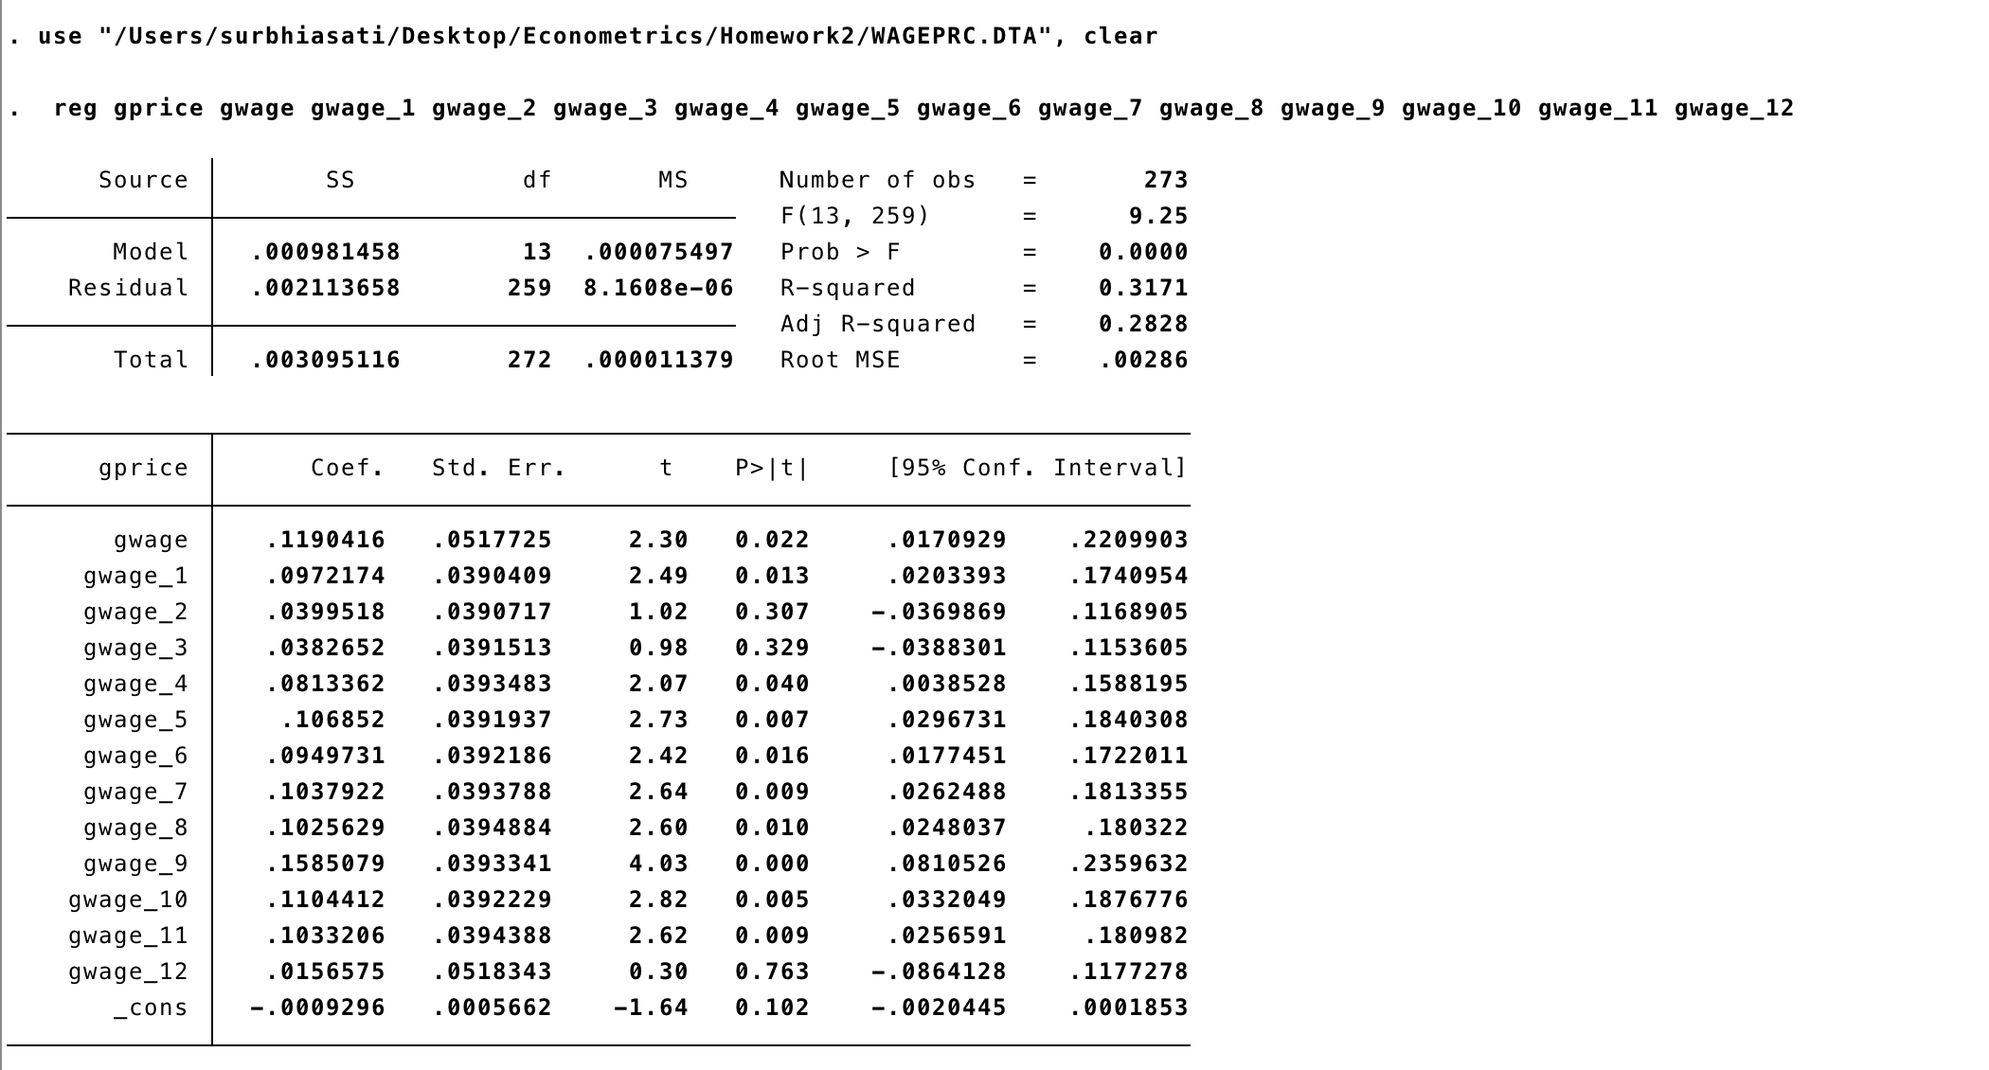

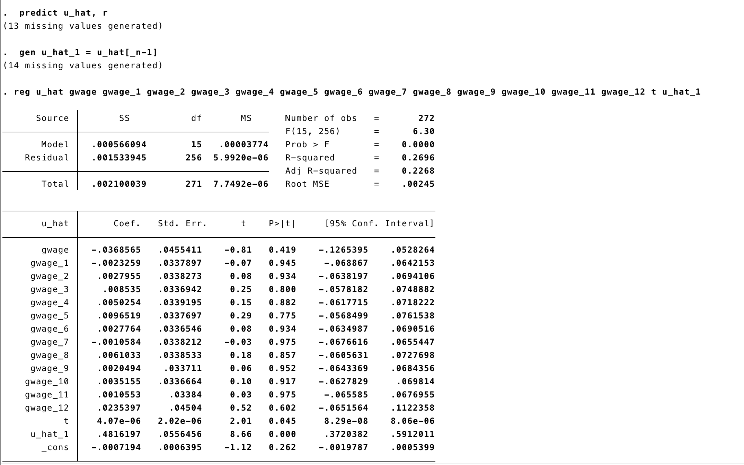

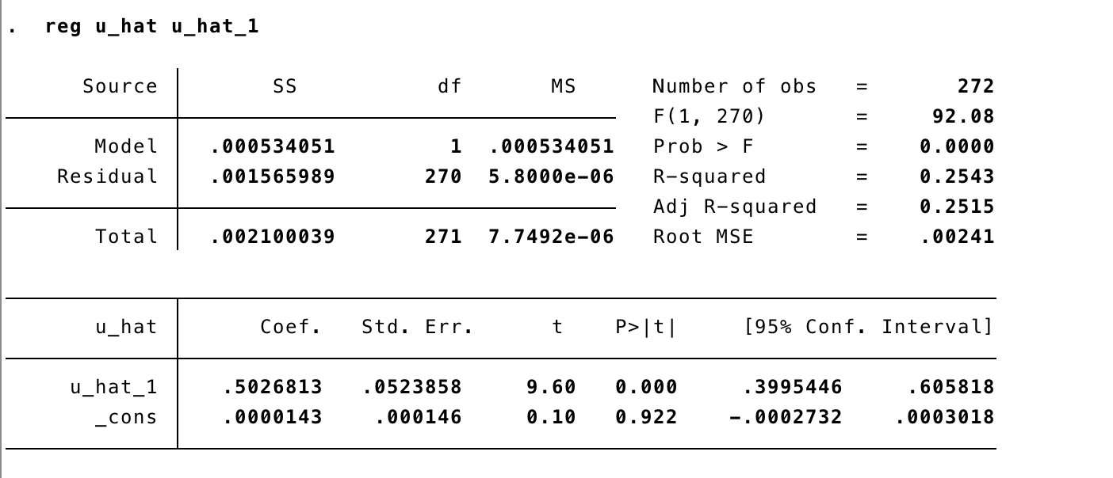

Regression uˆt on uˆt−1 gives t = 9.60, AR (1) correlation is positive

**(b)  Reestimate the model using iterated Cochrane-Orcutt (CO) estimation. What is your new estimate of the long-run propensity?**

The new estimate of the long-run propensity is = 1.110

**(c)  Using iterated CO, find the standard error for the LRP. Determine whether the estimated LRP is statistically different from one at the 5% level.**

gpricet = 0 + 0 gwaget + 1 (gwaget-1 – gwaget) + 2 (gwaget-2 – gwaget) + + 12 (gwaget-12 – gwaget) + ut

Estimating this equation by CO gives LRP =1.110

The tstatistic for testing is (1.110 – 1)/.191 = 0.57.

This is greater than 5%. Therefore, LRP is not significant.