**Optimization Strategies for Dietary supplement development project at**

**Nexgen Pharma**

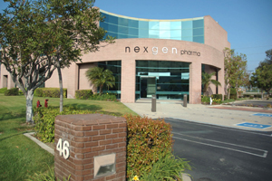

**Executive Summary:**

The cost of developing pharmaceutical drugs is rising to $1 billion and more per new drug (Herper 2013). Throughout the development process, if a pharmaceutical company finds itself in the situation where it cannot decide a certain drug/dietary supplement trial and production, it may have the option to sell opportunity from that point in development further.

Once a drug passes all phases of clinical trials, it can apply for FDA approval. If the drug gains FDA approval, the pharmaceutical company will then begin to commercialize the drug.

In this report, different models are built to evaluate new dietary supplement course of action and scheduling of number of scientists required throughout the day for Nexgen pharmaceuticals. In order to analyze if Nexgen Pharma should proceed with new dietary product from phase 1 to phase 2, with and without FDA approval, we used decision tree analysis approach to figure out the best course of action and optimal solution. For scheduling purposes, to identify the optimal number of scientists that are required throughout the day and to minimize cost we used linear programming to model the solution.

**Introduction:**

Nexgen Pharma specializes in the development and manufacture of dietary supplements, solid dose, powder and liquid Rx drugs, Medical Foods, OTC drugs. Nexgen Pharma has an 80+ years history of manufacturing pharmaceutical and nutritional products with a rigorous commitment to quality and customer satisfaction. Whether your needs are in product development, ANDA submission or you have a product ready to scale up to commercial production, Nexgen Pharma can meet those needs in an expedient, cost effective fashion. They have five facilities located in Irvine, California and Colorado Springs, Colorado with more than 325,000 square feet of manufacturing, laboratory and warehouse/distribution space.

At Nexgen Pharma, they partner with customers to create value with superior quality assurance and control standards, innovative delivery systems and information-based customer support services. Their scientific staff draw from years of pharmaceutical and dietary supplement industry experience. Nexgen has the capabilities to take product from development to commercial production. Their Services include:

1. Dietary supplement formulation and commercialization
2. Pharmaceutical product development, formulation and commercialization
3. NDA/ANDA product development and submission
4. Analytical methods development and validation
5. Complete product testing (product release and stability)
6. Process and cleaning validation
7. Finished packaging capabilities

The R&D team at Nexgen Pharma is trying to figure out if they should proceed working on a new dietary supplement or not. Throughout the development process, a dietary supplement must go through several clinical trial phases before the pharmaceutical company applies for FDA approval of the supplement to bring it to market. Phase I of clinical trials typically takes two years to complete and involves testing the safety of the supplement. Phase II typically lasts two years long and tests the effectiveness of the dietary supplement. What is the optimal path. Should Nexgen proceed with the new dietary supplement from Phase 1 trails to Phase 2 trails. If they choose to proceed with Phase 2 trails what is the expected monitory value (EMV). Once a dietary supplement passes these two phases of clinical trials, it can apply for FDA approval.

FDA regulates dietary supplements under a different set of regulations than those covering "conventional" foods and drug products. Under the Dietary Supplement Health and Education Act of 1994 (DSHEA). Manufacturers and distributors of dietary supplements and dietary ingredients are prohibited from marketing products that are adulterated or misbranded.  If the Nexgen supplement gains FDA approval, the company will then begin evaluating the safety and labelling of the new product before marketing to ensure that it meets all the requirements of FDA regulations and commercialize the dietary supplement.

The nature of a drug or diet supplement development project is characterized by large capital expenditures, and long timelines. This makes the development of such projects a challenging task. If the FDA approves, Nexgen can either sell the rights to the dietary supplement for a pre-launch exit value of $400 million, or it can launch production by investing $160 million in fixed assets and $40 million in net working capital.

At Nexgen Pharma, other issue is to be able to identify the optimal scheduling for number of research scientists that are required to work throughout the day on the project with minimum cost. We need to determine minimum number of scientists needed to meet the daily project requirements at Nexgen pharma to cut costs.

**Main Chapter:**

Nexgen Pharma New Dietary Supplement Decision tree Optimization

Nexgen researchers is in a dilemma if they should proceed with further trails for new dietary supplement and if they choose to proceed or not what is the expected monetary value. They have a pressure because if they invest resources and money what happens if FDA rejects the proposed supplement. In order to understand the best optimal solution that Nexgen should follow, we collected data, cleaned and summarized data, used decision tree approach to see the path and then calculated optimal path.

Our problem starts in year 0 with the firm, Nexgen, which has to decide to completed Phase I for a new compound, dietary supplement. If it proceeds with Phase 1 trials that takes a year, Nexgen will now be contemplating on whether to proceed to Phase II. Phase II takes two years to complete and requires an investment of $200 million. At the end of this Phase, a filing is made with the FDA, which will take a year to assess the efficacy of the proposed dietary supplement in providing adequate amounts of essential nutrients to manage some health conditions. If the FDA approves the application, Nexgen can either sell the rights of new product at the pre-launch exit value of $400 million, or it can launch production by investing $70 million in fixed assets and $30 million in net working capital.

**Steps in Decision Tree Analysis:**

1. The root node represents the start of the decision tree, where we face a decision choice to go with Phase 1 trials or not.
2. The objective of the exercise is to evaluate whether to go with production of the dietary supplement or not.
3. Event nodes represent the possible outcomes on a risky gamble; whether a dietary supplement passes the first stage of the FDA approval process or not.
4. End nodes represent the final outcomes of earlier risky outcomes and decisions made in response that is to produce or sell or abandon the dietary supplement

Below is the data set, probability of FDA approving new dietary supplement is 0.80, probability of FDA rejecting new dietary supplement is 0.20. Investment that is required in phase II is $200 million, associated production and marketing cost is $100 million. Unit margin value per supplement is $24. All sales volume below are in 1000’s of units. If approved by FDA, market can respond to supplement in three ways, thinking it’s a great product, fair product and awful product. Table below shows the associated probabilities of each event, sales volume and net revenue.

Dataset

|  |  |
| --- | --- |
| **Inputs** | |
| Phase 2 Investment | $2,000 |
| Production and marketing cost | $1,000 |
| Unit margin | $24 |

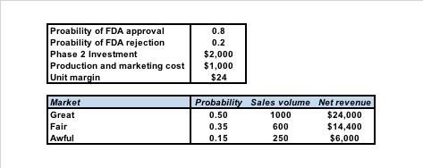

Decision Tree Analysis model solution

Please refer decision tree analysis below for new dietary supplement, associated probabilities of an event and expected monitory value. New dietary product (supplement) will have two options, proceed with no further trails or to proceed with phase 1 trails. At this stage Nexgen have a decision to make, either proceed with phase 2 trails or stop at phase 1 trails. If they choose to proceed with phase 2 trails, FDA may or may not approve product. If FDA approves the product, they have an option to not produce the product or produce and market the product. If they choose to not produce the product, then can make money by selling the rights or choose not to sell the rights. If they choose to produce and market the product, they will see three types of reaction from market. Each response (Great, Fair, and Awful) has a different probability or chance of occurring that will result in different expected monetary value.

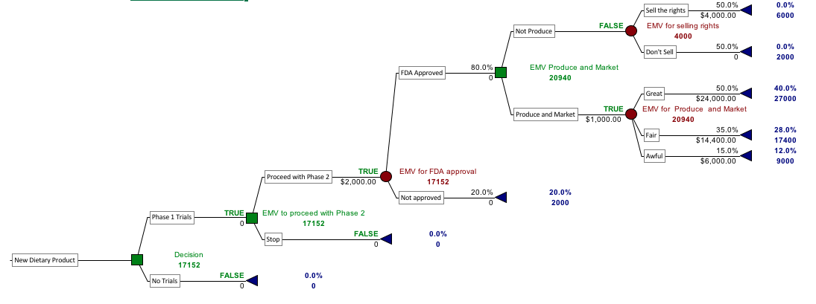

Optimal Decision Tree

The best decision is to proceed with Phase 1 trails to Phase 2 trails (EMV in this case is $1.7 mln). If it is approved by FDA (80% of chance) and Nexgen produces and market the product, if the response to supplement is great (50% of chance), the payoff will be $2.7 million. If it is approved by FDA and response to supplement is fair (35% of chance), the payoff will be $1.7 million. If it is approved by FDA and response to supplement is awful (5% of chance), the payoff will be $900k.

If the research team or management choose to proceed with new supplement from phase 1 trails to phase 2 trails and it is NOT approved by FDA (20% of chance), the payoff will be $2000K.

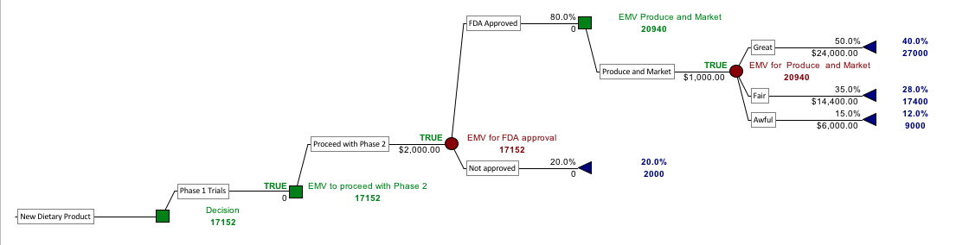

Statistical Summary

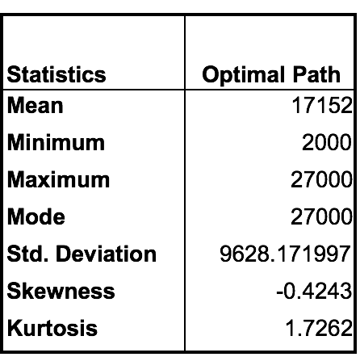

**Senstivity Analysis:**

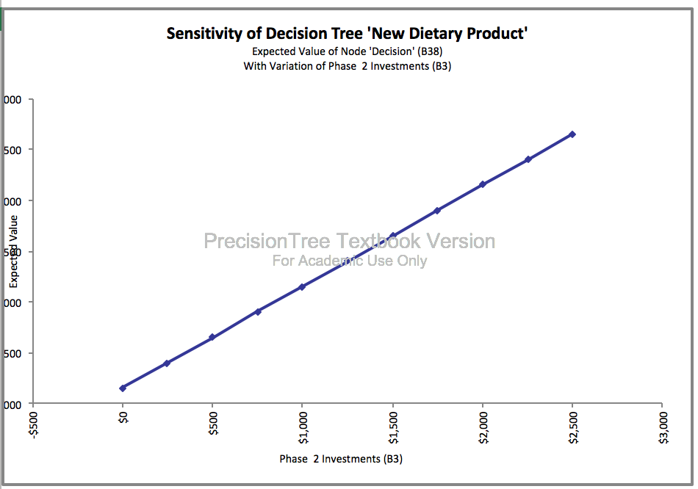 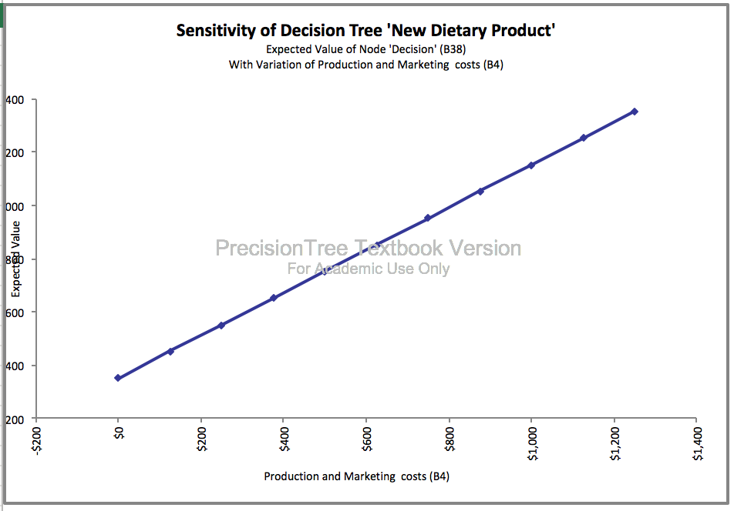

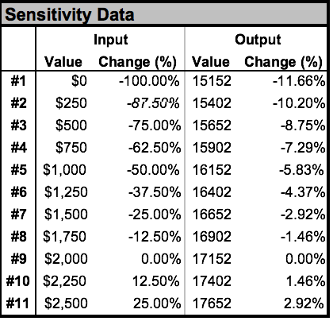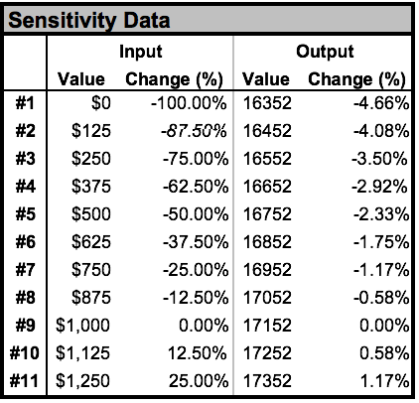

Clearly, the Expected payoff for the optimal decision for the Phase 2 investment increases linearly. Also, the Expected payoff of production and marketing cost increases linearly as the cost increases

Tornado

The Tornado graph shows that the most influential parameter considered for one-way sensitivity analysis,

1. The probability of FDA approval, which produces the highest variation of EMV.
2. The second most influential parameter is the unit margin value.
3. The third most influential parameter is Phase 2 investments.
4. The least influential is the production and marketing costs.

Strategy Region

According to this two-way sensitivity analysis, the decision of proceeding with phase 1 trails seems the optimal decision for probability of FDA approval between $18 and $30. The strategy region chart indicates for each combination of decision values, the best decision is to proceed with Phase 1 trials.

Strategy Graph

According to this sensitivity analysis, for the probability of FDA approval from 0.5 to 1.05, the initial decision to proceed with phase 1 trails is the best decision. Higher the probability of FDA approval, higher is the EMV value. This is completely insensitive to variations of the FDA approval.

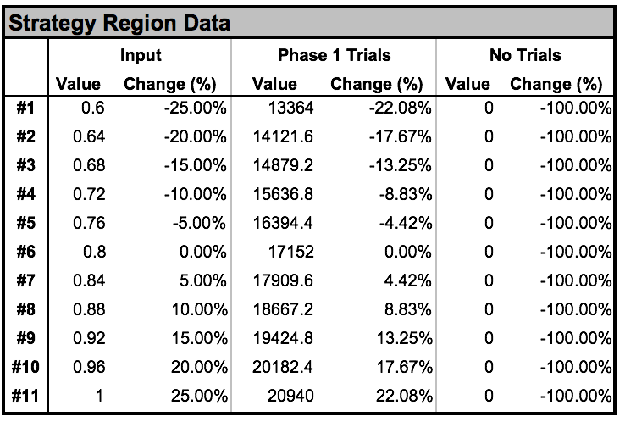

According to this sensitivity analysis, for unit margin from $16 to $32, the initial decision to proceed with phase 1 trails is the best decision. Higher the unit margin, higher is the EMV value. This is completely insensitive to variations of unit margin.

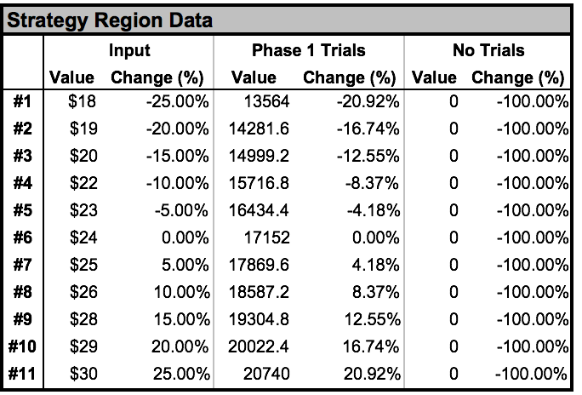

Nexgen Pharma Scientists Scheduling Optimization model solution

Linear programming model was used to address Nexgen pharma scheduling of research scientist’s problem for different shifts throughout the day. Idea is to minimize the number of scientist needed to meet Nexgen daily requirements and to minimize the total cost. During each four-hour period, the Nexgen pharma requires the following number of scientists on duty and each scientist works two consecutive four-hour shifts.

1. 8 from midnight to 4 am
2. 7 from 4am to 8 am
3. 6 from 8 am to noon
4. 6 from noon to 4 pm
5. 5 from 4 P.M. to 8 P.M
6. 4 from 8 P.M. to midnight

Decision variable:

Number of scientists starting their shifts at various times.

|  |
| --- |
| x1 = Let the number of scientists from 12 midnight to 8 Am |
| x2 = Let the number of scientists from 4 AM to 12 Noon |
| x3 = Let the number of scientists from 8 Am to 4 PM |
| x4 = Let the number of scientists from 12 noon to 8 PM |
| x5 = Let the number of scientists from 4 PM to 12 midnight |
| x6 = Let the number of scientists from 8 PM to 4 AM |

Objective function:

Minimize the total number of scientists (x1+x2+x3+x4+x5+x6)

Constraints:

1. 8 scientists from midnight to 4 am, x1+x6 >= 8
2. 7 scientists from 4am to 8 am, x1+x2 >=7
3. 6 scientists from 8 am to noon, x2+x3 >= 6
4. 6 scientists from noon to 4 pm, x3+x4 >= 6
5. 5 scientists from 4 P.M. to 8 P.M., x4+x5 >= 5
6. 4 scientists from 8 P.M. to midnight, x5+x6 >= 4

**Model:**



**Optimal number of scientists required = 19**

Sensitivity analysis

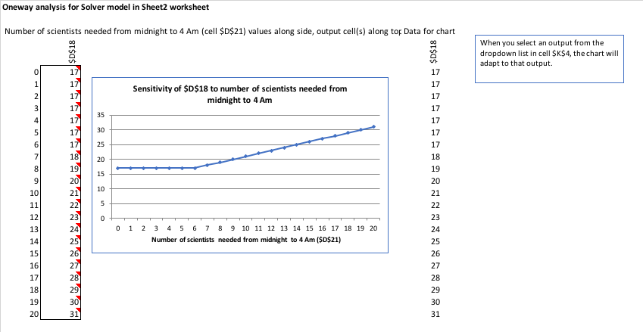

Minimum number of scientists needed between midnight to 4 AM is 8 and therefore the optimal number of research scientists required for a day is 19. For each additional scientist working from midnight to 4 AM, the total number of scientists increases by 1.

**Conclusion:**

We created one decision tree model to reflect the problem when a pharmaceutical company, Nexgen does not decide to pursue dietary supplement and when it does. We created another scheduling model to minimize the research scientist’s costs. We provided step by step instructions for decision tree analysis of the new dietary supplement production problem the research scientists are facing at Nexgen. As decision makers, we are most concerned with the ultimate outcomes: start phase to trials of the dietary supplement and eventually move to production and scheduling of the research scientists to minimize costs and get a real picture of their work routine.

Our model concludes the optimal solution of the decision-making problem is to proceed with the nutrition product trials with an EMV of $1.7 million. If it is approved by FDA (80% of chance) and Nexgen produces and market the product, if the response to supplement is great (50% of chance), the payoff will be $2.7 million. Also, minimum number of research scientists required per day is 19. We addressed the two major problems directly in the excel model using precision tree, solver table and sentivity analysis. The simpler and more direct a model is the better. The model can be extended in different directions. There is a good deal of risk facing Nexgen. As there is risk involved in every business decision. Therefore, the model can further be tested by risk analysis.

In summary, decision trees provide a flexible and powerful approach for dealing with the decision that occurs in phases, with decisions in each phase depending upon outcomes in the previous one. In addition to providing us with measures of probable outcomes at each phase, the precision tree also force us to think through how we will react to both adverse (abandon the product) and positive outcomes (produce the product) that may occur at each phase.

**Limitation:**

Once the dietary supplement passes all phases of clinical trials, it can apply for FDA approval. If the drug gains FDA approval, the pharmaceutical company will then begin to commercialize the drug.

At this point in the development process, Nexgen may discover that the dietary supplement is very effective for a subset of the population being tested, but not effective for other subsets of the population. From here, Nexgen can make the decision to pursue development of a nutritional product to help the subpopulation for which it has effective results, or the company can decide to stop development of the drug completely.

**Bibliography:**

URL **http://www.nexgenpharma.com/**

Website Title **Nexgen Pharma - Manufacturing Rx and OTC Drugs and Dietary Supplements**

Article Title **Nexgen Pharma - Manufacturing Rx and OTC Drugs and Dietary Supplements**

**References:**

https://www.fda.gov/Food/DietarySupplements/