Chapter 2 R Notebook

This is an [R Markdown](http://rmarkdown.rstudio.com) Notebook. When you execute code within the notebook, the results appear beneath the code.

Try executing this chunk by clicking the *Run* button within the chunk or by placing your cursor inside it and pressing *Ctrl+Shift+Enter*.

Add a new chunk by clicking the *Insert Chunk* button on the toolbar or by pressing *Ctrl+Alt+I*.

When you save the notebook, an HTML file containing the code and output will be saved alongside it (click the *Preview* button or press *Ctrl+Shift+K* to preview the HTML file).

The preview shows you a rendered HTML copy of the contents of the editor. Consequently, unlike *Knit*, *Preview* does not run any R code chunks. Instead, the output of the chunk when it was last run in the editor is displayed.

# Chapter 2

This is an R Notebook with the code from Machine Learning with R, Lantz.

## Blog post about Projects and Notebooks

[Prime Hings for Running A Data Project in R](https://kkulma.github.io/2018-03-18-Prime-Hints-for-Running-a-data-project-in-R/)

## Good website for learning about R.

[Quick-R](https://www.statmethods.net/)

# Chapter 2: Managing and Understanding Data

**Libraries**

library(here)

## here() starts at /home/esuess/classes/2017-2018/03 - Spring2018/Stat6620/Projects/Chap02

library(lattice)  
library(corrgram)  
library(gmodels)

here::here()

## [1] "/home/esuess/classes/2017-2018/03 - Spring2018/Stat6620/Projects/Chap02"

## R data structures

**Vectors**

create vectors of data for three medical patients

subject_name <- c("John Doe", "Jane Doe", "Steve Graves")  
temperature <- c(98.1, 98.6, 101.4)  
flu_status <- c(FALSE, FALSE, TRUE)

access the second element in body temperature vector

temperature[2]

## [1] 98.6

examples of accessing items in vector

include items in the range 2 to 3

temperature[2:3]

## [1] 98.6 101.4

exclude item 2 using the minus sign

temperature[-2]

## [1] 98.1 101.4

use a vector to indicate whether to include item

temperature[c(TRUE, TRUE, FALSE)]

## [1] 98.1 98.6

## Factors

add gender factor

gender <- factor(c("MALE", "FEMALE", "MALE"))  
gender

## [1] MALE FEMALE MALE   
## Levels: FEMALE MALE

add blood type factor

blood <- factor(c("O", "AB", "A"),  
 levels = c("A", "B", "AB", "O"))  
blood

## [1] O AB A   
## Levels: A B AB O

add ordered factor

symptoms <- factor(c("SEVERE", "MILD", "MODERATE"),  
 levels = c("MILD", "MODERATE", "SEVERE"),  
 ordered = TRUE)  
symptoms

## [1] SEVERE MILD MODERATE  
## Levels: MILD < MODERATE < SEVERE

check for symptoms greater than moderate

symptoms > "MODERATE"

## [1] TRUE FALSE FALSE

## Lists

display information for a patient

subject_name[1]

## [1] "John Doe"

temperature[1]

## [1] 98.1

flu_status[1]

## [1] FALSE

gender[1]

## [1] MALE  
## Levels: FEMALE MALE

blood[1]

## [1] O  
## Levels: A B AB O

symptoms[1]

## [1] SEVERE  
## Levels: MILD < MODERATE < SEVERE

create list for a patient and display the patient

subject1 <- list(fullname = subject_name[1],   
 temperature = temperature[1],  
 flu_status = flu_status[1],  
 gender = gender[1],  
 blood = blood[1],  
 symptoms = symptoms[1])  
subject1

## $fullname  
## [1] "John Doe"  
##   
## $temperature  
## [1] 98.1  
##   
## $flu_status  
## [1] FALSE  
##   
## $gender  
## [1] MALE  
## Levels: FEMALE MALE  
##   
## $blood  
## [1] O  
## Levels: A B AB O  
##   
## $symptoms  
## [1] SEVERE  
## Levels: MILD < MODERATE < SEVERE

methods for accessing a list

get a single list value by position (returns a sub-list)

subject1[2]

## $temperature  
## [1] 98.1

get a single list value by position (returns a numeric vector)

subject1[[2]]

## [1] 98.1

get a single list value by name

subject1$temperature

## [1] 98.1

get several list items by specifying a vector of names

subject1[c("temperature", "flu_status")]

## $temperature  
## [1] 98.1  
##   
## $flu_status  
## [1] FALSE

access a list like a vector get values 2 and 3

subject1[2:3]

## $temperature  
## [1] 98.1  
##   
## $flu_status  
## [1] FALSE

## Data frames

create a data frame from medical patient data and display the data frame

pt_data <- data.frame(subject_name, temperature, flu_status, gender,  
 blood, symptoms, stringsAsFactors = FALSE)  
pt_data

## subject_name temperature flu_status gender blood symptoms  
## 1 John Doe 98.1 FALSE MALE O SEVERE  
## 2 Jane Doe 98.6 FALSE FEMALE AB MILD  
## 3 Steve Graves 101.4 TRUE MALE A MODERATE

accessing a data frame

get a single column

pt_data$subject_name

## [1] "John Doe" "Jane Doe" "Steve Graves"

get several columns by specifying a vector of names

pt_data[c("temperature", "flu_status")]

## temperature flu_status  
## 1 98.1 FALSE  
## 2 98.6 FALSE  
## 3 101.4 TRUE

this is the same as above, extracting temperature and flu_status

pt_data[2:3]

## temperature flu_status  
## 1 98.1 FALSE  
## 2 98.6 FALSE  
## 3 101.4 TRUE

accessing by row and column

pt_data[1, 2]

## [1] 98.1

accessing several rows and several columns using vectors

pt_data[c(1, 3), c(2, 4)]

## temperature gender  
## 1 98.1 MALE  
## 3 101.4 MALE

Leave a row or column blank to extract all rows or columns

# column 1, all rows  
pt_data[, 1]

## [1] "John Doe" "Jane Doe" "Steve Graves"

# row 1, all columns  
pt_data[1, ]

## subject_name temperature flu_status gender blood symptoms  
## 1 John Doe 98.1 FALSE MALE O SEVERE

# all rows and all columns  
pt_data[ , ]

## subject_name temperature flu_status gender blood symptoms  
## 1 John Doe 98.1 FALSE MALE O SEVERE  
## 2 Jane Doe 98.6 FALSE FEMALE AB MILD  
## 3 Steve Graves 101.4 TRUE MALE A MODERATE

the following are equivalent

pt_data[c(1, 3), c("temperature", "gender")]

## temperature gender  
## 1 98.1 MALE  
## 3 101.4 MALE

pt_data[-2, c(-1, -3, -5, -6)]

## temperature gender  
## 1 98.1 MALE  
## 3 101.4 MALE

## Matrixes

create a 2x2 matrix

m <- matrix(c(1, 2, 3, 4), nrow = 2)  
m

## [,1] [,2]  
## [1,] 1 3  
## [2,] 2 4

equivalent to the above

m <- matrix(c(1, 2, 3, 4), ncol = 2)  
m

## [,1] [,2]  
## [1,] 1 3  
## [2,] 2 4

create a 2x3 matrix

m <- matrix(c(1, 2, 3, 4, 5, 6), nrow = 2)  
m

## [,1] [,2] [,3]  
## [1,] 1 3 5  
## [2,] 2 4 6

create a 3x2 matrix

m <- matrix(c(1, 2, 3, 4, 5, 6), ncol = 2)  
m

## [,1] [,2]  
## [1,] 1 4  
## [2,] 2 5  
## [3,] 3 6

extract values from matrixes

m[1, 1]

## [1] 1

m[3, 2]

## [1] 6

extract rows

m[1, ]

## [1] 1 4

extract columns

m[, 1]

## [1] 1 2 3

## Managing data with R

saving, loading, and removing R data structures

show all data structures in memory

ls()

## [1] "blood" "flu_status" "gender" "m"   
## [5] "pt_data" "subject_name" "subject1" "symptoms"   
## [9] "temperature"

remove the m and subject1 objects

rm(m, subject1)  
ls()

## [1] "blood" "flu_status" "gender" "pt_data"   
## [5] "subject_name" "symptoms" "temperature"

rm(list=ls())

## Exploring and understanding data

data exploration example using used car data

usedcars <- read.csv("usedcars.csv", stringsAsFactors = FALSE)

get structure of used car data

str(usedcars)

## 'data.frame': 150 obs. of 6 variables:  
## $ year : int 2011 2011 2011 2011 2012 2010 2011 2010 2011 2010 ...  
## $ model : chr "SEL" "SEL" "SEL" "SEL" ...  
## $ price : int 21992 20995 19995 17809 17500 17495 17000 16995 16995 16995 ...  
## $ mileage : int 7413 10926 7351 11613 8367 25125 27393 21026 32655 36116 ...  
## $ color : chr "Yellow" "Gray" "Silver" "Gray" ...  
## $ transmission: chr "AUTO" "AUTO" "AUTO" "AUTO" ...

## Exploring numeric variables

summarize numeric variables

summary(usedcars$year)

## Min. 1st Qu. Median Mean 3rd Qu. Max.   
## 2000 2008 2009 2009 2010 2012

summary(usedcars[c("price", "mileage")])

## price mileage   
## Min. : 3800 Min. : 4867   
## 1st Qu.:10995 1st Qu.: 27200   
## Median :13592 Median : 36385   
## Mean :12962 Mean : 44261   
## 3rd Qu.:14904 3rd Qu.: 55124   
## Max. :21992 Max. :151479

calculate the mean income

(36000 + 44000 + 56000) / 3

## [1] 45333.33

mean(c(36000, 44000, 56000))

## [1] 45333.33

the median income

median(c(36000, 44000, 56000))

## [1] 44000

the min/max of used car prices

range(usedcars$price)

## [1] 3800 21992

the difference of the range

diff(range(usedcars$price))

## [1] 18192

IQR for used car prices

IQR(usedcars$price)

## [1] 3909.5

use quantile to calculate five-number summary

quantile(usedcars$price)

## 0% 25% 50% 75% 100%   
## 3800.0 10995.0 13591.5 14904.5 21992.0

the 99th percentile

quantile(usedcars$price, probs = c(0.01, 0.99))

## 1% 99%   
## 5428.69 20505.00

quintiles

quantile(usedcars$price, seq(from = 0, to = 1, by = 0.20))

## 0% 20% 40% 60% 80% 100%   
## 3800.0 10759.4 12993.8 13992.0 14999.0 21992.0

boxplot of used car prices and mileage

boxplot(usedcars$price, main="Boxplot of Used Car Prices",  
 ylab="Price ($)")

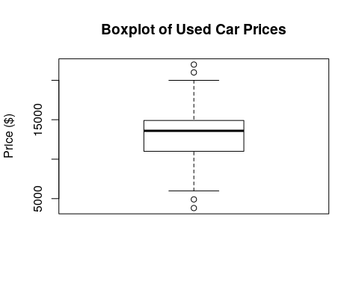

boxplot(usedcars$price ~ usedcars$transmission, main="Boxplot of Used Car Prices by Transmission",  
 ylab="Price ($)")

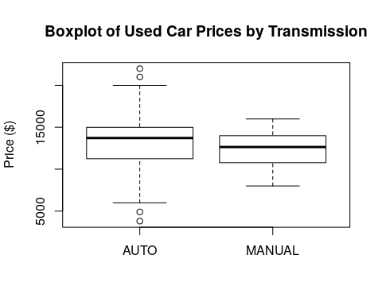

using the lattice package

lattice::bwplot(usedcars$price~usedcars$transmission,  
 ylab="Price", xlab="Transmission",  
 main="Price by Transmission")

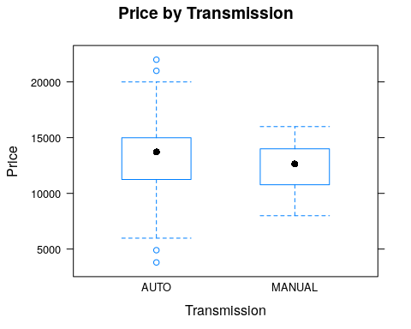

usedcars$year <- as.character(usedcars$year)  
  
lattice::bwplot(usedcars$price~usedcars$transmission|usedcars$year,  
 ylab="Price", xlab="Transmission",  
 main="Price by Transmission and Year", layout=(c(5,3)))

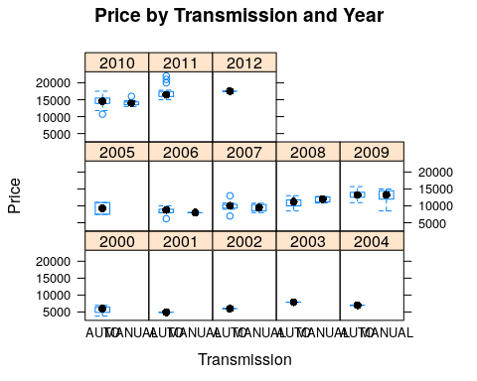

boxplot(usedcars$mileage, main="Boxplot of Used Car Mileage",  
 ylab="Odometer (mi.)")

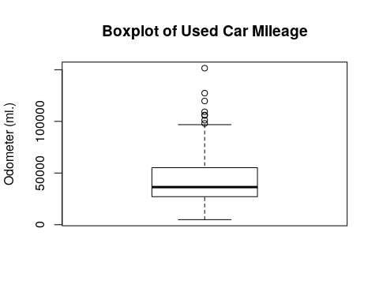

boxplot(usedcars$mileage ~ usedcars$transmission, main="Boxplot of Used Car Mileage by Transmission", ylab="Odometer (mi.)")

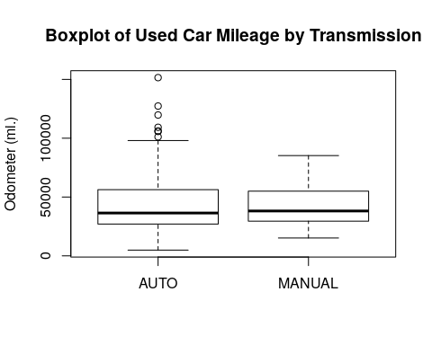

histograms of used car prices and mileage

hist(usedcars$price, main = "Histogram of Used Car Prices",  
 xlab = "Price ($)")

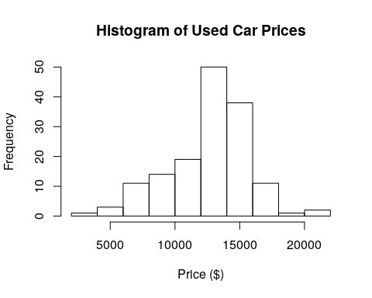

hist(usedcars$mileage, main = "Histogram of Used Car Mileage",  
 xlab = "Odometer (mi.)")

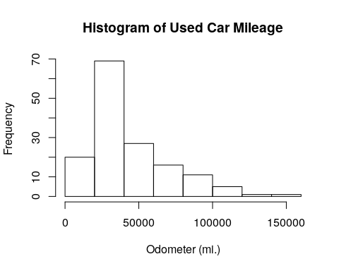

lattice::histogram(~ usedcars$price,  
 xlab="Price",  
 main="Distribution of Price")

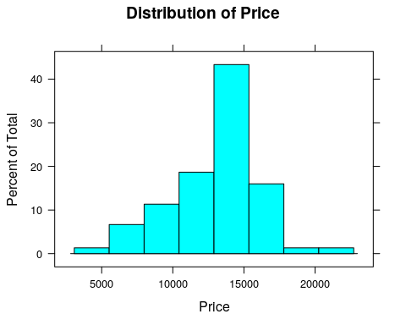

usedcars$year <- as.character(usedcars$year)  
  
lattice::histogram(~ usedcars$price | usedcars$year,  
 ylab="Price", xlab="Price",  
 main="Distribution of Price by Year", layout=(c(5,3)))

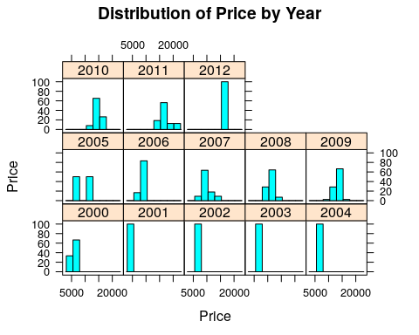

lattice::histogram(~ usedcars$mileage,  
 xlab="Mileagage",  
 main="Distribution of Mileage")

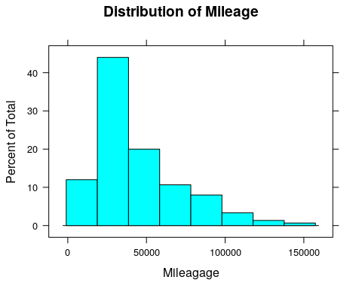

usedcars$year <- as.character(usedcars$year)  
  
lattice::histogram(~ usedcars$mileage | usedcars$year,  
 xlab="Mileage",  
 main="Distribution of Mileage by Year", layout=(c(5,3)))

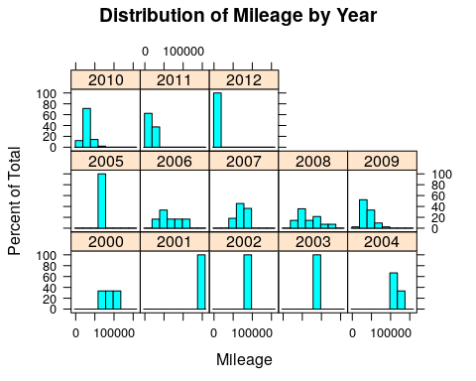

variance and standard deviation of the used car data

var(usedcars$price)

## [1] 9749892

sd(usedcars$price)

## [1] 3122.482

var(usedcars$mileage)

## [1] 728033954

sd(usedcars$mileage)

## [1] 26982.1

## Exploring numeric variables

one-way tables for the used car data

table(usedcars$year)

##   
## 2000 2001 2002 2003 2004 2005 2006 2007 2008 2009 2010 2011 2012   
## 3 1 1 1 3 2 6 11 14 42 49 16 1

table(usedcars$model)

##   
## SE SEL SES   
## 78 23 49

table(usedcars$color)

##   
## Black Blue Gold Gray Green Red Silver White Yellow   
## 35 17 1 16 5 25 32 16 3

compute table proportions

model_table <- table(usedcars$model)  
prop.table(model_table)

##   
## SE SEL SES   
## 0.5200000 0.1533333 0.3266667

round the data

color_table <- table(usedcars$color)  
color_pct <- prop.table(color_table) * 100  
round(color_pct, digits = 1)

##   
## Black Blue Gold Gray Green Red Silver White Yellow   
## 23.3 11.3 0.7 10.7 3.3 16.7 21.3 10.7 2.0

## Exploring relationships between variables

correlation

cor(x = usedcars$mileage, y = usedcars$price)

## [1] -0.8061494

scatterplot of price vs. mileage

plot(x = usedcars$mileage, y = usedcars$price,  
 main = "Scatterplot of Price vs. Mileage",  
 xlab = "Used Car Odometer (mi.)",  
 ylab = "Used Car Price ($)")

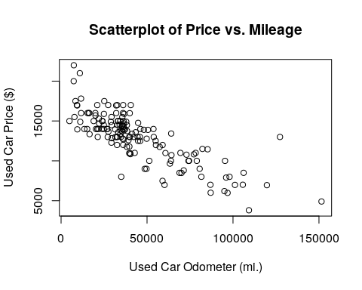

The corrgram package has the corrgram function that is nice for looking at relationships between numeric variable.

corrgram::corrgram(usedcars,lower.panel=panel.ellipse,  
 upper.panel=panel.pts)

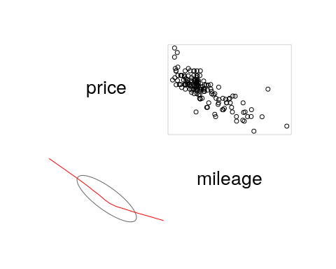

new variable indicating conservative colors

usedcars$conservative <-  
 usedcars$color %in% c("Black", "Gray", "Silver", "White")

checking our variable

table(usedcars$conservative)

##   
## FALSE TRUE   
## 51 99

Crosstab of conservative by model

gmodels::CrossTable(x = usedcars$model, y = usedcars$conservative)

##   
##   
## Cell Contents  
## |-------------------------|  
## | N |  
## | Chi-square contribution |  
## | N / Row Total |  
## | N / Col Total |  
## | N / Table Total |  
## |-------------------------|  
##   
##   
## Total Observations in Table: 150   
##   
##   
## | usedcars$conservative   
## usedcars$model | FALSE | TRUE | Row Total |   
## ---------------|-----------|-----------|-----------|  
## SE | 27 | 51 | 78 |   
## | 0.009 | 0.004 | |   
## | 0.346 | 0.654 | 0.520 |   
## | 0.529 | 0.515 | |   
## | 0.180 | 0.340 | |   
## ---------------|-----------|-----------|-----------|  
## SEL | 7 | 16 | 23 |   
## | 0.086 | 0.044 | |   
## | 0.304 | 0.696 | 0.153 |   
## | 0.137 | 0.162 | |   
## | 0.047 | 0.107 | |   
## ---------------|-----------|-----------|-----------|  
## SES | 17 | 32 | 49 |   
## | 0.007 | 0.004 | |   
## | 0.347 | 0.653 | 0.327 |   
## | 0.333 | 0.323 | |   
## | 0.113 | 0.213 | |   
## ---------------|-----------|-----------|-----------|  
## Column Total | 51 | 99 | 150 |   
## | 0.340 | 0.660 | |   
## ---------------|-----------|-----------|-----------|  
##   
##