CODE:

> setwd("~/Desktop/DMBIProject/Dataset")
> diam_data<-read.csv("~/Desktop/DMBIProject/Dataset/Diamond.csv")
> str(diam_data)
'data.frame': 308 obs. of 6 variables:
$ X : int 1 2 3 4 5 6 7 8 9 10 ...
$ carat : num 0.3 0.3 0.3 0.3 0.31 0.31 0.31 0.31 0.31 0.31 ...
$ colour : Factor w/ 6 levels "D","E","F","G",..: 1 2 4 4 1 2 3 4 5 6 ...
$ clarity : Factor w/ 5 levels "IF","VS1","VS2",..: 3 2 4 2 2 2 2 5 3 2 ...
$ certification: Factor w/ 3 levels "GIA","HRD","IGI": 1 1 1 1 1 1 1 1 1 1 ...
$ price : int 1302 1510 1510 1260 1641 1555 1427 1427 1126 1126 ...

> summary(diam_data)
X carat colour clarity certification price
Min. : 1.00 Min. :0.1800 D:16 IF :44 GIA:151 Min. : 638
1st Qu.: 77.75 1st Qu.:0.3500 E:44 VS1 :81 HRD: 79 1st Qu.: 1625
Median :154.50 Median :0.6200 F:82 VS2 :53 IGI: 78 Median : 4215
Mean :154.50 Mean :0.6309 G:65 VVS1:52 Mean : 5019
3rd Qu.:231.25 3rd Qu.:0.8500 H:61 VVS2:78 3rd Qu.: 7446
Max. :308.00 Max. :1.1000 I:40 Max. :16008
> barplot(table(diam_data$colour))
> hist(diam_data$price)
> boxplot(price~colour, data=diam_data)
> with(diam_data, plot(carat,price))
> cor(diam_data$carat, diam_data$price)
[1] 0.9447266
> pie(table(diam_data$colour))
> library(rpart)

#CLASSIFICATION USING GINI INDEX AS SPLITTING ATTRIBUTE
> rpart(colour ~ carat + certification + clarity, data=diam_data)
n= 308

node), split, n, loss, yval, (yprob)
* denotes terminal node

1) root 308 226 F (0.052 0.14 0.27 0.21 0.2 0.13)
2) carat< 0.565 138 92 F (0.051 0.16 0.33 0.23 0.13 0.094)
4) clarity=VS1,VVS1,VVS2 90 52 F (0.056 0.18 0.42 0.21 0.078 0.056) *
5) clarity=IF,VS2 48 35 G (0.042 0.12 0.17 0.27 0.23 0.17)
10) carat< 0.235 16 9 G (0 0.25 0.19 0.44 0.13 0) *
11) carat>=0.235 32 23 H (0.063 0.062 0.16 0.19 0.28 0.25) *
3) carat>=0.565 170 127 H (0.053 0.13 0.21 0.19 0.25 0.16)
6) clarity=IF,VS1,VS2,VVS1 124 93 F (0.048 0.15 0.25 0.16 0.25 0.14)
12) carat>=0.68 107 79 F (0.056 0.15 0.26 0.15 0.22 0.16) *
13) carat< 0.68 17 10 H (0 0.18 0.18 0.24 0.41 0) *
7) clarity=VVS2 46 33 G (0.065 0.065 0.11 0.28 0.26 0.22)
14) carat>=0.745 29 21 I (0.1 0.069 0.14 0.24 0.17 0.28)
28) certification=HRD,IGI 18 13 G (0.11 0.11 0.17 0.28 0.22 0.11) *
29) certification=GIA 11 5 I (0.091 0 0.091 0.18 0.091 0.55) *
15) carat< 0.745 17 10 H (0 0.059 0.059 0.35 0.41 0.12) *
> tree<-rpart(colour ~ carat + certification + clarity, data=diam_data)
> plot(tree)
> text(tree)
> plotcp(tree)
> printcp(tree)

Classification tree:
rpart(formula = colour ~ carat + certification + clarity, data = diam_data)

Variables actually used in tree construction:
[1] carat certification clarity

Root node error: 226/308 = 0.73377

n= 308

CP nsplit rel error xerror xstd
1 0.030973 0 1.00000 1.0000 0.034322
2 0.022124 1 0.96903 1.0221 0.033625
3 0.013274 2 0.94690 1.0265 0.033479
4 0.011062 3 0.93363 1.0221 0.033625
5 0.010000 7 0.88938 1.0177 0.033770

> post(tree, file = "~/Desktop/DMBIProject/tree.ps", title = "Classification based on colour")

#CLASSIFICATION USING INFORMATION AS SPLITTING ATTRIBUTE
> tree<-rpart(colour ~ carat + certification + clarity + price, data=diam_data, method = "class", parms=list(split="information"))
> printcp(tree)

Classification tree:
rpart(formula = colour ~ carat + certification + clarity + price,
data = diam_data, method = "class", parms = list(split = "information"))

Variables actually used in tree construction:
[1] carat certification clarity price

Root node error: 226/308 = 0.73377

n= 308

CP nsplit rel error xerror xstd
1 0.030973 0 1.00000 1.00000 0.034322
2 0.023599 3 0.90708 0.96460 0.035316
3 0.022124 6 0.83628 0.94690 0.035759
4 0.017699 7 0.81416 0.93363 0.036070
5 0.013274 9 0.77876 0.95133 0.035651
6 0.010000 13 0.72566 0.91593 0.036455

> ptree<-prune(tree,cp=0.017)
> plot(ptree)
> text(ptree)

GRAPHS:
Bar chart for colour
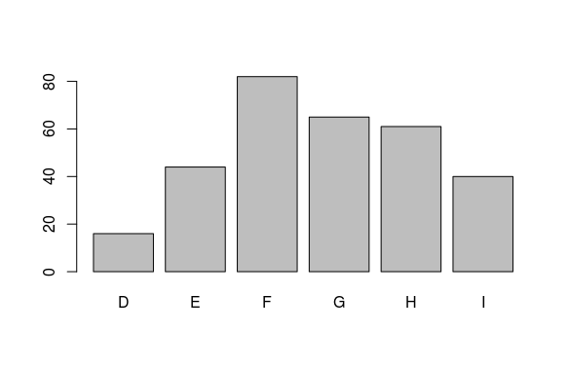
Histogram for price
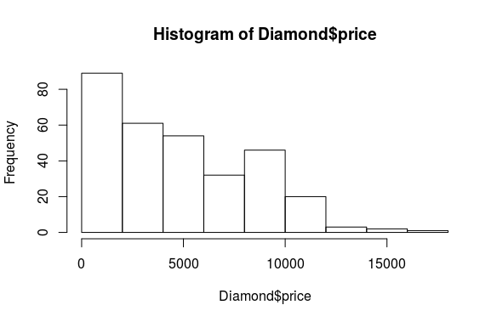

Boxplot of price according to colour
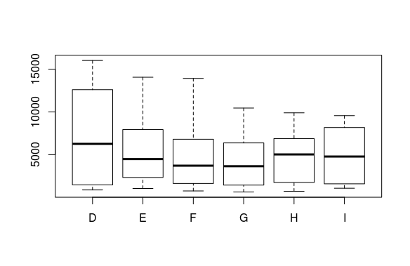

Scatter plot of carat vs price
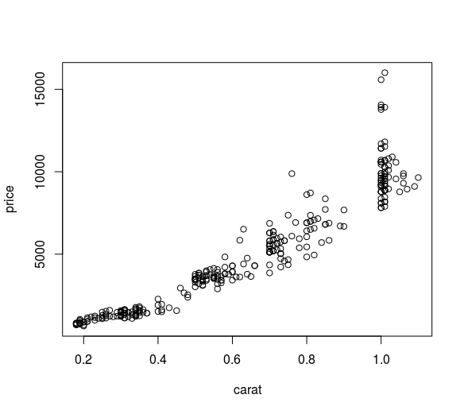
Pie chart for colour

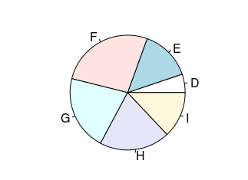
TREES:

Using Gini Index-
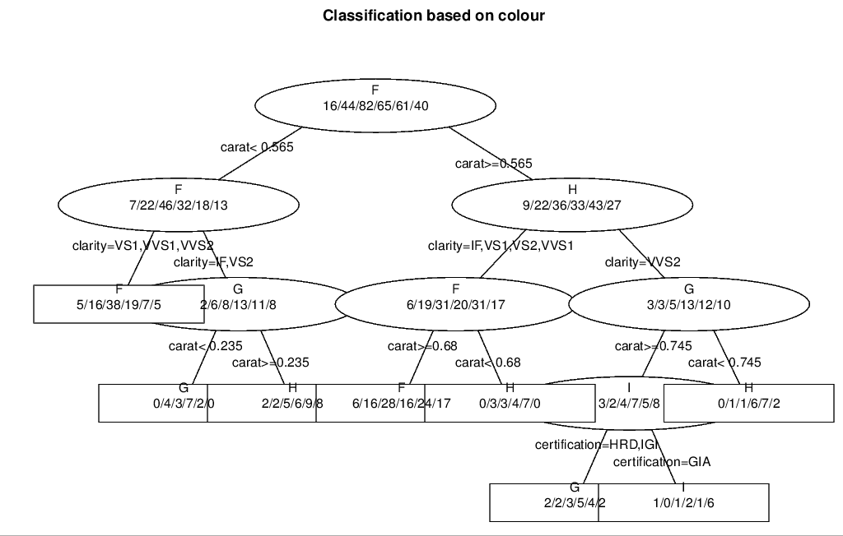

Using Information:
