11/17/2017

Melvin E. Asava

100574565

East African Recipes:

Kenyan Coastal Traditional Foods Website Testing

Table of Contents

Testing 2

Validation 4

Browser testing 6

Recommendations (Enhancements and Maintenance) 6

# Testing

Page: index.html

|  |  |  |  |  |
| --- | --- | --- | --- | --- |
| **Serial No.** | **Test Description** | **How Tested / Data** | **Expected Result** | **Actual Result** |
| 1 | Navigation links to html pages | Click on each link | Each html page displays | ✓ |
| 2 | Navigation Link to external page | Click on link | External site displays | ✓ |
| 3 | Spell check | Spell Checker | Misspelled words identified | ✓ |
| 4 | CSS link | Open page in browser | Style appears on page | ✓ |
| 5 | Resize browser | Change display size | Page adapts to change in size at break points. | 🗶 |
| 6 | Images displaying | Observe page | Each Image positioned at expected location | ✓ |
|  |  |  |  |  |

Page: about.html

|  |  |  |  |  |
| --- | --- | --- | --- | --- |
| **Serial No.** | **Test Description** | **How Tested / Data** | **Expected Result** | **Actual Result** |
| 1 | Navigation links to html and index pages | Click on each link | Each page displays | ✓ |
| 2 | Navigation Link to external page | Click on link | External site displays | ✓ |
| 3 | Spell check | Spell Checker | Misspelled words identified | ✓ |
| 4 | CSS link | Open page in browser | Style appears on page | ✓ |
| 5 | Resize browser | Change display size | Page adapts to change in size at break points. | 🗶 |
| 6 | Images displaying | Observe page | Each Image positioned at expected location | ✓ |
|  |  |  |  |  |
|  |  |  |  |  |

Page: breakfast.html

|  |  |  |  |  |
| --- | --- | --- | --- | --- |
| **Serial No.** | **Test Description** | **How Tested / Data** | **Expected Result** | **Actual Result** |
| 1 | Navigation links to html and index pages | Click on each link | Each page displays | ✓ |
| 2 | Navigation Link to external page | Click on link | External site displays | ✓ |
| 3 | Spell check | Spell Checker | Misspelled words identified | ✓ |
| 4 | CSS link | Open page in browser | Style appears on page | ✓ |
| 5 | Resize browser | Change display size | Page adapts to change in size at break points. | 🗶 |
| 6 | Images displaying | Observe page | Each Image positioned at expected location | ✓ |
|  |  |  |  |  |
|  |  |  |  |  |

Page: meals.html

|  |  |  |  |  |
| --- | --- | --- | --- | --- |
| **Serial No.** | **Test Description** | **How Tested / Data** | **Expected Result** | **Actual Result** |
| 1 | Navigation links to html and index pages | Click on each link | Each page displays | ✓ |
| 2 | Navigation Link to external page | Click on link | External site displays | ✓ |
| 3 | Spell check | Spell Checker | Misspelled words identified | ✓ |
| 4 | CSS link | Open page in browser | Style appears on page | ✓ |
| 5 | Resize browser | Change display size | Page adapts to change in size at break points. | 🗶 |
| 6 | Images displaying | Observe page | Each Image positioned at expected location | ✓ |
|  |  |  |  |  |
|  |  |  |  |  |

Page: contact.html

|  |  |  |  |  |
| --- | --- | --- | --- | --- |
| **Serial No.** | **Test Description** | **How Tested / Data** | **Expected Result** | **Actual Result** |
| 1 | Navigation links to html and index pages | Click on each link | Each page displays | ✓ |
| 2 | Navigation Link to external page | Click on link | External site displays | ✓ |
| 3 | Spell check | Spell Checker | Misspelled words identified | ✓ |
| 4 | CSS link | Open page in browser | Style appears on page | ✓🗶 |
| 5 | Resize browser | Change display size | Page adapts to change in size at break points. | 🗶 |
| 6 | Radio buttons, check boxes, text boxes, email link | All are working | Selects and accepts respective values | ✓ |
| 7 | Radio buttons, check boxes, text boxes | Clear fields | Items clear when reset | ✓ |
| 8 | JavaScript code | Functions work | Functions work | ✓ |
|  |  |  |  |  |

# Validation

HTML and CSS validation using the W3C validation service helps debug the checked documents. Validation helps check on the quality of scanned documents to ensure conformity to standards. Maintenance of websites is made easier because of uniformity of use of syntax.

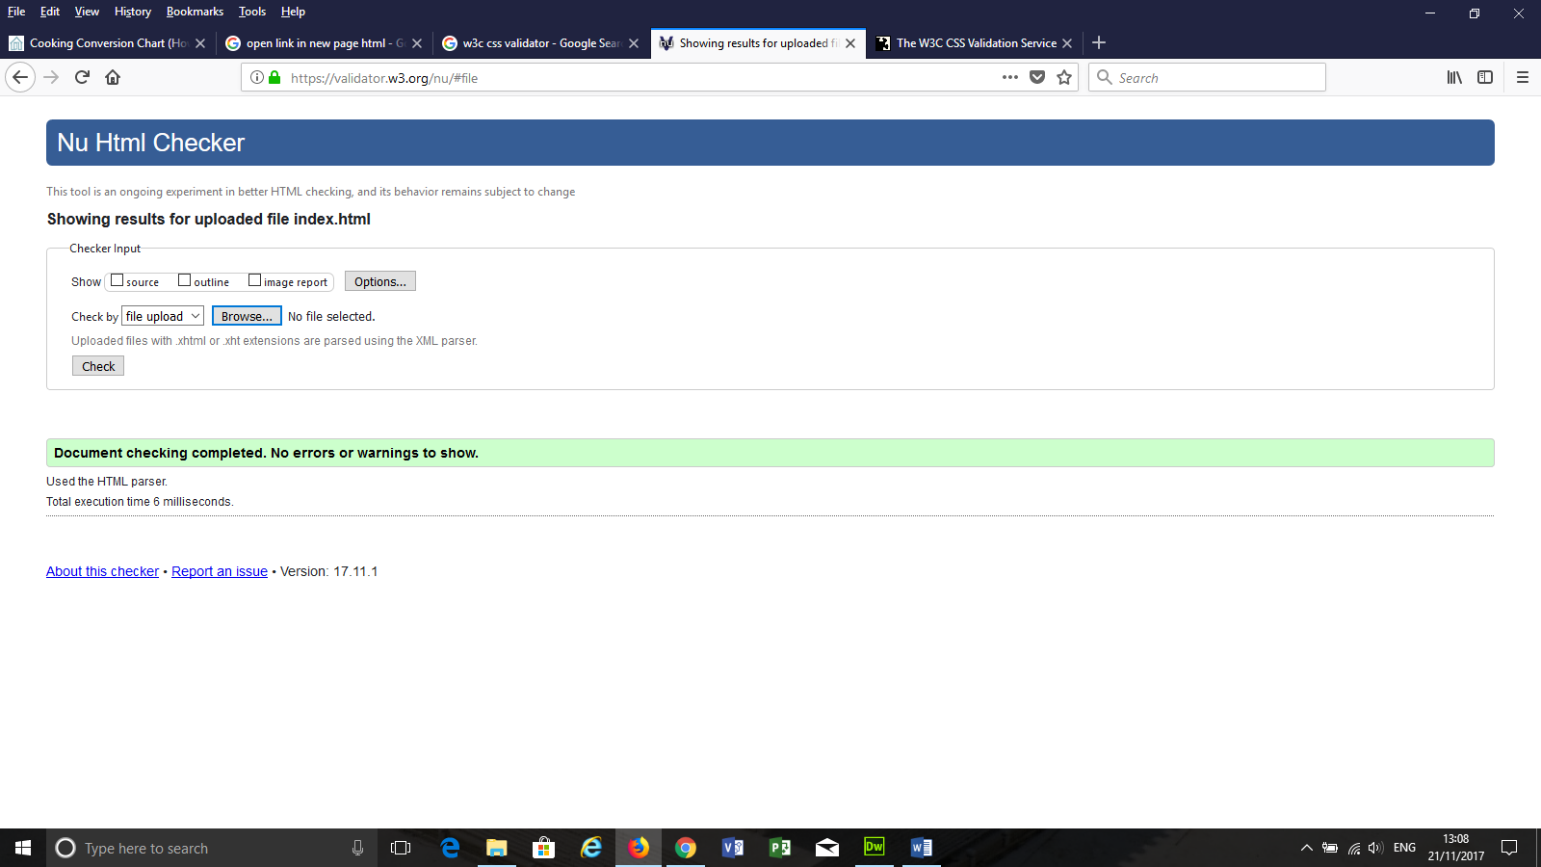

Figure index.html

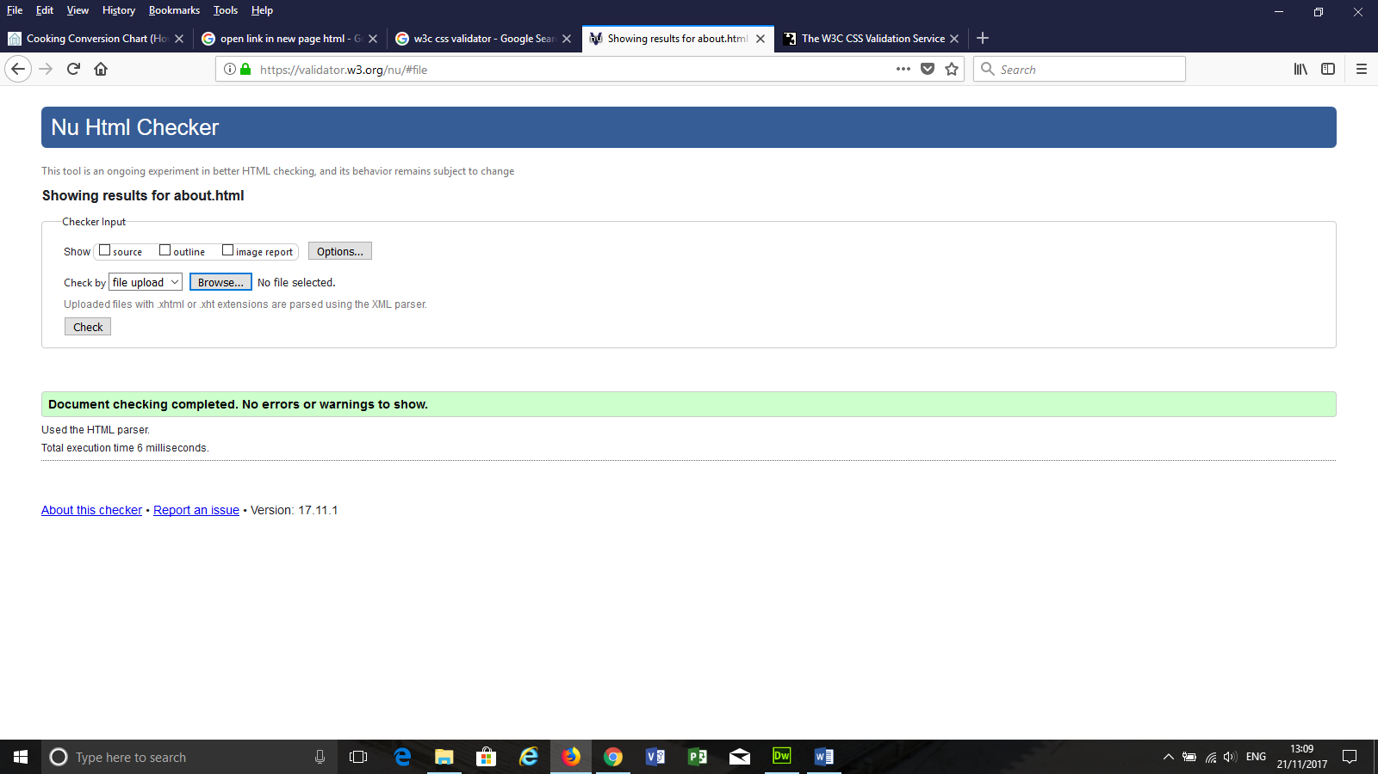

Figure about.html

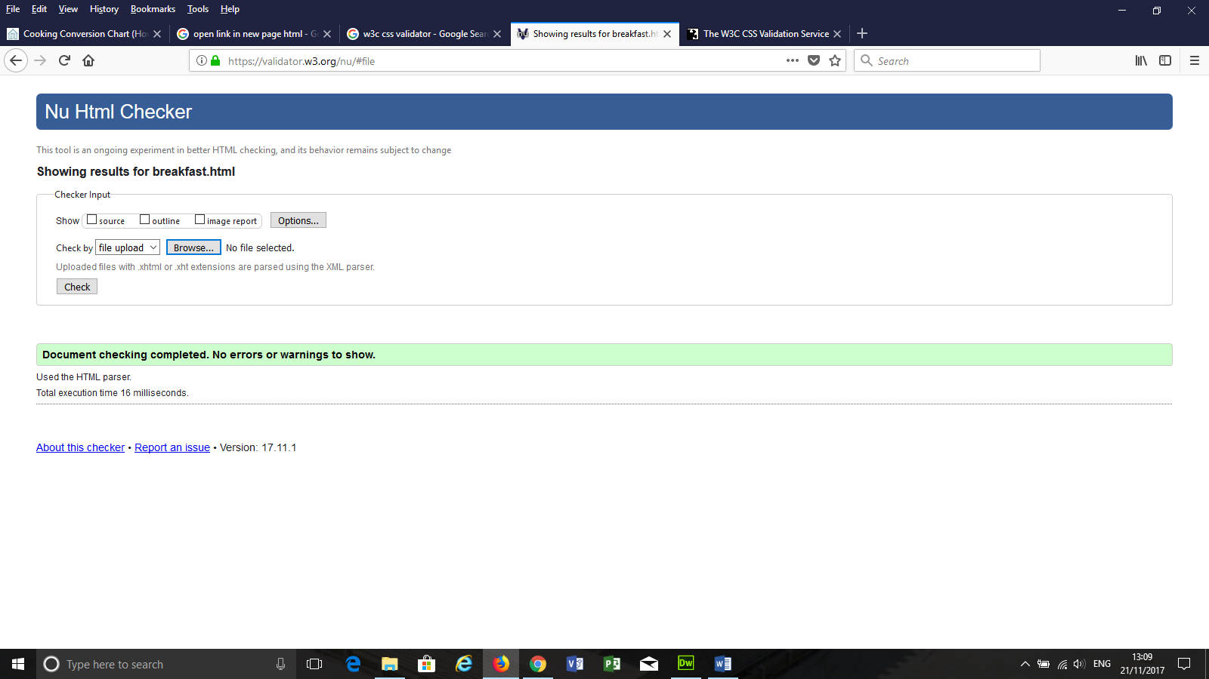

Figure breakfast.html

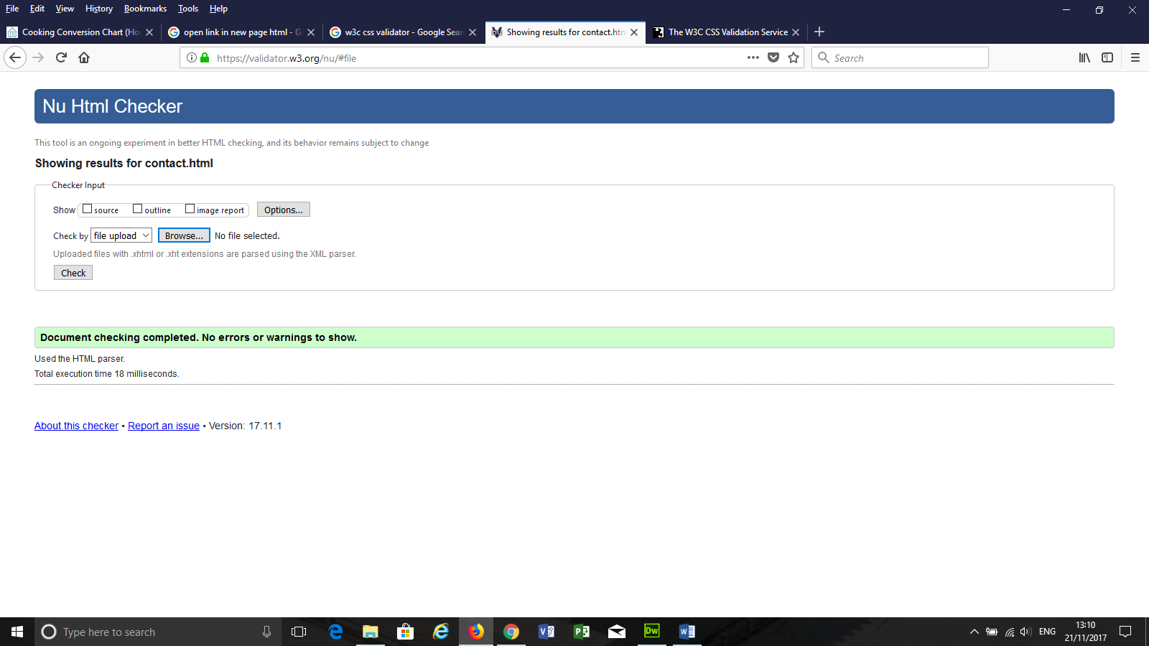

Figure contact.html

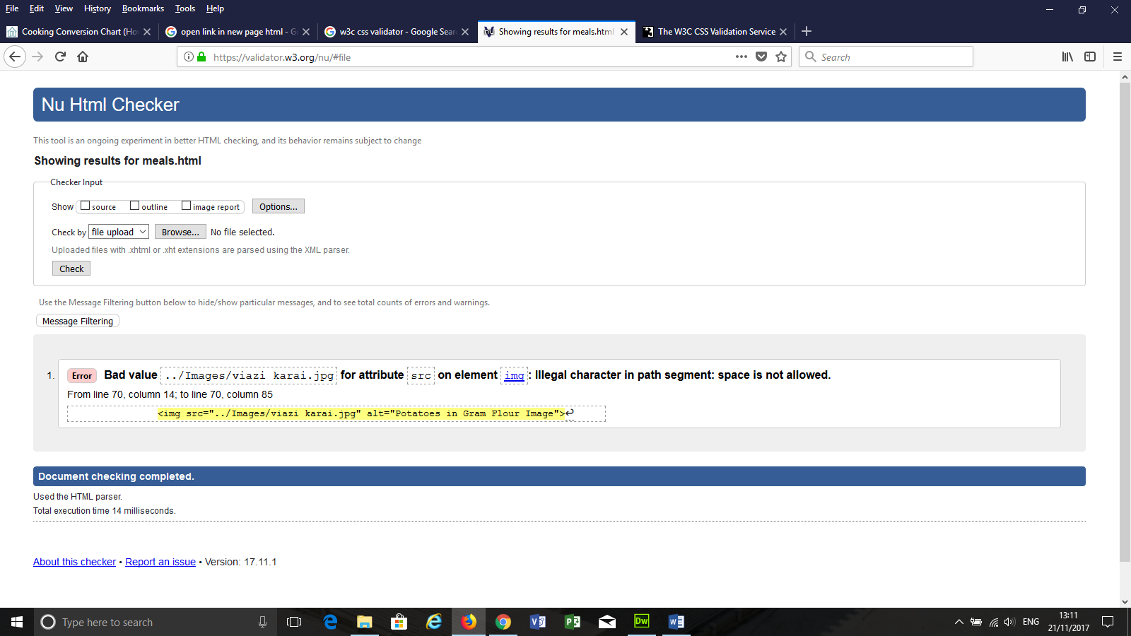

Figure meals.html

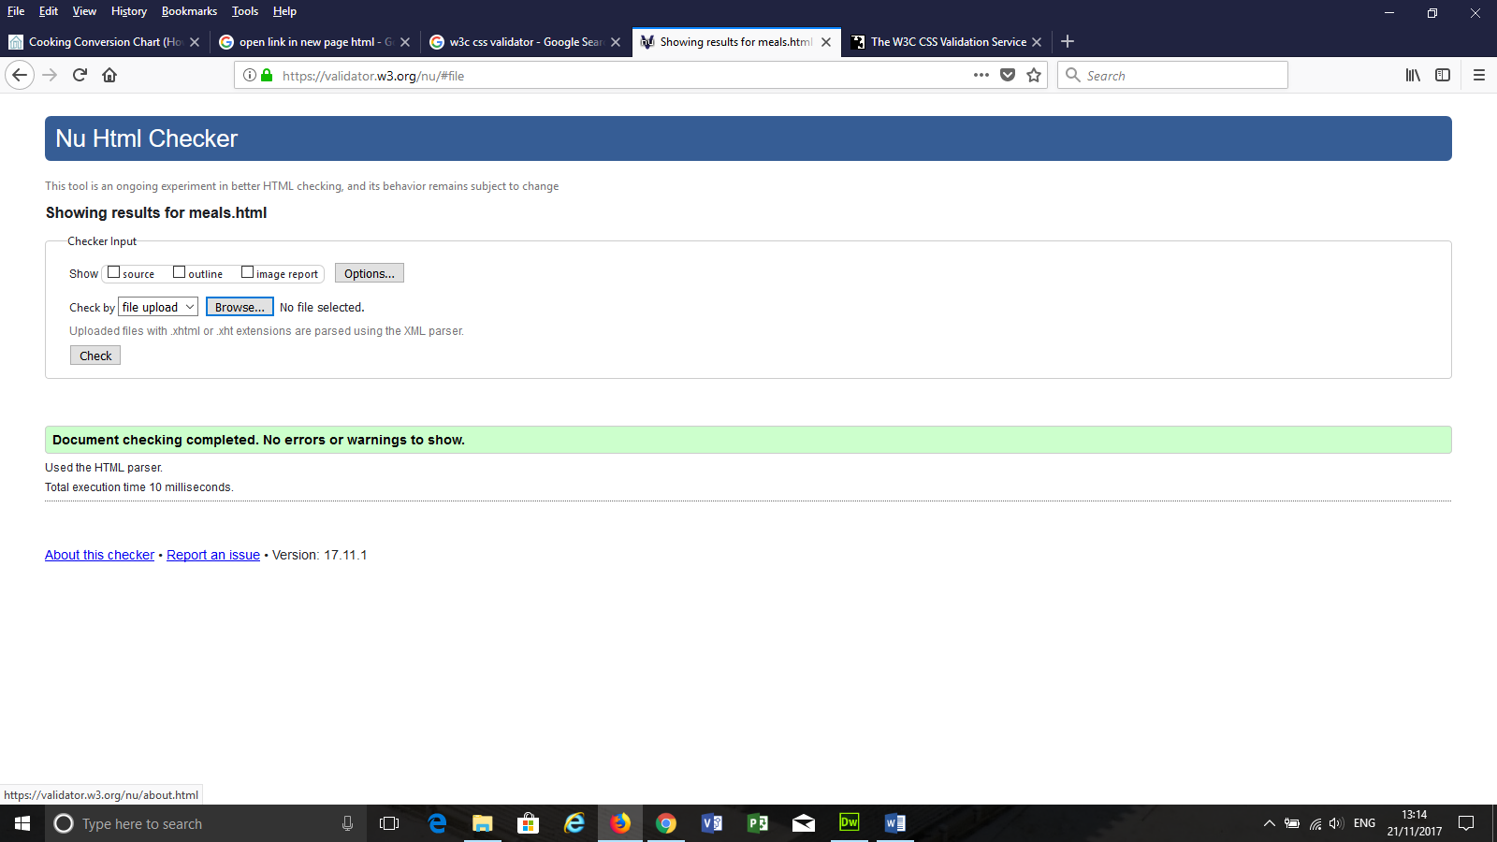

Figure meals.html 2

# Browser testing

Tested on Internet explorer, Microsoft edge, firefox 57.0 and Chrome 62 accessing from <https://asavamel.github.io/EARecpes/> and all browsers display the content uniformly.

# Recommendations (Enhancements and Maintenance)

1. The site can be enhanced with a shopping guide for local grocery shops which stock on the recipe ingredients.
2. Suggestions for changes to recipes can be reviewed and incorporated as versions of the recipes alongside them.
3. There is need to consult with copyright experts to advice before publishing the initial and subsequent versions of the website to cater for copyright issues.
4. A database may be set up to collect feedback and statistics generated by the site.
5. Create a newsletter to circulate to those who sign up.
6. Mobile first design needs more development.