WEEK – 3
Code:(DFS)
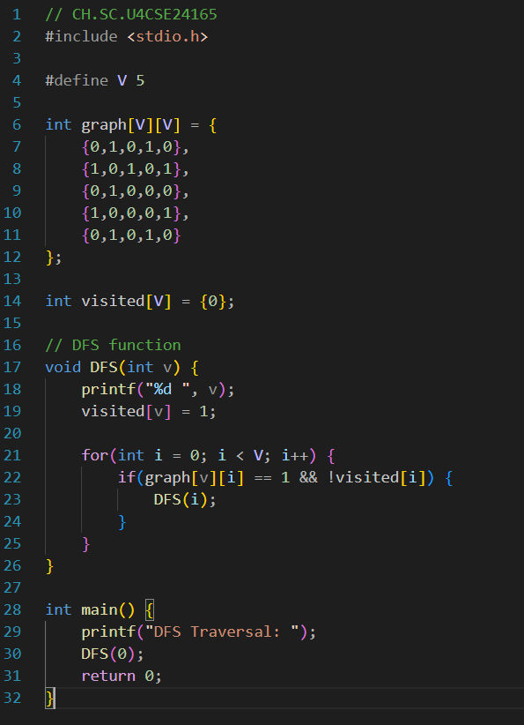
Output:
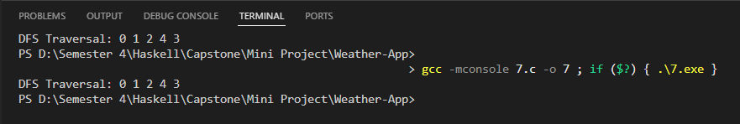

Code: (BFS)
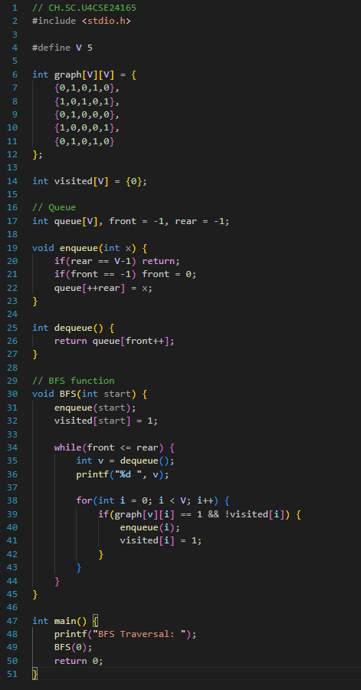

Output:
