Учреждение образования

«БЕЛОРУССКИЙ ГОСУДАРСТВЕННЫЙ ТЕХНОЛОГИЧЕСКИЙ УНИВЕРСИТЕТ»

Решение задачи коммивояжера

методом ветвей и границ

Студент: Савостин А. Д.

ФИТ 2 курс 1 группа

Минск 2020

Условие:

$$d_{i,j}= \begin{matrix}INF & 20 & 31 & INF & 10 \\ 10 & INF & 25 & 58 & 74 \\ 12 & 30 & INF & 86 & 59 \\ 27 & 48 & 40 & INF & 30 \\ 83 & 76 & 52 & 23 & INF\end{matrix}$$

Решение

|  |  |  |  |  |  |
| --- | --- | --- | --- | --- | --- |
|  | 1 | 2 | 3 | 4 | 5 |
| 1 | ∞ | 20 | 31 | ∞ | 10 |
| 2 | 10 | ∞ | 25 | 58 | 74 |
| 3 | 12 | 30 | ∞ | 86 | 59 |
| 4 | 27 | 48 | 40 | ∞ | 30 |
| 5 | 83 | 76 | 52 | 23 | ∞ |

Константы приведения по строкам:

|  |
| --- |
| 10 |
| 10 |
| 12 |
| 27 |
| 23 |

Сумма: 82

Приведение матрицы по строкам:

|  |  |  |  |  |  |
| --- | --- | --- | --- | --- | --- |
|  | 1 | 2 | 3 | 4 | 5 |
| 1 | ∞ | 10 | 21 | ∞ | 0 |
| 2 | 0 | ∞ | 15 | 48 | 64 |
| 3 | 0 | 18 | ∞ | 74 | 47 |
| 4 | 0 | 21 | 13 | ∞ | 3 |
| 5 | 60 | 53 | 29 | 0 | ∞ |

Константы приведения по столбцам:

|  |  |  |  |  |
| --- | --- | --- | --- | --- |
| 0 | 10 | 13 | 0 | 0 |

Сумма: 23

Приведение матрицы по столбцам:

|  |  |  |  |  |  |
| --- | --- | --- | --- | --- | --- |
|  | 1 | 2 | 3 | 4 | 5 |
| 1 | ∞ | 0 | 8 | ∞ | 0 |
| 2 | 0 | ∞ | 2 | 48 | 64 |
| 3 | 0 | 8 | ∞ | 74 | 47 |
| 4 | 0 | 11 | 0 | ∞ | 3 |
| 5 | 60 | 43 | 16 | 0 | ∞ |

φ = 82 + 23 = 105

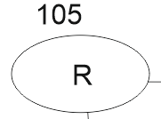

|  |  |  |  |  |  |
| --- | --- | --- | --- | --- | --- |
|  | 1 | 2 | 3 | 4 | 5 |
| 1 | ∞ | 0 | 8 | ∞ | 0 |
| 2 | 0 | ∞ | 2 | 48 | 64 |
| 3 | 0 | 8 | ∞ | 74 | 47 |
| 4 | 0 | 11 | 0 | ∞ | 3 |
| 5 | 60 | 43 | 16 | ∞ | ∞ |

Сумма констант приведения: 64

|  |  |  |  |  |
| --- | --- | --- | --- | --- |
|  | 1 | 2 | 3 | 5 |
| 1 | ∞ | 0 | 8 | 0 |
| 2 | 0 | ∞ | 2 | 64 |
| 3 | 0 | 8 | ∞ | 47 |
| 4 | 0 | 11 | 0 | ∞ |

Сумма констант приведения: 0

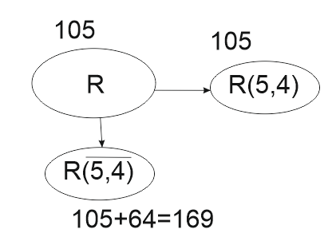

|  |  |  |  |  |
| --- | --- | --- | --- | --- |
|  | 1 | 2 | 3 | 5 |
| 1 | ∞ | 0 | 8 | ∞ |
| 2 | 0 | ∞ | 2 | 64 |
| 3 | 0 | 8 | ∞ | 47 |
| 4 | 0 | 11 | 0 | ∞ |

Сумма констант приведения: 47

|  |  |  |  |
| --- | --- | --- | --- |
|  | 1 | 2 | 3 |
| 2 | 0 | ∞ | 2 |
| 3 | 0 | 8 | ∞ |
| 4 | 0 | 11 | 0 |

Сумма констант приведения: 8

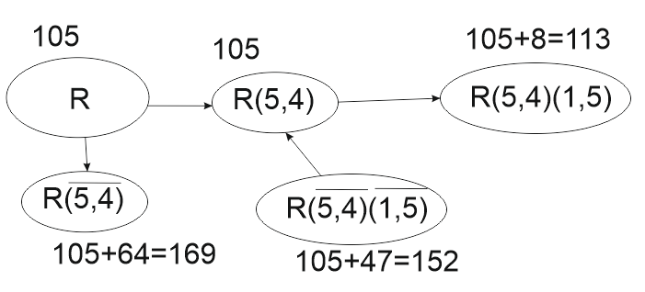

Приведенная матрица:

|  |  |  |  |
| --- | --- | --- | --- |
|  | 1 | 2 | 3 |
| 2 | 0 | ∞ | 2 |
| 3 | 0 | 0 | ∞ |
| 4 | 0 | 3 | 0 |

|  |  |  |  |
| --- | --- | --- | --- |
|  | 1 | 2 | 3 |
| 2 | 0 | ∞ | 2 |
| 3 | 0 | ∞ | ∞ |
| 4 | 0 | 3 | 0 |

Сумма констант приведения: 3

|  |  |  |
| --- | --- | --- |
|  | 1 | 3 |
| 2 | 0 | ∞ |
| 4 | 0 | 0 |

Сумма констант приведения: 0

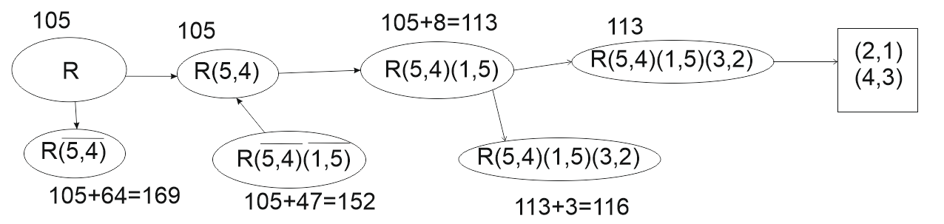

Ответ: 1­–5–4–3–2–1

Проверка:

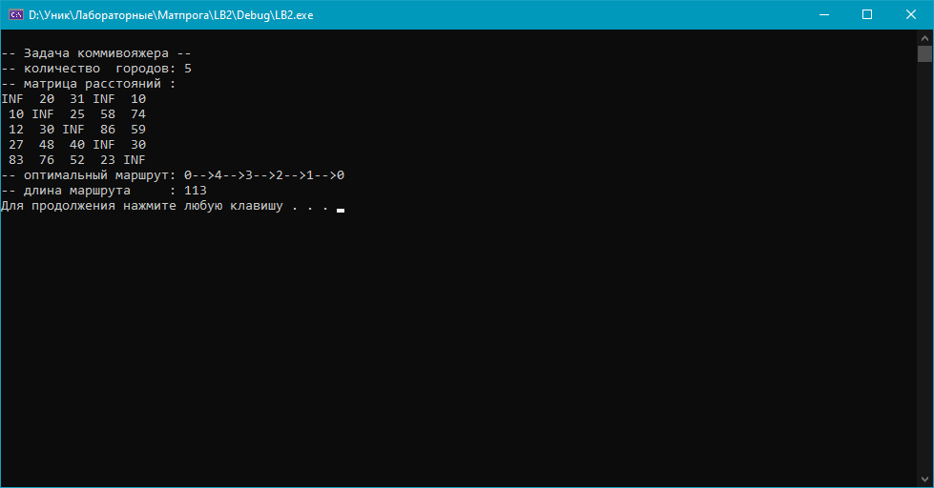

Ответ верен.