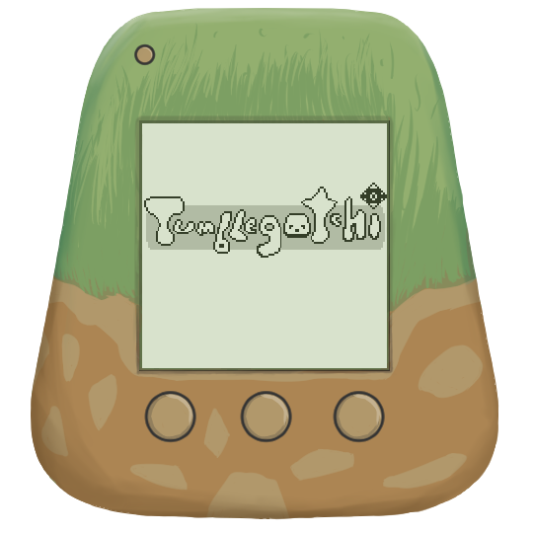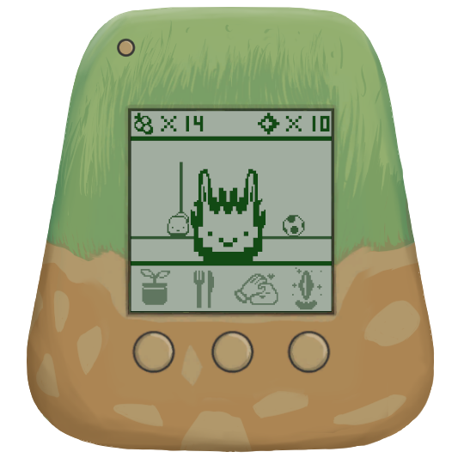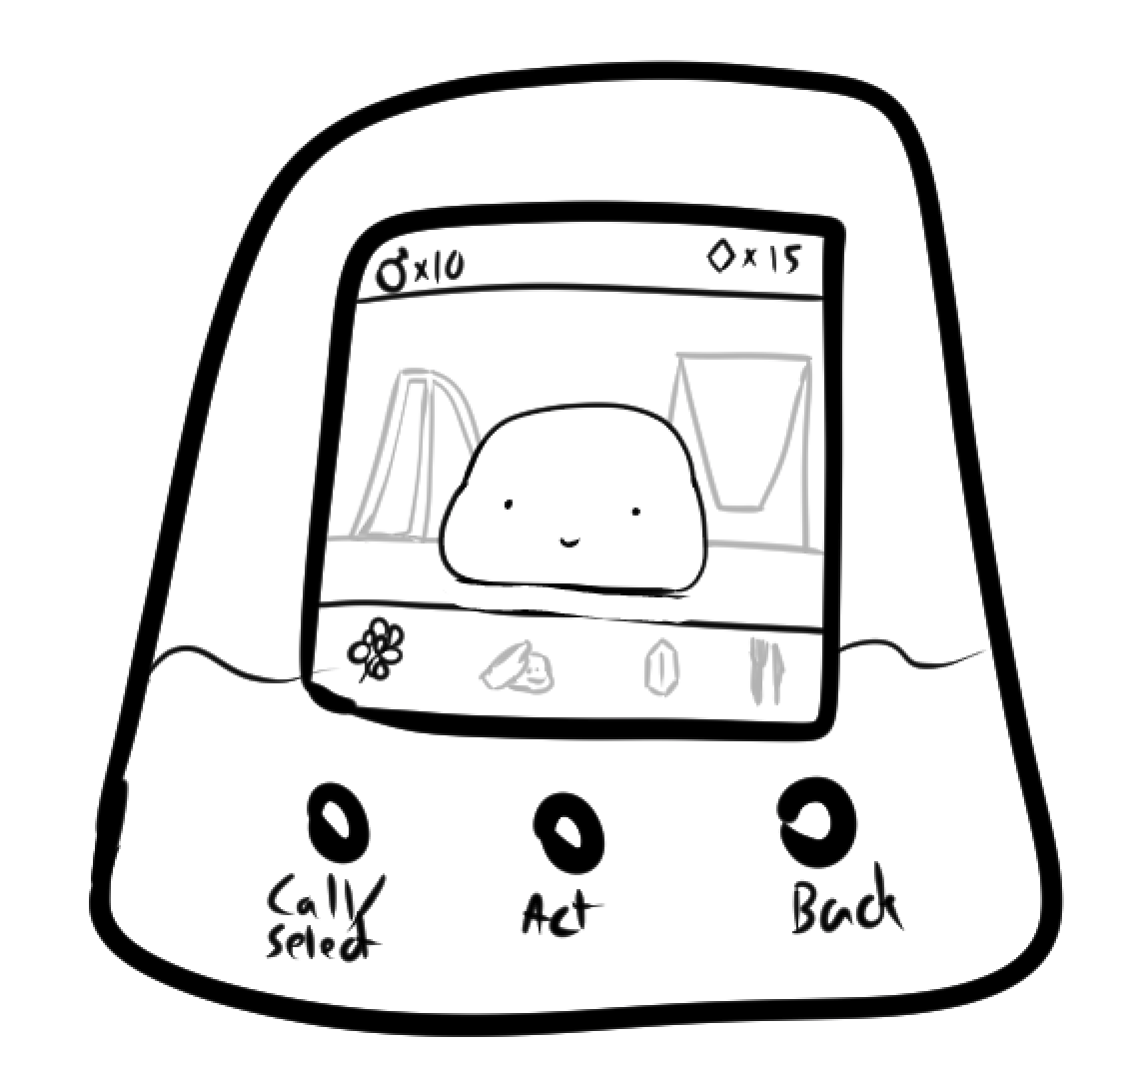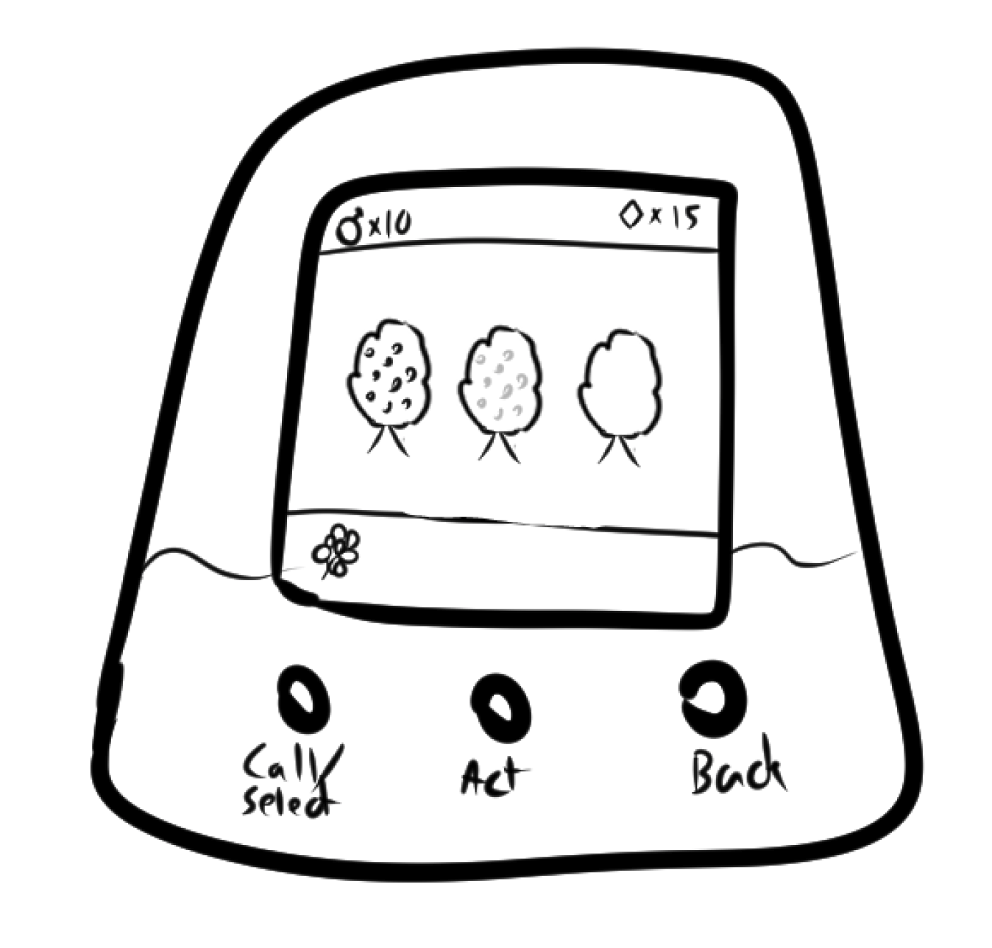­­

**Tumblegotchi Tomodachi idle pet game**

For me, the most important question when making any game is always:

What will the impact on the user be?

­­­

The Tamagotchi たまごっち(egg watch) impacted children by teaching them the difficulties and joys of caring for something helpless. The name is fitting considering how American grade school children were given chicken eggs to watch around that age to teach the same lesson.

For this digital version of the popular toy and my job regarding it I am focusing less on egg and more on watch. Any useful watch of course tells the time, but the egg watch is more of a *timer*. A game that is essentially a timer serves the purpose of reminding the user after a period of time has passed, or in other words, calls the user to attention after a period of time has passed.

This is at a surface level unattractive for the majority of productive people. A person working who is constantly distracted by a crying pet would no doubt be harassed by their supervisor to ditch the pet and focus on their job. Raising a family of jelly creatures and caring for their needs is a great way to cultivate compassion, our primary guiding design principle. If the jelly is too needy, the user will be impacted negatively by the game. If the jelly is not needy at all, the user will be unaffected by our attempts to cultivate compassion in them.

This is the nuance of balance that we must find a research-literature-informed solution to. There are some points of complexity to the science of attention that we can look into and actually take advantage of to completely change the dynamic of the *Tumblegotchi* from distraction to motivator.

One of the most popular productivity claims in pop psychology circling around is a misunderstanding of Mark, Gudith, Klocke 2008 “it takes 23 minutes to get back on track after a distraction”. Through the game of social media telephone it was transformed into two common takeaways; “the attention span is around 20 minutes” or “it takes around 20 minutes to get working”.

That really isn’t what the findings of their study dictate. To boil down their study into one sentence, they essentially found that “When people are constantly interrupted, they develop a mode of working faster (and writing less) to compensate for the time they know they will lose by being interrupted”. They notably mentioned the lack of a serious decrease in quality of work, even though the work was apparently done in a quicker window of time because of the interruptions. They also crucially offered the self-criticism that perhaps if their focus task (the activity the participants were doing that they were getting repeatedly distracted *from*) was more complicated, there may have been a higher decrease in work quality. It is no wonder, therefore, that companies aren’t purposely interrupting their employees all day to get them to do their work faster. The important and surprising takeaway is that maybe, in some cases, getting interrupted doesn’t have the effect that we anticipate.

Let’s dive further into the research investigating the effect of being interrupted. We know through a plethora of research, from many fields, that sustained attention definitely decreases over time. (Fortenbaugh, DeGutis, Esterman 2017) (Warm 2008 ) We also know, however, that taking breaks can reset the cognitive decline from extended labor. (Ariga & Lleras, 2011) (Buch et al 2021)(Sonnentag, Venz, & Casper 2017) Considering these two massively important studies, we can see that periodic, strategic interruptions can help people be more productive when working long hours. We don’t want people being forced to rush on their work because they have to feed him every moment. From this research we can support the nuance discussed at the beginning: constant interruption nor rare interruption via the *Tumblegotchi* doesn’t align with the research or the compassion design goal.

How can we utilize research to find the right spot within the window of constant and rare interruption to facilitate quality focus with the Tumblegotchi?

Disruptiveness of interruptions is for an important part determined by three factors: interruption duration, interrupting-task complexity, and moment of interruption.

Several studies have shown that the longer the interruption is, the longer it takes to resume the interrupted task [4,23,35], and the more errors are made after the interruption [4]. In addition, more complex interruptions (e.g., solving 17+36 as compared to 2+3; [23]) also lead to longer resumption times [13,14,20,23,35]. Both effects were nicely demonstrated by Monk et al. [35].

Depending on whether subjects were interrupted mid-subtask or between subtasks, interruptions were more or less disruptive.

Task Level, Difficulty of Next Subtask, and Carry-Over between Subtasks, were the most important predictors of interruption disruptiveness.

(Borst, Jelmer & Taatgen 2015)

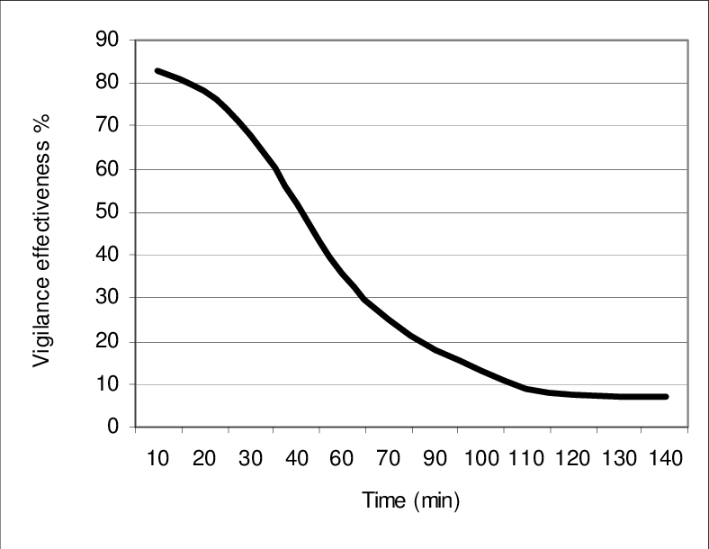Alteration of the forgetting curve through repetition according to Ebbinghaus (1885) and estimations from Paul (2007)” 


Depicted here on the left is showing vigilance decreasing over time for aviation (Hobbs 2008), on the right is an “Alteration of the forgetting curve through repetition according to Ebbinghaus (1885) and estimations from Paul (2007)” (Schimanke, Florian & Mertens, Robert & Vornberger, Oliver 2013)

Neither of these are perfect comparisons but I think we can thread the needle and derive some axioms with which we can base our *Tumblegotchi* timer on. From these we can see visually the application of decreased focus over time, and the effectiveness of a reset on that focus decrease by simply taking a short break. From Borst, Jelmer & Taatgen we can inform our balance design by limiting the descriptiveness of the interruptions. The ideal interruption avoids taking “attentional resources” because those are what need to be re-calibrated to the task on hand when the interruption has subsided.

Interruption Duration: we want to keep this low

Interruption task complexity: we want to keep this simple

Moment of interruption: How can we control this?

We can’t directly interrupt people perfectly when their subtask is complete, for we have no way of reliably knowing the schedule of every user. We can, however, understand the impact of choosing a shorter timer or a longer one.

The world of attention research has already found some solid benchmarks for cognitive fatigue and the Ebbinghaus forgetting curve. The examples which are useful in the case of this game are the Pomodoro Method, DeskTime method, and what I’ll call DeskTime v2.

* Pomodoro **is 25 minutes work, 5-10 minutes rest**
* DeskTime is **57 minutes work, 17 minutes rest**
* DeskTime v2 is **112 minutes work, 26 minutes rest.**

We want to prioritize a small interruption time, due to the fact that our game doesn’t have high gameplay complexity. On the other hand, We don’t want to interrupt the user too much and increase the chance of catching them between subtasks. Additionally, we have to balance the multiple means of interaction with the game (picking berries, playing with jelly, feeding jelly, etc.)

I suggest making use of all three findings, and it seems fitting since we have 3 activities of various involvement.

* Jelly play is a low attentional commitment, that only involves a single button press and no decision making. We can have the jelly want to be played with every 25 minutes in accordance with Pomodoro
* Feeding the jelly gives a reward which draws a person into the game further to browse the shop. We can have the jelly need to be fed every 57 minutes, in accordance with DeskTime.
* We can have the berry bush regenerate every 112 minutes per DeskTime v2. After picking the berries players will feed the jelly with them, and then they will visit the shop. Picking berry bush is the earliest event in the gameplay loop so it will create the most tasks.

**Bibliography**

Gloria Mark, Daniela Gudith, and Ulrich Klocke. 2008. The cost of interrupted work: more speed and stress. In Proceedings of the SIGCHI Conference on Human Factors in Computing Systems (CHI '08). Association for Computing Machinery, New York, NY, USA, 107–110. <https://doi.org/10.1145/1357054.1357072>

Fortenbaugh FC, DeGutis J, Esterman M. Recent theoretical, neural, and clinical advances in sustained attention research. Ann N Y Acad Sci. 2017 May;1396(1):70-91. doi: 10.1111/nyas.13318. Epub 2017 Mar 5. PMID: 28260249; PMCID: PMC5522184.

Warm, S.J. & Matthews, Gerald & Finomore, Victor. (2008). Vigilance, workload, and stress. Performance Under Stress. 115-141.

Sonnentag, S., Venz, L., & Casper, A. (2017). Advances in recovery research: What have we learned? What should be done next? Journal of Occupational Health Psychology, 22(3), 365–380. <https://doi.org/10.1037/ocp0000079>

Ariga, A., & Lleras, A. (2011). Brief and rare mental “breaks” keep you focused: Deactivation and reactivation of task goals preempt vigilance decrements. Cognition, 118(3), 439–443. <https://doi.org/10.1016/j.cognition.2010.12.007>

Buch et al., Consolidation of human skill linked to waking hippocampo-neocortical replay, Cell Reports, June 8, 2021, DOI: 10.1016/j.celrep.2021.109193

Borst, Jelmer & Taatgen, Niels & Rijn, Hedderik. (2015). What Makes Interruptions Disruptive?. 2971-2980. 10.1145/2702123.2702156.

Hobbs, Alan. (2008). An Overview of Human Factors in Aviation Maintenance.

Ebbinghaus H. Memory: a contribution to experimental psychology. Ann Neurosci. 2013 Oct;20(4):155-6. doi: 10.5214/ans.0972.7531.200408. PMID: 25206041; PMCID: PMC4117135.

Schimanke, Florian & Mertens, Robert & Vornberger, Oliver. (2013). WHAT TO LEARN NEXT? CONTENT SELECTION SUPPORT IN MOBILE GAME-BASED LEARNING.