**Software Requirements Specification**

**For**

**eCoin**

***Version 1.1***

Prepared by

**The Patriots**

**11/13/2020**

# 

Table of Contents

1. Introduction 4

1.1 Purpose 4

1.2 Scope 4

1.3 Definitions 5

1.4 Visual Statement 5

1.5 Overview of the Document 6

1.6 Document Conventions 6

1.7 Intended Audience and Further Information 6

1.8 References 6

2. Product Specifications 7

2.1 Product Perspective 7

2.1.1 All Coin Stat Screen 7

2.1.2 Favorites List 7

2.1.3 Investment Tracking List 8

2.2 Product Features 8

2.2.1 Real-Time Updates 8

2.2.2 Currency Trading and Conversion 8

2.2.3 Foreign Exchange Trading 8

2.2.4 Fast International Transfer 8

2.2.5 Buy/Sell Bot 9

2.3 Use Cases 9

2.3.1 Real-Time Updates Use Case 9

2.3.2 Currency Trading 10

2.3.3 Conversion Use Case 10

2.3.4 Foreign Exchange Trading 11

2.3.5 Fast International Transfer 12

2.3.6 Buy/Sell Bot 13

2.3.7 Establish a Connection Between the User’s Device and the Trading Server 14

2.3.8 Handling Market Data From the Trading Server 15

2.3.9 Handle Order Acknowledgement and Fill Trades 16

2.3.10 Search Crypto 16

2.3.11 Add Funds 17

2.4 State Diagrams 18

2.4.1 Login 18

2.4.2 Registration 19

2.4.3 Adding Cryptocurrency to Favorite List 20

2.4.4 Adding Funds 21

2.4.5 Transfers 21

2.5 Wire Flow Diagrams 23

2.6 Class Diagrams 24

2.7 Functional Requirements 24

2.7.1 Updating Cryptocurrency Prices 24

2.7.2 Currency Trading 24

2.7.3 Converting Currency 25

2.7.4 Foreign Exchange Trading 25

2.7.5 International Trading 26

2.7.6 Buy/Sell Bot 26

2.7.7 Establish a Connection Between the User’s Device and the Trading Server 27

2.7.8 Handling Market Data From the Trading Server 27

2.7.9 Handle Order Acknowledgement and Fill Trades 27

2.7.10 Search Crypto 28

2.7.11 Add Funds 28

2.8 Non-Functional Requirements 30

2.8.1 Logical Structure of Data 29

2.8.2 Security Requirements 32

2.8.3 Performance Requirements 32

2.8.4 Safety Requirements 32

2.8.5 Software Quality Requirements 33

2.9 Interface Requirements 33

2.9.1 External Interface Requirements 33

2.9.2 Internal Interface Requirements 33

3.0 System Requirements 34

Bibliography 36

# 

# 

# 1. Introduction

The introduction of this Software Requirements Specifications (SRS) provides an overview of this application including the purpose of the application, the scope of the internal data processing, definitions, a statement regarding the visual expectation, document formatting, intended audience, and references. This document is meant to give a deeper insight to eCoin so that project managers and application developers may further understand the expectations set by The Patriots to reach the application’s end goal.

## *1.1 Purpose*

eCoin is a mobile application which allows users to create a secure account where they may purchase and sell digital currencies, referred to as cryptocurrencies, based on the real-time market value. Each user may then monitor their purchases including the profit or loss margin, favorite specific cryptocurrencies, and convert their starting currency to the cryptocurrency and then to an end currency to find any conversion rate loss before making their purchase. This proactive approach allows users with an interest in international currency exchange to verify their risk before initiating any formal purchase.Whether transfers are international or not, eCoin gives users an easy to use interface with many useful tools.

## 1.2 Scope

The scope of this project includes the development of a visual communication between the cryptocurrency algorithm, including current market price with daily changes, and the requesting user’s device. The popular cryptocurrency price-tracking website, CoinMarketCap, will communicate with an internal database hosted by The Patriots and the database will populate real-time tables and graphs on the user interface in addition to tracking the user’s buying and selling currencies.

## *1.*3Definitions

According to Jake Frankenfield, “cryptocurrency is a digital or virtual currency that is secured by cryptography, which makes it nearly impossible to counterfeit or double-spend. Many cryptocurrencies are decentralized networks based on blockchain technology—a distributed ledger enforced by a disparate network of computers. A defining feature of cryptocurrencies is that they are generally not issued by any central authority, rendering them theoretically immune to government interference or manipulation. (Frankenfield)”

Fiat currency is a government issued currency not backed by any commodity. A virtual cryptocurrency wallet is a common storage method for encrypted keys which allows the user to send or receive cryptocurrencies.

Xref in this document refers to a cross referencing tool that is used to link sections.

SRT is an acronym for server response time

## 1.4 Visual Statement

The aim of eCoin is to create a user-friendly mobile application that allows users to monitor price fluctuation of cryptocurrency prices in table format, initiate buying and selling through form data. The application will allow the user to use bots to buy and sell their stocks. This data will be tracked through the chart on the main page of the application. The user will be able to add funds, convert currency, and transfer currency. Everyone can benefit from this application, but crypto traders and miners will be affected the most.

## 1.5 Overview of the Document

This document gives an overview of the product. The document describes the informal/formal requirements and is used to establish the technical requirements. This document is primarily written for the developers and is supposed to describe the complete functionality of the product.

## 1.6 Document Conventions

This SRS follows MLA Format. Italics and bold-faced text has been used to emphasize section and subsection headings.

## 1.7 Intended Audience and Further Information

This document is meant for the development team, project managers, testers, and document writers. The SRS has been organized approximately in order of increasing specificity. The developers and project managers need to become intimately familiar with the SRS.

For more information regarding cryptocurrency, refer to <https://www.investopedia.com/terms/c/cryptocurrency.asp>.

For more information regarding CoinMarketGap, refer to <https://coinmarketcap.com/>.

## 1.8 References

Consult the attached project scope for further information regarding project scope. A Use Case, State Diagram, and Wire Flow Diagram have been attached in sections 2.3, 2.4, and 2.5.

# 2. Product Specifications

## 2.1 Product Perspective

This software product being developed is for a standard mobile device structured as a mobile app. The software will have cross platform support for the most common commercial mobile operating systems.

### *2.1.1* ***All Coin Stat Screen***

All coins will be displayed with a name, ticker, trade volume, price, supply, profit/loss percentage, twenty-four hour change, twelve hour change, three day change, seven day change, and a one month change. In addition, the user will also be able to analyze the past six months, year, five years, and year to date. The user is allowed to sort any of the following fields to get the data requested for display. Selection of a currency will display details about the coin.

### *2.1.2* ***Favorites List***

A user can add and remove coins to their user-specific favorites list.

### 2.1.3 **Investment Tracking List**

A user is able to add coins to their user-specific investment list. The screen displayed will include the current gain or loss in value with percentages and a tracker showing the price paid and the quantity that was purchased.

## 2.2 Product Features

### 2.2.1 **Real-Time Updates**

A computer system updates information at the same rate it is received. Trends in price and Profit-Loss in finite periods of time will also be updated in real-time. This feature will periodically update, in minute intervals, the user’s view of their Investment Tracking List, the currently selected buy screen, and the user’s favorites list. The user may enable SMS push notifications of events to their mobile device.

### 2.2.2 **Currency Trading and Conversion**

Users are able to purchase and sell cryptocurrency with any type of currency. Currency can be bought and sold from any combination of physical currency to cryptocurrency. Users are also able to buy a fraction of a coin.

### 2.2.3 **Foreign Exchange Trading**

The purchasing and selling of currencies can be done in the foreign exchange market place. This allows for the transfer of money from country to country without using wire transfers. International trading is simpler with the ability for a user to specify which currency they wish to purchase cryptocurrency with.

### 2.2.4 **Fast International Transfer**

For international workers and students, moving money between their home country and currency to the currency of their host country can be a challenge and lengthy process. By using crypto currency as an intermediary, currency exchange fees at banks can be avoided while the time required for international transfer can be reduced.

### 2.2.5 **Buy/Sell Bot**

This feature will allow users to set specific price points at which automated buy and sell operations will happen for user-specified quantities in either fiat or cryptocurrency. The Buy/Sell Bot will execute the transaction based on an allocated budget or a ratio of available funds. The bot settings can be toggled to allow the user to confirm or deny any buy or sell requests through a push notification. Notifications can also be enabled on the user’s device to alert the user of a cryptocurrency reaching a particular price point without a transaction request.

## 2.3 Use Cases

### *2.3.1* ***Real-Time Updates Use Case***

Use Case: **Updating Cryptocurrency Prices**

**Diagram:**



**Brief Description**

The user opens the application and is prompted with updates of the cryptocurrency prices and profit/loss percentages from their Investment Tracking List and favorites list.

**Initial Step-By-Step Description**

Before this use case can be initiated, the user must first install the application. The application can be found in any mobile phone application store (Google Play Store, Samsung Galaxy Store, Apple App Store, etc.).

1. The user opens the application

**Xref:** Section 2.2.1, Real-Time Updates

### *2.3.2* ***Currency Trading***

Use Case: **Trading Currency**

**Diagram:**



**Brief Description**

The user, after signing in, can access fiat funds and trade cryptocurrencies.

**Initial Step-By-Step Description**

Before this feature can be used, the user must first be signed in.

1. The user can use fiat funds already on their account or draw funds from external accounts, such as a personal banking account.
2. With the fiat funds, the user can either purchase an existing offering for a specific cryptocurrency or create a listing of their own.

**Xref:** Section 2.2.2, Currency Trading and Conversion

### 2.3.3 **Conversion Use Case**

Use Case: **Converting Currency**

**Diagram:**



**Brief Description**

The user, after signing in, can trade between different cryptocurrencies.

**Initial Step-By-Step Description**

Before this feature can be used, the user must first be signed in and have cryptocurrency in their account.

1. User signs into their personal account
2. The user may purchase an existing offer for a specific cryptocurrency on the condition they have adequate currency of the type specified by the offer, or create a listing of their own

**Xref:** Section 2.2.2, Currency Trading and Conversion

### *2.3.4* ***Foreign Exchange Trading***

Use Case: **Speculative Investment in Global Currencies**

**Diagram:**

**Brief Description**

The user may exchange any fiat and cryptocurrencies available to them in exchange for any listed fiat currency.

**Initial Step-By-Step Description**

Before this feature can be used, the user must first be signed in and have funds available in their account.

1. The user signs into their account.
2. The user may purchase an existing offer for a desired fiat currency on the condition they have adequate funds available in the currency specified in the offer, or create an offer of their own.

**Xref:** Section 2.2.3, Foreign Exchange Trading

### 2.3.5 ***Fast International Transfer***

Use Case: **International Trading**

**Diagram:**

**Brief Description**

The user may transfer currency across international borders instantaneously

without any security issues and concerns

**Initial Step-By-Step Description**

Before this feature can be used, the user must be signed in and have a positive

amount of funds available in their account.

1. User signs into their account
2. User should navigate to the trading page
3. The user will have to select the amount they would like to transfer to the recipient. Next, the user will have to enter the recipient’s account information. Lastly, the user should be able to send their currency. Assuming all the information was correct, the recipient should have their currency.

**Xref:** Section 2.2.4, Fast International Transfer

### 2.3.6 ***Buy/Sell Bot***

Use Case: **Automated Trading**

**Diagram:**

**Brief Description**

The user will have to choose their bot, buy and/or sell price, and the maximum amount of

stock they want to purchase at a time. Once the cryptocurrency stock drops to the

sell price, the bot will then purchase that stock in the amount that the user

specified. Finally, the bot will hold the stock until the stock goes up to the user’s

chosen sell price and sell all of the stocks available.

**Initial Step-By-Step Description**

Before this feature can be used, the user must navigate to the Buy/Sell Bot’s page and enable Automated Trading by selecting a bot.

1. User will need to be signed into their account
2. Activate Automated Trading and select a bot
3. Set buy, sell price, and the maximum amount of stock
4. Choose currency/currencies for the bot to watch
5. Activate bot

**Xref:** Section 2.2.5, Buy/Sell Bot

### 2.3.7 **Establish a Connection Between the User’s Device and the Trading Server**

Use Case: **Establish a Connection Between the User’s Device and the Trading Server**

**Diagram:**

**Brief Description**

Brokerages need a fast SRT in order to successfully fulfill orders. It is

recommended to have an .08 average execution speed because the market is changing every second, therefore the server needs to update almost instantaneously.

**Initial Step-By-Step Description**

Before the user can use the application, they must have a device that is able to connect to the internet.

### 2.3.8 **Handling Market Data From the Trading Server**

Use Case: **Handling Market Data from the Trading Server**

**Diagram:**

**Brief Description**

The user's device should be able to present market data from the trading server in a neat and orderly fashion, such as the stock charts and any news about a particular currency.

**Initial Step-ByStep Description**

Before the user can use the application, they must have a device that is able to connect to the internet.

### 2.3.9 **Handle Order Acknowledgement and Fill Trades**

Use Case: **Handle Order Acknowledgement and Fill Trades**

**Diagram:**

**Brief Description**

Brokerages need to fill trades as soon as they are acknowledged. Since the servers are updating so fast, the currency changes just as fast. Therefore if the SRT is updating at an efficient speed, the user can buy the stock at the price they want to; but if it takes the server a while to process the order the user might end up buying a stock price that is higher or lower than what they originally bought.

**Initial Step-By-Step Description**

Before the user can use the application they must have a device that is able to connect to the internet.

### 2.3.10 **Search Crypto**

Use Case: **Search Crypto**

**Diagram:**

**Brief Description**

The user will be allowed to select a search icon that will allow them to search for a cryptocurrency or specified stock ticker number. After they find their specified currency they will then be shown information about the currency.

**Initial Step-By-Step Description**

1. The user first selects the search bar located on the search screen

2. A keyboard is popped up from the bottom of the screen where they can

then search for their desired stock.

3. The user can select their stock after they find the one they are looking for

### 2.3.11 **Add Funds**

Use Case: **Add Funds**

**Diagram:**

**Brief Description**

The user will have the ability to add funds via their banking details, credit/debit cards, PayPal, Apple Wallet, and Google Pay.

**Initial Step-By Description**

1. The user must be accessing their profile screen and then click on “Add Funds”
2. They will then be prompted to choose a way to add funds (banking details, credit/debit cards, PayPal, Apple Wallet, or Google Pay)
3. Their information will then be checked to make sure everything is valid.
4. If all of their information is correct and there is money available for transfer, the user will have their money.

## 2.4 State Diagrams

### 2.4.1 **Login**

**Brief Description**

The user is prompted to enter their username and password. After that is complete, the system checks to see if the username is valid and then checks to see if the password matches the credentials associated with the username. If the username and password are correct then the login is successful. If the username or password is invalid, the user will be prompted to try again. The user gets three attempts to guess their password. If they do not guess their password correctly they are prompted to change their password.

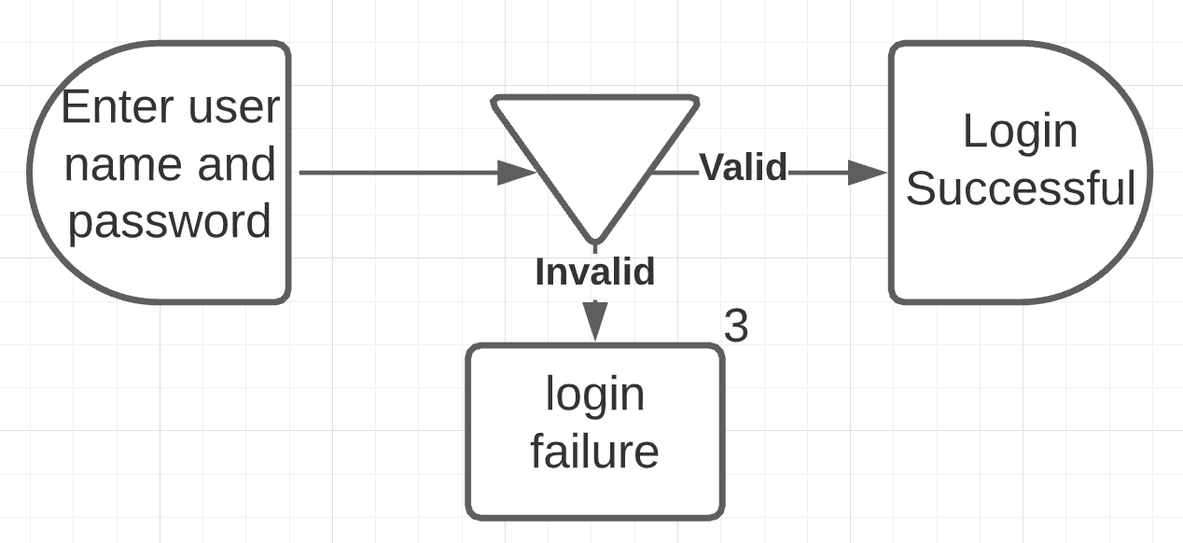

### 2.4.2 **Registration**

**Brief Description**

The user is prompted to enter their personal information. After that is complete, some of their information is checked (ex. Their birth year cannot be in the future). If everything is valid, then their account is created. If not, the user is returned to the page where they entered their information to do the process over.

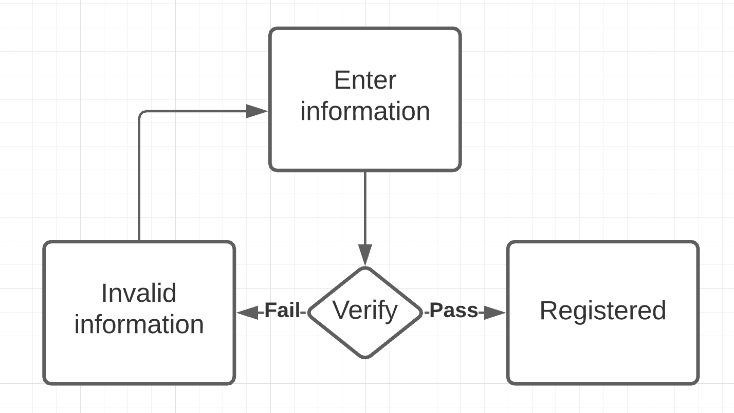

### 2.4.3 **Adding Cryptocurrency to Favorite List**

**Brief Description**

The user wants to add a cryptocurrency into their favorites list. By doing so, the cryptocurrency is checked to see whether or not it is already on their favorites list. If it is, they are redirected back to the view screen. If it is not already on the favorites list, it will be successfully added to it.

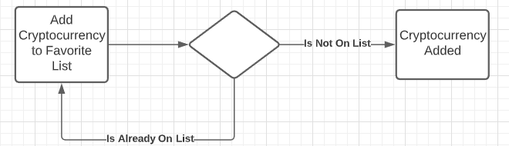

### 2.4.4 **Adding Funds**

**Brief Description**

If the user wants to add funds to their account, they will be prompted to log into their bank account and enter valid information. If the information is valid, the user is redirected to the add funds option and then decides the amount they would like to add. If the information is invalid, the user will be redirected to a failed login screen and then will be pushed back to the account login.

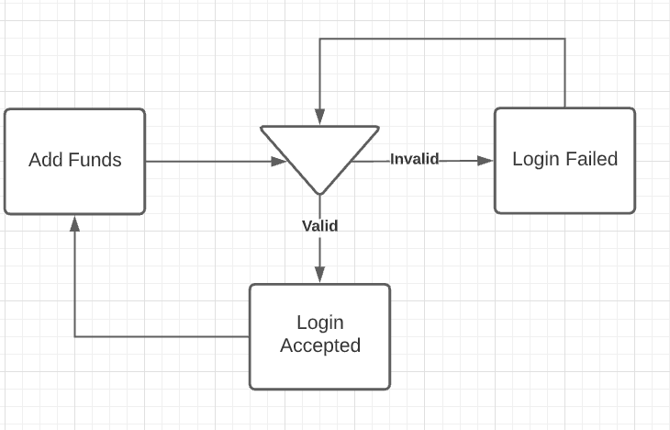

### 2.4.5 **Transfers**

**Brief Description**

The user wants to transfer to another user. To do this, the user would click on the transfer button. The user would be redirected to enter the recipient’s information. If the information is valid, the transfer will be made. If the information is invalid, the user will be redirected back to enter correct information.

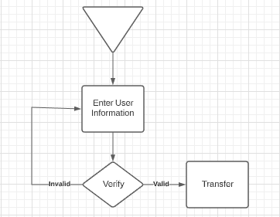

## 2.5 Wire Flow Diagrams

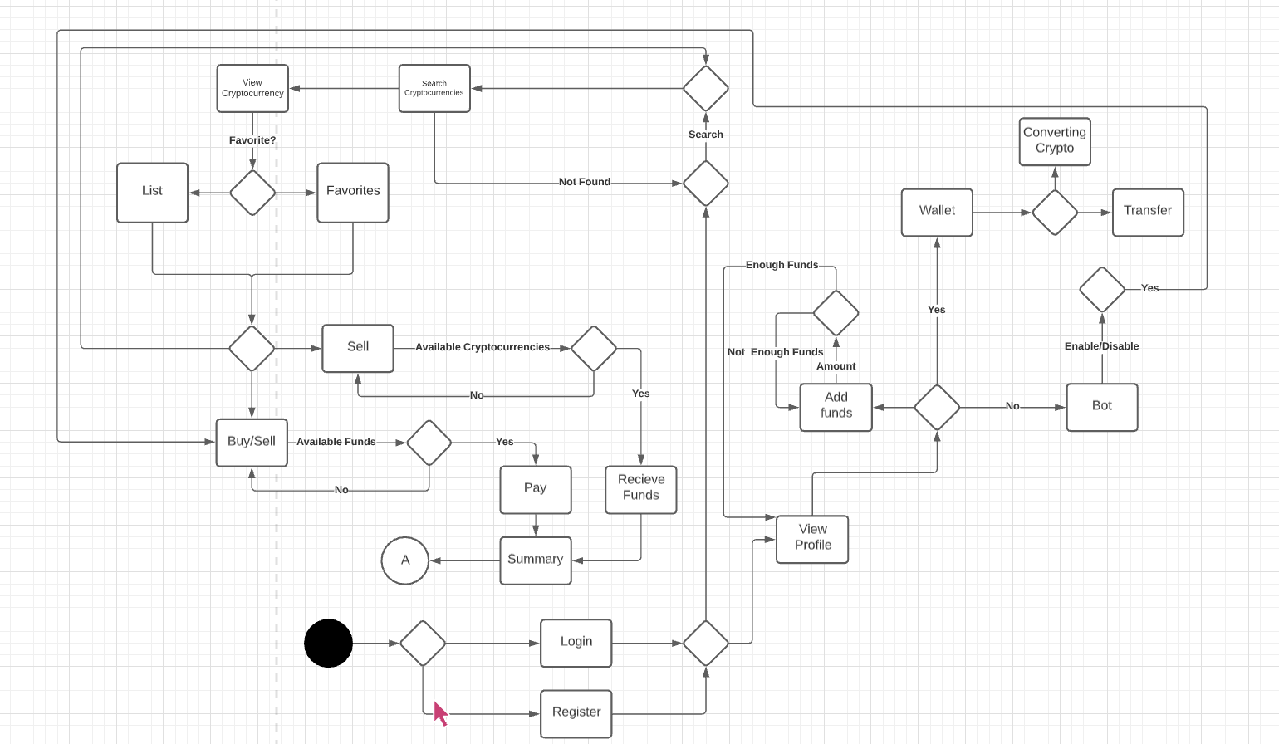

## 2.6 Class Diagrams

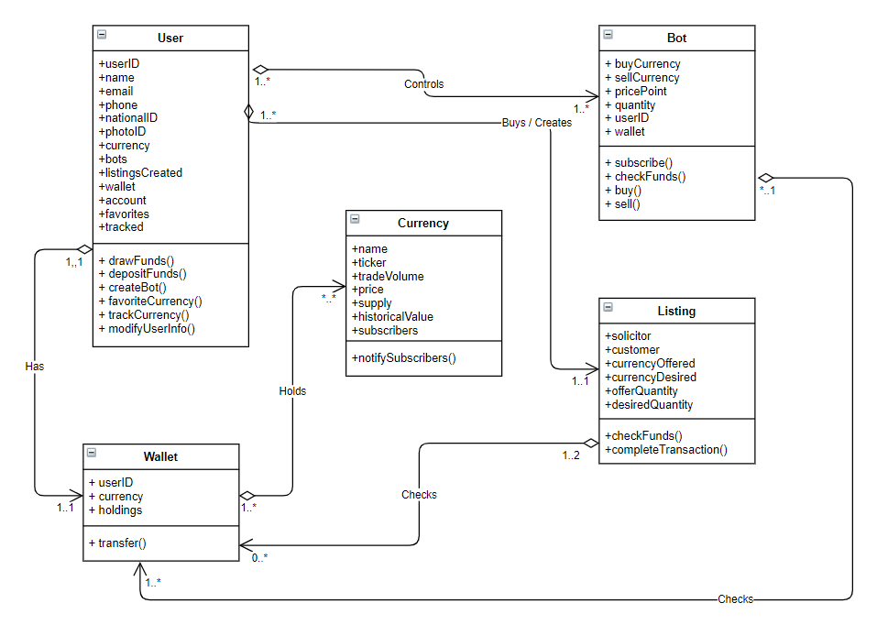

## 2.7 Functional Requirements

### 2.7.1 **Updating Cryptocurrency Prices**

|  |  |
| --- | --- |
| **Use Case Name** | **Updating Cryptocurrency Prices** |
| **Xref** | Section 2.3.1, 2.2.1 |
| **Trigger** | The user has to have eCoin open |
| **Precaution** | The user needs to be looking at a currency or update page |
| **Basic Path** | 1. Open eCoin 2. Navigate to a currency or update page |

### 2.7.2 ***Currency Trading***

|  |  |
| --- | --- |
| **Use Case Name** | **Currency Trading** |
| **Xref** | Section 2.3.2, 2.2.2 |
| **Trigger** | The user must be signed in and be on the wallet screen |
| **Precaution** | If the user enters the wrong information they will not be able to trade with the other user because the application does not know where to send the currency |
| **Basic Path** | 1. The user can use fiat funds already on their account or draw funds from external accounts, such as a personal banking account. 2. With the fiat funds, the user can either purchase an existing offering for a specific cryptocurrency or create a listing of their own. |

### 2.7.3 **Converting Currency**

|  |  |
| --- | --- |
| **Use Case Name** | **Converting Currency** |
| **Xref** | Section 2.3.3, 2.2.2 |
| **Trigger** | The user must have eCoin open and be on the currency converter window |
| **Basic Path** | 1. User signs into their personal account 2. The user may purchase an existing offer for a specific cryptocurrency on the condition they have adequate currency of the type specified by the offer, or create a listing of their own |

### 2.7.4 ***Foreign Exchange Trading***

|  |  |
| --- | --- |
| **Use Case Name** | **Speculative Investment in Global Currencies** |
| **Xref** | Section 2.3.4, 2.2.3 |
| **Trigger** | The user must first be signed in and have funds available in their account. |
| **Basic Path** | 1. Users signs into their account. 2. The user may purchase an existing offer for a desired fiat currency on the condition they have adequate funds available in the currency specified in the offer, or create an offer of their own. |

### 2.7.5 **International Trading**

|  |  |
| --- | --- |
| **Use Case Name** | **International Trading** |
| **Xref** | Section 2.3.5, 2.2.4 |
| **Trigger** | User must have eCoin open and must be on the trading window |
| **Precaution** | The user must have the tradies correct information |
| **Basic Path** | 1. User signs into their account 2. User should navigate to the trading page 3. The user will have to select the amount they would like to transfer to the recipient. Next, the user will have to enter the recipient’s account information. Lastly, the user should be able to send their currency. Assuming all the information was correct, the recipient should have their currency. |

### 2.7.6 **Buy/Sell Bot**

|  |  |
| --- | --- |
| **Use Case Name** | **Automated Trading** |
| **Xref** | Section 2.3.6, 2.2.5 |
| **Trigger** | The user must navigate to the “Buy/Sell Bot” page and enable Automated Trading by selecting a bot. |
| **Precaution** | The user will need to set bot settings. |
| **Basic Path** | 1. User will need to be signed into a account 2. Activate Automated Trading and select a bot 3. Set buy, sell price, and the maximum amount of stock 4. Choose currency/currencies for the bot to watch 5. Activate bot |

### 2.7.7 **Establish a Connection Between the User’s Device and the Trading Server**

|  |  |
| --- | --- |
| **Use Case Name** | **Establish a Connection Between the User’s Device and the Trading Server** |
| **Xref** | Section 2.3.7 |
| **Precaution** | The server is notified immediately when a user makes a transaction. |

### 2.7.8 **Handling Market Data From the Trading Server**

|  |  |
| --- | --- |
| **Use Case Name** | **Handling Market Data From the Trading Server** |
| **Xref** | Section 2.3.8 |
| **Trigger** | The user open eCoin and starts the boot up process |
| **Precaution** | The application is able to handle the market data from the server and display it in a neat and orderly fashion |

### 2.7.9 **Handle Order Acknowledgement and Fill Trades**

|  |  |
| --- | --- |
| **Use Case Name** | **Handle Order Acknowledgement and Fill Trades** |
| **Xref** | Section 2.3.9 |
| **Trigger** | A user makes trade |
| **Precaution** | The server is notified via an acknowledgement |
| **Basic Path** | 1. A user submits a transaction 2. The transaction is fulfilled by the server |

### 2.7.10 **Search Crypto**

|  |  |
| --- | --- |
| **Use Case Name** | **Search Crypto** |
| **Xref** | Section 2.3.10 |
| **Trigger** | The user selects the search icon |
| **Precaution** | A keyboard is displayed for searching |
| **Basic Path** | 1. The user should click on the search icon and they should search for their cryptocurrency by name or stock ticker 2. All the results that match the users specifications will show up |

### 2.7.11 **Add Funds**

|  |  |
| --- | --- |
| **Use Case Name** | **Add Funds** |
| **Xref** | Section 2.3.11 |
| **Trigger** | The user must be on the adds funds page |
| **Precaution** | The user has to enter correct information |
| **Basic Path** | 1. The user must have be looking at their profile screen and then click on “Add Funds” 2. They will then be prompted to choose a way to add funds (banking details, credit/debit cards, Apple pay, and Google pay) 3. Their information will then be checked to make sure everything is valid. 4. If all of their information is correct and the is money available for transfer, the user will have their money. |

## 

## 2.8 Non-Functional Requirements

### 2.8.1 **Logical Structure of Data**

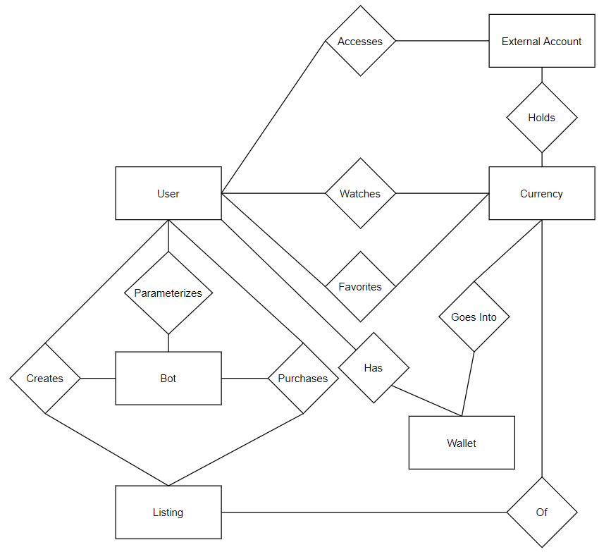

The descriptions of these data entities are as follows:

**User Data Entity**

|  |  |  |  |
| --- | --- | --- | --- |
| **Data Item** | **Type** | **Description** | **Comment** |
| User ID | Text | Unique ID of user |  |
| Name | Text | Name of user |  |
| Email | Text | Contact information |  |
| Phone | Long | Contact information |  |
| National ID | Int | Bookkeeping requirement | SSN or similar data |
| Photo ID | Pointer | Bookkeeping  requirement | Legal Identification |
| Currency | Pointer | Currency Entity | Users default currency to display relative value of other currencies |
| Bots | Pointer | Bot entity | May be several |
| Listings Created | Pointer | Listing Entity | May be several |
| Wallet | Pointer | Wallet Entity |  |
| Account | Pointer | Account Entity |  |
| Favorites | Pointer | Currency Entity | May be several |
| Tracked | Pointer | Currency Entity | May be several |

**Bot**

|  |  |  |  |
| --- | --- | --- | --- |
| **Data Item** | **Type** | **Description** | **Comment** |
| Buy Currency | Pointer | Currency Entity |  |
| Sell Currency | Pointer | Currency Entity |  |
| Price Point | Double | Value at which transaction is triggered | May be based off of either the buy or sell currency. |
| Quantity | Double | The amount of currency purchased | May be a specified value, or a ratio of available funds |
| UserID | Pointer | User Entity | The user the bot belongs to |
| Wallet | Pointer | Walled Entity | The source and destination of traded currencies  Will be 2. |

**Currency**

|  |  |  |  |
| --- | --- | --- | --- |
| **Data Item** | **Type** | **Description** | **Comment** |
| Name | Text | Name of this currency |  |
| Ticker | Text | Abbreviation of name |  |
| Trade Volume | Long | Value of trades of this currency over a specific time period |  |
| Price | Double | Value of this currency |  |
| Supply | Long | Unity of currency currently circulating |  |
| Historical Value | Pointer | Value of currency over time | Used to calculate and display coin value over a period. |

**Wallet**

|  |  |  |  |
| --- | --- | --- | --- |
| **Data Item** | **Type** | **Description** | **Comment** |
| UserID | Pointer | Owner of this wallet |  |
| Currency | Pointer | A Currency Entity | May be many |
| Holdings | Double | A quantity associated with a Currency entity | May be many |

**Listing**

|  |  |  |  |
| --- | --- | --- | --- |
| **Data Item** | **Type** | **Description** | **Comment** |
| Solicitor | Pointer | Creator of the listing |  |
| Customer | Pointer | Purchaser of the listing | May be null or flag value |
| Currency Offered | Pointer | The Currency the Customer will acquire |  |
| Currency Desired | Pointer | The Currency the Solicitor will acquire |  |
| Offer Quantity | Double | The amount of Currency the Customer will acquire |  |
| Desired Quantity | Double | The amount of Currency the Solicitor will acquire |  |

## 

### 2.8.2 **Security Requirements**

The database server does not need security on the trading aspect, but it does

regarding account security. There is no special protection against international

transfer because of the fast international transfer. Although, account security

needs to be high because one account is only for one individual person.

### 2.8.3 **Performance Requirements**

The user must have an up to date operating system.

### 2.8.4 **Safety Requirements**

* Strong authorization and authentication practices:
  + Minimum 12 digit, maximum 26 digit password with at least one of each of the following
    - Capital letter
    - Lower case letter
    - Number
    - Symbol
  + Sensitive data isn’t distributed among third party mediators
  + Sensitive data is not stored outside of the app’s storage system
  + Passwords are not exposed through the interface
  + Passwords are saved in a hashed manner in the internal database system and unhashed when being verified
  + Users are educated about the risks and security breach prevention methods

### 2.8.5 **Software Quality Requirements**

* Maintainability
  + Requires the application to be easily fixed and maintained
* Performance
  + The user interface needs to be responsive. There cannot be a slow refresh rate
* Availability
* The application needs to be available for service 100% of the time

## 2.9 Interface Requirements

### 2.9.1 **External Interface Requirements**

The only link to an external system the app would need is a strong link to

database server. The user’s device requests a pull from the database server and

populates the tables on the device. The user interface will organize the data in an orderly fashion.

### 2.9.2 **Internal Interface Requirements**

The home screen offers a menu of functions with a detailed chart showing the user invested cryptocurrencies stats. There will also be an expandable drop down menu that will allow the user to navigate to different pages on the application. The user interface will offer easy scrolling options to navigate screens easily.

## 3.0 System Requirements

|  |  |  |  |
| --- | --- | --- | --- |
| **ID** | **Type**  **NF= Nonfunctional**  **F= Functional** | **Used in**  **Use Case(s)** | **Description** |
| 2.7.1 | F | 2.3.1 | The system shall provide real-time updates regarding cryptocurrencies. |
| 2.7.2 | F | 2.3.2 | The system shall allow the user to trade cryptocurrencies. |
| 2.7.3 | F | 2.3.3 | The system shall allow the users to convert cryptocurrencies into other cryptocurrencies. |
| 2.7.4 | F | 2.3.4 | The system shall allow the user to convert any fiat or cryptocurrency to another provided by the system. |
| 2.7.5 | F | 2.3.5 | The system shall allow the user to transfer any cryptocurrency to existing fiat currency instantaneously without any security issues or concerns. |
| 2.7.6 | F | 2.3.6 | The system shall provide an automated buy and sell bot for the user to conduct automatic trading. |
| 2.7.7 | F | 2.3.7 | The system shall establish a connection between the users device and the trading server. |
| 2.7.8 | F | 2.3.8 | The system shall be able to handle market data from the trading server. |
| 2.7.9 | F | 2.3.9 | The system shall be able to handle order acknowledgement and fulfill trades. |
| 2.7.10 | F | 2.3.10 | The system shall provide a search option for the user to search for desired cryptocurrencies. |
| 2.7.11 | F | 2.3.11 | The system shall allow the user to add funds to their respective account via a connected bank account. |

# 

# Bibliography

CoinMarketCap. “Today's Cryptocurrency Prices by Market Cap.” *CoinMarketCap*, 2020, https://coinmarketcap.com/. Accessed 31 October 2020.

Frankenfield, Jake. “Cryptocurrency.” *Investopedia*, 5 May 2020, https://www.investopedia.com/terms/c/cryptocurrency.asp. Accessed 31 October 2020.

Investopedia. “Cryptocurrency.” *Investopedia*, 2020, https://www.investopedia.com/terms/c/cryptocurrency.asp. Accessed 31 October 2020.