|  |  |
| --- | --- |
| Project Plan  Online Learning Platform | Prince2  Author:  Owner:  Client: Jarl Tuxen  Version: |

# Project Plan History

## Revision History

|  |  |  |  |
| --- | --- | --- | --- |
| version | Revision date | Implemented by | Reason |
| 1.0.0 | 04-03-2016 | Åsa Wegelius | First draft |
| 1.0.1 | 07-03-2016 | Åsa Wegelius | Added Gantt Chart, WBS, Flow Diagram and start of Requirements table |
|  |  |  |  |
|  |  |  |  |

## Approvals

|  |  |  |  |
| --- | --- | --- | --- |
| Version | Name | Title | Date |
|  |  |  |  |
|  |  |  |  |
|  |  |  |  |
|  |  |  |  |

## Distribution

|  |  |  |  |
| --- | --- | --- | --- |
| Version | Name | Title | Date |
|  |  |  |  |
|  |  |  |  |
|  |  |  |  |
|  |  |  |  |

# Table of Contents

Table of Contens

1. Project Plan History 1

1.2 Revision History 1

1.3 Approvals 1

1.4 Distribution 1

2. Table of Contents 2

3. Purpose 3

4. Plan Description 3

5. Prerequisites 3

6. Dependencies 3

7. Assumptions 3

8. Project Plan 3

8.1 Gantt or Bar Chart 3

8.2 Product Breakdown Structure 4

8.3 Product Flow Diagrams 5

8.4 Product Descriptions 5

8.5 Activity Network 5

8.6 Financial Budget 5

8.7 Change Budget 5

8.8 Resource Requirements 5

8.9 Specific Resources 5

8.10 Tolerance 5

8.11 Contingency Plans 5

# Purpose

The Project Plan shall establish a basis for the cost, management stages and control points in Online Learning Platform.

# Plan Description

[A brief description of what the plan covers]

# Prerequisites

A Product Brief have been put together and have been approved by the Steering Committee.

# Dependencies

The product depends on gathering a pool of content writers to add relevant courses to the platform. It will just be an empty shell without any course material and as such it will be hard to show its relevance.

# Assumptions

[what aspects of the planning are assumed and not yet verified]

# Project Plan

## Gantt or Bar Chart

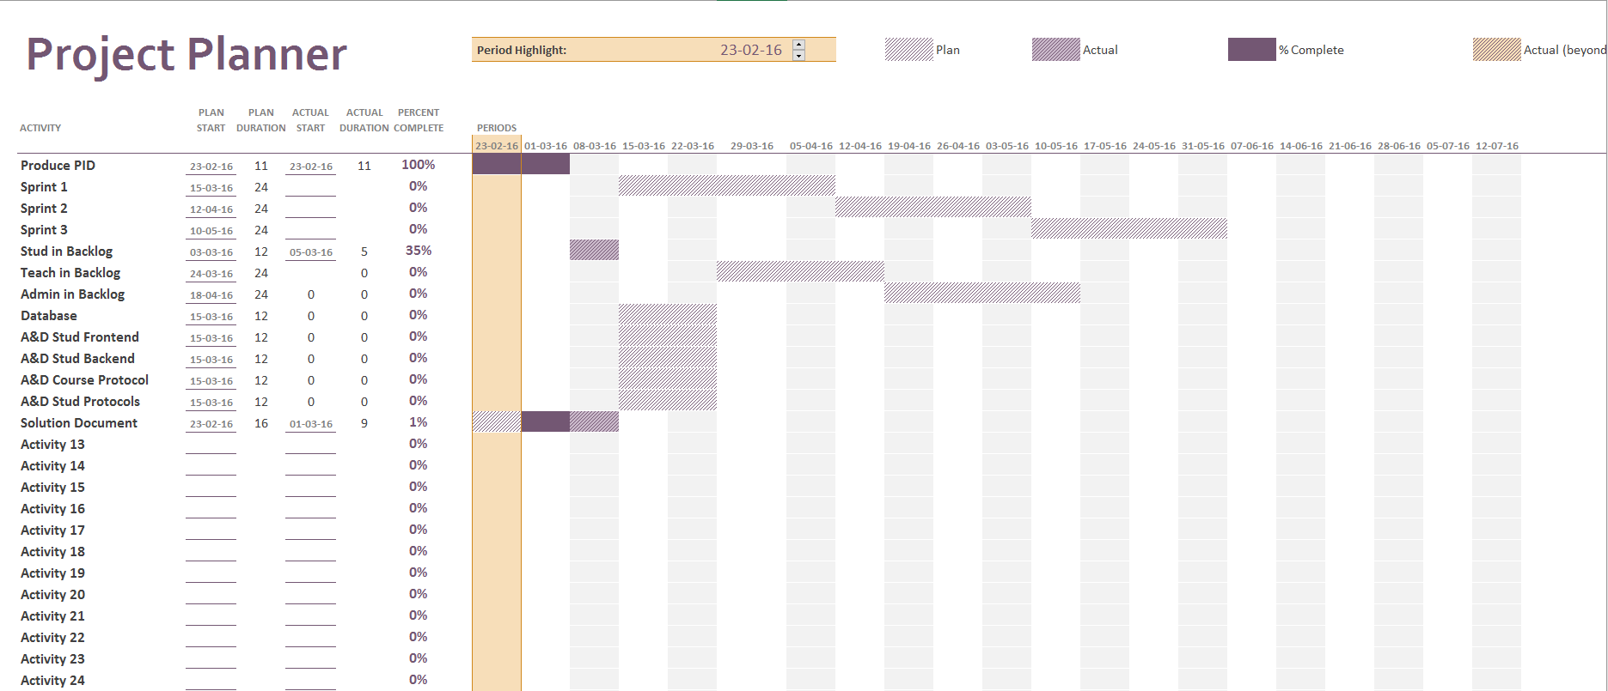

Double click icon to open embedded file.

## Product Breakdown Structure

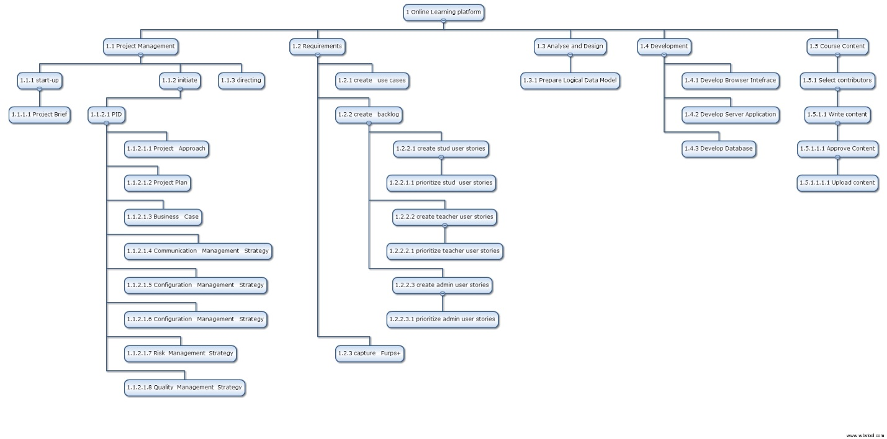

Double click icon to open embedded file.

## Product Flow Diagrams



## Product Descriptions

## Activity Network

## Financial Budget and Change Budget

We have no funding. All involved work pro-bono.

## Resource Requirements

|  |  |  |  |  |  |  |  |
| --- | --- | --- | --- | --- | --- | --- | --- |
| WBS | Activity | Skill needed | Name | Deliverable | Effort days | Start | End |
| 1.2.1 | Create use cases | Domain knowledge | Ionut Vieru | Use Case document |  |  |  |
| 1.2.2 | Create Backlog | Domain knowledge | Åsa Wegelius | Backlog |  |  |  |
| 1.2.3 | Capture Furps+ | Domain knowledge |  |  |  |  |  |
| 1.3 |  |  |  |  |  |  |  |
|  |  |  |  |  |  |  |  |
|  |  |  |  |  |  |  |  |
|  |  |  |  |  |  |  |  |

## Specific Resources

There are no specific resources planned apart from the above mentioned.

## Tolerance

[e.g. time and budget]

## Contingency Plans

[Explain how it is intended to deal with the consequences of any risks that materialise]