|  |  |
| --- | --- |
| Project Initiation Document  Online Learning Platform | Prince2  Author:  Owner:  Client: Jarl Tuxen  Version:1.0.3 |

# Project Initiation Document History

## Revision History

|  |  |  |  |
| --- | --- | --- | --- |
| version | Revision date | Implemented by | Reason |
| 1.0.0 | 28-02-2016 | Åsa Wegelius | First draft |
| 1.0.1 | 03-03-2016 | Åsa Wegelius | Added changes to team structure and responsibilities, project approach and Communication Strategy |
| 1.0.2 | 04-03-2016 | Åsa Wegelius | Adding brief quality management, configuration and control |
| 1.0.3 | 04-03-2016 | Åsa Wegelius | Added quality document written by Tudor Stoica |
|  |  |  |  |

## Approvals

|  |  |  |  |
| --- | --- | --- | --- |
| Version | Name | Title | Date |
|  |  |  |  |
|  |  |  |  |
|  |  |  |  |
|  |  |  |  |

## Distribution

|  |  |  |  |
| --- | --- | --- | --- |
| Version | Name | Title | Date |
| 1.0.3 | Jarl Tuxen | Steering Commitee | 04-03-2016 |
|  |  |  |  |
|  |  |  |  |
|  |  |  |  |

# Table of Contents

Table of Contents

1. Project Initiation Document History 1

1.2 Revision History 1

1.3 Approvals 1

1.4 Distribution 1

2. Table of Contents 2

3. Project Definition 3

3.2 Background 3

3.3 Scope and Exclusions 3

3.4 Objectives 3

4. Project Approach 4

5. Business Case 4

6. Project Management Team Structure 5

7. Role Description 5

7.2 The Executive 5

7.3 Senior User 6

7.4 Senior Supplier 6

7.5 Project Manager 6

7.6 Development Team 6

8. Quality Management Strategy 7

9. Configuration Management Strategy 8

10. Risk Management Strategy 8

11. Communication Management Strategy 8

12. Project Plan 8

13. Project Controls 8

# Project Definition

## Background

The physical classroom is losing its monopoly as the only learning method, since the arrival of world wide web students can access information and learn from everywhere they are in the world just by having an internet connection and an online learning platform that help them learn long variety of subjects from economic to programming languages to philosophy and literature. With online learning platform students can learn and implement their learning on their own pace and time.

In this project we will develop the backbone of an online education platform. It will support three roles, Admin, Teacher and Student. Admin administer the system, Teacher produces and update courses and Student takes courses. The outcome of the project will be a prototype that fulfil this functions and can be extended to a further advanced learning platform.

## Scope and Exclusions

Scope:

* A database
* Browser interfaces for students, content providers and administrators
* The database access objects
* Servlets
* Login service

Exclusions:

* Course videos
* Course tests
* Payment service

## Objectives

* **The project shall be completed in 01/06/16.** It is the last delivery day on Fronter so it is a hard deadline.
* **The budget is 810 man hours.** The project delivery day gives 14 ½ weeks. This time-span includes six holidays. That gives us 66 working days for the project. We calculate with 7h/day. Given we divide a day between one-hour project time and six hours spent on courses up until 06/05/16 we have 16 full time days and 50 * 1h/day. That gives 16*7 + 50*1 hours per person = 162h/person. A project group of five persons gives a budget of 810 man hours.
* **The outcome shall be an online learning platform.** The aim is to develop a learning platform directed to Arabic audiences allowing students, ordinary people to learn and test their abilities on the subjects provided by the platform. Not only will the normal people learn and develop skills through this platform but the universities and schools will have the benefit of variety in learning methods for their students, giving them the advantage of going through study materials on their own pace and time.
* **The project shall be managed according to Prince2.**
* **The development team shall follow the Scrum methodology.**

# Project Approach

 Double click on icon to open embedded document.

# Business Case

The business case for this project is very compelling since there are around half billion Arabic speaking people in the world and many universities and schools are missing on use of technology which gives us the opportunity to expand fast through this market with both enterprise users and single users who wants to learn on subjects. In the Arabic world exist today over 900 universities that day by day are getting more and more digitalized and students are in need to keep up with all new trends and technologies. But students are not the only ones that need to learn and here we can add a lot off business that need to train their personnel in order to stay competitive and the list continues. Nowadays e-learning started being used at a very large scale and all because of the mass digitalization process. It is very easy today to find online materials about almost everything but most of the materials are in English because it is the international language and this can be very frustrating for many Arabic speaking people. Providing a solution to this problem will definitely going to be a success.

# Project Management Team Structure

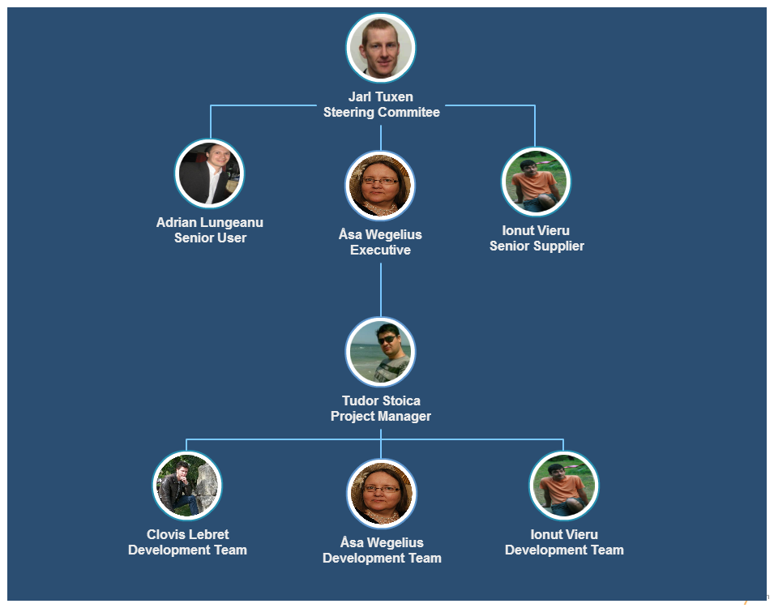

# Role Description

The role descriptions below will be adjusted to fit Scrum roles when those have been distributed to the team members.

## The Executive

* Is ultimately responsible for the project.
* Carries out business Assurance
* Communicates with organizational management and reports on project progress and any problems that need upward referral.

## Senior User

* Makes sure the project delivers *fit-for-purpose* results
* Specifies and delivers business benefits that will result from the project
* Provides user staff resources
* Collaborate between user areas and the project
* Carries out user Assurance

## Senior Supplier

* Makes sure the project delivers what was specified
* Checks the deliverables achieves the user objectives
* Makes sure the project meets technical and industry standards
* Carries out suppliers Assurance
* Provides staff resources for the team work

## Project Manager

* Planning the project and successive stages
* Giving out work assignments
* Monitoring progress and making adjustments to the running of stages as necessary.
* Warning the board if he projects that the stage or project will stray beyond set limits

## Development Team

* Cross functional development team

# Quality Management Strategy

Double click to open embedded document.

|  |  |  |  |
| --- | --- | --- | --- |
| Quality Expectations | DB portability | Priority | H |
| Acceptance Method | Use of a ORM (Hibernate) | | |
| Tolerance | none | | |
| Acceptance Responsible |  | | |

|  |  |  |  |
| --- | --- | --- | --- |
| Quality Expectations | Portability | Priority | H |
| Acceptance Method | Java + JRE runs on any operating system that supports the Java standard | | |
| Tolerance |  | | |
| Acceptance Responsible |  | | |

|  |  |  |  |
| --- | --- | --- | --- |
| Quality Expectations | Browser portability | Priority | H |
| Acceptance Method | Runs on Explorer, Safari, Firefox, Chrome | | |
| Tolerance |  | | |
| Acceptance Responsible |  | | |

|  |  |  |  |
| --- | --- | --- | --- |
| Quality Expectations | Easy to maintain | Priority | H |
| Acceptance Method | Separation of Concern, Folder structure match Content structure, follow coding and folder conventions, code is either self-explainable or commented, low coupling – high coherence | | |
| Tolerance | none | | |
| Acceptance Responsible |  | | |

|  |  |  |  |
| --- | --- | --- | --- |
| Quality Expectations | Installability | Priority | H |
| Acceptance Method | Use of Maven | | |
| Tolerance |  | | |
| Acceptance Responsible |  | | |

|  |  |  |  |
| --- | --- | --- | --- |
| Quality Expectations | Findability | Priority |  |
| Acceptance Method | Search engine optimization | | |
| Tolerance |  | | |
| Acceptance Responsible |  | | |

|  |  |  |  |
| --- | --- | --- | --- |
| Quality Expectations | Download speed | Priority |  |
| Acceptance Method | Minimize HTTP requests, reduce server response time, optimize images | | |
| Tolerance |  | | |
| Acceptance Responsible |  | | |

# Configuration Management Strategy

We use GitHub as configuration management tool

# Risk Management Strategy

 Double click on icon to open embedded document.

# Communication Management Strategy

 Double click on icon to open embedded document.

# Project Plan

Under Construction

# Project Controls

* Progress reporting occur on the Skype Weekly Meetings
* Risk reporting occur on the Skype Weekly Meeting
* Change negotiation occur during Sprint Planning