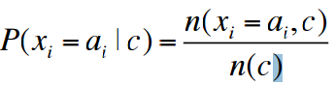

P(class): P(pos) / P(pos + neg), P(neg) / P(pos + neg)

P(F­i | class): sum(Feat x = a) / n( c)

classNB(x): max( P(class) prod(p(xi|class)) )

|  |  |  |  |
| --- | --- | --- | --- |
|  | | **+** | **-** |
|  |  |
| F1 | 0 |  |  |
| 1 |  |  |
| F2 | 0 |  |  |
| 1 |  |  |
| F3 | 0 |  |  |
| 1 |  |  |
| F4 | 0 |  |  |
| 1 |  |  |

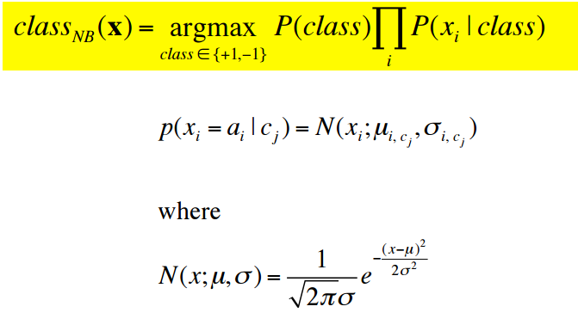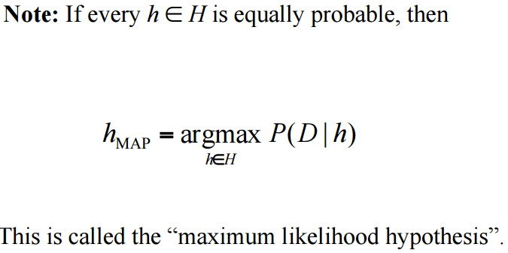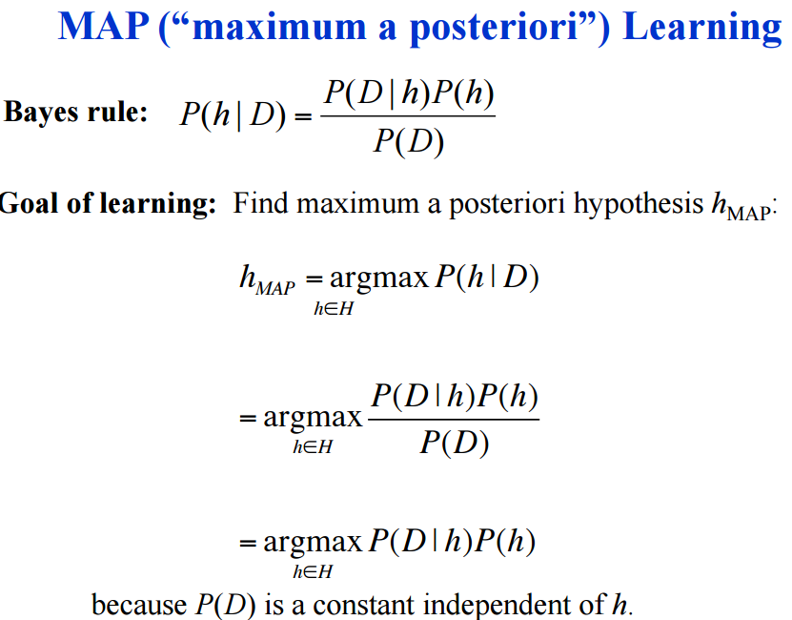

**GAUS**

Mean: avg

sDev: sqrt(sum(V) / total)

F-1(pos) , F-1(neg)

M = , sDev =

M = , sDev =

F-2(pos) , F-2(neg)

M = , sDev =

M = , sDev =

X10 | 0.9 | 0.4 | ?

P(+) = p(f1=0.9 | +) * p(f2=0.4|+)

P(-) = p(f1=0.9 | -) * p(f2=0.4|-)

P(prob x = a | given class) = . sum( instances (feature x == a && class == C)) +1 .

(instancs with class C) + k

Laplace where k is the number of possible values of attribute a

