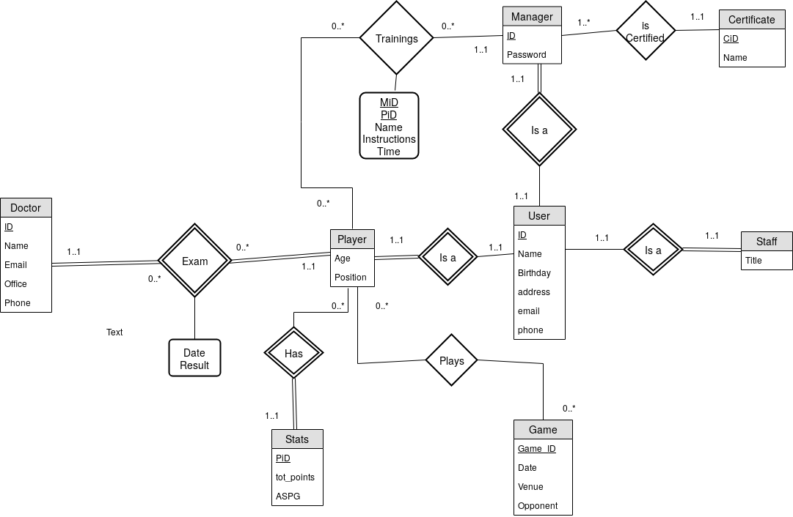
Create table user
(
);
Create table Staff
(
);
Create table Player
(
);
Create table manager
(
);
Create table certificate
(
);
Create table Trainings
(
);
Create table Game
(
);
Create table Stats
(
);
Create table Exam
(
);
Create Table Doctor
(
);

