Andrew Baca
October 2, 2018
Xeno Affordance Design
CS 485

The Tool – A PlayStation 4 DualShock Remote controller
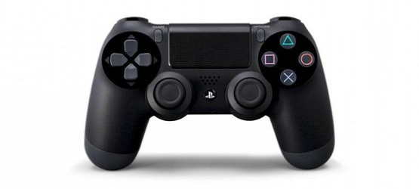

Specs/Functions-
- Traditional Joystick/analog layout for game play and other applications on the PS4 platform designed for human hands:
  - Two handles to grip your palms around
  - Two joysticks mapped to the mid left and right of the front of the remote, mapped conveniently for your thumbs to function.
  - Analogs mapped to the upper left of the left Joystick, and upper right of the right joysticks mapped for your thumbs to switch upward and perform an action (along with the options and capture buttons)
  - bumpers and triggers on the back side of the remote for pointer finger or middle finger to perform actions
  - Middle button with PS4 logo signifies that it will power on the system, and go to the main menu
  - Swipe pad mainly used for typing, and used as a button to pull up maps on most games

The Animal – A Giant Tarantula
A Giant tarantula with human thought process that likes to play games on the PlayStation 4.
- Based on simple observations, a tarantula generally uses all 8 of its legs to move from point A to Point B
- It’s pedipalps (the two smaller looking legs in the front of it’s body) are commonly used to dig, pick things up, and as a defense mechanism (along with it’s front four legs) while the back four legs are used as support to the ground at all times, with the mid-front two legs (labeled leg2 in the picture) are commonly used as suport too.
Based on these facts, the front 2 legs, and the pedipalps would most likely be the limbs used to perform most task besides moving
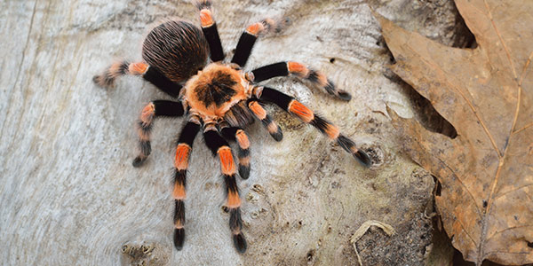
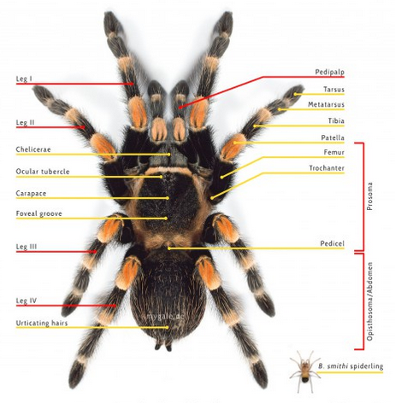

New Tool -

Image Of New Tool-

Discussion-

