INTRODUCTION:

* 1. **OVERVIEW;**

Employees travel on business trips to attend conferences, perform research, scout potential locations, meet suppliers, visit clients, and for numerous other essential reasons. Whatever the reason, such trips enable them to seek lucrative opportunities, build relationships, solve problems, enhance productivity, and drive growth.

Unfortunately, a persistent problem facing many with such aspirations is that they often find themselves in situations where the trips become a tiresome burden with exponentially higher costs than expected.

* 1. **PURPOSE**

The first and foremost thing that one must consider while creating a travel request approval workflow is where your employees will be requesting for funds. By educating the employees about the medium through which they will be requesting the fund, you can simplify the process

1. Next, ensure employees provide the information that is needed to request funds
2. Once the request is raised the managers will go through the requests raised by the employees to approve or reject the funds
3. Define the time the finance team will take to transfer the funds. Also, you can mention the processing time
4. Mention the account to which the money will be sent

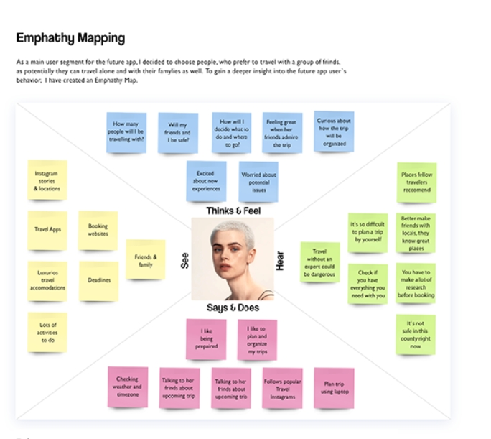

**2.2 IDEATION & BRAINSTORMING MAP**

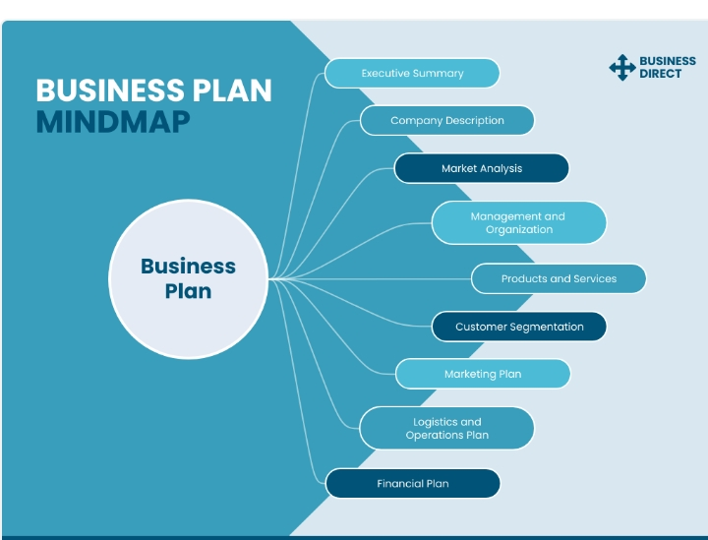

**3.1 DATA MODEL :**

|  |  |
| --- | --- |
| Object Name | Fields in the Object |
| Obj 1 | |  |  | | --- | --- | | Field label | Data type | | Travel Approval | Auto Number | | Travel Approval | Auto Number | |
| Obj 2 | |  |  | | --- | --- | | Field label | Data type | | Total Expenses | Roll- up summary | | Status Indicator | Text | |

3.2 ACTIVITY & SCREENSHOT

MILESTONE :1

ACTIVITY:1

## er can print an itinerary or receive the itinerary as a PDF file. The Travel Support System (this is the name that you can see on the screen when executing the application) is a small sample application for NaturalONE. As a sample application, its focus is to show NaturalONE functionality rather than being a full-fledged travel support application.

## The Travel Support System (TSS) allows you to request and approve business trips. Flights, hotels and even more external information such as cell phone expenses or car rentals can be entered with the trip request. For the destination, weather information can be queried. A manager can do both, request own trips as well as approve trips that have been requested by employees. After the manager has approved single or multiple requests, the manag

The usage of the travel approval application is described bel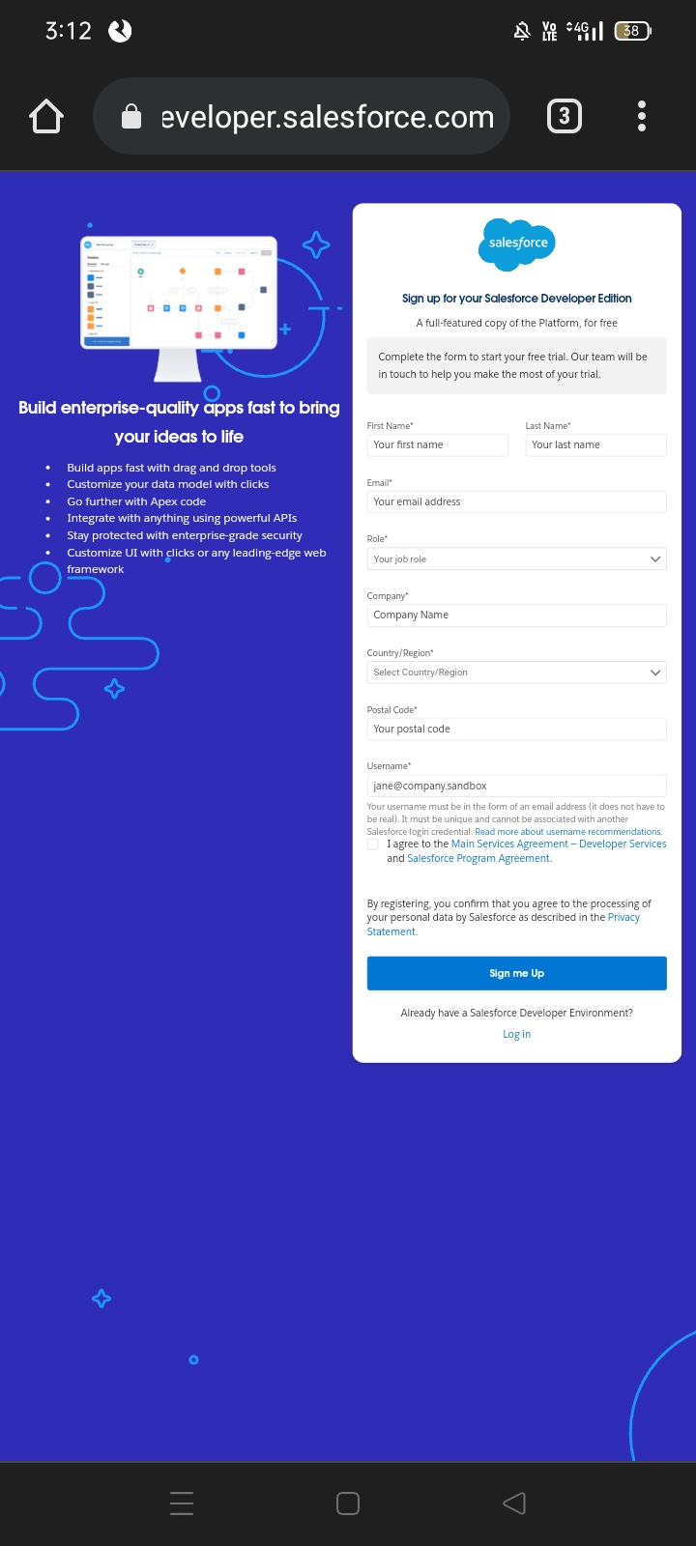

ACTIVITY : 2

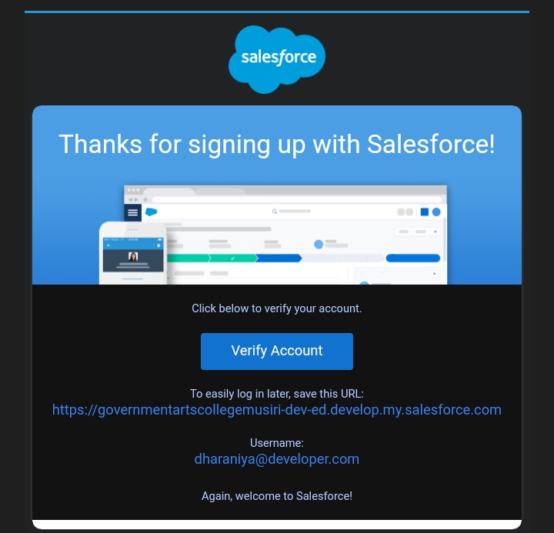

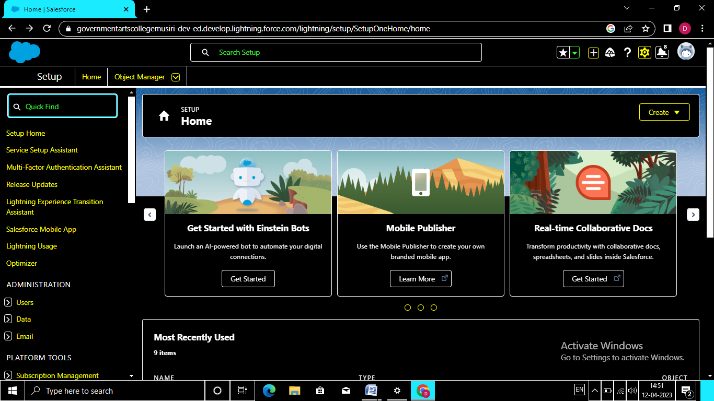

MILESTONE: 2

ACTIVITY: 1

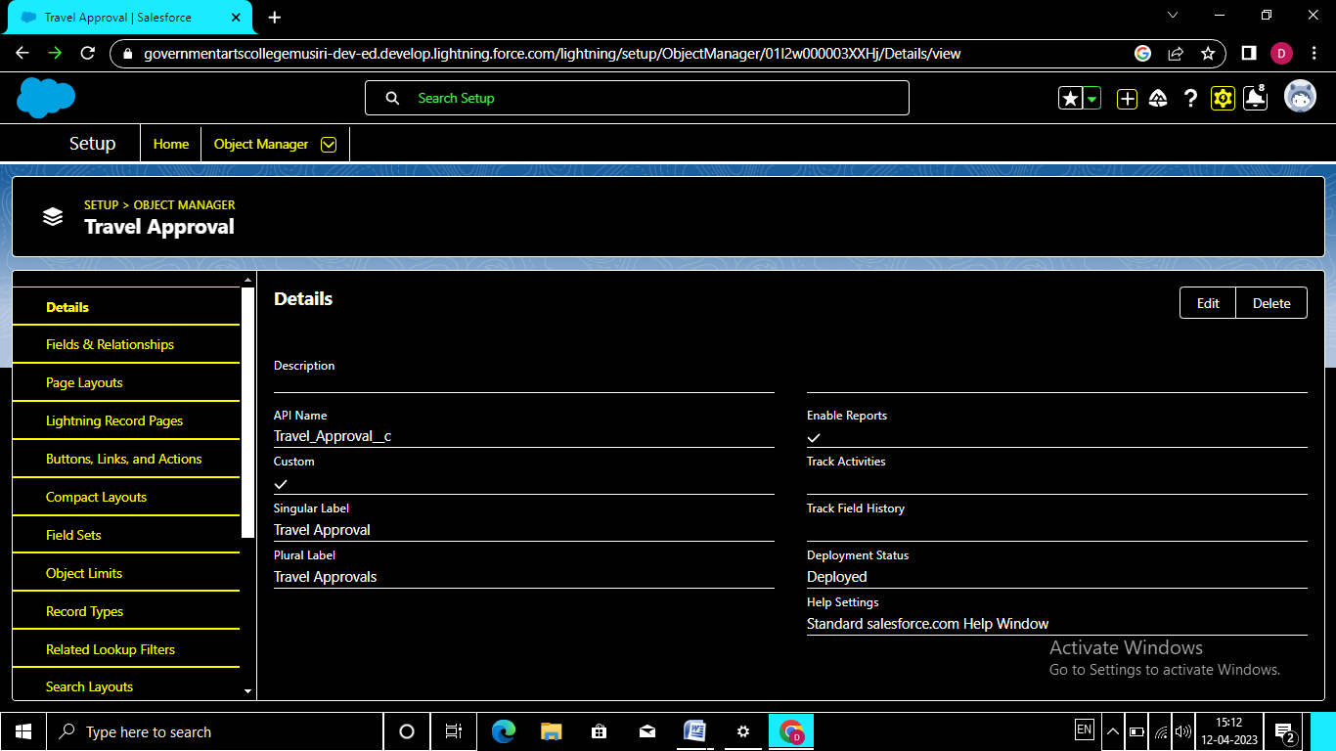

**MILESTONE: 3**

**ACTIVITY : 1**

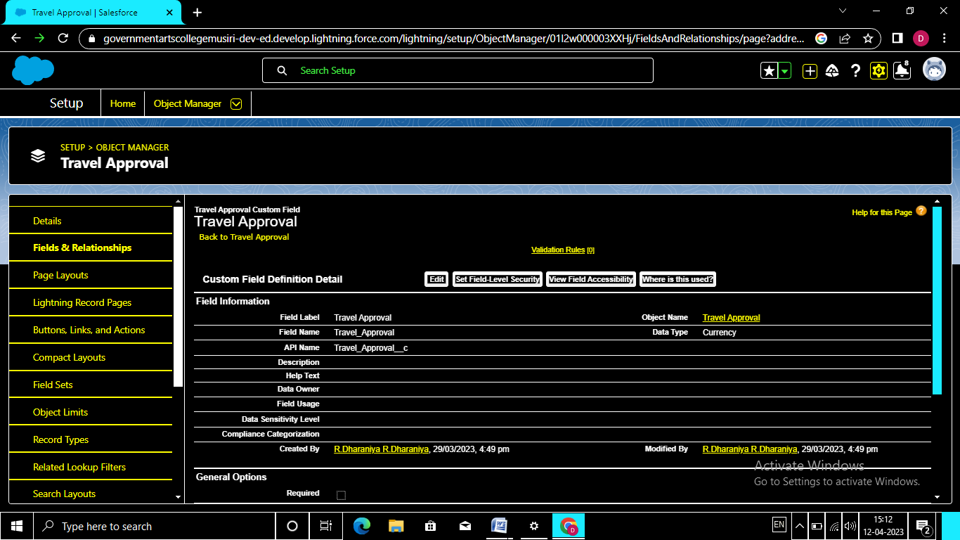

**MILESTONE: 4**

ACTIVITY:1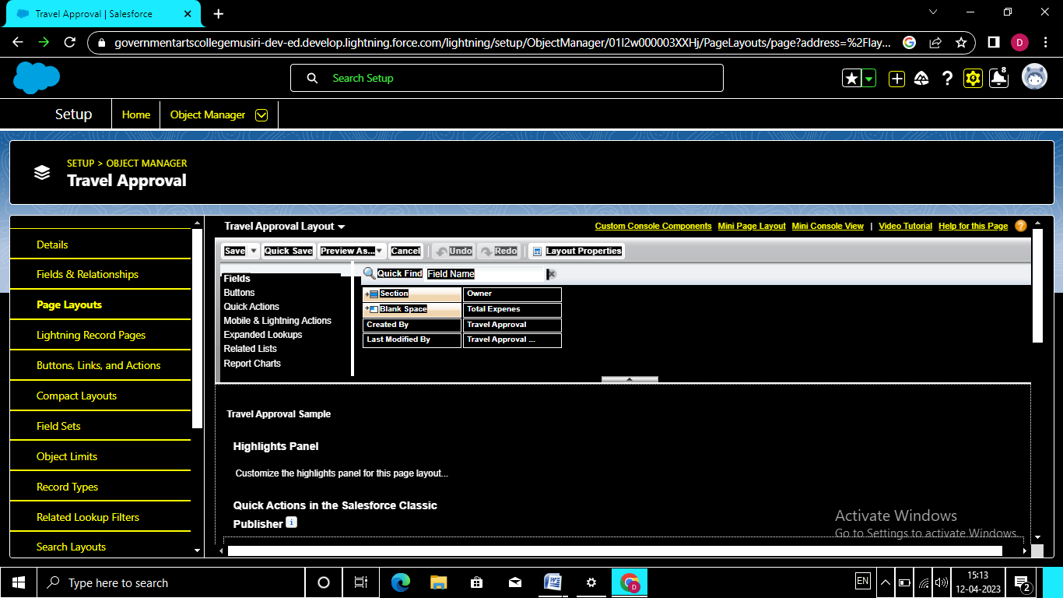

**MILESTONE 5**

**ACTIVITY 1**

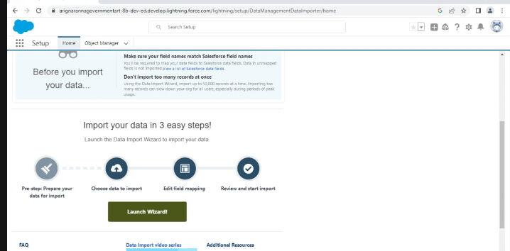

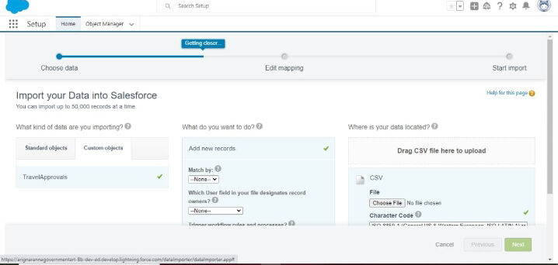

**MILESTONE 6**

**ACTIVITY 1**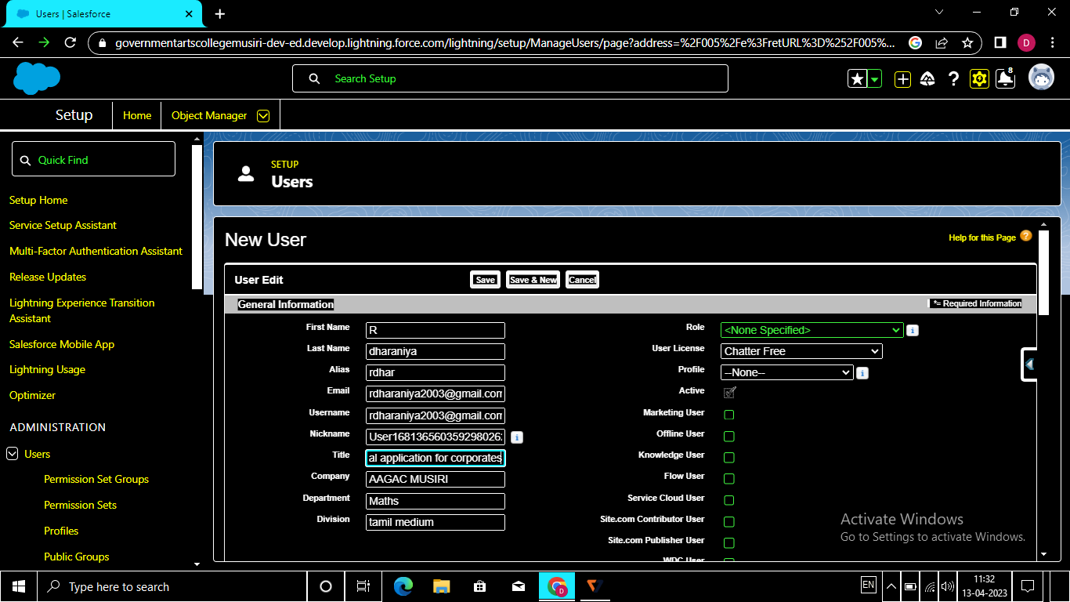

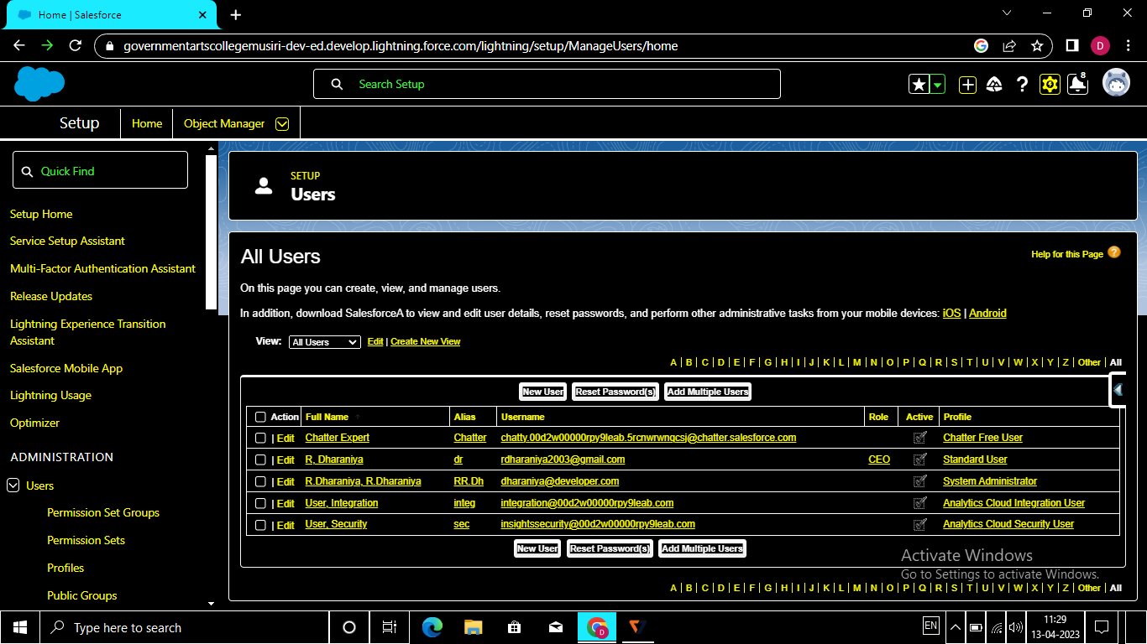

**MILESTONE 7**

**ACTIVITY 1**

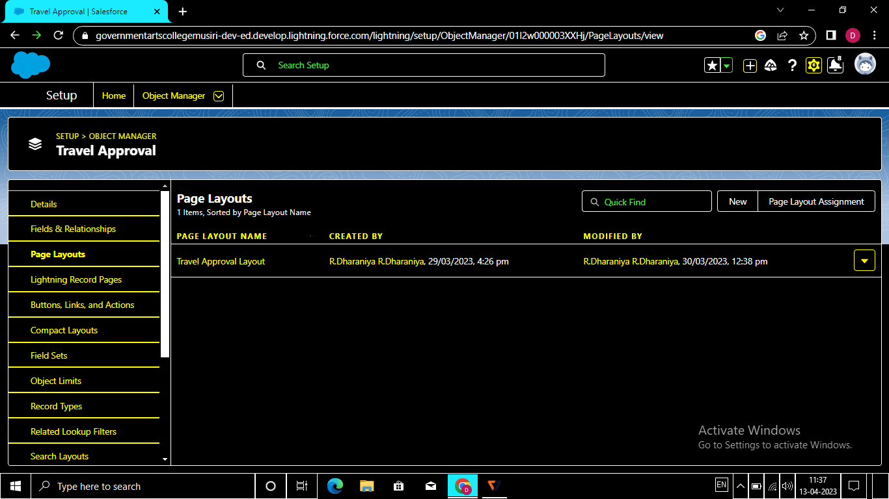

MILESTONE 8

ACTIVITY 1

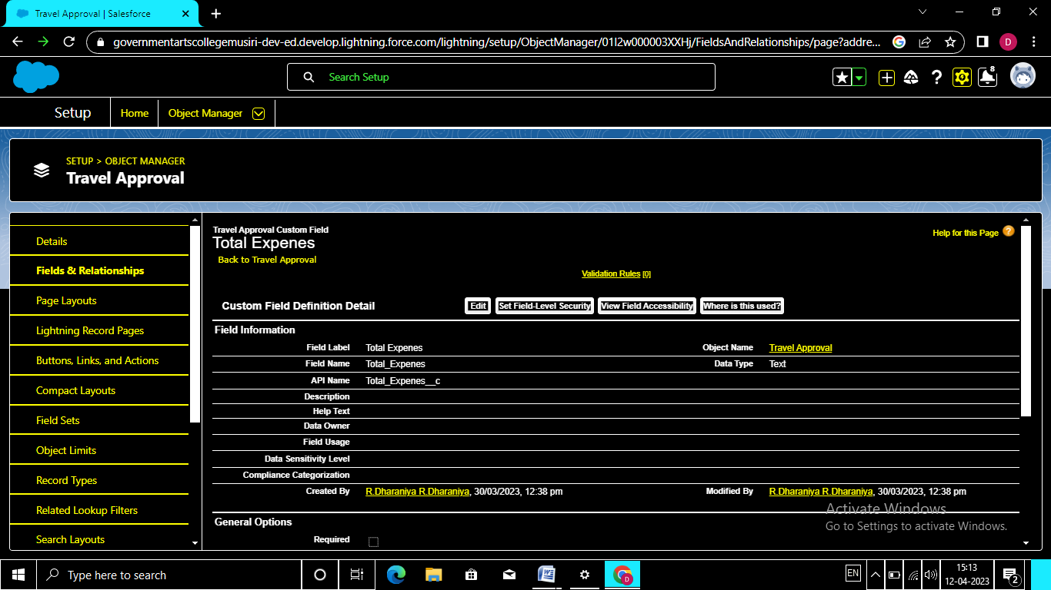

**MILESTONE 10**

**ACTIVITY 1**

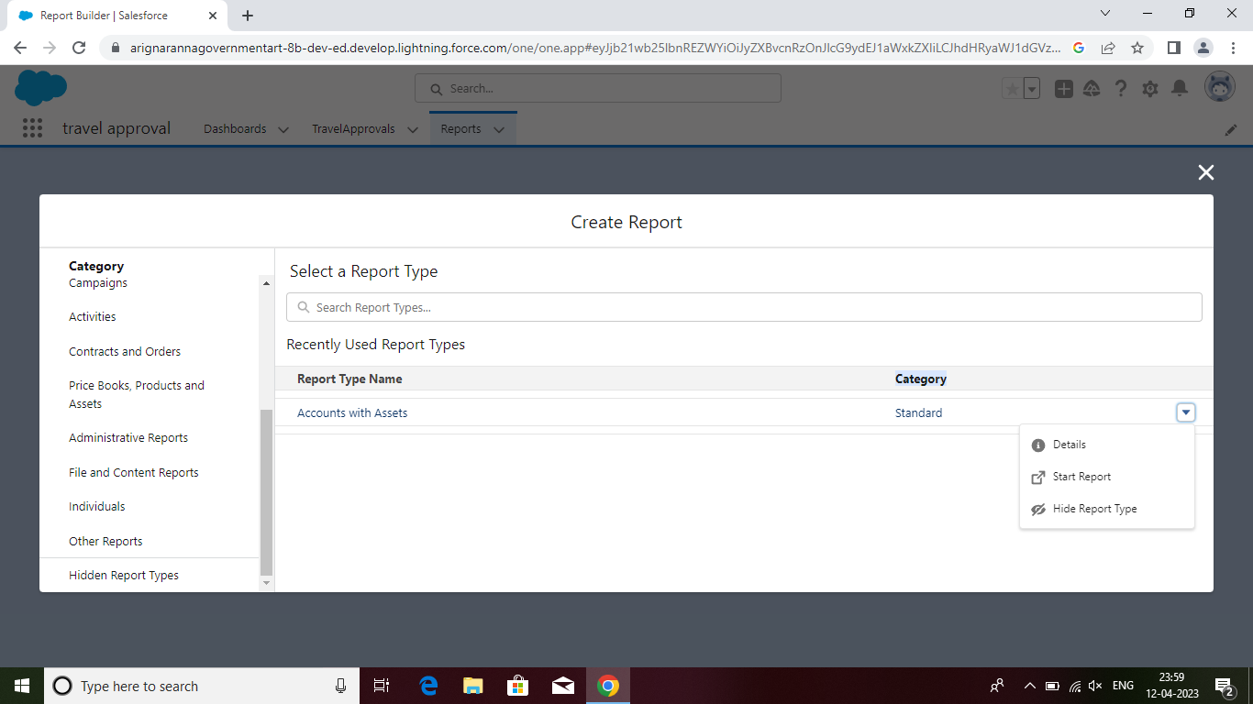

**MILESTONE 11**

**ACTIVITY 1**

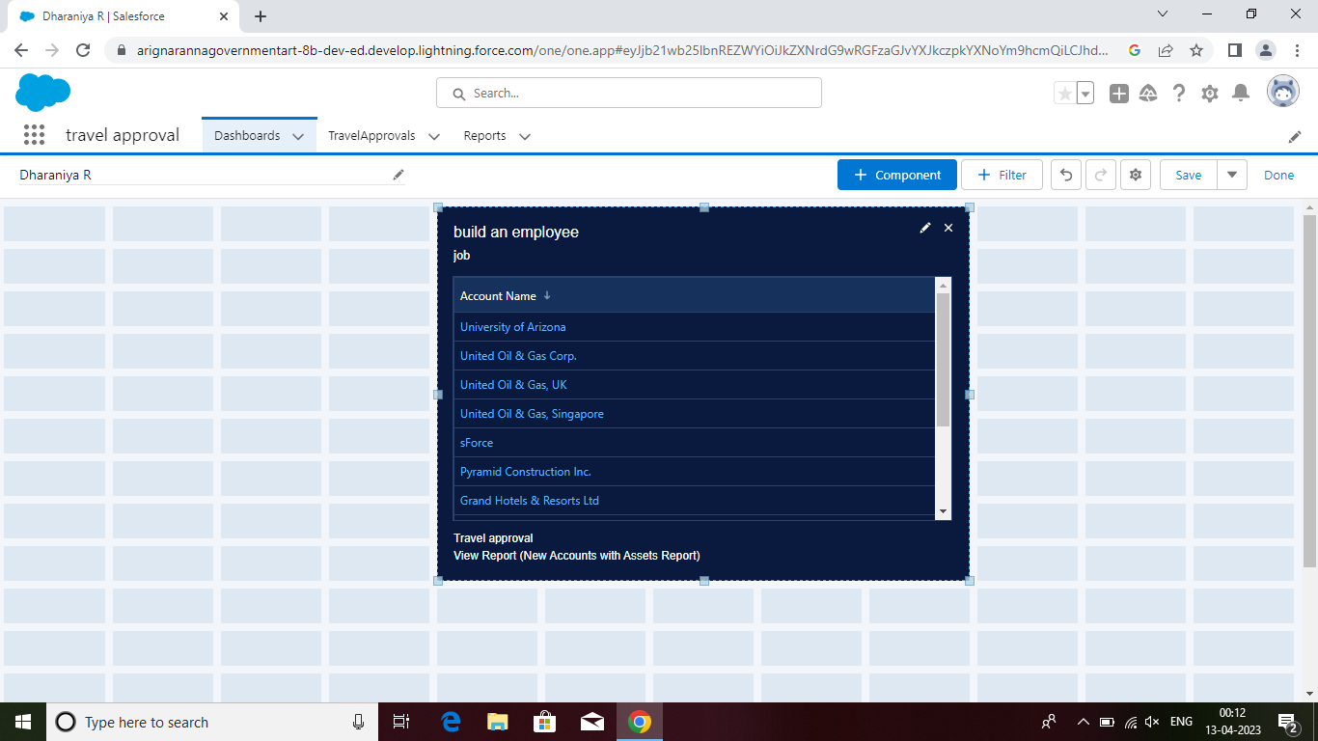

4 Trailhead Profile Public URL

Team Head: <https://trailblazer.me/id/dharr371>

Team member :1 <https://trailblazer.me/id/divas44>

Team member :2 <https://trailblazer.me/id/durgr6>

Team member :3 <https://trailblazer.me/id/ggokul30>

**5 ADVANTAGES & DISADVANTAGES**

**Advantages:**

Employees have to travel to different locations as part of their job profiles in business organizations. These trips to meet specific objectives include travel and accommodation. To set ground rules for booking of flights, hotels, etc., an organization has to formulate a sound travel policy. The business travel policy covers several aspects of travel and offers guidelines to employees, corporate managers, finance staff, and travel agencies. It details the expenses employees may claim during business trips for reimbursement.

The standard travel policy of an organization clarifies travel arrangement procedures, approval processes, the scope of business travels, expense reporting, and reimbursement processes. An ideal [corporate travel management company](https://www.paxes.com/blog/top-corporate-travel-management-companies/)‘s  travel policy aims to facilitate safe and comfortable travel for higher productivity and greater control over travel costs.

Approvals on time. The entire process of planning and managing a trip is a long and stressful process.

Customize approval workflows. The approval process can differ from company to company.

Increase compliance and reduce costs.

Faster process.

**Disadvantages:**

Inefficient & inconsistent T& E management – Companies that fail to adopt travel policy have found their business trips to be highly inefficient, unsystematic and inconsistent. This is due to travel employees booking and arranging travel with travel partners, suppliers and operators of their choice. Lack of set process within defined parameters can mask visibility of even the vital travel & expenses (T&E) data and information. This, in turn, can drive inefficiency into the system as the travel manager is left bereft of making informed travel decision and improvements in targeted travel policy.

Failing to partner with TMCs – Organizations that have partnered with travel management companies (TMCs) have benefitted a lot out of their industry knowledge and experience. Firms that haven’t, thinking that it may be expensive, would possibly end up paying more at the end of the day.

Application:

The Travel Support System (this is the name that you can see on the screen when executing the application) is a small sample application for NaturalONE. As a sample application, its focus is to show NaturalONE functionality rather than being a full-fledged travel support application.

The Travel Support System (TSS) allows you to request and approve business trips. Flights, hotels and even more external information such as cell phone expenses or car rentals can be entered with the trip request. For the destination, weather information can be queried. A manager can do both, request own trips as well as approve trips that have been requested by employees. After the manager has approved single or multiple requests, the manager can print an itinerary or receive the itinerary as a PDF file.

The usage of the travel approval application is described below.

**Conclusion:**

This blog concludes with the advantages and disadvantages of business travel. The primary purpose of [business travel](https://at.tumblr.com/stoneberry432/a-list-of-the-top-10-resorts-in-jharkhand-with/723dk66pxu6v)is to develop new ideas about business operations. On the other hand, the disadvantage of business travel is that it enhances the organization’s expense. So it may affect the growth of the organization.

**FUTURE SCOPE:**

Travel request forms are designed to give management an overview of the intended business trip from both a cost and a strategic point of view. The fields that typically appear on a travel request form include;

Employee name and contact information.

The business purpose of the trip.

Destination details.

Departure and return dates.

Predicted travel costs which are broken down by category. For example, airfares, other transportation, accommodation, and meal allowances.

Notes of any visa requirements for international travel.

Any relevant comments from the employee's manager.