**PROJECT REPORT TEMPLATE**

**ARIGNAR ANNA GOVERNMENT ARTS COLLEGE-MUSIRI**

## Recruiting Assistant for HR Managers

**INTRODUCTION**

* 1. Overview

The HR Assistant duties involve a wide range of support activities inside our HR department, from coordinating meetings to maintaining our employee database to posting job ads. An important part of your role will be to act as the liaison between HR and employees, ensuring smooth communication and prompt resolution of requests and questions. You’ll also assist in creating policies, processes and documents.

An HR Assistant oversees all operations in an organization that deals with employee issues. They work with Recruiters and other Human Resources staff members to make paperwork more efficient.

* 1. **Purpose**

HR Assistant skills we’re looking for include excellent organization ability, familiarity with HR software and strong communication skills. To be an ideal candidate for the human resources assistant position, you should also hold an HR-related degree and have some experience in our industry. You should be able to work autonomously and remain calm under pressure. Following our training sessions, you’ll be able to assist HR Managers in the whole recruitment lifecycle (e.g. onboarding new hires and [candidate sourcing](https://resources.workable.com/hiring-with-workable/sourcing-candidates).)

HR assistants provide office support to HR directors and the entire human resources department by helping with tasks like storing staff files, writing letters, and conducting other administrative responsibilities.

They also maintain the confidentiality of employee information by using a relevant HRIS or HR software. As a part of the role, HR administrative assistants cater to employee requests regarding benefits, salaries, payroll preparation, and payroll practices.

Their responsibility is management support, which includes hr functions such as complaint writing, absenteeism, termination, compensation information, and performance reports.

HR administrative assistants submit job vacancies and publish job openings, gather information on new applicants, and inform employees of their employment status. They also work with human resource managers to select applicants who meet the specified job requirements.

## Two HR Assistant Description Samples

The HR duties of an administrator vary from company to company. Here, we provide you with two job descriptions applicable for the post of HR assistant, which you can use according to their applicability and your company’s requirement.

### HR Assistant Job Description – Sample #1

This is the first of the two samples which you can use according to your company’s needs. You can use the one which suits your company’s agenda better and lead you to find the right HR assistant.

#### HR Assistant Job Brief

Our company requires an experienced Human Resource Assistant to assist the HR Department in coordinating all activities within their departments.

You will assist HR officers in employee recruitment, training, and fostering a healthy work culture.

Your excellent communication skills are expected to help the Human Resource Managers ensure the success and efficiency of the work environment. The HR administrative duties are important to improve productivity and work morale of our company.

As a Human Resources assistant, you will also work in partnership with the HR department to improve communication and resolve employee issues in the workplace. The HR assistant is also responsible for coordinating and maintaining the staff records.

Your job will involve providing help in implementing services, policies, and programs that promote a safe, positive work environment, and promote the recruitment and development of our workforce. HR assistants are usually assigned to an HR director and assist managers in dealing with Human Resources issues.

HR assistants perform various functions in human resources. You will also assist to recruit, hire and train employees. HR Assistants are also expected in implementing programs for the improvement of employee welfare.

As an HR administrator, you will also help the company in administering tests for new employee onboarding.

You will coordinate with line managers to determine the needs for recruiting new employees and training existing ones. HR administrators prepare reports relating to HR projects, assist the HR department in the hiring process, create job ads, and follow the best Human Resources practices

As part of your job description, an HR assistant will also contribute to improving the overall human resources experience of an organization. We do not expect you to be an expert in employment regulations, but at least have a basic understanding of labor laws.

They are also responsible for arranging for accommodation and organizing outdoor training activities for new employees as may be necessary.

The company manages payrolls and keeps archiving the personnel’s important information to ensure the smooth operations of the HR department. The HR Assistant’s typical tasks additionally include posting job ads and shortlisting qualified candidates from job sites immediately.

Our company is a proponent of diversity and we welcome applicants from various faith systems and orientations. Our company strives to hire candidates with the highest potential, regardless of race, culture, belief, or sexual orientation. As an Equal Opportunity Employer, we take pride in having a diversified workforce.

As a result, sending birthday greetings to employees and arranging for their birthdays will be an important task of your job. We want to keep our employee morale high and thereby, want you to be a part of a growing team.

If you have no prior experience, please note you can still apply. Only shortlisted candidates will be contacted.

## Requirements and skills

* Proven experience as an HR Assistant, [Staff Assistant](https://resources.workable.com/staff-assistant-job-description) or relevant human resources/administrative position
* Fast computer typing skills (MS Office, in particular)
* Hands-on experience with an HRIS or HRMS
* Familiarity with ATS software and resume databases
* Basic knowledge of labor laws
* Excellent organizational skills
* Strong communications skills
* Degree in Human Resources or related field

**Problem Definition & Design Thinking**

2.1 **Empathy Map**

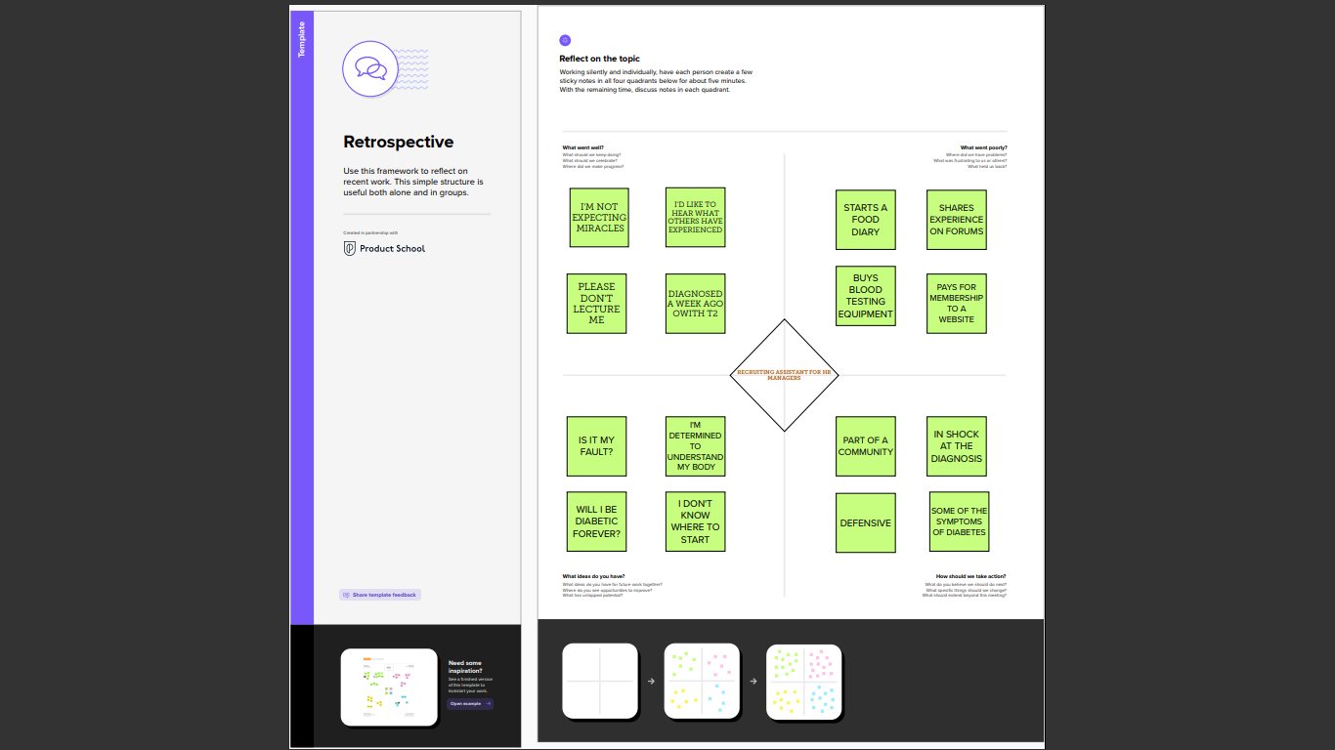

2.2 **Ideation & brainstorming map screenshot**

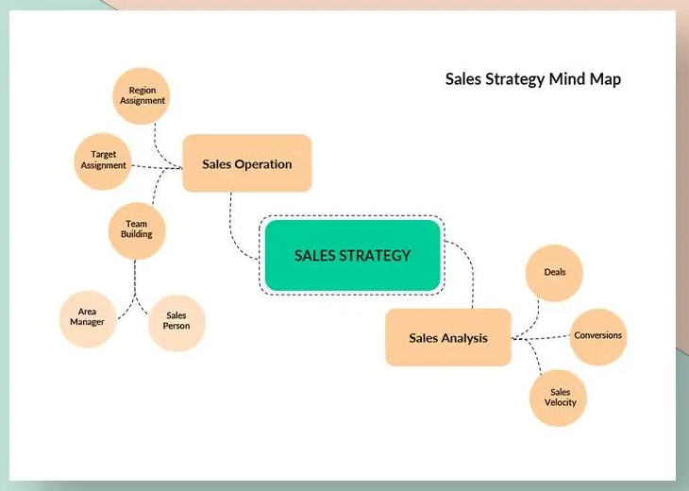

J

**RESULT**

3.1 **Data Model:**

|  |  |
| --- | --- |
| Object name | Fields in the Object |
| Obj1 | |  |  | | --- | --- | | Field label | Data type | | Job Posting Site | Text | | Review | Auto Number | |
| Obj2 | |  |  | | --- | --- | | Field label | Data type | | Job Posting | Auto number | |

3.2 Activity & Screenshot

Milestone1: Creation of developer account

Activity-1:  
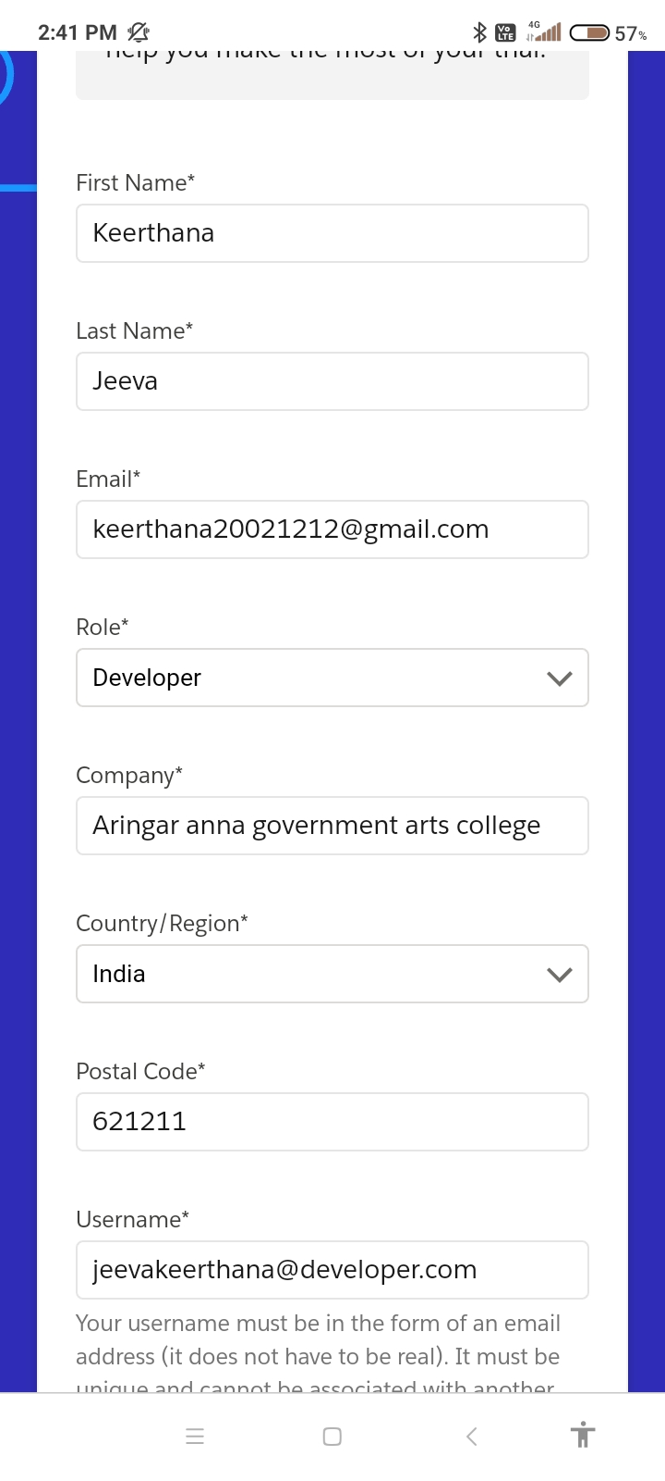

Milestone 2:

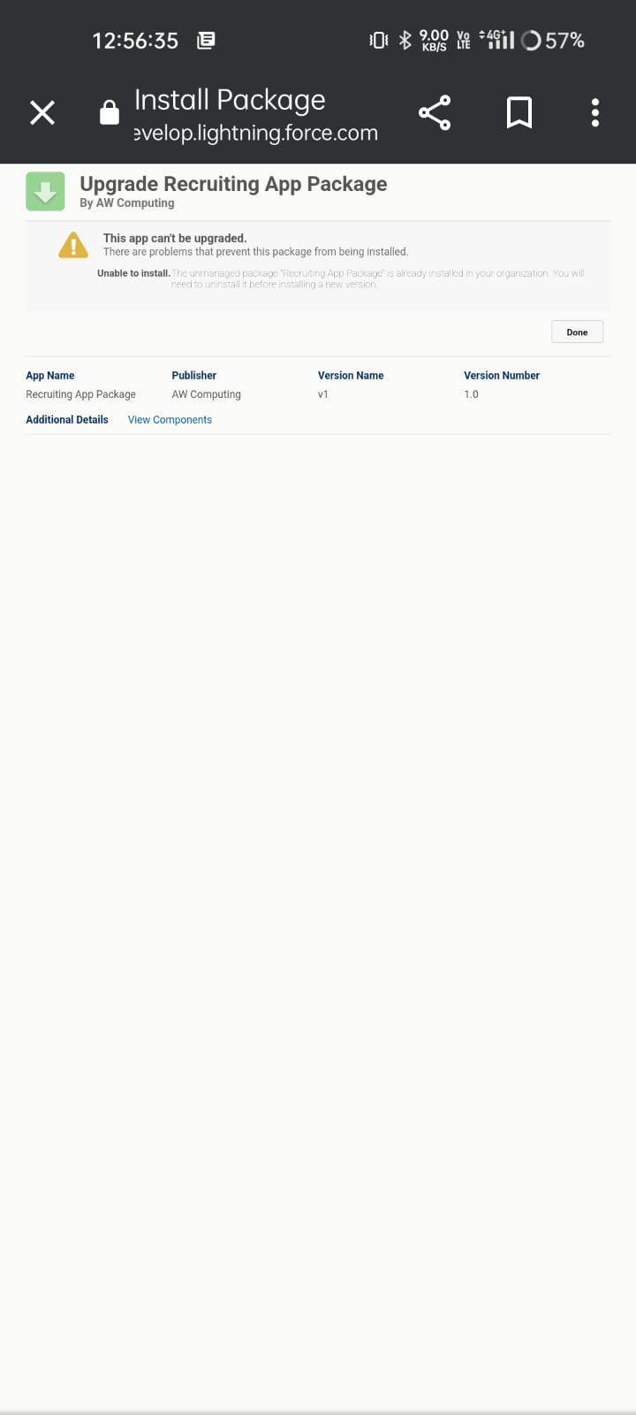

Milestone 3: Object

Activity-1

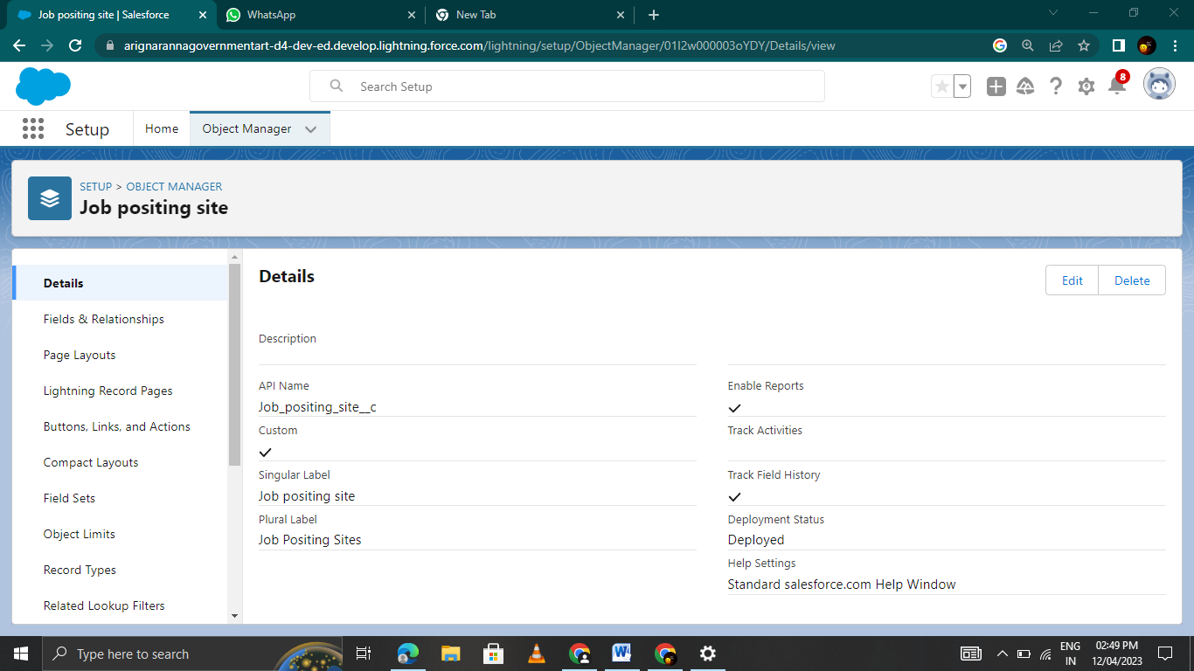

Activity-2

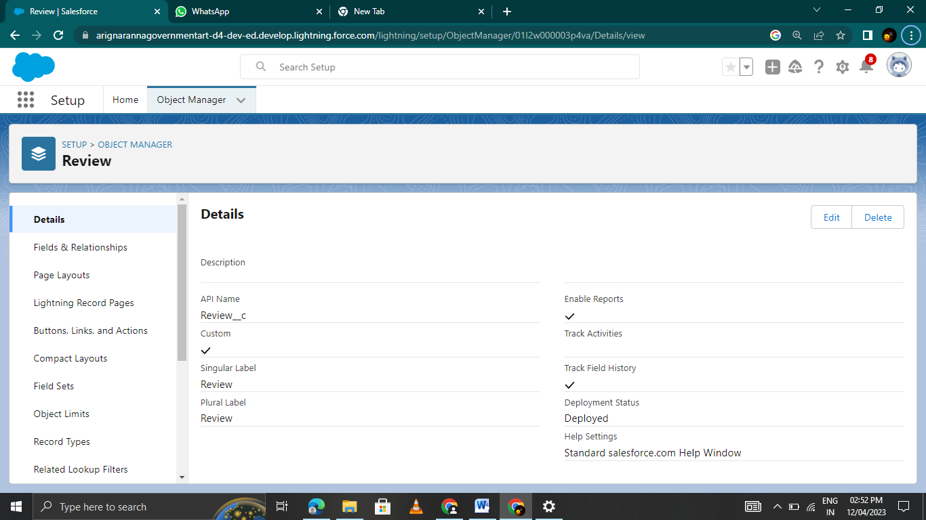

Milestone 4: Tabs

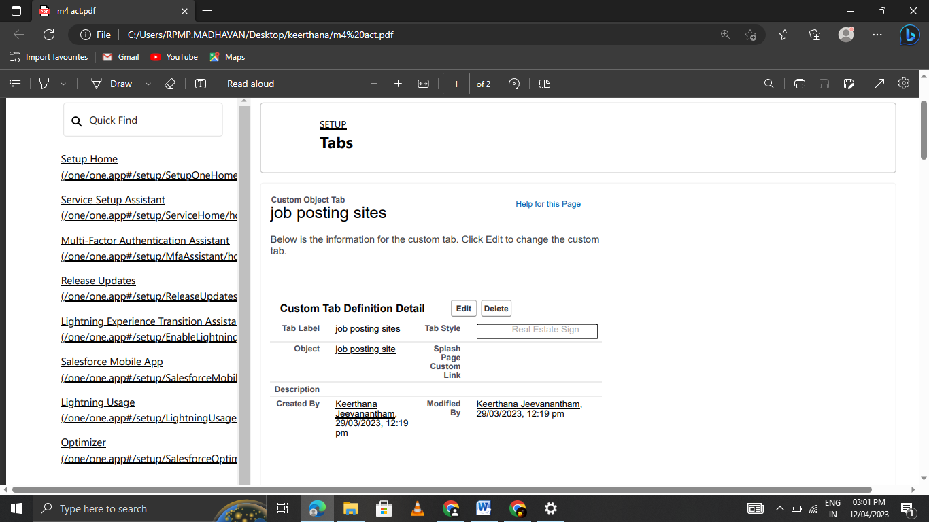

Milestone 5:Fields

Activity-1

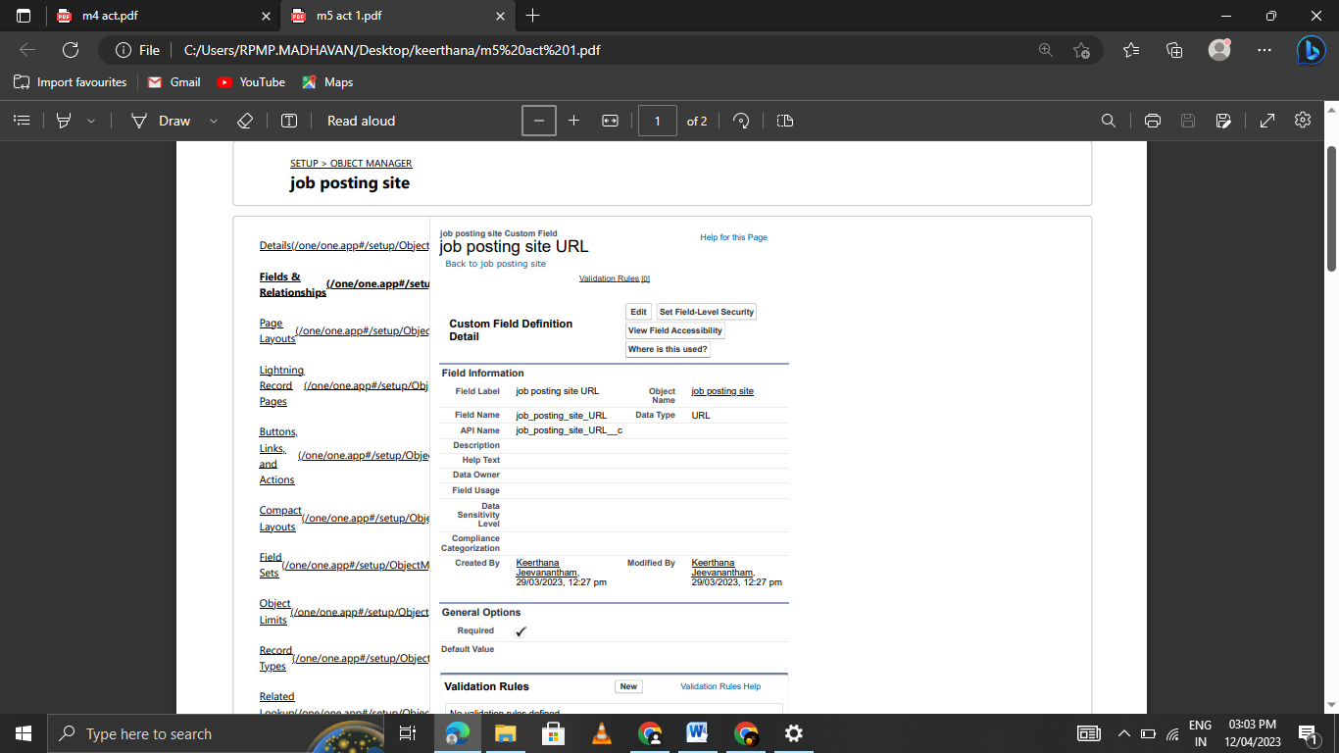

Milestone 6: Junction Object

Activity-1

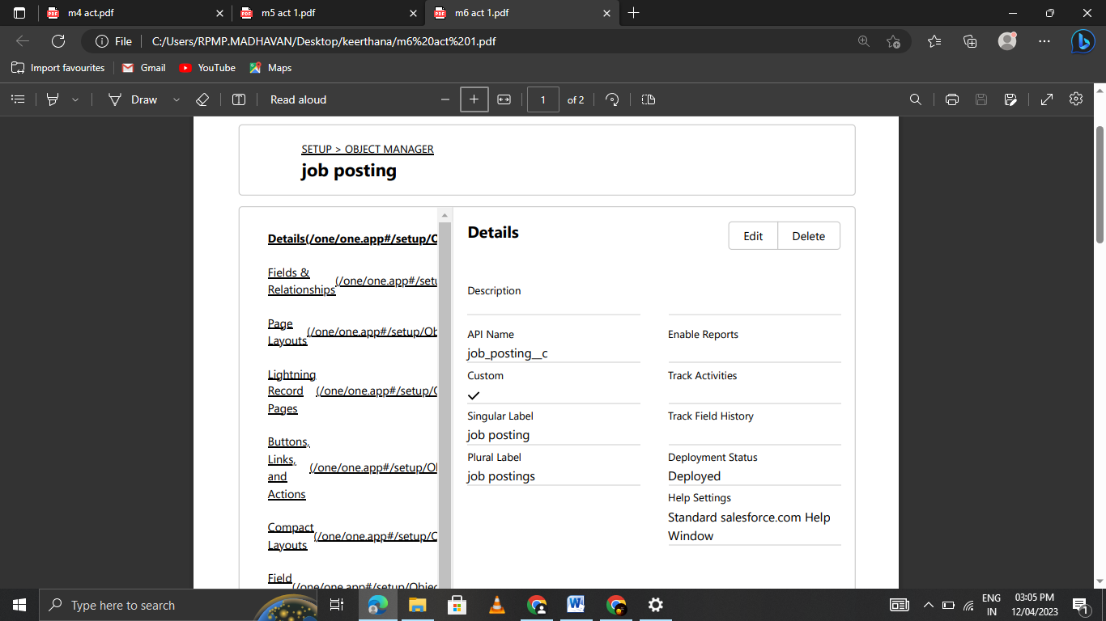

Activity-2

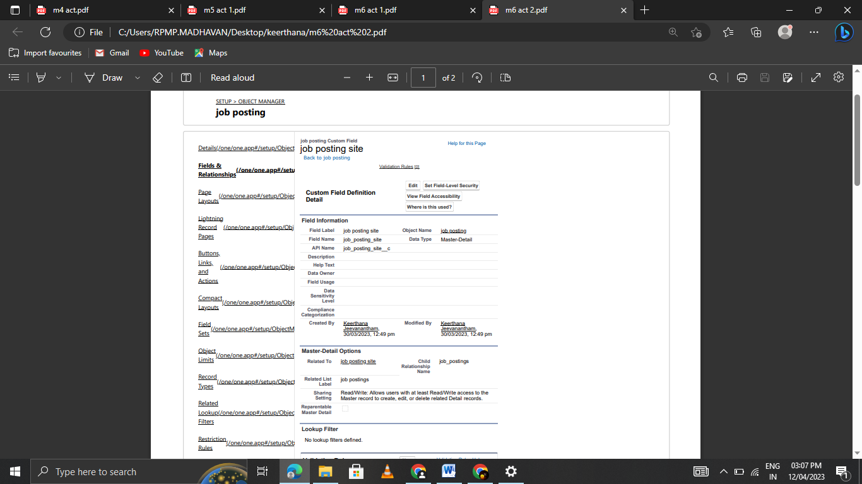

Milestone 7:Page Layout

Activity-1

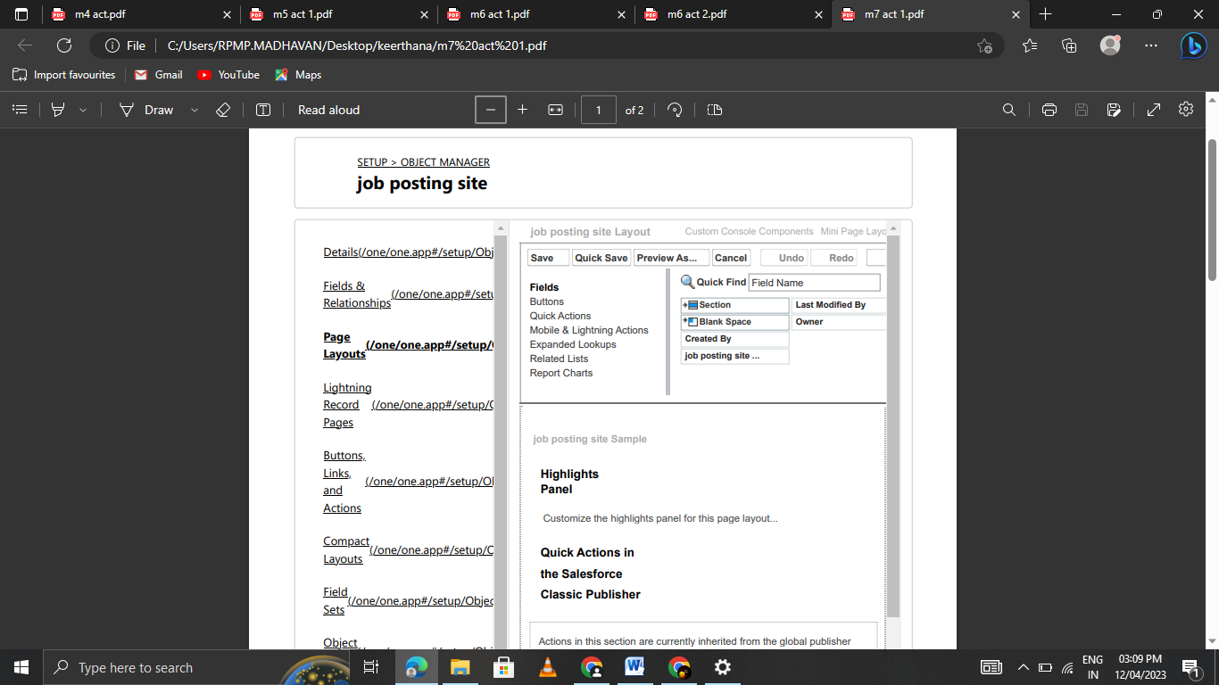

Milestone 8: Validation Rules

Activity-1

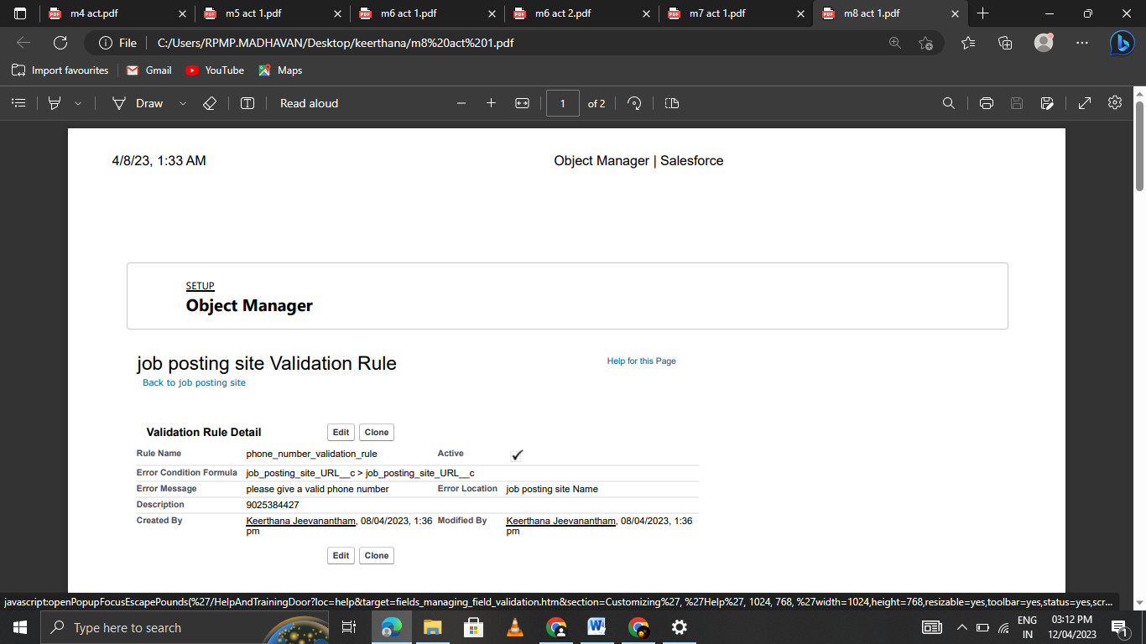

Milestone 9: Profile

Activity

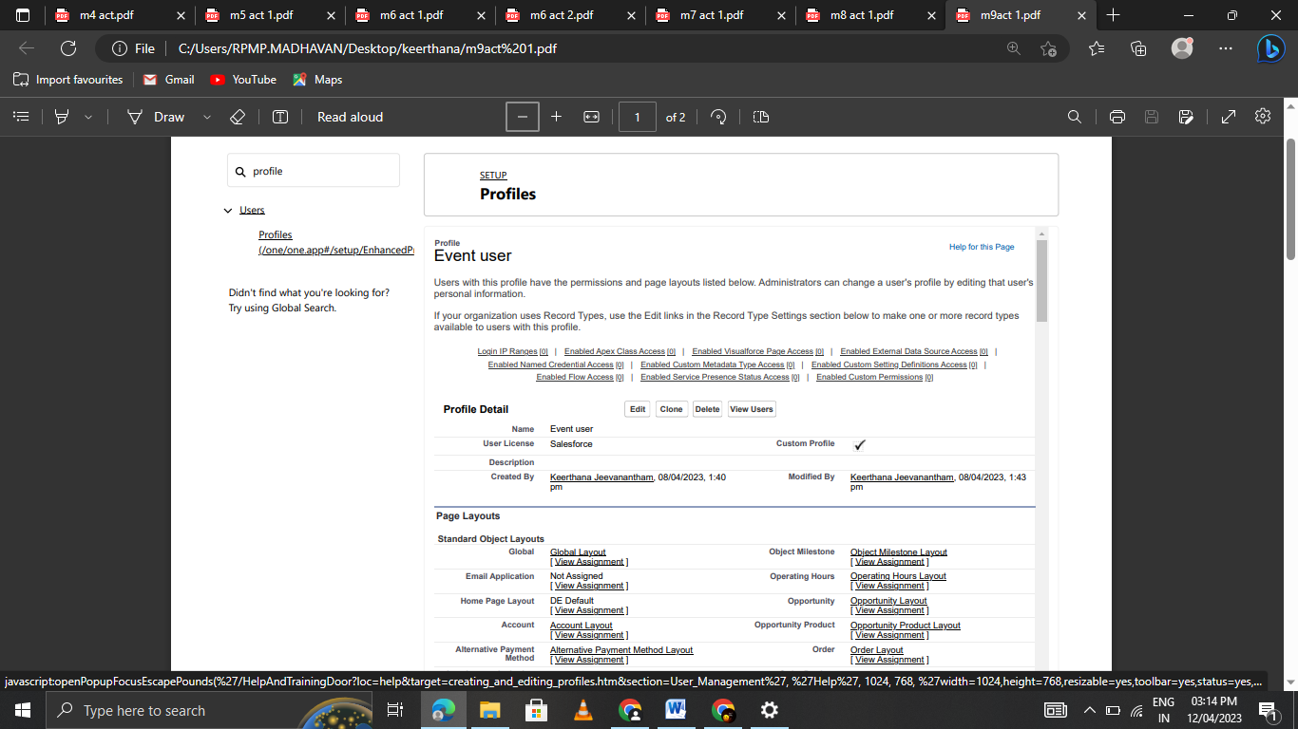

Milestone 10: User

Activity-1

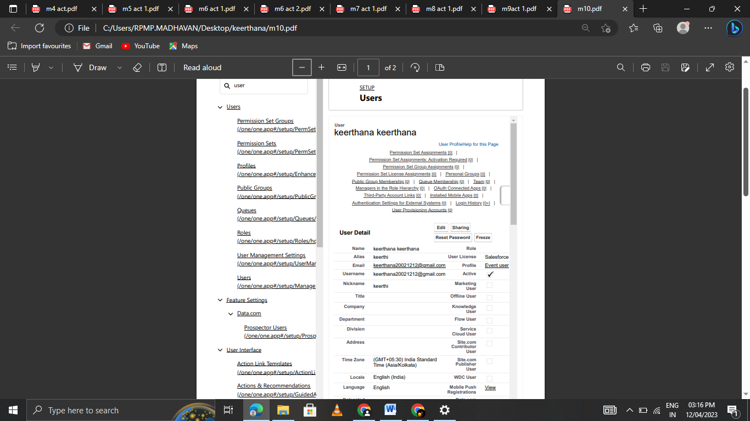

Milestone 11:Permission set

Activity-1

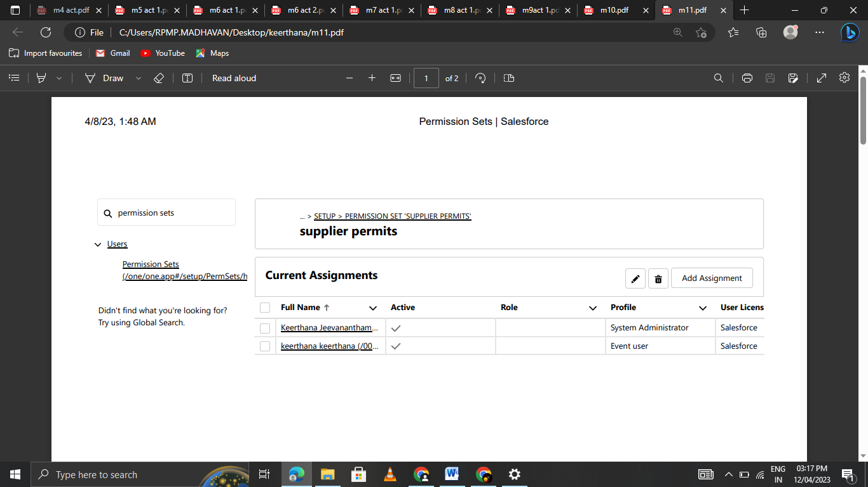

Milestone 12: Reports

Activity-1

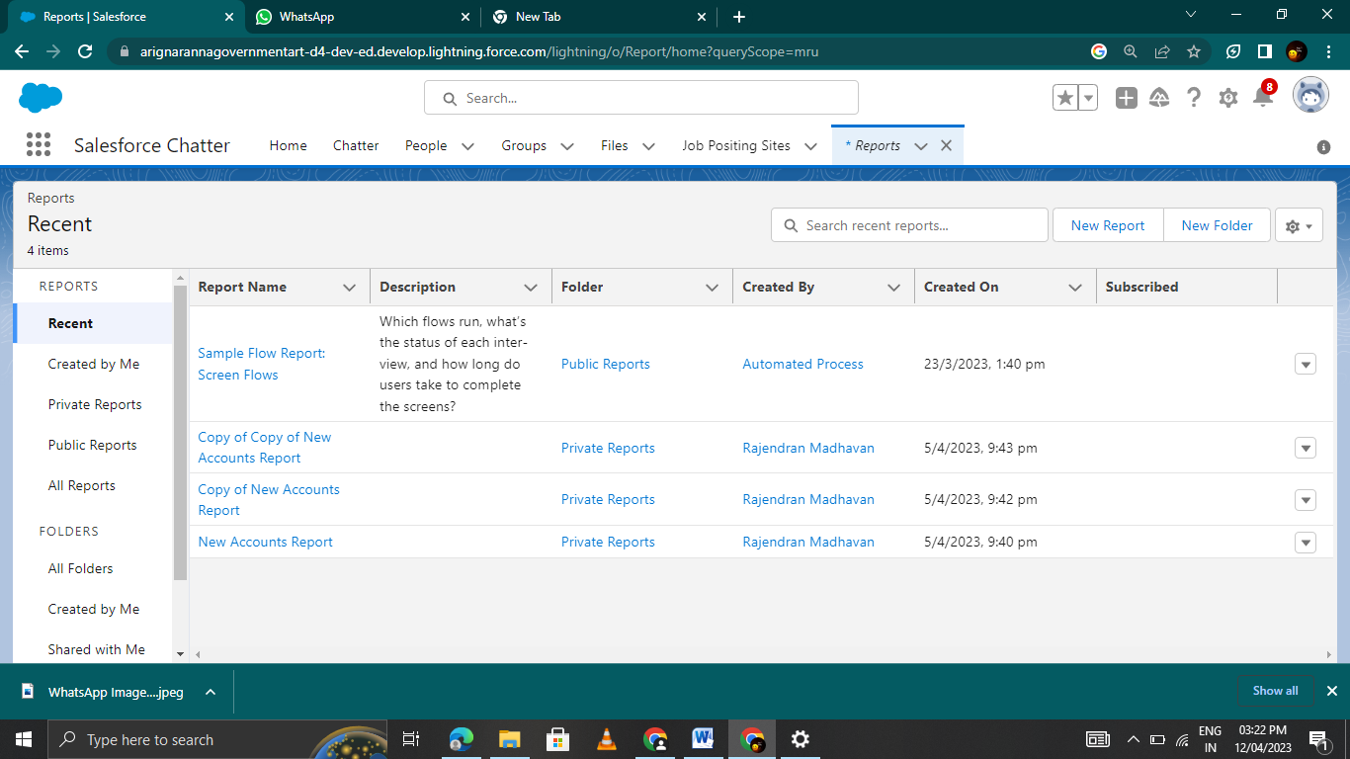

**Trailhead Profile Public URL**

Team Lead – <https://trailblazer.me/id/kee122002>

Team Member 1­- <http://trailblazer.me/id/kkiruba3>

Team Member 2 - <https://trailblazer.me/id/rmadhavan90>

Team Member 3- <https://trailblazer.me/id/vmanikandan9>

ADVANTAGES & DISADVANTAGE

Advantages

1. You can develop your skills

2. You have various opportunities for employment

3. You may find a job with no experience requirements

4. You can make meaningful contributions to an organization

5. You can build your professional network

6. You can decide whether you want to pursue a career in HR

7. You may help develop other staff members

8. You can welcome new employees

9. You may have a varied work routine

10. You can gain experience

11. You can collaborate with other professionals.

12. You can contribute to a diverse workplace

13. You may have a flexible position

Disadvantages

* Maintaining a safe distance
* Higher competition
* Lower recognition value
* Greater experience expected
* Conflicts of opinion
* Legal liabilities
* Position restrictions

APPLICATIONS

I am writing to apply for the HR assistant post at ABC Company. With

4+ years of extensive experience, I am keen to join your company as an HR assistant. I am passionate about assisting and streamlining HR routine operations.

**CONCLUSION**

Recently Salesforce introduced Salesforce for HR – the Employee Success Platform. By taking advantage of the powerful Salesforce1 platform organizations like Virgin America and Coca-Cola are transforming employee engagement with mobile tools, communities and analytics.

For most people working in HR, Salesforce is synonymous with CRM – an array of sales and marketing cloud-based tools designed to manage all aspects of your customer relationship and closing new business. Even their company stock symbol is listed as “CRM”. However, the days of being a CRM only company are long over as they evolve to deliver the most versatile, mature cloud platform built for the next generation.

Salesforce for HR is a set of human resource tools designed to improve employee engagement and retention similar to how Salesforce has been delivering tools for increasing productivity of the front office for years.

**Here is brief description of Salesforce for HR:**

* Employee journeys designed to offer employee engagement from efficient onboarding to employee development
* Employee communities for collaboration
* HR help desk for self service on HR related issues powered by Salesforce’s Service Cloud
* Salesforce HR Analytics for talent related decisions based on productivity metrics
* Engagement apps designed to help organizations build mobile apps to support business processes

FUTURE SCOPE

This software will give more job opportunities in future. Maintaining a safe distance.

One should remember that HR needs to adapt and be agile i.e. an HR professional must not stop learning. HR will not be replaced, but HR professional must take up relevant courses to empower your working and be in a race. Thus, **MBA in HR future scope is bright!.**

A human resources (HR) assistant is a certified professional who handles the daily administrative and HR duties of an organization. They **assist HR managers with recruitment, record maintenance, and payroll processing, and provide clerical support to all employees.**

An effective job title wiil typically include a general term, the level of experience and any special requirements. The general term will optimize your job title to show up in a general search for jobs of the same nature. The level of experience will help you attract the most qualified applicants by outlining the amount of responsibility and prior knowledge required. And if your position is specialized, consider including the specialization in the job title as well. But avoid using internal titles, abbreviations or acronyms to make sure people understand what your job posting is before clicking.

* HR Assistant
* Junior HR Assistant
* HR Assistant (with ADP Workforce Now proficiency)
* HR Assistant (Part-Time)
* Human Resources Assistant