
Streamlining IT Procurement
Automating Standard Laptop Orders with Flow Designer
A Seminar Presentation
Presented by
A. Sowfiya
B.Sc., Computer Science
Annai Ayesha Arts and Science College for Women
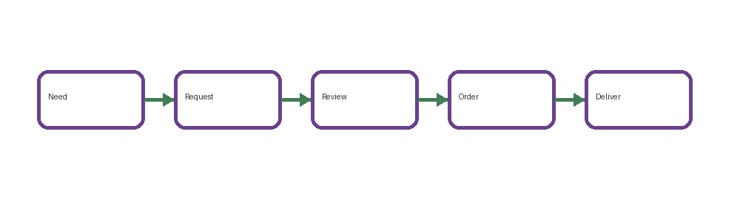


1. Introduction
• IT procurement involves obtaining technology equipment through a controlled request, approval, purchasing and delivery process.
• Standard laptop orders are repetitive and therefore suitable for workflow automation.
• Flow Designer can connect request submission, approvals, tasks and notifications into one structured process.


2. What is IT Procurement?
• IT procurement identifies technology needs, selects approved products, obtains authorization and coordinates purchasing and delivery.
• A standard laptop process can define approved specifications, quantity rules, budget limits and approval paths.
• A documented process improves consistency and visibility.

3. Challenges in Manual Laptop Ordering
• Repeated data entry and email-based coordination can slow routine requests.
• Unclear approval ownership may cause delays.
• Non-standard specifications can create purchasing exceptions.
• Requesters may have limited visibility into status.
• Manual follow-ups increase administrative workload.

4. Standard Laptop Ordering Model
• A standard catalog item can define an approved laptop configuration and optional accessories.
• The request form can capture requester, department, location, quantity and justification.
• Rules can distinguish standard requests from exceptions.
• Standardization creates a predictable foundation for automation.

5. Introducing Flow Designer
• Flow Designer is a visual ServiceNow capability for creating automated workflows.
• Flows use triggers, conditions and actions to move work through defined steps.
• For laptop procurement, a flow can route approvals, create tasks, update records and send notifications.
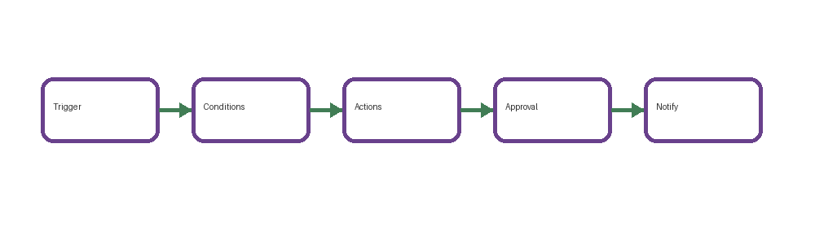

6. Proposed Automated Workflow
• Trigger: a standard laptop request is submitted.
• Validate: required fields and standard-item rules are checked.
• Approval: the request is routed to the appropriate approver.
• Procurement: an approved request creates the required fulfillment or purchasing task.
• Notification: requester and relevant teams receive status updates.
• Closure: the request is updated after fulfillment.
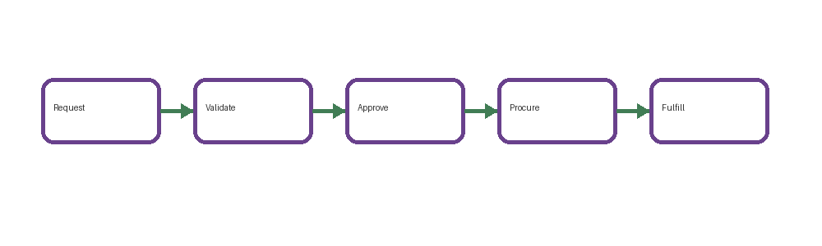

7. Flow Designer Components
• Trigger — starts the flow when a defined event occurs.
• Conditions — decide whether the flow continues or follows an alternate path.
• Actions — perform work such as updating records or creating tasks.
• Approvals — route decisions to authorized users.
• Notifications — communicate progress, exceptions and completion.

8. Example: Standard Laptop Request
• An employee selects the approved Standard Laptop catalog option.
• The request captures department, location, manager and quantity.
• The flow validates the information and routes it for approval.
• After approval, a procurement or fulfillment task is created.
• Status notifications keep the requester informed until completion.

9. Benefits of Automation
• Consistent handling of routine requests.
• Reduced repetitive administrative work.
• Clearer ownership and request visibility.
• Better standardization of laptop specifications.
• More consistent notifications and documentation.
• A structured workflow can support auditing and process improvement.

10. Controls, Exceptions & Best Practices
• Keep the standard catalog limited to approved configurations.
• Use role-based approvals and clearly defined authorization rules.
• Validate required information before procurement tasks are created.
• Create an exception path for non-standard laptops or unusual quantities.
• Test normal, rejected and exception scenarios before deployment.
• Monitor failed flow runs and update rules when requirements change.

11. Conclusion & References
• Automating standard laptop procurement converts repetitive manual steps into a structured workflow.
• Flow Designer can connect request submission, validation, approval, procurement tasks, notifications and closure.
• The approach supports consistency, visibility and controlled fulfillment.
References
• ServiceNow Documentation — Flow Designer and workflow automation.
• ServiceNow Documentation — Service Catalog and request fulfillment.
• ServiceNow Product Documentation — Flow Designer triggers, conditions and actions.

