Project Documentation

**Project Title:CookBook:Your Virtual kitchen Assistant**

# 1.Introduction :

## Welcome to our cookbook! This collection of recipes is designed to inspire and guide you in the kitchen, whether you're a seasoned chef or just starting out. Inside, you'll find a variety of delicious dishes to try, from classic favorites to new and exciting flavors. Let's get cooking!

## Project Title: CookBook:Your Virtual kitchen Assistant

* + **Team ID :NM2025TMID35672**
  + **Team Leader:** barani m baranichutty27@gmail.com

## Team Members:

* + 1. DHIVAKAR M [dhivarkarkaarai@Gmail.Com](mailto:baladinesh2225@Gmail.Com)
    2. BALASUBRAMANIAN K [palasuppu41@Gmail.Com](mailto:palasuppu41@Gmail.Com)
    3. GOPINATH S gopi64929@Gmail.Com

# 2.Project Overview

* + **Purpose:** To empower home cooks with a personalized cooking companion that provides recipe inspiration, meal planning tools, and step-by-step cooking guidance, making it easier to create delicious meals and explore new culinary possibilities.

## Features:

* + - Recipe Library
    - Meal Planning
    - Step-by-Step Guidance
    - Customization

# 3.Architecture

* + **Frontend:** React.js with Bootstrap and Material UI
  + **Backend:** Node.js and Express.js managing server logic and API endpoints
  + **Database:** MongoDB stores user data, project information, applications, and chat messages

# 4.Setup Instructions

* **Node.js and npm**:

Node.js is a powerful JavaScript runtime environment that allows you to run JavaScript code on the local environment. It provides a scalable and efficient platform for building network applications.

Install Node.js and npm on your development machine, as they are required to run JavaScript on the server-side.

* Download: <https://nodejs.org/en/download/>
* Installation instructions: <https://nodejs.org/en/download/package-manager/>

* **React.js**:

React.js is a popular JavaScript library for building user interfaces. It enables developers to create interactive and reusable UI components, making it easier to build dynamic and responsive web applications.

Install React.js, a JavaScript library for building user interfaces.

* Create a new React app:

npx create-react-app my-react-app

Replace my-react-app with your preferred project name.

* Navigate to the project directory:

cd my-react-app

* Running the React App:

With the React app created, you can now start the development server and see your React application in action.

* Start the development server:

npm start

This command launches the development server, and you can access your React app at http://localhost:3000 in your web browser.

* **HTML, CSS, and JavaScript**: Basic knowledge of HTML for creating the structure of your app, CSS for styling, and JavaScript for client-side interactivity is essential.

* **Version Control**: Use Git for version control, enabling collaboration and tracking changes throughout the development process. Platforms like GitHub or Bitbucket can host your repository.

 • Git: Download and installation instructions can be found at: <https://git-scm.com/downloads>

* **Development Environment**: Choose a code editor or Integrated Development Environment (IDE) that suits your preferences, such as Visual Studio Code, Sublime Text, or WebStorm.

• Visual Studio Code: Download from <https://code.visualstudio.com/download>

• Sublime Text: Download from <https://www.sublimetext.com/download>

• WebStorm: Download from [https://www.jetbrains.com/webstorm/download](https://www.jetbrains.com/webstorm/download%20)

To get the Application project from drive:

Follow below steps:

**Install Dependencies:**

• Navigate into the cloned repository directory and install libraries:

cd fitness-app-react

npm install

* **Start the Development Server**:

• To start the development server, execute the following command:

npm start

**Access the App:**

• Open your web browser and navigate to [http://localhost:3000](http://localhost:3000/).

• You should see the application's homepage, indicating that the installation and setup were successful.

 You have successfully installed and set up the application on your local machine. You can now proceed with further customization, development, and testing as needed.

# 5.Folder Structure

SB-Works/

|-- client/ # React frontend

| components/ L pages/

| server/ # Node.js backend

| routes/

| models/

| controllers/

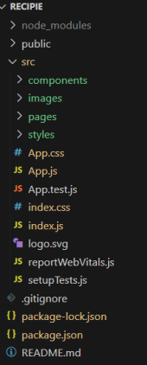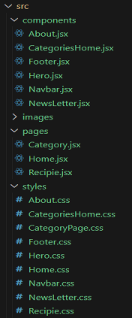

# 6.Running the Application

* **Install Dependencies:**

Navigate into the cloned repository directory and install libraries:

* + - * + cd store
        + npm install
* **Start the Development Server**:

To start the development server, execute the following command:

* + - * + npm start

# 7.API Documentation

## User:

* + - /api/user/register
    - /api/user/login

**Projects:**

/api/projects/create

/api/projects:id

Applications:/api/apply

# 8.Authentication

* + User Profile Creation
  + Password Protection
  + Data Encryption

# 9.User Interface

* + Browse Recipes
  + Personalize Experience:
  + Access Cooking Guides:
  + Personalize Experience:

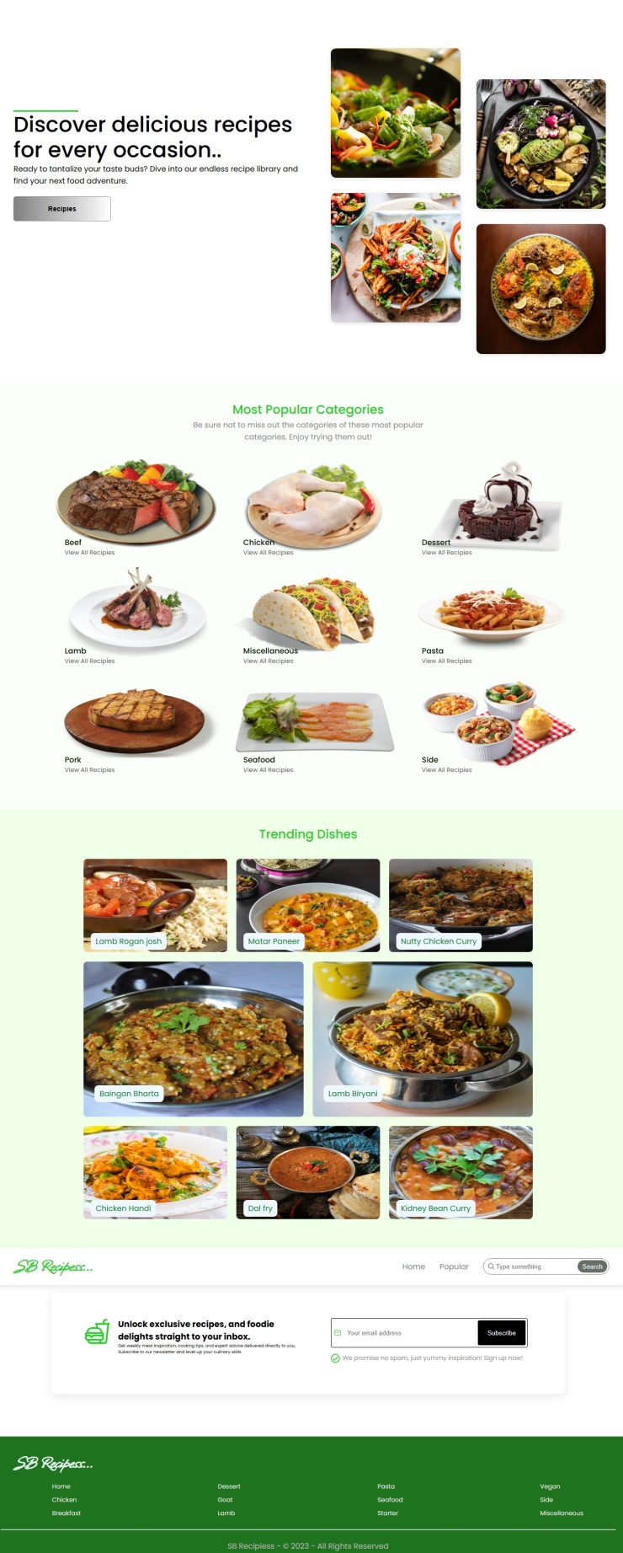

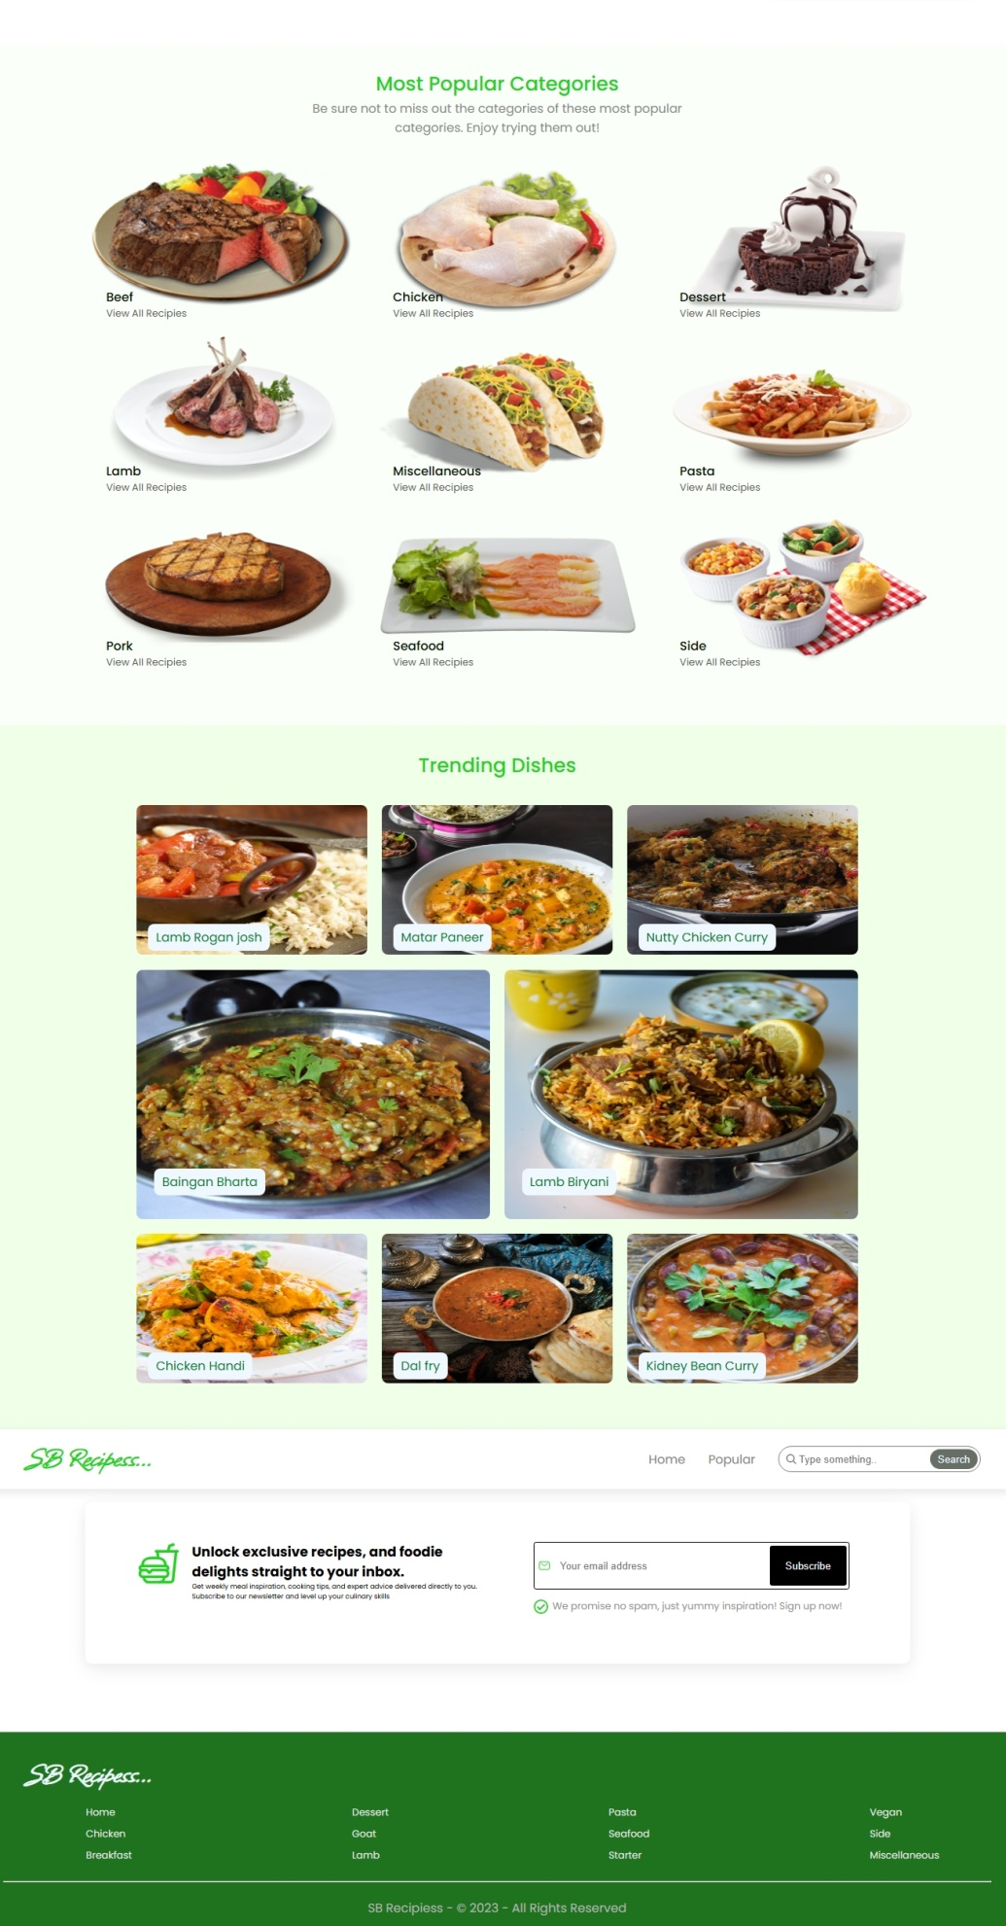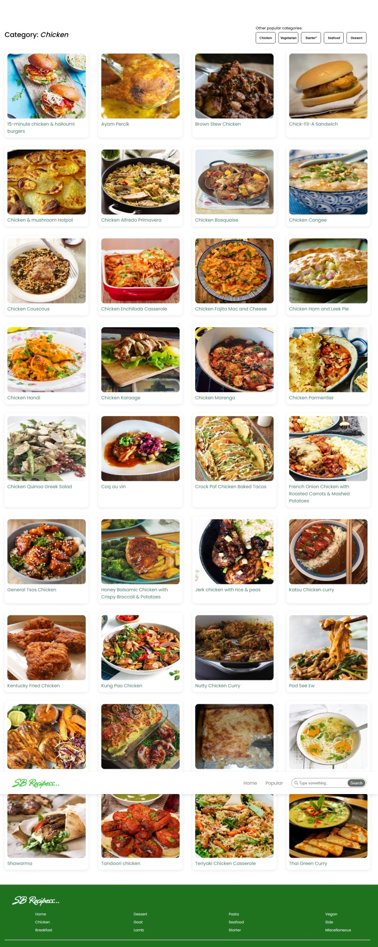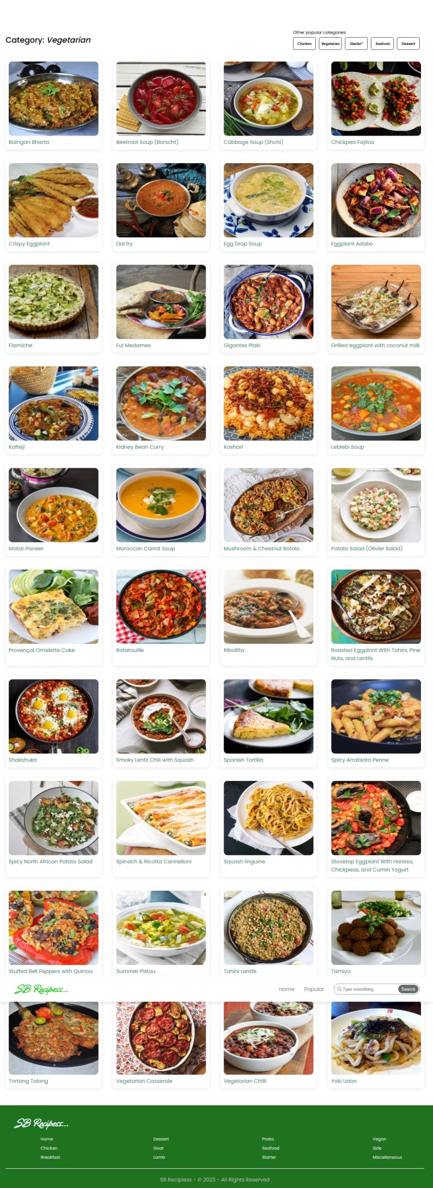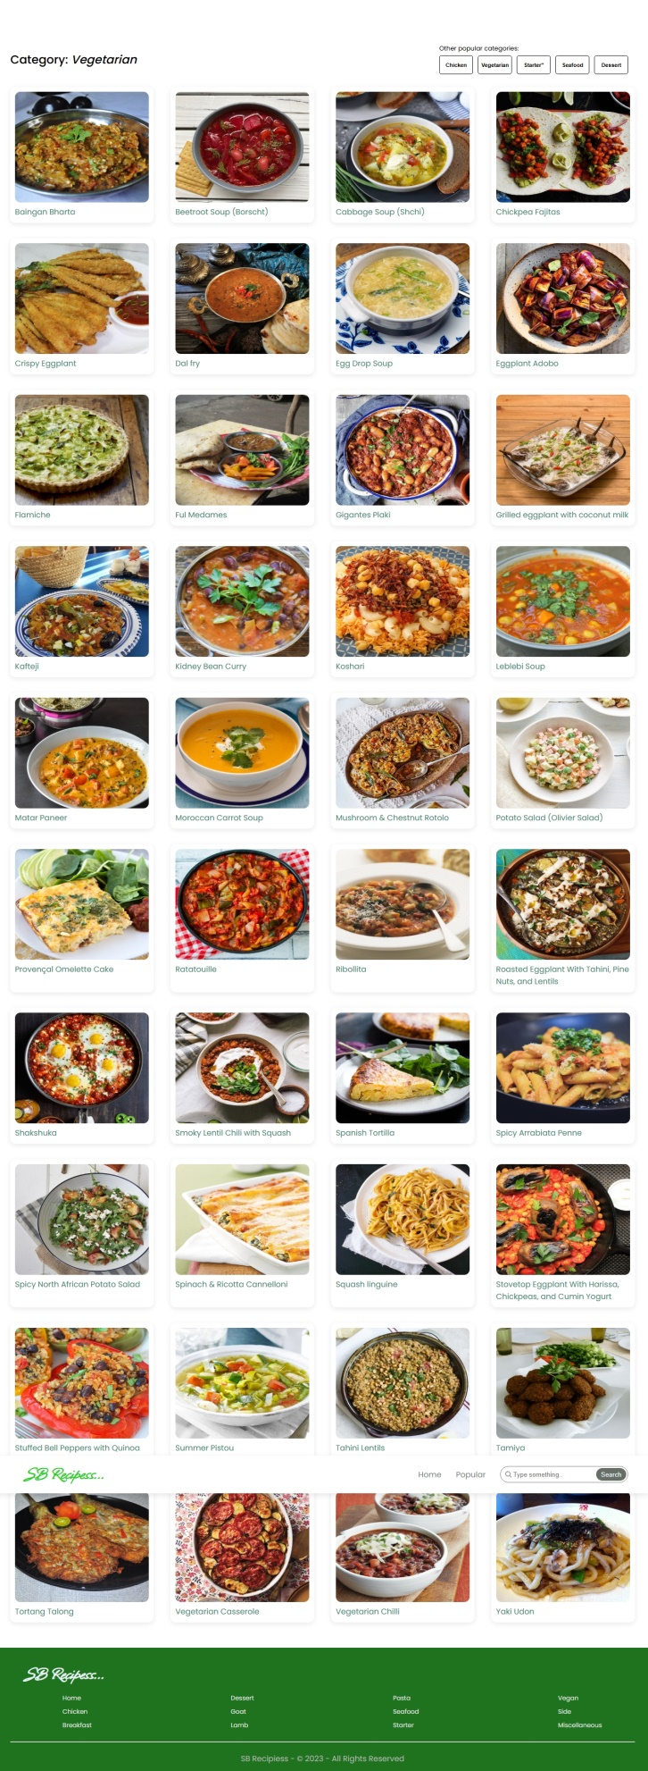

# 10.Testing

* + Cookbook Creator
  + Grocery List Manager
  + Recipe Finder

**11.Known Issues**

1. Recipe Display Issues: Formatting problems on certain devices or browsers.

2. Search Limitations: Inaccurate or incomplete search results.

3. Meal Plan Conflicts: Overlapping or duplicate meal plans.

4. Ingredient Calculation Errors: Inaccurate quantity calculations.

5. App Stability Issues: Occasional crashes or freezes.

**12.Future Enhancements**

1. 1. AI-Powered Recipe Suggestions: Personalized recipe recommendations based on user preferences and cooking history.

2. Voice Assistant Integration: Hands-free cooking guidance with voice commands.

3. Smart Kitchen Device Integration: Seamless integration with smart kitchen appliances and devices.

4. Social Sharing Features: Ability to share favorite recipes and cooking creations with friends and family.

5. Advanced Nutrition Analysis: Detailed nutritional analysis and meal planning based on dietary needs