CHEAT-SHEET

miniworldmaker v.0.1

### Token

Tokens on board.

direction: direction of token

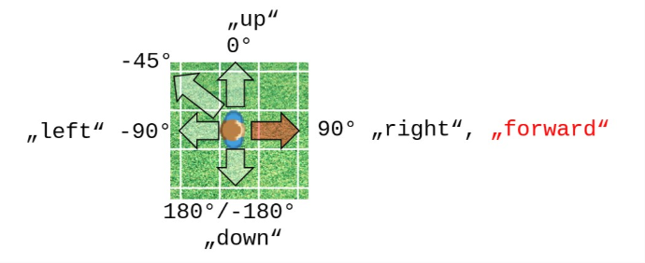

size: Size of token as tuple (e.g. (40, 40)

position: Position of tuple (e.g. (30, 20)

x; y: x and y coordinate

add_image(path) – Adds an image

add_costume(path) – Adds an costume with default image

switch_costume(index) – Switch to next costume or costume with index

Actor (Subclass of Token):

Can use all attributes and methods of token

speed: The actor speed (Used in combination with move()

__init__(position) – Creates new actor

point_in_direction(direction) – Actor points in direction

point_towards_position(destination) – Actor points towards position

point_towards_token(destination) – Actor points towards token or actor

turn_left(degrees) – Actor turns left by degrees degrees

turn_right(degrees) – Actor turns left by degrees degrees

move_in_direction (direction) – Actor moves in direction

move_to (position) – Actor moves to position

move (distance) – Actor moves distance (or self.speed) steps forward (distance can be negative)

flip_x() – Flips the actor

bounce_from_border(border) – Actor bounces from border

bounce_from_token(token) – Actor bounces from token or actor

sensing_tokens(distance, token, exact) – Actor senses tokens. **token**: The class of tokens to search for. **exact**: Should be the collision detection exact?

Sensing_borders(distance) – Gets list of borders as string

sensing_on_board(distance) – True if sensing on_board_position

sensing_color(color, distance) – Senses number of pixels of a given color

sensing_colors(distance) – Senses all colors.

Board

Don’t use this. Use either PixelBoard or TiledBoard

speed – The animation speed (between 0 and 100

width, height: width and height of board

rows, columns: rows and columns of board

add_image(path) – Adds an image

add_to_board(token) – Adds token or actor to board

get_tokens_by_pixel(pixel) – Gets all tokens by pixel

remove_from_board(token) – Removes token or actor from board

play_sound(path) – plays a sound

play_music(path) – plays a music

get_mouse_position() – Gets the mouse_position

### TiledBoard

__init__(columns, rows, tile_size, tile_margin) – Creates a new TilesBoard

### PixelBoard

__init__(columns, rows) – Creates a PixelBoard

### Costume (Subclass of Appearance)

Can be accessed via token.costume

is_animated: Is token animated?

is_rotatable: Is token rotatable?

is_textured: Is token a texture and should be repeated?

is_scaled: Is token scaled to actor.size remaining aspect ratio?

is_scaled: Is token upscaled to actor.size not remaining aspect ratio?

orientation: Correct initial orientation (e.g. self.costume.orientation = -90)

add_image(path) – Adds an image

colorize(color) – Colorizes a token with a color

### Background (Subclass of appearance)

Can be accessed via board.background

See costume for attributes, because they are sharing same attributes and methods.

### is_scaled_to_tile: Is background scaled to tile_size? Use this in combination with is_textured

### BoardPosition

A board position. On TiledBoard this is the coordinate of the tile.

BoardPosition.from_pixel(position) – Creates a BoardPosition from Pixel-Coordinates (e.g. mouse coordinates)

near(other, distance): Is Position near another position

to_tuple() – Transforms position to tuple (x, y)

up(value), down(value),… – Gets the position value steps up

is_on_board() – Tests if position is on board