#count pickups per zone

create table taxi\_p as SELECT p\_zoneid, count(\*) FROM taxi GROUP BY p\_zoneid;

#top 10 zone by pickup count

select \* from taxi\_p sort by cnt desc limit 10

taxi_P 
161 
| 162 
230 
| 186 
237 
| 138 
234 
| 178 
236 
. p_zoneid 
taxi _ p . cnt 
3246532 
3e24176 
3ee7896 
3ee3729 
2968498 
2914466 
2897685 
281e52e 
2749506 
2678978 

#count drop offs pr zone

create table taxi\_d as SELECT d\_zoneid, count(\*) as cnt FROM taxi GROUP BY d\_zoneid

select \* from taxi\_d sort by cnt desc limit 10

Machine generated alternative text:
taxi 
161 
230 
236 
170 
237 
162 
48 
234 
186 
142 
zoneid 
taxi d. cnt 
3061677 
2705400 
2705248 
2667692 
2641226 
2610168 
2422992 
2372409 
2365333 
2159235 

#taxi pickups by borough

create table taxi\_b\_cnt\_p as SELECT borough, count(\*) FROM taxi1 GROUP BY borough;

ALTER TABLE taxi\_b\_cnt\_p CHANGE `\_c1` `cnt` bigint;

select \* from taxi\_b\_cnt\_p sort by cnt;

borough 
Staten Island 
Bronx 
Brooklyn 
Queens 
Manhattan 
taxi b cnt_p.cnt 
229e 
87495 
1492647 
62€e821 
81471339 

#top 10 zone by crime count

create table crime\_zone as SELECT crimetaxizoneid, count(\*) FROM crime GROUP BY crimetaxizoneid;

select \* from crime\_zone sort by cnt desc limit 10

crime 
61 
76 
35 
74 
42 
129 
168 
37 
89 
225 
zone. 
crimetaxizoneid 
crime 
1817 
1695 
1465 
14e 6 
1216 
1162 
IB81 
1068 
1e36 
1036 
zone. cnt 

select p\_zoneid,count(\*) as cnt from taxi\_man group by p\_zoneid sort by cnt asc limit 10;

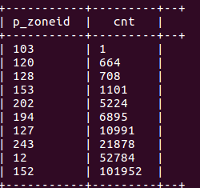

select crimetaxizoneid,count(\*) as cnt from crime\_man group by crimetaxizoneid sort by cnt asc limit 10;

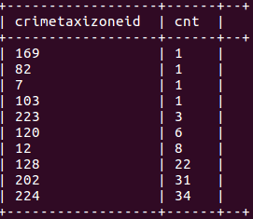

select p\_zoneid,count(\*) as cnt from taxi\_bro group by p\_zoneid sort by cnt asc limit 10;

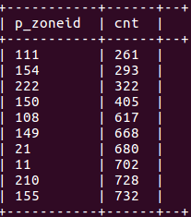

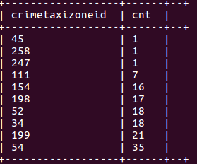select crimetaxizoneid,count(\*) as cnt from crime\_bro group by crimetaxizoneid sort by cnt asc limit 10;

select p\_zoneid,count(\*) as cnt from taxi\_que group by p\_zoneid sort by cnt asc limit 10;

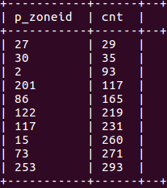

select crimetaxizoneid,count(\*) as cnt from crime\_que group by crimetaxizoneid sort by cnt asc limit 10;

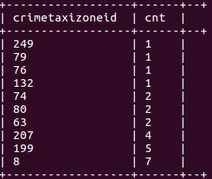

select p\_zoneid,count(\*) as cnt from taxi\_bronx group by p\_zoneid sort by cnt asc limit 10;

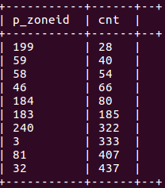

select crimetaxizoneid,count(\*) as cnt from crime\_bronx group by crimetaxizoneid sort by cnt asc limit 10;

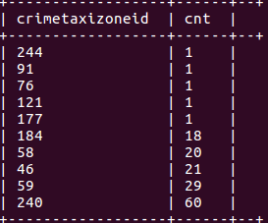

select p\_zoneid,count(\*) as cnt from taxi\_sta group by p\_zoneid sort by cnt asc limit 10;

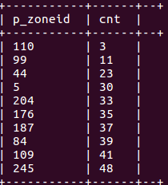

select crimetaxizoneid,count(\*) as cnt from crime\_sta group by crimetaxizoneid sort by cnt asc limit 10;

