**VL53LDK**

* The VL53L0X is a new generation laser-ranging module that works on the Time-of-Flight (ToF) principle which is developed by ST Microelectronics
* It is used to measure the distance up to 2 meters. It uses Laser beam for measuring distance range.
* This Module is 4 Pin, which works on the I2C communication protocol.
* This sensor operates on a 2.8 to 5.5 V power supply

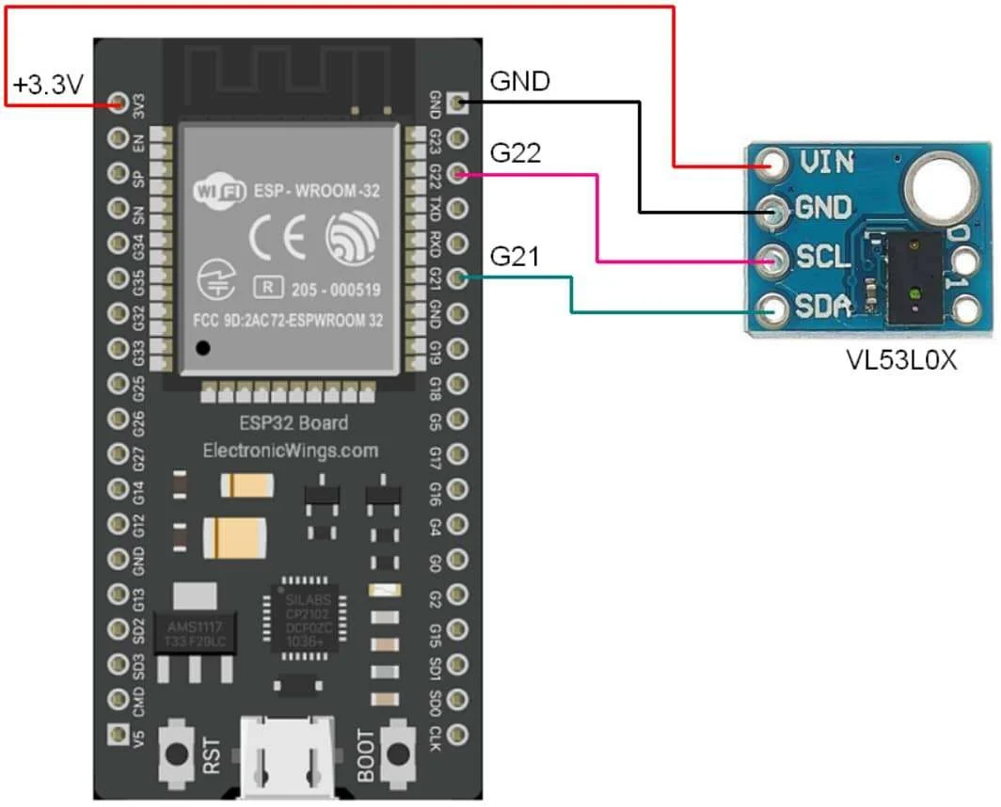

**Working Principle**

VL53L0X is a laser ranging sensor. It uses the Time of flight principle for measuring the distance of the objects. Here a laser beam is released from the Vertical Cavity Surface Emitting Laser present in the device. This beam stricks the surface of the object and bounces back. The time taken by the laser beam to strick the surface of the object and reflect back to the sensor is known as the Time of flight. This time is measured to calculate the distance between the object and the sensor. To measure the photon timing and photon distance SPAD array is used in the device. This also increases the accuracy of the device. VL53L0X can measure the distance range of the object even if its surface is highly reflective.

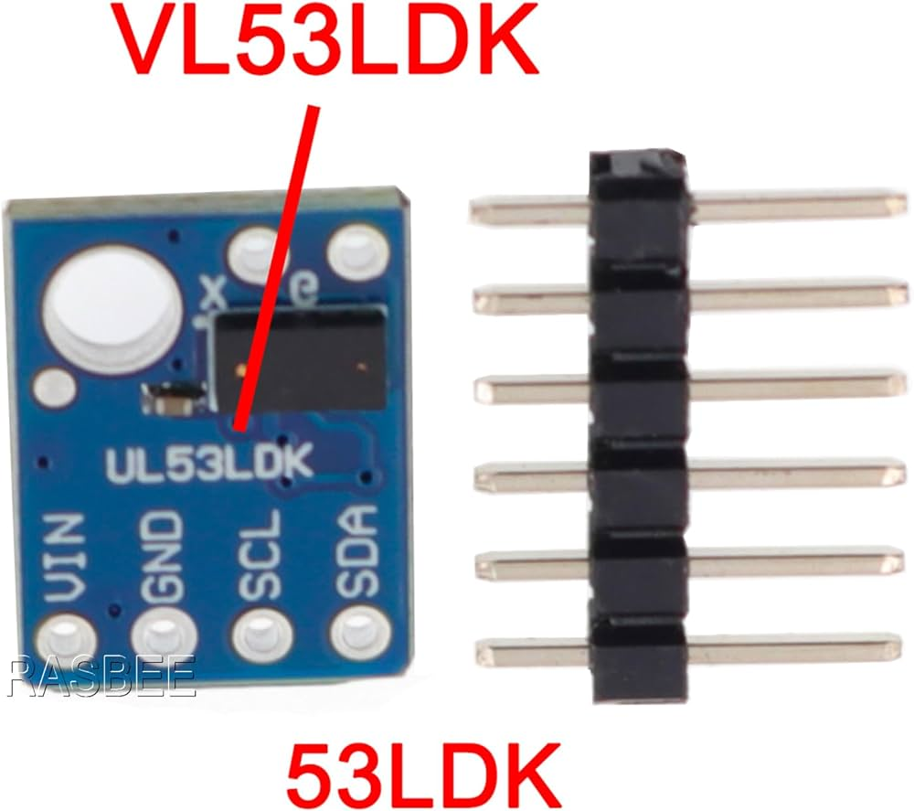

**Install Require Library for VL53L0X**

Here we are using Adafruit libraries for the above example. We will need to install the **Adafruit VL53L0X** library using the Arduino Library Manager.

Open the Arduino IDE and navigate to **Sketch ► Include Library ► Manage Libraries…**

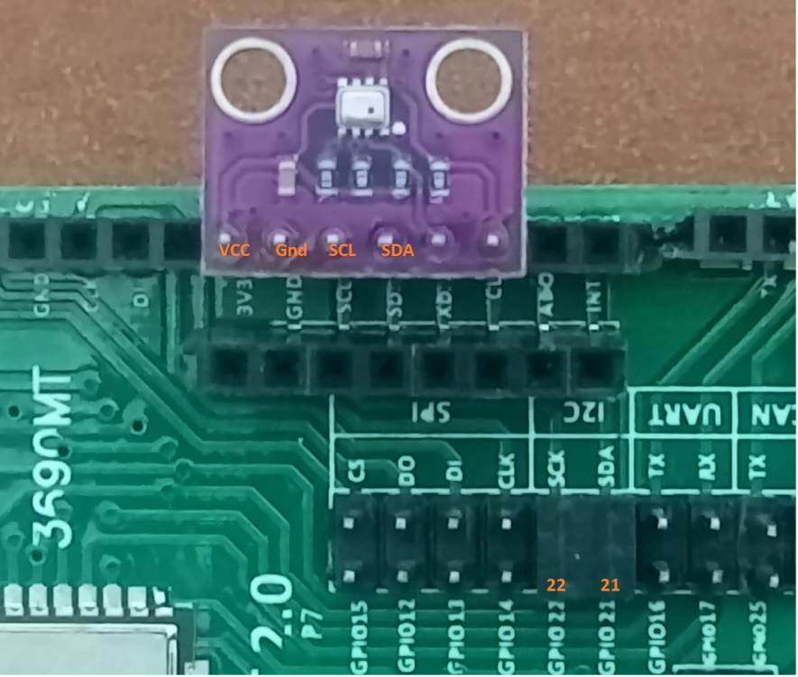

|  |  |
| --- | --- |
| ESP 32 Pin | VL53LDK Laser ToF |
| 3.3 V | Vcc (pin 1) |
| Gnd | Gnd (pin 2) |
| SCL / SCK (GPIO 22) | SCL (pin 3) |
| SDA (GPIO 21) | SDA (pin 4) |

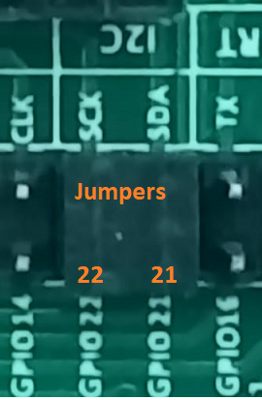

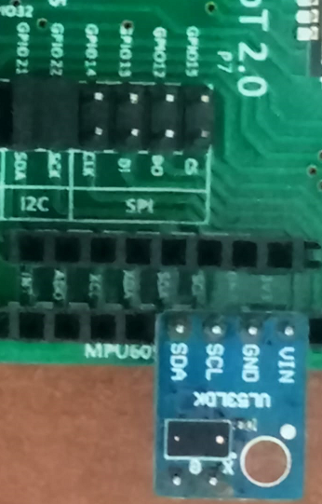

Keep the jumpers of I2C in place as shown above.

References:

<https://www.elprocus.com/vl53l0x-pin-configuration-circuit-diagram-and-applications/>

https://www.electronicwings.com/esp32/vl53l0x-sensor-interfacing-with-esp32