MoodLy: Daily Mood Tracker

Aliah Jezrine S. Casabuena

Asia Pacific College  
492 Riverside St.

Maricaban, Pasay City  
+639282561378 , 1300

ascasabuena@student.apc.edu.ph

**ABSTRACT**

This project aims to have a program that will aid the user to have a regular self-reflective activity by tracking one’s daily mood. Lack of mental health awareness and Information risk has led this project to implementation of MoodLy: Daily Mood Tracker. MoodLy is a python written program that help the user to have a daily self-reflective activity and mood tracking for the improvement of one’s mental health, in accordance to the good health and well-being of the sustainable development goals (SDG) by United Nations Development Program.

# INTRODUCTION

A lot of people are now becoming more conscious about their own mental health. The Philippines as stated by the local news site Philstar Global [1], said that Philippines has the highest number of depressed people in Southeast Asia and according to the National Statistics Office, mental illness is the third disability that they consider in the Philippines. Knowing this, people among social media come up with a lot of techniques on how to care for their mental health.

A good example of this, is the use of Mood Tracker. To describe, this mood tracker is a paper-based table were the user set their own style and own meaning of legends. Each day, the user will log the mood that describe their day. Mood is the define as the generalize term of how we feel, that can last for an hour or a day. [2]

Monitoring your mood can help you manage them well and feel better. If a person is more aware of one’s mood, he or she can make a healthier life decision and avoid negative moods more often. [3]

This tool is also endorsed by mental health therapist as Jessica Powers [4] stated in an ENTITY article. According to them, therapist can help more and gave a better analysis in your appointments when you provide them this kind of information.

## Statement of the Problem

The researcher observed that in the world of innovations, people tend to disregard important aspects of their being, that prompted the researcher to make a project that will address the following problem:

### Lack of knowledge and awareness

Lack of knowledge and awareness about mental health cause people to disregard simple factors like eventful stress and frequent emotion, that can be a sign and source of mental problem that can lead to serious condition if ignored.

### Inefficiency and risk

People have different way of monitoring mental health. An example of this is the mood tracker, journal and diary. The use of these methods is subject to privacy issues and information risk. Information that is written can be easily lost because of natural factors and open for unauthorized viewing. This method is also considered inefficient to use, to produce several copies of the said

method, a lot of natural resources are put into waste before and after the use of this method.

### Inefficiency and risk

Mental health issues are rising among the generation possibly because most of the people doesn’t have enough time to take care of one’s mental health or at least have a time for their self in a day.

The project will be for one’s mental health awareness and it is connected to a sustainable development goal which is “Good health and well-being”

## Objectives

To address the stated problems observed by the researcher, this project seeks to attain the following objectives:

• Make a program called “MoodLy: Daily Mood Tracker”, that will serve as a reflective journal that will not consume time.

• Provide an evaluation of the monthly mood percentage of the user, for better analysis of the data.

• Provide a simple advice for the user on how to improve their mood for the better, in accordance to the evaluation result of the program.

• Ensure the safety and privacy of the user’s data.

## Significance of the Study

The result of the project MoodLy will benefit the following:

### App user

The user can improve his/her awareness of one’s self by knowing and tracking the everyday mood he/she has. With MoodLy and its data, the user can assess whether she needed to change or in need of help from somebody. Like, parents, friends and doctors.

### Parents

With the use of MoodLy program, parents can track their child’s mood on a monthly basis, this will help the parents know whether their child is in need of companion or going through difficulties.

### Doctors and future researchers

For the future implementation of the project MoodLy, the project can be improved to have a connection with the psychologists and therapists to have a better analysis of the data input by the user.

# RELATED APPLICATIONS AND METHODS

This chapter includes existing applications, methods, and researches that use same approach with the proposed project: “MoodLy: Daily Mood Tracker” which is tracking or mood logging program. The following applications also serves as the basis of improvement and modification of the project.

## Methods

In the past years, when the use of computer is limited to big companies, people do some methods to track their everyday activities as well as feelings. A famous example of this is the use of Diaries and Journals. It is a method that uses any kind of pen and paper to log down everyday activities or anything that was done and felt within the day. According to the University of Rochester, writing down your thoughts and feelings can help a person to understand one’s self and gain control over his/her emotion to improve mental health. [5]

However, as technology become more advance and more accessible this day, people lost interest with this kind of method and search for something that is a lot easier to fit with their hectic schedule, that eventually lost the essence of this reflective activity.

## Applications

A lot of mental care app is now built by a lot of developers, phone applications can easily be used with the use of smart phones and because of this, the interest of people in using the website applications have become less significant. Mood Panda is an example of mental health care website application that allow the user to have a diary like approach to the app, like the project this app collect moods and emotions, as well as notes or diary for the day. The difference with the project, Mood Panda categorize the emotion of the user in two categories, which is happy or unhappy and provide a graph in a weekly basis. The app is also intended for social use, since Mood Panda’s new updated is to linked social media to the website app and have a circle that can share mood or feeling. [6]

Since website applications are now becoming inefficient because of phone applications which is more accessible, a good example of phone application that is similar to the project is Daylio. Daylio is also a mental health care application currently available on android devices. The application collects inputs about the activity done by the user within the day, then the app will provide a monthly summary of all the activities done and how frequent the activity was done by user. The app also has a journal section for the user everyday notes. [7]

Another similar application is the Grid Diary that is exclusive for iOS devices. Grid Diary is an app that focuses on the old way of writing diaries and collecting notes on a daily basis. After storing the notes, the app will display the notes in a grid structure for easy viewing of the user. [8] The difference of this app to the project, is the collection of notes which the researcher avoids because it consumes time and effort that can lead to inconsistency monitoring.

# COMPLEXITY ANALYSIS

The program MoodLy: Daily Mood Tracker were written using the Python 3.7 language and compiled using Anaconda Spyder.

Abstract data type such as graph and array were implemented in the program. Graph were implemented using the module *matplotlib.pyplot.* This python module allows the program to display a visual representation of the classified moods per month in a bar graph form.

For arrays, Arrays was used for grid function in order to have a table that will represent the whole year. For rows, we have 31 rows for the days of each month, for months that has 28 and 30 days, it was modified through the use of “if” statements. For columns, we have 13 int total. 1 for labels and 12 for the months of the years. Array object were used and recommended on this part since it will be needing 2-dimensional array. Dealing with 2-dimensional array will give the program a complexity of $O(n^{2})$ for best case, worst case and average case, since each iteration will process the inner loop and outer loop for rows and columns.

Data structures that was implement in the program Moodly is a list. In total, there are 10 list that was used to store data. List were used because of its flexibility and low complexity. Also, since it is already built-in in python the use of codes can be minimize. The program also requires a lot of append activity as the user input new data that make the list more suitable and efficient for storing data.

Data input by the user were stored inside a list and retrieved from the list. The program retrieved specific data for monthly computations, and in order to retrieve the specific data the program was given specific indexes containing the corresponding data needed for the month. This algorithm gives the program a complexity of *O(1)* for the best case, average case, and worst case, since the program will not check all the items in the list in order to find the specific data needed.

# THE APPLICATION

Initial running of the program will produce a screen (see Figure 1) that ask the user if he/she wants to start the program after giving a brief information of what is the program and how it will work.

If the user input “no”, the program will end. If by chance the user input neither “yes” or “no”, the program will raise an error and will ask again the user for an input.

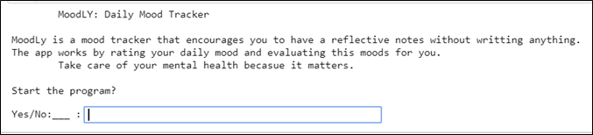

**Figure 1. Initial screen**

If the program received “yes”, the program will start tracking the mood by giving the current date and will ask how’s the day of the user, the user can rate his mood by the ratings that the program will display. The rating will be ranging from 1 to 5, 1 representing the negative mood and 5 as the positive mood. (see Figure 2).

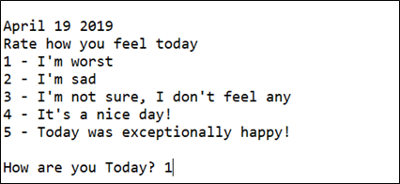

Figure 2. Daily mood tracking.

.

Upon entering the mood for the day, the program will provide a table summarizing all the inputs that was given by the user since January 1st of the year. Legends such as numbers 1 to 5 represents the mood of the user felt in that day, while “X” represents wrong input or no input at all (see Figure 3).

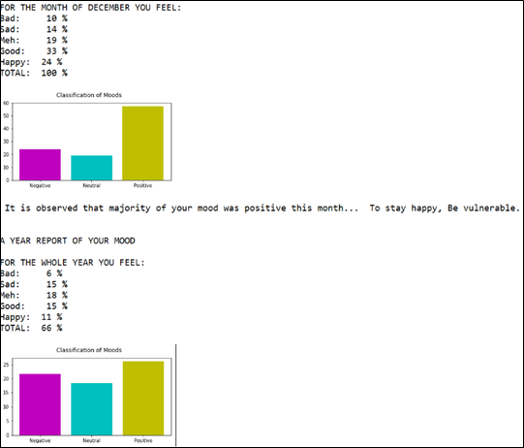

Figure 5. Display of year-end evaluation and end of program.

.

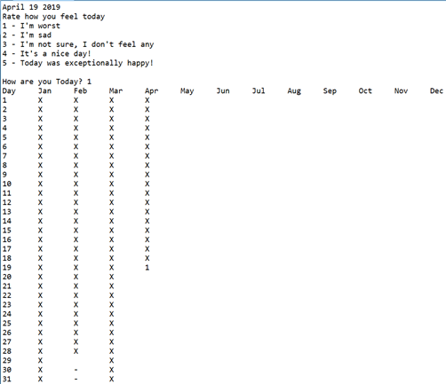

Figure 3. Display of Table.

.

The program will repeat this step every day until the last day of the month. On the last day of the month, the program will give an evaluation and a simple advice to the user according to the evaluation result (see Figure 4).

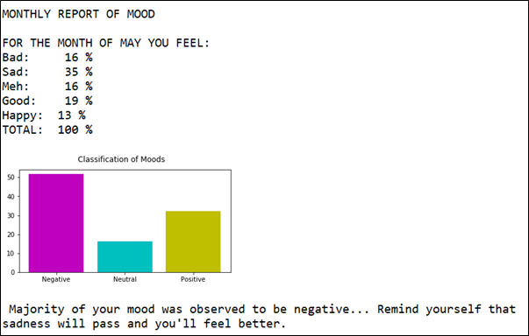

Figure 4. Display of monthly report.

.

The program will have monthly evaluations and year-end evaluation. For the monthly evaluation, this evaluation will execute at the last day of each month and for the year-end evaluation, this will execute at the end of December together with the month evaluation for December, (see Figure 5).

To use again the program after the year-end, simply re-run the program to start at the current date.

# CONCLUSION AND RECOMMENDATIONS

This chapter discusses the conclusion drawn from the project implementation and recommendations for future researchers.

## Conclusion

## The researcher come up with the idea of MoodLy because of the observation that the new generation is prone to mental stress and have a limited time to have a reflective activity once a day. Observing the use of diaries and journals, the researcher notice that this method become inefficient and unsecure for the new generations.

## In order to address this, the project MoodLy: Daily Mood Tracker were written to minimize the time spent in reflective activity and ensuring that it is done consistently. It also secures the safety of information since it is store in computer system.

## Moreover, the project was written to encourage people to have a habit of regularly checking their mental state by means of their daily mood. This also aims to bring back the traditional self-reflective activities that was done before, like diaries and journals to answer one of the sustainable development goals, which is good health and well-being.

## Recommendations

Based on the observation in the implementation of the project MoodLy: Daily Mood Tracker, the following recommendations are proposed for the improvement of the program:

1. The project should have a graphic user interface that is attractive to the user.

2. The program should run automatically when the date of the computer changes, prompting the user to input his/her mood for the day.

3. The program should only run at a certain time of the day, to make sure that the day of the user is done and to make mood tracking a habit.

4. The project contains different advices for the user, it is recommended to the future researcher to modify the program to have different advices that is approved and verified by the psychologists and mental therapists.

5. The project should draw critical evaluation of the moods of the user, this can be achieved through the help of psychologists and statisticians.

6. The project should have statistics that can be a basis of the features of the application to fit well with the future app users.

# REFERENCES

|  |  |
| --- | --- |
| [1] | S. s. D. Guzman, "Mental health of Filipinos today," 27 August 2018. [Online]. Available: https://www.philstar.com/opinion/2018/08/27/1846128/mental-health-filipinos-today. |
| [2] | J. Freedman, "Emotions, Feelings and Moods," 15 May 2017. [Online]. Available: https://www.6seconds.org/2017/05/15/emotion-feeling-mood/. |
| [3] | "Monitoring your Mood," December 2017. [Online]. Available: https://www.betterhealth.vic.gov.au/health/HealthyLiving/monitoring-your-mood#. |
| [4] | J. Powers, "What is a Mood Tracker and Why You Need One in Your Life?," 15 June 2018. [Online]. Available: https://www.entitymag.com/mood-tracker/. |
| [5] | "Health Encyclopedia," 2019. [Online]. Available: https://www.urmc.rochester.edu/encyclopedia/content.aspx?ContentID=4552&ContentTypeID=1. |
| [6] | "MoodPanda," 2019. [Online]. Available: http://www.moodpanda.com/help.aspx. |
| [7] | "DAYLIO features," [Online]. Available: https://daylio.webflow.io/. |
| [8] | "Grid Diary Classic," 2019. [Online]. Available: https://itunes.apple.com/au/app/grid-diary-personal-gratitude/id597077261?mt=8. |