TITLE FOR EXTENDED ABSTRACT OF ASCEND 2026
(TIMES NEW ROMAN, 16 FONT SIZE, BOLD, ALL CAPS, CENTERED)

Author’s Name and Surname¹, Author’s Name and Surname² (12 font size)
¹Affiliation 1
²Affiliation 2

*Corresponding author: abc@uitm.edu.my

Abstract: The abstract should be written in Times New Roman, 12 font size, single line spacing, and justified. The abstract should summarize the introduction, problem statement, objective, methods, findings, and conclusions. The length of the abstract should not be more than 350 words.

Keywords: This section should contain a maximum of 5 keywords separated by commas.

GENERAL GUIDELINES
The extended abstract must contain the following sections: abstract and keywords, introduction, methodology, findings, conclusion, and references. Subsections can be included.

The extended abstract shall be written in Times New Roman, single line spacing, 12 font size, and justified. The extended abstract is at a minimum of 3 pages and a maximum of 5 pages including references. Extended abstracts can contain figures, tables, and/or images which will not be included in the word count. The references are not included in the word count either. The page format should be A4 page size with margins 2.5 cm wide from the right, left, top, and bottom. Pages should not be numbered.

In-text citations are included when referring to, summarizing, paraphrasing, or quoting from other sources. Every in-text citation must have a corresponding entry in the reference list. This template uses IEEE Style. References must be numbered consecutively in the order in which they are first mentioned in the text. Cite them using Arabic numerals in square brackets, for example, [2], or [1, 3–5].

INTRODUCTION (Times New Roman, 12 font size, bold, all caps)
The introduction section should (1) present the scope and objective of the paper and state the problem, (2) briefly review the pertinent literature, (3) describe an overview of the methods, and (4) provide an overview of the main results of the work.

METHODOLOGY
The methodology must be clearly stated and described in detail or with appropriate references. The author shall explain the research question, describe the research framework, and the methods applied in detail. It should further highlight the research question, and why the chosen method(s) are suitable for the problem.

Subsection 1 (Times New Roman, 12 font size, title case)
This subsection should describe the first method. Please be concise and accurate. Additional subsections may be added as necessary.

FINDINGS AND DISCUSSIONS
The findings and discussions are described in detail in this section.

Figures, tables and images of the results (no more than three figures and three tables) may be included in the extended abstract (without exceeding the maximum 5 pages).

All the tables, images, and figures should be centered. Figures and images should be bordered and numbered (see Figure 1 for an example) and figure headers should be placed under the figure or image; as for the tables, they should also be numbered (see Table 1 for an example) and the table header should be placed at the top. References (if any) of the tables, figures, and images should be presented right under the tables, figures, and images.

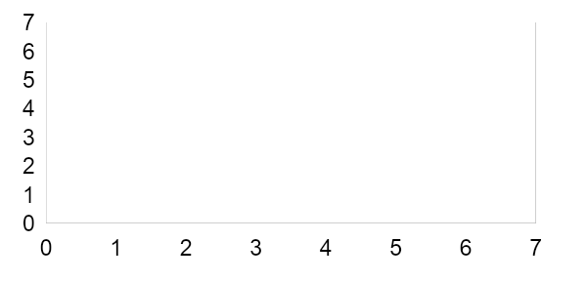

Figure 1. Caption (Times New Roman, 9, bold)
Source: Author, year (if any)

Table 1. Caption (Times New Roman, 9, bold)
Sample | Label | K (min ⁻¹)
 | Times New Roman, 10

CONCLUSION
A conclusion may include (1) the principles and generalization inferred from the results, (2) any exceptions, problems, or limitations of the work, (3) theoretical and/or practical implications of the work, and (5) conclusions drawn and recommendations.

REFERENCES
References should be concise and relevant, with a suggested limit of 15.
The reference list at the end of the document must be organized numerically, not alphabetically, and formatted strictly according to the IEEE Citation Style. (Refer to the official guide: ieee.org).
Examples:-

(Journal Article)
[1] J. A. Smith, L. B. Jones, and K. R. Williams, "Deep learning frameworks for predictive analysis in modern healthcare systems," J. Med. Syst., vol. 14, no. 2, pp. 123–145, 2024.

