Ascend Now — Business Overview
A Plain-English Guide to What the System Does and Why It Was Built
Sneha · B.Tech CSE, IGDTUW
19 July 2026
Table of Contents

A plain-English guide to what the system does and why it was built. This is the non-technical companion to the technical documentation. It’s written for anyone — no software background needed — who wants to understand the problem Ascend Now solves and how it helps the people who use it every day.

About this document
Document | Ascend Now — Business Overview (Non-Technical Guide)
Version | 1.0
Prepared by | Sneha · B.Tech CSE, IGDTUW (edit as needed)
Date | 19 July 2026
Companion to | Ascend Now — Technical Documentation (the developer-facing version)
Who it’s for | Business owners, coordinators, teachers, reviewers — anyone non-technical

1. Introduction
Ascend Now is a tutoring and college-counselling business. Teachers and coaches run one-to-one sessions with students, students buy blocks of hours in advance, and the office keeps everything running — enrolling students, collecting payments, paying teachers, and sending out reports.
Ascend Now (the system) is the single online place where all of that now happens. Instead of a pile of spreadsheets that someone has to keep updating by hand, there is one website where a teacher logs a session and everything else takes care of itself — the student’s remaining hours go down, the office is warned when someone is running low, invoices and monthly reports prepare themselves, and families can log in to see their own progress.
This guide explains, in everyday language:
- The problems the business had while running on manual spreadsheets.
- The idea behind the new system.
- Who uses it and what each person gets out of it.
- What it does, feature by feature.
- The difference it makes, side by side.

2. The problem: life with manual spreadsheets
A tutoring business has to keep track of a surprising number of moving parts. On paper it sounds simple — “students take lessons” — but underneath, the office is constantly juggling questions like:
- Who taught which student, on what day, for how long?
- How many hours did that student pay for, and how many are left?
- Which coach looks after which student?
- What should we invoice this month, and did the payment actually arrive?
- How many hours did each teacher work, so we can pay them correctly?
- What should the monthly report to each family say?
For a long time, each of these lived in its own spreadsheet, and a person had to copy numbers from one sheet into the next by hand.
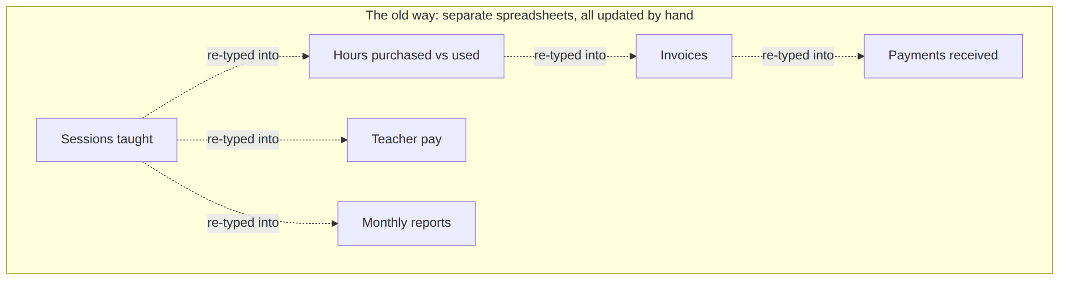
Figure 1 — Life on manual spreadsheets: the same numbers re-typed from sheet to sheet

Why that becomes painful
This works when there are five students. It stops working quickly as the business grows. Here is what goes wrong — and why it matters:
The spreadsheet problem | What it means in real life
Numbers drift apart | Update the “sessions” sheet but forget the “hours left” sheet, and the two now disagree. Nobody is sure which number is correct.
Easy to mistype | One wrong keystroke and a student is billed for the wrong number of hours — or a teacher is paid for the wrong ones.
No warnings | A student’s paid hours quietly reach zero. Nobody notices until they’re already being taught for free, or a lesson is cancelled at the last minute.
Slow month-ends | Building invoices and reports means hours of tallying and copy-pasting, every single month.
No privacy | A shared spreadsheet means everyone can see — and accidentally change — everyone’s data: students’ personal details, other teachers’ pay, the lot.
Hard to answer simple questions | “How many hours does this student have left?” or “How many hours did this teacher do in June?” should take seconds. On spreadsheets it means digging.
Families are left in the dark | Parents and students can’t check their own balance, reports, or session history — they have to email and wait for someone to look it up.
Things get lost | Session notes and feedback end up scattered across chats, documents and people’s memories. One accidental deletion and data is simply gone.
The deeper issue is that there is no single source of truth. The same fact — “this student has 12 hours left” — is written in several places, and those places slowly disagree. Everyone ends up spending time reconciling spreadsheets instead of teaching and running the business.

3. Why a proper system was needed
The business didn’t need “a nicer spreadsheet.” It needed to stop re-typing the same information in different places. The goal was simple to state:
Record each session once. Let everything else be worked out automatically from that.
If the system always knows who was taught, for how long, and against which purchased package, then it can calculate the remaining hours, the invoices, the reports and the teacher’s pay — instead of a person maintaining all of those by hand and hoping they stay in step.
That one idea is what Ascend Now is built around.

4. The big idea: log once, everything follows
With Ascend Now, a teacher logs a session the way you’d write a diary entry — who, when, what subject, how long. That single action quietly sets off everything downstream.
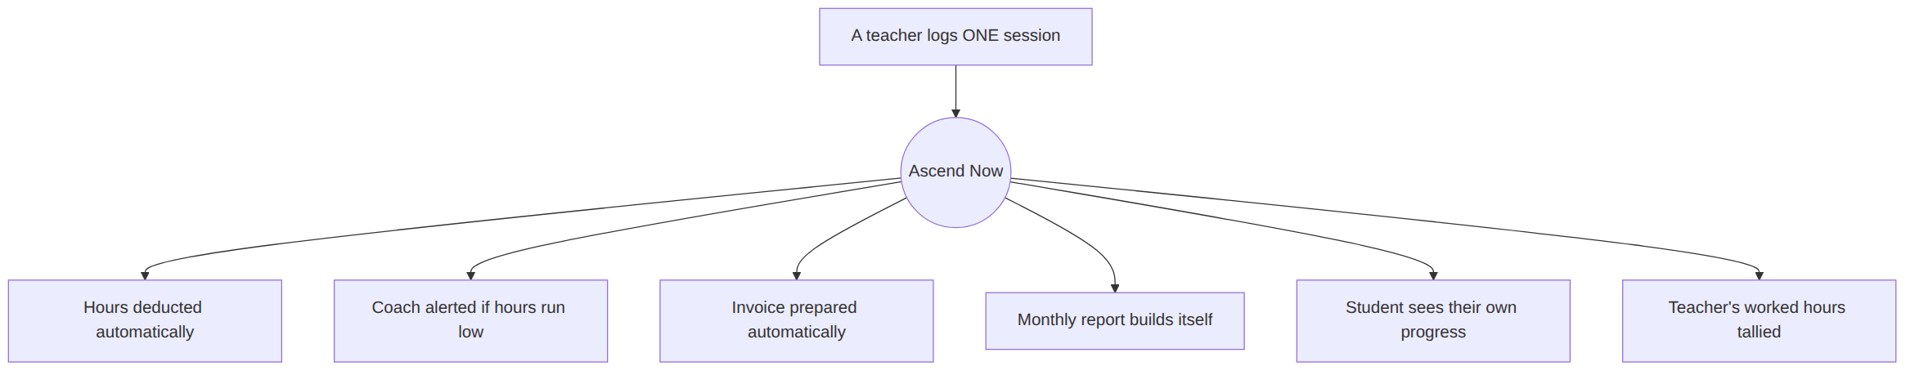
Figure 2 — One system, one source of truth: log a session once and the rest happens automatically
From that one logged session, the system automatically:
- Reduces the student’s remaining hours — no separate sheet to update.
- Warns the student’s coach when the package is running low (at 50%, 75% and 100% used), so a renewal can be arranged before hours run out.
- Prepares the invoice and the monthly report — built from the real sessions, not re-typed.
- Adds the time to the teacher’s worked-hours total, ready for pay.
- Shows the update to the family, who can log in and see it for themselves.
Nobody copies a number from one place to another. The session log is the single fact, and everything else is a view of it.

5. Who uses it, and what they get
Everyone signs in with their own login and sees only what’s relevant to them. There are four kinds of user.
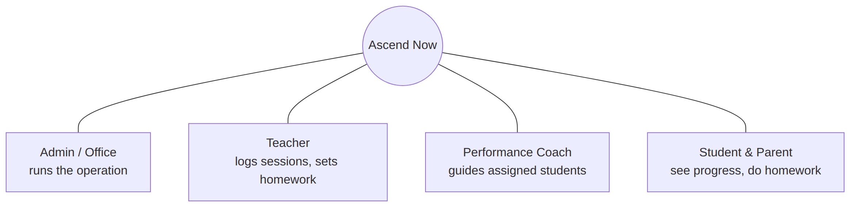
Figure 3 — The four kinds of user, and what each one does
Person | What they use it for
Admin / Office | Runs the whole operation: enrols students, reviews payments, generates monthly reports, manages teachers and coaches, and sees the big-picture analytics.
Teacher | Logs their own sessions, keeps their subject list up to date, uploads their monthly invoice, and creates homework for students.
Performance Coach | Everything a teacher does, plus looking after their assigned students — tracking progress, flagging renewals, and keeping coaching notes. (A coach is simply an experienced teacher with extra responsibilities.)
Student & Parent | A private, read-only window into their own world: hours remaining, session history, reports, coaching notes, and homework to attempt. One login covers the student and their family.
A helpful detail: there is no public sign-up. Every account is created by someone already inside the business, so the list of users always matches the real students and real staff — no strangers, no clutter.

6. What the system does, feature by feature
Here is the whole system in plain terms, grouped by what it helps with.

6.1 Bringing a new student on board
Adding a student is a proper, guided process rather than a quick row in a sheet:
- The office fills in a short enrolment form and chooses the student’s package of hours.
- The system emails an invoice and a secure payment link to the family.
- The family pays and uploads a screenshot of the payment through that link — no login needed.
- The office checks the payment and confirms. The student’s login and hours are created automatically, and their credentials are emailed to them.
Everyone follows the same steps every time, so nothing is missed and nothing is inconsistent.

6.2 Logging sessions and tracking hours
When a teacher logs a session, the student’s remaining hours go down automatically. Missed lessons (“no-shows”) are handled fairly, with different rules for whether the teacher is still paid and whether the student’s hours are used — all applied consistently, without anyone having to remember the policy.

6.3 Never running out by surprise
Because the system always knows how many hours are left, it can warn the coach in advance — the first time a student passes 50%, 75% and 100% of their hours. Renewals can be arranged calmly and on time, instead of discovering the problem after the fact.

6.4 Invoices and reports that build themselves
At month-end, the office generates each family’s report and the business’s monthly figures with a click. They’re built from the real sessions, laid out neatly by subject and teacher, and can be downloaded as professional PDF documents. Once a month is “locked,” its figures are frozen so they can’t be accidentally changed later.

6.5 A window for families
Students and parents get their own private dashboard. They can see their remaining hours, their session history, the reports the office has shared with them, their teachers’ notes, and any homework. It answers the everyday questions instantly — no email, no waiting.

6.6 The Homework Generator (with a helping hand from AI)
This is the newest and most eye-catching part. A teacher can turn a lesson — or an uploaded PDF, or even a photo of an existing paper — into a proper question paper, with the help of AI (Google’s Gemini). The student attempts it online, it’s marked automatically, and a teacher always reviews and approves the grade before the student sees it. The computer does the heavy lifting; a human still has the final say.
Figure 4 — How homework flows, from idea to approved grade

6.7 Coaching and progress notes
Coaches keep a running record of each student’s goals, progress, grades and renewal status. Teachers can attach notes and files to a student’s subject. It all stays in one place, visible to the right people, instead of scattered across chats and memories.

7. Before and after, side by side
Everyday task | The old way (spreadsheets) | With Ascend Now
Tracking hours used | Tallied by hand across sheets, often out of date | Deducted automatically the moment a session is logged
Knowing a package is running low | Noticed only once it’s empty | Coach alerted at 50%, 75% and 100% used
Creating invoices | Built by hand every month | Prepared automatically from real sessions
Monthly reports | Hours of copy-paste | Generated and locked in a click
Adding a new student | Done differently each time | A guided enrol → pay → confirm process
Collecting payments | Chased and tracked by hand | Paid through a secure link, proof stored safely
Setting homework | Ad hoc, if at all | Papers drafted, attempted and graded in one place
Privacy | One shared sheet — everyone sees everything | Each person signs in and sees only their own data
“How many hours are left?” | Dig through a sheet | On screen for the family, instantly
Session notes & feedback | Scattered and easily lost | Kept with the student, visible to the right people

8. A day in the life
The office manager. Instead of spending the morning reconciling three spreadsheets, they open the dashboard and see everything at a glance: who needs a renewal, which payments came in, which reports are due. Month-end reporting that used to take a day now takes minutes.
The teacher. After a lesson, they log it in under a minute — student, subject, time, a few notes. That’s it. They never touch a hours sheet, an invoice, or a pay calculation; those all update themselves. When they want to set homework, they generate a paper from the lesson in a few clicks.
The student and parent. They enrol and pay through a simple link. From then on they can log in any time to see how many hours are left, read their reports, and attempt homework — no need to email and wait for someone to check.
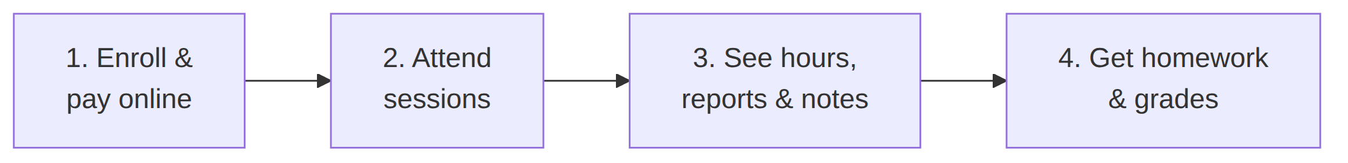
Figure 5 — A student’s journey through the system

9. Keeping data safe and private
On a shared spreadsheet, anyone who has the link can see — and change — everything. Ascend Now works the opposite way: each person signs in and only ever sees their own slice.
- A student can only see their own record — never another family’s.
- A teacher sees their own sessions and the students they work with.
- A coach sees the students assigned to them.
- Only the office sees the full picture.
Importantly, this isn’t just a matter of hiding menus. The rules are enforced deep in the system itself, so a person genuinely cannot reach data that isn’t theirs, even if they went looking. Family payment screenshots, personal details and reports are all kept private and shared only with the people who should see them.

10. The benefits at a glance
- Time saved. No more re-typing the same numbers between sheets; month-ends shrink from days to minutes.
- Fewer mistakes. One source of truth means the numbers can’t quietly disagree.
- No nasty surprises. Low-hour warnings mean renewals happen on time, not after a package empties.
- A professional image. Clean, branded invoices and reports go out consistently.
- Transparency for families. Parents and students can self-serve, which builds trust.
- Better teaching. Homework and progress notes live in one place, tied to each student.
- Peace of mind. Private, per-person logins keep everyone’s data safe.

11. In summary
The business didn’t just swap spreadsheets for a website. It changed the way information flows. A session is now recorded once, and the remaining hours, the alerts, the invoices, the reports and the teacher’s pay all follow automatically from that single fact. The office spends less time reconciling numbers and more time running the business; teachers spend less time on admin and more time teaching; and families get a clear, trustworthy view of their own progress.
That is the whole point of Ascend Now: less manual bookkeeping, fewer errors, and a calmer, more professional operation — all built around recording each session just once.

12. A few terms, explained simply
Term | In plain English
Package / pool | A block of hours a student has paid for in advance.
Session log | The record a teacher creates after a lesson — the single fact everything else is worked out from.
Performance Coach | An experienced teacher who also looks after a group of assigned students.
No-show | A missed lesson; handled with fair, consistent rules for pay and hours.
Renewal | Buying more hours when a package runs low.
Homework Generator | The AI-assisted tool that turns a lesson or a PDF into a question paper.
Dashboard | The screen each person sees when they log in, showing what’s relevant to them.
This is the plain-English companion to the full technical documentation. For the developer-facing detail — architecture, data model, and workflows — see Ascend Now — Technical Documentation.

