Ascend Now — Technical Documentation
Operations Data System for a Tutoring & College-Counselling Business
Sneha · B.Tech CSE, IGDTUW
19 July 2026
Table of Contents

Operations Data System for a Tutoring & College-Counselling Business A role-based web platform for logging tutoring sessions, tracking purchased-hour packages, generating invoices and reports, and producing AI-assisted homework — with database-enforced access control end to end.

Document control
Field | Value
Document title | Ascend Now — Technical Documentation
Version | 1.0
Status | Internship submission
Prepared by | Sneha · B.Tech CSE, IGDTUW (edit as needed)
Date | 19 July 2026
Repository | snehaa006/ascend-now
Audience | Future developers, reviewers, and maintainers of the system
Confidentiality | Internal — contains architecture detail, no secrets/credentials
On accuracy and sources. This document is a narrative + architectural reference written for a developer who was not here when the code was written. Where an exact, machine-verifiable fact is needed (a column type, an RLS policy, a live row count), the single source of truth remains the in-repo reference docs — chiefly db/docs/VERIFIED_DATABASE_STATE.md (regenerated by direct introspection of the live database), README.md (project status), and SYSTEM_WORKFLOW.md (plain-language walkthrough). This file explains how the pieces fit and why; those files hold the exhaustive detail.

1. Introduction

1.1 What this system is
Ascend Now is the internal operations platform for a tutoring and college-counselling business. It replaces spreadsheets and manual bookkeeping with a single web application where:
- Teachers and performance coaches log every tutoring session they run.
- Logged sessions automatically deduct hours from the student’s purchased package.
- Invoices and monthly reports build themselves from that session data.
- A Gemini-powered Homework Generator turns a session transcript or an uploaded PDF into a question paper that a student can attempt and be graded on.
- Every screen is gated by role-based logins whose real security boundary is enforced in the database, not the browser.

1.2 Purpose of this document
To give a developer joining the project a complete mental model of the system without needing to read all ~160 source files first: what the moving parts are, how data flows through them, which decisions were made deliberately (and why they might look surprising), and where to find authoritative detail when they need it.

1.3 Scope
This document covers the application architecture, data model, backend functions, key workflows, and engineering conventions. It does not reproduce the exhaustive column-by-column schema (that lives in db/docs/VERIFIED_DATABASE_STATE.md) nor a line-by-line API reference for every edge function (each function’s index.ts carries a detailed header comment — see §11).

1.4 At a glance
Metric | Value
Frontend pages | 63
React components | 59
Data hooks | 37
Supabase Edge Functions (Deno) | 19
Database tables | 46 (all with RLS enabled)
Migrations (single tracked system) | 86
User roles | 4 — admin, teacher, performance_coach, student
External AI provider | Google Gemini (homework generation & grading)

2. Product overview

2.1 The problem it solves
A tutoring business runs on a handful of facts that are painful to keep consistent by hand: who taught whom, for how long, against which purchased package, and what is owed as a result. Done in spreadsheets, these drift immediately — hours get double-counted, packages run out unnoticed, invoices disagree with the schedule. Ascend Now makes the session log the single input and derives everything else (hour balances, threshold alerts, invoices, monthly reports, payroll-style teacher-hour totals) from it automatically.

2.2 One-sentence pitch
“Coaches log sessions, hours get deducted from a student’s purchased package automatically, invoices and monthly reports generate themselves from that data, and a Gemini-powered homework generator turns a session or an uploaded PDF into a paper the student can attempt and get graded on — all behind role-based logins with database-enforced access control.”

2.3 Capability map
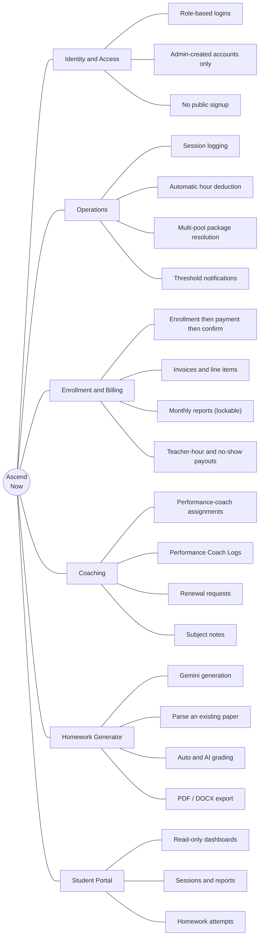
Figure 1 — Capability map

2.4 Design principles that shaped the build
- The database is the boundary. Client-side role checks are a UX convenience; Postgres Row-Level Security (RLS) is the real access control. If you deleted the React app and hit the database with a student’s token, they still could not read another student’s data.
- One input, derived outputs. A session log is a diary entry; hours, alerts, invoices and reports fall out of it via triggers and edge functions, not manual re-entry.
- No public signup. Every account is created by someone already inside the system, keeping the roster exactly matching real students and employed staff.
- Docs are load-bearing. The repo keeps a live-verified schema doc and per-feature architecture docs in lockstep with the code (see CLAUDE.md); this discipline exists because an earlier schema/doc drift produced a 63-file migration mess that had to be consolidated away.

3. Stakeholders & roles

3.1 Actor / stakeholder map
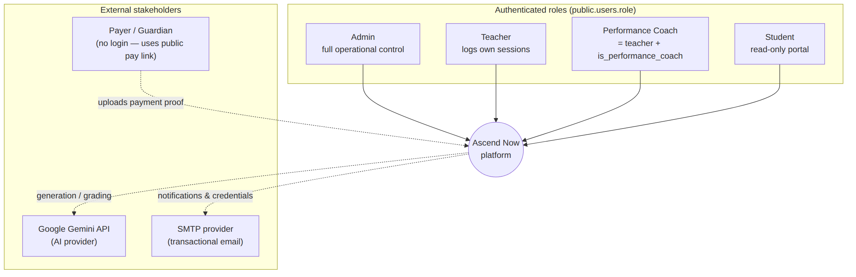
Figure 2 — Actor / stakeholder map

3.2 Role responsibilities
Role | user_role value | Primary responsibilities | Access boundary
Admin | admin | Full CRUD on teachers, students, sessions; enrollment review; monthly reports; settings; analytics | is_admin() → ALL on every table
Teacher | teacher | Log own sessions, manage own subjects, upload Zoom invoices, generate homework | Scoped to my_teacher_id(); own rows only
Performance Coach | performance_coach | Everything a teacher does plus managing assigned students, renewal requests, coordinator logs, coach profile | Scoped through pc_student_assignments and is_performance_coach()
Student | student | Read-only: package balance, reports, session history, homework attempts | can_view_student() → own record only
Key modelling decision. A Performance Coach is not a separate account type — it is a teachers row with is_performance_coach = true. In this business a coach is always a teacher first, so one table and one flag model both, rather than a separate coaches table. A trigger (sync_teacher_pc_role()) keeps users.role in step with the flag. There is no parent role — a former parent/guardian portal was merged into the student dashboard on 2026-07-07; the guardian’s name and phone are now plain fields on the student’s own record.

4. Use cases

4.1 Use-case diagram
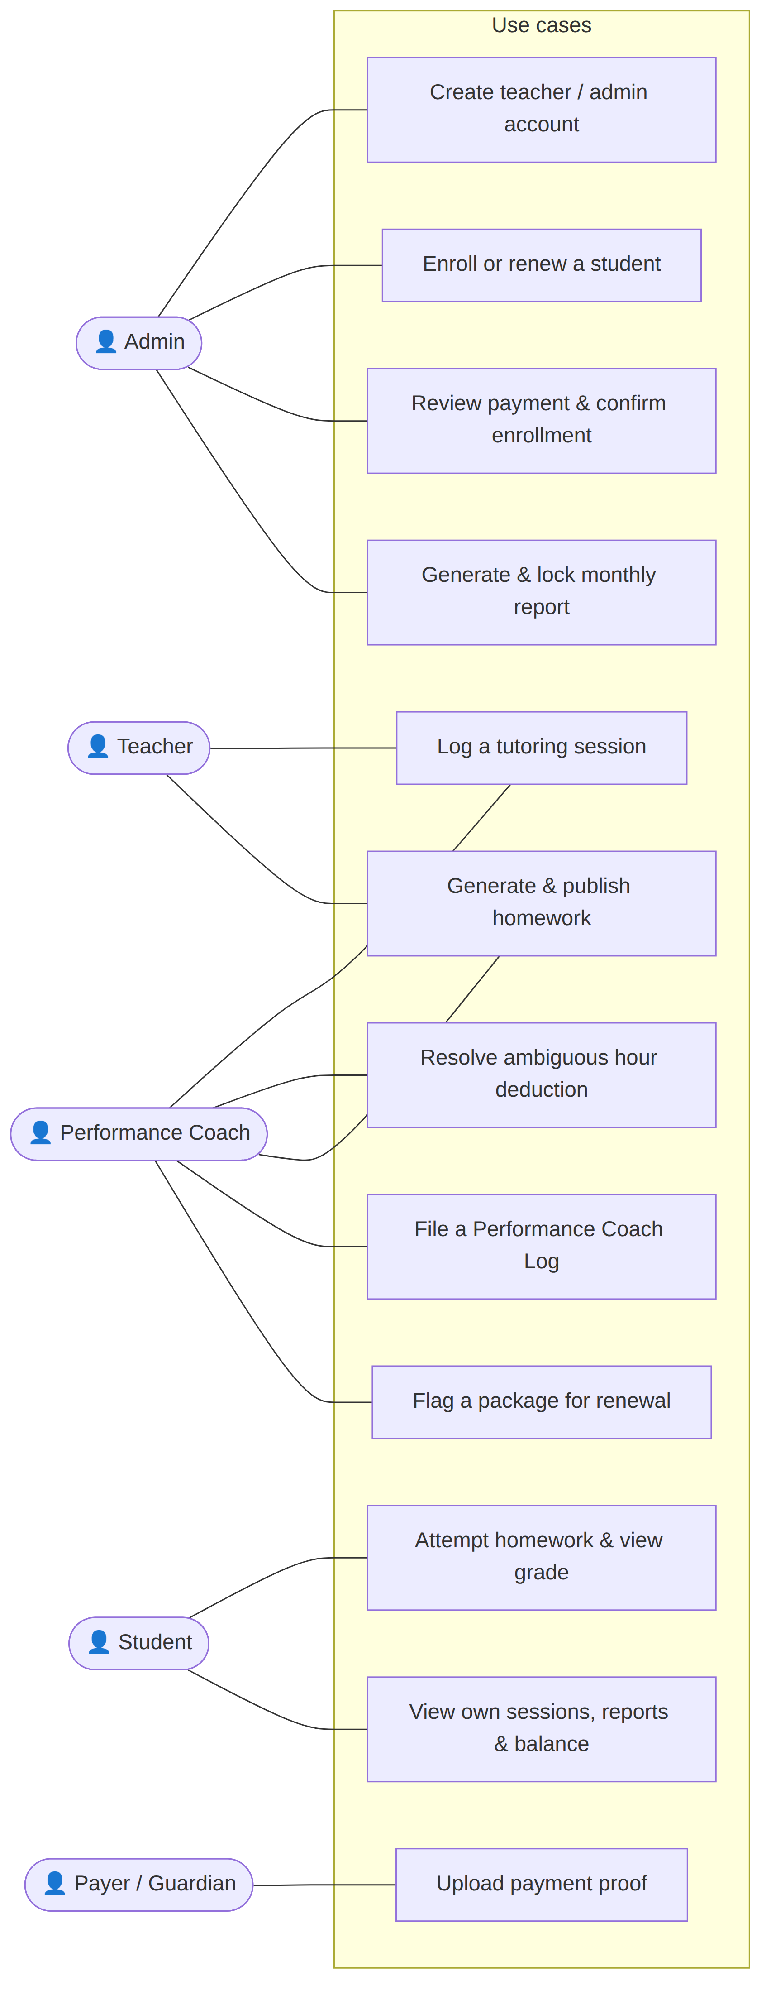
Figure 3 — Use-case diagram

4.2 Selected use-case narratives
UC-04 — Log a tutoring session (primary actor: Teacher / PC)
Pre-conditions | Actor is logged in; student exists with an active package
Main flow | Actor opens the session-log form → picks student, program type, subject, duration → pastes Fathom-derived notes → submits
System reaction | One session_logs row is written; a BEFORE trigger links it to the correct unlocked package and deducts the hours; threshold and pool-issue edge functions fire as needed
Alternate flows | No-show variants (No Show 1/2/+) behave differently for billing/payout; a multi-pool student may leave the session pool_ambiguous for a coach to resolve
Post-conditions | Student’s hour balance updated; coach notified if a threshold crossed
UC-06 — Generate & publish homework (primary actor: Teacher / PC)
Pre-conditions | A student is selected; a content source exists (session transcript, uploaded PDF, or an existing paper to parse/clone)
Main flow | Actor builds a composition (e.g. 10× MCQ + 5× Short Answer) → “Generate draft” → reviews the Answer/Question sheets → “Confirm & Publish”
System reaction | generate-homework-paper calls Gemini per block, writes questions_json; publishing emails the student
Post-conditions | Paper appears on the student’s dashboard; grades stay hidden until the teacher explicitly publishes them

5. System architecture
Ascend Now is a single-page application (SPA) that talks directly to a managed Postgres database for everything RLS can safely gate, and to serverless edge functions for anything that needs a privileged key or an external API call. There is no bespoke application server in between.

5.1 Logical architecture
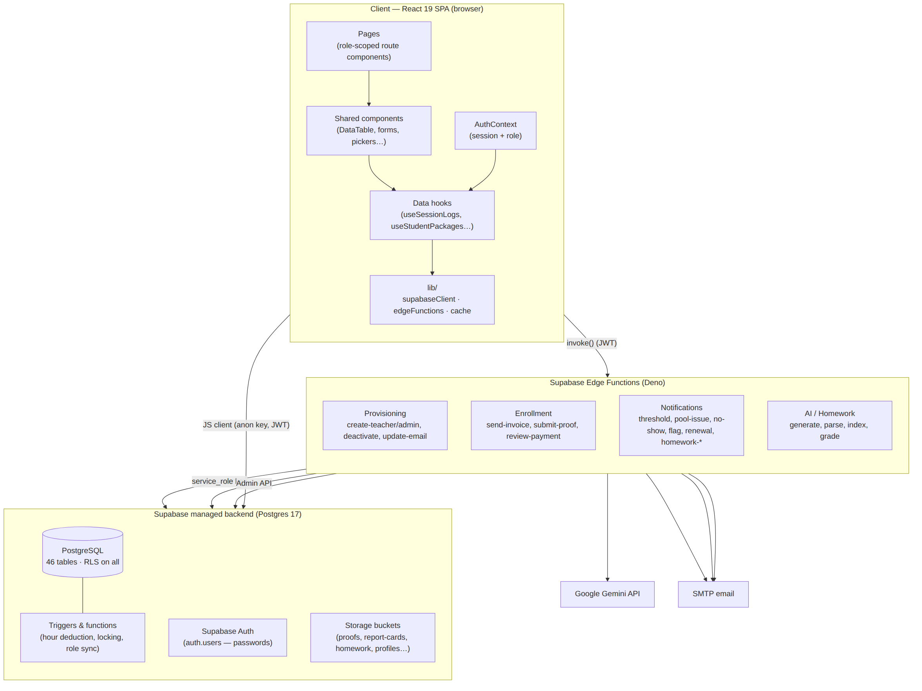
Figure 4 — Logical architecture
Reading the diagram. The browser holds only the anon key and the logged-in user’s JWT; every direct database call is filtered by RLS as that user. Anything requiring the service_role key (which bypasses RLS) or an external secret (Gemini, SMTP, the Auth Admin API) is isolated in an edge function that the browser can only invoke, never inspect.

5.2 Physical / deployment architecture
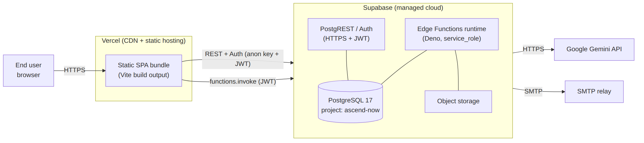
Figure 5 — Physical / deployment architecture
- Frontend hosting: Vercel deploys the static Vite build automatically on push to the default branch. Configuration is vercel.json + VITE_* environment variables.
- Backend hosting: Supabase (managed Postgres 17 + Auth + Edge Functions + Storage).
- Out-of-band operations: Migrations and edge-function deploys are applied through the Supabase CLI / MCP, not through CI — a known operational detail (a stale frontend deploy, not missing code, is the usual cause when the live site behaves like an older version).

5.3 Technology stack
Layer | Choice | Notes
Language | TypeScript | Frontend + Deno edge functions
UI framework | React 19 (Vite) | SPA, function components + hooks
Styling | Tailwind CSS | Brand scale (navy, lime, sky) in tailwind.config.js
Routing | React Router v7 | Every page has its own URL; role-gated via ProtectedRoute
Backend / DB | Supabase (PostgreSQL 17) | Direct JS-client access under RLS
Auth | Supabase Auth | Owns all password hashing/verification
Serverless | Supabase Edge Functions (Deno) | Privileged operations & external APIs
Charts | Recharts | Admin analytics dashboard
Documents | docx, jspdf + jspdf-autotable | Word summaries; invoice/report PDFs
Markdown/Math | react-markdown, remark-gfm, remark-math, rehype-katex, katex | Homework paper rendering (incl. LaTeX)
PDF rasterization | pdfjs-dist | Client-side page→image for figure cropping
AI | Google Gemini API | Homework generation, parsing, indexing, grading
Hosting | Vercel (frontend) + Supabase (backend)

5.4 Security architecture (defence in depth)
Security is layered, and the layers are deliberately not interchangeable:
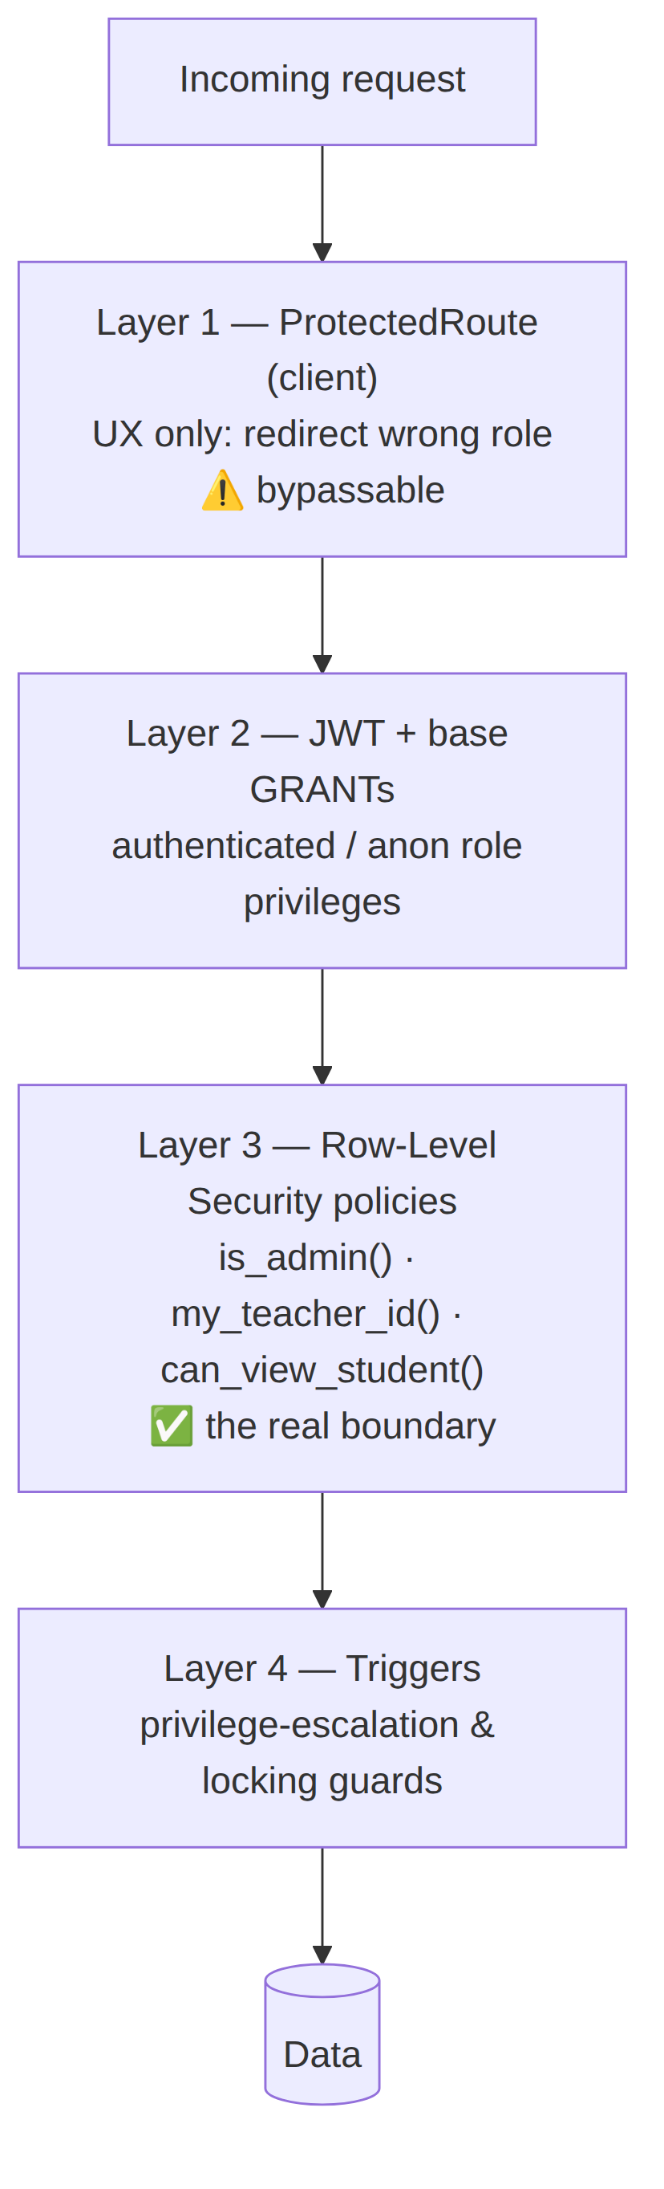
Figure 6 — Security: defence in depth
Key points a maintainer must internalise:
- ProtectedRoute is not security. Its own source says so — it only prevents a wrong-role dashboard from flashing. The comment in src/components/ProtectedRoute.tsx is explicit about it.
- RLS only works on top of base GRANTs. A correct policy still yields permission denied if the role was never granted base table access — a real bug the project hit on zoom_invoices (twice: missing table grant, then missing sequence USAGE) and on service_role for the whole enrollment workflow. The lesson is recorded in db/README.md and db/docs/DEBUGGING_HISTORY.md.
- service_role bypasses RLS but not base grants. Every new edge function that is the first to touch a table must be granted on it explicitly.
- Triggers backstop the policies. prevent_self_privilege_escalation() blocks a user changing their own role/is_active; prevent_non_admin_student_relink() blocks re-pointing a student’s login; locking triggers freeze session logs inside a locked reporting month and block edits to locked invoices/reports/packages.
- The service_role key never reaches the browser. It lives only in edge-function secrets.

6. Data architecture (database schema)
The full, introspection-verified schema — every column, constraint, policy, function and trigger — is in db/docs/VERIFIED_DATABASE_STATE.md. This section gives the shape and the relationships, grouped by domain, so the model is legible at a glance.

6.1 Domain map
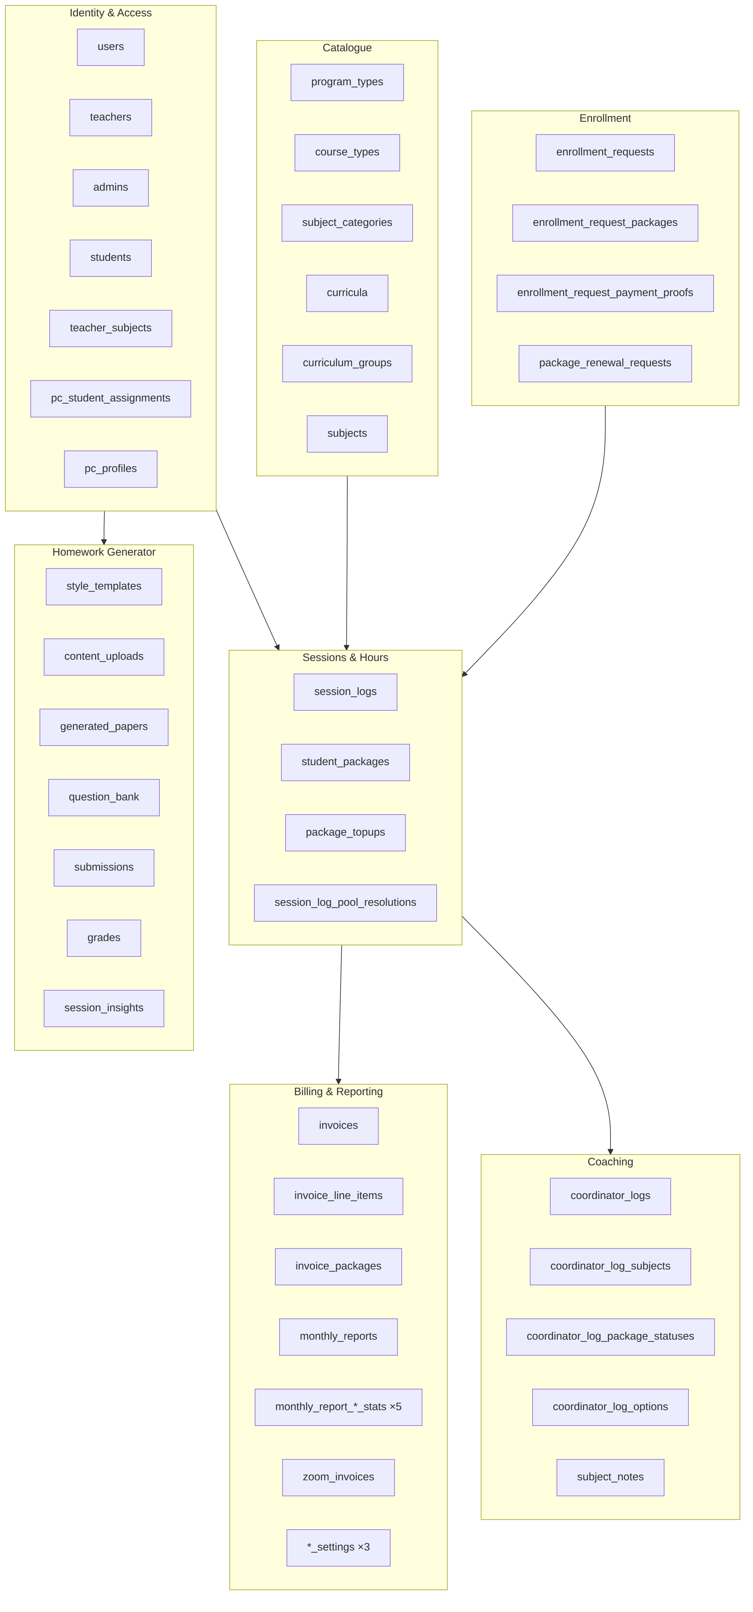
Figure 7 — Data domain map

6.2 ER diagrams by domain
A single ER diagram of 46 tables is unreadable, so the model is shown per domain. Cardinality is Crow’s-foot (|| = exactly one, o{ = zero-or-many).
Identity & access
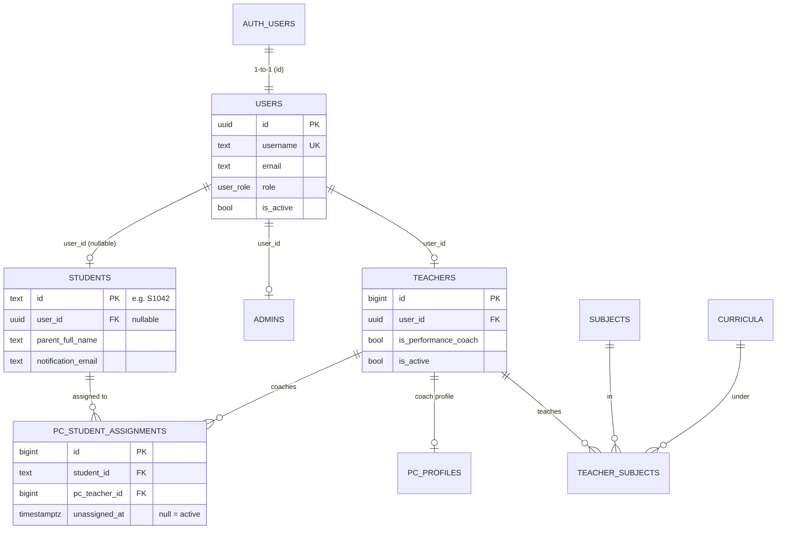
Figure 8 — ER: Identity & access
Sessions, packages & catalogue (the operational core)
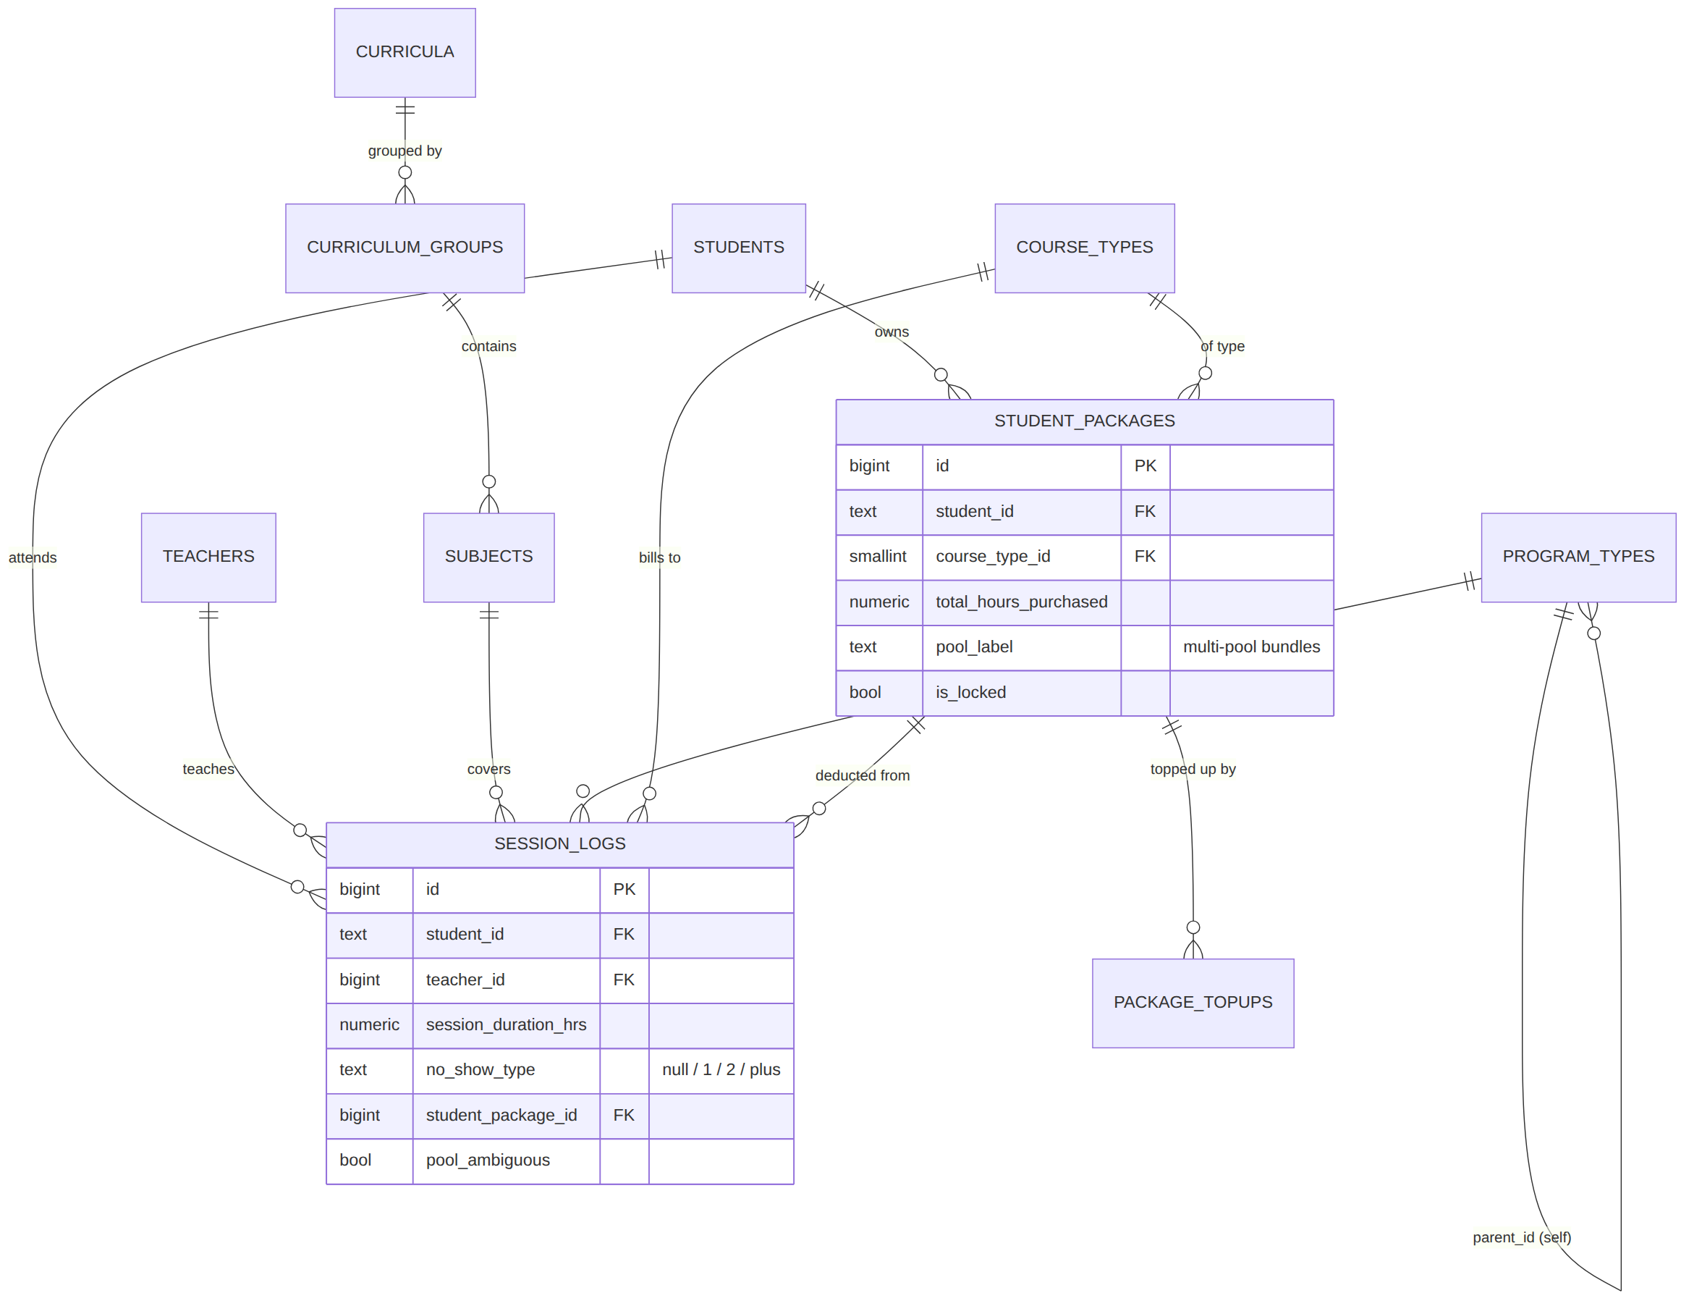
Figure 9 — ER: Sessions, packages & catalogue
Enrollment & billing
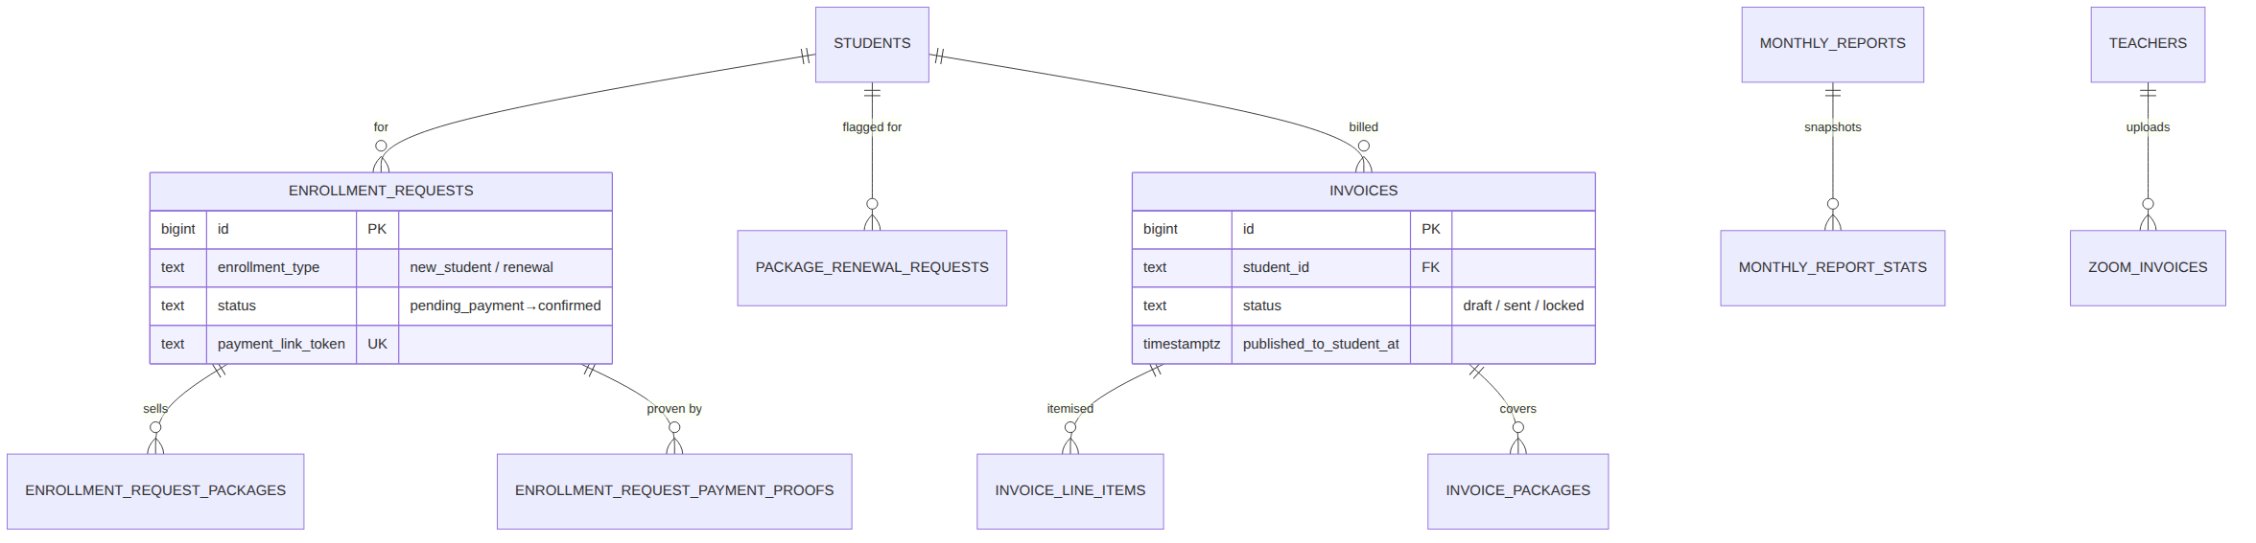
Figure 10 — ER: Enrollment & billing
Homework Generator
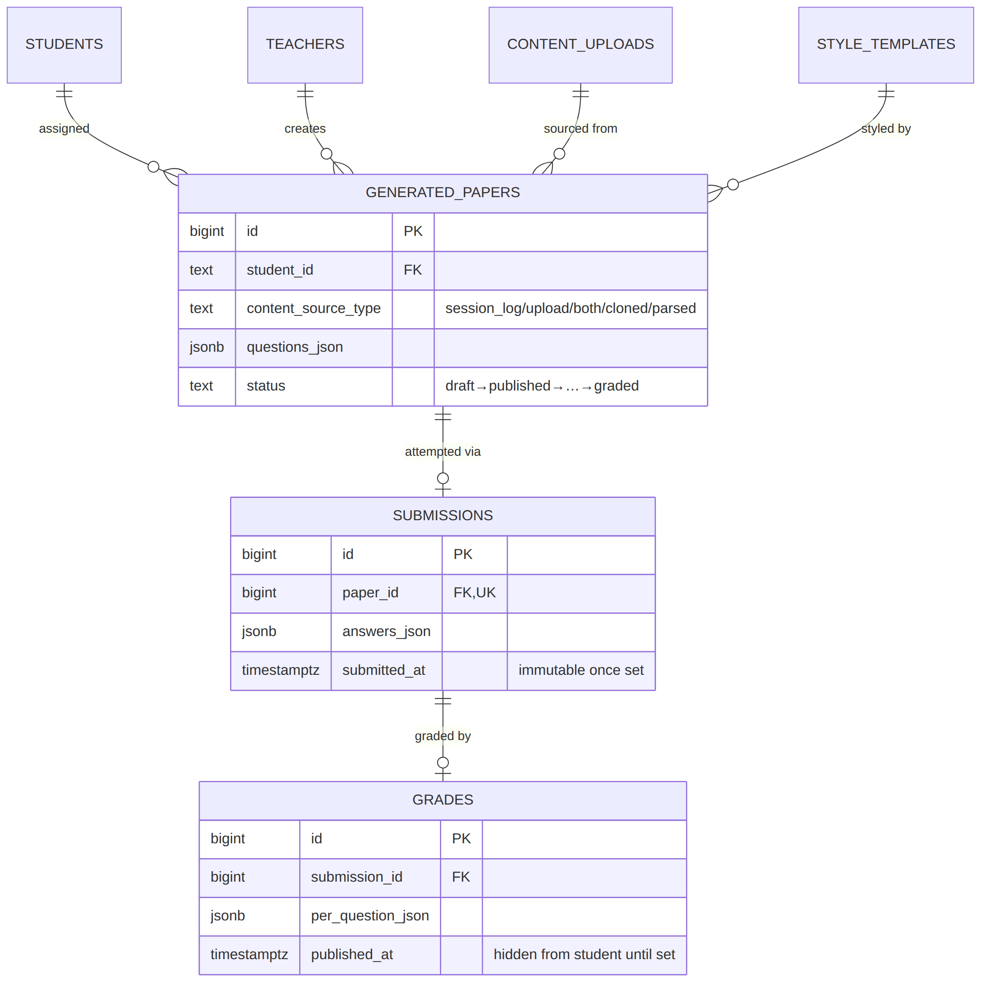
Figure 11 — ER: Homework Generator

6.3 Table catalogue
The 46 tables, grouped by domain (see db/docs/VERIFIED_DATABASE_STATE.md for full column detail):
Domain | Tables
Identity & access | users, teachers, admins, students, teacher_subjects, pc_student_assignments, pc_profiles
Catalogue | program_types (self-hierarchical), course_types, subject_categories, curricula, curriculum_groups, subjects
Sessions & hours | session_logs, student_packages, package_topups, session_log_pool_resolutions
Billing & reporting | invoices, invoice_line_items, invoice_packages, monthly_reports + monthly_report_{teacher,student,teacher_subject,student_subject,subject}_stats, zoom_invoices, no_show_settings, session_duration_settings, bundle_pool_settings
Enrollment | enrollment_requests, enrollment_request_packages, enrollment_request_payment_proofs, package_renewal_requests
Homework Generator | style_templates, content_uploads, generated_papers, question_bank, submissions, grades, session_insights
Coaching | coordinator_logs, coordinator_log_subjects, coordinator_log_package_statuses, coordinator_log_options, subject_notes
Enum types: user_role (admin/teacher/performance_coach/student), engagement_rating (low/medium/high).
Notable constraints & conventions: - Dates are stored as one real DATE column, never split into year/month/day (month/year derived at query time) — avoids drift. - session_duration_hrs must round to 0.25-hour (15-minute) increments (CHECK constraint). - No password column exists anywhere — Supabase Auth (auth.users) owns all credentials. - students.id is a human-readable text key ('S' || nextval(...), e.g. S1042). - One-active-per-partial-index patterns: one active coach per student (pc_student_assignments … WHERE unassigned_at IS NULL); one unlocked package per course type (student_packages … WHERE NOT is_locked).

6.4 Row-Level Security model
RLS is enabled on all 46 tables. The pattern is consistent:
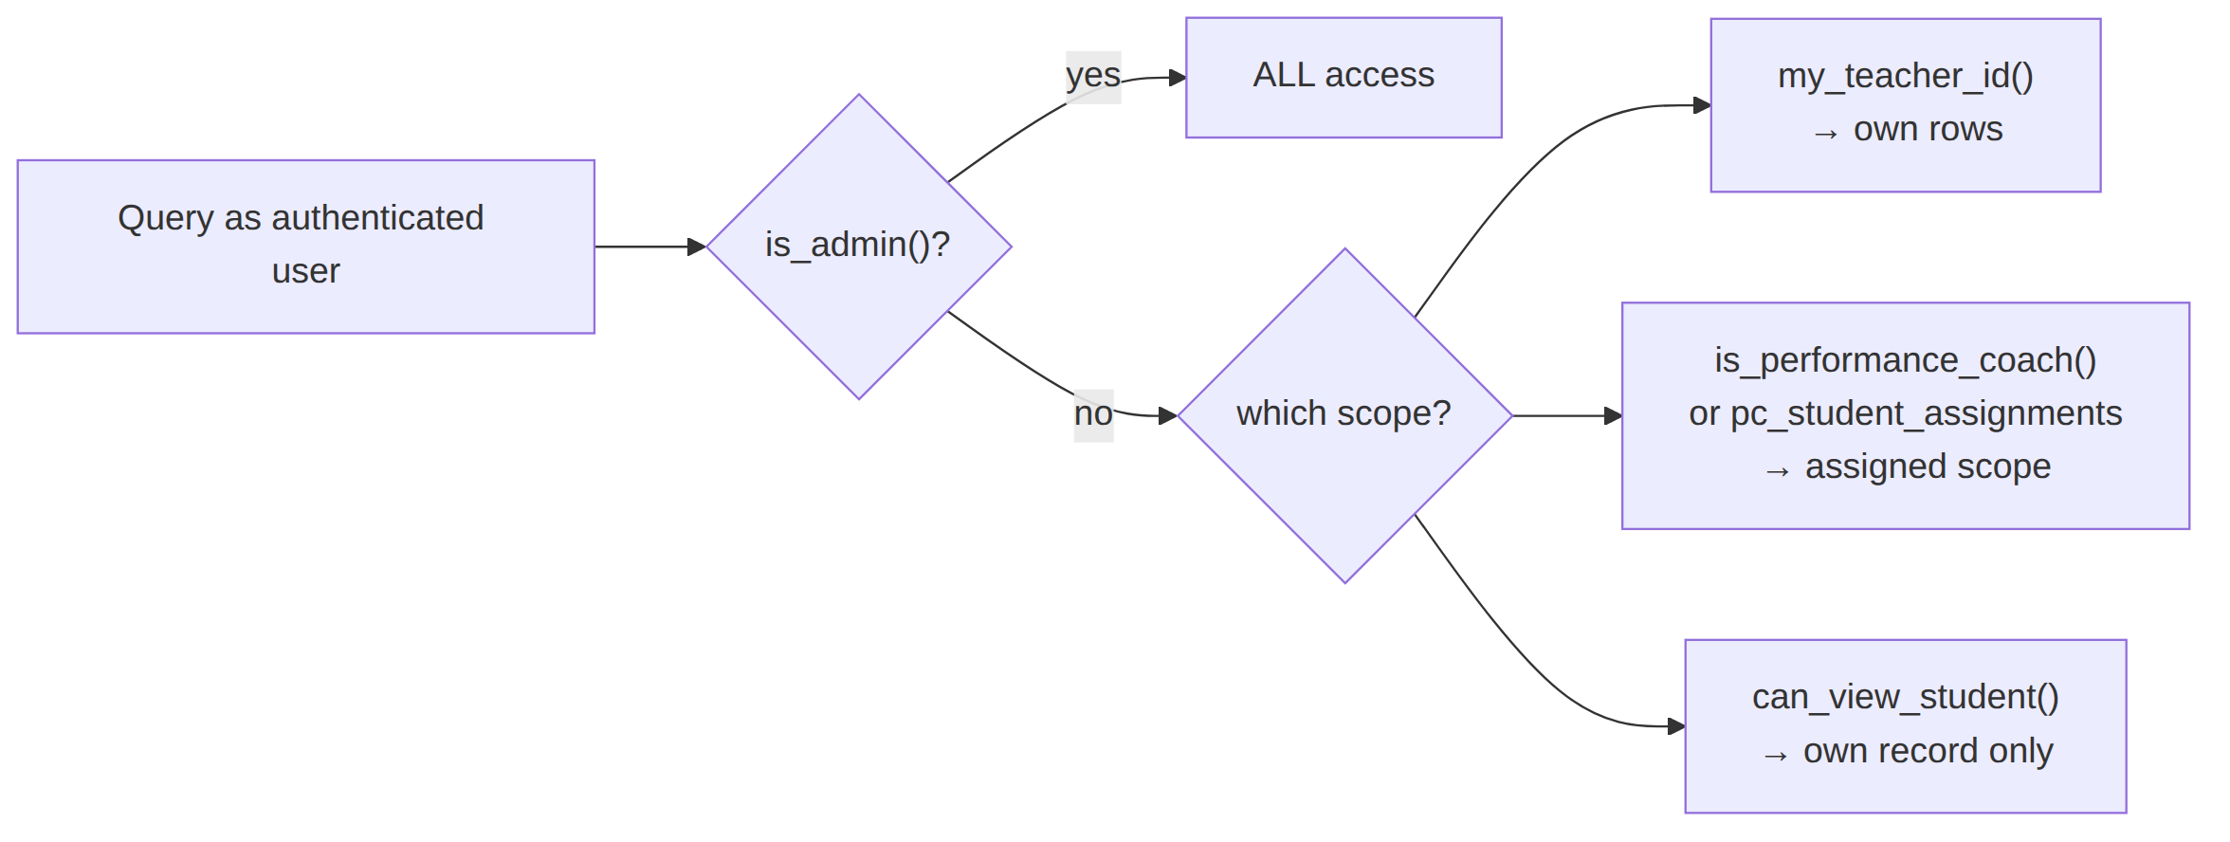
Figure 12 — Row-Level Security access model
Helper functions (all SECURITY DEFINER) that back the policies:
Function | Returns | Used for
is_admin() | bool | Full-access gate on every table
is_performance_coach() | bool | Coach-wide read/write on operational tables
my_teacher_id() | bigint | “My own rows” scoping for teachers
can_view_student(id) | bool | Student reads only their own record
get_email_for_username(u) | text | Pre-auth username→email resolution for login
The username→email resolver is SECURITY DEFINER on purpose: at login time nobody is authenticated yet, so a normal RLS-filtered read would return nothing. This narrow function only ever returns an email, never a full row.

7. Frontend structure

7.1 Folder layout
src/
├── App.tsx # Route table (role-gated via ProtectedRoute)
├── main.tsx # React entry
├── context/AuthContext.tsx # Session + profile (role) provider
├── lib/ # supabaseClient · edgeFunctions · cache
├── pages/ # Route components, grouped by role
│ ├── admin/ (33 pages)
│ ├── teacher/ (19 pages)
│ └── student/ ( 8 pages)
├── components/ # Reusable UI + feature components
│ ├── ui/ # Button, Card, DataTable, inputs, dialogs…
│ ├── sessionLogs/ # Shared list/detail/form views
│ ├── students/ homework/ coordinatorLogs/ notes/ pc/ portal/ …
├── hooks/ # 37 data hooks (one per table/feature area)
├── utils/ # Pure helpers (PDF/DOCX build, dates, grading…)
├── types/database.ts # TS types mirroring the DB schema
└── data/ # Static reference data (countries, dial codes)

7.2 Routing map
Routing is fully role-partitioned. ProtectedRoute allowedRoles={[…]} wraps every route and redirects a mismatched role to its own dashboard.
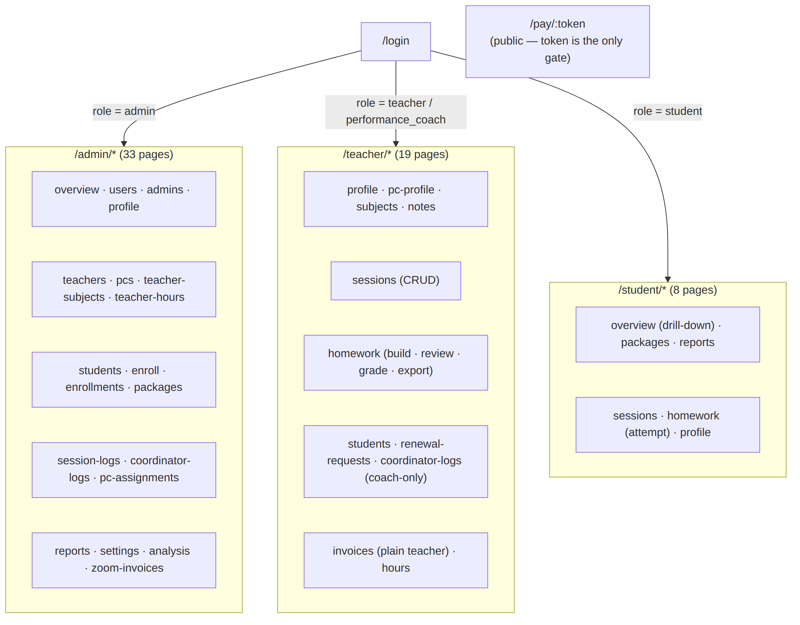
Figure 13 — Frontend routing map
The complete route→purpose table lives in README.md §3; src/App.tsx is the authoritative source.

7.3 Component & data patterns
- AuthContext loads the public.users row on session change and exposes role, which drives every redirect and permission check. It deliberately ignores redundant Supabase auth events (tab focus / token refresh) for the same user, so long forms don’t reload underneath the user.
- Data hooks (useSessionLogs, useStudentPackages, useInvoices, …) encapsulate all Supabase queries for a feature area and are reused across role pages. The same list/detail/form components back both the admin and teacher/PC versions of a screen (e.g. SessionLogsListView / SessionLogFormView), differing only by props (scoping, extra columns, edit permissions) — one implementation, not a per-role copy.
- invokeEdgeFunction wraps supabase.functions.invoke with automatic 401 → session-refresh → retry, falling back to a clean re-login if the session is truly dead.
- UI copy is deliberately minimal — a project convention (see CLAUDE.md): a clickable row shows it’s clickable through affordances, not a text hint.

8. Backend — edge functions
Edge functions (Deno, running on Supabase) exist for exactly three reasons a browser can’t safely handle itself: the service_role key (bypasses RLS), the Auth Admin API (creating logins), and external secrets (Gemini, SMTP). There are 19, grouped by concern:
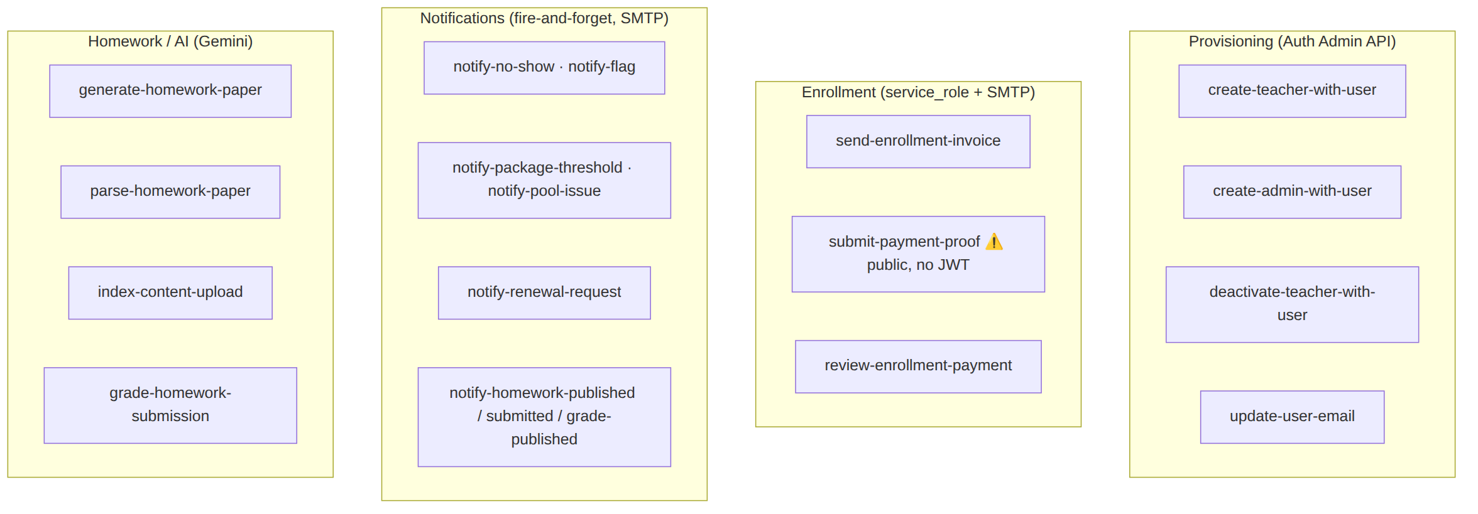
Figure 14 — Edge functions by concern
Function | JWT | Purpose (summary)
create-teacher-with-user | ✅ | Atomically create Auth account + users + teachers + teacher_subjects; email credentials
create-admin-with-user | ✅ | Same shape for an admin account
deactivate-teacher-with-user | ✅ | Deactivate a teacher/coach (refuses a coach still holding active assignments)
update-user-email | ✅ | Change email in auth.users + public.users + teachers in one shot (keeps login in sync)
send-enrollment-invoice | ✅ | Email the invoice + /pay/:token link
submit-payment-proof | ❌ public | Token-gated proof upload — the only function with no JWT check, by design
review-enrollment-payment | ✅ | Confirm (create student/login/package or top-up) or reject; auto-closes matching renewal requests
notify-* (7) | ❌ | Fire-and-forget transactional emails (thresholds, pool issues, no-shows, flags, renewals, homework lifecycle)
generate-homework-paper | ✅ | Gemini generation per composition block; dedup vs question_bank
parse-homework-paper | ✅ | Transcribe an uploaded existing paper verbatim + build the answer key
index-content-upload | ✅ | Ask Gemini for a PDF’s chapter→section outline so generation can be scoped
grade-homework-submission | ✅ | Auto-grade objective questions, Gemini-grade subjective per mark-scheme point
Each function’s index.ts opens with a detailed header comment documenting its request shape, required secrets, deploy command, and any non-obvious scope decisions (see §11 for the convention).

9. Core workflows (sequence diagrams)

9.1 Login (username-based, Auth-verified)
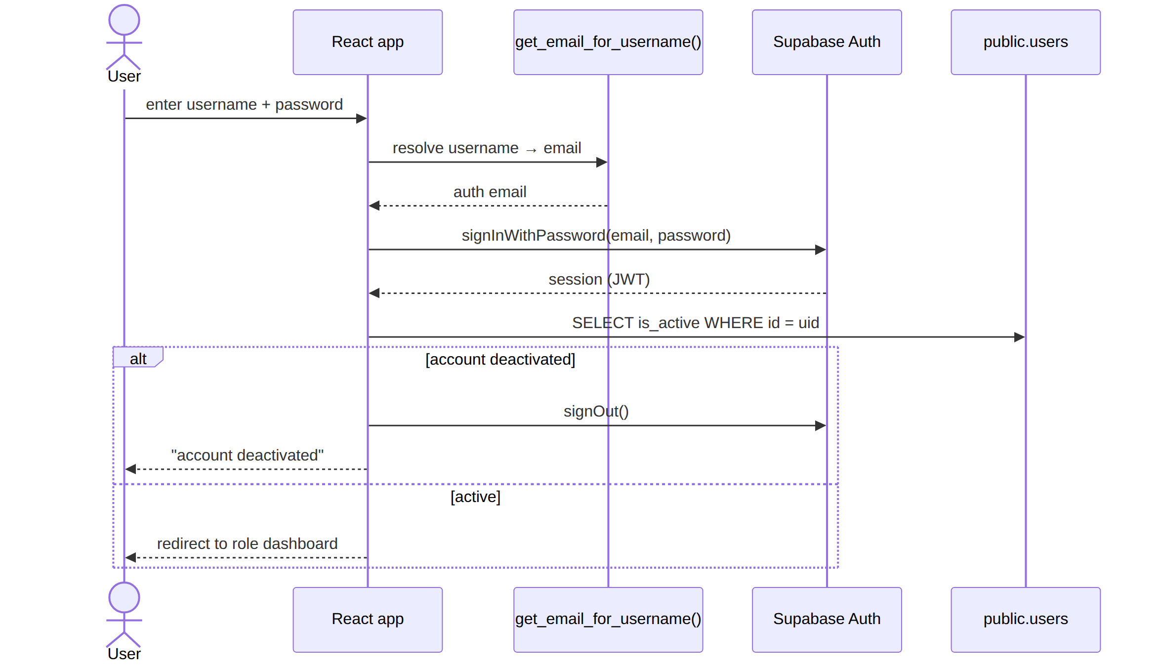
Figure 15 — Login sequence

9.2 Student enrollment → payment → confirmation
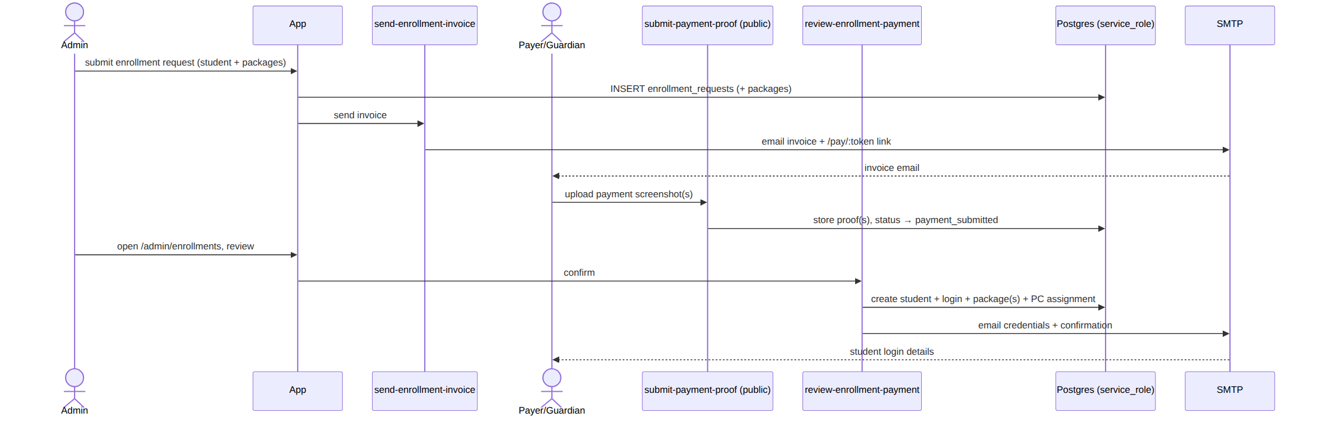
Figure 16 — Enrollment → payment → confirmation

9.3 Session logging → automatic hour deduction → alerts
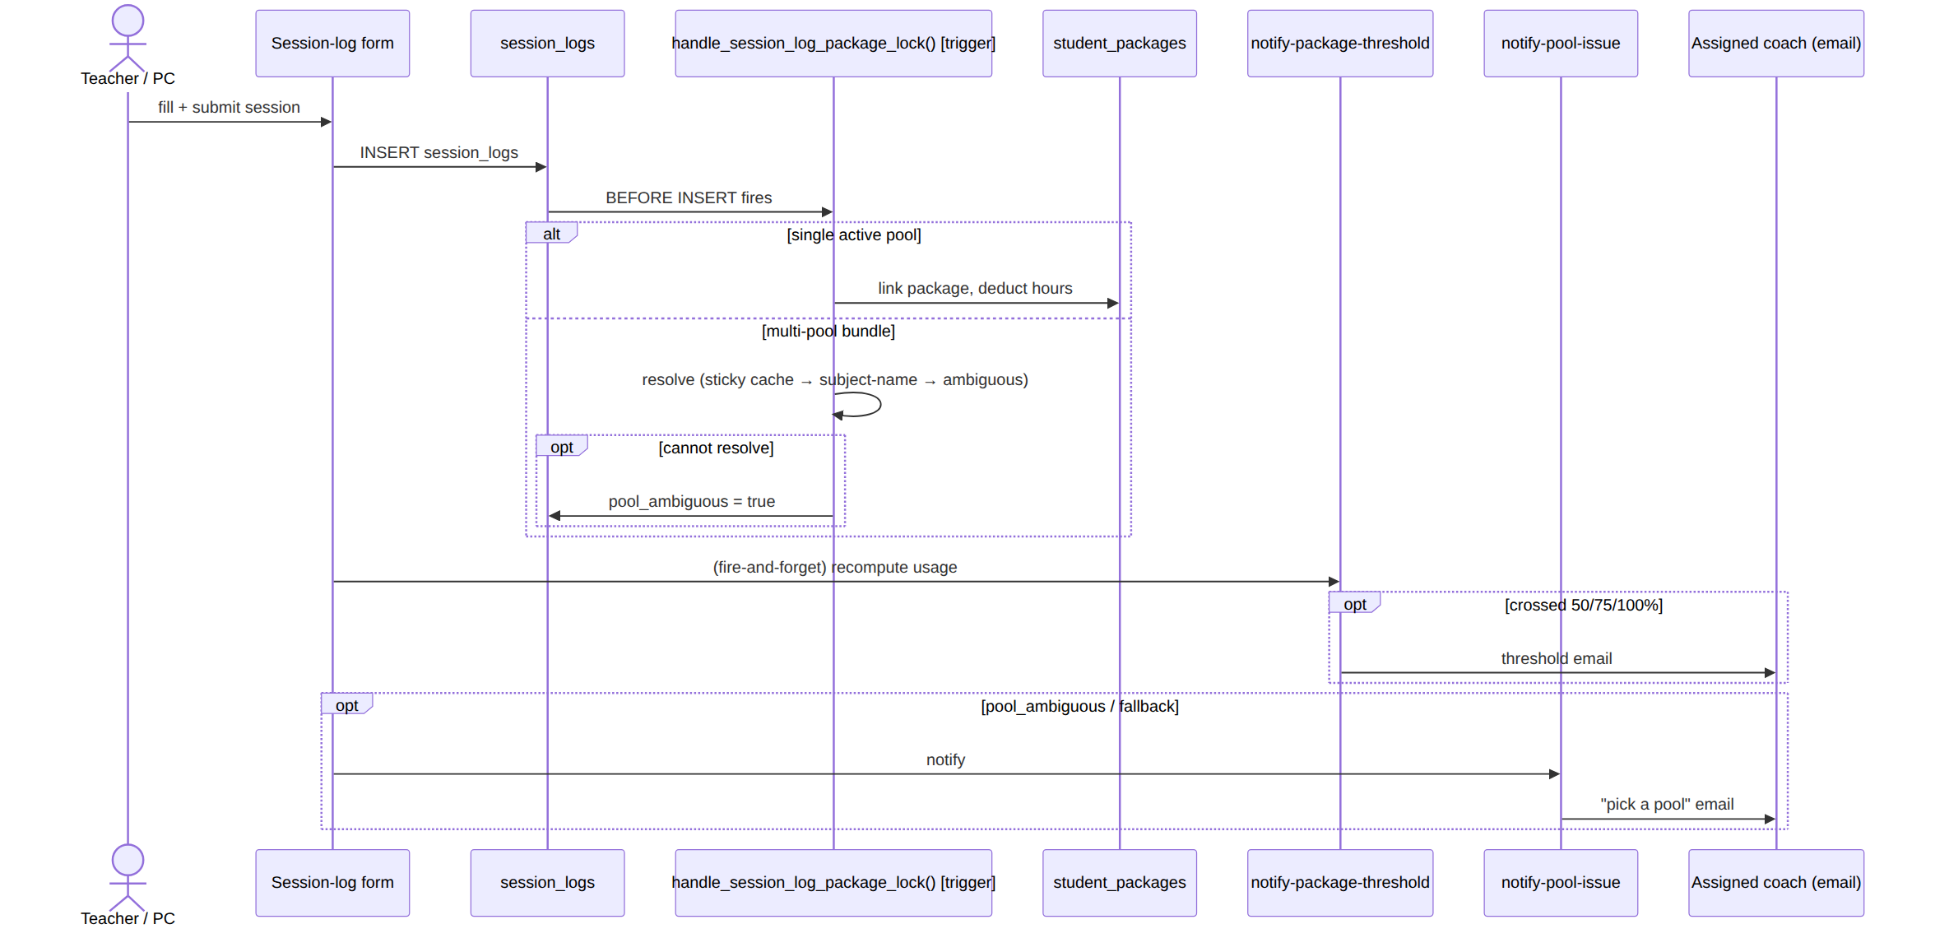
Figure 17 — Session logging → hour deduction → alerts

9.4 Homework: generate → attempt → grade → publish
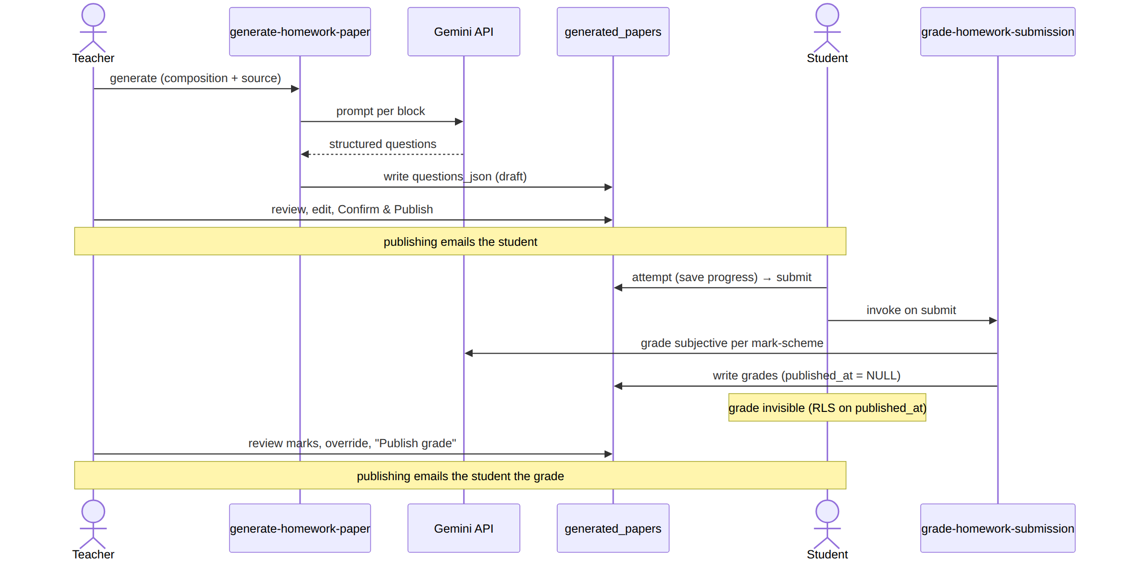
Figure 18 — Homework: generate → attempt → grade → publish

9.5 Monthly reporting (state machine)
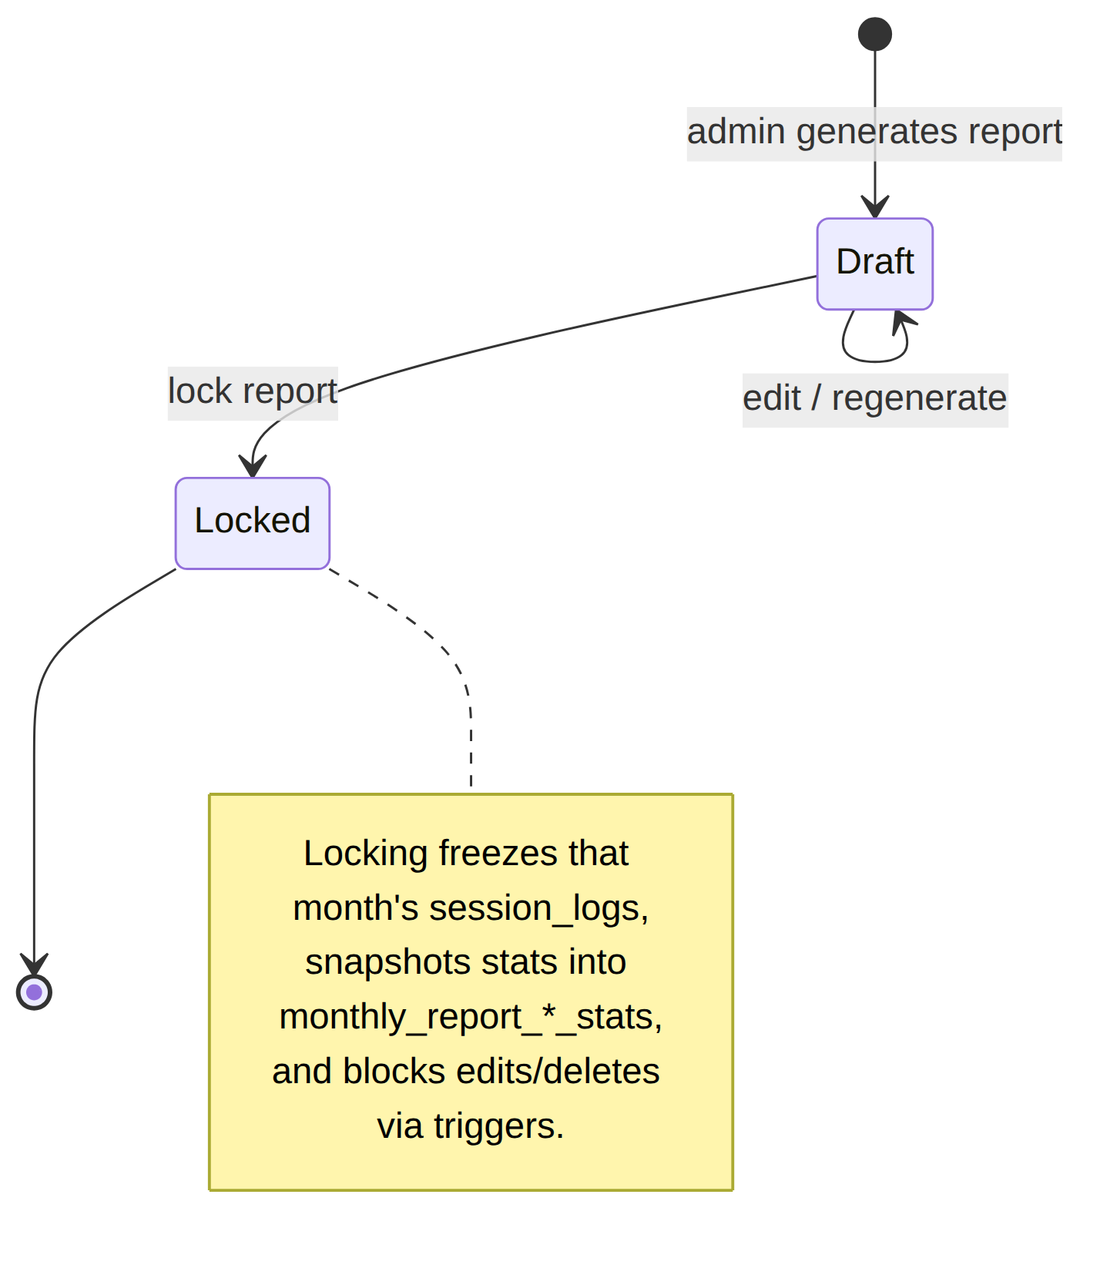
Figure 19 — Monthly reporting state machine

10. Feature deep-dives

10.1 Hours & revenue logic — two independent counters
Every session feeds two separate calculations that are easy to conflate:
- Teacher hours — “how much has this teacher taught.” Summed for every non-no-show session, ignoring student/package entirely (fetchTeacherPeriodDetail). Powers payroll-style reports.
- Student package hours (“Monthly Revenue” in the UI) — “how many purchased hours has this student used.” Counted only when a session has both a student_id and a matching course_type_id (computeHoursUsed).
“Monthly Revenue” is a count of billable hours, not currency — there is no price/rate anywhere in the schema yet. See db/docs/HOURS_AND_REVENUE_LOGIC.md.
No-show variants are the subtle part:
No-show type | Pays teacher? | Deducts student hour?
No Show 1 | ❌ | ❌
No Show 2 | ✅ (fixed rate) | ❌
No Show + | ✅ (fixed rate) | ✅ (admin-default duration)

10.2 Multi-pool package resolution
A Foundation Program / All-In-One student holds several concurrent pools of the same course type. When they log a Beyond Academic session, which pool should it deduct from? Subject alone often can’t say. The handle_session_log_package_lock() trigger resolves it without ever blocking the save:
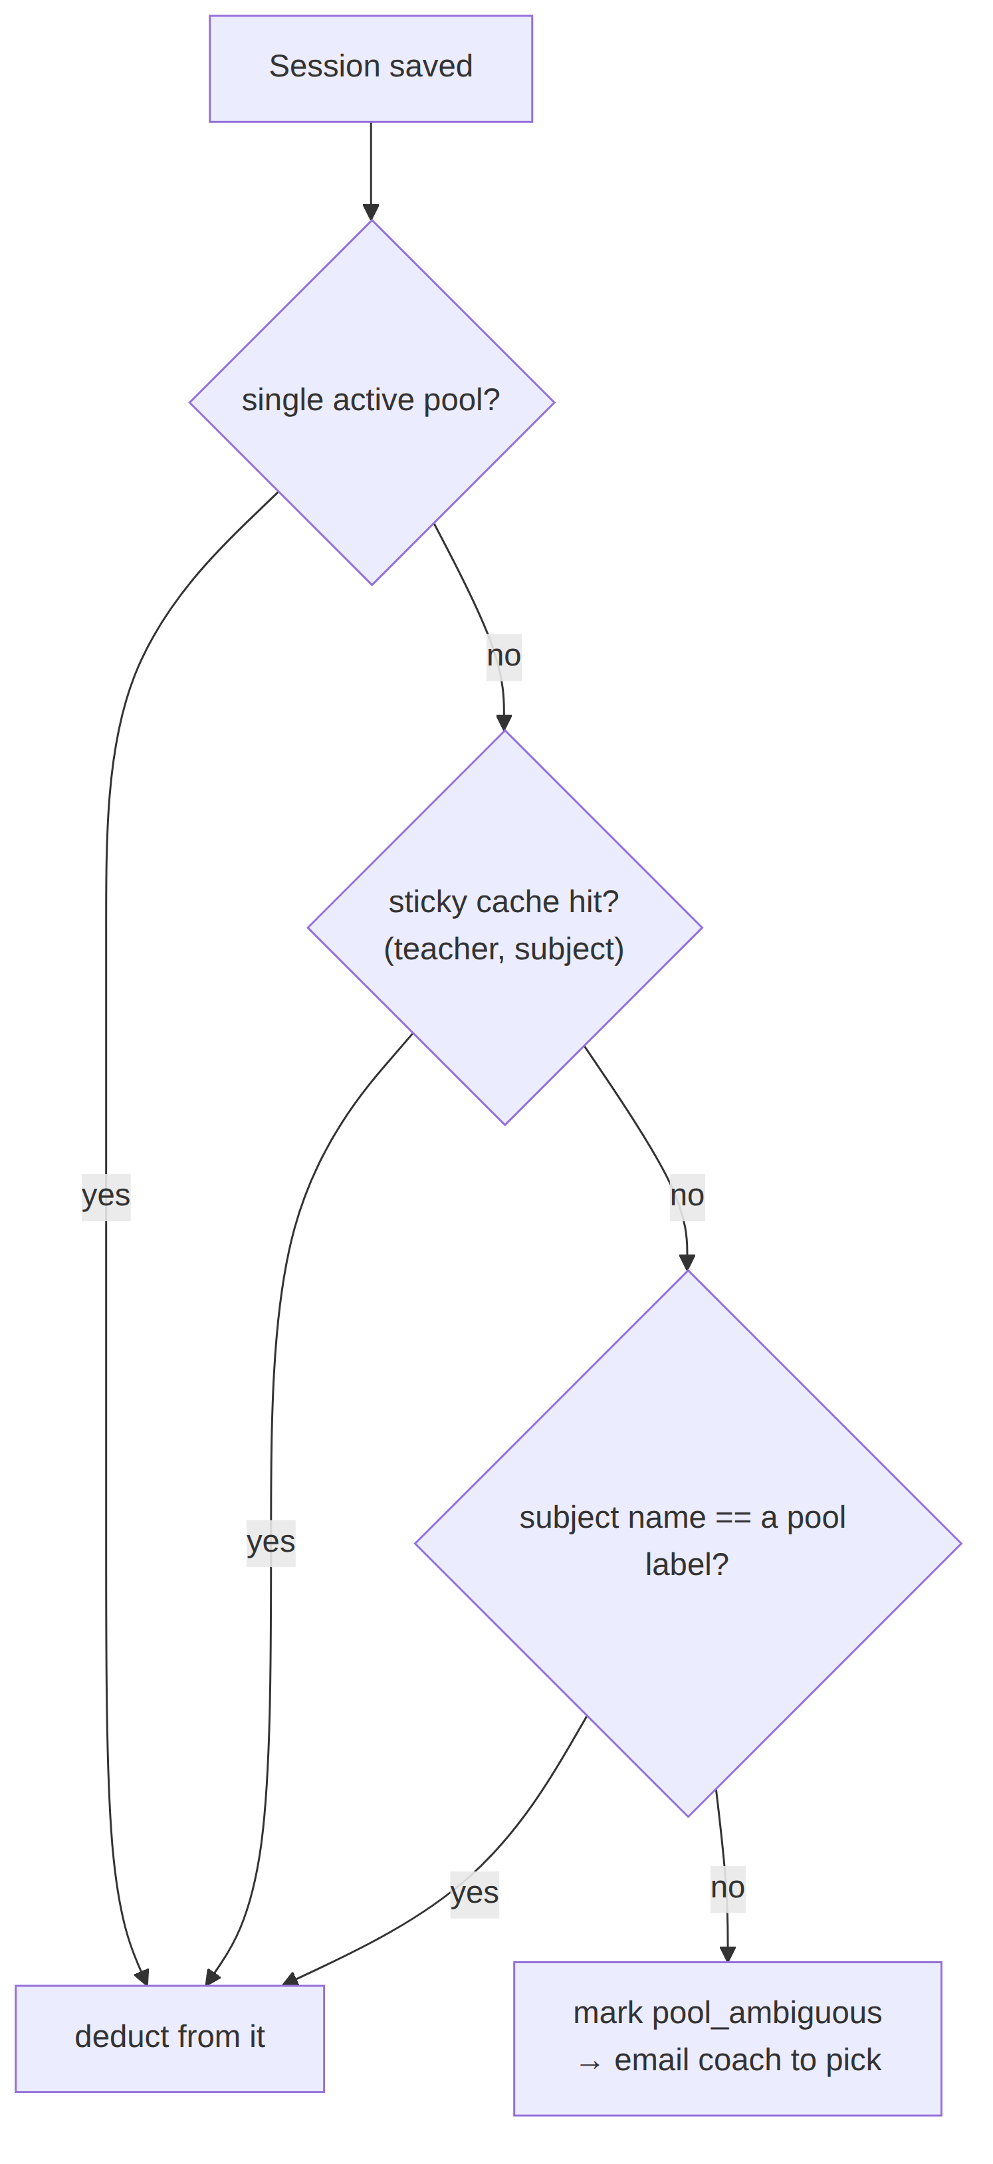
Figure 20 — Multi-pool package resolution
The sticky cache (session_log_pool_resolutions) is checked before the subject-name match so a coach’s manual reassignment isn’t silently reverted; and once a session is already deducted, later unrelated edits never re-run resolution. Full history of this (and the two ordering bugs that motivated it) is in db/README.md.

10.3 Homework Generator (the only place an LLM is in the write path)
An eight-phase, from-scratch subsystem. A teacher picks a student and a content source — a session transcript, an uploaded PDF (auto-indexed into chapters/sections), an existing paper to parse verbatim, or another paper to clone — composes a question mix, and generates via Gemini. The paper flows through review → publish → attempt → auto/AI-grade, and grading always ends with a human teacher’s sign-off: grades are invisible to the student (RLS on grades.published_at) until the teacher clicks Publish grade. Objective questions auto-grade; subjective ones are Gemini-graded per mark-scheme point (degrading to “pending teacher review” if no key is configured). PDFs and photos of hand-worked answers are never AI-graded — the teacher marks them by dropping comment pins directly on the image. Full design and phase status: db/docs/HOMEWORK_GENERATOR_ARCHITECTURE.md.

10.4 Performance Coach Logs
A coach files periodic per-student check-ins (goals, progress, ratings, renewal signals). It is append-only — each save is a new dated row prefilled from the latest, keeping full history — and admin + coach only (enforced by RLS scoped through pc_student_assignments). Renewal status is automatic per-package: triggers file a new log by themselves when any package crosses a usage threshold or a renewal request changes state, so the log’s history is the dated record of what changed. Detail in README.md §2.11 and the schema doc.

11. Code documentation conventions
The codebase favours fewer, denser explanatory comments that record why, not what — aimed squarely at a developer who wasn’t present when the code was written.

11.1 Edge-function header comments
Every edge function opens with a structured header covering intent, request shape, required secrets, and deliberate scope decisions. Example (generate-homework-paper/index.ts):
// Supabase Edge Function: generate-homework-paper
// Homework Generator generation service (Phase 4) + scoped regeneration (Phase 5).
//
// Request body (all run as the calling teacher — RLS-enforced, no service_role):
// { paper_id } -> full (re)generation of the whole paper
// { paper_id, regenerate_block: N } -> regenerate only composition block N
// { paper_id, regenerate_question: id }-> regenerate a single question by id
//
// Required edge function secret: GEMINI_API_KEY
// Deploy: supabase functions deploy generate-homework-paper
//
// Deliberate scope decision (see db/docs/HOMEWORK_GENERATOR_ARCHITECTURE.md):
// PDF uploads are handed to Gemini via the File API … PPT/PPTX/DOCX extraction
// is still unbuilt infra and fails generation with a clear message.

11.2 “Why”, captured at the point of surprise
Non-obvious code carries the reasoning inline. From AuthContext.tsx, explaining why redundant auth events are ignored:
// Supabase also fires onAuthStateChange with SIGNED_IN / TOKEN_REFRESHED
// every time the tab regains focus … which made long pages appear to reload
// and jump to the top. … so ignore any event where the user hasn't changed.
And from ProtectedRoute.tsx, stating the security posture outright:
/**
* This is a client-side convenience layer only … The REAL security boundary
* is Row Level Security on the database tables themselves. Never rely on this
* component alone to protect sensitive data.
*/

11.3 Types mirror the schema
src/types/database.ts mirrors the DB schema in TypeScript, with the header instruction “Keep these in sync with the SQL migrations as the schema evolves,” and per-field comments that explain intent (e.g. why notification_email exists and falls back to email).

11.4 Repository documentation discipline
CLAUDE.md codifies a docs-in-lockstep-with-code rule: any schema change adds a timestamped migration, applies it through a tracked path, and updates db/docs/VERIFIED_DATABASE_STATE.md (regenerated by introspection, never hand-edited from memory). This exists because earlier drift produced two out-of-sync migration systems and a stale README — the current single migration system (supabase/migrations/) and single schema doc are the correction.

12. Technical decision log
Architecture-Decision-Record style. These are the resolved choices that shaped the system, recorded so the reasoning isn’t lost.
# | Decision | Context / problem | Rationale
D1 | RLS is the real boundary; client checks are UX only | An SPA can be bypassed | Deleting the frontend must not grant data access; every table has RLS
D2 | One DATE column, never split y/m/d | Redundant date parts drift | Derive month/year at query time; single source of truth per date
D3 | Session duration in 0.25-hr increments | Free-form durations are messy | CHECK constraint as a safety net regardless of entry path
D4 | Coach = teacher + flag, no separate table | A coach is always a teacher | One teachers table + is_performance_coach; sync_teacher_pc_role() keeps users.role aligned
D5 | No public signup | Roster must match real people | Every account admin-created; create_user_profile trigger fires however the Auth row is made
D6 | Username login, Auth-verified | Prefer usernames over emails | get_email_for_username() resolves the email; Supabase Auth still owns password verification
D7 | Structured catalogue over free text | Free-text subjects/students don’t aggregate | subjects/curricula/students tables with FKs from session_logs
D8 | Parent role merged into student (2026-07-07) | Student & guardian share the same info | Removed parent role/table; guardian name/phone became plain student fields — one login per family
D9 | Gemini for AI | Explicit product choice | Generation + subjective grading use Gemini, not another provider
D10 | Grades gated behind teacher publish | AI grading must not be the last word | grades.published_at (RLS-enforced) hides marks until a human signs off
D11 | Single migration system + introspection-verified schema doc | Two drifting migration systems caused a 63-file mess | supabase/migrations/ is the only system; VERIFIED_DATABASE_STATE.md regenerated from live DB
D12 | Enrollment is the only way hours are added | Direct hour entry caused inconsistency | Invoice → payment-proof → confirm pipeline is the single source of truth for package changes
D13 | session_no dropped entirely | A manual running counter drifted | Removed rather than automated; no running-count column exists

13. Build, environments & deployment

13.1 Local development
npm install
npm run dev # Vite dev server
npm run build # tsc -b && vite build
npm run lint # eslint

13.2 Environment variables
Variable | Where | Purpose
VITE_SUPABASE_URL | Frontend (Vercel / .env) | Supabase project URL
VITE_SUPABASE_ANON_KEY | Frontend | Public anon key (RLS-gated)
GEMINI_API_KEY (+ optional _2…_8) | Edge-function secret | Homework generation/grading (extra keys multiply free-tier throughput)
SMTP_* / PUBLIC_APP_URL | Edge-function secrets | Transactional email + link building
The service_role key never appears in frontend env vars — it lives only in edge-function secrets, since it bypasses RLS entirely (see src/lib/supabaseClient.ts).

13.3 Deployment pipeline
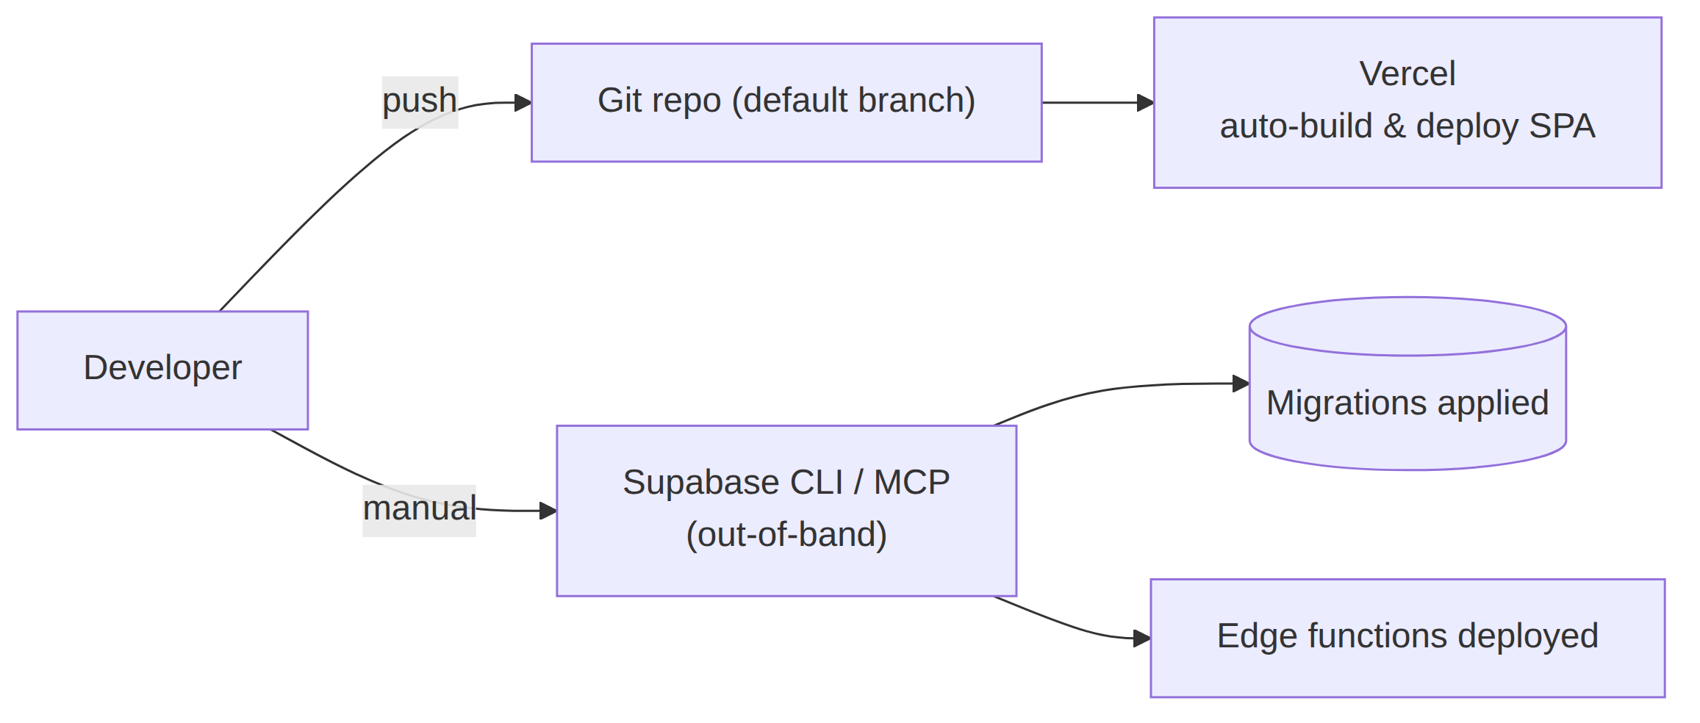
Figure 21 — Deployment pipeline
- Frontend: auto-deploys from the default branch on push (Vercel).
- Migrations & edge functions: applied manually via the Supabase CLI / MCP (no CI). A live site behaving like an older version almost always means a stale frontend deploy, not missing code.

13.4 Bootstrapping a fresh environment
- Apply the baseline migration supabase/migrations/20260701000000_baseline_full_schema.sql.
- Seed lookup tables (program_types, course_types, curricula, subjects, …).
- Create the first admin (the one manual step): db/scripts/create-admin.mjs, or a Supabase Dashboard user + db/scripts/promote-user-to-admin.sql. From there every other account is created in-app.

14. Known gaps & future work
Drawn from README.md §5 and the schema doc’s open items:
- No pricing/amount on invoices. The schema has no price/currency concept; invoices list packages/hours/student details only. Adding per-hour rates would touch the reporting layer and HOURS_AND_REVENUE_LOGIC.md together.
- First-time bundle purchases use fixed pool sizes. A Foundation/All-In-One first purchase creates pools at admin-configured default hours; only renewals are per-pool editable.
- Duplicate/redundant RLS policies remain on several tables (session_logs, curricula, subjects, …) — leftovers from iterative migrations, functionally harmless, worth consolidating.
- Fathom API not integrated. Session durations are typed in per session; auto-pulling real durations from a Fathom link depends on API availability.
- session_insights is unused — a Homework Generator table reserved for future prompt-steering.

15. Glossary
Term | Meaning
RLS | Row-Level Security — Postgres policies that filter rows per authenticated user; the real security boundary
Edge function | A Deno serverless function on Supabase, used for privileged/external operations
Performance Coach (PC) | A teacher with is_performance_coach = true; manages assigned students
Package / pool | A block of purchased hours (student_packages); bundles hold several labelled pools
Bundle | Foundation Program / All-In-One — a grouping of several same-course-type pools
No Show + | The one no-show type that both pays the teacher and deducts a student hour
Content source | What a homework paper is generated from: session log, upload, cloned, or parsed
Fathom transcript | The session-summary text a teacher pastes into a session log (formerly “Fathom Summary”)
service_role | Supabase key that bypasses RLS; confined to edge-function secrets
anon key | Public frontend key; every call it makes is RLS-filtered

Appendix — authoritative in-repo references
Document | What it holds
README.md | Project status: full route tables, feature-area summaries, decisions, open items
SYSTEM_WORKFLOW.md | Plain-language, demo-ready walkthrough of the whole system
db/docs/VERIFIED_DATABASE_STATE.md | Introspection-verified schema: columns, constraints, policies, functions, triggers
db/docs/HOMEWORK_GENERATOR_ARCHITECTURE.md | Homework Generator design & phase status
db/docs/HOURS_AND_REVENUE_LOGIC.md | How a session becomes teacher-hours vs. package-hours
db/docs/SUBJECT_HIERARCHY.md | Subject/curriculum/category hierarchy and where it’s picked
db/docs/DEBUGGING_HISTORY.md | The login/permissions bug trail (RLS vs. grants lesson)
CLAUDE.md | Repository conventions, incl. the docs-in-lockstep rule
End of document.

