Timebomb on EK-TM4C123GXL

Table of Contents
- Features Demonstrated
- Running the Example
This example implements the Timebomb sample application on the EK-TM4C123GLX board (ARM Cortex-M4F).
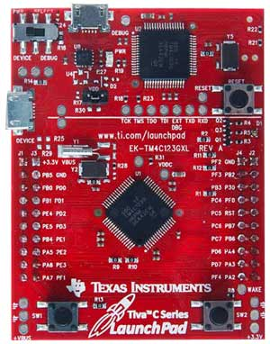
EK-TM4C123GXL board
The Timebomb example is located in the directory qpm/examples/arm-cm/Timebomb_ek-tm4c123gxl, which is organized as follows:
qpn/ - QP-[micro] installation directory
+-examples/ - QP-[micro] examples directory (application)
| +-arm-cm/ - QP-[micro] examples for ARM Cortex-M
| | +-Timebomb_ek-tm4c123gxl/ - Timebomb example on the EK-TM4C123GLX board
| | | +-qv/ - QV version
| | | | +-arm/ - ARM-KEIL toolchain
| | | | | +-Timebomb-qv.uvprojx - uVision project

Features Demonstrated
- cooperative QV-[micro] kernel
  - with ARM-KEIL toolchain

Running the Example
Once programmed into the board, the User LED, D1, shows the time bomb status, the left button is the Trigger button, and the right button is the arm/disarm button. The LED has the following states:
Disarmed : Blue
Armed : Green
Triggered : Red blinking @ 1Hz rate
Exploded : White
The program should initialize after power up or programming into the “Armed” state. Once armed the “Arm/disarm” button can be used to disarm the time bomb by pressing and releasing the button (toggling). Once armed, the “trigger” button can be toggled to put the time bomb into the “Triggered” state. Once “Triggered” the time bomb will no longer respond to the “Trigger” button, counting the number of “Triggered” blinks. If the number of “Triggered” blinks reaches 5, the time bomb explodes, displaying the “Exploded” LED state. In any of the time bomb states, toggling the “Arm/disarm” button will change that state to “Disarmed”, unless it is in the “Disarmed” state, in which case, it toggles into the “Armed” state.

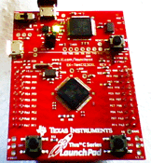
Timebomb on EK-TM4C123GLX (TivaC LaunchPad)

